Terminal Sheet

cd- change drive

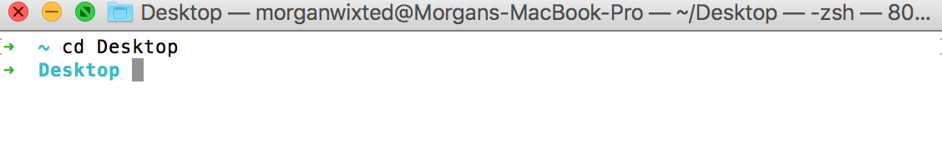pwd- print working directory

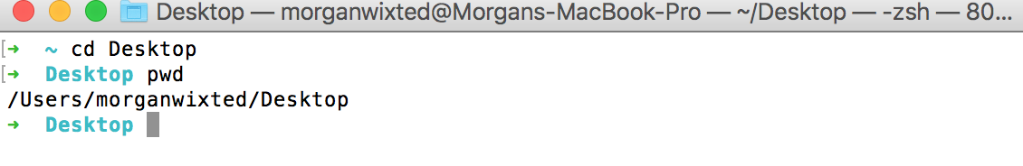

ls- list files

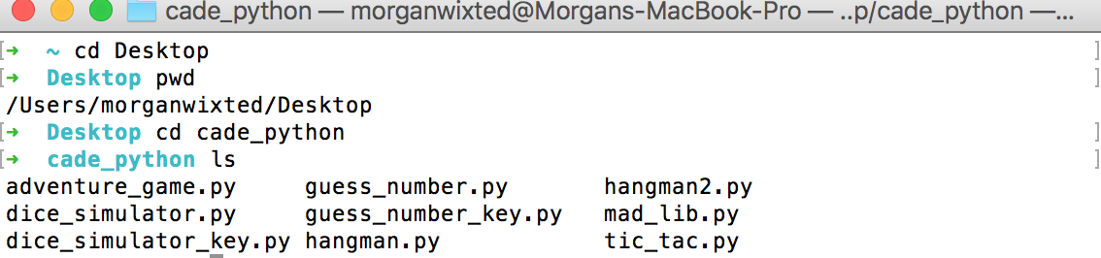

How to run a python file

1. pwd



2. cd into Desktop if you aren’t already in your desktop



3. Find the file you want to run and put python before your file name

Example: python guess_number.py

