Name : Mwizere Kisa Sabin
Id: 28408
*Step 1 — Problem Definition
A small supermarket wants to analyze customers, products, and sales transactions.

*Data Challenge
Management cannot easily see:
- best selling products
- top customers
- monthly sales trends
Expected Outcome
Use SQL to generate reports for better business decisions.
Sales with customer + product info
INNER JOIN
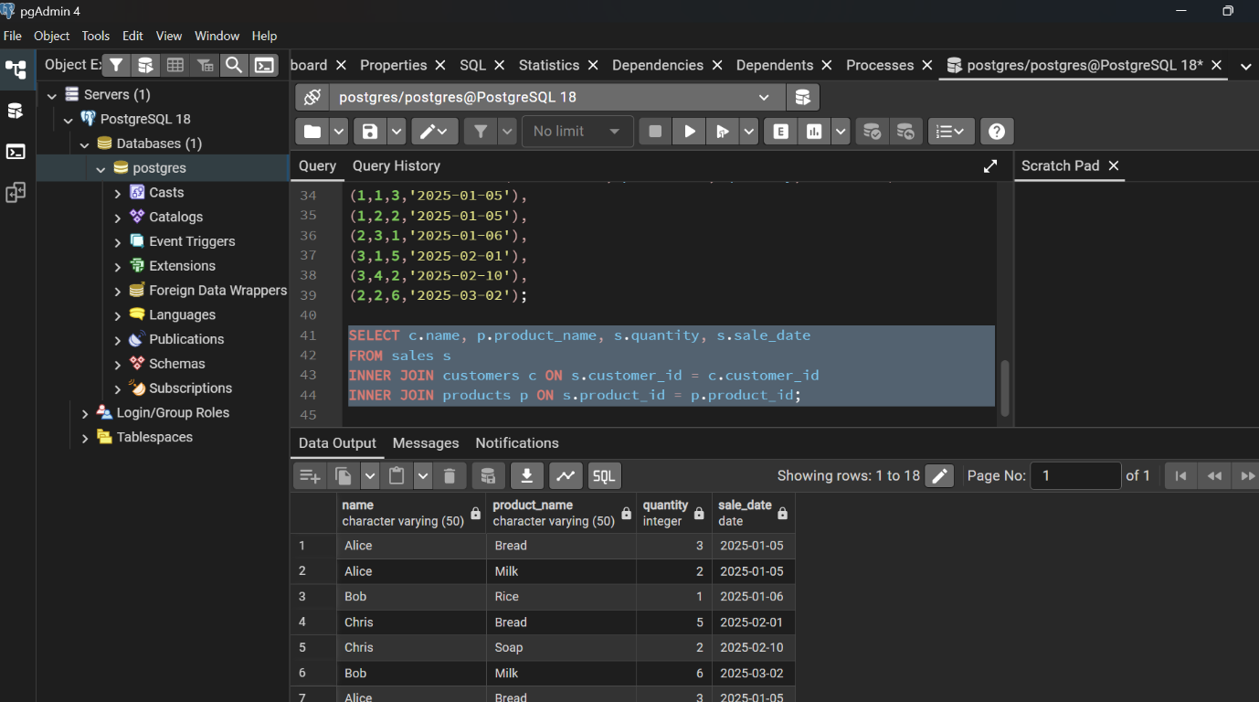LEFT JOIN
Customers with no sales
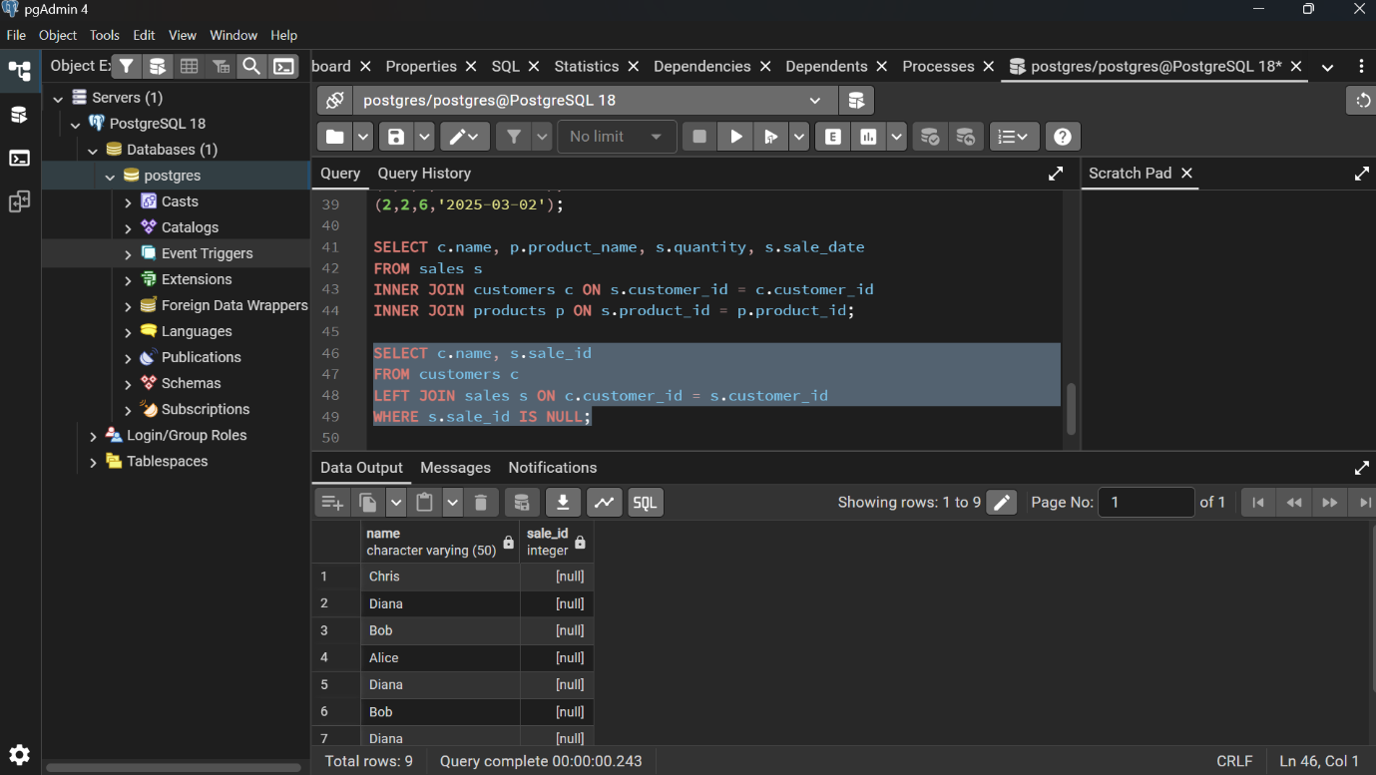RIGHT JOIN (or FULL)
Products never sold
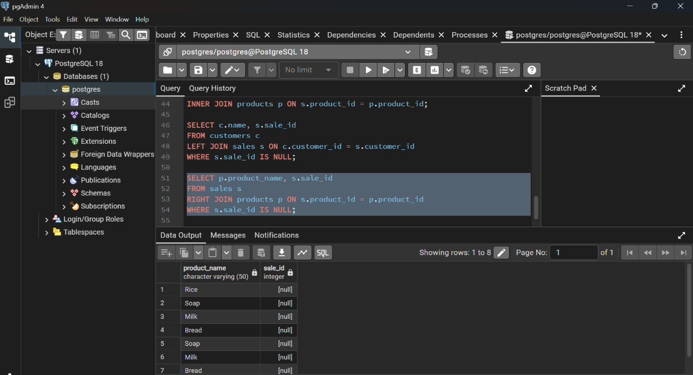
FULL OUTER JOIN

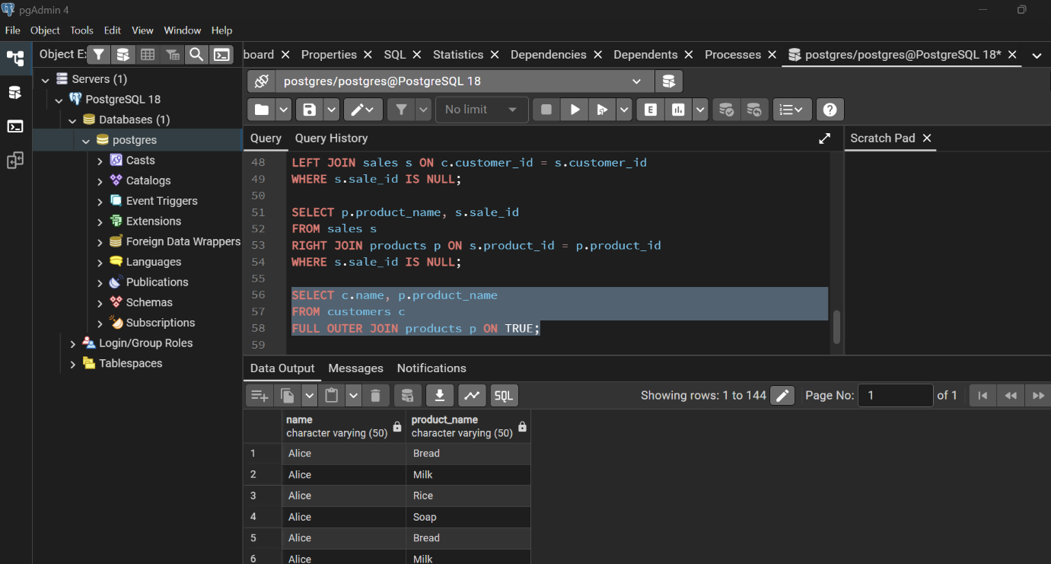
SELF JOIN

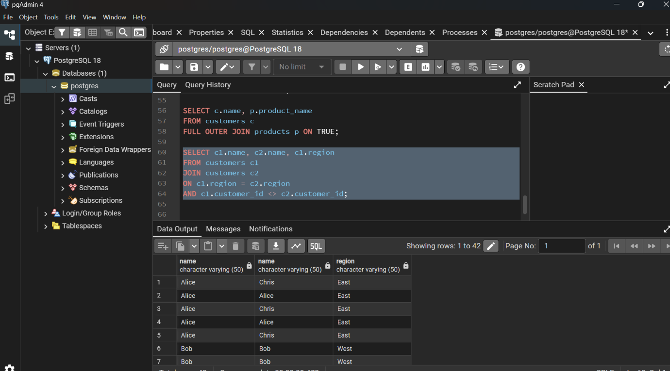

Step 5 — Window Functions
RANK() — Top products
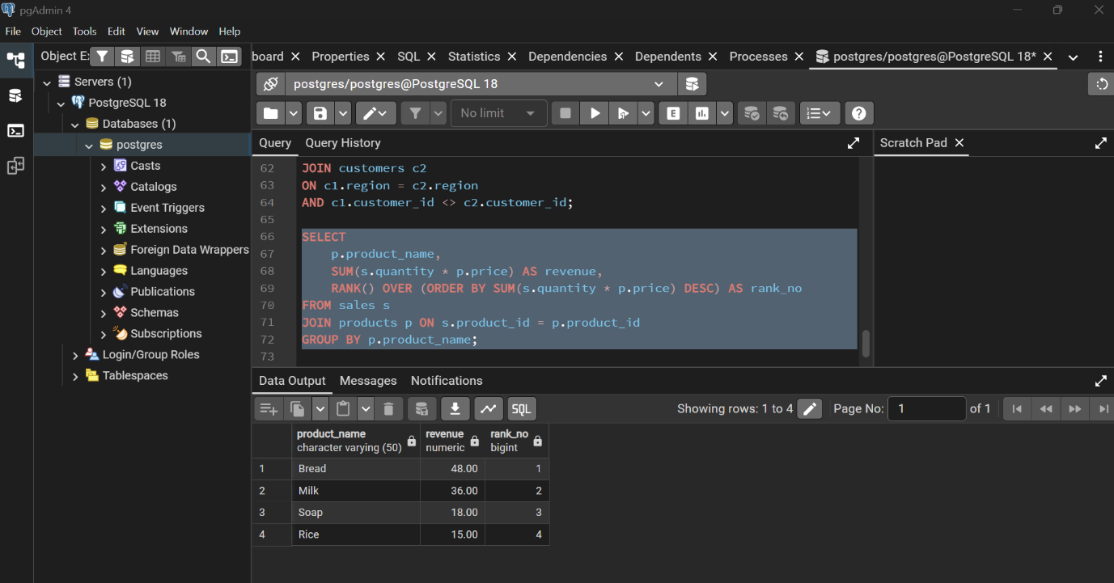

Running total — SUM() OVER()

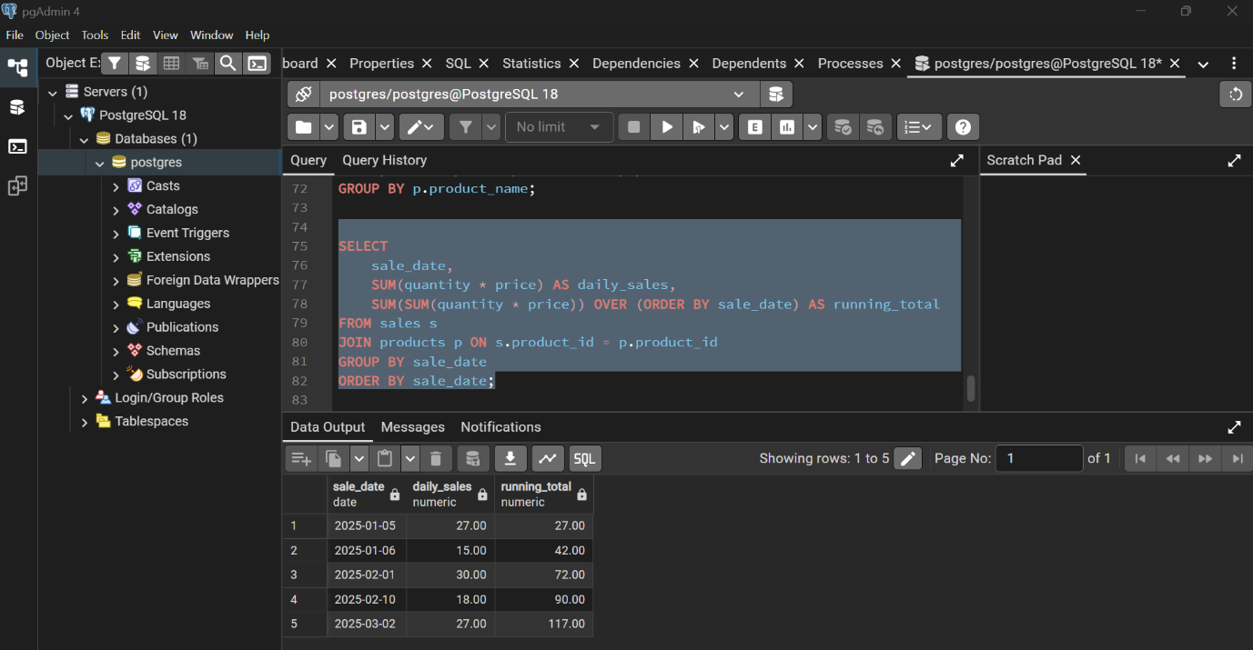

LAG() — Month growth

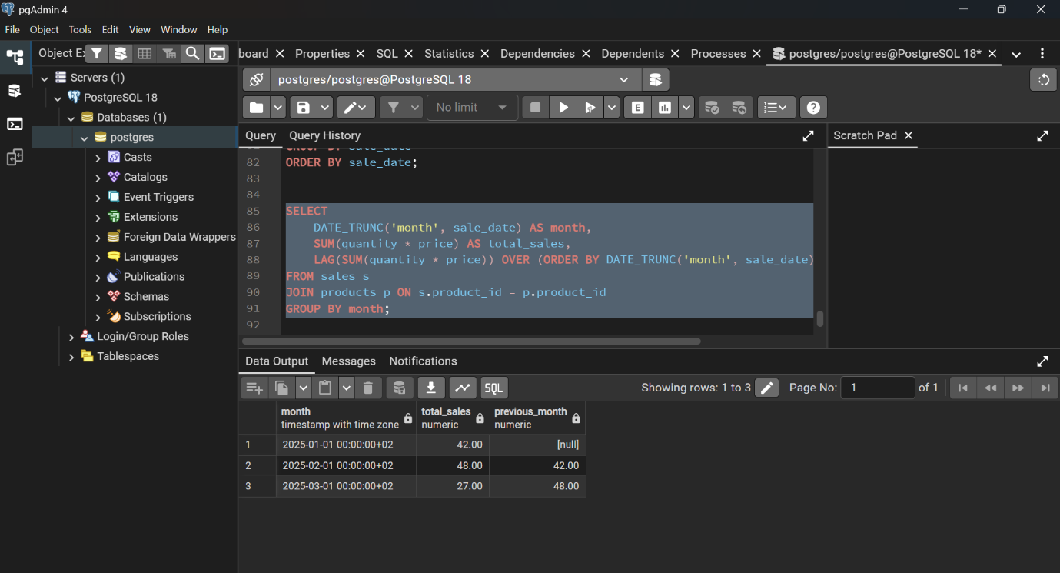

NTILE(4) — Customer segmentation
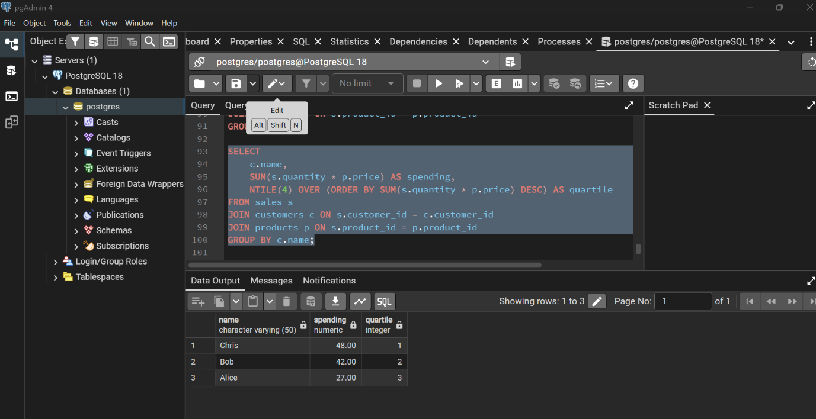

Moving average — AVG()
