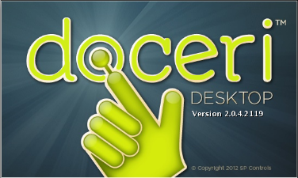**THE DOCERI APP**

By: Michael W. Krier  
Websites: [www.mwkrier.com](http://www.mwkrier.com)  
 [www.doceri.com](http://www.doceri.com)

**WHAT IS DOCERI?**

* Doceri is an interactive whiteboard for your iPad or Windows 10 Tablet
* This app allows you to create, save and edit presentations for your classroom.
* This app also streams to your desktop or laptop without any assistance of an outside device such as an Apple TV.

**WHY DOCERI?**

* Create your presentations while teaching.
* Allows for more engagement from students.
* Automatically records your pen strokes.
* Record yourself teaching and upload straight to YouTube.

**HOW TO USE THE DOCERI APP:**

Computer: - Go to Doceri.com and download Doceri for desktop.  
 *(The Desktop Version is a just a streaming program and does not have the functionality of the app.)*

* Desktop Program Cost $30.00 for a lifetime license and includes updates and new versions.

iPad or Windows 10 Tablet: Go to the App or Microsoft Store and Download the App

* App is free
* App is available for use without the Desktop Streaming App.

*(Warning the Windows 10 App will need help with the screen size. You will resize the window to see the entire whiteboard.)*

OPEN DOCERI

* Two Options: From iPad or Through A Computer
* On the Next Screen you choose from a created presentation or tap the + (plus sign) on the bottom left corner to create a new presentation.

TOOL BAR:

Starting from left to right.

Project Icon (File Folders)– Allows you to open or switch to another project.

Record Icon (Red Dot with REC) – Allows you to record your presentation.

Background Icon (Two Rectangles) – Change the white board to other preset or your own backgrounds.

Image Icon (Picture) – Use a picture as a background.

Drawing Tools (Six square boxes) – Pen, Markers, Highlighters, Shapes, Eraser that are changeable.

Clear Icon (Windshield Wiper) – Clears the entire board.

Undo & Redo Icon (Spiraling Arrows) – Undo or redo any pen strokes.

Setting Icon (Gear) – Allows you to change app settings.

Close (X inside a Circle) - Closes the current presentation.

SLIDER

The Doceri app records each pen stroke every time you lift off the screen.

The slider tool will allow you to go through all your pen strokes.

There is a scale allowing you to control the playback speed.

There are stops that can be added into the timeline to pause the playback.

Finally, a add new slide feature clearing the past strokes and giving you a new screen to continue without recording the eraser marks.

RECORD

* The record feature will create a video while you are doing your presentation.
* It also records a voice over of you talking.
* You can upload the video straight to YouTube or save the video.

PRACTICE TIME

Instructions: 30 Minutes

* Team up with teachers in your content area.
* Plan a small lesson you would teach in your classroom.
* Create a presentation on Doceri.
* Remember to use the slider and place appropriate stops.
* After the 30 minutes is up each group will present their lesson.