1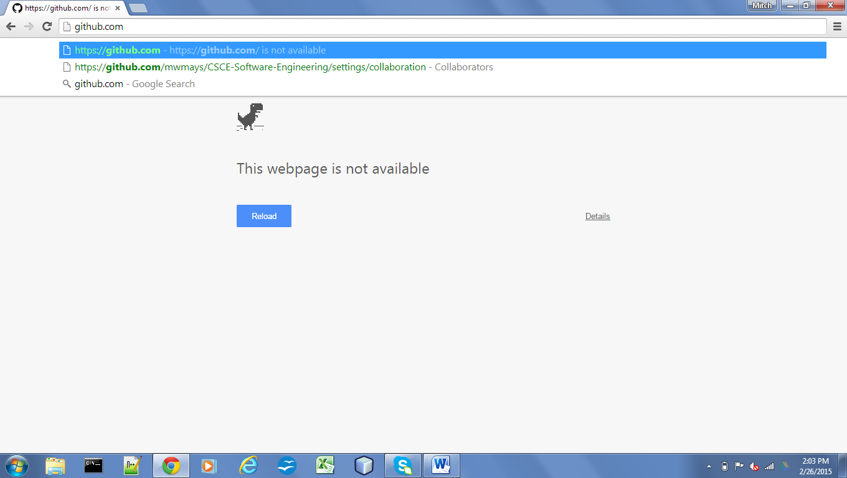

3

3

3

3

2

2

2

2

2

2

2

1

1

1

1

Notification to tell user to create account for extra features

Create an Account

View most recent ratings

Ad rating and commenting

View Comment and rating system

User input form for creating ad (price, ad title, ect.

View Ad

Create Ad

Place to Sell

Compared Prices

Search

User Settings

View my listings

Private messages

User Hub

Login System

Compared prices

Index - Search