**Software Engineering**

**Software Requirements Specification**

**(SRS) Document**

**Knocked-Out**

**9/20/2022**

**0.1**

**Matthew Mitchell, Senih Tosun, Joshua Hinojo**

**All work is subject to the UNCG Academic Integrity   
policy: https://osrr.uncg.edu/academic-integrity/. Academic dishonesty includes submitting for credit any software that you (or your   
team, in case of a team project) did not write yourself/yourselves.**

|  |
| --- |
| **Table of Contents** |

1. Introduction 2

2. General Description 3

3. Functional Requirements 3

4. Technical Requirements 4

4.1 Operating System & Compatibility 4

4.2 Interface requirements 4

4.2.1 User Interfaces 4

4.2.2 Hardware Interfaces 4

4.2.3 Communications Interfaces 4

4.2.4 Software Interfaces 4

5. Non-Functional Requirements 4

6. Appendix6

1. Introduction
   1. **Purpose:** Our purpose is to provide a comprehensive set of services to fulfill our customer’s needs in all steps of their tournament creation process.
   2. **Document conventions:**

The purpose of this Software Requirements Document (SRD) is to describe the participant-view, organizer-view, and administrator-view requirements for the Tournament Organization System (TOS). Participant-oriented requirements describe the system from the naive-user participants perspective. These requirements include a description of the participant served by the system. Organizer-oriented requirements describe the system from a higher-level end-user perspective. These requirements include a detailed description of the of the organizer served by the system. Administrator-oriented requirements describe the system from a software developer’s perspective. These requirements include a detailed description of data, performance, functional, and other pertinent requirements.

* 1. **Definitions, Acronyms, and Abbreviations**

Include any specialized terminology dictated by the application area or the product area.

For example:

|  |  |
| --- | --- |
| **Term** | **Definition. Acronym, Abbreviation** |
| .Net | A set of software technologies from Microsoft for connection information, people, and computer systems. |
| TOS | An abbreviation for Tournament Organization System. This is the name of the system that is being built. |
| C# | A programming language created by Microsoft. We will be using this language to build the ATPS. |
| DB | An abbreviation for Database. |
| MS | An abbreviation for Microsoft. Microsoft is a large software company which produces the software that will be used to implement ATPS. |
| Microsoft Access | A database software created by Microsoft. The campus police vehicle violation database was created using Microsoft Access. |
| SRD | An abbreviation for Software Requirements Document. This is the name of the document. |

* 1. **Intended audience:** Sections 1 and 2 are intended for participants which only need a limited understanding of software requirements. Sections 1, 2, 3, 4 include important information for organizers to gain in depth knowledge of the software. Administrators should review the entire document to gain a holistic understanding of the software to ensure all other stakeholders are represented accurately.
  2. **Project Scope:** The software goals are to provide a fully functional tournament organization tool set to our end-users. The overall business goal is to gain a customer base that can be leveraged for both paid and non-paid sponsors.
  3. **Technology Challenges:**
  4. **References:**

Alred, F., Brusaw, C., and Oliu, W. (2003). *Handbook of Technical Writing* (7th ed.)*.* Boston: Bedford/St. Martin’s.

## General Description

* 1. **Product perspective:** Tournament Organization System (TOS) that guides users to build and maintain complex tournaments for any competitive event.
  2. **Product features:** The TOS handles participant sign-up, organizer tools for setting up different types of tournament styles while also providing a choice between random seeding and statistical seeding for participants, an administrator is necessary for verifying and maintaining the integrity of participants and organizers through moderation.
  3. **User class and characteristics:** Our website application does not expect our participant users to have any prior knowledge of a computer, apart from using a web browser, or knowledge of tournament organization. Our website application has removed the need for them to have tournament knowledge and allows the user to focus on competing in a tournament. However, organizer users are required to have knowledge of which tournament style best suits their needs and/or limitations such as time, venue size, etc. Implementation of a particular tournament is handled entirely by the system. Administrators must have the same amount of knowledge as the organizer to ensure the integrity of all users.
  4. **Operating environment:** Software for TOS is designed to operate in any environment that supports web browser access.
  5. **Constraints:** To limit user error when entering the participant’s information fields, we implemented a drop-down AJAX selection.
  6. **Assumptions and dependencies:** It is assumed users have access to a web browser and an internet connection. TOS include external dependencies Spring Boot and (insert api).

## Functional Requirements

* 1. **Primary**
* FR0: The system will allow the user to lookup the participants associated team and relevant data associated with that team.
* FR1: The system will allow the user to enter a new team into a specific tournament being organized.
* FR2: The system will allow the user to issue a tournament seeding. The seeding will be derived from team statistics or randomly generated.
* FR3: The system will automatically fill in bracket information based on tournament type selected.
* FR4: The system will allow the user to update the bracket once the tournament has started.
* FR5: The system will allow the user to delete a team before or after the tournament has started.
* FR6: The system will keep the user’s team information and the server’s tournament statistic database synchronized to within 24 hours.
  1. **Secondary:** N/A

## Technical Requirements

* 1. Operating System & Compatibility
  2. Interface requirements
     1. User Interfaces

The logic behind the interactions between the users and the software. This includes the sample screen layout, buttons and functions that would appear on every screen, messages to be displayed on each screen and the style guides to be used.

* + 1. Hardware Interfaces

All the hardware-software interactions with the list of supported devices on which the software is intended to run on, the network requirements along with the list of communication protocols to be used.

* + 1. Communications Interfaces

Determination of all the communication standards to be utilized by the software as a part of the project

* + 1. Software Interfaces

The interaction of the software to be developed with other software components such as frontend and the backend framework to the used, the database management system and libraries describing the need and the purpose behind each of them.

## Non-Functional Requirements

* 1. **Performance requirements**
* NFR0(R): The local copy of the TOS database will consume less than 20 MB of memory
* NFR1(R): The novice user will be able to create a team and join a tournament in less than 5 minutes
* NFR2(R): The expert user will be able to generate seeding in less than 5 minutes.
* NFR3(R): The expert user will be able to generate tournament brackets in less than 1 minute.
* NFR4(R): N/A
* NFR5(R): The novice user will be able to delete a team in less than 5 minutes.
* NFR6(R): The local copy and server side TOS database will consume less than 20 MB of memory
  1. **Safety requirements**

N/A

* 1. **Security requirements**
* NFR6(R): The system will only be usable by authorized users.
  1. **Software quality attributes**
  2. Availability
  3. Correctness
  4. Maintainability
  5. Reusability
  6. Portability
  7. **Process Requirements**
     1. Development Process Used
     2. Time Constraints
     3. Cost and Delivery Date
  8. **Other requirements**

N/A

## Appendix

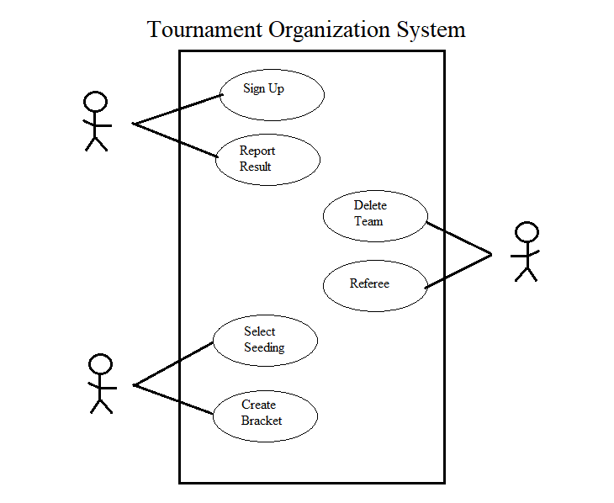

**Section I: Brief Description**

* **Sign up**

The participant can sign up as an individual or a collective team to an open tournament. After signing up, a participant can view the bracket of the current tournament.

* **Report Result**

The participant must report the results of their current match in the tournament to continue progressing. Once the results are returned to the system, the bracket is updated.

* **Delete Team**

The administrator can delete a team from the current tournament. The tournament bracket will update, displaying a grayed-out box indicating the change.

* **Referee**

The administrator can act as the final referee to settle any discrepancies that may arise during the tournament. A tournament may have its statistics modified retroactively through this process.

* **Select Seeding**

The organizer can select the type of seeding that the system will employ when creating the bracket for a tournament. The seeding may either be manual or randomly generated by the system.

* **Create Bracket**

The organizer can create a bracket, which is populated according to the tournament type, once the seeding has been selected. Creating a bracket opens the tournament sign-up for participants.

**Section II: Scenarios**

1. **Sign up:**
2. **Initial Assumption:**
3. **Normal:**
4. **What can go wrong:**
5. **Other activities:**
6. **System state on completion:**

**b) Report Result:**

1. **Initial Assumption:**
2. **Normal:**
3. **What can go wrong:**
4. **Other activities:**
5. **System state on completion:**

**b) Delete Team:**

1. **Initial Assumption:**
2. **Normal:**
3. **What can go wrong:**
4. **Other activities:**
5. **System state on completion:**

**b) Referee:**

* 1. **Initial Assumption:** The tournament has begun.
  2. **Normal:** The administrator considers the discrepancy and makes a settlement.
  3. **What can go wrong:**
  4. **Other activities:**
  5. **System state on completion:** Any discrepancies that arise are settled and tournament statistics modified accordingly. The tournament may continue.

**b) Select Seeding:**

* 1. **Initial Assumption:** The organizer knows which seeding type they require and can view the seeding options.
  2. **Normal:** The organizer successfully selects a seeding type for the bracket.
  3. **What can go wrong:** The organizer chooses the incorrect seeding type.
  4. **Other activities:** The organizer can reselect the seeding type by choosing a different one from a drop-down box.
  5. **System state on completion:** The organizer successfully selects a seeding type.

**b) Create Bracket:**

* 1. **Initial Assumption:** The seeding type for the bracket has been selected.
  2. **Normal:** The organizer successfully creates a bracket to be populated. The tournament sign-up is opened for participant users.
  3. **What can go wrong:**
  4. **Other activities:**
  5. **System state on completion:** The new bracket is created and the tournament participant sign-up is open.