User Instructions

You should have already been provided a username and password for the deep learning machines. Please read all instructions first before beginning.

1. SSH into the machine you want to work on. Available IP addresses are 10.202.0.12, 10.202.0.13, 10.202.0.14

ssh ldapusername@ipddress
enter password

You can run nvidia-smi to see what GPUs are on the system and which are being used. Since only a small group of people are using these machines, just let people know which machine and GPUs you plan to use.

2. Copy code and data to NAS

Test these commands out on some trivial files to ensure everything works and you understand what’s going on before moving your code and data. If you have terabytes of data on a computer that isn’t connected to the 10GB switch (in the server rack), we should talk before you try to move that much data across the CDN. We might be able to save time by just moving the data with an external hard drive.

From your computer’s terminal, not logged in via ssh copy files to your user home directory

scp /path/to/local/file ldapuser@ipaddress:/path/to/home/directory

example
scp xorg.conf jdickey@10.202.0.12:/home/jdickey

You can ssh into the machine and type ls to see the file in your home directory. If you try to move the file to a location outside your home directory you will get permission denied.

3. Create your dockerfile

Basic dockerfiles are located on the NAS at NAS_DATA/docker_files. These utilize nvidia_cuda to enable GPU support. Most users will only need to modify the requirements specific to their code at the bottom of the docker file (The RUN pip install… section at the bottom)

The NAS_DATA folder is mounted at /mnt/NAS/docker_files. After logging in:
cd /mnt/NAS/docker_files/

Edi the basic dockerfile to meet your code requirements. This may take a few iterations to get all of your requirements met. If you can’t open the file for editing because of permission issues let Capt Westing know.

sudo nano dockerfile_basic

Then save this file with your ldap username in the filename.

After editing the dockerfile, run:

sudo docker build -t tagname -f dockerfile_name .

The period at the end is part of the command.

To list all images on the machine:
docker images
You should see your image listed with the tag you gave it.

4. Push your image to Dockerhub

Once a new image has been created, this image can be pushed to dockerhub using the following instructions. This step allows all other machines to pull down your new image when they can’t find them locally. The docker hub username is “ovechkin20” and the password is the standard one.
https://docs.docker.com/docker-cloud/builds/push-images/

Since we’re using a repository, here’s an example set of instructions
docker login
username is ovechkin20
password is the one we’ve been using for everything
docker tag container_name afitdl/afit:container_name
docker push afitdl/afit:container_name

5. Create Docker Compose File

Install Docker Compose on your personal machine, you will run the docker compose command below on your local machine by following instructions here: https://docs.docker.com/compose/install/

A basic docker compose file is located on the NAS at NAS_DATA/docker_files titled docker-compose.yml. You will need to make sure your tagged image name is listed after “image” under the deeplearning service and that your username is listed in the device path under volumes.

An example is shown below for user nwesting2 using GPU devices 0 and 1 on the machine. Note the image should match the name of the dockerfile you pushed to Dockerhub. You should specify a unique port number for the ssh port forwarding (change 1722 to some random port number). Everything you must change is boxed in the image below. Users have also noted that they need to change the name nfsnasmount, you can try this too if you’re having connection issues.

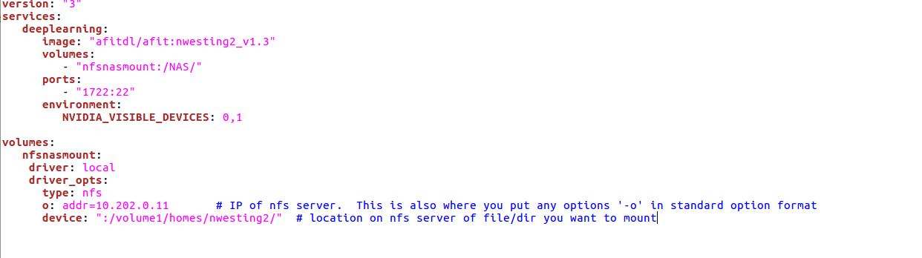
Save the docker compose file in its own directory on your personal machine. Change your terminal location to that directory

6. Run docker-compose file

All users will use port 2376 for their docker-compose command. This port has been set in the daemon.json on each machine and cannot be changed.

After installing docker-compose on your own machine following the instructions in step 5, you should now be able to run the docker-compose command. Change your directory to the folder containing your docker-compose.yml file and run

docker-compose -H ipaddress:port up

example: docker-compose -H tcp://10.202.0.12:2376 up

This command will return something like:
Recreating compose_nwesting2_deeplearning_1 ... done
Attaching to compose_nwesting2_deeplearning_1

If you have opened containers before you may get an error about your volume being in use:
Error response from daemon: remove compose_nwesting2_nfsnasmount: volume is in use – [1628ea5baca755ea5c174d41cc70f33d88937f97377dddae5299baa9f984244f]

To correct this you must bring the container down and remove the volume:
docker-compose -H tcp://ipaddress:port down
sudo docker -H tcp://ipaddress:port volume rm volume_name

If you want to continue using the terminal you ran the command from, press Ctrl+z then type bg to send the process to the background. You can view background processes with the jobs command. To bring the process back up type fg to bring it to the foreground. You can kill the running compose file by bringing the process to the foreground and then press Ctrl+c.

The ports command in the docker compose sets the ssh port you will need to use when setting your Pycharm interpreter.

7. Mount code from the NAS

From any CDN connected computer:
sudo mount -t nfs 10.202.0.11:volume1/homes/username localmountpoint
The username is your LDAP username
Example:
sudo mount -t nfs 10.202.0.11:volume1/homes/nwesting2 /NAS

You will want to mount your code on your local machine so that you can configure a path mapping in Pycharm for the remote interpreter.

Change the ownership of the project directory recursively, this will allow your local user to view the contents of the mounted folders.
sudo chown -R localusername localmountpoint

8. Configure your interpreter

After doing all this, you still could just work locally on your machine and use the NAS for code and data storage. Depending on file sizes, this could cause some delays as you will be limited by your CDN connection speed.

To configure a remote interpreter in Pycharm, go to File→Settings→Project: project_name→ Project Interpreter. Click the gear next to Project Interpreter and click ‘Show All’. This should open a new dialog box. Click the ‘+’ to add a new interpreter, then select SSH interpreter. The username is root and the password is the same one we’ve been using. The SSH port was set in the docker-compose.yml file with the ports command (you selected some random port number).

The python interpreter path should be /opt/conda/bin/python. You can set this by clicking on the folder icon and selecting the this file.

The path mapping should be from the locally mounted folder (Step 7) to /NAS/code_location. An example is shown below where the home directory was mounted on the local machine at /home/afit-dl3/Documents/HSI_ML_NAS_MOUNT.

9. Configure GitLab
a. Go to 10.202.0.11:10080
b. Login with your LDAP username and password
c. Configure Git for your project
d. Make sure you are not putting your data on Git. Git should be used only for your code. Look at how to use .gitignore to make this work.

If you get an error such as oserror 37 - no locks available, this means nfs didn’t start the nfs service. To correct this run:
sudo systemctl enable rpc-statd # Enable statd on boot
sudo systemctl start rpc-statd # Start statd for the current session

