EDA and Revised Project Statement

Final Project Milestone #3

APCOMP 209A

Anthony Sciola, Maia Woluchem, and Jay Dev

Description of the data

The Yelp Dataset Challenge data consisted of six separate data files: check-ins, photos, tips, reviews, users, and businesses. Each of these data sets contain different fields at separate levels, but we are most interested in the data sets on reviews (which is at the review-level), users (which is at the user-level), and businesses (which is at the establishment-level).

The reviews data set contains 2,927,859 records. Among the fields provided by Yelp, we were most interested in two: the star rating given in each review (*rating*) and the date that the review was logged (*review_date*). We immediately noticed that the mean of *rating* is 3.70 and the median is 4.00, indicating that reviews are skewed towards higher ratings. The users data contains 1,183,362 user records, with key variables average rating (*average_stars*), total number of reviews (*review_count*), years the user had ‘elite’ status (which we aggregate to the number of years with elite status: *elite_count*), and the date that the user joined yelp (*join_date*). In reviewing this data, we notice that *average_stars* match the ratings seen in the reviews data set (with mean 3.71 and median 3.89). We can also see that *review_count* follows an exponential decay function with a long tail—many users post just one or a handful of reviews with a small segment of very active users. This is reflected in users that have ever achieved elite status: less than 5 percent have ever held elite status.

[On size, missingness, and patterns of business data]

Within our initial analysis, we looked at the number of check-ins, photos, and tips at each establishment, as well as the number of tips provided by each user, but found that these data were missing for a majority of businesses and users, so we have opted not to ultimately use them.

Visualizations of Noteworthy Findings

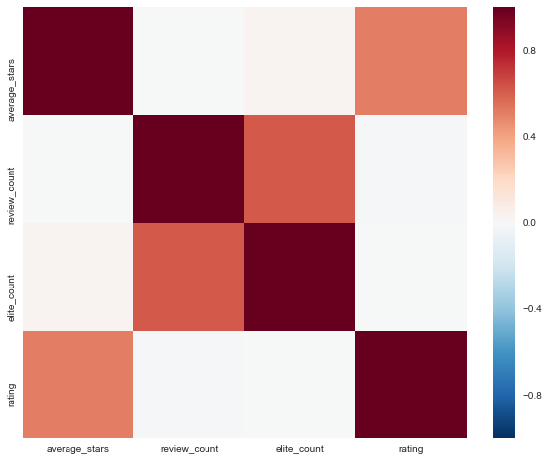

*Figure 1*. We see here that among users, *average_stars* is highly correlated with *rating*

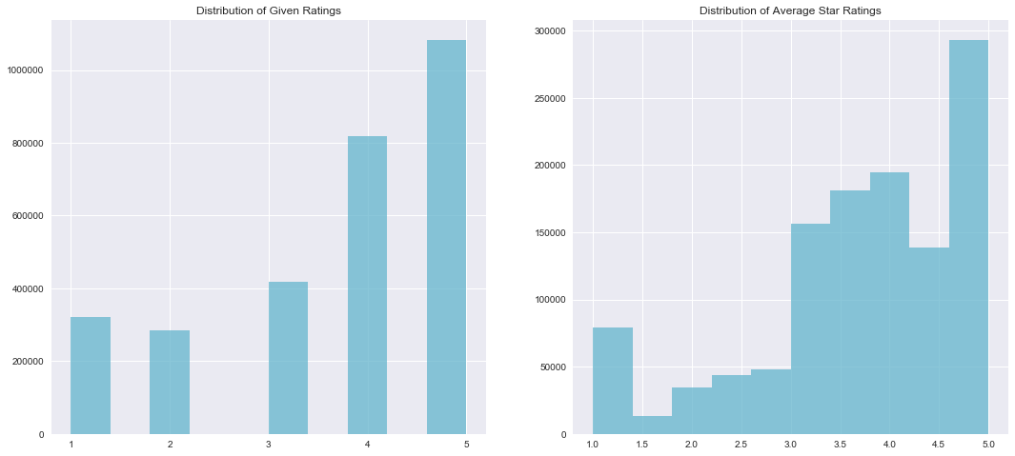

*Figure 2*. Corroborating the result above, the distribution of *ratings* and *average_stars* match one another quite closely.

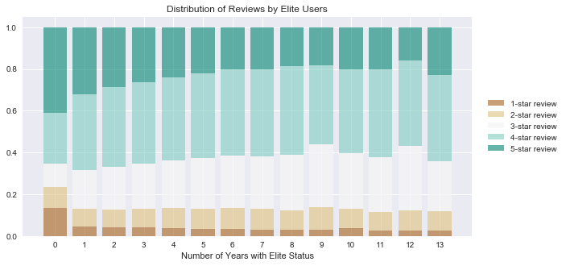

*Figure 3.* We find that those without Elite status are more likely to give 1- or 5-star reviews (which follows one-and-done angry/happy reviewers). We also see that more active users with a higher number of reviews are more likely to give 3 and 4-star reviews (visualization not shown).

Revised Project Question

Based on our exploratory data analysis findings, we are interested in understanding the impact of local market on prediction power. We plan to run the model separately for each of the eight cities that we have identified above. We will also run it with records from all of the cities together and compare results across the models.