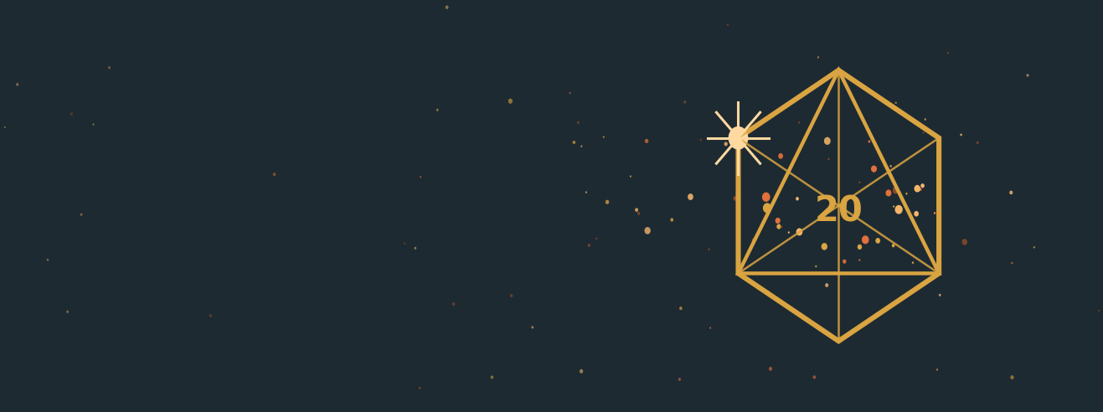
STARWROUGHT
CONSTELLATION COMPENDIUM
You are what you do.
HOW TO USE THIS
This book is generated from the game data, not written by hand. Every Constellation, Talent, Maneuver and reference table below is read straight out of assets/trees.json, assets/roster.json and assets/actions.json, so it is never out of step with the app, the Foundry system, or the character sheet.
The rules themselves live in the Player's Handbook (v4.10), which is written by hand. The short paragraphs between the tables restate it; where the two ever disagree, the handbook wins and this file needs a rebuild.
Contents: the character-creation menus (Ancestries and Bloodlines, Cultures, Backgrounds, Callings, Defenses), then every Constellation in the game with its full Talent list and star map, then the reference appendices: conditions and Zones, Vigor and Wounds, traits, Maneuvers and Activities, equipment, and the damage tables.

Character Creation at a Glance
Step | You choose… | You get… | Talent Points
1. Ancestry | Your body and blood. This forms the core of your Origin Constellation and gives you starting Vigor, Speed, and unique characteristics (e.g., keen eyes). | Vigor per level, Size, Speed, and 1 Special Ability. | 1 Origin (your Ancestry's root Talent)
2. Bloodline | Your lineage. This adds a branch to your Origin Constellation and gives you additional unique characteristics. | 1 Special Ability. | 1 Origin (your Bloodline's root Talent)
3. Culture | Where you were raised. This adds a branch to your Origin Constellation and gives you additional customization options. | Starting language(s), and a bonus to Diplomacy checks with those who share your Culture. | 1 Origin (your Culture's Root Talent)
4. Background | Your trade. This grants 1 Lore Talent Point and 2 Skill Talent Points. | — | 1 Lore / 2 Skill
5. Calling | Your adventuring identity. This adds special techniques such as entering a rage or sneak attacking. | Training in one Skill or other Constellation, Vigor per level, and a signature ability. | 1 Calling
6. Defenses | Your defensive posture. You begin Trained in two of the four Defenses (Awareness, Evade, Guard, and Endure), your choice. Each answers two of the four kinds of threat (Blows, Blasts, Blights, Beguilement), so two Trained Defenses cover three kinds and leave one gap; choose the pair whose gap you can live with. | Two Trained Defenses. A Defense you leave Untrained still adds its Attribute, but every Threshold that depends on it is 3 lower. | 2 Defense
7. Comets | Comets, which are Talent Points that can be used for any purpose (as long as you still meet the prerequisite). | — | 3 Comets
Granted | Melee Training or Ranged Training, your choice: every character begins Trained in one of them. It is granted automatically, not spent from the steps above. | Trained in Melee or Ranged: +3 to Strikes with a weapon in your hand, or with one that leaves it. A completed 1st-level character has spent at least 14 Talent Points, 13 from the steps above plus this one. | 1 Melee or Ranged Training
A finished 1st-level character has at least 14 Talent Points spent: one granted automatically (Melee Training or Ranged Training, your choice) and thirteen from creation: 3 Origin, 3 Skill (your Calling's free Training is one of them), 1 Lore, 1 Calling, 2 Defense, and 3 Comets. Some choices grant more, so your total may be higher. Points are never banked: each is spent the moment it arrives.

Types of Talent Point
Type | May be spent on | Flare required?
Origin Talent Point | Your Origin Constellation only (Ancestry, Bloodline, Culture) | If obtained after character creation, unless otherwise stated
Calling Talent Point | Calling Constellations only | If obtained after character creation, unless otherwise stated
Defense Talent Point | The four Defense Constellations only: Awareness, Evade, Guard, or Endure | If obtained after character creation, unless otherwise stated
Skill Talent Point | Skill Constellations only (includes Lore) | If obtained after character creation, unless otherwise stated
Lore Talent Point | Lore Constellations only | If obtained after character creation, unless otherwise stated
Opening Talent Point | Opening a new Constellation only, whatever kind. It buys a Root Talent and nothing else | If obtained after character creation, unless otherwise stated
Comet | Anything you qualify for | No
Milestone Talent Point | Anything you qualify for | Yes. However, if there are no Flared Constellations available, it becomes a Deferred Talent Point.
Deferred Talent Point | Anything you qualify for | Yes; must be spent the instant a Constellation is Flared.

Rank Math, Attributes and Checks
Ranks. Every Talent costs exactly 1 Talent Point, and your running total in a Constellation sets your Proficiency Rank there, gated by level: Trained +3 (1 point, level 1), Expert +6 (4 points, level 5), Master +9 (9 points, level 10), Legendary +12 (16 points, level 15). Buying a Constellation's root is what makes you Trained in it; nothing else in it can be bought first. Capstones (★) need a Master Talent in the same Constellation.
Parents. Melee and Ranged are parent Constellations. Every Combat Style is a child of one of them, and every Talent you buy in a child counts toward the parent's rank as well as the child's. Only rank is inherited: the parent's own Talents must still be bought for their effects, and a Talent's Attribute Point is counted once, at its own Constellation.
Attributes. Every Talent feeds one Attribute (Might, Agility, Wits, or Presence), usually its Constellation's Key Attribute. Attribute Bonus = Attribute Points ÷ 4, rounded down, to a maximum of +5: 0 to 3 points is +0, 4 to 7 is +1, 8 to 11 is +2, and every 4 more adds +1. A single point in a Constellation buys proficiency, not an Attribute Bonus.
Checks. One formula for everything: d20 + Attribute Bonus + Proficiency Bonus + Situation, Condition and Gear bonuses and penalties. Level never touches the die; it opens the door to higher ranks and pays out Talent Points. A Threshold is 10 + the same modifier, so a Guard of +7 is a Guard Threshold of 17, and an adversary's Thresholds are built the same way. Bonuses of the same type do not stack: take the highest bonus and the worst penalty of each type, and add across types.

Ancestries & Bloodlines
Your Ancestry is the body you were born in. It forms the trunk of your Origin Constellation and sets your Vigor per level, Size, Speed (in feet per Move ❶), and one special ability. Your Bloodline is the lineage inside it, and adds a branch. Both roots are Origin Talent Points granted by the choices themselves.
Ancestry | Vigor/lvl | Size | Speed | Senses | Key Attribute
Human | 8 | Medium | 6 ft | — | Presence

Human: Vigor 8 • Medium • 6 ft
Humans are restless, adaptable, and ambitious, at home anywhere and finished nowhere.
Bloodline (choose one; root granted free) | Grants
Versatile Human | You gain 1 Opening Talent Point. (feeds Wits)
Torchbearer Human | Allies within 15 feet gain a +1 Situation bonus to their first Defense roll each round while they can see or hear you.

Cultures
Culture is deliberately separate from Ancestry: an orc raised in the Kestrel Reach is simply both. Choosing a Culture grants its root free, and that root is always a language plus a scaled bonus to Diplomacy toward those who share it. The bonus rises with your rank in your Origin Constellation: +1 Trained, +2 Expert, +3 Master, +4 Legendary.
Culture | Language(s) | Key Attribute | About
Serrovane | Serrovine • Common | Presence | A lowland order-state where nothing is real until it is written and witnessed. Serrovane settles its disputes by formal challenge, keeps its ledgers in triplicate, and considers a broken oath a more serious crime than the violence that follows it.
Kestrel Reach | Reachspeak • Common | Wits | The trade-towns of a wide river delta, where six languages meet at every dock and a good broker is worth more than a good sword. Reach folk talk first, and are very good at it.

Languages
Language | Rarity | About
Common | Common | The trade tongue of the roads, ports, and mercenary camps: everyone's second language and nobody's first.
Serrovine | Uncommon | The tongue of Serrovane: precise, clause-ridden, and built for oaths that will be read back to you later.
Reachspeak | Uncommon | The dock-cant of the Kestrel Reach: fast, borrowed from six directions, and rich in words for a bad deal.

Backgrounds
KEYWORD: BECOME TRAINED IN
When an effect says you become Trained in a Constellation, you gain a Talent Point that must be spent in that Constellation. If it isn't open yet, the point buys the Training root, and that purchase IS becoming Trained. Already open? The point buys any Talent there you qualify for: training stacks into growth, never wasted.
Your life before the road. Each Background grants 2 Skill Talent Points and 1 Lore Talent Point.
Background | Skills (1 point each) | Lore (1 point) | You were…
Acrobat | Athletics & Acrobatics | Lore (Circus) | In a circus or on the streets, you earned your pay by performing as an acrobat. You might have turned to adventuring when the money dried up, or simply decided to put your skills to better use.
Soldier | Athletics & Intimidation | Lore (Warfare) | You served in somebody's army: a levy, a free company, a city watch that saw real fighting. You learned the drill, the marching, and the waiting, and you learned what a line looks like just before it breaks.
Criminal | Guile & Stealth | Lore (Underworld) | You made your living outside the law, whether by picking pockets, running contraband, or talking your way through doors that were meant to stay shut. You still know who to ask, and which questions never to.

Callings
Callings are what other games call classes, except the signature feature sits at the root, so your very first point buys the fantasy. Each Calling grants Training in one Skill or other Constellation, adds Vigor per level, and gives you a special ability. Only your first Calling counts toward Vigor, however many you open later.
Calling | Free Training | Vigor/lvl | Key Attribute | Special Ability
Ambusher | Stealth | 2 | Agility | Sneak Attack: +1d6 precision damage vs. Off-Guard foes, rising to +2d6 at Expert, +3d6 at Master, and +4d6 at Legendary.
Berserker | Athletics | 4 | Might | Rage ❶: Temporary Vigor equal to your level + Might, +2 melee damage, −1 Evade, and you are Heedless while it lasts. The damage rises to +4 at Expert, +6 at Master, +8 at Legendary.
Bravo | Acrobatics | 3 | Presence | Panache: held on a critical Strike, a Feint, or a Demoralize; +1 Situation to Evade and +1 ft to your Speeds while you hold it (Speed +2 ft at Expert, Evade +2 at Master, Speed +3 ft at Legendary).
Hunter | Awareness | 3 | Wits | Mark Prey ❶: +1d8 precision damage the first time each round you Hit your prey (2d8 at Expert, 3d8 at Master, 4d8 at Legendary), and you always know roughly where it is within 60 feet.
Weaponmaster | Athletics | 3 | Might | Drilled: Weapon Familiarity free; treat your Melee or Ranged Proficiency Bonus as 2 higher with that Weapon Group; and you may take Reactive Strike without being Expert in Melee.

Defenses
Your four Defenses are Constellations like any other. You begin play Trained in two of them, your choice; the other two stay Untrained until you spend Defense Talent Points on them, and an Untrained Defense still adds its Attribute. Each works two ways: your check is what you roll, and your Threshold (10 + the same modifier) is what someone else has to beat.
Every threat is a Blow, a Blast, a Blight, or a Beguilement, and each kind is answered by two Defenses: Guard (Presence) meets Blows and holds its nerve against Beguilement; Evade (Agility) slips Blows and Blasts; Endure (Might) stands through Blasts and Blights; Awareness (Wits) catches Blights early and sees through Beguilement. Guard answers a ranged Blow only with a shield Raised, and is unavailable when you are unaware of the attack or have nothing to ward with; Evade is unavailable while you are Grabbed or Restrained; Endure and Awareness are never unavailable.
Defense | Key Attribute | In a word | Physical checks | Mental checks
Awareness | Wits | Don't be surprised. | Blights: poison, disease, and anything that must be caught early. Initiative is usually Awareness. Never unavailable. | Beguilement: Feint, Lie, Sneak, and illusions are measured against your Awareness Threshold.
Evade | Agility | Don't be there. | Blows and Blasts. Unavailable while you are Grabbed or Restrained. | —
Guard | Presence | Don't let it through. | Blows (a ranged Blow only with a shield Raised). Unavailable while you are unaware of the attack, or have nothing equipped to ward it away. | Beguilement: fear, charm, confusion, and other assaults on your composure.
Endure | Might | Survive what does come through. | Blasts and Blights: poison, disease, exhaustion, Persistent Damage, and Recovery checks while Dying. Never unavailable. | —

Reactions
You may always roll one of the two Defenses that answer a threat, however many actions you have left: that is your basic defense. For the chance to do better you use a Reaction ↺: a Maneuver performed the moment the attack is declared, paid for from the same six actions you attack with, on anyone's Opportunity and as often in a round as you can afford. Each is granted by a Talent; without the Talent, the basic roll is all you have. A Reaction never triggers another Reaction. A Posture ⓿↺ costs no actions, but it always Exposes a Zone of your choice until the end of the round, and Recenter does not clear it.
Reaction | Granted by • Defense | Effect
Parry ❶↺ | Guard Training • Guard +2 Situation | You Guard with a +2 Situation bonus. You need a rigid weapon, a shield, or a permitted natural weapon in hand. If you Stop a Deliberate or Committed Strike, you take Control of the attacking weapon rather than a neutral Bind, and you may at once make a Quick Strike ⓿ against its owner: the riposte. A Stopped Quick Strike gives only a neutral Bind.
Void ❶↺ | Evade Training • Evade +2 Situation | You Evade with a +2 Situation bonus. If the attack is Stopped, you may Step in any direction.
Counter ❶↺ | Melee Expert • Guard or Evade, no bonus | Answer a melee Blow from a foe within your Reach with a Quick Strike of your own. No bonus to your Defense. Roll both; resolve both. Both can land. You cannot Counter a Counter or an Intercept, and the fighter you Counter rolls only their basic Defense against it.
Intercept ❶↺ | Melee Training • no Defense roll | When a foe Moves from outside your Total Reach to inside it, or Strikes you with an Unwieldy weapon from inside its Unwieldy distance, make a Quick Strike at the moment they enter. Once per foe per Move. A Wound stops their movement; anything less and it continues.
Posture ⓿↺ | Specific Talents • the named Defense | A Situation bonus to the named Defense, taken before you know whether the attack succeeded. It costs no actions, but a Zone of your choice becomes Exposed until the end of the round, whether or not the Posture works, and Recenter does not clear it. Its bonus is Situation, the same type Parry and Void grant, so a Posture and a Parry or Void do not stack.
Give Ground ⓿↺ | Evade Training • Evade +2 Situation | +2 Situation bonus to Evade for the triggering attack. A Zone of your choice becomes Exposed until the end of the round, win or lose; Recenter does not clear it.
Set Your Feet ⓿↺ | Guard Training • Guard +2 Situation | +2 Situation bonus to Guard for the triggering attack. A Zone of your choice becomes Exposed until the end of the round, win or lose; Recenter does not clear it.

Size
Size | Space / token | Natural Reach | Effect on Evade & Guard
Tiny | 1 ft x 1 ft | Adjacent | +2 Evade, −2 Guard
Small | 2 ft x 2 ft | 1 ft | +1 Evade, −1 Guard
Medium | 3 ft x 3 ft | 2 ft | No effect
Large | 5 ft x 5 ft | 4 ft | −1 Evade, +1 Guard
Huge | Varies | Varies | −2 Evade, +2 Guard
Gargantuan | Varies | Varies | −2 Evade, +2 Guard

Skills, Melee, Ranged & Combat Styles
Skill Constellation | Key Attribute | Covers
Acrobatics | Agility | Balance, tumbling, Tumble Through a foe's space, escapes
Athletics | Might | Climb, Swim, Leap, and every Grapple / Shove / Trip / Disarm / Reposition
Diplomacy | Presence | Rally, Talk Them Down, Aid, and making an impression
Guile | Wits | Feint, Lie, Look Harmless, and reading a mark
Intimidation | Presence | Demoralize, Coerce, and No Quarter
Lore | Wits | Deep knowledge of a chosen field (take it once per field)
Stealth | Agility | Hide, Sneak, and staying off the bottom rung of the ladder
The Lore Constellation is a template: every Lore you take, Lore (Circus) or Lore (Warfare) or any other, is its own copy of it, so a character can grow several Lores side by side.

Melee, Ranged and the Combat Styles
Melee and Ranged are the parent Constellations of every weapon. Melee Training adds its Proficiency Bonus to attacks with anything in your hand and grants the Intercept ❶↺ Reaction, and Counter ❶↺ once you are Expert in it; Ranged Training covers anything that leaves your hand, a thrown dagger included. You begin play Trained in one of the two, your choice. A Combat Style is a school of exploits, not your attack bonus: attacks always use your Melee or Ranged Proficiency, while the style sets the Attribute and opens that school's Talents. Every Combat Style is a child of Melee or Ranged, so every Talent you buy in it also counts toward the parent's rank.
Style | Feeds | Fights with
Archery | Agility | Bows and careful ranged attacks. Child of Ranged.
Armored Fighting | Presence | Using matched harnesses for additional benefits. Child of Melee.
Brawling | Might | Fists, feet, tusks, headbutts. Child of Melee.
Crossbow Fighting | Wits | Prepared mechanical ranged weapons. Child of Ranged.
Dueling | Agility | One one-handed weapon, other hand free. Child of Melee.
Great Weapon Fighting | Might | Two-handed, non-hafted weapons. Child of Melee.
Missile Skirmishing | Agility | Slings, thrown weapons, bolas. Child of Ranged.
Shield Fighting | Presence | Weapon and shield as one machine. Child of Melee.
Spear & Polearm Fighting | Wits | Hafted weapons: polearms and spears. Child of Melee.
Two-Weapon Fighting | Agility | A weapon in each hand. Child of Melee.

The Constellations
Every Constellation in the game, with its full Talent list and its star map. Tier is the Proficiency Rank a Talent needs: T Trained, E Expert, M Master, L Legendary. Every Talent costs exactly 1 Talent Point. A Combat Style's header names its parent; its Talents count toward that parent's rank as well as its own.

Ancestry Constellations

Human
Ancestry constellation • Presence (Medium • Vigor 8 • 6 ft • bonus to Aid)
Example flares: Crit succeed or crit fail on any roll with consequences, directly related to a talent in this constellation.
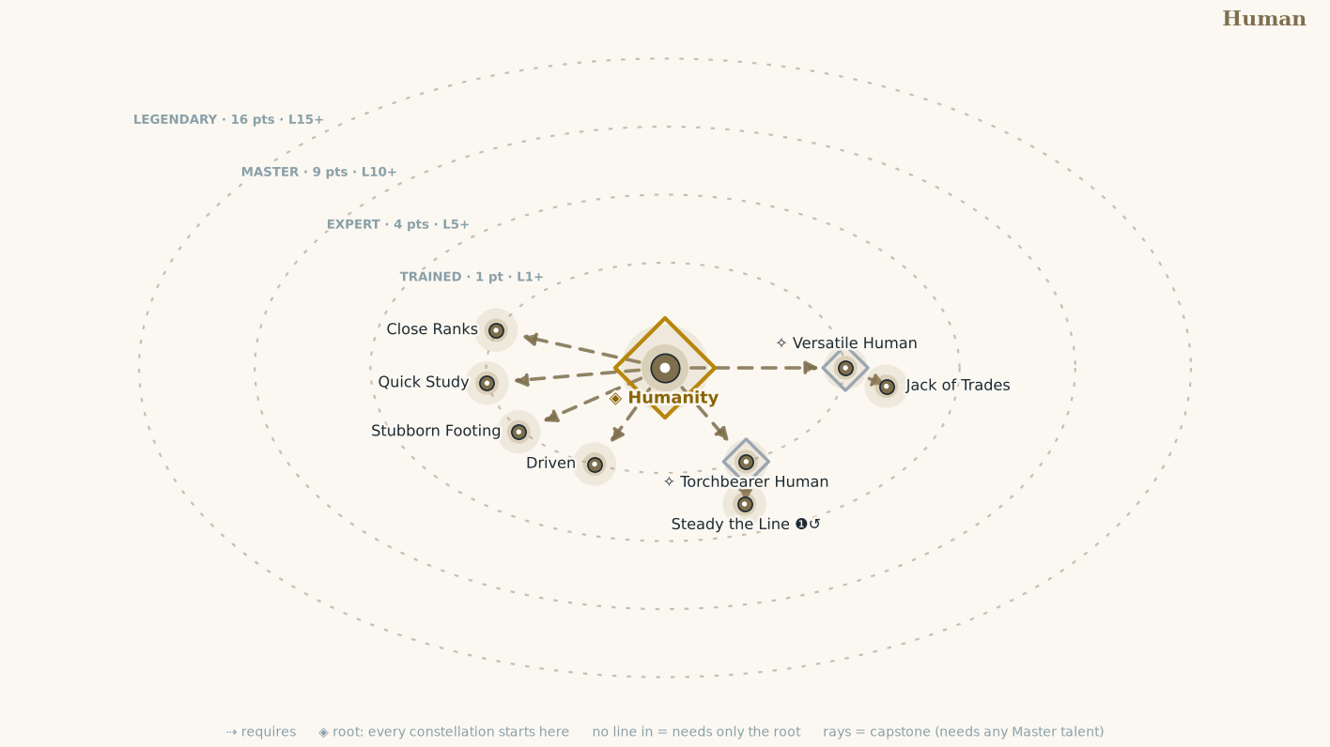
Talent | Tier | Cost | Effect
Humanity | T | 1 | You gain a +1 Condition bonus on checks to Aid. If you are Expert in Human, this becomes a +2 Condition bonus. If you are Master, +3. If you are Legendary, +4.
Driven | T | 1 | You gain a Calling Talent Point.
Quick Study | T | 1 | You gain a Skill Talent Point.
Stubborn Footing | T | 1 | The first time each encounter you would be knocked prone, you are not.
Close Ranks | T | 1 | While an ally is adjacent to you, both of you gain a +1 Situation bonus to Guard for physical Attacks.
Jack of Trades | T | 1 | You gain a +1 Situation bonus to your Untrained checks. Requires Versatile Human. (feeds Wits)
Steady the Line ❶↺ | T | 1 | Trigger An adjacent ally's Strike is Stopped and would Expose them.  Effect It Exposes nothing. Requires Torchbearer Human.

Culture Constellations

Kestrel Reach
Culture constellation • Wits (Reachspeak + Common; delta trade-towns where a good broker beats a good sword)
Example flares: Crit succeed or crit fail on any roll with consequences, directly related to a talent in this constellation.
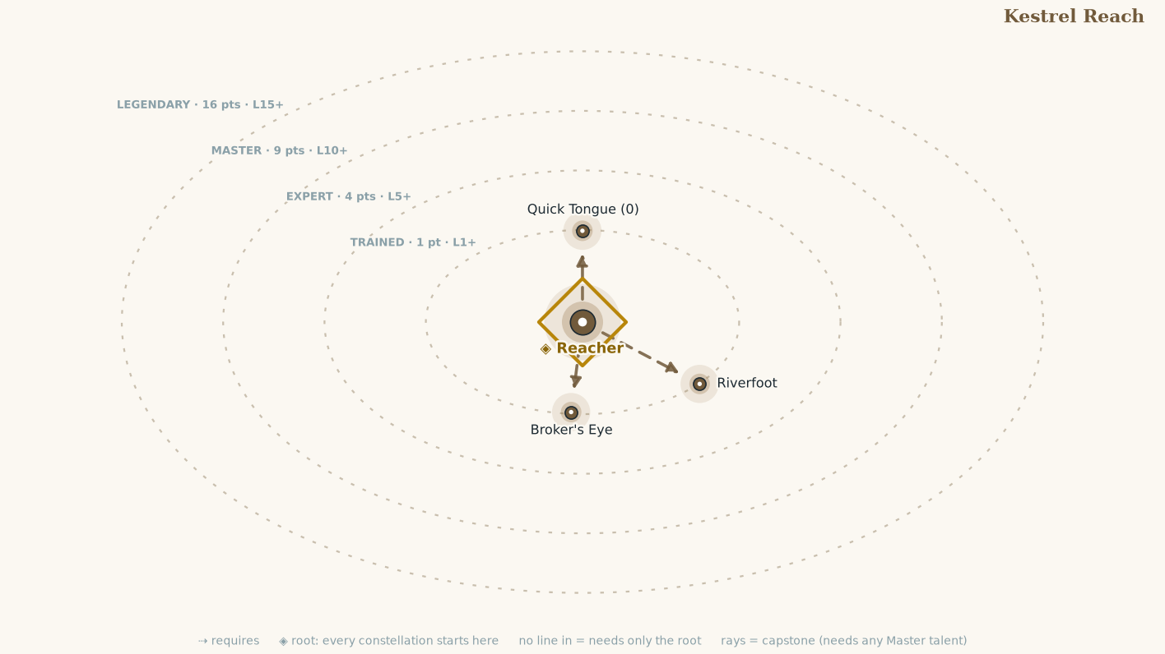
Talent | Tier | Cost | Effect
Reacher | T | 1 | You know Reachspeak and Common.  You gain a +1 Condition bonus to Diplomacy checks toward those who share the same Culture. When you are Expert in your Origin Constellation, the bonus increases to +2. Master: +3. Legendary: +4.
Quick Tongue ⓿ | T | 1 | You gain the Quick Tongue action:  Quick Tongue ⓿  Trigger You critically fail a Diplomacy check.  Requirements You're in a settlement or community, and you haven't used Quick Tongue in this settlement or community within the past month.  Reroll the triggering Diplomacy check, using the second result.
Riverfoot | T | 1 | You ignore difficult terrain from mud, decking, loose stone, and shallow water, and your first Move each encounter is 1 foot longer.
Broker's Eye | T | 1 | You always know an item's fair price, and gain +2 Situation to Diplomacy and Guile checks when trading.

Serrovane
Culture constellation • Presence (Serrovine + Common; a lowland order-state where nothing is real until written and witnessed)
Example flares: Crit succeed or crit fail on any roll with consequences, directly related to a talent in this constellation.
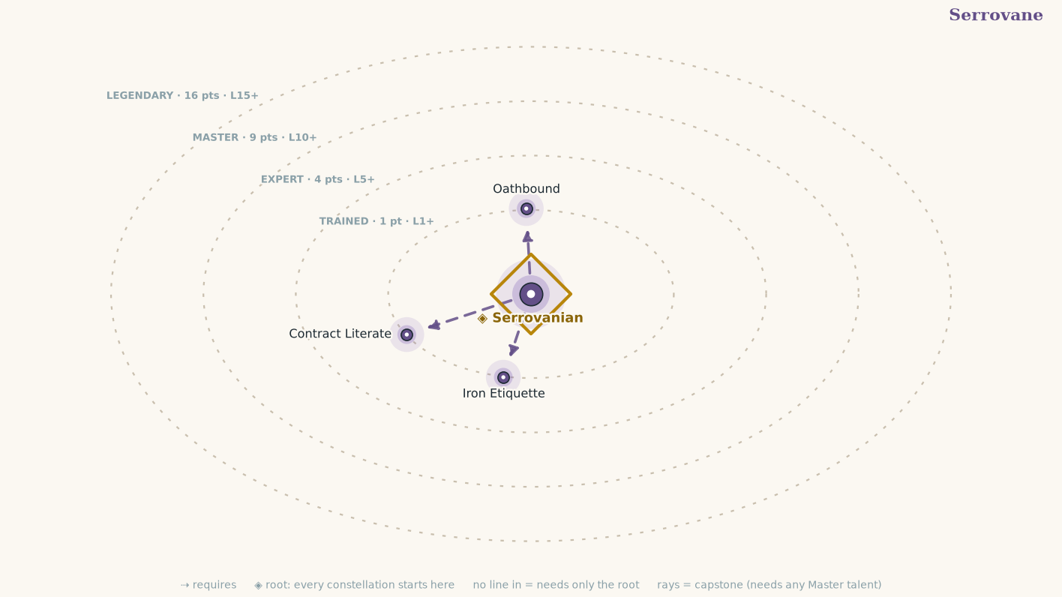
Talent | Tier | Cost | Effect
Serrovanian | T | 1 | You know Serrovine and Common.  You gain a +1 Condition bonus to Diplomacy checks toward those who share the same Culture. When you are Expert in your Origin Constellation, the bonus increases to +2. Master: +3. Legendary: +4.
Oathbound | T | 1 | Name one creature that has broken a bargain, a truce, or a formal challenge with you. You gain a +1 Situation bonus to Attack rolls and Defense rolls against that creature until the encounter ends. You may have only one Oathbound creature at a time.
Contract Literate | T | 1 | +2 Situation to notice hidden clauses, traps, and altered terms in any agreement.
Iron Etiquette | T | 1 | +1 Situation to checks against Intimidation and social manipulation.

Calling Constellations

Ambusher
Calling • Agility (2 Vigor/level • Sneak Attack)
Example flares: Crit succeed or crit fail on any roll with consequences, directly related to a talent in this constellation.
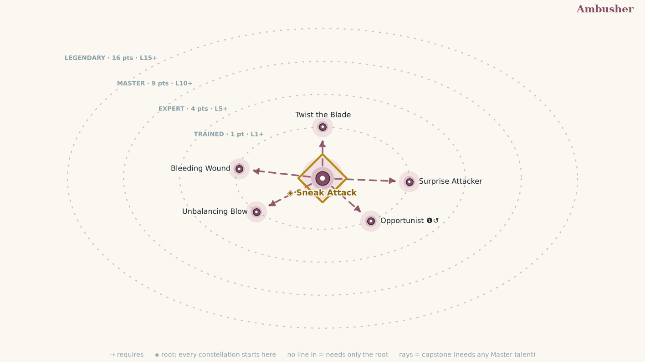
Talent | Tier | Cost | Effect
Sneak Attack | T | 1 | You become Trained in Stealth.  You gain Sneak Attack:  +1d6 precision damage vs. Off-Guard foes.  Rises to +2d6 at Expert rank, +3d6 at Master, +4d6 at Legendary.
Surprise Attacker | T | 1 | In the first round, foes that haven't acted yet are Wrong-Footed to you.
Opportunist ❶↺ | T | 1 | Trigger An ally Hits a creature within your reach.  Effect Strike that creature. It is Off-Guard to this Strike.
Twist the Blade | T | 1 | Once per round, when your Sneak Attack damage applies to a Hit, the Zone it landed on becomes Exposed.
Bleeding Wound | T | 1 | When your Sneak Attack damage applies, the target also takes 1d4 persistent bleed damage. This rises to 1d6 at Expert rank, 1d8 at Master, and 1d10 at Legendary.
Unbalancing Blow | T | 1 | Whenever your Strike is a critical hit and deals damage, the target is Wrong-Footed against your attacks until the end of the next round.

Berserker
Calling • Might (4 Vigor/level • Rage)
Example flares: Crit succeed or crit fail on any roll with consequences, directly related to a talent in this constellation.
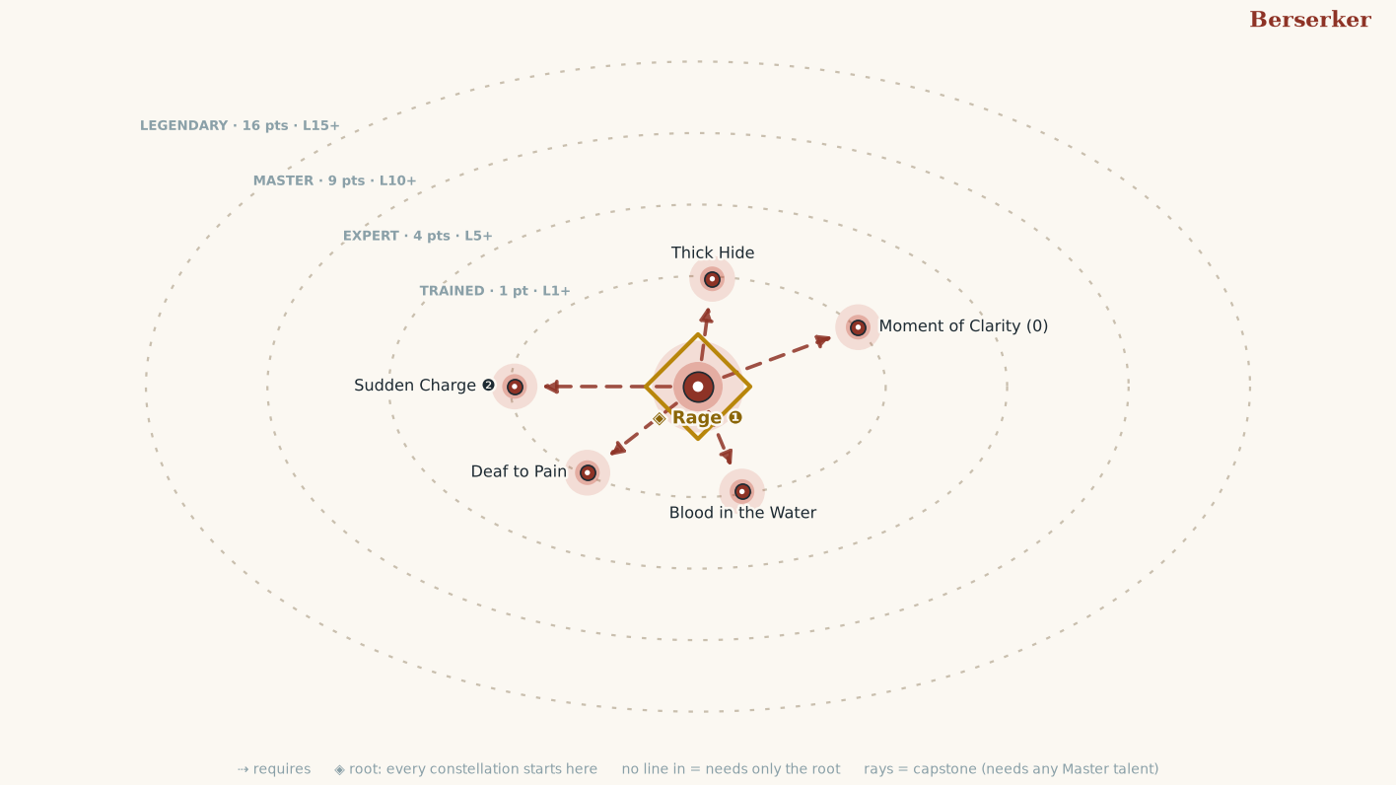
Talent | Tier | Cost | Effect
Rage ❶ | T | 1 | You become Trained in Athletics.  You gain the Rage action:  Rage ❶  Duration 10 rounds  You gain Temporary Vigor = level + Might, +2 melee damage, −1 Evade. While raging, you are Heedless.  Afterward, you're fatigued until you spend three actions to catch your breath.  You may end your Rage as a free action, becoming fatigued as though it had run its course.  Damage bonus rises to +4 melee damage at Expert rank, +6 at Master, +8 at Legendary.
Sudden Charge ❷ | T | 1 | You gain Sudden Charge:  Sudden Charge ❷  Move twice, then Quick Strike. Your Moves may provoke Intercepts as normal.
Thick Hide | T | 1 | While you are Raging, every Zone on you has +1 Protection, including Zones with no armor at all. An Exposed Zone still counts as 0.
Blood in the Water | T | 1 | When your Strike drops a creature while you are Raging, your Rage's remaining duration resets to 10 rounds.
Deaf to Pain | T | 1 | You ignore the Fatigued condition while Raging, and when your Rage ends you need to spend only 1 action to catch your breath rather than 3.
Moment of Clarity ⓿ | T | 1 | Frequency once per encounter  You push back your rage for a moment in order to think clearly. Until the end of this round, you lose your Heedless condition. (feeds Presence)

Bravo
Calling • Presence (3 Vigor/level • Panache)
Example flares: Crit succeed or crit fail on any roll with consequences, directly related to a talent in this constellation.
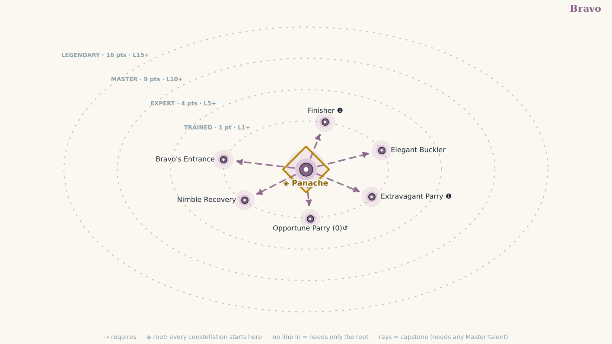
Talent | Tier | Cost | Effect
Panache | T | 1 | You become Trained in Acrobatics.  You gain Panache whenever you critically succeed on a Strike, or when you successfully Feint or Demoralize.  You can hold one Panache at a time and you keep it until you spend it or the encounter ends (whichever happens first).  While you have Panache you gain a +1 Situation bonus to Evade and a +1-foot Situation bonus to your Speeds. At Expert rank, Speed bonus increases to 2 feet. At Master rank, your Evade bonus increases to +2. At Legendary rank, your Speed bonus increases to 3 feet.  Every talent here requires this.
Finisher ❶ | T | 1 | Spend your Panache and Strike, with the following effects:  Hit add 2d6 precision damage.  Graze add 1d6 precision damage.  You lose the Panache either way.
Opportune Parry ⓿↺ | T | 1 | Trigger A creature's Strike against you is Stopped (a Graze or a Miss) while you have Panache.  Effect You take Control of the attacking weapon as though you had Parried, without spending an action.
Nimble Recovery | T | 1 | While you have Panache, you may Recenter ⓿ once per round.
Bravo's Entrance | T | 1 | You begin every encounter with Panache if you are not surprised.
Elegant Buckler | T | 1 | When you Raise a Shield ❶ to gain a Situation bonus to Guard from a buckler, increase the bonus from +1 to +2.  While you have a buckler raised, if a creature critically misses you with a Strike, you gain panache.
Extravagant Parry ❶ | T | 1 | Requirements You're wielding one or more one-handed weapons  You gain a +1 Situation bonus to Guard until your next Opportunity, or a +2 Situation bonus if you have a free hand or are wielding a weapon with the parry trait. You lose this Situation bonus if you no longer meet this feat's requirement. If a creature misses you with a Strike while you have this bonus, you gain panache.

Hunter
Calling • Wits (3 Vigor/level • Mark Prey)
Example flares: Crit succeed or crit fail on any roll with consequences, directly related to a talent in this constellation.
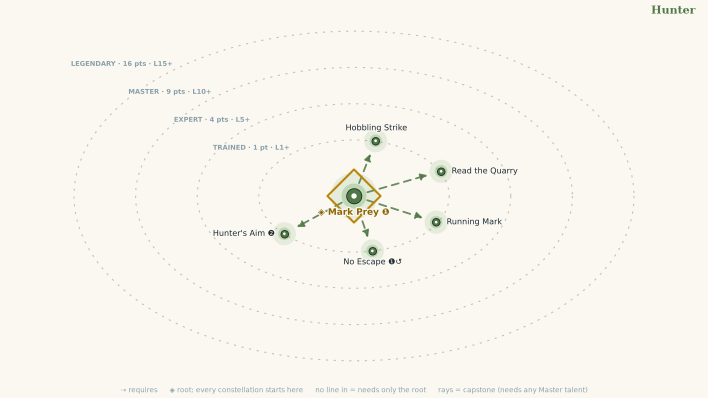
Talent | Tier | Cost | Effect
Mark Prey ❶ | T | 1 | You become Trained in Awareness.  (Concentrate) Choose one creature you can see. It is your prey until you Mark another or the encounter ends.  The first time each round that you Hit your prey, add 1d8 precision damage. You also always know roughly where your prey is while it is within 60 feet, even while it is Hidden or Undetected. The extra precision damage rises to 2d8 at Expert rank, 3d8 at Master, and 4d8 at Legendary.  Every talent here requires this.
Running Mark | T | 1 | You may Mark Prey as part of a Move rather than spending an action.
Read the Quarry | T | 1 | The first time each encounter your prey attacks you, you learn if its Evade or Guard is higher.
Hobbling Strike | T | 1 | When you Hit your prey with the first Strike of the round, its Speed is reduced by 2 feet until the end of the next round.
No Escape ❶↺ | T | 1 | Trigger Your prey Moves away from you.  Effect Move up to your Speed toward it. This does not provoke Reactions from your prey.
Hunter's Aim ❷ | T | 1 | Make a Deliberate weapon Strike ❷ against your Marked Prey. On this Strike, you gain a +2 Situation bonus to the attack roll and ignore your prey's concealed condition and any lesser cover.

Weaponmaster
Calling • Might (3 Vigor/level • Drilled)
Example flares: Crit succeed or crit fail on any roll with consequences, directly related to a talent in this constellation.
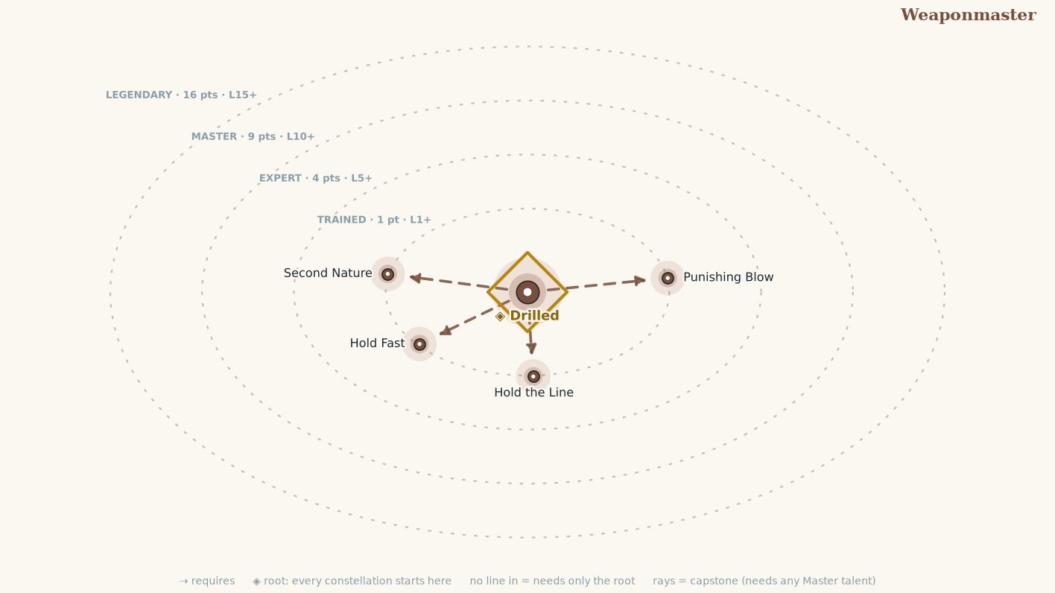
Talent | Tier | Cost | Effect
Drilled | T | 1 | You become Trained in Athletics.  You gain the Weapon Familiarity Talent for free.  Choose one Weapon Group in which you are Familiar. When making attacks with weapons of that Group, treat your Weapons Proficiency Bonus as 2 higher. This does not actually increase your Proficiency Rank and does not satisfy Expert, Master, or Legendary prerequisites.  You may take the Reactive Strike Talent, even if you are not Expert in Melee. However, you may still only use Reactive Strike with weapons in which you are at least Expert Proficiency Rank.  Every Talent in this Constellation requires this.
Hold the Line | T | 1 | Your Intercept also triggers when a creature within your Reach uses any Motion Maneuver, whether or not it leaves your Reach.
Punishing Blow | T | 1 | Your Intercept disrupts the triggering Maneuver on a Hit, not only a Critical Hit, if the Zone struck was Exposed.
Second Nature | T | 1 | Your weapon specialization damage arrives one rank early with your Drilled group: +2 while Trained, +3 at Expert, +4 at Master, +5 at Legendary.
Hold Fast | T | 1 | When one of your Strikes is Stopped and would Expose you, you may take 1 Vigor damage per level and Expose nothing instead.

Defense Constellations

Awareness
Defense constellation • Wits (don't be surprised)
Example flares: Crit succeed or crit fail on any roll with consequences, directly related to a talent in this constellation.
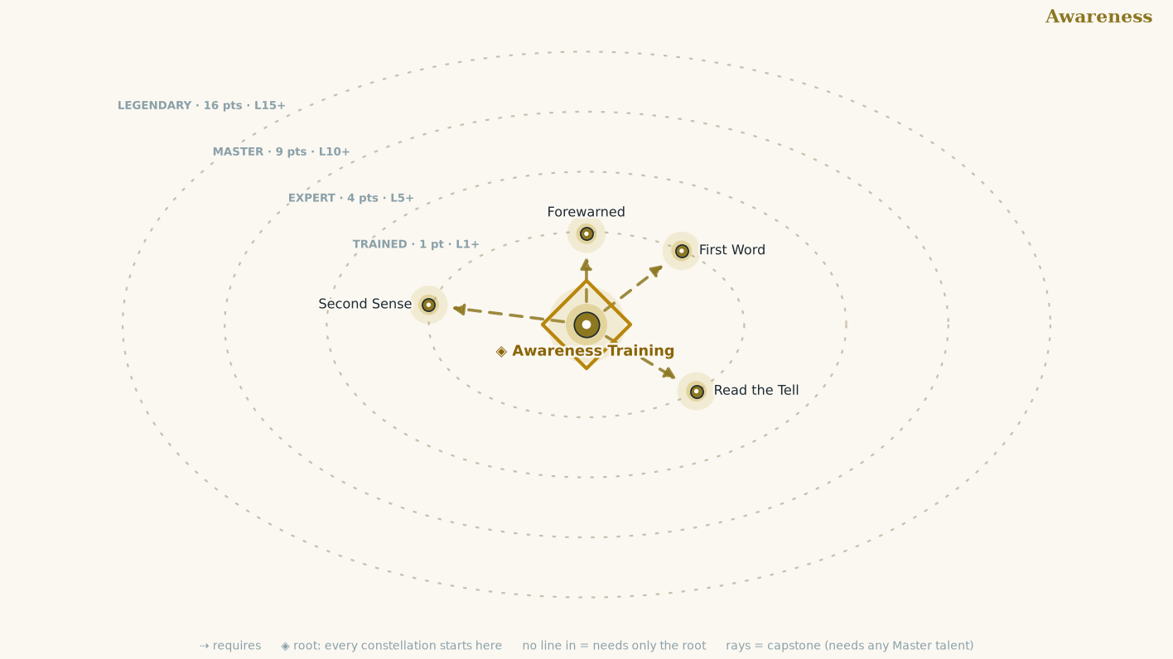
Talent | Tier | Cost | Effect
Awareness Training | T | 1 | You are Trained in Awareness: add this Constellation's Proficiency Bonus to your Awareness checks, and to your Awareness Threshold (the number Sneak, Feint, and Lie attempts are measured against). Initiative is usually an Awareness check. Awareness answers Blights and Beguilement (see Chapter 2: The Four Threats).
Forewarned | T | 1 | Once per encounter, after you roll a Defense but before the outcome is announced, you may add your Wits to that roll.
Read the Tell | T | 1 | When a creature critically fails to Feint against you, Lie to you, or Sneak past you, it becomes Exposed (Head) until it Recenters.
First Word | T | 1 | When you roll initiative and are not surprised, you may swap your place in the order with one willing ally.
Second Sense | T | 1 | The first time each encounter that a hidden or unnoticed creature attacks you, you may use Guard against that attack even though you were unaware of it.

Endure
Defense constellation • Might (survive what does come through)
Example flares: Crit succeed or crit fail on any roll with consequences, directly related to a talent in this constellation.
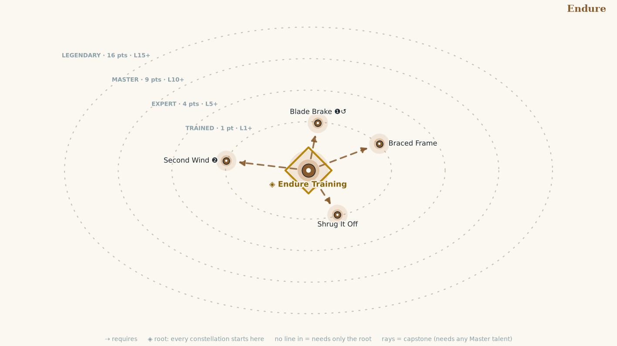
Talent | Tier | Cost | Effect
Endure Training | T | 1 | You are Trained in Endure: add this Constellation's Proficiency Bonus to your Endure checks. It is the check you roll against poison, disease, exhaustion, and anything trying to break your body. Endure answers Blasts and Blights. You also reduce your Load Strain by 1 (to a minimum of 0) once you reach Expert rank, 2 at Master, and 3 at Legendary.
Shrug It Off | T | 1 | Reduce each instance of persistent damage you take by your Might. This can never reduce it below 1.
Second Wind ❷ | T | 1 | Once per day, dig deep: regain Vigor equal to half your level plus your Might.
Braced Frame | T | 1 | +2 Situation bonus to your Guard against Shove, Trip, and Reposition.
Blade Brake ❶↺ | T | 1 | Trigger You would be moved by a forced movement effect  Requirements You are wielding a melee weapon and are within reach of a hard surface  You plow your weapon into a floor, wall, or another sturdy surface, anchoring yourself in place. If you would be moved 6 feet or more, you are moved only 1 foot. Otherwise, you don't move at all.

Evade
Defense constellation • Agility (don't be there • Void Reaction and Give Ground Posture)
Example flares: Crit succeed or crit fail on any roll with consequences, directly related to a talent in this constellation.
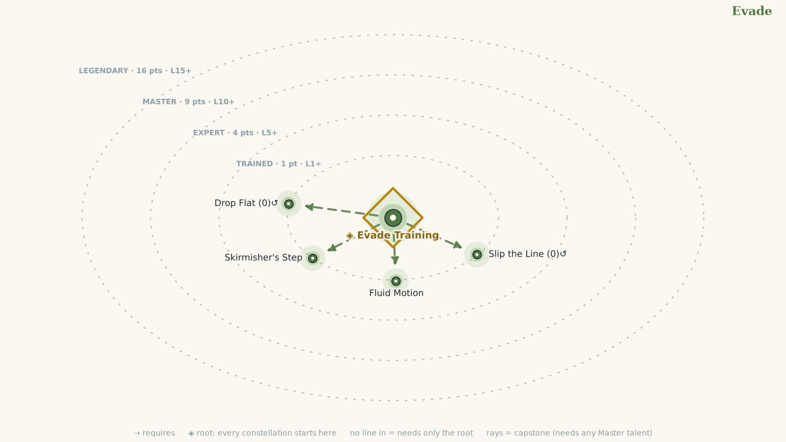
Talent | Tier | Cost | Effect
Evade Training | T | 1 | You are Trained in Evade: add this Constellation's Proficiency Bonus to your Evade checks. It is the number attack rolls are measured against when you try to slip a blow, and the check you roll against area effects, traps, and hazards. Evade answers Blows and Blasts.  You gain the Void ❶↺ Reaction, and the Give Ground ⓿↺ Posture:  You gain a +2 Situation bonus to Evade for the triggering attack.  A Zone of your choice becomes Exposed until the end of the round, win or lose.
Fluid Motion | T | 1 | Your Speed increases by 1 foot while your Load Strain is 1 or less.
Skirmisher's Step | T | 1 | Your Steps ignore difficult terrain.
Slip the Line ⓿↺ | T | 1 | Posture +2 to your Evade against one attack. If the blow does not Hit, you end in any square adjacent to the attacker, your choice.
Drop Flat ⓿↺ | T | 1 | Posture +4 to your Evade against every attack until your next Opportunity. You end prone.

Guard
Defense constellation • Presence (don't let it through • Parry Reaction and Set Your Feet Posture)
Example flares: Crit succeed or crit fail on any roll with consequences, directly related to a talent in this constellation.
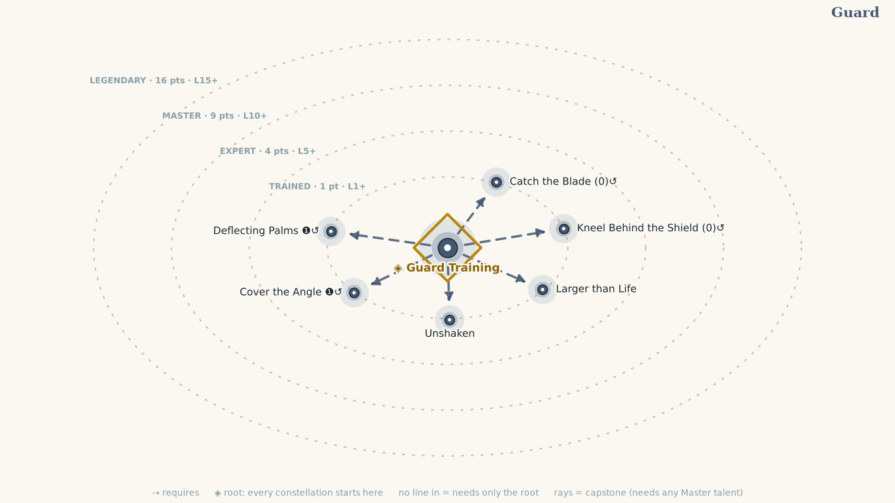
Talent | Tier | Cost | Effect
Guard Training | T | 1 | You are Trained in Guard: add this Constellation's Proficiency Bonus to your Guard checks. It is the number attack rolls are measured against when you meet a blow with weapon, shield, or braced arm, and the check you roll against fear, charm, confusion, and other assaults on your composure. Guard answers Blows and Beguilement, and answers a ranged Blow only with a shield Raised.  You gain the Parry ❶↺ Reaction, and the Set Your Feet ⓿↺ Posture:  You gain a +2 Situation bonus to Guard for the triggering attack.  A Zone of your choice becomes Exposed until the end of the round, win or lose.
Catch the Blade ⓿↺ | T | 1 | Posture +2 to your Guard against one melee attack made with a weapon or natural weapon you could Bind. If the blow does not Hit, you take Control of the attacking weapon as though you had Parried. A Zone of your choice becomes Exposed until the end of the round, win or lose.
Kneel Behind the Shield ⓿↺ | T | 1 | Posture You must have a shield Raised.  +4 to your Guard against every attack until your next Opportunity. Your Arms become Exposed, and your Speed is 0 until you spend an action to rise.
Unshaken | T | 1 | The first time each encounter that you take a Posture, it Exposes nothing.
Deflecting Palms ❶↺ | T | 1 | Trigger You are hit and have a hand free.  Effect Reduce that attack's damage by 2 plus your Presence.
Cover the Angle ❶↺ | T | 1 | Trigger An adjacent ally is attacked.  Effect The attack is measured against your Guard instead of their chosen Defense, and any Bind that forms is with your weapon or shield.
Larger than Life | T | 1 | Requirements You are wearing Plate in all Zones.  Though you don't get any larger, you're treated as one size larger for the purposes of affecting other creatures with actions like Disarm, Grapple, Reposition, Shove, and Trip while wearing heavy armor. Similarly, you're treated as one size larger for the purposes of creatures affecting you with those same actions, as well as with Swallow Whole and similar actions, while wearing heavy armor. (feeds Might)

Melee and Ranged

Melee
Weapon • Might (Represents transferable fundamentals: measure, timing, reading an opponent, footwork, maintaining guard, committing to a strike, etc. Melee is a parent Constellation: every Talent you buy in Two-Weapon Fighting, Shield Fighting, Brawling, Dueling, Great Weapon Fighting, Spear & Polearm Fighting, or Armored Fighting counts toward your Melee rank.)
Example flares: Crit succeed or crit fail on any roll with consequences, directly related to a talent in this constellation.
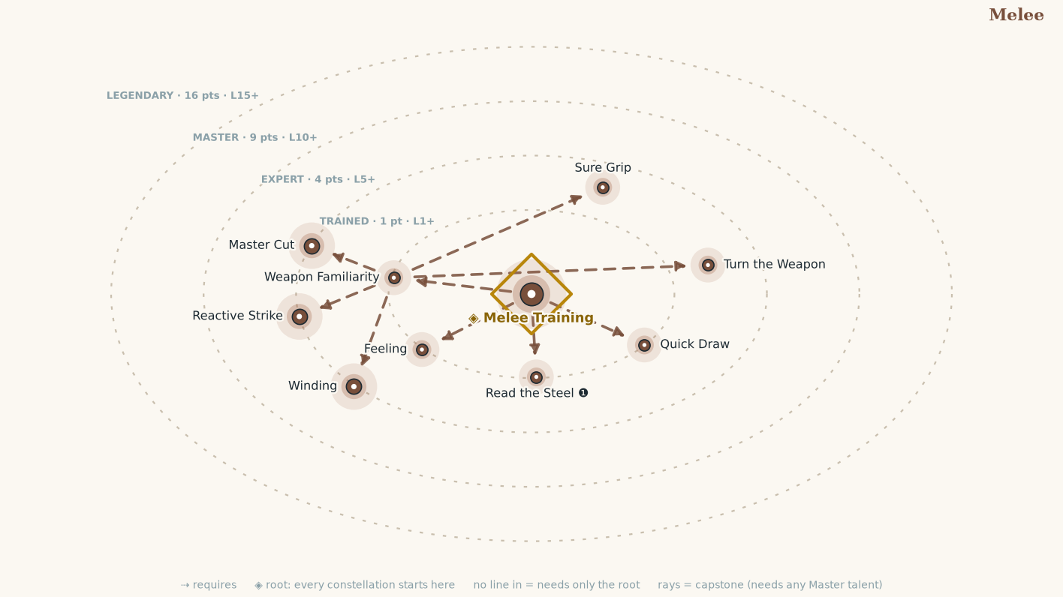
Talent | Tier | Cost | Effect
Melee Training | T | 1 | You are Trained in Melee: add this Constellation's Proficiency Bonus to your attack rolls with any weapon in your hand, and to Gain Control. You gain the Intercept ❶↺ Reaction. At Expert rank in Melee you also gain the Counter ❶↺ Reaction.  Special Intuitive weapons use your full Melee Proficiency Bonus. Practiced or Technical weapons do not; see Chapter 5: Equipment for rules on Weapon Traits.
Weapon Familiarity | T | 1 | Choose a Weapon Group or a Technical weapon. You are Familiar with weapons in that group or that Technical weapon.
Quick Draw | T | 1 | Use a Reaction ⓿↺ to draw or stow an item, weapon, or shield in each hand (or in both hands, if it requires two hands).
Turn the Weapon | T | 1 | You may deal bludgeoning damage with any Familiar melee weapon you wield, striking with the pommel, the haft, or the flat. Its damage die drops one step when you do (d12 to d10 to d8 to d6 to d4). Requires Weapon Familiarity.
Sure Grip | T | 1 | +2 Situation bonus to your Guard against Disarm regarding a Familiar weapon. When a Disarm against you would succeed, you keep hold of the weapon and suffer only the loosened grip. Requires Weapon Familiarity.
Read the Steel ❶ | T | 1 | Study one creature you can see. Until the end of the encounter you know the Protection and the material of each of its Zones, and your Strikes against it ignore 1 Protection.
Reactive Strike | E | 1 | Your Intercept ❶↺ also triggers when an Observed creature within your Reach begins a Manipulate Maneuver, or a Motion Maneuver that would carry it out of your Reach. You may only use this with weapons in which you are at least Expert. On a Critical Hit, the triggering Maneuver is disrupted: it fails, and any actions still to come in it are lost. Requires Weapon Familiarity.
Feeling | T | 1 | You read the pressure in the bind before you commit to it. When your Gain Control Misses, the target does not take Control of your weapon; the Bind is simply neutral.
Winding | E | 1 | While you Control a foe's weapon, your Committed Strike ❸ against that foe is not Weighted, and your Strikes against that foe do not end the Bind. You cut from the bind without leaving it. Requires Weapon Familiarity.
Master Cut | E | 1 | When you Counter, you gain a +2 Situation bonus to the Defense you roll against the triggering attack. Your parry and your cut are one motion. Requires Weapon Familiarity.

Ranged
Weapon • Agility (Represents what transfers between every weapon that leaves the hand: judging distance, timing a release, leading a moving target, and shooting past friends. Ranged is a parent Constellation: every Talent you buy in Archery, Crossbow Fighting, or Missile Skirmishing counts toward your Ranged rank.)
Example flares: Crit succeed or crit fail on any roll with consequences, directly related to a talent in this constellation.
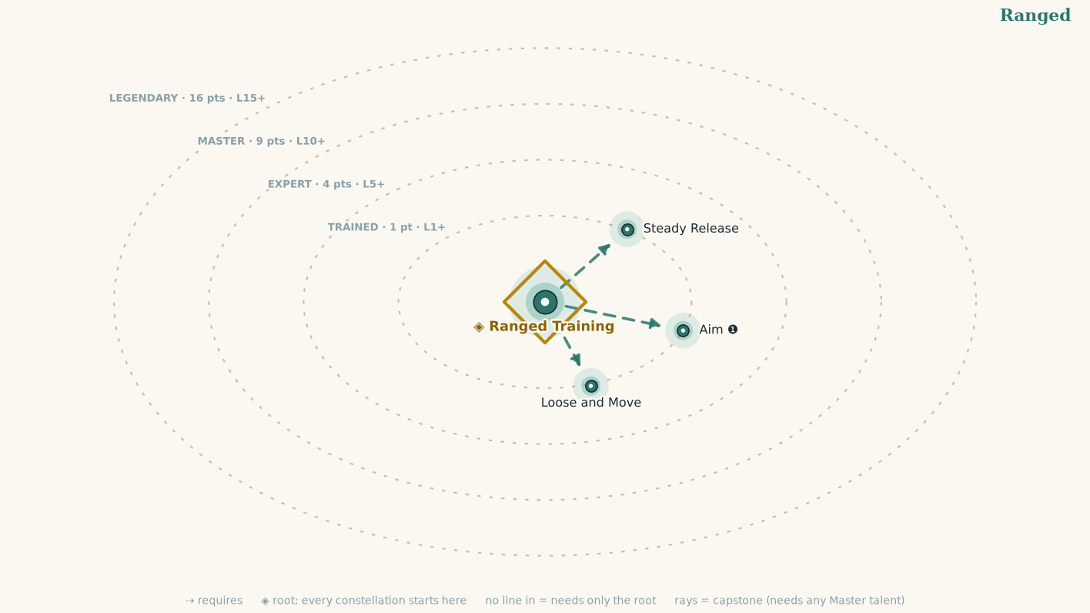
Talent | Tier | Cost | Effect
Ranged Training | T | 1 | You are Trained in Ranged: add this Constellation's Proficiency Bonus to your attack rolls with any weapon that leaves your hand: bows, crossbows, slings, and thrown weapons (a dagger uses Melee in your hand and Ranged in the air).  Special Intuitive weapons use your full Ranged Proficiency Bonus. Practiced or Technical weapons do not; see Chapter 5: Equipment.
Aim ❶ | T | 1 | Concentrate Choose one creature you can Observe within your weapon's range. Your next ranged Strike against it before the end of your next Opportunity gains a +1 Situation bonus, and on a Hit you may choose the Zone it strikes.
Loose and Move | T | 1 | After making a ranged Strike, you may Step ⓿ once per round.
Steady Release | T | 1 | Your ranged Strikes ignore a target's Lesser Cover (the +1 it grants, and the Zone rule) if you have not Moved this round. Patience finds the gap.

Combat Styles

Archery
Combat Style • Agility (bows and careful ranged attacks) • child of Ranged
Example flares: Crit succeed or crit fail on any roll with consequences, directly related to a talent in this constellation.
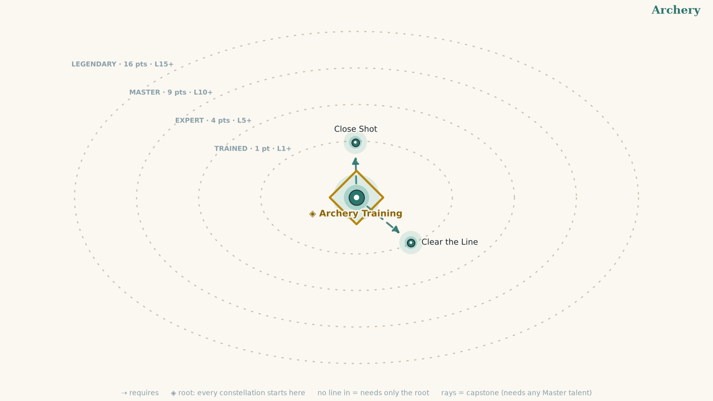
Talent | Tier | Cost | Effect
Archery Training | T | 1 | You are Trained in this fighting style: its exploits are open to you, and checks its Talents call for use this Constellation's Proficiency. Attack rolls use your Ranged Proficiency, and every Talent here counts toward your Ranged rank. You gain the Draw a Bead ❶ action.  Draw a Bead ❶ Concentrate  Choose one creature you can Observe and can reach with your bow.  Until the end of your next Opportunity:  your next bow Strike against that creature gains a +1 Situation bonus to the attack;  ignore the weapon's Unwieldy penalty for that Strike;  if that Strike Grazes, you choose the Zone it lands on instead of the defender.
Clear the Line | T | 1 | Your ranged attacks treat Lesser Cover as no Cover. (feeds Wits)
Close Shot | T | 1 | Reduce the minimum distance of Unwieldy by 5 feet. If that would reduce it to 0, the weapon no longer has Unwieldy for you.

Armored Fighting
Combat Style • Presence (the harness as a weapon) • child of Melee
Example flares: Crit succeed or crit fail on any roll with consequences, directly related to a talent in this constellation.
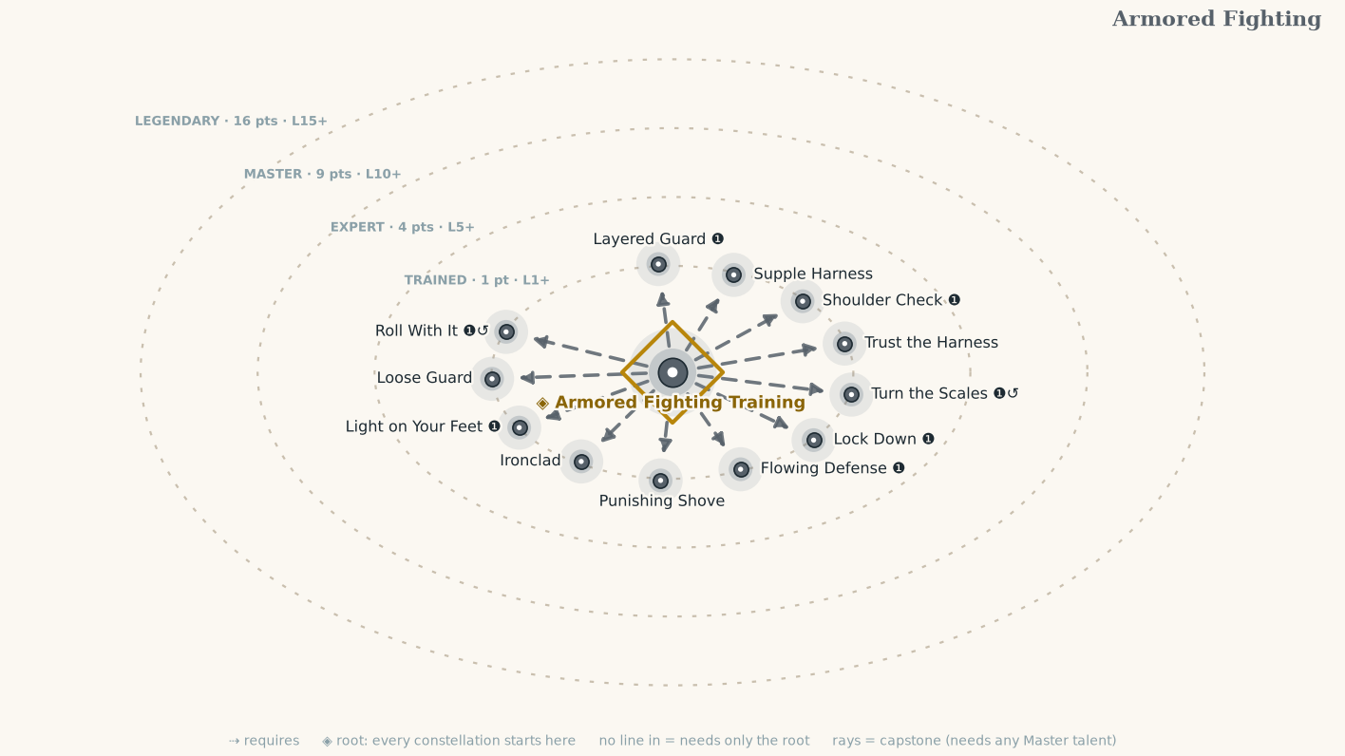
Talent | Tier | Cost | Effect
Armored Fighting Training | T | 1 | You are Trained in this fighting style: its exploits are open to you, and checks its talents call for use this Constellation's Proficiency. Attack rolls use your Melee Proficiency, and every Talent here counts toward your Melee rank.  When determining whether your armor forms a complete harness for an Armored Fighting Talent, all four Zones must be armored in the required material. If you are Master, only three Zones must be armored in the required material. (feeds Might)
Ironclad | T | 1 | While wearing Full Plate, gain +1 Condition bonus Physical Guard against Shove, Trip, and Reposition. (feeds Might)
Trust the Harness | T | 1 | While wearing Full Plate, when you would choose an armored Zone for a Graze, you may choose the Torso even if another rule would normally require another Zone. (feeds Might)
Lock Down ❶ | T | 1 | You settle your weight into your Full Plate harness.  While in this Stance:  +1 Condition bonus to Physical Guard.  You cannot be forcibly moved more than 3 feet by a single effect unless it critically succeeds.  Your Speed is reduced by 1 foot. (feeds Might)
Punishing Shove | T | 1 | When you successfully Shove a creature, that creature takes an amount of bludgeoning damage equal to your Might modifier (or double that amount on a Critical Success). This damage increases by 2 when you become an expert in Armored Fighting, 6 when you become a master, and 12 when you become legendary. (feeds Might)
Shoulder Check ❶ | T | 1 | You hit a foe with your armor to throw them off balance. Make a fist Strike even if you don't have a hand free; if you're wielding a gauntlet or spiked gauntlet, you can make a Strike with one of those weapons instead. The Strike gains the following additional results:  Critical Success The target is Wrong-Footed for you until the end of the next round.  Success The target is Wrong-Footed for you against the next Attack you attempt against it before the end of your next Opportunity.  Critical Failure You are Wrong-Footed against melee attacks the target attempts against you until the end of the next round. (feeds Might)
Flowing Defense ❶ | T | 1 | Flowing Defense ❶ Stance  While wearing Full Mail:  when you Recenter, you may also Step;  -1 Condition Physical Guard versus Shove  retains mail's normal vulnerability to piercing
Supple Harness | T | 1 | Your first Step each round ignores 1 point of Load Strain's effect on movement-related checks.
Roll With It ❶↺ | T | 1 | When you are Grazed while wearing Full Mail, you may Step after resolving the attack and damage.
Turn the Scales ❶↺ | T | 1 | When you would be Hit, shift the blow to another armored, non-Exposed Zone. (feeds Wits)
Layered Guard ❶ | T | 1 | Layered Guard ❶ Stance  While wearing Full Scale:  the first time each round a Zone becomes Exposed, another Zone of your choice gains +1 Protection until your next Opportunity. (feeds Wits)
Loose Guard | T | 1 | While all four Zones are Padded or Leather and your Load Strain is 0, Recenter lets you Step as part of the action. (feeds Agility)
Light on Your Feet ❶ | T | 1 | Light on Your Feet ❶ Stance  While in light armor:  +1 Condition Physical Evade;  After a creature Misses you, Step once per round;  Cannot be used if Load Strain exceeds 0. (feeds Agility)

Brawling
Combat Style • Might (fists, feet, tusks, headbutts) • child of Melee
Example flares: Crit succeed or crit fail on any roll with consequences, directly related to a talent in this constellation.
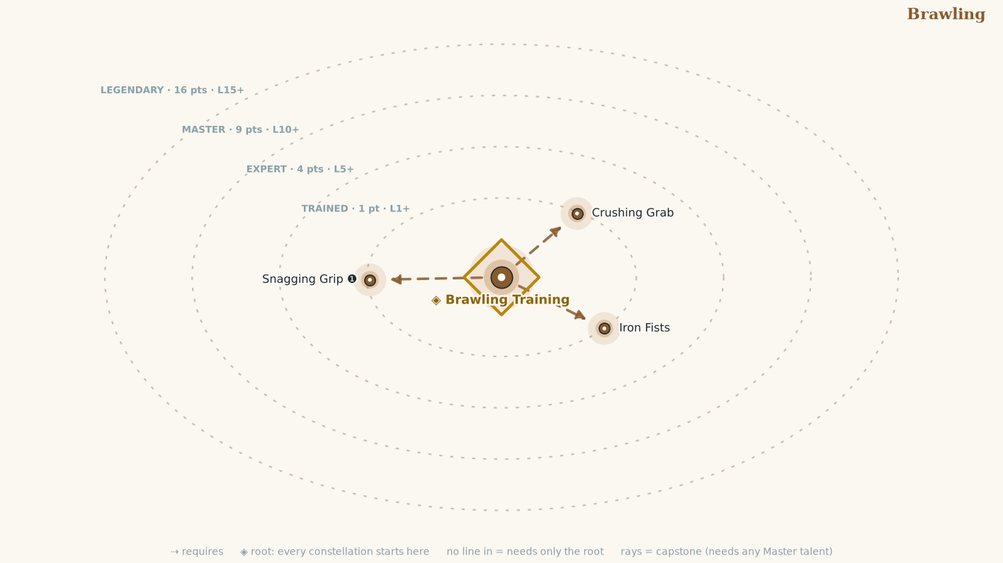
Talent | Tier | Cost | Effect
Brawling Training | T | 1 | You are Trained in this fighting style: its exploits are open to you, and checks its talents call for use this Constellation's Proficiency. Attack rolls use your Melee Proficiency, and every Talent here counts toward your Melee rank. Every talent here requires this. You gain the Clinch action.  Clinch ❶ Stance While you are in this stance, a bare hand counts as a rigid implement: you may Parry, Bind, and Gain Control with it, and a creature whose weapon or limb you Control with a bare hand is also Grabbed. At Master rank, a creature you have Grabbed cannot Recenter.
Iron Fists | T | 1 | Your unarmed strikes deal 1d6 and count as weapons (lethal by default, your choice).
Snagging Grip ❶ | T | 1 | Strike with a free hand; on a hit, the target is Off-Guard until your next Opportunity.
Crushing Grab | T | 1 | When you successfully Grapple a creature, you can deal bludgeoning damage to that creature equal to your Might bonus. You can make this attack nonlethal with no penalty.

Crossbow Fighting
Combat Style • Wits (prepared mechanical ranged weapons) • child of Ranged
Example flares: Crit succeed or crit fail on any roll with consequences, directly related to a talent in this constellation.
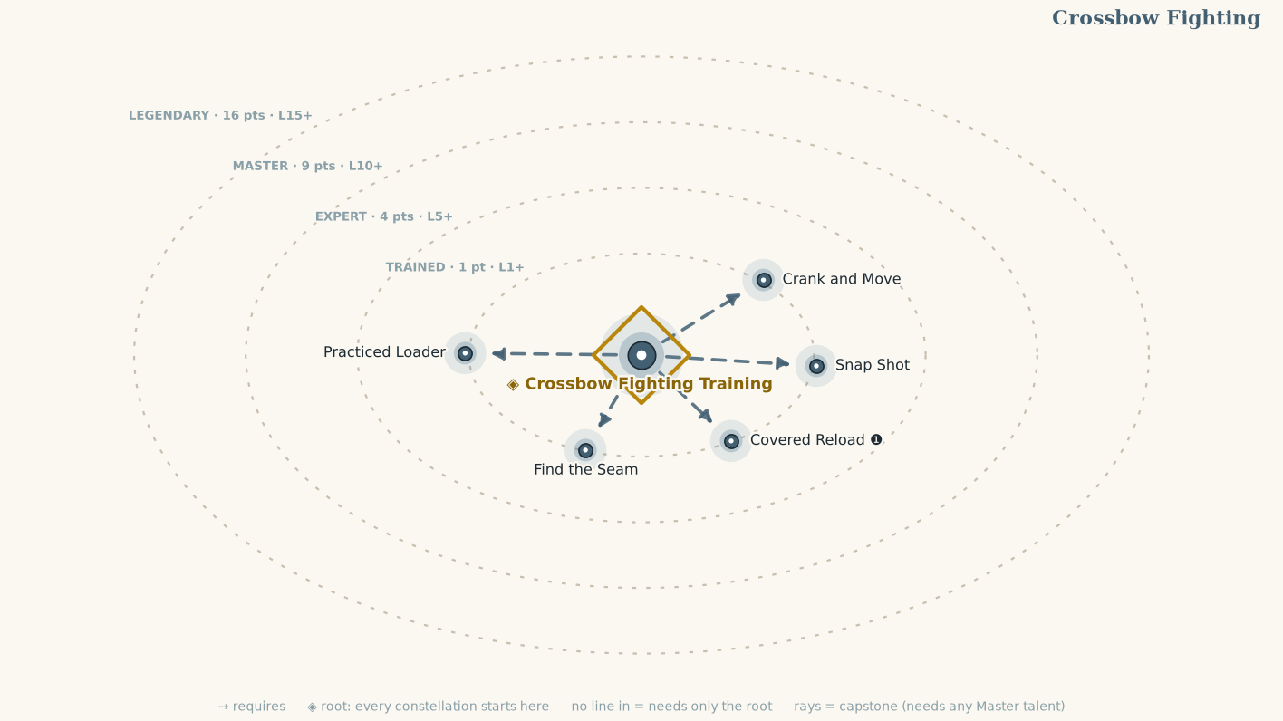
Talent | Tier | Cost | Effect
Crossbow Fighting Training | T | 1 | You are Trained in this fighting style: its exploits are open to you, and checks its talents call for use this Constellation's Proficiency. Attack rolls use your Ranged Proficiency, and every Talent here counts toward your Ranged rank. You gain the Brace the Stock ❶ action.  Brace the Stock ❶ Stance  You settle into a firing position.  Until you Move:  gain a +1 Situation bonus to all crossbow Strikes;  increase any Armor-Piercing [N] value of those attacks by 1;  if the attack Grazes, you choose the Zone it lands on.  The effect ends after you make a Move.
Practiced Loader | T | 1 | Once per round, reduce the Reload value of a crossbow by 1, to a minimum of 1. (feeds Agility)
Crank and Move | T | 1 | When you spend an action Reloading, you may Step as part of that action.
Find the Seam | T | 1 | Your Crossbow Strikes do an additional 2 damage against Exposed Zones.
Snap Shot | T | 1 | You may Intercept ❶↺ with a loaded crossbow that has the Close trait, if you have the Intercept Reaction.
Covered Reload ❶ | T | 1 | Take Cover, then Interact to reload. As normal, you must meet the requirements to Take Cover.

Dueling
Combat Style • Agility (one one-handed weapon, other hand free) • child of Melee
Example flares: Crit succeed or crit fail on any roll with consequences, directly related to a talent in this constellation.
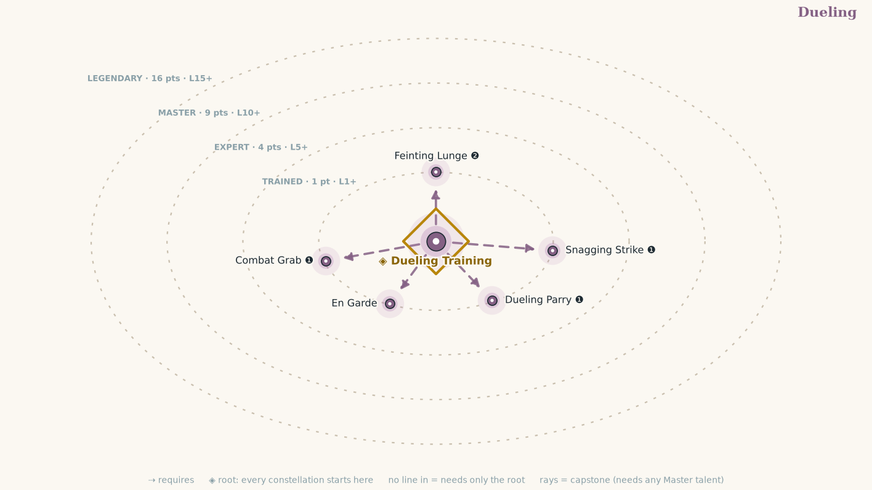
Talent | Tier | Cost | Effect
Dueling Training | T | 1 | You are Trained in this fighting style: its exploits are open to you, and checks its talents call for use this Constellation's Proficiency. Attack rolls use your Melee Proficiency, and every Talent here counts toward your Melee rank. Every talent here requires this. You gain the Hold the Cadence action.  Hold the Cadence ❶ Stance You must wield a single one-handed weapon with your other hand free. Name one creature as you enter the stance. That creature must answer your Strikes with the same Defense it used against your previous Strike, until you leave the stance or name another. At Master rank you may name a new creature ⓿.
En Garde | T | 1 | +1 Situation Guard vs. melee while wielding a one-handed weapon with your other hand free. (feeds Presence)
Feinting Lunge ❷ | T | 1 | Feint, Strike, then Step.
Snagging Strike ❶ | T | 1 | You combine an attack with quick grappling moves to throw an enemy off balance as long as it stays in your reach. Make a Strike while keeping one hand free. If this Strike hits, the target is Off-Guard until your next Opportunity or until it's no longer within the reach of your hand, whichever comes first.
Combat Grab ❶ | T | 1 | Press  Requirements You have one hand free, and your target is within reach of that hand  Using your prior attack to shift your opponent's guard, you take another swing and grab them. Make a melee Strike while keeping one hand free. If the Strike hits, you grab the target using your free hand. The creature remains grabbed until the end of the next round or until it Escapes, whichever comes first. (feeds Might)
Dueling Parry ❶ | T | 1 | Requirements You are wielding a single one-handed melee weapon and hold nothing else in your hands  You can parry attacks against you with your one-handed weapon. You gain a +2 Situation bonus to Guard until your next Opportunity as long as you continue to meet the requirements. (feeds Presence)

Great Weapon Fighting
Combat Style • Might (two hands, full commitment) • child of Melee
Example flares: Crit succeed or crit fail on any roll with consequences, directly related to a talent in this constellation.
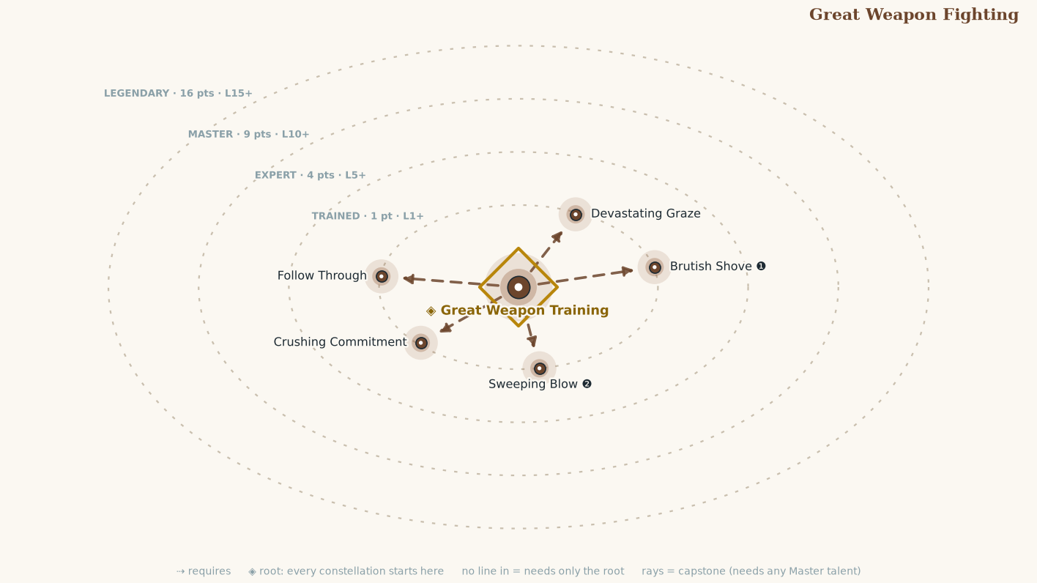
Talent | Tier | Cost | Effect
Great Weapon Training | T | 1 | You are Trained in this fighting style: its exploits are open to you, and checks its talents call for use this Constellation's Proficiency. Attack rolls use your Melee Proficiency, and every Talent here counts toward your Melee rank. You gain the Overreach action.  Overreach ❶ Stance  You must be wielding a two-handed melee weapon.  While you are in this stance your Hits and Critical Hits deal +2 damage and your Evade drops by 2, rising to +3 damage at Expert rank, +4 at Master, and +5 at Legendary. Every talent here requires this.
Sweeping Blow ❷ | T | 1 | One attack roll against two creatures within your reach, resolved separately against each one's chosen Defense. This Strike is Weighted.
Follow Through | T | 1 | When your Strike drops a creature, your next Strike this round against another creature is not Weighted.
Brutish Shove ❶ | T | 1 | Requirements You are wielding a two-handed melee weapon  Using the momentum of your last attack to throw your weight into another, you make your opponent stumble back. Make a Strike with a two-handed melee weapon. If you hit a target that is your size or smaller, that creature is Off-Guard until your next Opportunity, and you can automatically Shove it, with the same benefits as the Shove action (including the Critical Success effect, if your Strike was a Critical Hit). If you move to follow the target, your movement doesn't trigger Reactions. This Strike has the following failure effect:  Failure The target becomes Off-Guard until your next Opportunity.
Crushing Commitment | T | 1 | When you make a Strike ❸ with a two-handed weapon, deal one extra weapon die of damage.
Devastating Graze | T | 1 | If you Strike and it results in a Graze, you add your Might bonus to the damage.

Missile Skirmishing
Combat Style • Agility (slings, thrown weapons, bolas) • child of Ranged
Example flares: Crit succeed or crit fail on any roll with consequences, directly related to a talent in this constellation.
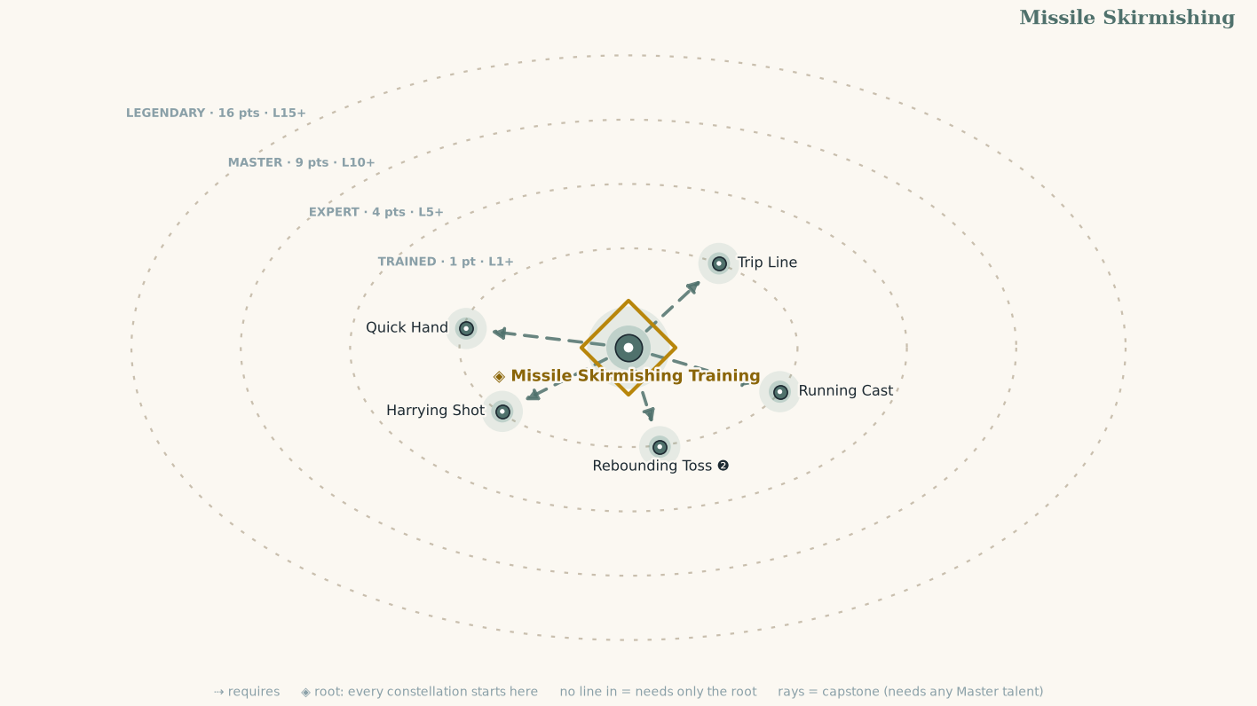
Talent | Tier | Cost | Effect
Missile Skirmishing Training | T | 1 | You are Trained in this fighting style: its exploits are open to you, and checks its talents call for use this Constellation's Proficiency. Attack rolls use your Ranged Proficiency, and every Talent here counts toward your Ranged rank. You gain the Keep Moving ❶ action.  Keep Moving ❶ Stance  Requirements You wield a sling or a weapon with the Thrown trait.  While in this stance:  if you make a ranged Strike, you may Step immediately before or after it;  you may use this benefit only once per round.
Quick Hand | T | 1 | Draw a thrown weapon as part of the Strike made with it.
Running Cast | T | 1 | If you Moved at least 3 feet immediately before making a ranged Strike with a sling or thrown weapon, increase its Range by 10 feet for that Strike.
Harrying Shot | T | 1 | When you Graze with a sling or thrown weapon, the target takes a −1 Situation penalty to its next Attack before the end of the next round.
Trip Line | T | 1 | You get a +2 Condition bonus to your Trip checks when using a Ranged weapon with the Trip Trait.
Rebounding Toss ❷ | T | 1 | Requirements You are wielding a thrown weapon  You bounce your weapon off one foe to strike another. Make a ranged Strike with a thrown weapon. If this Strike hits, the weapon rebounds toward an enemy within 10 feet of the original target. Make an additional Strike against this second target. Both are Quick Strikes. (feeds Wits)

Shield Fighting
Combat Style • Presence (weapon and shield as one machine) • child of Melee
Example flares: Crit succeed or crit fail on any roll with consequences, directly related to a talent in this constellation.
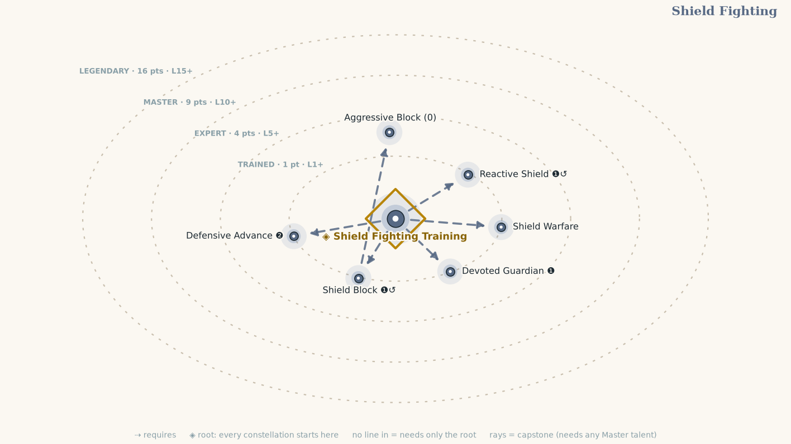
Talent | Tier | Cost | Effect
Shield Fighting Training | T | 1 | You are Trained in this fighting style: its exploits are open to you, and checks its talents call for use this Constellation's Proficiency. Attack rolls use your Melee Proficiency, and every Talent here counts toward your Melee rank. Every talent here requires this. You gain the Shield Wall action.  Shield Wall ❶ Stance You must be wielding a shield. While you are in this stance your shield counts as Raised at all times, without spending an action for it, but you cannot Move; you may only Step. At Master rank you may Move up to half your Speed while the stance holds.
Reactive Shield ❶↺ | T | 1 | When attacked, Raise your Shield. (feeds Agility)
Shield Block ❶↺ | T | 1 | Reduce an attack's damage to you by your shield's hardness.
Aggressive Block ⓿ | T | 1 | Trigger You use Shield Block, and the opponent that triggered Shield Block is adjacent to you and is your Size or smaller  You push back as you block, knocking your foe away or off balance. You use your shield to push the triggering creature, either automatically Shoving it 3 feet or causing it to become Off-Guard until your next Opportunity. The triggering creature chooses whether to be moved or become Off-Guard. If it chooses to be moved, you choose the direction. If the Shove would cause it to hit a solid object or enter another creature's space, it must become Off-Guard instead of being moved. Requires Shield Block. (feeds Might)
Devoted Guardian ❶ | T | 1 | Requirements Your last action was to Raise a Shield.  You adopt a wide stance, ready to defend both yourself and your chosen ward. Select one adjacent creature. As long as your shield is raised and the creature remains adjacent to you, the creature gains a +1 Situation bonus to their Guard, or a +2 Situation bonus if the shield you raised was a tower shield.
Defensive Advance ❷ | T | 1 | Flourish  With the protection of your shield, you dive into battle! You Raise your Shield and Move. If you end your movement within melee reach of at least one enemy, you can make a melee Strike against that enemy. You can use Defensive Advance while Burrowing, Climbing, Flying, or Swimming instead of Moving if you have the corresponding movement type.
Shield Warfare | T | 1 | You know how to use shields offensively far better than most. Increase the weapon damage die of any shield bash, shield boss, or shield spikes you wield by one step.

Spear & Polearm Fighting
Combat Style • Wits (polearms and spears) • child of Melee
Example flares: Crit succeed or crit fail on any roll with consequences, directly related to a talent in this constellation.
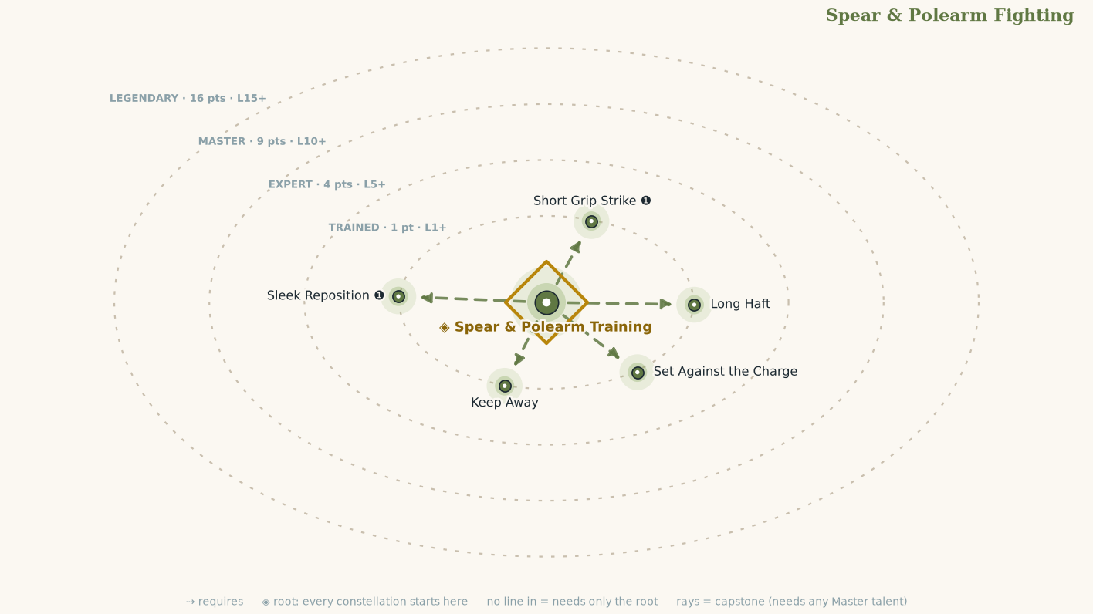
Talent | Tier | Cost | Effect
Spear & Polearm Training | T | 1 | You are Trained in this fighting style: its exploits are open to you, and checks its talents call for use this Constellation's Proficiency. Attack rolls use your Melee Proficiency, and every Talent here counts toward your Melee rank. You gain the Keep Measure ❶ action.  Keep Measure ❶ Stance  Requirements You are wielding a Hafted weapon.  While in this stance:  The first time each round an enemy moves from outside your Reach into it, you may Step ⓿ directly away after that movement finishes.  If that movement keeps the enemy within your Reach, it does not trigger Reactions from that enemy.
Set Against the Charge | T | 1 | When you Intercept with a Spear & Polearm weapon, it deals +2 damage per weapon die. Set, the spear is at its most dangerous the moment the enemy arrives.
Short Grip Strike ❶ | T | 1 | Flourish  Requirements You are wielding a Hafted weapon.  Reduce your weapon's Unwieldy value by 2 ft. (feeds Agility)
Long Haft | T | 1 | Increase Hafted Weapon Reach by 2 ft while using two hands.
Keep Away | T | 1 | When one of your Strikes is Stopped and would Expose you, you may Step directly away from the target instead.
Sleek Reposition ❶ | T | 1 | Press  While your opponent is still recovering from your prior attack, you snag its armor, clothing, or flesh to move it as you please. Make a melee Strike with a spear or polearm. If you hit a target that is your size or smaller, you can automatically Reposition it, with the same benefits as the Reposition action (including the Critical Success effect, if your Strike was a Critical Hit). Use your Total Reach for this Reposition.  This Strike has the following failure effect:  Failure The target becomes Off-Guard until your next Opportunity.

Two-Weapon Fighting
Combat Style • Agility (a weapon in each hand) • child of Melee
Example flares: Crit succeed or crit fail on any roll with consequences, directly related to a talent in this constellation.
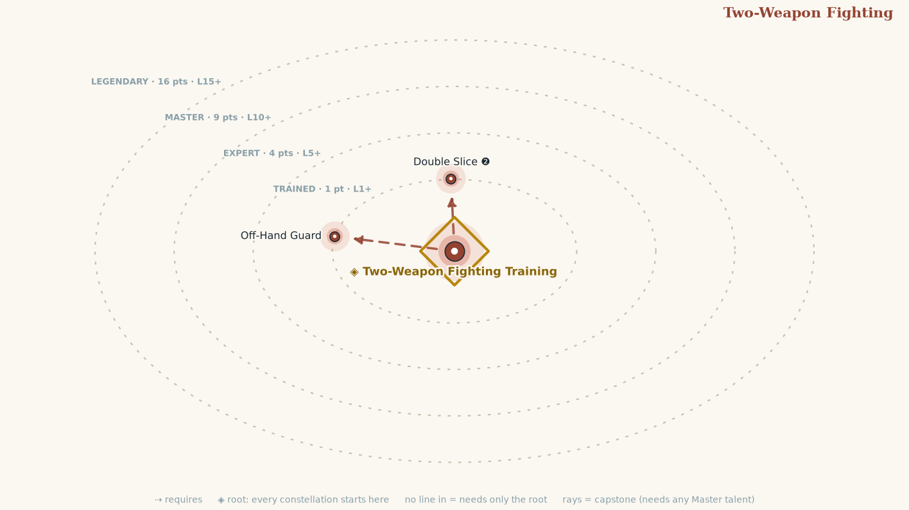
Talent | Tier | Cost | Effect
Two-Weapon Fighting Training | T | 1 | You are Trained in this fighting style: its exploits are open to you, and checks its talents call for use this Constellation's Proficiency. Attack rolls use your Melee Proficiency, and every Talent here counts toward your Melee rank. Every talent here requires this. You gain the Twin Openings action.  Twin Openings ❶ Stance You must have a weapon in each hand. While you are in this stance, the first time each round that you hit the same creature with both of your weapons, you may make one of its zones Exposed after resolving the attack and damage.
Double Slice ❷ | T | 1 | Quick Strike with each weapon against the same target, one roll for each. Combine the damage of both blows before subtracting Protection.
Off-Hand Guard | T | 1 | +1 Situation to Guard while wielding two weapons and not raising a shield. (feeds Presence)

Skill Constellations

Acrobatics
Skill constellation • Agility
Example flares: Crit succeed or crit fail on any roll with consequences, directly related to a talent in this constellation.
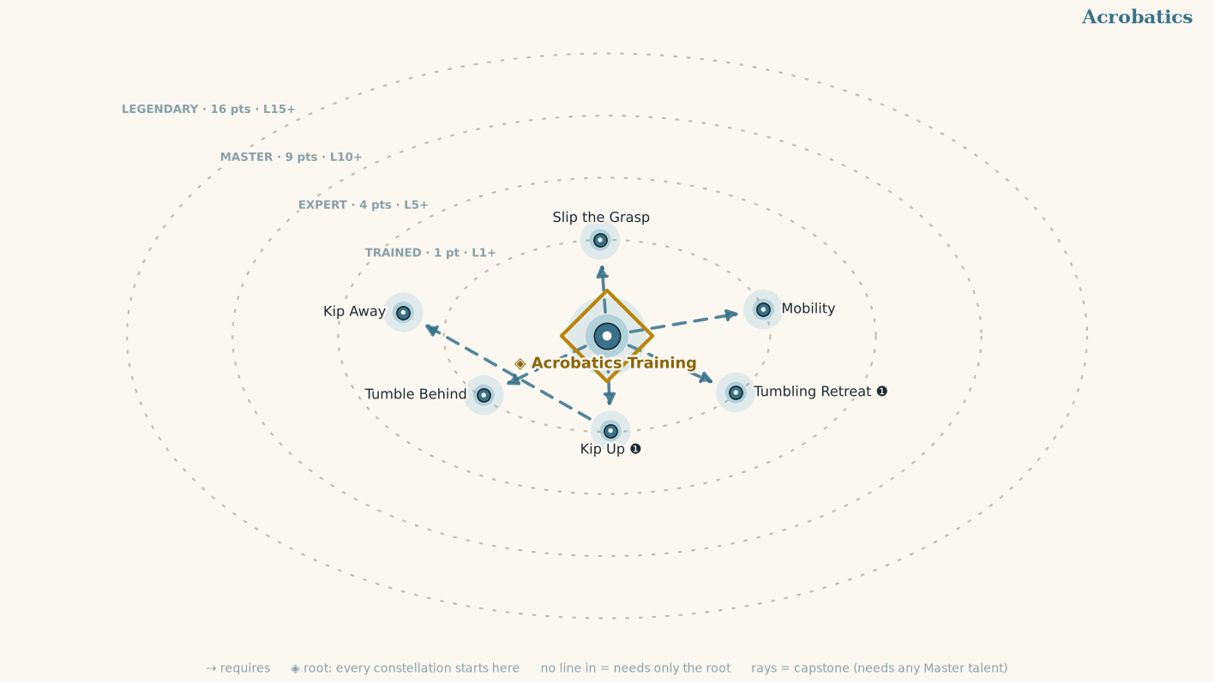
Talent | Tier | Cost | Effect
Acrobatics Training | T | 1 | You are Trained in this skill: add the Constellation's rank to its checks. Every talent here requires this.
Tumbling Retreat ❶ | T | 1 | Step your full Speed away from your foes. You still cannot Step in Difficult Terrain or Greater Difficult Terrain.
Slip the Grasp | T | 1 | +2 Situation bonus to Escape.
Kip Up ❶ | T | 1 | Stand up. This movement doesn't trigger Reactions.
Kip Away | T | 1 | When you Stand, you may Step as part of the same action. Requires Kip Up.
Tumble Behind | T | 1 | When you successfully Tumble Through, the foe whose space you passed through is Wrong-Footed against the next attack you make before the end of your next Opportunity.
Mobility | T | 1 | When you Move half your Speed or less, that movement does not trigger Intercepts or other Reactions. You can use Mobility when Climbing, Flying, or Swimming instead of Moving if you have the corresponding movement type.

Athletics
Skill constellation • Might
Example flares: Crit succeed or crit fail on any roll with consequences, directly related to a talent in this constellation.
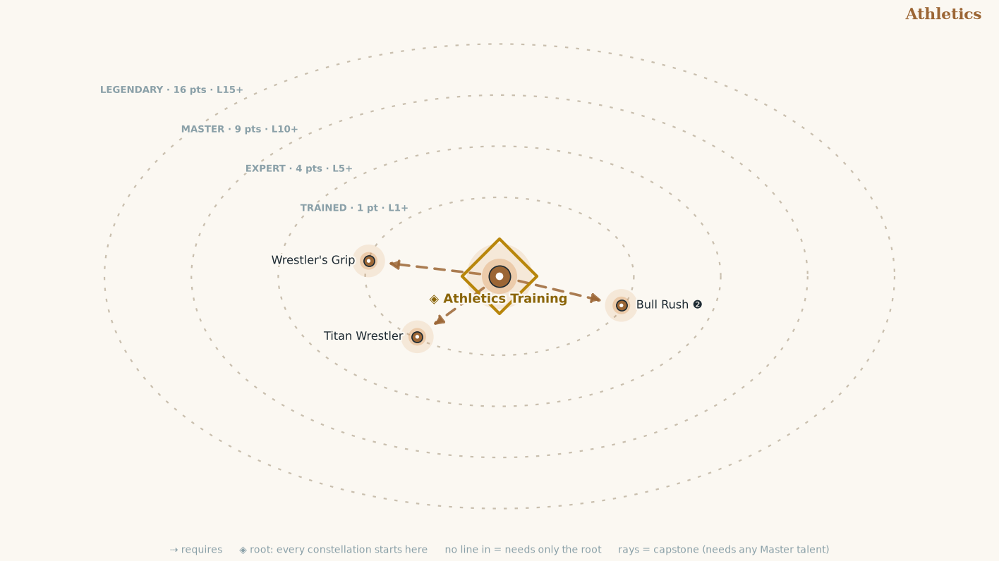
Talent | Tier | Cost | Effect
Athletics Training | T | 1 | You are Trained in this skill: add the Constellation's rank to its checks. Every talent here requires this.
Bull Rush ❷ | T | 1 | Move, then Shove.  Add 1 foot to the push for every 2 feet you moved first.
Wrestler's Grip | T | 1 | A creature you have Grabbed takes a −2 Situation penalty to Escape.
Titan Wrestler | T | 1 | Grapple, Shove, and Trip creatures up to two sizes larger than you.

Diplomacy
Skill constellation • Presence
Example flares: Crit succeed or crit fail on any roll with consequences, directly related to a talent in this constellation.
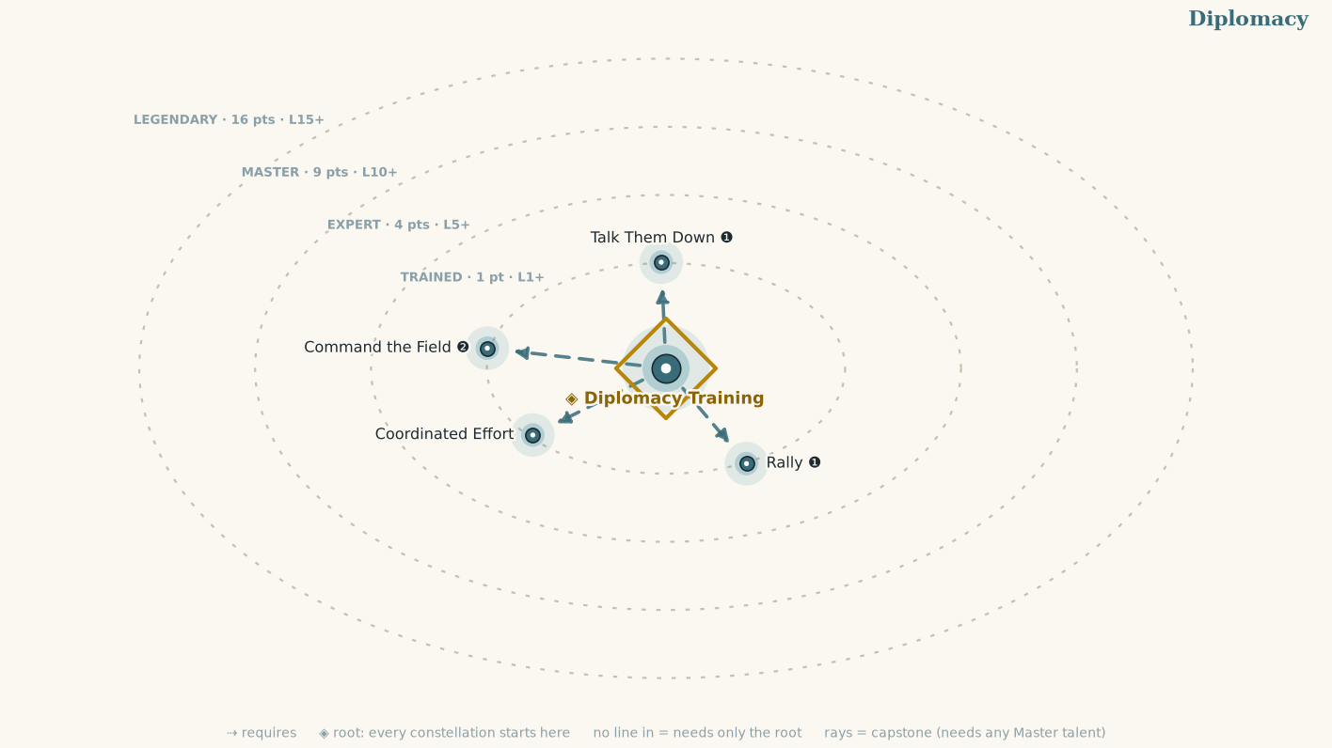
Talent | Tier | Cost | Effect
Diplomacy Training | T | 1 | You are Trained in this skill: add the Constellation's rank to its checks. Every talent here requires this.
Rally ❶ | T | 1 | You gain the Rally ❶ action:  Rally ❶  Auditory, Emotion, Mental  Roll Diplomacy against a Threshold of 14. On a success, one ally within 30 feet who can hear you gains a +1 Situation bonus to their next Defense roll before your next Opportunity. On a critical success, +2, and they can Recenter ❶ as a free action.
Talk Them Down ❶ | T | 1 | You gain the Talk Them Down ❶ action:  Talk Them Down ❶  Auditory, Concentrate, Emotion, Mental  Roll Diplomacy against the target's Guard. On a success, it takes a -2 Situation penalty to Attacks against you until the end of the next round; on a critical success, until the end of the encounter. On a critical failure it gains a +1 Situation bonus to Attacks against you.
Coordinated Effort | T | 1 | When you Aid an ally, the bonus is +2 instead of +1, and +3 on a critical success.
Command the Field ❷ | T | 1 | You gain the Command the Field ❷ action:  Command the Field ❷  Auditory, Concentrate, Emotion, Mental  Roll Diplomacy against a Threshold of 14. On a Success, two allies who can hear you may each Step ⓿. On a critical success, they may each Move half their Speed instead.

Guile
Skill constellation • Wits
Example flares: Crit succeed or crit fail on any roll with consequences, directly related to a talent in this constellation.
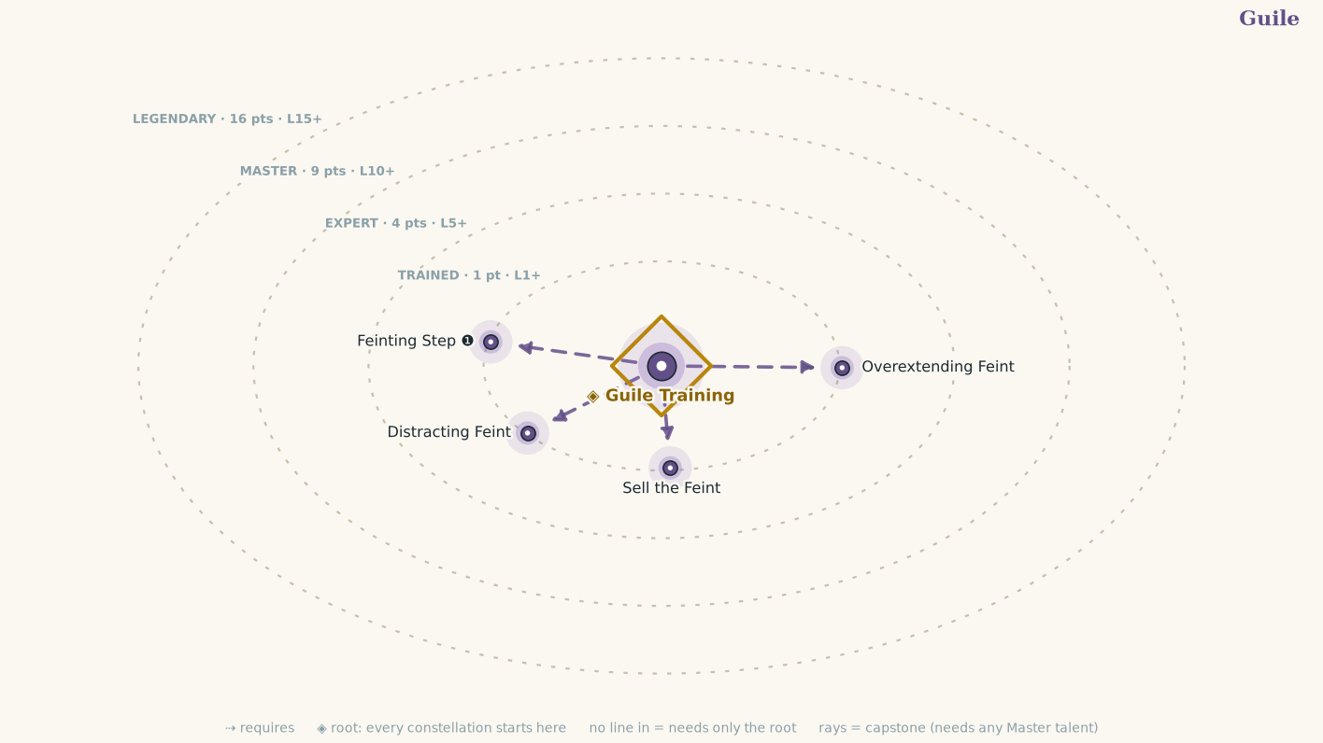
Talent | Tier | Cost | Effect
Guile Training | T | 1 | You are Trained in this skill: add the Constellation's rank to its checks. Every talent here requires this.
Feinting Step ❶ | T | 1 | Feint, then Step.
Sell the Feint | T | 1 | When you critically succeed at a Feint, the target is off-guard to everyone, not just you, until the end of the next round.
Overextending Feint | T | 1 | On a successful Feint, you can use the following success and critical success effects instead of any other effects that would occur when you Feint.  Critical Success The target takes a -2 Situation penalty to all attack rolls against you before the end of the next round.  Success The target takes a -2 Situation penalty to its next attack roll against you before the end of the next round.
Distracting Feint | T | 1 | While a creature is Off-Guard or Wrong-Footed by your Feints, it also takes a -2 Situation penalty to Awareness and Agility checks and Thresholds.

Intimidation
Skill constellation • Presence
Example flares: Crit succeed or crit fail on any roll with consequences, directly related to a talent in this constellation.
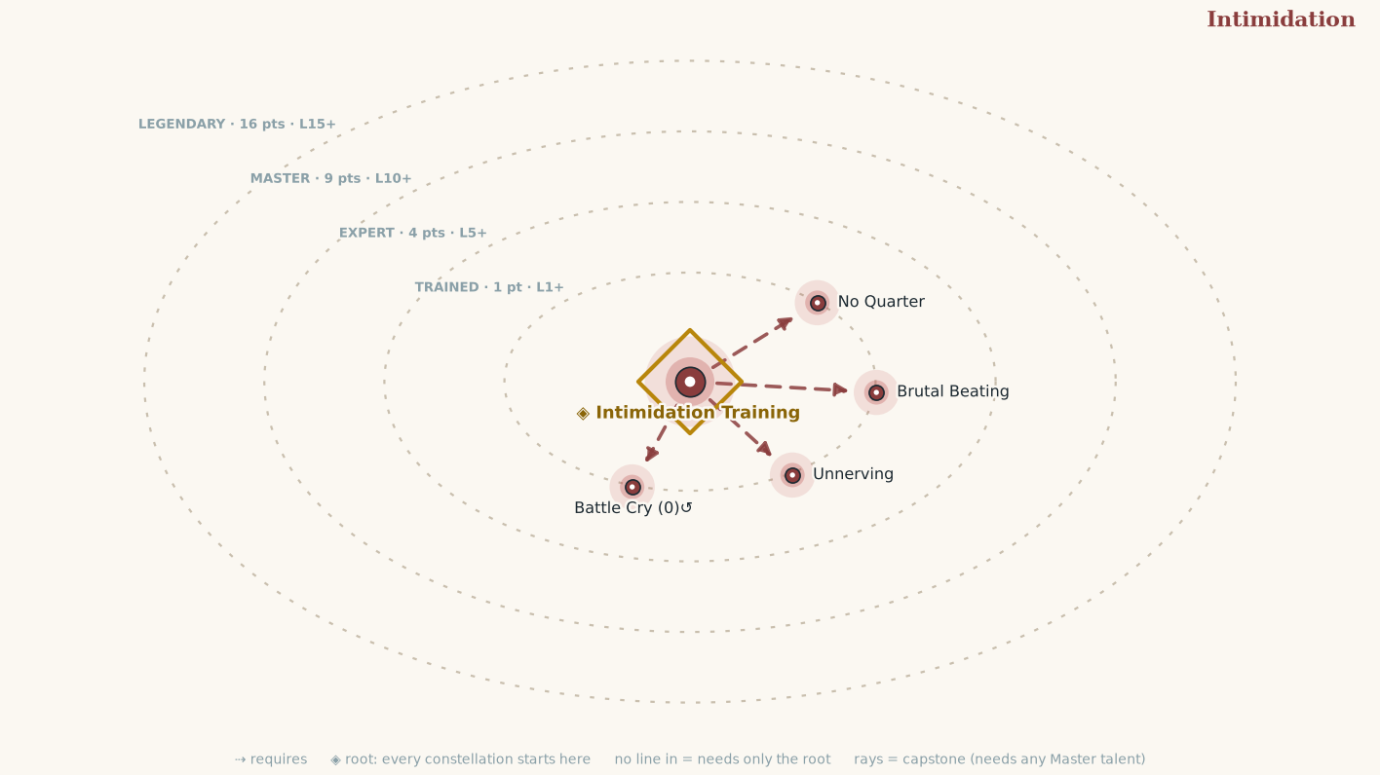
Talent | Tier | Cost | Effect
Intimidation Training | T | 1 | You are Trained in this skill: add the Constellation's rank to its checks. Every talent here requires this.
Battle Cry ⓿↺ | T | 1 | Trigger You are about to roll Initiative.  Demoralize every enemy within 15 feet with a single roll, compared separately against each one's Guard.
No Quarter | T | 1 | When you drop a creature, you may Demoralize ⓿ one enemy who saw it fall.
Unnerving | T | 1 | A creature you have Demoralized this encounter takes a −1 Situation penalty to attacks against you for the rest of it.
Brutal Beating | T | 1 | Whenever your Strike is a critical hit and deals damage, the target is Frightened 1.

Lore
Skill constellation • Wits (the template every Lore (X) Constellation copies)
Example flares: Crit succeed or crit fail on any roll with consequences, directly related to a talent in this constellation.
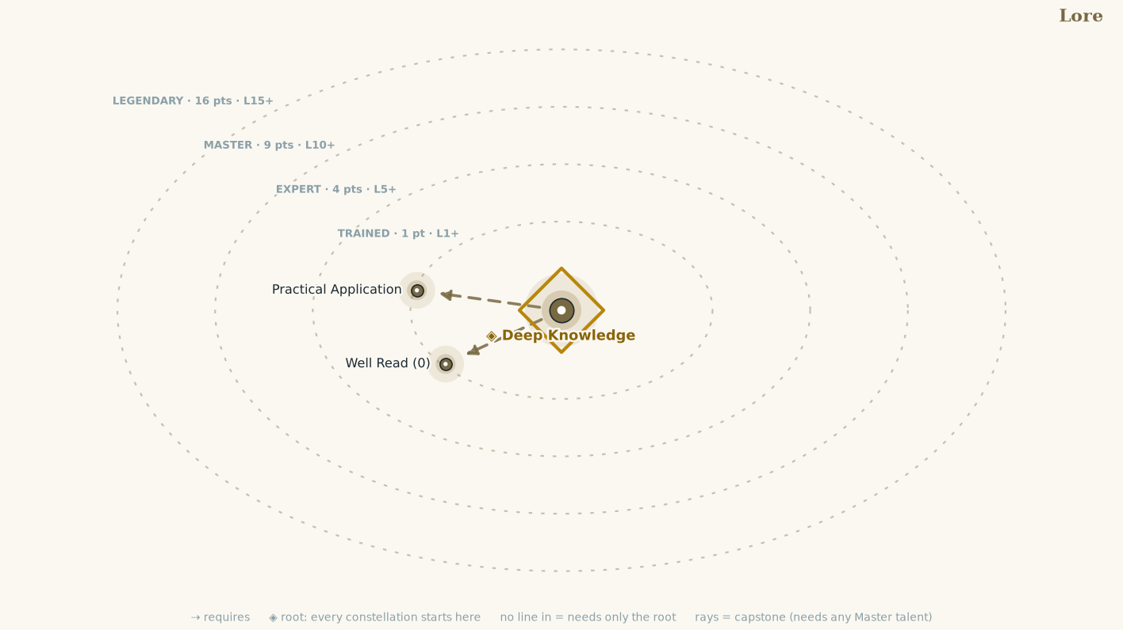
Talent | Tier | Cost | Effect
Deep Knowledge | T | 1 | You are Trained in this Lore: add the Constellation's rank to its checks. Recall and research within its field; you know its people, texts, and secrets. Every talent here requires this.
Practical Application | T | 1 | +2 Situation to any check where you can explain how this field directly applies. The GM is the judge; the story is the proof.
Well Read ⓿ | T | 1 | Once per scene, Recall Knowledge ⓿ about your field.

Stealth
Skill constellation • Agility
Example flares: Crit succeed or crit fail on any roll with consequences, directly related to a talent in this constellation.
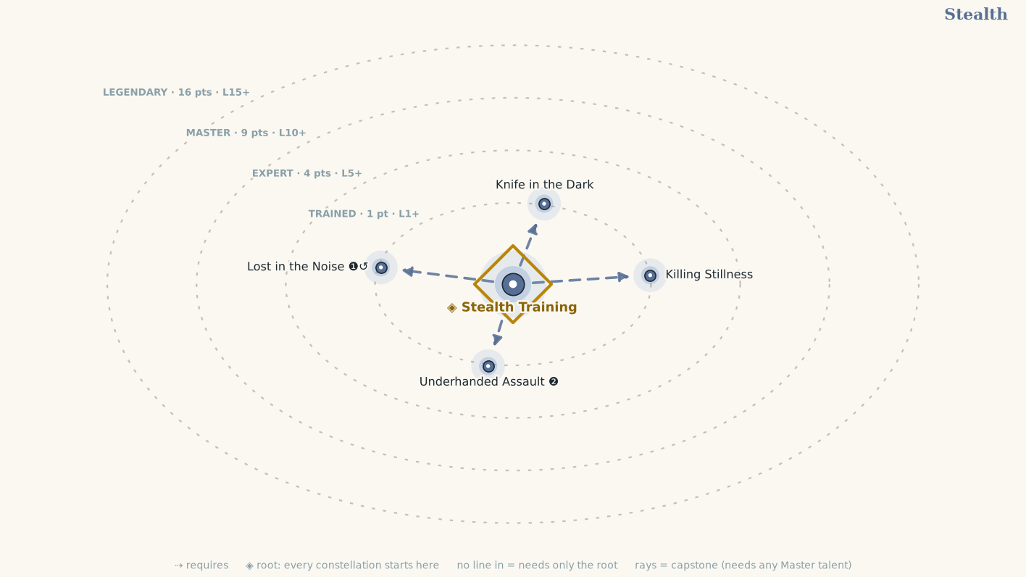
Talent | Tier | Cost | Effect
Stealth Training | T | 1 | You are Trained in this skill: add the Constellation's rank to its checks. Every talent here requires this.
Knife in the Dark | T | 1 | When you Hit a creature that is Off-Guard or Wrong-Footed to you, you choose which Zone the blow lands on.
Lost in the Noise ❶↺ | T | 1 | Trigger An attack against you Misses.  Effect If you have cover or concealment, Hide as part of this Reaction.
Killing Stillness | T | 1 | The first time each encounter that you Strike a creature that is unaware of you, a Graze becomes a Hit.
Underhanded Assault ❷ | T | 1 | You Sneak up to a foe adjacent to one of your allies. You can roll against the foe you're Sneaking up on, even if it's currently observing you, as though you were hidden. You take a -2 penalty on your Stealth check. If your Stealth check against the chosen foe succeeds, you can make a melee Strike against that foe at the end of your Sneak, and they are Wrong-Footed against that Strike.

Appendix A. Conditions
Condition | In one line
Off-Guard | −2 Situation to Evade and Guard against all foes.
Wrong-Footed [X] | Off-Guard against that creature only.
Frightened N | −N to all checks and Thresholds; reduce by 1 at the end of each round.
Prone | Off-Guard, −2 to Attacks; +2 Situation to Evade vs. ranged Attacks. Stand ❶ to clear.
Grabbed | Off-Guard and can't Move or Step; Escape ❶ to break free.
Heedless | Commitment so complete that you have stopped thinking. Maneuvers with Concentrate take 1 extra action.
Restrained | As Grabbed but can't take any action other than Escape ❶.
Stunned N | Lose the next N actions; may carry over across rounds.
Slowed N | Lose N actions at the start of each round. Reduce by 1 at the end of each round.
Fatigued | −1 to Evade and Guard; can't use Exploration Mode Activities.
Persistent Damage | Take it at the end of each round; Endure check (10 + the amount of persistent damage you just took) to end.
Dying | You're Dying (see Chapter 2: Core Rules), and you're also unconscious.
Wounded [Zone] | That Zone carries a Wound: its critical effect made lasting (see Chapter 2: Vigor & Wounds). Fill the Torso's or Head's Wound capacity (two, for anyone Medium or smaller) and you are Dying.
Spent | You have 0 Vigor. Every Hit that lands on you Wounds the Zone struck; a Critical Hit inflicts two. Grazes never Wound.
Bound [X] | Your implement is in a neutral Bind with X's. The Bind ends if either of you Moves, Steps, or Recenters, or when a Strike between you resolves.
Controlled [X] | X Controls your weapon. You have an Exposed Zone of X's choice while the Bind lasts, and your attacks with that weapon take a −2 Situation penalty. Recenter ❶ or Step to end it.
Controlling [X] | You Control X's weapon: X has an Exposed Zone of your choice. You may Close ❶ on X. The Bind ends if a third party attacks you.
Preparing | You have begun a Maneuver of three or more actions: one action spent, the rest reserved. You cannot Pass; you finish or abandon at your next Opportunity. Taking a Wound abandons it.
Exposed [Zone] | That Zone is Exposed: ordinary Hits can land there instead of your Torso. Recenter ❶ to clear, unless a Posture Exposed it: that lasts until the end of the round.
Blinded | Cannot see. Cannot Observe any creature. Is Off-Guard.
Deafened | Cannot hear. Immune to any Auditory Maneuver or Activity.
Unconscious | You are out, Dying or knocked cold: you drop everything you are holding in your squares, and you're also Prone.

Zones
There are four Zones: Arms, Legs, Torso, Head. Each can carry its own armor for Protection. Hits go to the Torso unless a Zone is Exposed or the Hit is Critical, when the attacker chooses. An Exposed Zone's Protection counts as 0 against a Deliberate ❷ or Committed ❸ Strike, an ordinary Hit from one may be placed there, and a Critical Hit on it with one Wounds it; a Quick Strike ❶ gains nothing from it. Recenter ❶ clears every Exposed Zone on you except one a Posture Exposed, which lasts until the end of the round.
Zone | Critical Hit | Critical Hit on an Exposed Zone
Torso | The target is Off-Guard until it Recenters. | As left, and if the Strike was Deliberate or Committed, the Zone is Wounded (see Vigor & Wounds).
Arms | The target takes a −2 Situation penalty to attack rolls until it Recenters. | As left, and if the Strike was Deliberate or Committed, the Zone is Wounded (see Vigor & Wounds).
Legs | The target's Speed is halved until it Recenters. | As left, and if the Strike was Deliberate or Committed, the Zone is Wounded (see Vigor & Wounds).
Head | The target cannot use Reactions until it Recenters. | As left, and if the Strike was Deliberate or Committed, the Zone is Wounded (see Vigor & Wounds).

Vigor, Wounds and Dying
Vigor. Vigor is what you have left in you: wind, focus, and luck. At 1st level it is 10 + your Ancestry's Vigor + your Calling's Vigor, and every level after adds both again (only your first Calling counts). A night's rest restores your level × your Presence, and at least your level. Temporary Vigor is one pool laid over it and spent first; a larger pool replaces a smaller one, and losing it does not make you Spent.
Spent. At 0 Vigor you are Spent: still on your feet, but every Hit that lands Wounds the Zone it struck, and a Critical Hit inflicts two. A Graze never Wounds. Damage cannot take you below 0, and nonlethal damage that would Wound a Spent creature knocks it out instead.
Wounds. A Wound is a real injury to a Zone, taken when a Critical Hit with a Deliberate or Committed Strike lands on an Exposed Zone (an attack with the Massive trait Wounds on any Critical Hit), or when any Hit lands while you are Spent. Its effect is the Zone's critical effect made lasting: Arms, −2 Situation to attacks and Guard, then a useless arm; Legs, Speed halved, then Prone and unable to Stand; Torso, Off-Guard and 1d4 persistent bleed, then Dying; Head, no Reactions, then Dying and unconscious. A Medium or smaller creature's Zone carries two Wounds (Large 3, Huge 4, Gargantuan 5), every Wound between the first and the last repeats the first effect, and a further Wound to a useless Arm or Leg goes to the Torso. Wounds do not clear with Recenter or rest: treating one takes ten minutes and an Endure check against 10 + the Wounds carried, and it heals after a week of Downtime.
Dying. Dying begins when your Torso or Head takes its final Wound: Dying 1, or 2 if the blow was a Critical Hit. You are unconscious and helpless; damage while Dying adds 1 (2 from a Critical Hit), and at Dying 5 you die. At the start of each round make a Recovery check: Endure against 10 + your Dying value + the Wounds you carry. An adjacent ally may spend ❶ for a +2 Situation bonus to it, and any Vigor restored ends Dying at once. When you would die you may spend all your Hero Points to refuse it: Dying 0, unconscious and stable at 0 Vigor, Wounds intact.
Recovery check | Effect
Critical success | Your Dying ends. You are conscious, on your feet if you spend an action to stand, with 1 Vigor.
Success | Your Dying value drops by 1. If it reaches 0, your Dying ends and you are stable: still unconscious, but no longer sliding.
Failure | Your Dying value rises by 1.
Critical failure | Your Dying value rises by 2.

Appendix B. Traits
A Trait is a word attached to a Maneuver, a Talent, an item, or another word that plugs it into a rule written somewhere else. A Trait is never flavor: if the word is in a Trait line, some rule cares about it.

Maneuver Traits
Trait | What it means
Attack | An action a foe answers with a Defense. Attacks are resolved as Exchanges (see Chapter 2: The Exchange). A Committed Strike ❸ is also Weighted.
Motion | You change position under your own power. Moving into a foe's Total Reach may provoke an Intercept from that foe; moving out of it may provoke a Reaction from anyone with a Talent that allows it. Step does neither.
Manipulate | You use your hands. You need at least one free, and fine work near an enemy can provoke a Reaction from them.
Concentrate | Maneuvers with this Trait take an extra action to complete if you are Heedless.
Stance | A way of standing and holding yourself. You can be in only one stance at a time, and it lasts until you leave it, fall unconscious, or enter another.
Auditory | It works through sound. It fails on the deafened, and on anyone who cannot hear you.
Visual | It works through sight. It fails on the blinded, and on anyone who cannot see you.
Mental | It works on the mind. It fails on anything mindless.
Emotion | A mental effect that works on feeling. Anything immune to emotion ignores it.
Reaction | A Maneuver you may perform outside your Opportunity, the moment its Trigger occurs. It costs its listed actions from the same six as everything else, and you may use as many Reactions in a round as you can afford. A Reaction never triggers another Reaction. Marked ↺ beside its cost.
Press | Actions with this trait follow up an earlier attack. You can use a Press action only if your previous action this round was a Strike against the same target, and only at your own Opportunity. Some actions with the Press trait also grant an effect on a failure. The effects that are added on a failure don't apply on a critical failure. If your Press action succeeds, you can choose to apply the failure effect instead (for example, when an attack deals no damage due to resistance).
Weighted | A Committed Strike ❸. If it is Stopped (a Graze or a Miss), you are Exposed in a Zone of the defender's choice.
Prepared | A Maneuver of three or more actions. Spend one action now and reserve the rest; it resolves at your next Opportunity (see Encounter Mode).
Flexible | A weapon that cannot Parry, form a Bind, or be Bound.
Massive | An attack so heavy that any Critical Hit Wounds, whether or not the Zone was Exposed. Reserved for the largest creatures.
Unparryable | An attack that cannot be answered with Parry and offers nothing to Bind. Guard still applies to it.

Weapon Traits
Trait | Effect
Agile | Light enough to bite on the way in: a Quick Strike ❶ with it may Critically Hit.
Close | You may attack with it while you are Grabbed, while Squeezing, and against a creature you have Grabbed, with no penalty.
Deadly dX | On a critical hit, add one die of the listed size to the damage. It is a critical effect of the weapon rather than one of the dice rolled for damage, so it is added after the damage has been doubled, and is not itself doubled.
Finesse | You may use Agility instead of Might on attack rolls with this weapon. Damage still uses Might.
Nonlethal | It knocks out rather than kills.
Parry | A guard built for defense. +1 Gear bonus to Guard against melee Attacks while you wield it.
Sweep | +1 Situation bonus to attack a target you have not yet attacked this round.
Thrown X | You may throw it up to X feet, using Might for the attack roll.
Grapple, Trip, Disarm, Shove | You may attempt that Maneuver with this weapon in hand rather than a free hand.
Two-Hand dX | Wielded in two hands, its damage die becomes dX.
Two-Handed | It requires both hands.
Unwieldy [N] | You take a −2 Situation penalty to attack rolls with it against a target within N feet, and you cannot attack with it at all while you are Grabbed. A creature within N feet that you attack with it may Intercept you, as though you had entered its Reach.
Flexible | It cannot Parry, form a Bind, or be Bound. You can still Guard with it.
Versatile X | You may deal X damage instead of its usual type.
Ranged [N] | You may Strike a target up to N feet away. Use Agility instead of Might for the Attack roll.
Mechanical | You do not add Might to damage with this weapon.
Reload [N] | Reloading takes N actions.
Armor-Piercing [N] | Ignore N Protection when dealing piercing damage with this weapon.
Capacity [N] | The weapon can fire N times before it must be reloaded. Reloading its full capacity takes the listed Reload actions.

Armor Traits
Trait | Effect
Comfort | You can sleep in it without waking fatigued.
Noisy | −1 Situation penalty to Stealth, on top of your Load Strain.
Quiet | Your Load Strain never applies to Stealth while this is your only armor.

Appendix C. Maneuvers & Activities
A Maneuver is anything you do at an Opportunity: a Step, a Strike, a Gain Control, a spell. Every combatant receives six actions at the start of each round, and each Maneuver costs some of them, marked ⓿ to ❻; unspent actions expire when the round ends. Initiative order is fixed and play cycles through it. Each time it reaches you is an Opportunity: perform one Maneuver you can afford, begin or finish a Prepared Maneuver, or Pass. A ⓿ Maneuver costs nothing and never uses up your Opportunity. A Maneuver of two or more actions is a single indivisible thing; one of three or more is Prepared: one action now, the rest reserved, resolved at your next Opportunity. A Reaction ↺ is a Maneuver performed outside your Opportunity, the moment its Trigger occurs, paid from the same six; a Reaction never triggers another Reaction. When a full circuit passes in which everyone Passes, the round ends.

Basic Action
Maneuver | Cost | Traits | Effect
Aid | ❶ |  | Requirements The ally is willing to accept your aid.  You use an action to help an ally.  You must explain to the GM exactly how you're trying to help, and they determine whether you can Aid your ally.  Attempt a Relevant Check. The typical Threshold is 15, but the GM might adjust this Threshold for particularly hard or easy tasks. The GM can add any relevant traits to your action depending on the situation, or even allow you to Aid checks other than skill checks and attack rolls.  Critical Success If your ally attempts the check you specified, you grant them a +2 Situation bonus to the check. If you're a master with the check you attempted, the bonus is +3, and if you're legendary, it's +4.  Success If your ally attempts the check you specified, you grant them a +1 Situation bonus to the check.  Critical Failure If your ally attempts the check you specified, you grant them a -1 Situation penalty to the check.

Motion Maneuvers
Maneuver | Traits | Effect
Move ❶ | Motion | Move up to your Speed. Crossing into a foe's Total Reach may provoke an Intercept.
Rush ❸ | Motion | Move up to five times your Speed in a straight line, less your Load Strain in feet. You cannot use Reactions until your next Opportunity, and you are Off-Guard against any Intercept made against you during the Rush.
Leap ❶ | Motion | Jump 10 feet horizontally (less your Load Strain in feet) or 3 feet vertically, without a check. Longer or higher jumps are an Athletics check, and count as part of the Leap.
Crawl ❶ | Motion | While prone, move 3 feet.
Stand ❶ | Motion | Get up from prone.
Climb ❶ | Motion | An Athletics check against a Threshold the GM sets. On a success you move half your Speed (your full Speed on a critical success). On a critical failure you fall.
Swim ❶ | Motion | An Athletics check against a Threshold the GM sets. On a success you move half your Speed (your full Speed on a critical success). On a critical failure you sink.
Tumble Through ❶ | Motion | Acrobatics against the target's Awareness Threshold, to move through a foe's space. On a success you pass through, though their space is difficult terrain for this move. On a failure your movement stops in front of them.
Squeeze ❶ | Motion | Requirements You are entering a space narrower than your token size, but at least half as wide.  Move up to 3 feet, regardless of your Speed. While any part of you is in that space you are Off-Guard, Evade is unavailable to you, and you can attack only with weapons that have the Close trait. A space narrower than half your own stops you entirely: for a Medium creature, a gap of 1½ feet or less.

Attack Maneuvers
Maneuver | Traits | Effect
Strike ❶ to ❸ | Attack | Attack with a weapon or an unarmed blow. Roll Melee (or Ranged, for a weapon that leaves your hand) against Evade or Guard, and deal damage and effects as normal. The actions you spend say how much of yourself is behind the blow (see Chapter 2: The Exchange).  ❶ Quick. A probe: one weapon die plus precision damage, nothing else, on the Torso. It cannot Critically Hit (Agile weapons excepted) and Protection applies in full even to an Exposed Zone. Stopped, it costs you nothing and can only be bound, never Controlled.  ❷ Deliberate. All dice, specialization, and your Might. It may be placed on an Exposed Zone, and on a Critical Hit you may Expose a plausible Zone. A Graze costs only the tempo; on a Miss you are Exposed. A Parry that Stops it takes Control.  ❸ Committed. Prepared. All dice, specialization, and your Might. On a Hit or Critical Hit, you may Expose a plausible Zone. Weighted: Stopped, Graze or Miss, you are Exposed. A Parry that Stops it takes Control.
Gain Control ❶ | Attack | Requirements A rigid weapon, shield, or permitted natural weapon in hand; the target's weapon or natural attack is within the longer of your two Total Reaches; the target is no more than one Size larger than you.  Roll Melee against the target's Guard.  Critical Success You Control the weapon, and the target is Off-Guard until its next Opportunity. Success You Control the weapon. Graze A neutral Bind forms. Miss You pressed badly. The target Controls your weapon instead.  Special Evade cannot answer this attack. While you Control a weapon, the target has an Exposed Zone of your choice and takes −2 Situation to attacks with it (see Chapter 2: The Exchange).
Close ❶ | Motion | Requirements You Control a foe's weapon.  Step toward that foe. The Bind holds, and the Controlled weapon cannot Intercept you. This is the only movement that does not end a Bind.
Grapple ❶ to ❷ | Attack | Requirements You have a free hand or a weapon with the Grapple Trait, and the target must be within reach and no more than one Size larger than you.  Roll Athletics against Evade or Guard.  Critical Success The target is Restrained until the end of the next round. Success The target is Grabbed until the end of the next round. Graze No effect. Miss You overcommit and are Off-Guard until your next Opportunity.  ❷ Tackle. Move, then Grapple. Critical Success The target is Restrained until the end of the next round and knocked Prone. Success The target is Grabbed until the end of the next round and knocked Prone. You fall Prone adjacent to them. Graze No effect, and you are Exposed in a Zone of the defender's choice. Miss You overcommit and are Off-Guard until your next Opportunity, and fall Prone adjacent to them.
Shove ❶ to ❷ | Attack | Requirements You have a free hand or a weapon with the Shove Trait, and the target must be within reach and no more than one Size larger than you.  Roll Athletics against Evade or Guard.  Critical Success The target is pushed 6 feet. You may Move as part of this action, if it is in the same direction. Success The target is pushed 3 feet. Graze No effect. Miss You overcommit and are Off-Guard until your next Opportunity.  ❷ Heave. You set your feet and put your weight behind it. Critical Success The target is pushed 12 feet. Success The target is pushed 6 feet. Graze No effect, and you are Exposed in a Zone of the defender's choice. Miss You overcommit and are Off-Guard until your next Opportunity.
Trip ❶ to ❷ | Attack | Requirements You have a free hand or a weapon with the Trip Trait, and the target must be within reach and no more than one Size larger than you.  Roll Athletics against Evade or Guard.  Critical Success The target is knocked Prone, and takes damage equal to your Might. Success The target is knocked Prone. Graze No effect. Miss You overcommit and are Off-Guard until your next Opportunity.  Special If the target's Legs are Exposed, increase the degree of success by one.  ❷ Leg Sweep. Critical Success The target is knocked Prone, takes damage equal to your Might, and becomes Exposed [Legs]. Success The target is knocked Prone and becomes Exposed [Legs]. Graze No effect, and you are Exposed in a Zone of the defender's choice. Miss You overcommit and are Off-Guard until your next Opportunity. The Special above still applies.
Disarm ❶ or ❸ | Attack | Requirements You have a free hand or a weapon with the Disarm Trait, and the target must be within reach and no more than one Size larger than you.  Roll Athletics against Evade or Guard.  Critical Success The item drops from their grip and lands in one of their squares. Success Their grip is loosened: −2 Situation penalty to attacks with it, and the next Disarm against them gains a +2 Situation bonus, until they spend an Interact to resettle it. Graze No effect. Miss You overcommit and are Off-Guard until your next Opportunity.  Special If the target's Arms are Exposed, increase the degree of success by one.  ❸ Wrench. Critical Success The item flies from their grip and lands 1d10 squares away, in a direction of your choosing. Success The item drops from their grip and lands in one of their squares. Graze No effect, and you are Exposed in a Zone of the defender's choice. Miss You overcommit and are Off-Guard until your next Opportunity. The Special above still applies.
Reposition ❶ to ❷ | Attack | Requirements You have a free hand or are already Grabbing or Restraining the target, and the target must be within reach and no more than one Size larger than you.  Roll Athletics against Evade or Guard.  Critical Success Move the target up to 6 feet, staying within your reach, not into or through obstacles. Success Move the target up to 3 feet, staying within your reach, not into or through obstacles. Graze No effect. Miss The target can move you up to 3 feet as though it Repositioned you.  ❷ Haul. Critical Success Move up to your full Speed, bringing the target with you. Success Move up to half your Speed, bringing the target with you. Graze No effect, and you are Exposed in a Zone of the defender's choice. Miss The target can move you up to 6 feet the same way.

Defense & Recovery Maneuvers
Maneuver | Traits | Effect
Raise a Shield ❶ | — | Gain your shield's Gear bonus to Guard until your next Opportunity. You must be wielding it.
Recenter ❶ | Concentrate | Gather yourself: clear every Exposed Zone on you (except one Exposed by a Posture) and end any Bind you are in.
Take Cover ❶ | — | Requirements You have Cover, or Greater Cover, or are wielding a tower shield.  Press yourself into your cover. Your Cover improves by one grade. Adjust the Zones Covered to match. This lasts until you Move, Step or Attack.  Special A raised tower shield gives you Cover with nothing to get behind, so Taking Cover behind one gives you Greater Cover.
Escape ❶ | — | Break free of a grab, a restraint, or anything holding you.  Requirements You are Grabbed or Restrained.  Roll your best of Athletics or Acrobatics against the grabber's Endure.  Critical Success You are no longer Grabbed or Restrained, and may Step ⓿. Success You are no longer Grabbed or Restrained. Failure The Grabbed or Restrained condition persists. Critical Failure The condition persists and their hold improves: if you were Grabbed, you are now Restrained.
Step ❶ | — | Move up to half your Speed. Step has no Traits at all, which is the point: it never provokes Intercepts or other Reactions. Stepping ends any Bind you are in (Close excepted). You cannot Step into difficult terrain.
Parry ❶↺ | Reaction | Requirements You have Guard Training, and a rigid weapon, shield, or permitted natural weapon in hand.  Answer an attack with Guard at a +2 Situation bonus. If you Stop a Deliberate or Committed Strike, you take Control of the attacking weapon instead of forming a neutral Bind, and you may at once make a Quick Strike ⓿ against its owner (the riposte). A Stopped Quick Strike gives only a neutral Bind.
Void ❶↺ | Reaction | Requirements You have Evade Training.  Answer an attack with Evade at a +2 Situation bonus. If the attack is Stopped, you may Step in any direction.
Counter ❶↺ | Reaction, Attack | Requirements You are Expert in Melee; the attacker is within your Reach and the attack is a melee attack.  Answer the attack with a Quick Strike of your own. You gain no bonus to your Defense. Roll both; resolve both. You cannot Counter a Counter or an Intercept, and the fighter you Counter rolls only their basic Defense against it.
Intercept ❶↺ | Reaction, Attack | Requirements You have Melee Training.  Trigger A foe Moves from outside your Total Reach to inside it, or Strikes you with an Unwieldy weapon from inside its Unwieldy distance.  Make a Quick Strike against them at the moment they enter. Once per foe per Move. A Wound stops their movement; anything less and it continues.
Pass ⓿ | — | Do nothing at this Opportunity. You may still use Reactions. When a full circuit passes in which everyone Passes, the round ends. You cannot Pass while Preparing.

Watching, Deceiving & Helping Maneuvers
Maneuver | Traits | Effect
Seek ❶ | Concentrate | Roll one Awareness against the Stealth of anything Hiding, or against a Threshold the GM sets for a hidden object. Covers everything within 30 feet.  Critical Success As Success, but the creature moves two states. Success The creature moves one state toward Observed: Undetected becomes Hidden, Hidden becomes Concealed, Concealed becomes Observed. Failure You learn nothing. Critical Failure You commit to the wrong place. You are Wrong-Footed to that creature until your next Opportunity.
Hide ❶ | — | Requirements You are currently benefiting from at least Lesser Cover, or from Concealment.  Roll one Stealth against the Awareness of every creature around you (including your allies).  Critical Success You are Hidden to the creature, and they are Wrong-Footed to you until the end of the next round. Success You are Hidden to the creature. Failure They still see you. Critical Failure You have drawn the eye. You are Wrong-Footed to that creature until your next Opportunity.
Sneak ❶ to ❷ | Motion | Requirements You are (or believe you are) currently at least Hidden from at least one creature.  Move up to half your Speed while staying Hidden or Undetected. You must end this movement with Concealment or at least Lesser Cover from each creature you wish to remain at least Hidden from. Roll one Stealth against the Awareness of every creature to which you are currently at least Hidden (including your allies).  Critical Success You move and remain Hidden and/or Undetected, and they are Wrong-Footed to you until the end of the next round. Success You move and remain Hidden and/or Undetected. Failure You are Observed during your movement. Critical Failure You are Observed, and you are Wrong-Footed to them until your next Opportunity.  ❷ Creep. As above, except: Failure You realize you would be Observed if you moved, and may choose not to move after all. Critical Failure You are Observed during your movement.
Point Out ❶ | Auditory, Visual | Indicate a creature you have located, whether you can see it or it is merely Hidden to you. It becomes Hidden rather than Undetected, or Concealed rather than Hidden, to any ally who can hear or see you.
Demoralize ❶ to ❷ | Auditory, Concentrate, Emotion, Mental | Roll Intimidation against the target's Guard.  Critical Success The target is Frightened 2. Success The target is Frightened 1. Failure No effect. Critical Failure No effect, and it is emboldened: +1 Situation bonus to its Attacks against you until the end of the next round.  ❷ Break Them. Critical Success The target is Frightened 3 and Heedless. Success The target is Frightened 2. Failure The target is Frightened 1. Critical Failure No effect.
Feint ❶ | Mental | Roll Guile against the target's Awareness.  Critical Success The target is Wrong-Footed to you until the end of the next round. Success The target is Wrong-Footed to you until the end of your next Opportunity. Failure No effect. Critical Failure You overcommit. You are Wrong-Footed to that creature until your next Opportunity.
Recall Knowledge ❶ to ❷ | Concentrate | Learn something true about a creature, place, or object. Possible topics include Defense Thresholds, Protection and armor materials, Weaknesses, Resistances and Immunities, Attack Thresholds, Special Abilities, and maximum Vigor.  Roll a Lore or relevant Skill check against the level-based Threshold of your target.  Critical Success You recall all facts about two topics. Success You recall all facts about one topic. Failure You recall nothing. Critical Failure You recall all (incorrect) facts about one topic.  Special You may attempt this once per target per Skill, so a character with several Lores or relevant Skills may get several angles on the same problem.  ❷ Study. As above, except: Critical Failure You recall nothing.

Handling Things Maneuvers
Maneuver | Traits | Effect
Interact ❶ | Manipulate | Draw or stow a weapon, open a door, pull a potion from your pack, pick something up, work a lever.
Release ⓿ | — | Drop or let go of something you are holding.
Drop Prone ⓿ | — | Fall prone.

Special Maneuvers
Maneuver | Traits | Effect
Avert Gaze ❶ | — | Name one creature or object Observed by you. Watch its feet, its shadow, the floor in front of it. Until your next Opportunity you gain a +2 Situation bonus to your Defenses against its effects with the Visual trait, and it is Concealed to you.
Grab an Edge ⓿↺ | — | Trigger You fall past an edge, ledge, or handhold within your reach. Requirements You have a hand free; you may Release ⓿ an item as part of this Reaction to free a hand.  Roll Athletics or Acrobatics against a Threshold of 15.  Critical Success You catch it and pull yourself up in the same motion. You do not fall. Success You catch it and hang there. You are Off-Guard. Failure You fall, but the damage from the falling distance is reduced by 10 feet. Critical Failure You fall the full distance.

Exploration Mode
Activity | Speed | Effect
Travel | Full | When an encounter begins, you can roll Awareness.
Hustle | Double | When an encounter begins, you can roll Athletics.
Search | Half | Roll an Awareness check; the GM applies it to the Thresholds to spot hidden objects and creatures. When an encounter begins, you can roll Awareness.
Scout | Half | Every ally gains a +1 Situation bonus to initiative, and you may Step ⓿ when you roll initiative. When an encounter begins, you can roll Awareness.
Defend | Half | Your shield begins Raised and a weapon is already in hand. When an encounter begins, you can roll Awareness.
Investigate | Half | Roll a relevant Lore or Skill check; the GM applies it to the Thresholds to potentially recall relevant information about your surroundings. When an encounter begins, you can roll the same Lore or Skill check, if the encounter is related to what you are Investigating.
Look Harmless | Half | Hands empty, eyes down, pace unhurried. You are not hiding. You are simply not worth watching.  Requirements You wield no weapon with a Reach greater than Adjacent, and your worn armor totals Load 1 or less.  When an encounter begins, you may roll Guile for Initiative. Compare the roll against the Awareness of each enemy you are Observed to.  Critical Success They are Wrong-Footed to you until the end of your first Opportunity. Success They are Wrong-Footed to your first attack. Failure Nothing; they were watching you all along. Critical Failure You overplayed it. You are Wrong-Footed to them until your next Opportunity.  Outside an encounter, a successful Guile check lets you approach, pass, or linger without being challenged by anyone who would otherwise have wanted to know your business.

Downtime Mode
Activity | Duration | Effect
Retrain | 1 month | Move 1 already spent Talent Point to another Talent you qualify for. You cannot retrain away from a Talent in your Origin Constellation, a Root Talent, a Talent that another Talent you own requires, or a Talent that would reduce your Proficiency Rank in a Constellation.
Train | 7 days | You work with a teacher, a rival, or a manual. A Constellation of your choice becomes Flared. You may benefit from Train only once between Milestones.
Provision | 1 day | Buy and sell in a settlement. Common goods are simply available. For anything uncommon, roll a relevant Skill or Lore against a Threshold the GM sets to find someone who has one. You sell at half price.

Appendix D. Equipment
Your sword does not make you accurate and your armor does not make you hard to hit. Skill does that, and skill lives in your Constellations. Gear decides what happens when steel finally meets you: a weapon sets the size of the wound, armor sets how much of it your body actually feels. There are no magic plusses; quality and enchantment give a piece Traits, never numbers.

Armor
Armor is worn in four places, one piece per Zone. Each piece has Protection, Load, and Traits. Protection subtracts from every instance of damage that lands on its Zone, a Graze included, and on its own never reduces damage below 1. Load Strain is the total Load of your armor, less your Endure reduction: it comes off your Evade, off any Might or Agility Skill check, and off your Rush and Leap distances in feet. From the end of the third round, a fighter with Load Strain 1 or more rolls Endure against 10 + Load Strain each round or is Fatigued (−1 Evade and Guard) until after the fight. A closed helm gives a −2 Situation penalty to Awareness checks, your Awareness Threshold and Initiative; an open helm −1.
Piece | Zone | Prot | Load | Price | Traits | Material
Padded coif | Head | 1 | 0 | 1 gp | Padded, Comfort | Padded
Leather cap | Head | 2 | 0 | 2 gp | Leather, Quiet | Leather
Open helm | Head | 3 | 1 | 5 gp | Plate | Plate
Scale coif | Head | 3 | 2 | 5 gp | Scale, Noisy | Scale
Closed helm | Head | 4 | 2 | 10 gp | Plate | Plate
Gambeson | Torso | 1 | 0 | 1 gp | Padded, Comfort, Quiet | Padded
Leather cuirass | Torso | 2 | 0 | 5 gp | Leather, Quiet | Leather
Mail shirt | Torso | 3 | 1 | 10 gp | Mail, Noisy | Mail
Scale hauberk | Torso | 3 | 2 | 10 gp | Scale, Noisy | Scale
Breastplate | Torso | 4 | 2 | 15 gp | Plate, Noisy | Plate
Padded sleeves | Arms | 1 | 0 | 1 gp | Padded, Comfort | Padded
Leather bracers | Arms | 2 | 0 | 1 gp | Leather, Quiet | Leather
Mail sleeves | Arms | 3 | 1 | 5 gp | Mail, Noisy | Mail
Scale sleeves | Arms | 3 | 2 | 6 gp | Scale, Noisy | Scale
Vambraces w/ gauntlets | Arms | 4 | 2 | 10 gp | Plate, Noisy | Plate
Padded leggings | Legs | 1 | 0 | 1 gp | Padded, Comfort | Padded
Leather leggings | Legs | 2 | 0 | 1 gp | Leather, Quiet | Leather
Mail chausses | Legs | 3 | 1 | 5 gp | Mail, Noisy | Mail
Scale skirt | Legs | 3 | 2 | 6 gp | Scale, Noisy | Scale
Greaves | Legs | 4 | 2 | 10 gp | Plate, Noisy | Plate

Armor of proof
Against the damage type its material turns poorly, a piece's Protection is reduced by 1. A Zone with no armor has no material, and so has no such weakness. A matched harness (four pieces of one material and one Protection value) adds +1 Protection to your Torso and takes 1 off your Load Strain.
Material | Turns poorly
Padded | slashing
Leather | slashing
Mail | piercing
Scale | nothing
Plate | bludgeoning

Shields
A shield is not armor: it grants no Protection, because it does not cover a Zone. It improves Guard, and only while Raised. Raise a Shield ❶ grants its Gear bonus to Guard until your next Opportunity. A Raised shield is a rigid implement: you may Parry, Bind and Gain Control with it, and a tower shield gives you Cover when Raised. Hardness matters only with the Shield Block Talent.
Shield | Gear bonus to Guard when Raised | Hardness | Load | Price | Note
Buckler | +1 | 3 | 0 | 1 gp
Shield | +2 | 5 | 1 | 5 gp
Tower Shield | — | 5 | 2 | 10 gp | No Gear bonus to Guard. Gives you Cover when Raised, and Greater Cover if you Take Cover while it is Raised.

Weapons
A weapon gives you a damage die and a handful of Traits. It never touches your attack roll: that comes from your Melee or Ranged Proficiency and your Strike Attribute, the higher of the weapon's natural Attribute (Might, or Agility for a Finesse weapon and for any ranged weapon other than a composite bow or a thrown weapon) and the Key Attribute of a Combat Style whose root you own and whose weapons you are wielding. A Deliberate ❷ or Committed ❸ Hit deals your weapon dice (one; two at 4th level, three at 8th, four at 12th, five at 16th), plus your weapon specialization (+2 at Expert, +3 at Master, +4 at Legendary), plus your Might unless the weapon is Mechanical. A Quick ❶ Hit deals one die plus precision damage; a Graze deals one die and nothing else, and Protection cannot take it below 1. There is no multiple attack penalty: the price of another Strike is the actions it costs. The Parry trait is a +1 Gear bonus to Guard against melee Attacks while you wield the weapon; a Flexible weapon cannot Parry, form a Bind, or be Bound.

Weapon Handling
Handling | Meaning | If you lack Familiarity
Intuitive | General weapon training transfers easily | Use your full Melee or Ranged Proficiency Bonus
Practiced | Requires familiarity with that weapon family | Use your Melee or Ranged Proficiency Bonus one rank lower
Technical | Requires specialized instruction | You are Untrained

Melee Weapons
Weapon | Handling | Group | Damage | Reach (ft) | Traits | Price
Unarmed Strike | Intuitive | Natural Weapons | 1d4 B | Adjacent | Agile, Close, Finesse, Nonlethal | —
Dagger | Intuitive | Knives | 1d4 P | Adjacent | Agile, Close, Finesse, Thrown 10 ft | 1 gp
Club | Intuitive | Clubs | 1d6 B | 3 ft | Thrown 10 ft | 1 gp
Shortsword | Practiced | Swords | 1d6 P | 2 ft | Agile, Finesse | 1 gp
Mace | Practiced | Clubs | 1d6 B | 3 ft | Shove | 1 gp
Spear | Intuitive | Spears | 1d6 P | 7 ft | Thrown 20 ft, Two-Hand d8, Unwieldy 3 | 1 gp
Quarterstaff | Intuitive | Clubs | 1d6 B | 4 ft | Parry, Two-Hand d8 | 1 gp
Rapier | Practiced | Swords | 1d8 P | 4 ft | Finesse, Deadly d8, Parry | 5 gp
Longsword | Practiced | Swords | 1d8 S | 4 ft | Versatile P, Parry | 5 gp
Battleaxe | Practiced | Axes | 1d8 S | 2 ft | Sweep, Trip | 5 gp
Warhammer | Practiced | Hammers | 1d8 B | 2 ft | Shove | 5 gp
Greatsword | Practiced | Swords | 1d12 S | 5 ft | Versatile P, Two-Handed | 5 gp
Greataxe | Practiced | Axes | 1d12 S | 5 ft | Sweep, Two-Handed | 5 gp
Halberd | Practiced | Polearms | 1d10 S | 8 ft | Sweep, Trip, Two-Handed, Unwieldy 4 | 5 gp
Maul | Technical | Hammers | 1d12 B | 5 ft | Two-Handed | 5 gp
Longspear | Practiced | Spears | 1d8 P | 14 ft | Two-Handed, Unwieldy 7 | 7 gp
Flail | Technical | Flails | 1d8 B | 4 ft | Disarm, Trip, Flexible | 5 gp
Whip | Technical | Whips | 1d6 S | 8 ft | Finesse, Disarm, Trip, Unwieldy 2, Flexible | 1 gp
Estoc | Technical | Swords | 1d8 P | 5 ft | Armor-Piercing 1, Deadly d8, Parry | 3 gp
Chain Flail | Technical | Flails | 1d10 B | 6 ft | Disarm, Sweep, Two-Handed, Unwieldy 2, Flexible | 5 gp
War Pick | Technical | Picks | 1d8 P | 3 ft | Armor-Piercing 1, Deadly d10 | 3 gp

Ranged Weapons
Weapon | Handling | Group | Damage | Range | Traits
Sling | Intuitive | Slings | 1d6 B | 60 ft | Ranged 60, Reload 1
Light Crossbow | Intuitive | Crossbows | 1d8 P | 100 ft | Ranged 100, Mechanical, Reload 2, Two-Handed
Shortbow | Practiced | Bows | 1d6 P | 120 ft | Ranged 120, Reload 1, Two-Handed, Unwieldy 10
Longbow | Practiced | Bows | 1d8 P | 180 ft | Ranged 180, Reload 1, Two-Handed, Unwieldy 20
Heavy Crossbow | Practiced | Crossbows | 1d10 P | 140 ft | Ranged 140, Mechanical, Reload 3, Armor-Piercing 1, Two-Handed
Hand Crossbow | Technical | Crossbows | 1d6 P | 60 ft | Ranged 60, Mechanical, Reload 2, Close
Repeating Crossbow | Technical | Crossbows | 1d6 P | 80 ft | Ranged 80, Mechanical, Capacity 5, Reload 3, Two-Handed
Bolas | Technical | Slings | 1d4 B | 30 ft | Ranged 30, Nonlethal, Trip

Appendix E. Thresholds and Damage
A Threshold is what a roll is measured against: 10 + Attribute Bonus + Proficiency Bonus, plus any bonuses and penalties that apply. It is the same sum as the check, with a flat 10 in place of the die, and there is no level term anywhere in it. Monsters carry Thresholds for their attacks and Defenses and the player rolls against them; a Threshold the GM sets for a task sits on the same scale.
Beat the Threshold by 10 or more and it is a critical success (a Critical Hit, for an Attack); meet or beat it, a success (a Hit); miss it by less than 10, a failure (a Graze: Stopped, but one die or one round lands, and position shifts the defender's way); miss by 10 or more, a critical failure (a Miss: nothing lands, and the attacker is Exposed). A natural 20 or 1 steps the result one degree. The player always rolls, so the defender reads the same bands from the other side.

Damage: order of operations
Work top to bottom after rolling the dice. Weakness is added before Resistance is subtracted; a Critical Hit doubles the total before Protection comes off; a Deadly die is a critical effect of the weapon and lands after the doubling, before Protection.
Step | What you do
1 | Apply Immunity.
2 | Add up all of the remaining dice, damage bonuses, and damage modifiers.
3 | Add Weakness of the applicable damage type(s).
4 | Subtract Resistance from the dice rolls of the applicable damage type(s).
5 | Double the total if it was a Critical Hit.
6 | Subtract Protection from the total (if applicable).
7 | Deal damage to Temporary Vigor (if applicable).
8 | Deal damage to Vigor.

Finding a Zone's Protection
Step | What you do
1 | If the Zone is Exposed and the Strike is Deliberate or Committed, its Protection is 0; you can stop here. (A Quick Strike always meets full Protection.)
2 | Start with the Protection of the piece worn there. No piece worn means 0.
3 | Add any bonus that applies to that Zone (a matched harness adds 1 to your Torso; some Talents add to every Zone).
4 | Subtract 1 if the incoming damage type is the one that piece's material turns poorly. A Zone with no armor has no material, and so has no such weakness.
5 | Subtract any Protection the attacker ignores.

