9-10 Challenge: Win Oculus Rift!

Challenge will launch on Thursday, September 10 at 6pm PDT. Gear up!

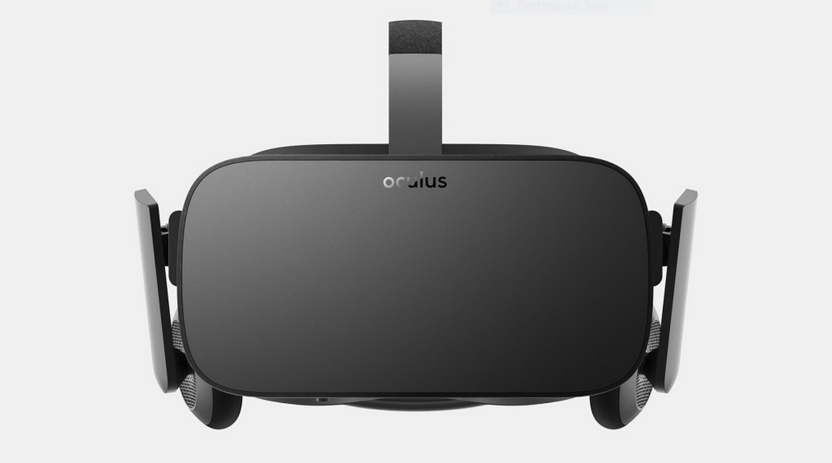
The first person to receive a solid score to our 9-10 challenge will receive Oculus Rift

FAQ

When is the challenge deadline?
If you complete the challenge by 9/15 6am, we will be able to present your profile to employers starting on 9/21. The challenge will remain open after that time, but you would only be presented to the next batch of companies.

Does the programming language I choose make a difference?
You should choose a programming language that offers the standard libraries you think you'll need for the program. We recommend choosing a language that you're comfortable with and in which you'll write high quality code to showcase to companies. In terms of efficiency, the choice of algorithm will make more of a difference than what language you use.

What are code execution CPU/RAM/Time limits?
RAM: 256 MB, CPU: 1 CPU core (exclusive) 2.2 GHz, JVM -Xmx: 256M, compilation time: 10 seconds, execution time: 2 seconds.

