**Patient Assistance Tracking System (PATS)**

**USER GUIDE FOR PHYSICIANS**

**I.** **ACCESSING PATS**

**Go to the Website**: <https://www.maxaid.org/>

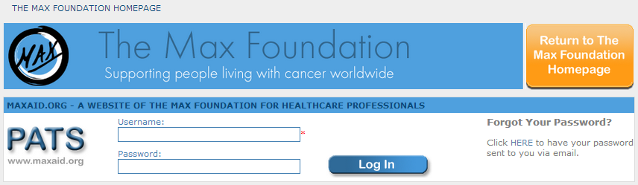

**Log-in**

You will be prompted to enter your Username and Password. When complete, click the “Log In” button.

For security and for processing reasons, please do not share your Username and Password.

If you forget your Username and Password, you may request it by using the link “Forgot Your Password?” on the login screen. An email will be generated and mailed to the email address you provided us, which is also saved under your PATS profile.

***Troubleshooting Login Difficulties:***

If your Username or Password are not recognized,

1. Be sure you are typing them exactly as they were provided. Use upper and lower case letters exactly as issued. Do not use extra spaces or symbols.
2. Your password may have changed. Use the link “Forgot Your Password?” to request your password again.
3. If you still encounter difficulties, write to us at [gipap@themaxfoundation.org](mailto:gipap@themaxfoundation.org).

When you are successfully logged in, you should see the following homepage:

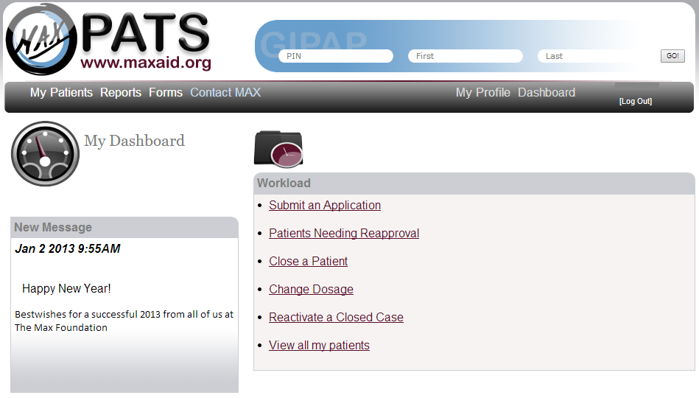

Dashboard

Menu

**II. NAVIGATING THE SYSTEM**

**MY DASHBOARD:** When you log in to PATS, you will see your homepage also called “My Dashboard”. This page will show messages and/or announcements that The Max Foundation wishes to communicate to you. This page will also list the actions you may take for the patients under your care.

* Submit an Application
* Patients Needing Reapproval
* Close a Patient
* Change Dosage
* Reactivate a Closed Case
* View all my patients

**MENU:** You may choose from a variety of actions that you see listed from left to right of your screen. (Refer to above homepage screenshot). These actions are organized in sections:

1. **My Patients**: These are the patient-related action requests you can take. These actions are also listed on your homepage / dashboard.
2. **Reports:** You may view a log of the Adverse Events reported for your patients.
3. **Forms:** You may download this Help/ User Guide, the MAX-Physician MOU, Patient Consent Form, and Adverse Event Report Form.
4. **Contact MAX:** You may submit an email that will be generated in PATS and mailed to [gipap@themaxfoundation.org](mailto:gipap@themaxfoundation.org). This email will automatically include your name and email address so that a Program Officer can follow up with you directly.
5. **My Profile:** These actions allow you to view and update information about yourself that PATS has on file for you. To make changes to your profile click on the edit button at the top of the box. You may also change your PATS password in this section.
6. **Dashboard:** This will return you to the Dashboard.

PLEASE NOTE: The menu will not change regardless of the page you are on within PATS. However, clicking on a link from the menu, when you are in the middle of another action, will cause that action to be abandoned. It is important you submit the action before clicking on another link from your menu.

**III. SUBMITTING A PATIENT APPLICATION**

**Step 1:**

From your “My Patients” menu, or from your dashboard, click on the link “Submit an Application.”

**Step 2:**

The country and physician fields will be automatically filled in. Select the diagnosis from the drop down box and click on “Next Page>>” to proceed.

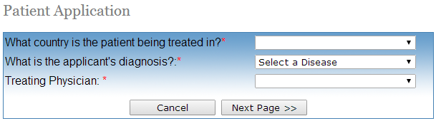

**Step 3:**

You will be presented with the GIPAP application corresponding to the patient’s diagnosis. Please complete the form and click on “Next Page>>” to proceed.

Required fields will have a red asterisk * next to them. You will be prompted to enter missing information before you may proceed.

A summary will appear to the right of the screen as you move through the application. Each section is editable through the “edit” link provided.

PLEASE NOTE: If you attempt to click back in your browser, the patient’s application will be lost, and you will need to re-enter the patient application.

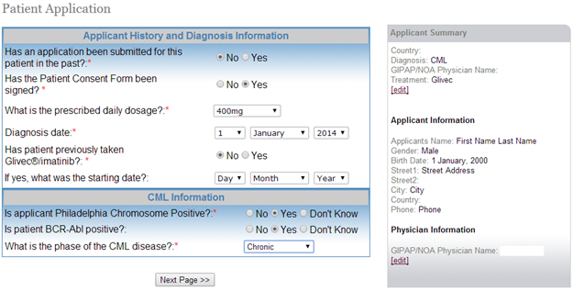

**Step 4:**

Review the summary page to ensure information is correct. After you are satisfied that the patient application is accurate and complete, click “Submit Patient Application”.

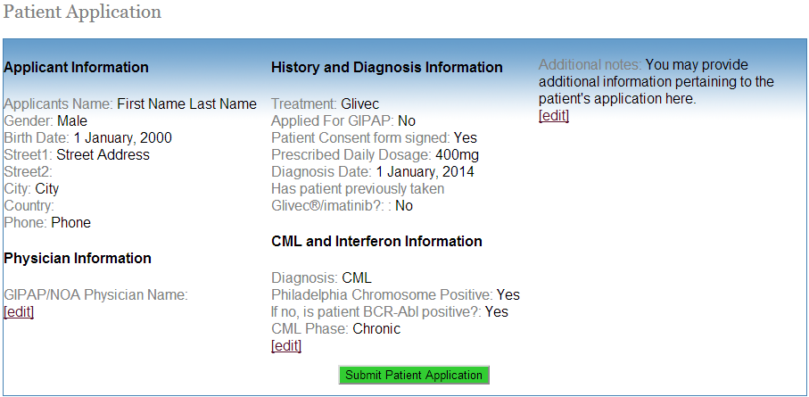

**Step 5:**

Once submitted, you will see the following message:

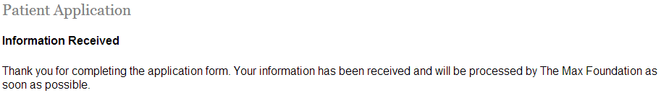

**IV. REQUEST RE-APPROVAL**:

Patient applications are approved for a 120-day approval period. You may reapprove patients for the next approval period 30 days before the end of the current approval period.

You will receive a PATS generated email with re-evaluation questions for those patients who are queued for reapproval. You may also view the list of patients queued for reapproval under the link “Patients Needing Reapproval”.

For example:

* Patient approved on 1 January 2014 for a 120-day approval period.
* Current approval period is 1 January 2014 – 1 May 2014.
* On 1 April 2014, patient re-approved for the next approval period.
* Next approval period is 1 May 2014 – 1 September 2014.

**Step 1:**

From your “My Patients” menu, or from your dashboard, click on the link “Patients Needing Reapproval”.

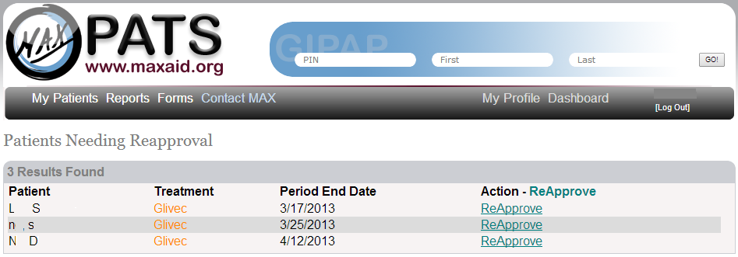

**Step 2:**

PATS will list your patients who are currently eligible for reapproval (ie, patients who are 30 days or less from the end of their current approval period). Patients are listed in chronological order of their period end date. This means that any patients overdue for reapproval, if any, will be listed first. Click on the link “Re-Approve” for any patients you would reapprove.

PLEASE NOTE: If you do not see the name of a patient whom you believe should be re-approved, please send a note to [gipap@themaxfoundation.org](mailto:gipap@themaxfoundation.org).

**Step 3:**

Confirm whether you recommend the patient continue with treatment and click the “Submit” button to complete the reapproval.

**Step 4:**

If a change in dose is needed, you may click on “Change Dosage”. You will be asked to confirm if the change in dose is AE related. If so, you will need to provide a reason for the dose change.

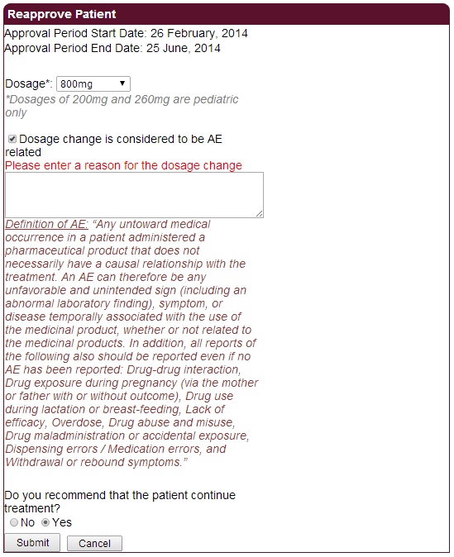

**V. REQUEST TO CLOSE A PATIENT’S CASE**

**Step1:**

From your “My Patients” menu, or from your dashboard, click on the link “Close a Patient Case”.

**Step 2:**

PATS will list the active patients under your care in alphabetical order by last name. Click on the “Request to Close” link highlighted in red.

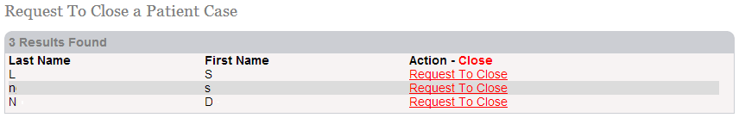

**Step 3:**

Select the “Reason for Closing” that best describes your request for case closure and click “Submit”.

**Step 4:**

If a closure reason is selected that is tied to an Adverse Event, such as “Patient has passed away”, you will be prompted to provide further details.

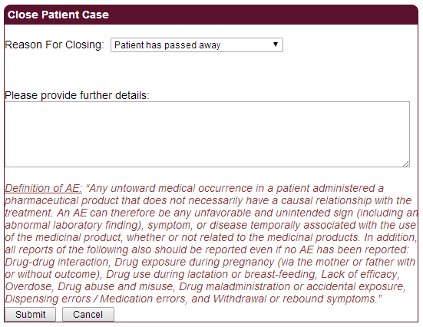

**VI. REQUEST TO CHANGE THE DOSAGE**

You may request changes in dose within the approved label indication. You may request either an increased dose or lowered dose in PATS.

**Step 1:**

From your “My Patients” menu, or from your dashboard, click on the link “Change Dosage”.

**Step 2:**

PATS will list the active patients under your care in alphabetical order by last name. Click on the “Change Dosage” link to the right of the patient’s name highlighted in purple.

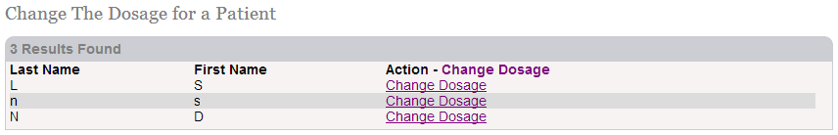

**Step 3:**

From the drop down box, select the new dosage and click “Submit”. Note that only label approved dosages are listed.

**Step 4:**

If the change in dose is tied to an Adverse Event, you will be prompted to provide further details.

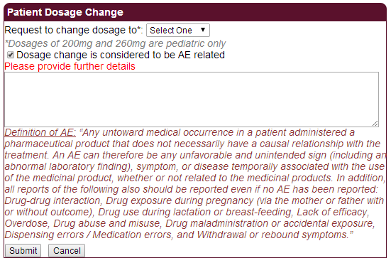

**VII. REACTIVATE A CASE**

Patients’ cases are closed for a variety of reasons. When you learn that your patient may still be eligible for GIPAP/NOA, you may request reactivation of the patient’s case for re-entry into GIPAP.

**Step 1:**

From your “My Patients” menu, or from your dashboard, click on the link “Reactivate a Case”.

**Step 2:**

PATS will list all of the patients whose cases have been closed for reasons other than death. Click on the link to the right of the patient’s name highlighted in green “Request to Re-activate.”

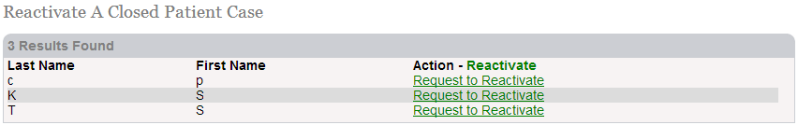

**Step 3:**

Provide a reason for reactivation. Confirm the dose you wish to restart the patient on. Confirm whether you recommend the patient restart treatment and whether the patient’s financial status remains the same and click “Submit”.

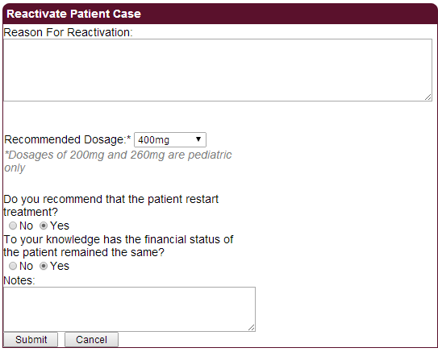

**VIII. VIEW DETAILED INFORMATION ON A PATIENT**

You may view the information that we have on file for each of your patients. This can be especially useful in verifying patients with the same name but different Personal Identification Numbers (PINs).

**Step 1:**

From your “My Patients” menu, or from your dashboard, click on the link “View all my patients”.

**Step 2:**

PATS will group your patients by status and in alphabetical order. Click on the highlighted PIN to the left of the patient name.

You will see the following screen:

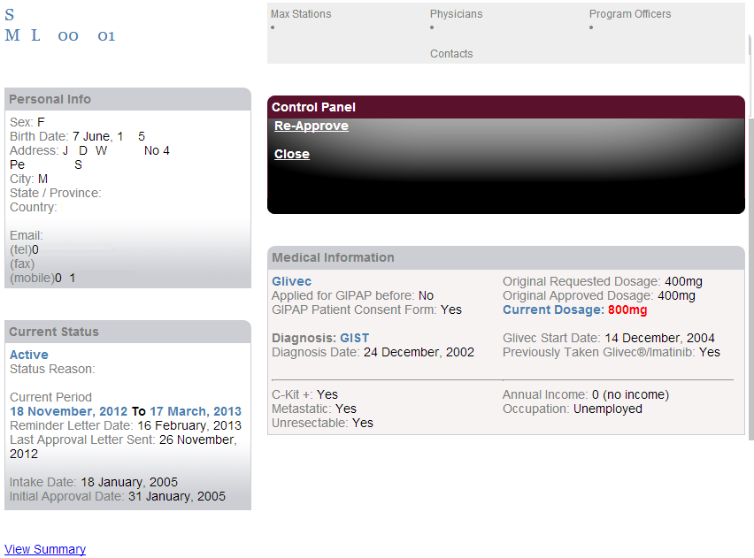

**IX. REPORT ADVERSE EVENT**

Regulatory agencies overseeing the safety of registered drugs stipulate that Adverse Events (AEs) must be reported. PATS provides you with the tools to report AEs to the Novartis safety officer within each country. For your convenience, you may download a copy of the Novartis Adverse Event Report Form and submit it to the Novartis safety officer for your country.