**Project 2: Lab 1 Report**

Matthew Santiago

University of Maryland Global Campus

CCS 625 Network Engineering

Andrzej (Andrew) Hoppe

November 1, 2024

**Lab Summary:** In this lab I had to configure an AWS Virtual Private Cloud (VPC), Internet Gateway and attach the internet gateway to the VPC. During the process I checked the command help pages to understand how to properly execute the command. I also ran commands to add tags to the created VPC and internet gateway. When finished detached and deleted the internet gateway and VPC.

**Steps Taken:**

1. Access CloudShell by logining into AWS Academy Learner Lab
2. Used the cloudshell command line and viewed the help page for commands
   1. aws help
   2. aws ec2 help
3. Created a VPC for 10.0.0.0/16
   1. aws ec2 create-vpc --cidr-block 10.0.0.0/16
   2. Received this output:

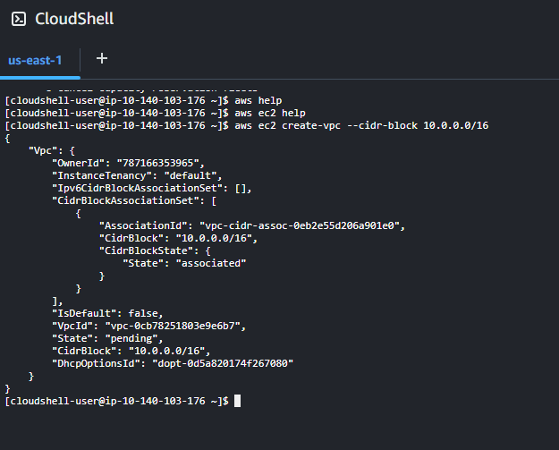

* 1. Added a tag to the VPC
     1. aws ec2 create-tags --resources vpc-0cb78251803e9e6b7 --tags "Key=Name, Value=CLI VPC"



* 1. Verified the VPC was created in the VPC dashboard

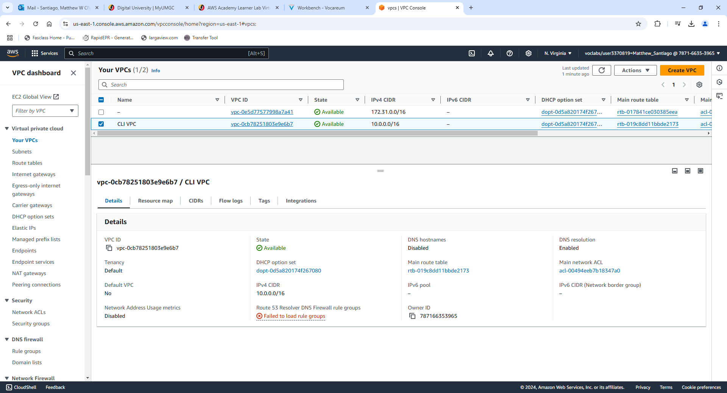

1. Created an Internet Gateway
   1. aws ec2 create-internet-gateway

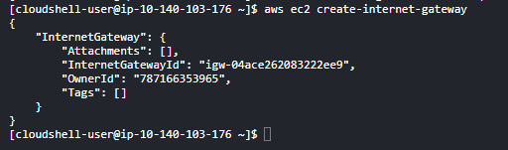

* 1. Added a tag to the Internet Gateway
     1. aws ec2 create-tags --resources igw-04ace262083222ee9 --tags "Key=Name, Value=CLI IG"



* 1. Verified the Internet Gateway was created in the Dashboard.

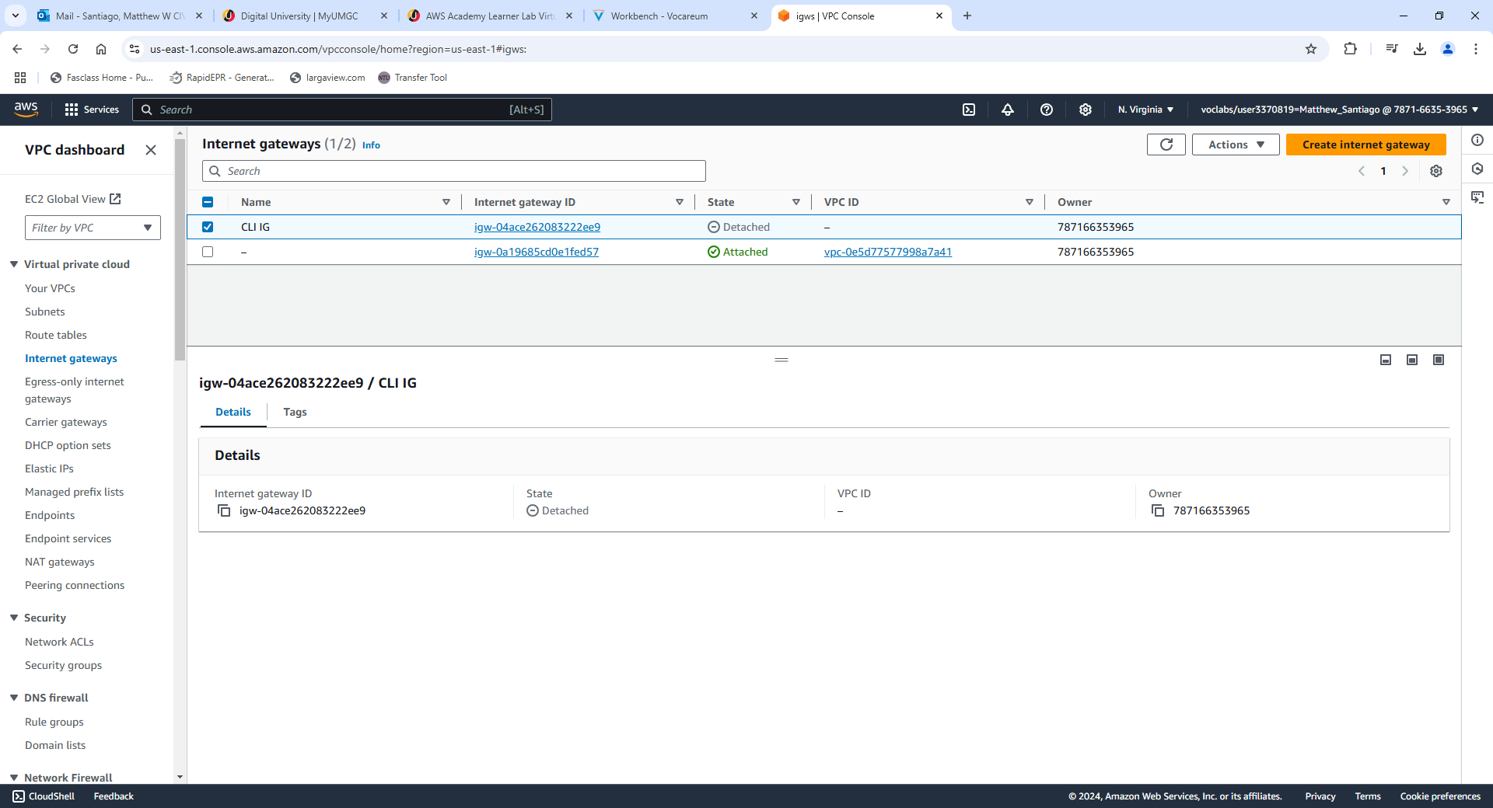

* 1. Attached the internet gateway to the VPC
     1. aws ec2 attach-internet-gateway --internet-gateway-id igw-04ace262083222ee9 --vpc-id vpc-0cb78251803e9e6b7



* 1. Confirmed the internet gateway was attached to the VPC in the dashboard

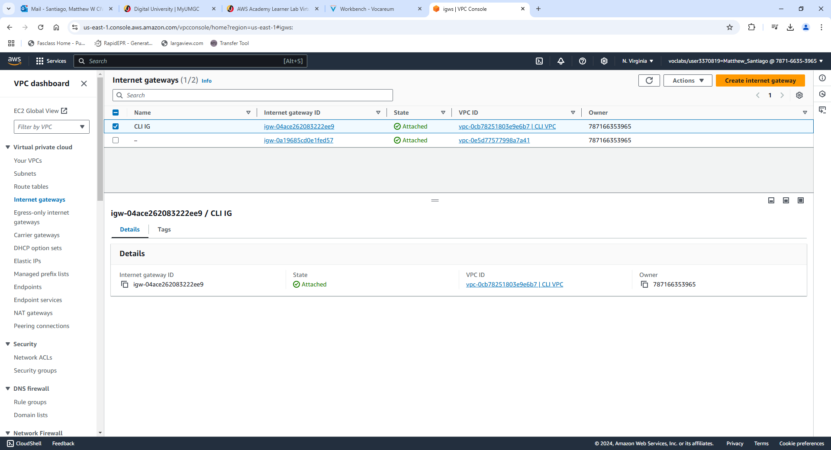

* 1. Detached the Internet Gateway from the VPC and deleted both the Internet Gateway and VPC.

**CLI use for BallotOnline**

After testing the AWS CLI, it proved to be useful in many ways for BallotOnline. The AWS CLI "enables you to interact with AWS services using commands in your command-line shell" (Amazon Web Services, n.d.). The use of the CLI will provide BallotOnline automation, standardization, and quick disaster recovery. Scripts help with automation and standardization by completing “task-oriented processes across all types of computing environments” (NinjaOne, 2024). Scripting deployment and management will “reduce redundancy in execution, standardize everyday tasks, cut costs, better utilize human resources, and streamline processes” (NinjaOne, 2024). Since using the CLI and scripts standardize our commands and make sure deployments are error free and quickly deployable, if a disaster does occur within the AWS network, getting the BallotOnline network back up quickly is possible. Using the AWS CLI will make BallotOnline infrastructure more reliable and easily managed.

# **References**

Amazon Web Services. (n.d.). *What is the AWS Command Line Interface?* From AWS: https://docs.aws.amazon.com/cli/latest/userguide/cli-chap-welcome.html

NinjaOne. (2024, March 24). *IT Automation Scripts: Definition and Overview*. From NinjaOne: https://www.ninjaone.com/blog/it-automation-scripts-definition-and-overview/