**Project 2: Lab 2 Report**

Matthew Santiago

University of Maryland Global Campus

CCS 625 Network Engineering

Andrzej (Andrew) Hoppe

November 7, 2024

**Lab Summary:** In this lab

**Steps Taken:**

1. **Login to CloudFormation Dashboard and Designer Tool**
   1. Access CloudFormation by logging into AWS Academy Learner Lab and then launch the Designer Tool from inside cloudformation.
2. **Design a Stack With a VPC and Internet Gateway, and Attach the Gateway to the VPC**
   1. Dragged a VPC resource into the designer tool.
      1. Edit the template in properties to add a cidr block.
      2. Edit the json to add Tags for VPC name: CF VPC
   2. Dragged Internet Gateway into the designer tool
      1. Linked the internet gateway to be dependent on the VPC and attached the Internet gateway to the VPC, by dragging blue and brown dots to the VPC from Internet gateway.
      2. Edited the JSON to add tags on the internet gateway, for name CF IG.
   3. Validated the template and saved as CCA625-P2-mws.template

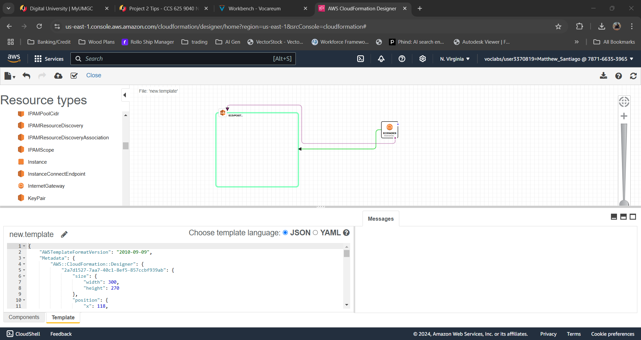

1. **Create the Stack and Verify the Configuration**
   1. Click create stack and upload the saved template to the create stack wizard.
   2. Named stack CCA625-P2-MWS
   3. Once finished with create stack wizard, went to the cloudformation dashboard to check status of creation. Received CREATE_COMPLETE.

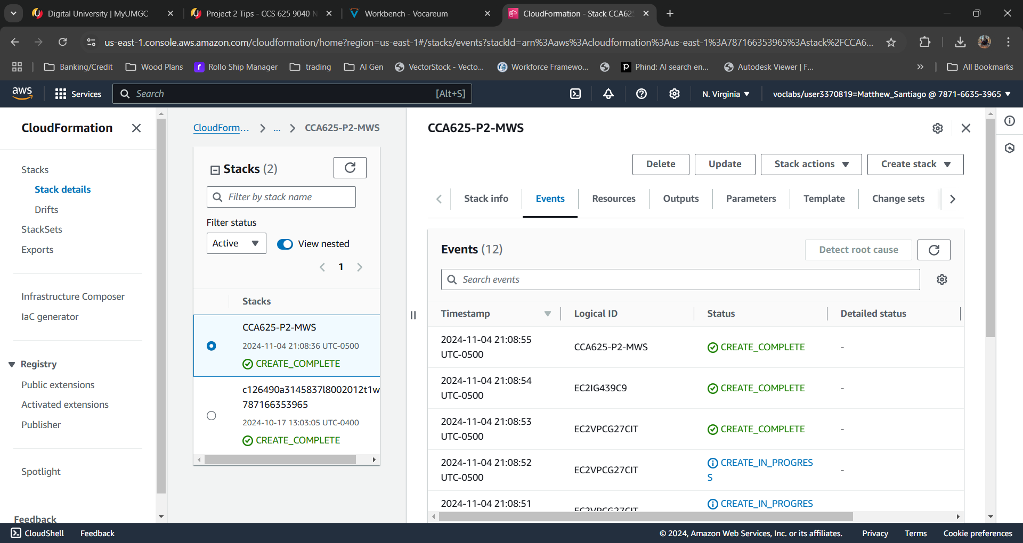

* 1. Verified stack was created in AWS VPC Service

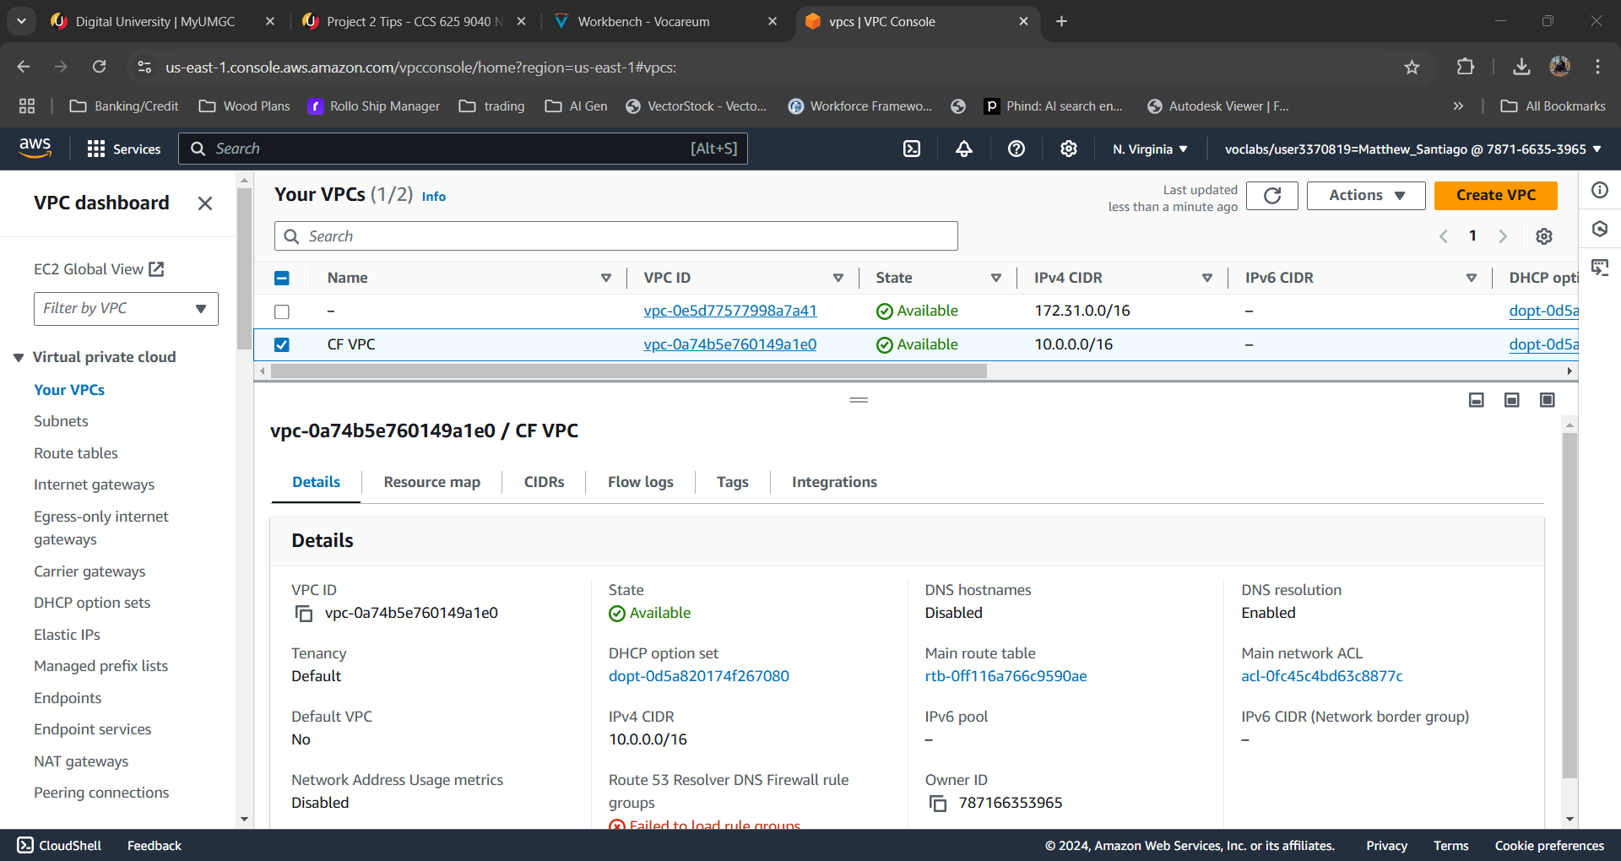

* 1. Verified internet gateway was created

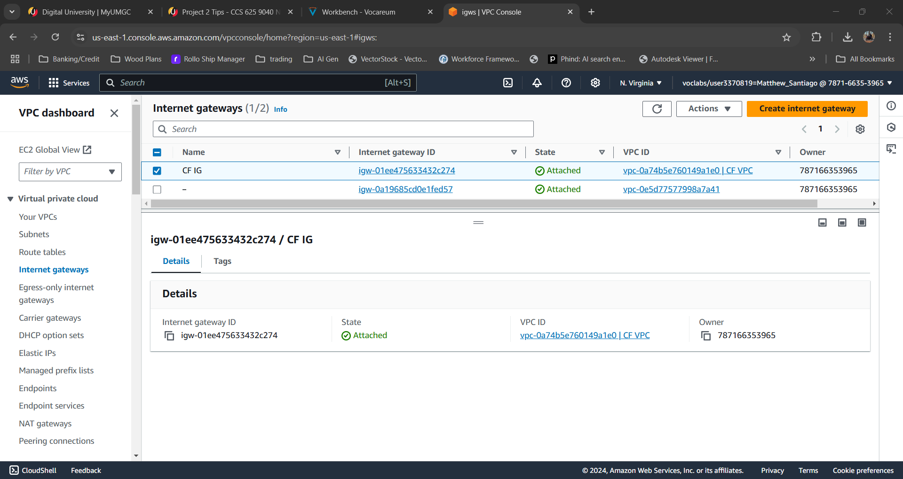

* 1. Terminated and deleted all resources.

1. **Declarative IaC for BallotOnline**

Declarative programming Infrastructure as Code within AWS CloudFormation will provide BallotOnline with a method for implementing cloud deployments. Declarative allows BallotOnline to define infrastructure through templates that describe the configuration of the device. It allows the system to figure out the steps needed for deployment (TechTarget, 2022). This provides automatic provisioning and infrastructure management (Amazon Web Services, n.d.). By using declarative templates BallonOnline can monitor changes over time to improve deployments. This method also makes sure that each time the template is used it reduces or eliminates mistakes and prevents configuration drift (Amazon Web Services, n.d.). Also using the declarative templates allows for scalability that gives BallotOnline the ability to provision and manage infrastructure that adapts to changing requirements (Amazon Web Services, n.d.). Finally, declarative programming will allow BallotOnline to achieve a reliable and flexible cloud environment.

# **References**

Amazon Web Services. (n.d.). *What is Infrastructure as Code?* From Amazon Web Services: https://aws.amazon.com/what-is/iac/

TechTarget. (2022, March 21). *What is declarative programming?* From TechTarget: https://www.techtarget.com/searchapparchitecture/tip/The-basics-of-working-with-declarative-programming-languages#