**Project 2: Lab 3 Report**

Matthew Santiago

University of Maryland Global Campus

CCS 625 Network Engineering

Andrzej (Andrew) Hoppe

November 7, 2024

**Lab Summary:** In this lab

**Steps Taken:**

1. **Login** 
   1. Login to Aws and access Cloudshell
2. **Analyze a Python Script, Provisioning an EC2 Instance**
   1. Download the create_instance.py and update the script by adding keypair_name = 'CCA625P1-key'
   2. Uploaded the script to cloudshell
   3. Showed the script on cloudshell by using command “more Create_Instance.py”

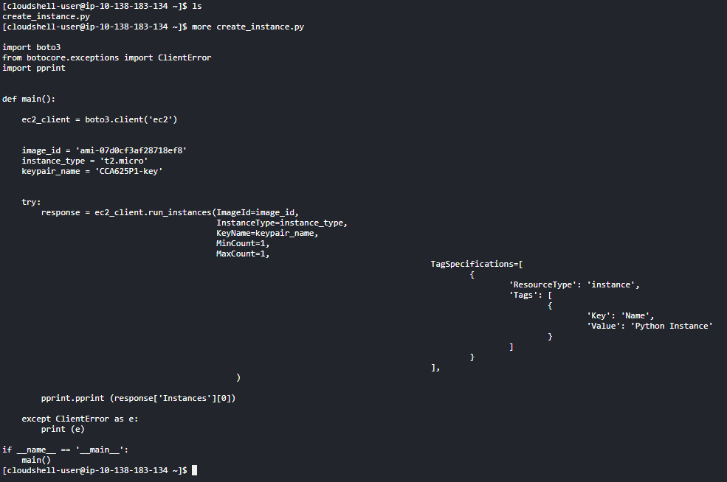

* 1. Analyzed the script

1. **Run a Python Script**
   1. Ran the script with this command “python create_instance.py”

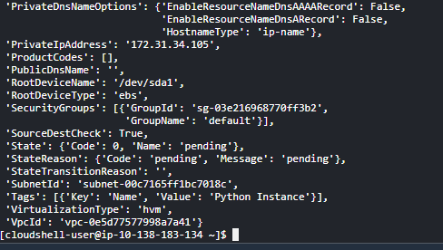

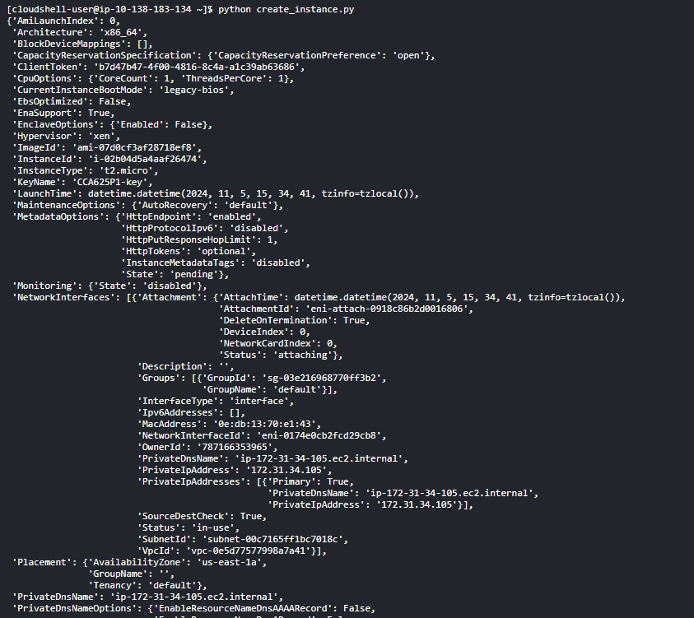

1. **Verify the Instance Has Been Provisioned**
   1. Went to AWS dashboard then accessed EC2 dashboard. Once in the dashboard looked in the Instances section to verify the instance was made.

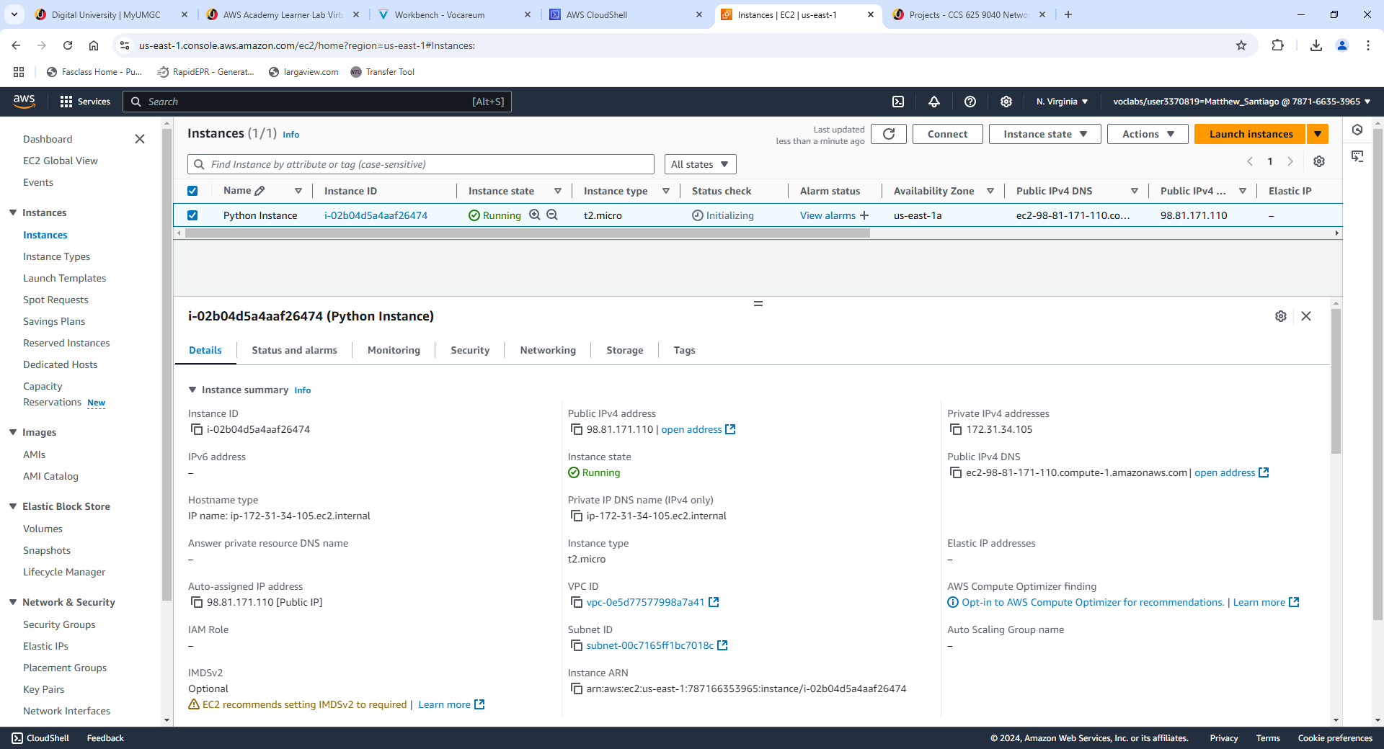

1. **Cloud APIs for BallotOnline**

Using cloud APIs has the ability to improve BallotOnline’s deployment and management of the cloud infrastructure by using standard procedure calls. Cloud APIs like AWS Cloud Control API provide “a consistent way of accessing and provisioning those resources” (Amazon Web Services, 2024). When using APIs, BallotOnline can simplify routine tasks, for example: setting up and managing virtual machines, networks and storage (Cloudflare, n.d.). APIs could also help reduce the need for user interaction which will reduce errors from occurring. Once a template is made and the user initiates the template to be used the “API handles the actual calls to the underlying web services to perform the requested changes” (Amazon Web Services, 2024). Cloud APIs can improve automation and consistency for BallotOnline’s cloud deployment.

# **References**

Amazon Web Services. (2024). *Cloud Control API User Guide.* From Amazon Web Services: https://docs.aws.amazon.com/pdfs/cloudcontrolapi/latest/userguide/cloudapi-service.pdf#what-is-cloudcontrolapi

Cloudflare. (n.d.). *What is a cloud API?* From Cloudflare: https://www.cloudflare.com/learning/security/api/what-is-a-cloud-api/