Project 1: Lab 1 Report

Matthew Santiago
University of Maryland Global Campus
CCS 625 Network Engineering
Andrzej (Andrew) Hoppe
October 17, 2024

Step 1:
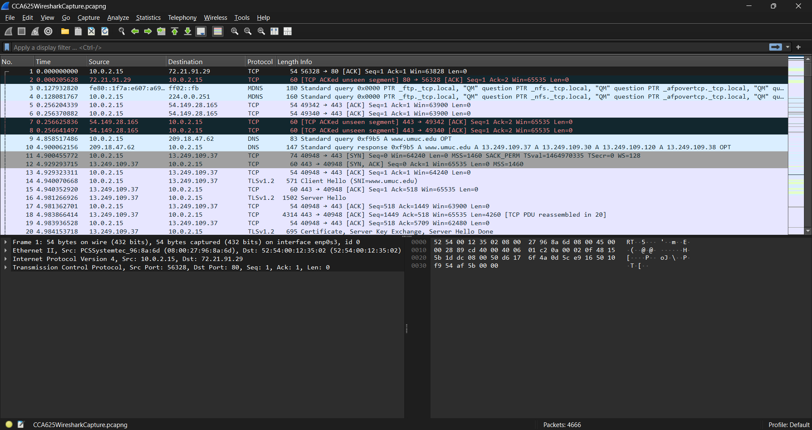
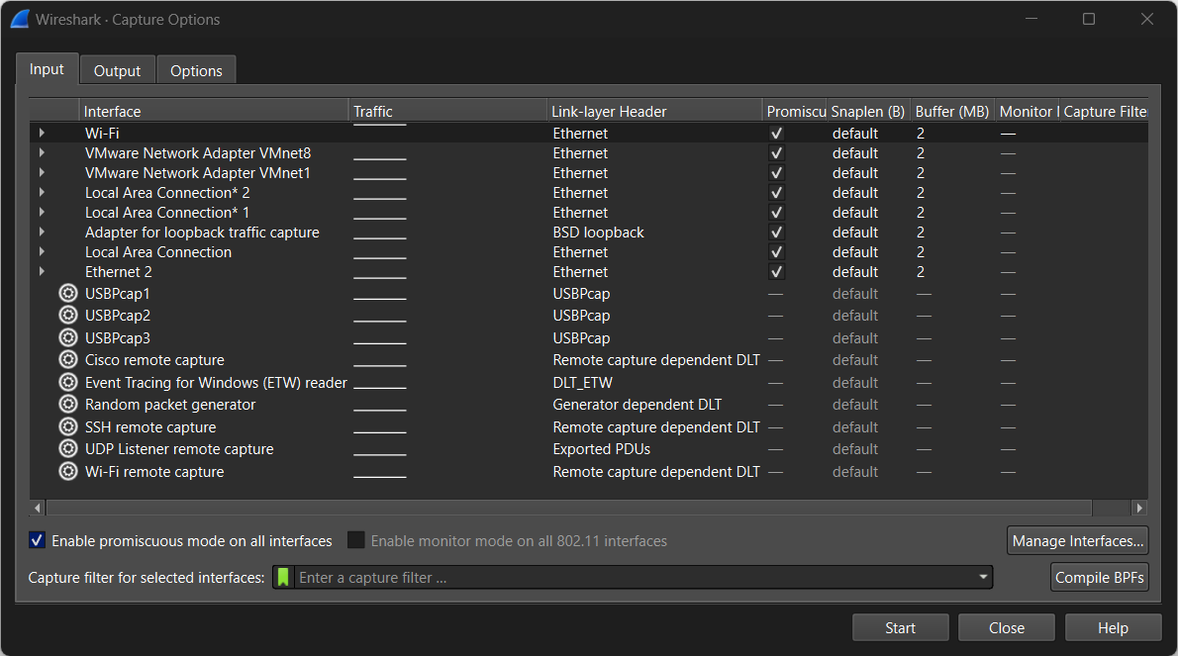
What are the Capture Options in the Input tab you can choose?
- Wifi
- Vmware network adapter
- Ethernet
- Local Area Connection

Step 2:
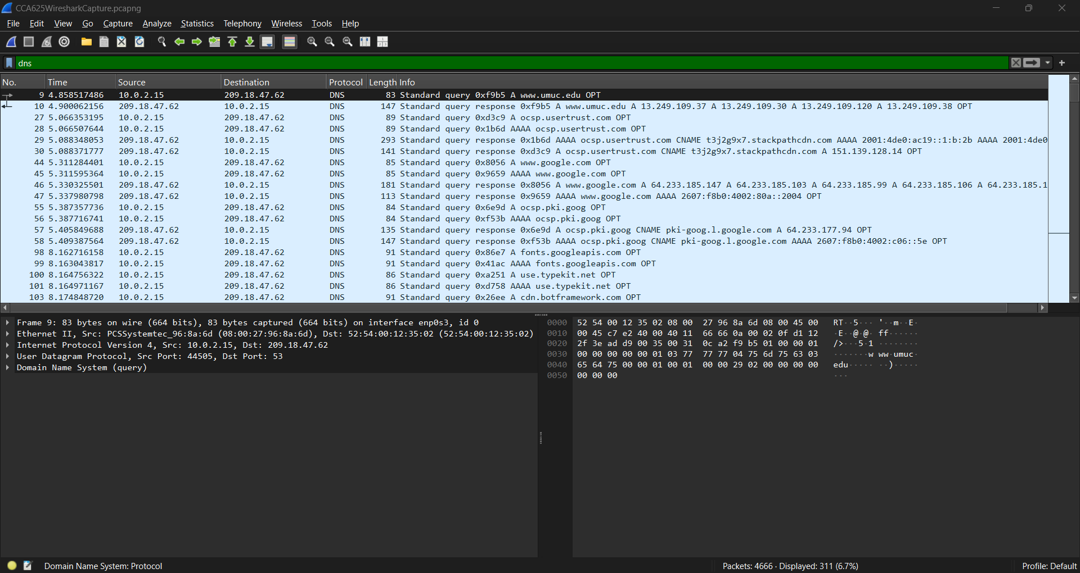
What is the IP address of the requesting computer? 10.0.2.15
What is the IP address of the DNS server used by this computer? 209.18.47.62
What site does this request look up? www.umuc.edu

Step 3:
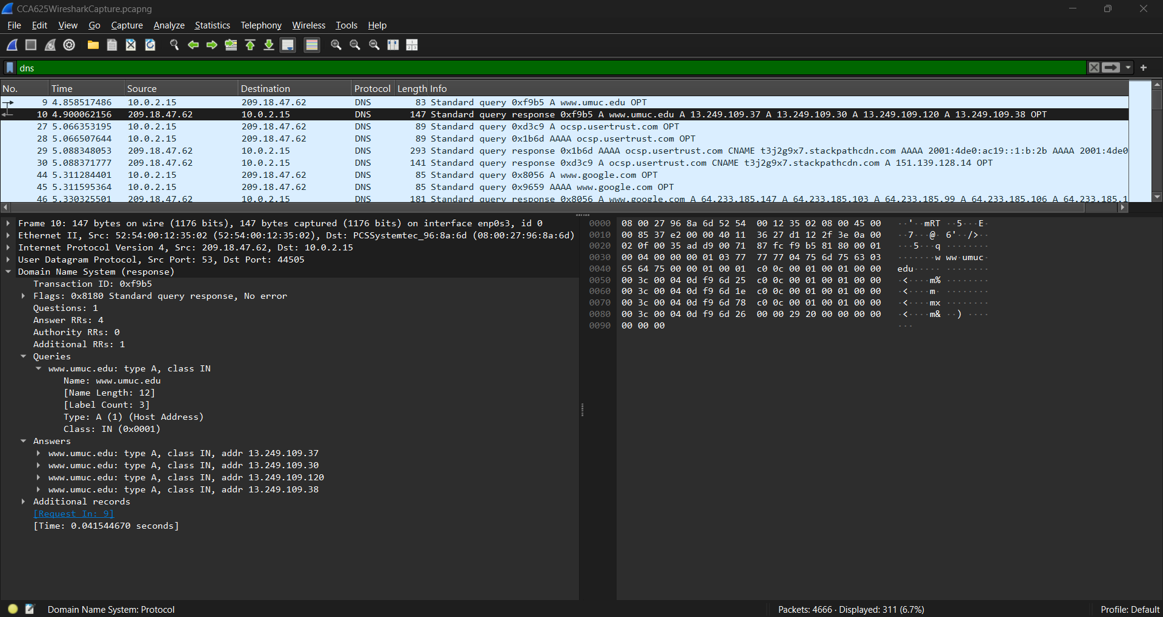
How many IP addresses are assigned to the site, and what are these IP addresses?
- 4 IP Address
  - 13.249.109.37
  - 13.249.109.30
  - 13.249.109.120
  - 13.249.109.38
What protocol is the DNS protocol implemented on top of? User Datagram Protocol (UDP)
What is the destination port number used in that protocol? Port 44505

Filter used next was udp.port==44505
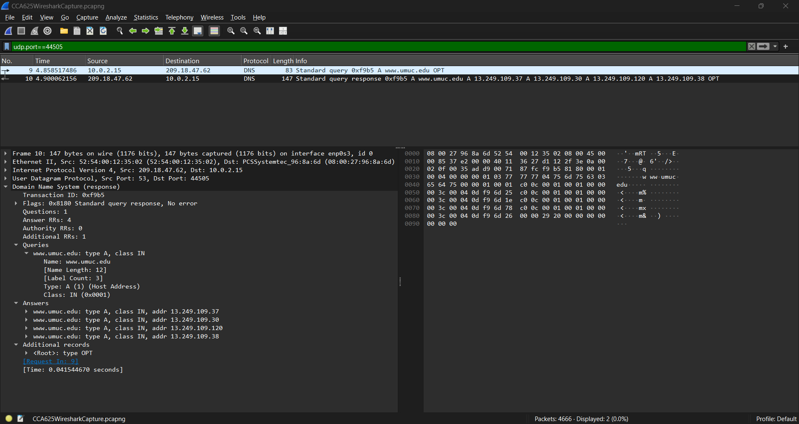
What packet list is displayed with this filter? Packets 9&10

Step 4:
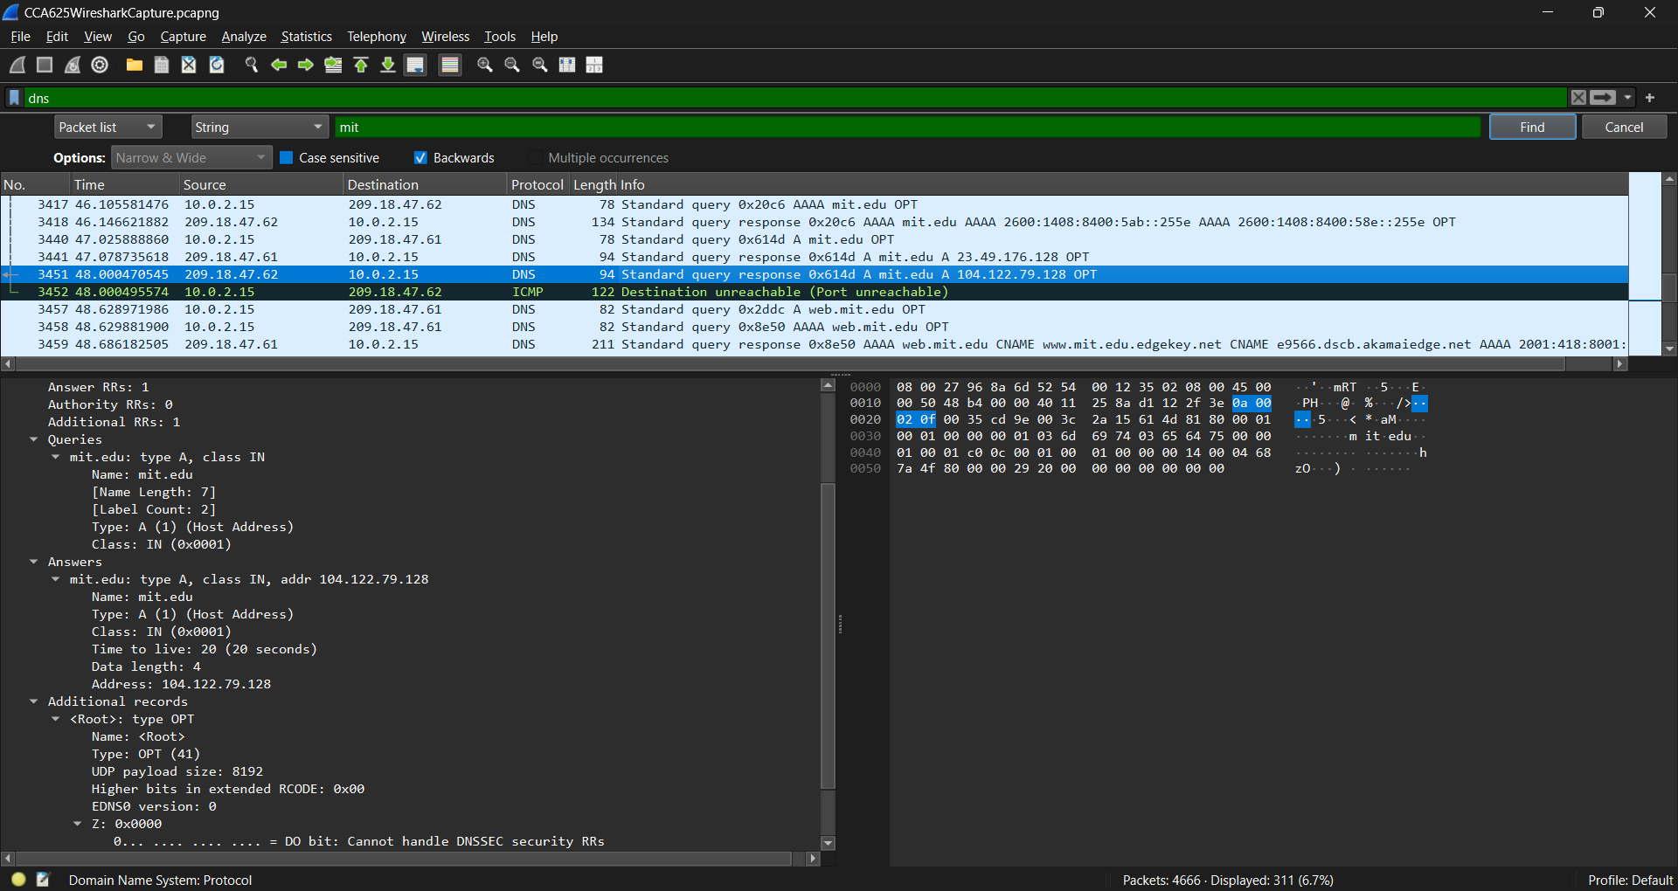
What website does the DNS request found by the search? Mit.edu
What is the IP address that was found? 104.122.79.128

Step 5:
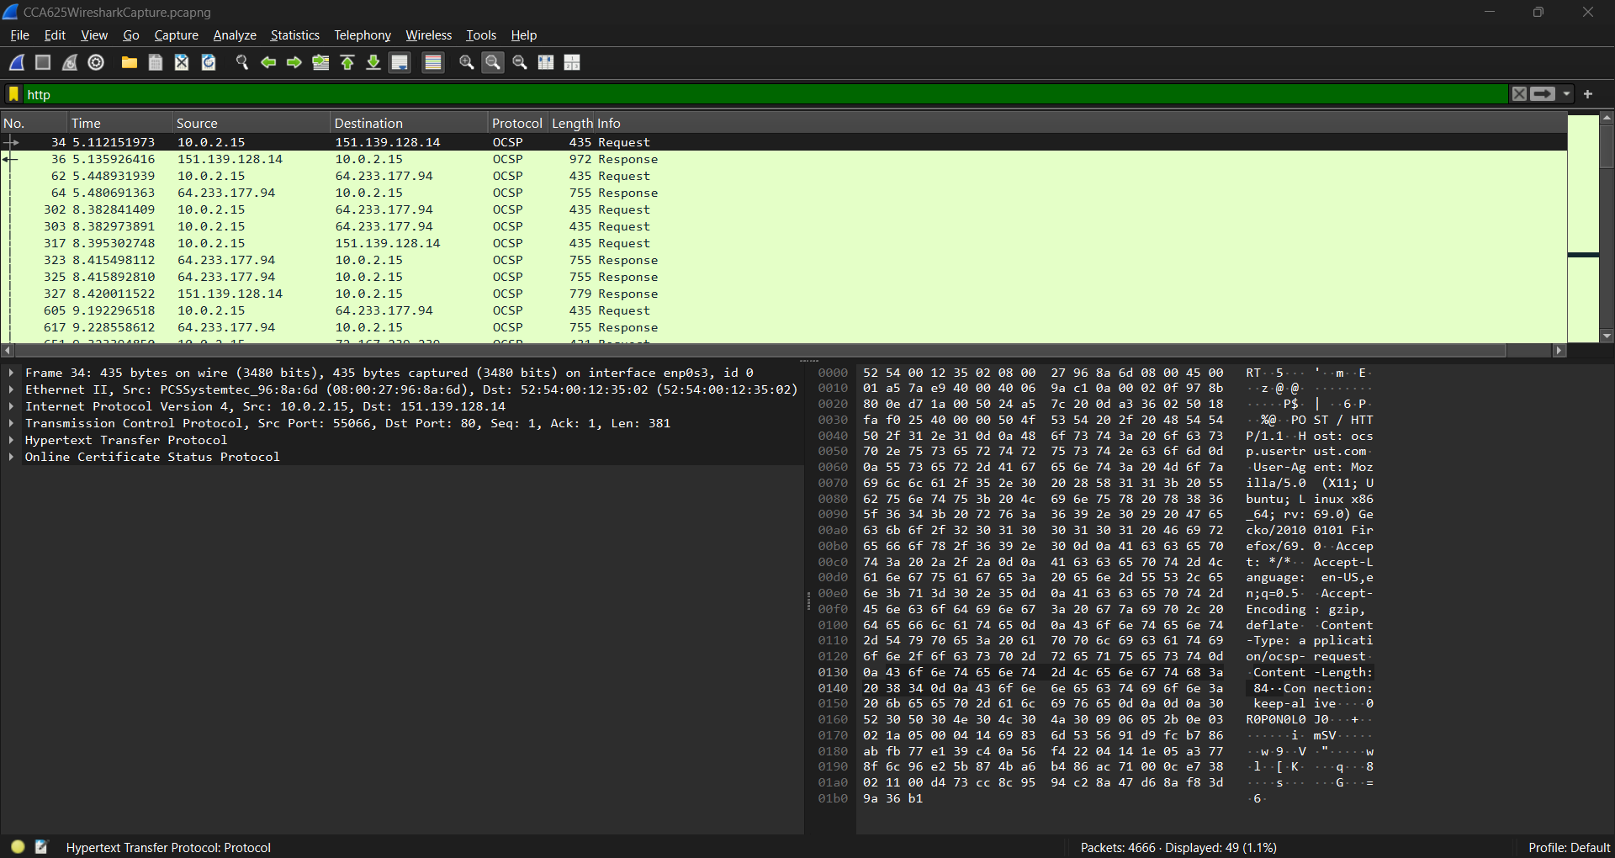
What protocol implemented on top of HTTP is used in this capture? OCSP (Online Certificate Status Protocol)
Research this protocol on Internet and briefly describe what it is used for.
The OCSP is an Internet Protocol (IP) that certificate authorities (CAs) use to determine the status of secure sockets layer/transport layer security (SSL/TLS) certificates, which are common applications of X.509 digital certificates. This helps web browsers check the status and validity of Hypertext Transfer Protocol Secure (HTTPS) websites. (https://www.fortinet.com/resources/cyberglossary/ocsp#:~:text=What%20is%20OCSP%3F,if%20it%20has%20been%20revoked.)

Step 6:
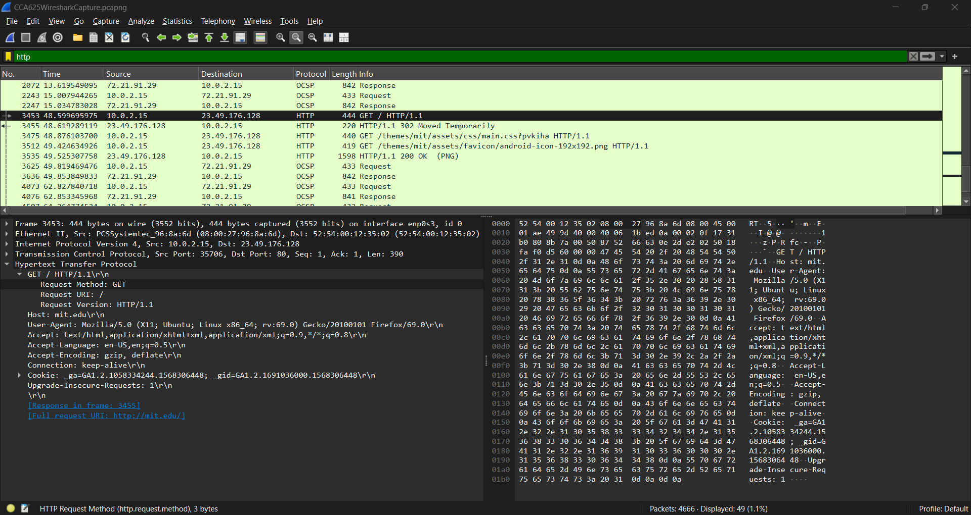
What is the IP address of the request's destination? 23.49.176.128
What is the HTTP response code? 200

Step 7:
packet #3512
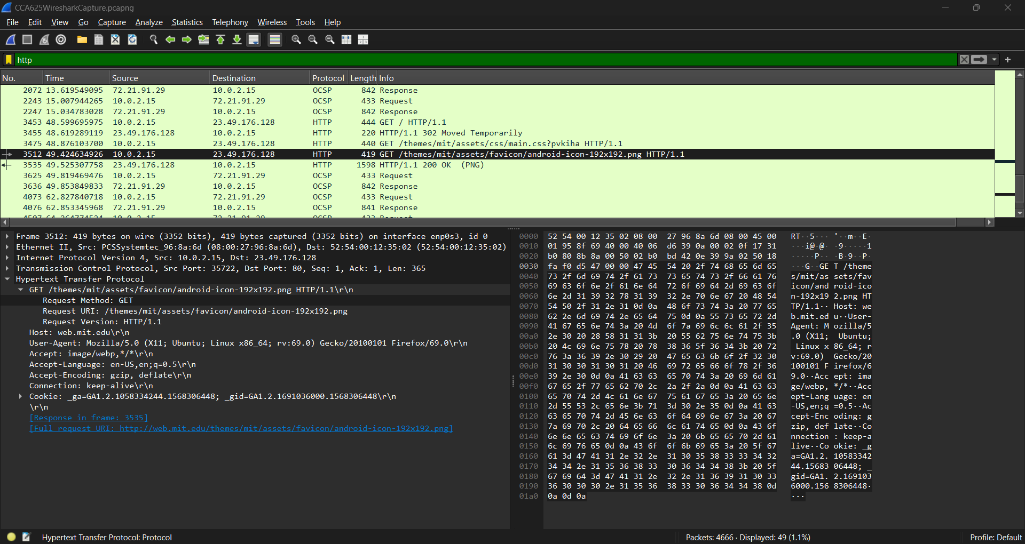
What HTTP operation does this request invoke? GET
What is its destination? 23.49.176.128

Response packet #3535
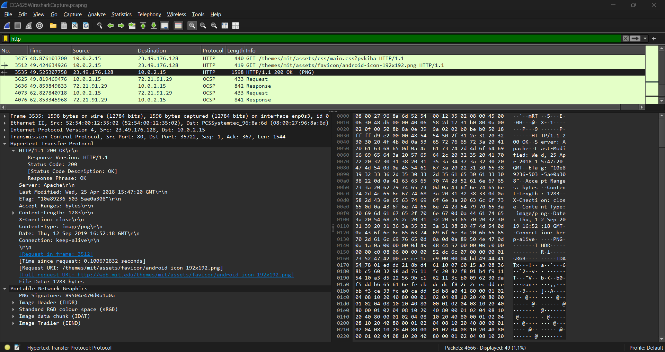
What is the HTTP response code? 200
What is the length of the returned data file? 1283 bytes
What is the extra header tucked on top of this response? Portable Network Graphics

Step 8:
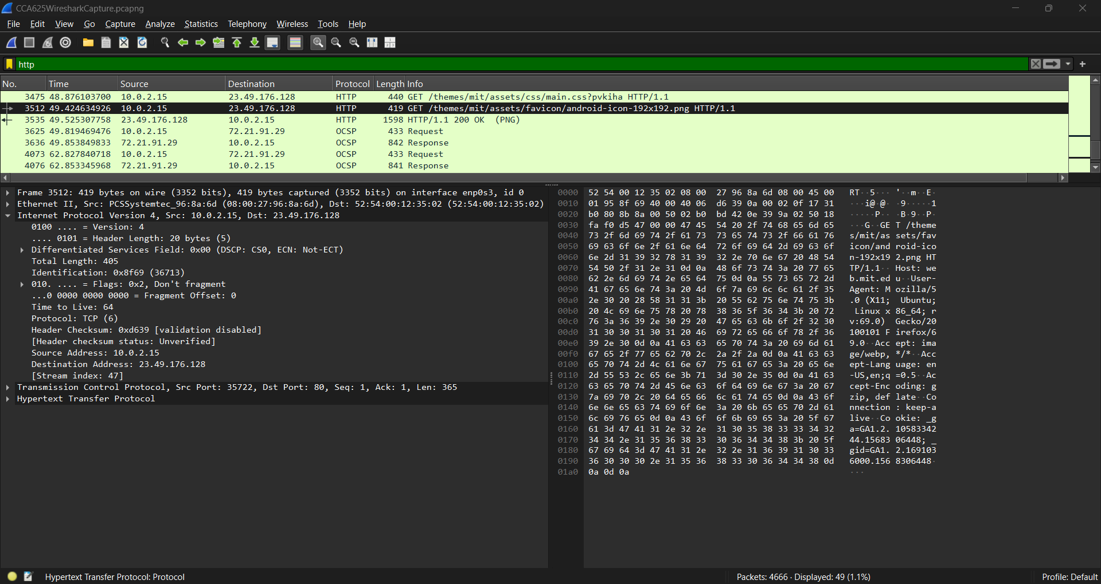
What is the total length of the IP header? 405 Bytes
What is the request's Time to Live? 64

Step 9:
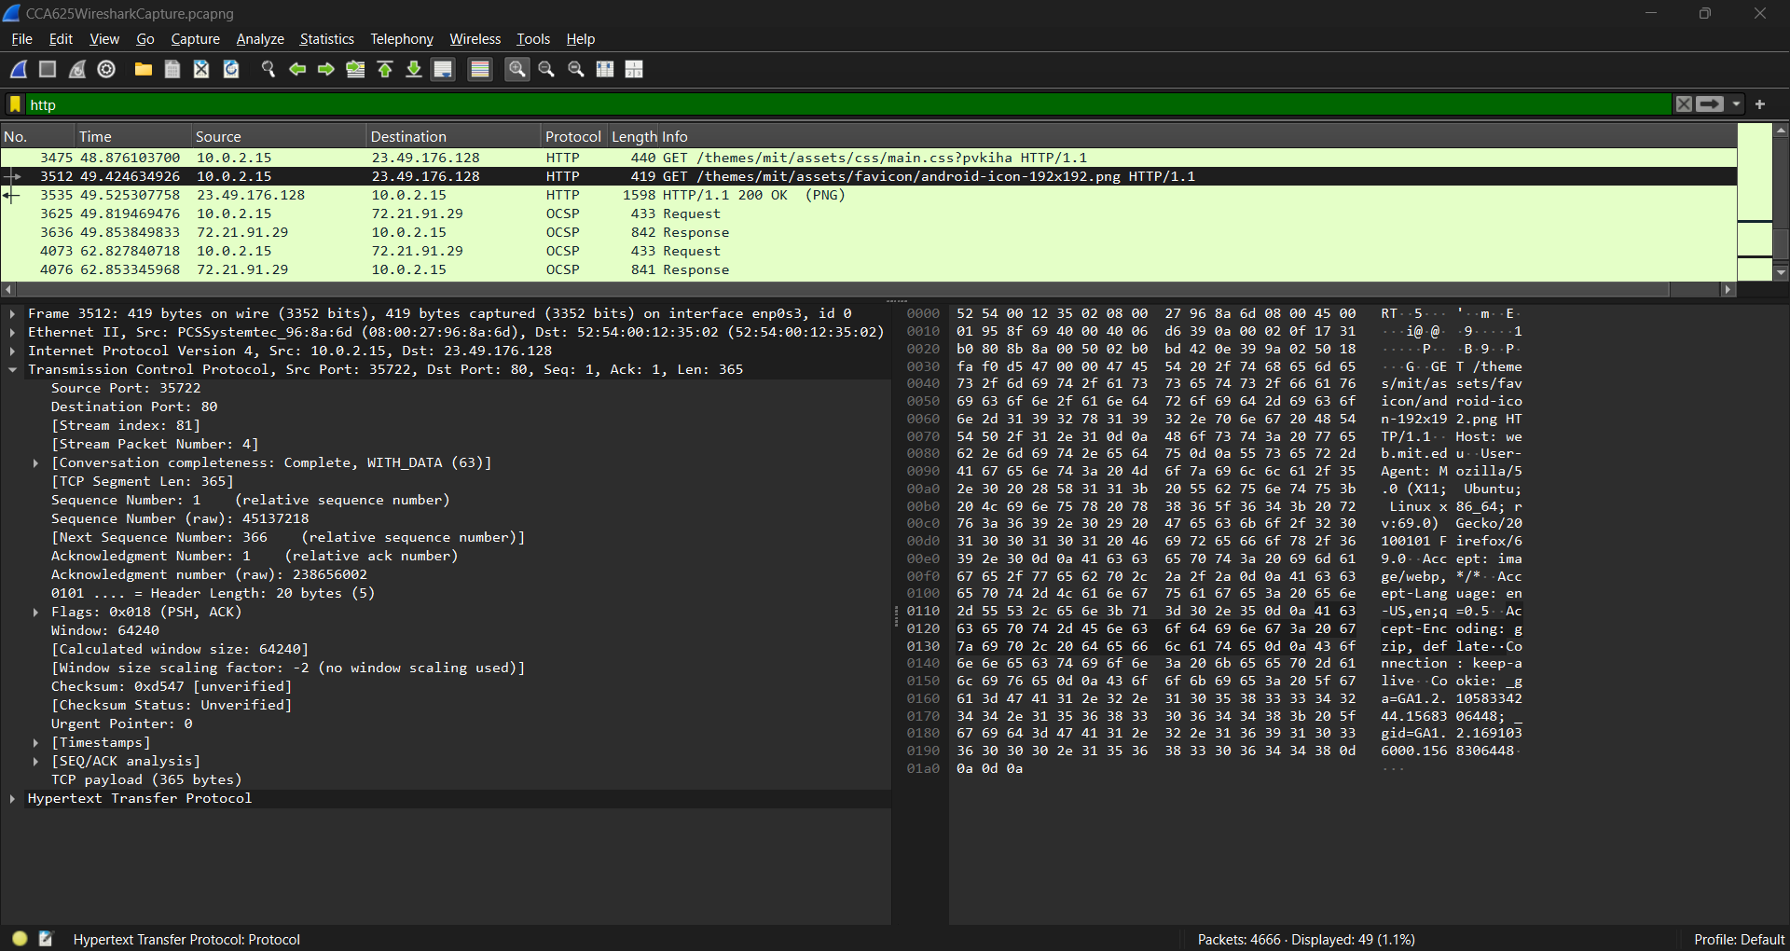
What are the source and destination ports in the TCP header? SRC Port: 35722, DST Port: 80
What is the TCP sequence number for this request? 415371218
What is the sliding window size? 64240

Step 10:
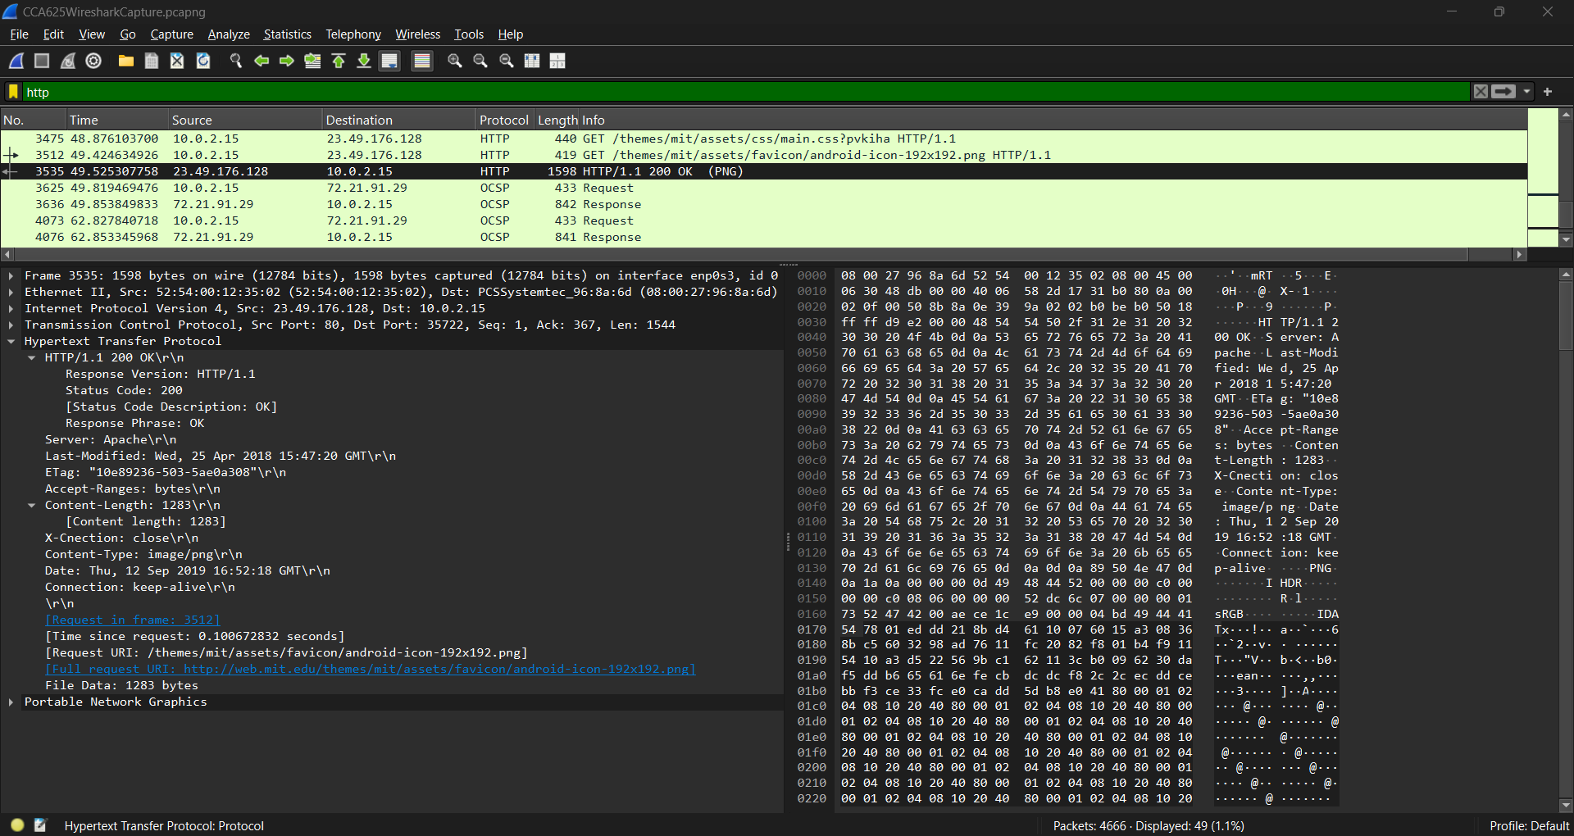
What kind of file is that? Portable Network Graphics (PNG)

Step 11:
What capture filters were used for this capture? None
How many addresses in the domain of akamai.net were resolved? None
I/O Graph - What does this graph show? Shows the number of packets per second over time. Packets in black and TCP errors in red. Lets you plot packet and protocol data in a variety of ways. (https://www.wireshark.org/docs/wsug_html_chunked/ChStatIOGraphs.html)
Flow Graph - What does this graph show? The Flow Graph window shows connections between hosts. It displays the packet time, direction, ports and comments for each captured connection. (https://www.wireshark.org/docs/wsug_html_chunked/ChStatFlowGraph.html)
