Project 1: Lab 2 Report

Matthew Santiago
University of Maryland Global Campus
CCS 625 Network Engineering
Andrzej (Andrew) Hoppe
October 22, 2024

Lab Summary: In this lab I had to configure a AWS EC2 server and establish a SSH and RDP connection to it. Once connected, I had to set up a virtual network using Mininet and monitoring network traffic with Wireshark to analyze.

Steps Taken:
- Provision an AWS EC2
  - Launched an EC2 instance using the AMI provided
  - Created a key pair and set up security group rules to allow SSH and RDP access.
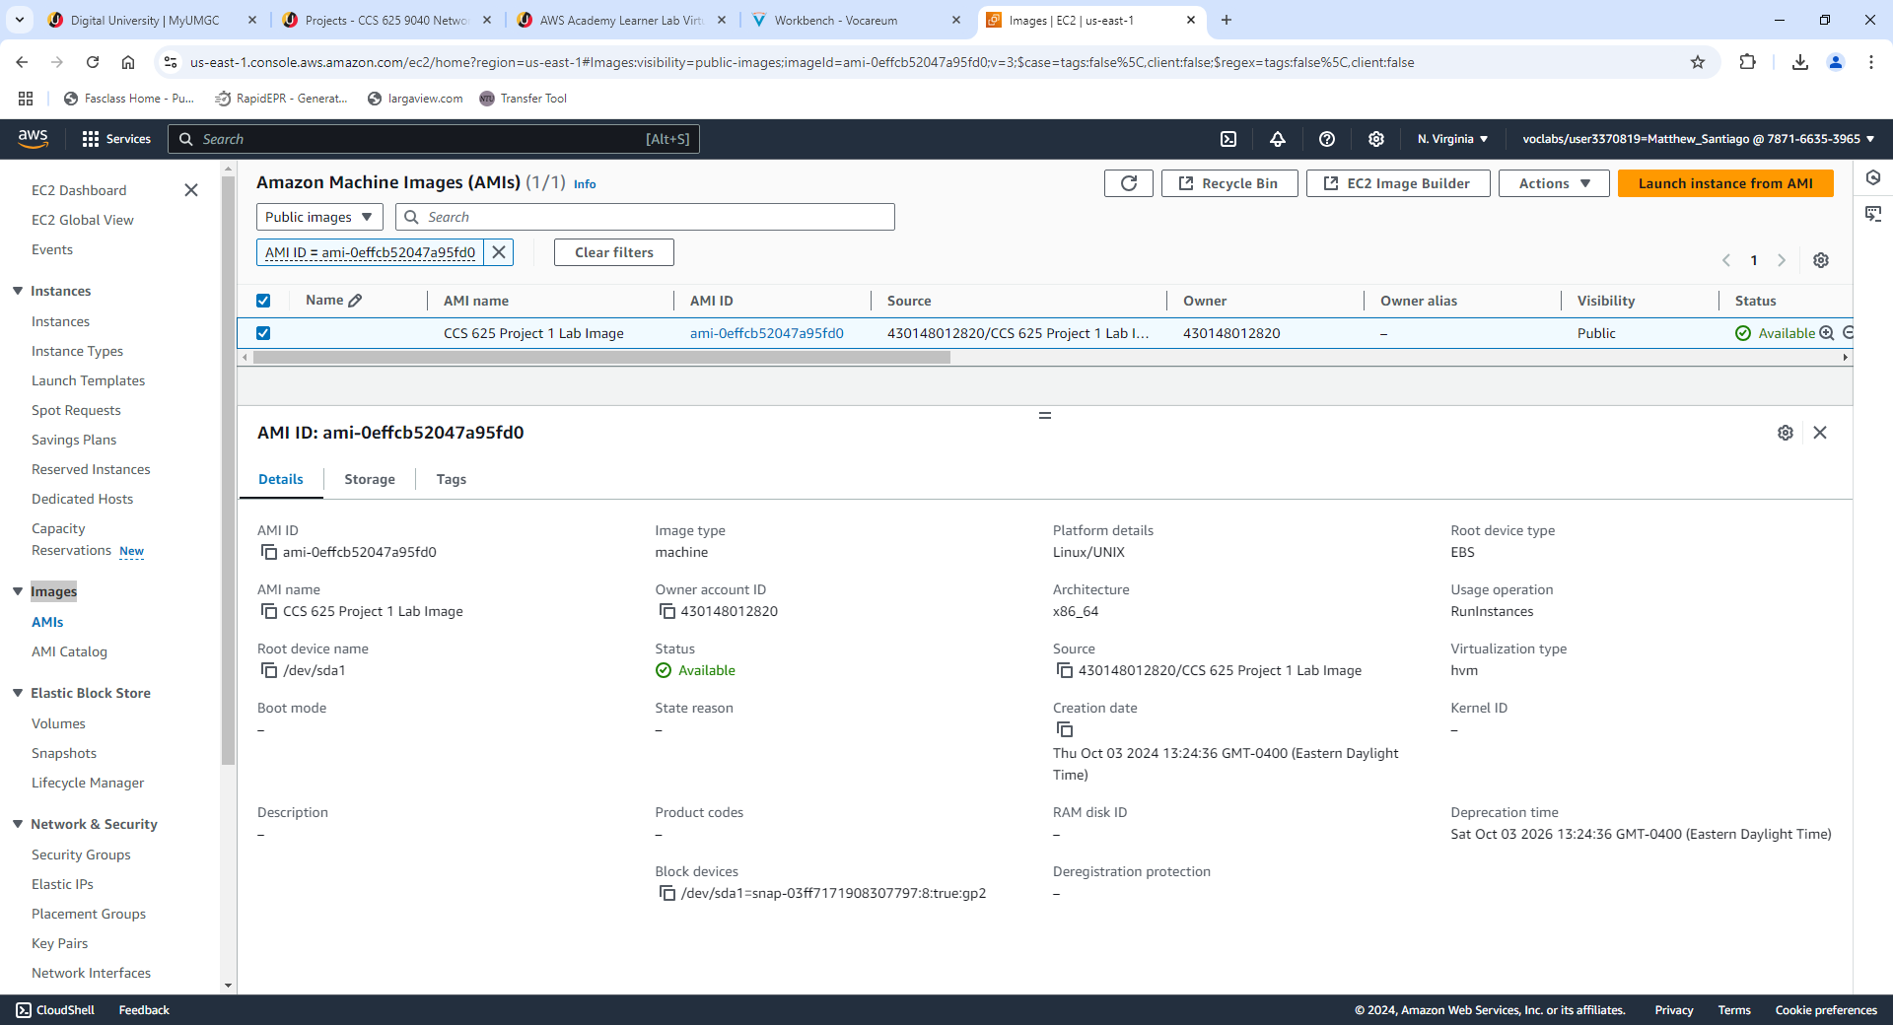
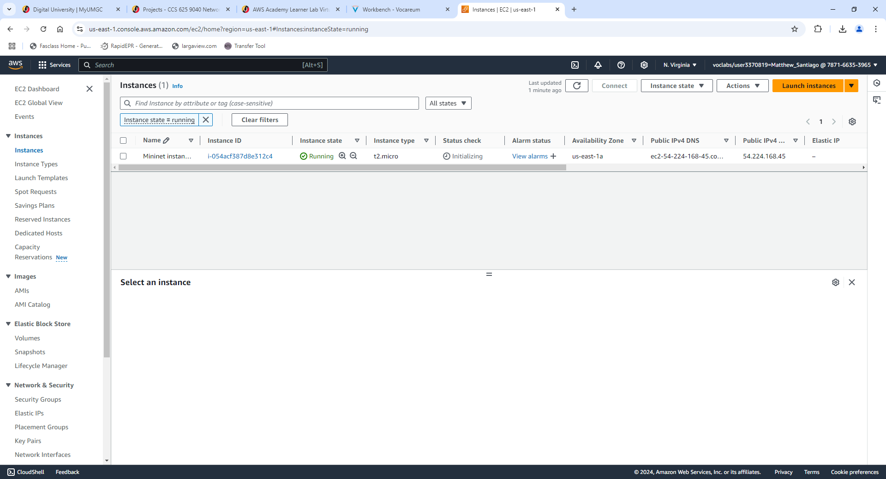
- Connect via SSH
  - Connected to the instance using the key pair via PowerShell.
    - ssh -i "CCA625P1-key.pem" ubuntu@ec2-52-207-231-217.compute-1.amazonaws.com
  - Set a password for the Ubuntu
    - Sudo passwd ubuntu
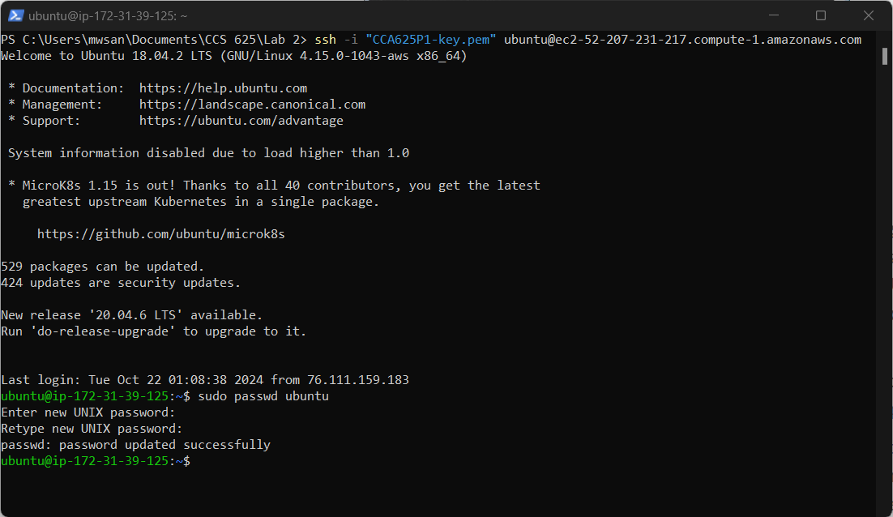
- Connect via RDP
  - Connected to the instance using the user and password set up in SSH connection
- Start Mininet and Wireshark
  - Opened Byobu terminal, launched Mininet
  - Ran “h1 wireshark &” and “h2 wireshark &” to start wireshark
  - Ran “h1 ping h2” and captured the packets on both wireshark instances
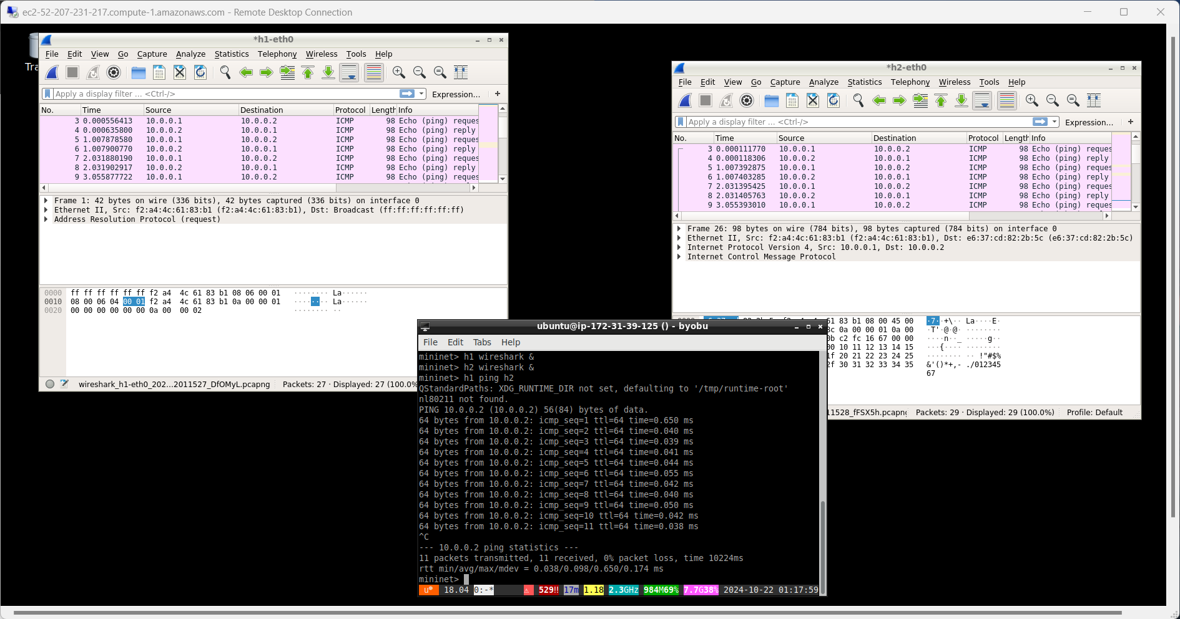
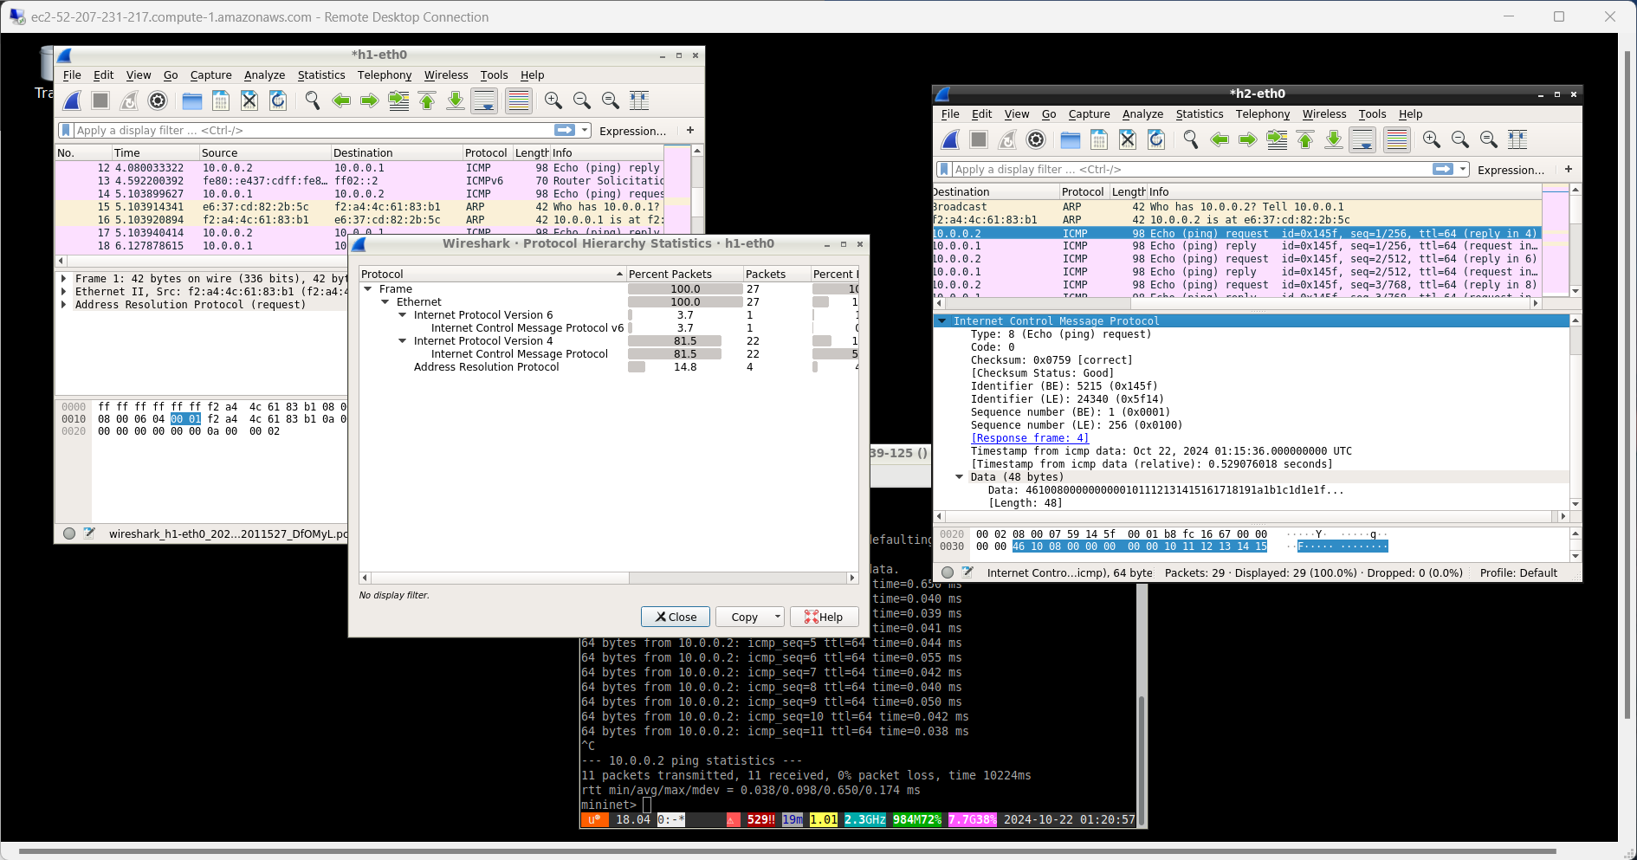
- Lab end
  - Stopped and terminated the instance
  - Deleted the custom security group
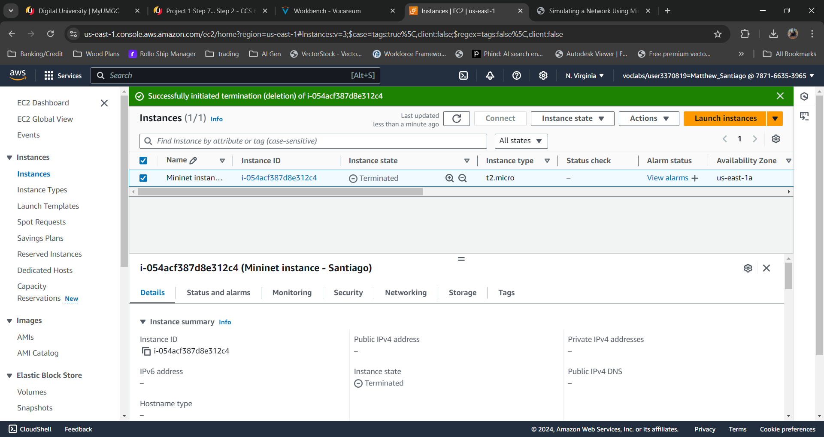

Questions:
What are the IP addresses of both hosts?
- H1 = 10.0.0.1
- H2 = 10.0.0.2

What protocol packets are captured in this communication? What are these protocols? Research if needed.
- Captured Protocols: ICMP, ICMPv6, ARP
- ICMP “is a protocol that devices within a network use to communicate problems with data transmission.” (Fortinet, n.d.)
- ICMPv6 “is used by IPv6 nodes to report errors encountered in processing packets, and to perform other internet-layer functions, such as diagnostics (ICMPv6 "ping").” (wireshark, n.d.)
- ARP “is a protocol or procedure that connects an ever-changing Internet Protocol (IP) address to a fixed physical machine address, also known as a media access control (MAC) address, in a local-area network (LAN).” (Fortinet, n.d.)
What values are captured in the Wireshark Info column?
- Echo (ping) request
- Echo (ping) reply

References
Fortinet. (n.d.). What Is Address Resolution Protocol (ARP)? From Fortinet: https://www.fortinet.com/resources/cyberglossary/what-is-arp
Fortinet. (n.d.). What Is Internet Control Message Protocol (ICMP)? From Fortinet: https://www.fortinet.com/resources/cyberglossary/internet-control-message-protocol-icmp
wireshark. (n.d.). Internet Control Message Protocol version 6 (ICMPv6). From wireshark: https://wiki.wireshark.org/ICMPv6

