Project 2: Technical Report

Matthew Santiago
University of Maryland Global Campus
CCS 625 Network Engineering
Andrzej (Andrew) Hoppe
November 18, 2024

Introduction
As BallotOnline continues to grow and expand its secure online voting systems to a wider market around the world, our cloud infrastructure will need to be able to quickly expand to support our operations. There are several options to provision our cloud infrastructure through Amazon Web Services (AWS), like using the dashboard with wizards and or utilizing Infrastructure as a Code (IaC). Manually setting up different resources through the dashboard can be done but it is “time-consuming and prone to error—especially when you manage applications at scale” (Amazon Web Services, n.d.). In an effort to reduce time waste, increase deployment speed and reduce errors, utilizing IaC provides “the ability to provision and support [our] computing infrastructure using code instead of manual processes” (Amazon Web Services, n.d.). Using IaC, will help BallotOnline “control costs, reduce risks, and respond with speed to new business opportunities” (Amazon Web Services, n.d.). This report will look at how Infrastructure as a Code (IaC) can help improve BallotOnline’s cloud infrastructure through exploring AWS Virtual Private Cloud (VPC), command line interfaces, declarative resources, and cloud API’s.
Networking in the Cloud
In order to continue to discuss IaC, we need to talk about networking within the cloud, specifically, AWS VPC and other associated networking services. An Amazon VPC is “virtual network closely resembles a traditional network that you'd operate in your own data center, with the benefits of using the scalable infrastructure of AWS” (Amazon Web Services, 2024). In easier to understand terms, the AWS VPC is the cloud version of a local area network or private network, where internal resources can be secured, accessed and managed. Within the VPC we can “specify an IP address range for the VPC, add subnets, add gateways, and associate security groups” (Amazon Web Services, 2024). VPC can also be spread across a region while at the same time different subnets created and placed in different availability zones within that region. This example of a VPC leads to resource redundancy and low latency ensuring our resources will continue to service our customers in that region even if there is problems in one availability zone the others will be able to support operations.
Within the VPC, there are other networking components are needed to properly configure the VPC and they are subnets, security groups and route tables. First, subnets are created to split up the VPC into small sections that will help organize and control the resources. AWS states subnets are “a range of IP addresses in your VPC. You can create AWS resources, such as EC2 instances, in specific subnets” (Amazon Web Services, n.d.). Within AWS, subnets can be put into different categories for different uses: Public, Private, VPN-Only, Isolated subnets (Amazon Web Services, n.d.). Second, security groups act like firewalls which control traffic going in and out of network. AWS defines security groups as “virtual firewalls, controlling the traffic for one or more stacks (an instance or a set of instances)” (Amazon Web Services, n.d.). Third, routing tables which are used to move traffic into and out of the network certain ways to keep efficient network traffic flow. AWS defines routing tables as “A route table contains a set of rules, called routes that determine where network traffic from your subnet or gateway is directed” (Amazon Web Services, n.d.).
Moving forward, BallotOnline can use AWS VPC with regions and availability zones to build a reliable cloud deployment due to each region being completely independent while each Availability Zone is isolated, but the Availability Zones in a region are connected through low-latency links (Amazon Web Services, n.d.). Deploying BallotOnline services across regions and availability zones will ensure high availability and defend against failures or disasters. Through the use of security groups BallotOnline can setup allow or deny rules for various traffic types to increase security on network traffic. Also with the use of routing tables, BallotOnline can setup efficient traffic flow that routes traffic to devices that monitor the packets before entering or leaving the network, which increases the security posture of the cloud deployment.
Cloud Command Line Interfaces
Cloud Command Line Interfaces (CLIs) give administrators the ability to interact with cloud services directly through a command line interface, like AWS CloudShell. Amazon defines CLI as “an open source tool that enables you to interact with AWS services using commands in your command-line shell” (Amazon Web Services, 2024). CLIs allow users to automate tasks like resource provisioning and cloud management. For example, the AWS CLI documentation lists and provides many examples of command line functions, options and variables (Amazon Web Services, 2024) that can be used for scripting and automating processes to reduce manual setup and management of the cloud infrastructure. The CLI enables administrators to develop repeatable templates and processes to streamline employee workflow and reduce errors while deploying and managing cloud infrastructure.
As for BallotOnline, command line interfaces can have a positive impact on provisioning and maintenance in cloud deployments. Using scripts through the CLI by BallotOnline employees can reduce errors and manual changes. For example, one well written script can be run by an employee that deploys VPCs in several regions that are configured and provisioned with EC2, subnets, security groups etc. CLI’s also are useful when BallotOnline will need to scale up its resources because operations are increasing. AWS states a CLI script can “stop the instance if it's running, changes the instance type, and then, if requested, restarts the instance” (Amazon Web Services, 2024). Lastly, BallotOnline can use the CLI for auditing the network to ensure the network complies with standards. In the AWS CLI, “Audit Manager is a service that provides automated evidence collection… use it to assess the effectiveness of your controls, manage risk, and simplify compliance” (AWS CLI Reference).
Declarative Resource Definitions
Declarative Infrastructure as Code (IaC) is a method of provisioning a cloud deployment by stating the end state and letting the system interpret and handle the steps in between. Declarative IaC is defined as “a style of coding where developers express computation logic without the need to program the control flow of individual processes” (TechTarget, 2022). Within AWS, CloudFormation is a service that provides declarative IaC for Amazon Web Services. “You don't need to individually create and configure AWS resources and figure out what's dependent on what; CloudFormation handles that” (Amazon Web Services). Cloudformation uses “A template describes all your resources and their properties” (Amazon Web Services) then cloudformation provisions everything else for you. Using declarative IaC provides simplification of infrastructure management, quick replication of infrastructure, and a way to easily track changes to the infrastructure (Amazon Web Services). Due to the coding of the template, Declarative IaC makes sure that deployments are consistent across VPCs which will reduce the chances of mistakes and inconsistencies.
Declarative programming Infrastructure as Code within AWS CloudFormation will provide BallotOnline with a method for implementing cloud deployments. By using declarative templates BallonOnline can monitor changes over time to improve deployments. This method also makes sure that each time the template is used it reduces or eliminates mistakes and prevents configuration drift (Amazon Web Services, n.d.). Also using the declarative templates allows for scalability that gives BallotOnline the ability to provision and manage infrastructure that adapts to changing requirements (Amazon Web Services, n.d.). Finally, declarative programming will allow BallotOnline to achieve a reliable and flexible cloud environment. By using AWS CloudFormation, BallotOnline can reduce mistakes enhance consistency and streamline infrastructure deployments allowing BallotOnline to focus on providing outstanding services to its customers.
Cloud APIs
Cloud APIs offer a way for applications to talk with cloud services in a standard programmable way. Cloud APIs are defined as “software programs that transfer data between cloud computing services, or between cloud services and on-premise applications” (Cloudflare, n.d.). The APIs allow developers to program processes like setting up and managing resources through commands rather than relying on manual procedures. Cloudflare states APIs allow users to “simplify routine tasks, for example: setting up and managing virtual machines, networks and storage” (Cloudflare, n.d.). An important aspect of cloud APIs is that APIs help reduce mistakes made by helping automating different tasks. AWS explains that, “the API handles the actual calls to the underlying web services to perform the requested changes” (Amazon Web Services, 2024). Due to the API handling the actual calls to services, this reduces errors in scripts and leads to less logic programming, which speeds up creation of deployment scripts and deployments of cloud infrastructure. Cloud APIs enable the flexibility and scalability to cloud infrastructure management.
BallotOnline can utilize cloud APIs to improve the efficiency and reliability of its cloud infrastructure. For example, Boto3 which is AWS’s Python SDK that “provides a Python API for AWS infrastructure services” (Amazon Web Services, n.d.). It offers “high level, object oriented interface… generated from these shared JSON files” (Amazon Web Services, 2024) for creating a consistent API for various services. By creating JSON files in Boto3 template BallotOnline employees will be able to automate most tasks and develop BallotOnline network templates to quickly deploy and provision networks as needed. This type of network management reduces the need for hands on tasks but will keep constancy between all employees. BallotOnline could develop custom templates for various situations or needs. For example, a script can be written to scale up resources during high demand elections and or when the elections are done another script could be used to shut down the resources. Using the cloud API in conjunction with scripting languages, BallotOnline will be able to quickly respond to demand on the system and maintain consistent deployments through our cloud infrastructure.
Conclusion
In conclusion, having BallotOnline use Infrastructure as Code (IAC) is essential to move the company into the global market and expand our cloud infrastructure to support elections worldwide. BallotOnline’s adoption of IaC will enable employees the ability to automate the management of cloud resources removing tasks that are time consuming and reduce errors. Using the different services provided by AWS, like AWS Virtual Cloud (VPC), AWS CloudFormation, AWS CloudShell, and AWS Python SDK, BallotOnline can create a dependable and scalable environment to support global elections.
AWS Virtual Private Cloud creates a secure network that will look like our current data center but enables BallotOnline to scale our resources quickly not like our current data center where it can take months. Within AWS VPC, the security groups, subnets, and routing tables will improve security and control traffic flow. Using regions and availability zones allows BallotOnline to maintain high availability and reduce downtime, which is vital during elections. AWS CloudFormation will allow BallotOnline to use declarative IaC templates that will streamline deployments. They support scaling and change tracking to improve system reliability and efficiency.
Lastly, AWS CloudShell and cloud APIs like AWS Boto3 enable the automation of tasks. They can be used to manage and adjust network resources for peak election times and also for scaling back resources after elections to lower cost. IaC supports BallotOnline in becoming the global leader of voting solutions worldwide by staying ahead of voting demands. Implementation of these tools BallotOnline can focus on offering secure and accessible online voting while having the ability to deploy and maintain a scalable and robust infrastructure.

References
Amazon Web Services. (2024). AWS Command Line Interface. From Amazon Web Services: https://docs.aws.amazon.com/pdfs/cli/latest/userguide/aws-cli.pdf#cli-chap-welcome
Amazon Web Services. (2024). Boto3. From Boto3 Documentation: https://boto3.amazonaws.com/v1/documentation/api/latest/guide/new.html
Amazon Web Services. (2024). Change an Amazon EC2 instance type with a bash script in the AWS CLI. From Amazon Web Services: https://docs.aws.amazon.com/cli/latest/userguide/cli-services-ec2-instance-type-script.html
Amazon Web Services. (2024). Cloud Control API User Guide. From Amazon Web Services: https://docs.aws.amazon.com/pdfs/cloudcontrolapi/latest/userguide/cloudapi-service.pdf#what-is-cloudcontrolapi
Amazon Web Services. (2024). What is Amazon VPC? From Amazon Web Services: https://docs.aws.amazon.com/pdfs/vpc/latest/userguide/vpc-ug.pdf#what-is-amazon-vpc
Amazon Web Services. (n.d.). AWS SDK for Python (Boto3) Documentation. From Amazon Web Services: https://docs.aws.amazon.com/pythonsdk/
Amazon Web Services. (n.d.). Configure route tables. From Amazon Web Services: https://docs.aws.amazon.com/vpc/latest/userguide/VPC_Route_Tables.html
Amazon Web Services. (n.d.). Regions, Availability Zones, and Local Zones. From Amazon Web Services: https://docs.aws.amazon.com/AmazonRDS/latest/UserGuide/Concepts.RegionsAndAvailabilityZones.html
Amazon Web Services. (n.d.). Security groups. From Amazon Web Services: https://docs.aws.amazon.com/managedservices/latest/userguide/about-security-groups.html
Amazon Web Services. (n.d.). Subnets for your VPC. From Amazon Web Services: https://docs.aws.amazon.com/vpc/latest/userguide/configure-subnets.html
Amazon Web Services. (n.d.). What is AWS CloudFormation? From Amazon Web Services User Guide: https://docs.aws.amazon.com/AWSCloudFormation/latest/UserGuide/Welcome.html
Amazon Web Services. (n.d.). What is Infrastructure as Code? From Amazon Web Services: https://aws.amazon.com/what-is/iac/
AWS CLI Reference. (n.d.). auditmanager. From AWS CLI Reference: https://docs.aws.amazon.com/cli/latest/reference/auditmanager/
Cloudflare. (n.d.). What is a cloud API? From Cloudflare: https://www.cloudflare.com/learning/security/api/what-is-a-cloud-api/
TechTarget. (2022, March 21). What is declarative programming? From TechTarget: https://www.techtarget.com/searchapparchitecture/tip/The-basics-of-working-with-declarative-programming-languages#

Lab 1:
Lab Summary: In this lab I had to configure an AWS Virtual Private Cloud (VPC), Internet Gateway and attach the internet gateway to the VPC. During the process I checked the command help pages to understand how to properly execute the command. I also ran commands to add tags to the created VPC and internet gateway. When finished detached and deleted the internet gateway and VPC.

Steps Taken:
- Access CloudShell by logining into AWS Academy Learner Lab
- Used the cloudshell command line and viewed the help page for commands
  - aws help
  - aws ec2 help
- Created a VPC for 10.0.0.0/16
  - aws ec2 create-vpc --cidr-block 10.0.0.0/16
  - Received this output:
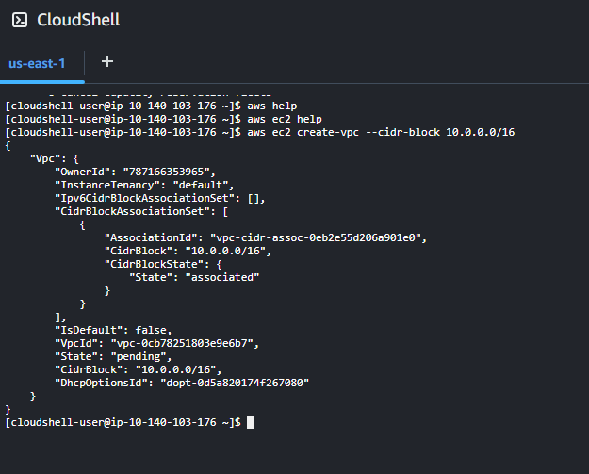
  - Added a tag to the VPC
    - aws ec2 create-tags --resources vpc-0cb78251803e9e6b7 --tags "Key=Name, Value=CLI VPC"
  - Verified the VPC was created in the VPC dashboard
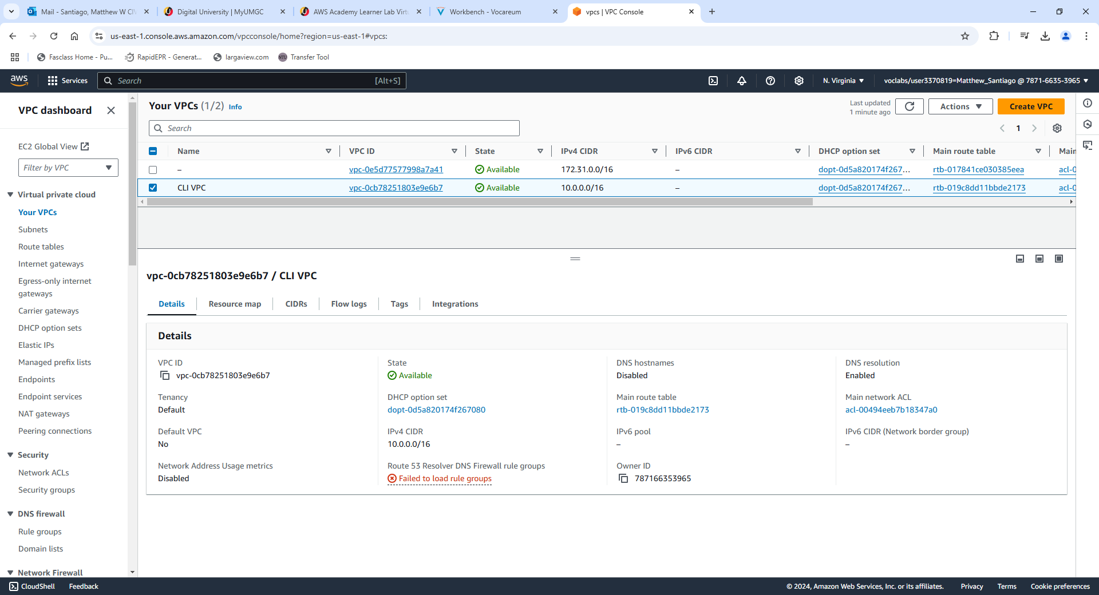
- Created an Internet Gateway
  - aws ec2 create-internet-gateway
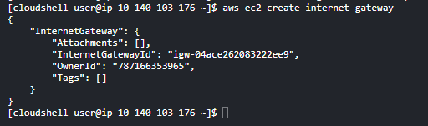
  - Added a tag to the Internet Gateway
    - aws ec2 create-tags --resources igw-04ace262083222ee9 --tags "Key=Name, Value=CLI IG"
  - Verified the Internet Gateway was created in the Dashboard.
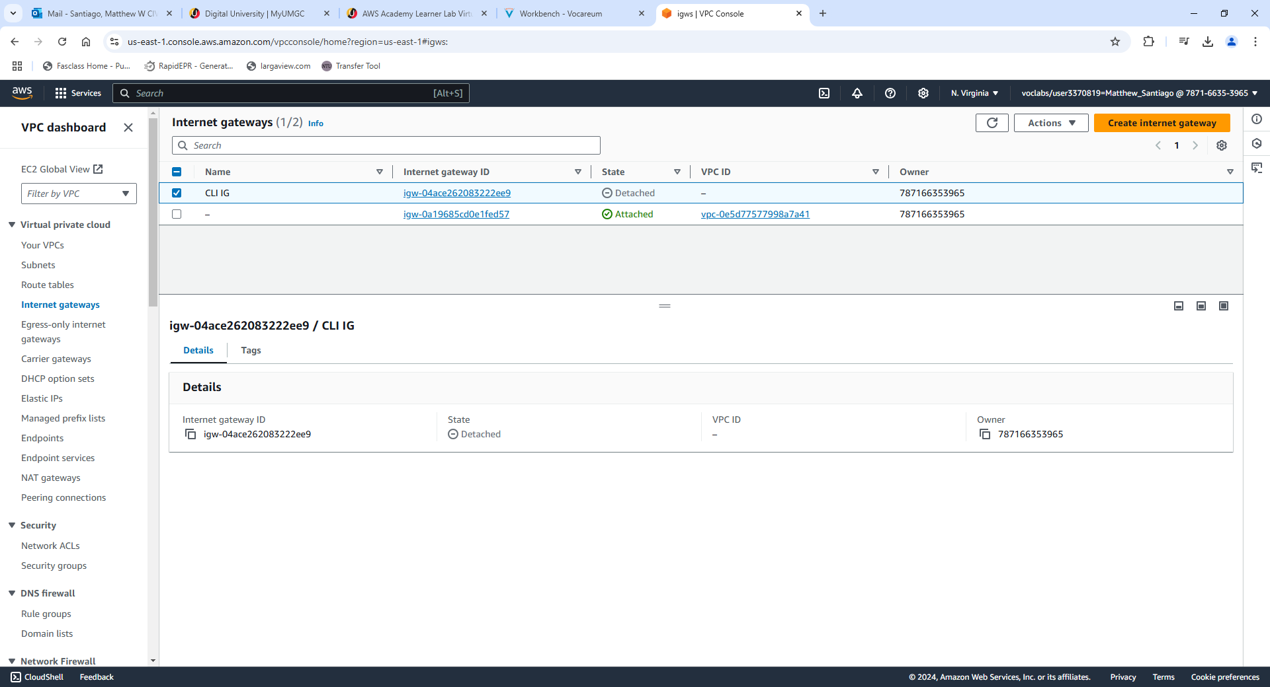
  - Attached the internet gateway to the VPC
    - aws ec2 attach-internet-gateway --internet-gateway-id igw-04ace262083222ee9 --vpc-id vpc-0cb78251803e9e6b7
  - Confirmed the internet gateway was attached to the VPC in the dashboard
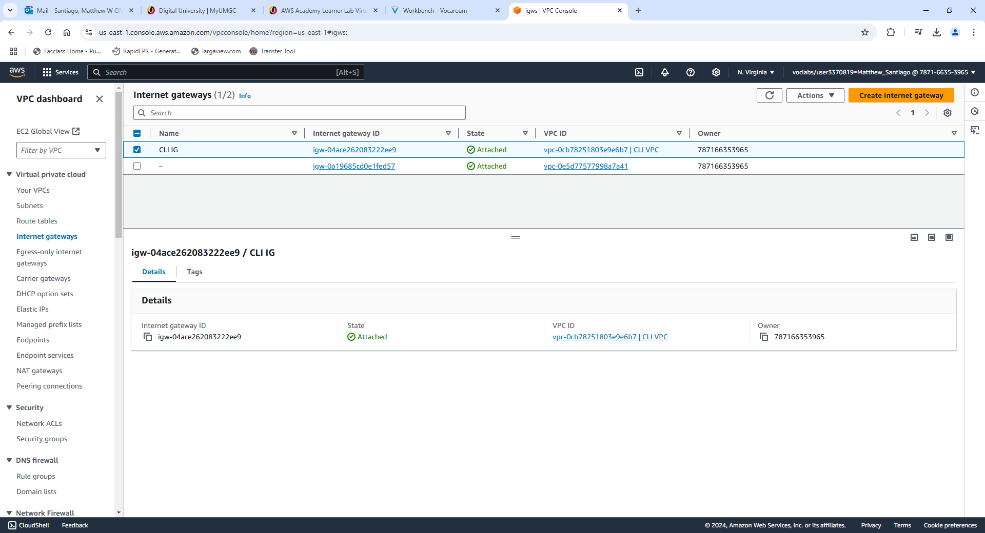
  - Detached the Internet Gateway from the VPC and deleted both the Internet Gateway and VPC.

CLI use for BallotOnline
After testing the AWS CLI, it proved to be useful in many ways for BallotOnline. The AWS CLI "enables you to interact with AWS services using commands in your command-line shell" (Amazon Web Services, n.d.). The use of the CLI will provide BallotOnline automation, standardization, and quick disaster recovery. Scripts help with automation and standardization by completing “task-oriented processes across all types of computing environments” (NinjaOne, 2024). Scripting deployment and management will “reduce redundancy in execution, standardize everyday tasks, cut costs, better utilize human resources, and streamline processes” (NinjaOne, 2024). Since using the CLI and scripts standardize our commands and make sure deployments are error free and quickly deployable, if a disaster does occur within the AWS network, getting the BallotOnline network back up quickly is possible. Using the AWS CLI will make BallotOnline infrastructure more reliable and easily managed.

References
Amazon Web Services. (n.d.). What is the AWS Command Line Interface? From AWS: https://docs.aws.amazon.com/cli/latest/userguide/cli-chap-welcome.html
NinjaOne. (2024, March 24). IT Automation Scripts: Definition and Overview. From NinjaOne: https://www.ninjaone.com/blog/it-automation-scripts-definition-and-overview/

Lab2:
Steps Taken:
- Login to CloudFormation Dashboard and Designer Tool
  - Access CloudFormation by logging into AWS Academy Learner Lab and then launch the Designer Tool from inside cloudformation.
- Design a Stack With a VPC and Internet Gateway, and Attach the Gateway to the VPC
  - Dragged a VPC resource into the designer tool.
    - Edit the template in properties to add a cidr block.
    - Edit the json to add Tags for VPC name: CF VPC
  - Dragged Internet Gateway into the designer tool
    - Linked the internet gateway to be dependent on the VPC and attached the Internet gateway to the VPC, by dragging blue and brown dots to the VPC from Internet gateway.
    - Edited the JSON to add tags on the internet gateway, for name CF IG.
  - Validated the template and saved as CCA625-P2-mws.template
{
"AWSTemplateFormatVersion": "2010-09-09",
"Metadata": {
"AWS::CloudFormation::Designer": {
"2a7d1527-7aa7-40c1-8ef5-857ccbf939ab": {
"size": {
"width": 300,
"height": 270
},
"position": {
"x": 118,
"y": -2
},
"z": 0,
"embeds": []
},
"f812dadd-2f81-401c-89c9-9bd71b052237": {
"size": {
"width": 60,
"height": 60
},
"position": {
"x": 720,
"y": 30
},
"z": 0,
"embeds": []
},
"28dbb02a-2ad1-4229-b5d5-23f97c2f2189": {
"source": {
"id": "f812dadd-2f81-401c-89c9-9bd71b052237"
},
"target": {
"id": "2a7d1527-7aa7-40c1-8ef5-857ccbf939ab"
},
"z": 0
},
"91d96eee-278c-4664-9721-92f64e8101bd": {
"source": {
"id": "f812dadd-2f81-401c-89c9-9bd71b052237",
"selector": "g:nth-child(1) g:nth-child(4) g:nth-child(2) circle:nth-child(1) ",
"port": "AWS::DependencyLink-*"
},
"target": {
"id": "2a7d1527-7aa7-40c1-8ef5-857ccbf939ab"
},
"z": 2
},
"e0417b96-81d7-40ef-b726-bb8639922178": {
"source": {
"id": "f812dadd-2f81-401c-89c9-9bd71b052237",
"selector": "g:nth-child(1) g:nth-child(4) g:nth-child(2) circle:nth-child(1) ",
"port": "AWS::DependencyLink-*"
},
"target": {
"x": 160,
"y": -10
},
"z": 2
}
}
},
"Resources": {
"EC2VPC53T0M": {
"Type": "AWS::EC2::VPC",
"Properties": {
"CidrBlock": "10.0.0.0/16",
"Tags": [
{
"Key": "Name",
"Value": "CF VPC"
}
]
},
"Metadata": {
"AWS::CloudFormation::Designer": {
"id": "2a7d1527-7aa7-40c1-8ef5-857ccbf939ab"
}
}
},
"EC2IG439C9": {
"Type": "AWS::EC2::InternetGateway",
"Properties": {
"Tags": [
{
"Key": "Name",
"Value": "CF IG"
}
]
},
"Metadata": {
"AWS::CloudFormation::Designer": {
"id": "f812dadd-2f81-401c-89c9-9bd71b052237"
}
}
},
"EC2VPCG27CIT": {
"Type": "AWS::EC2::VPCGatewayAttachment",
"Properties": {
"InternetGatewayId": {
"Ref": "EC2IG439C9"
},
"VpcId": {
"Ref": "EC2VPC53T0M"
}
},
"Metadata": {
"AWS::CloudFormation::Designer": {
"id": "28dbb02a-2ad1-4229-b5d5-23f97c2f2189"
}
}
}
}
}
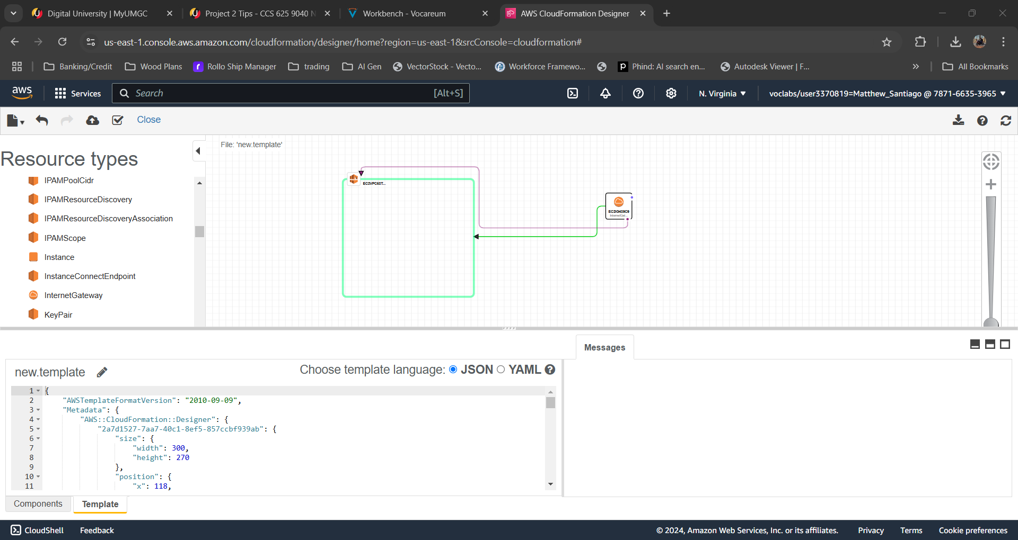

- Create the Stack and Verify the Configuration
  - Click create stack and upload the saved template to the create stack wizard.
  - Named stack CCA625-P2-MWS
  - Once finished with create stack wizard, went to the cloudformation dashboard to check status of creation. Received CREATE_COMPLETE.
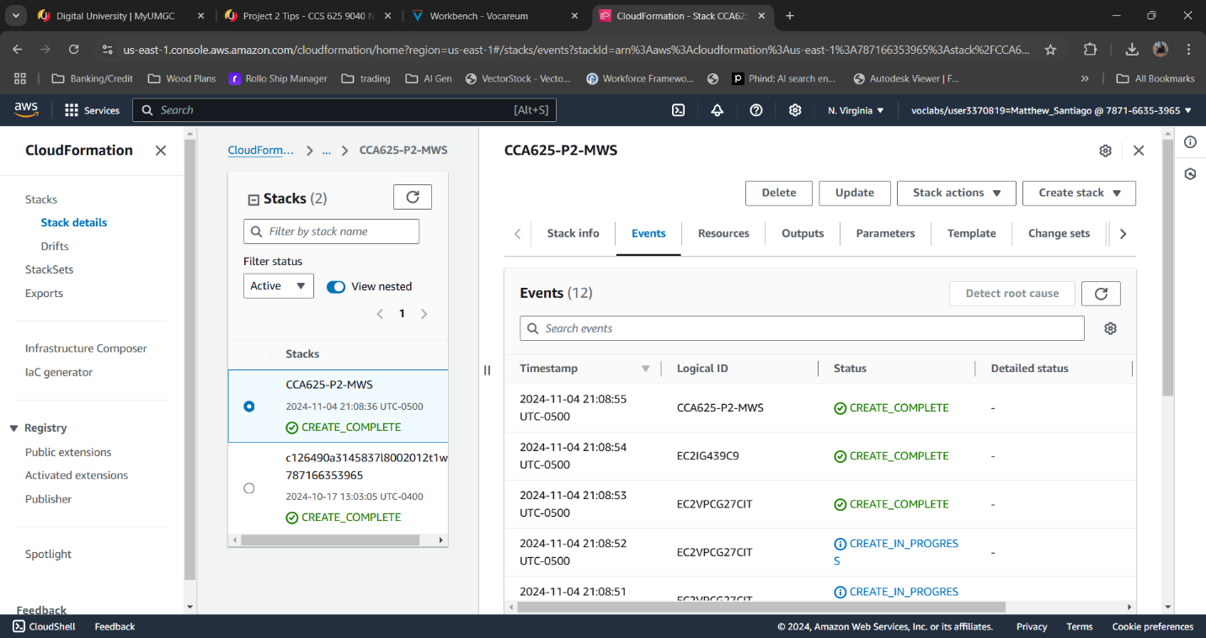
  - Verified stack was created in AWS VPC Service

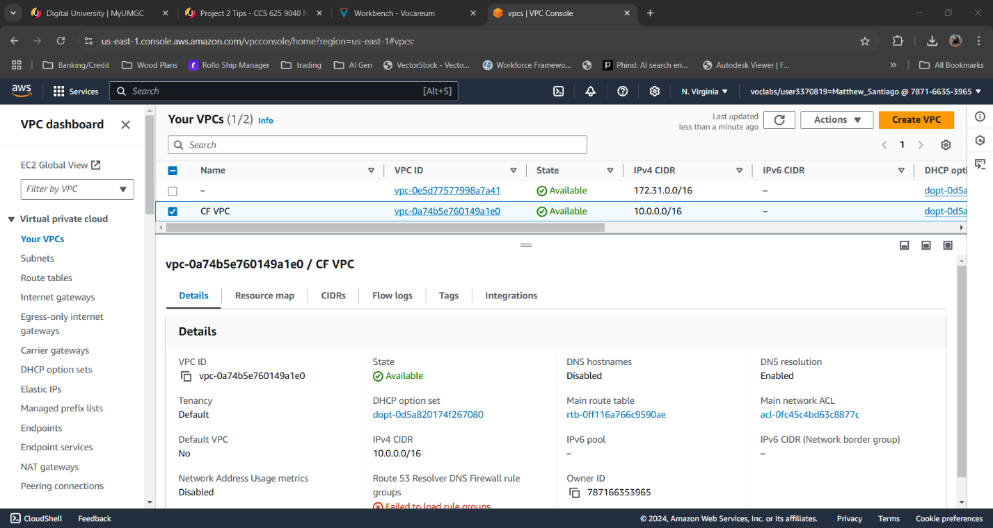
  - Verified internet gateway was created
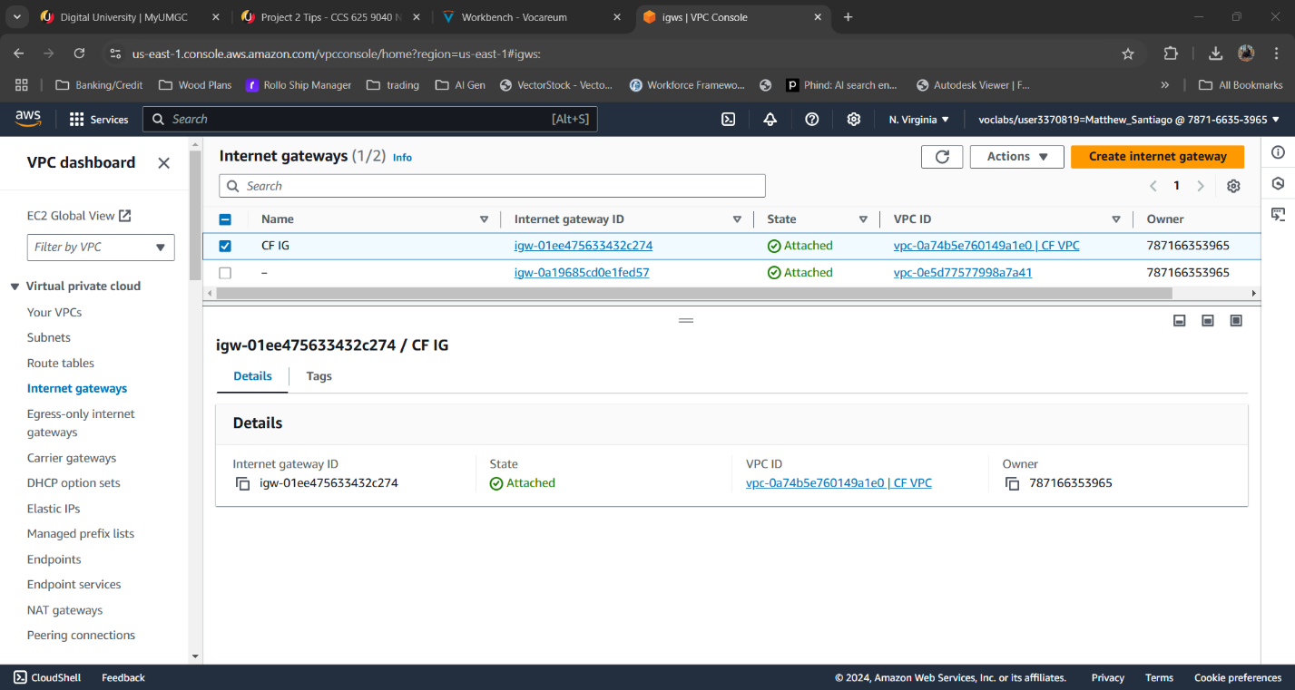

  - Terminated and deleted all resources.

- Declarative IaC for BallotOnline
Declarative programming Infrastructure as Code within AWS CloudFormation will provide BallotOnline with a method for implementing cloud deployments. Declarative allows BallotOnline to define infrastructure through templates that describe the configuration of the device. It allows the system to figure out the steps needed for deployment (TechTarget, 2022). This provides automatic provisioning and infrastructure management (Amazon Web Services, n.d.). By using declarative templates BallonOnline can monitor changes over time to improve deployments. This method also makes sure that each time the template is used it reduces or eliminates mistakes and prevents configuration drift (Amazon Web Services, n.d.). Also using the declarative templates allows for scalability that gives BallotOnline the ability to provision and manage infrastructure that adapts to changing requirements (Amazon Web Services, n.d.). Finally, declarative programming will allow BallotOnline to achieve a reliable and flexible cloud environment.

References
Amazon Web Services. (n.d.). What is Infrastructure as Code? From Amazon Web Services: https://aws.amazon.com/what-is/iac/
TechTarget. (2022, March 21). What is declarative programming? From TechTarget: https://www.techtarget.com/searchapparchitecture/tip/The-basics-of-working-with-declarative-programming-languages#

Lab 3:
Steps Taken:
- Login
  - Login to Aws and access Cloudshell
- Analyze a Python Script, Provisioning an EC2 Instance
  - Download the create_instance.py and update the script by adding keypair_name = 'CCA625P1-key'
  - Uploaded the script to cloudshell
  - Showed the script on cloudshell by using command “more Create_Instance.py”
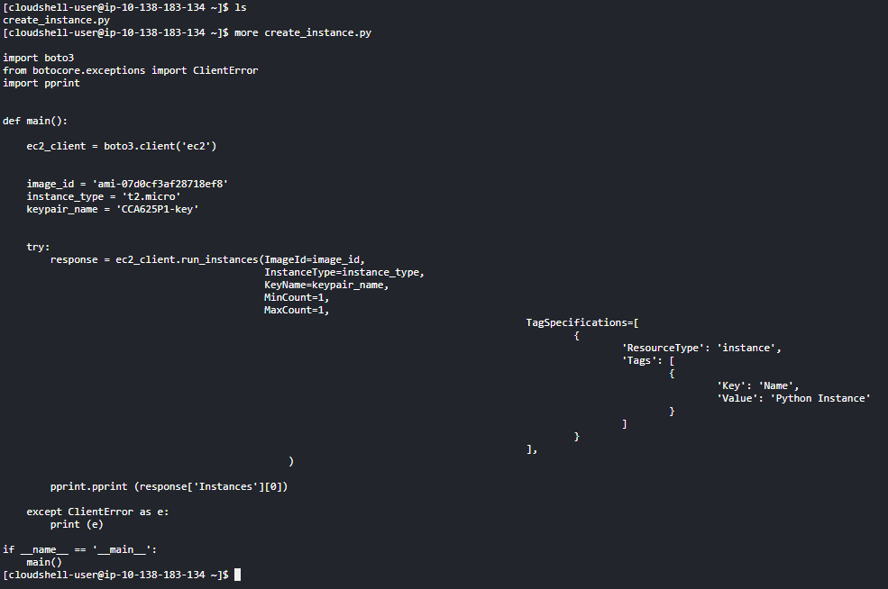
  - Analyzed the script
- Run a Python Script
  - Ran the script with this command “python create_instance.py”
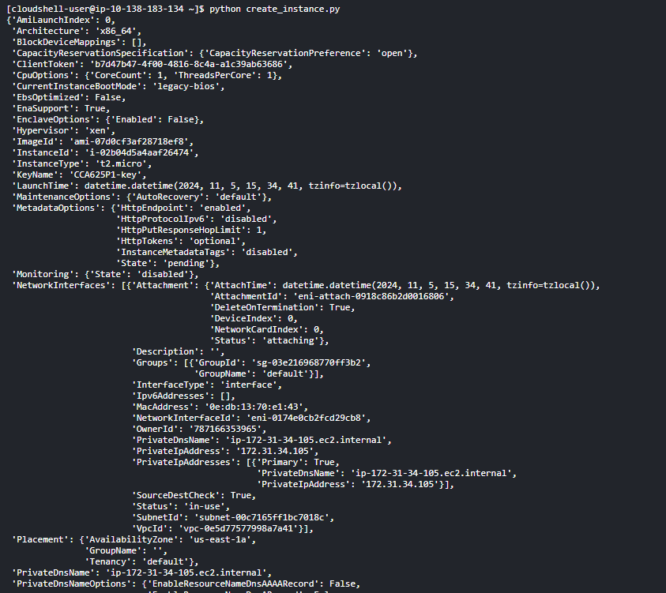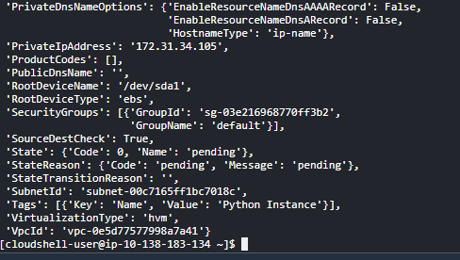
- Verify the Instance Has Been Provisioned
  - Went to AWS dashboard then accessed EC2 dashboard. Once in the dashboard looked in the Instances section to verify the instance was made.
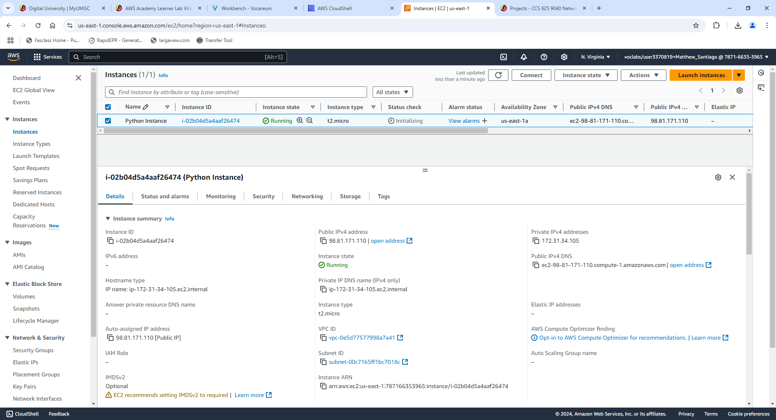
- Cloud APIs for BallotOnline
Using cloud APIs has the ability to improve BallotOnline’s deployment and management of the cloud infrastructure by using standard procedure calls. Cloud APIs like AWS Cloud Control API provide “a consistent way of accessing and provisioning those resources” (Amazon Web Services, 2024). When using APIs, BallotOnline can simplify routine tasks, for example: setting up and managing virtual machines, networks and storage (Cloudflare, n.d.). APIs could also help reduce the need for user interaction which will reduce errors from occurring. Once a template is made and the user initiates the template to be used the “API handles the actual calls to the underlying web services to perform the requested changes” (Amazon Web Services, 2024). Cloud APIs can improve automation and consistency for BallotOnline’s cloud deployment.

References
Amazon Web Services. (2024). Cloud Control API User Guide. From Amazon Web Services: https://docs.aws.amazon.com/pdfs/cloudcontrolapi/latest/userguide/cloudapi-service.pdf#what-is-cloudcontrolapi
Cloudflare. (n.d.). What is a cloud API? From Cloudflare: https://www.cloudflare.com/learning/security/api/what-is-a-cloud-api/

