Project 3: Final Report

Matthew Santiago
University of Maryland Global Campus
CCS 625 Network Engineering
Andrzej (Andrew) Hoppe
December 9, 2024

Executive Summary
In this project, the goal was to look at different aspects of cloud technology to build a proof of concept for migrating BallotOnline’s website to Amazon Web Service’s (AWS) cloud. This migration of our website into the AWS environment was to test how the cloud will enhance BallotOnline’s infrastructure’s efficiency and reliability. When I shifted our services to the cloud, I was able to develop a strong and flexible cloud infrastructure that was able to meet our requirements and is able to adapt to future requirements. Using the AWS services I was able to develop a new infrastructure that is cost-effective, simple to manage and able to with stand unexpected errors.
The proof of concept infrastructure included some key AWS services, such as, Amazon EC2, Elastic Load Balancer, auto-scaling groups, and CloudWatch. The virtual machines deployed through Amazon EC2 and these instances were linked to the Elastic Load Balancer (ELB) for distributing the traffic equally among them. The auto scaling group determined when the cloud environment could automatically scale the number of servers up or down depending on the load or when an error occurred. In order to monitor the traffic and health of the cloud environment I used AWS CloudWatch. Through the combination of all these services we created a reliable cloud environment for BallotOnline.
In order to make the cloud environment resilient we used CloudWatch for monitoring, Elastic Load Balancer (ELB) for distributing the traffic equally, and auto-scaling for instance replacement. These services helped me make sure that when a lot of requests or errors occurred the infrastructure would be able to handle it. The simulations of the system outages indicated that the infrastructure was able to replace the unhealthy instances when needed, which kept the website available during the errors. For that reason, this project has shown that moving to cloud infrastructure can improve BallotOnline’s performance and reliability by providing a stable, adaptable, and secure environment.

Lab Results
Lab 1: Build AWS Migration Environment and Configure Web Services
Lab Summary: In this lab, we learned how to create security groups, autoscaling and load balanced network.

Steps Taken:
- Created a Security Group
  - Logged into AWS dashboard. Then proceeded to EC2 Dashboard
  - Created a security group named “BallotOnline Web Server security group” that has inbound rules set to SSH from My IP and HTTP protocol from Anywhere IP.

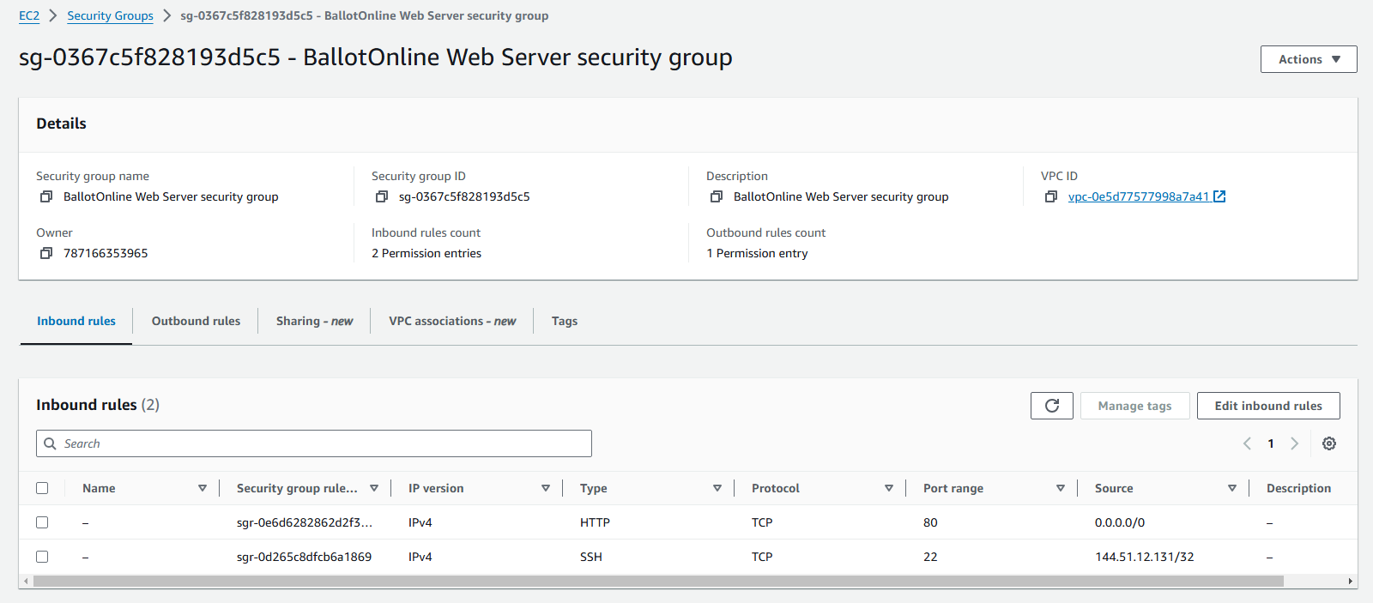
- Configure Launch Template
  - In the EC2 Dashboard went to Launch template. Started to create a new template. Named the template “CCS625LaunchTemplate”.
  - It was set up with autoscaling and Linux operating system, t2.micro instance type.
  - The login key pair set to “CCA625P1-key.pem” and the security group named “BallotOnline Web Server security group” that was created before was selected.
  - Added tags to the launch template named “BallotOnline PoC” then finished creating the template.
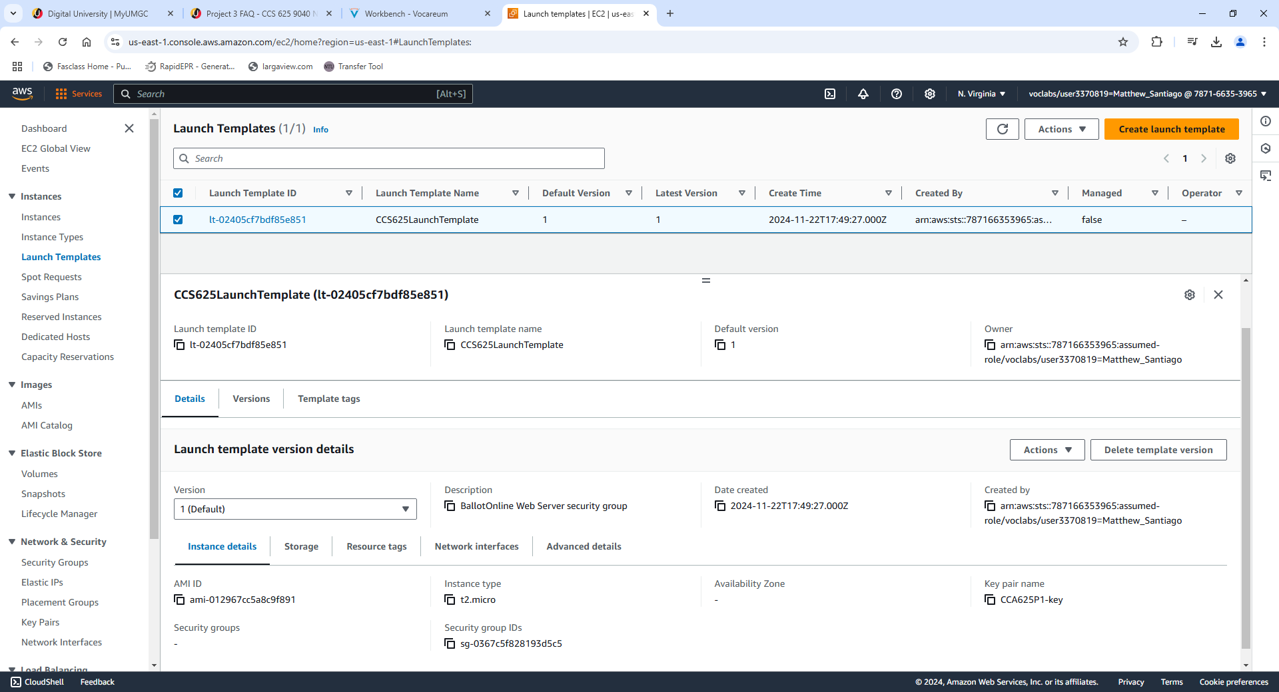

- Auto Scaling and Load Balancer
  - In auto scaling group section created a new auto scaling group named “CCS625 ASG”
  - Chose the us-east 1-a subnet then moved to create a new load balancer.
  - Chose application load balancer and named “CCS625LoadBalancer” and set up for internet facing. Chose us-east 1-a and us-east 1-c availability zones.
  - Created a target group named “CCS625TargetGroup”, enabled metric collection with clouthwatch and configured group size desired to 2 and minimum capacity to 1 and max capacity to 2.
  - Finished created and provisioned the instances.
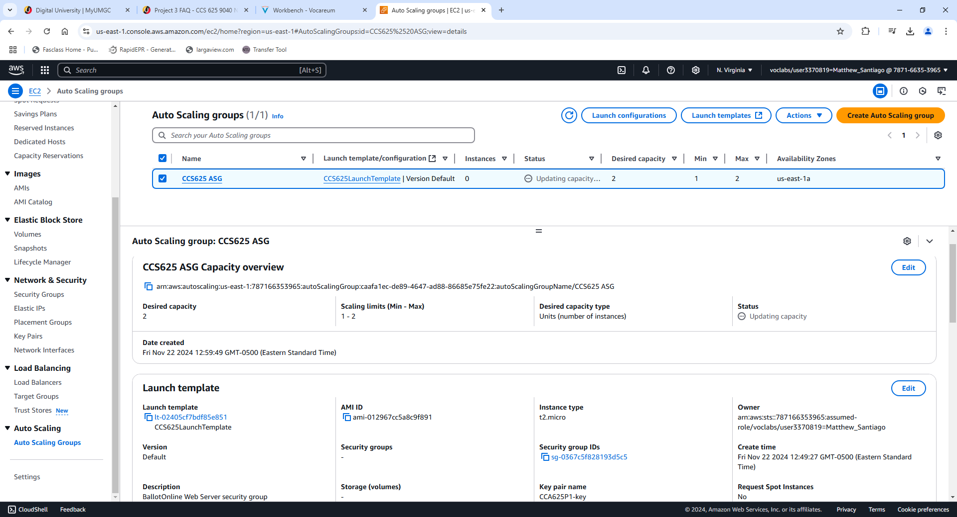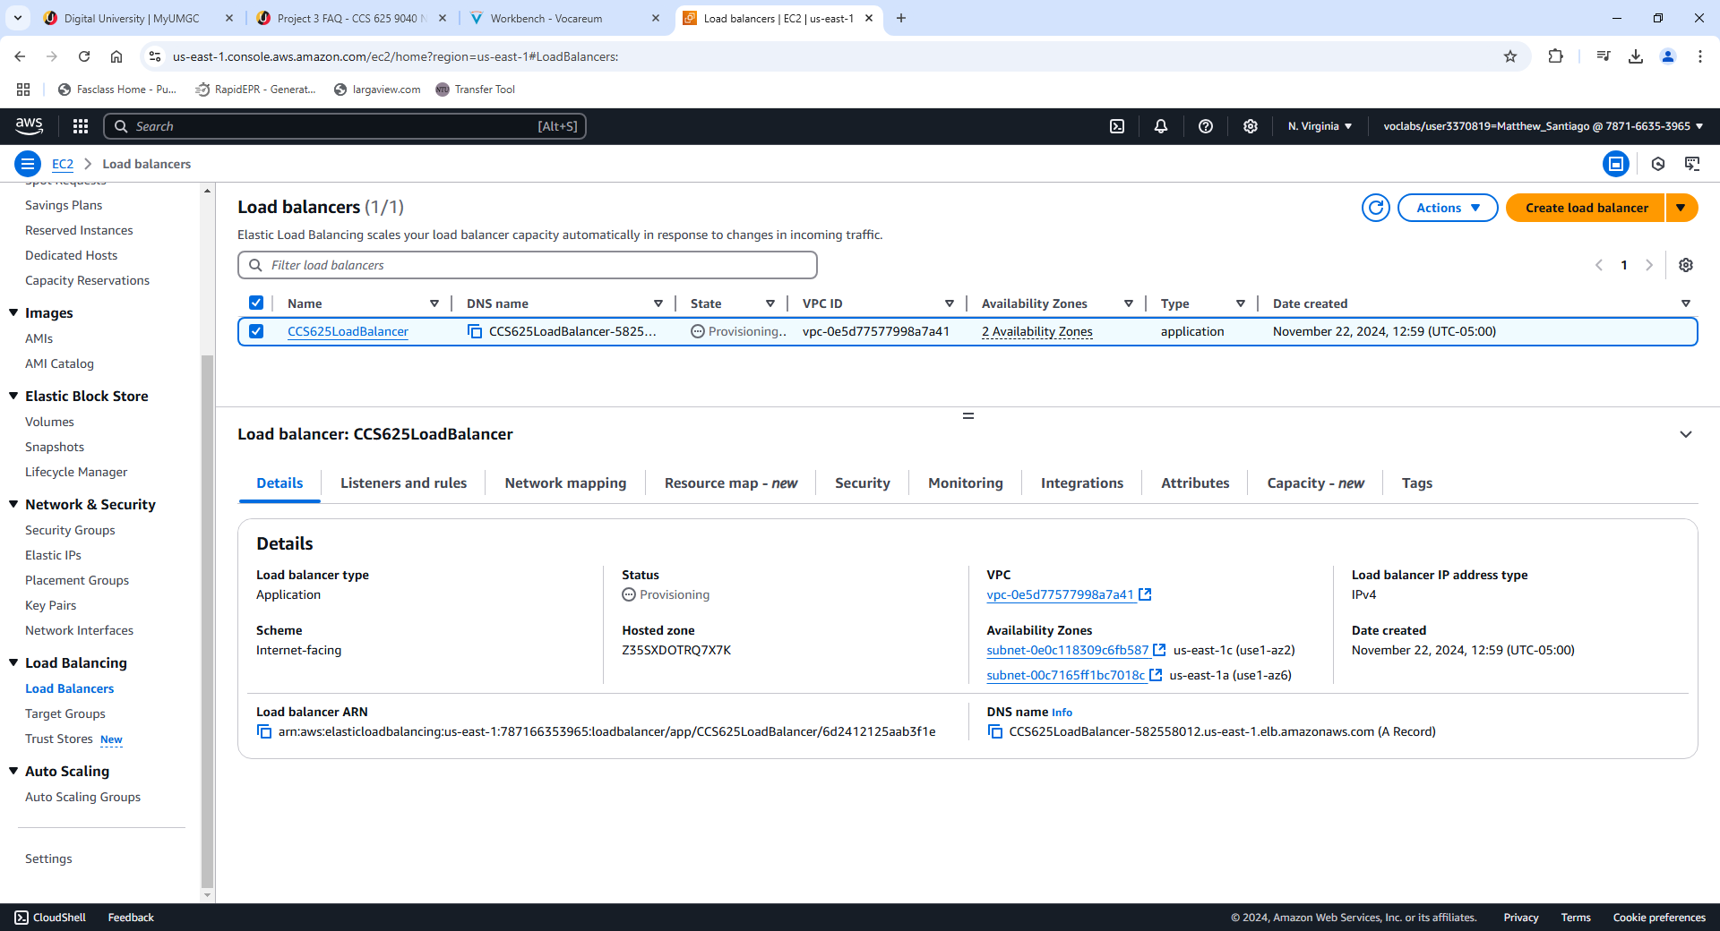
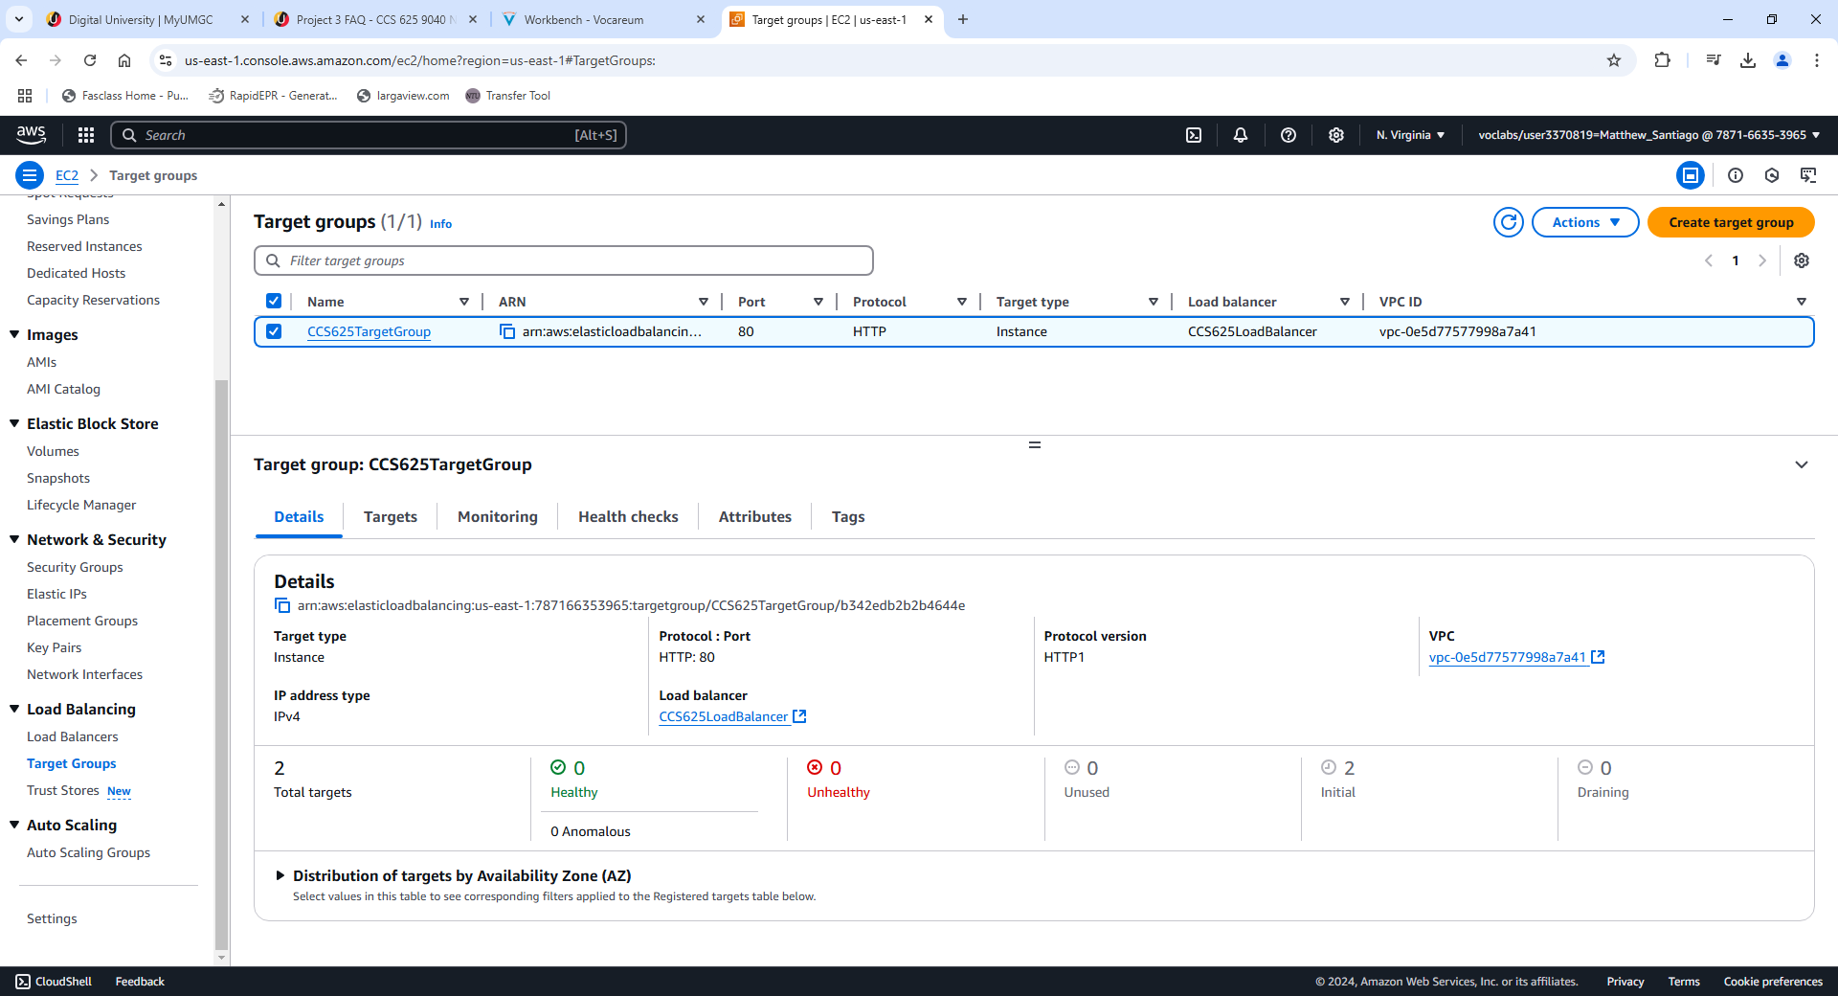

Load balancer DNS Name:
CCS625LoadBalancer-582558012.us-east-1.elb.amazonaws.com
BallotOnline New Web Service URL:
http://CCS625LoadBalancer-582558012.us-east-1.elb.amazonaws.com
Instance 1 IP: 54.204.51.10
Instance 2 IP: 54.165.203.159

Lessons learned:
Completing this lab taught me valuable lessons on creating a network for BallotOnline. Learning how to configure security groups to manage SSH and HTTP connections into our network will make sure we configure our network to be used by only authorized members of our team. More advanced security groups will ensure BallotOnline deployments are secure leading to secure elections. As the lab continued we covered launching templates which will help us quickly deploy instances when needed. Creating effective templates will reduce errors and lead to consistent deployments.
In this lab I also learned how to create and configure auto scaling groups and load balancers. Learning how to effectively configure these services, has taught me to create a network that will maintain high availability and be reliable for our customers and elections.

Lab 2:Test the Migration Environment
Lab Summary: In this lab, we learned how to deploy the BallotOnline website on Nginx while enabling load balancing and autoscaling.

Steps Taken:
- Connect to 1st instance via SSH on powershell
  - Used the CCA625P1-key.pem key and logged into the instance
  - Command run was: ssh -i "CCA625P1-key.pem" ec2-user@ec2-35-153-135-68.compute-1.amazonaws.com

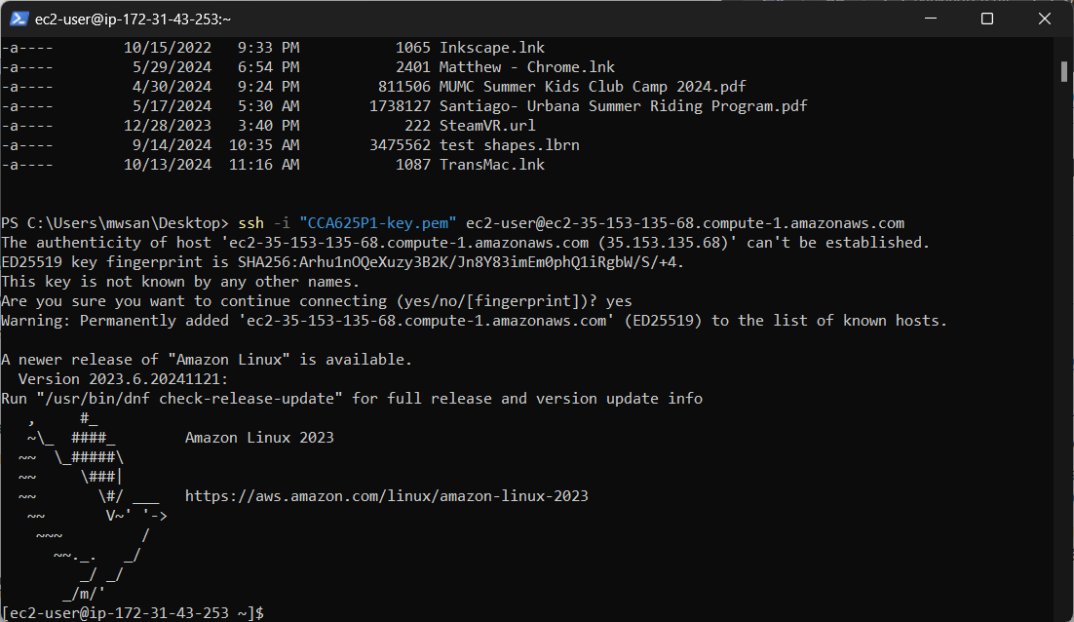
Screenshot of successful ssh login to instance 1.
- Update and install nginx
  - Once logged in ran “sudo yum update” to install security updates.
  - After the yum update was completed ran the “sudo yum install nginx” command to install nginx web server.
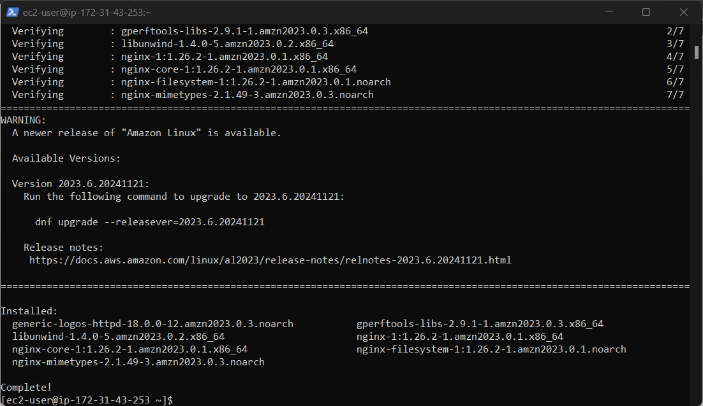Screenshot of successful install of nginx
- Create website files
  - Created the website data file by running this command: sudo mkdir –p /data/www
  - Changed directory into /data/www
  - Ran “sudo wget https://bizballotonline.azurewebsites.net/website.zip” to download the website zip file
  - Ran “sudo unzip website.zip -d /data/www/BallotOnline” to unzip and place the unzip files into ballotonline file in the website folder.
  - Checked to see if the data was copied over correctly by running: “cat /data/www/BallotOnline/index.html”
- Configure the nginx server
  - Changed the file permission of /data/www/BallotOnline/ to 755 by running the command sudo chmod -R 755 /data/www/BallotOnline/
  - Replaced the default nginx config file
    - Take the old config file and rename by “sudo mv /etc/nginx/nginx.conf /etc/nginx/nginx.conf.old”
    - Take the new config file and copy it to nginx directory “sudo cp /data/www/BallotOnline/nginx.conf /etc/nginx/”
    - Started nginx by running sudo nginx
- AMI, template, load balancer, and autoscaling
  - Went to the public IP for instance 1 and tested to see if the instance page was running.
  - Once verified went to ec2 dashboard and selected the instance and selected template create image and named it “CCS 625 BO Web Server Image”
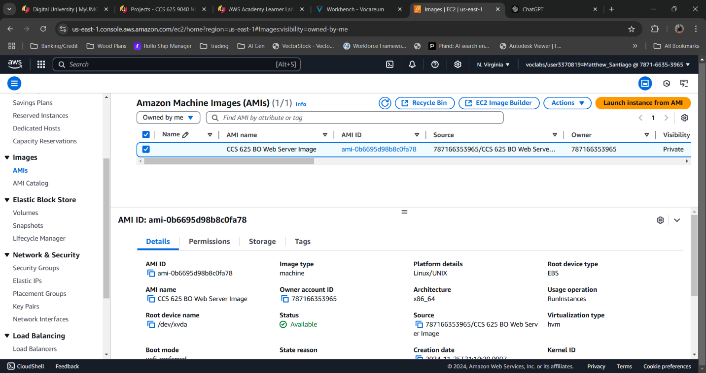

  - Then went to EC2 dashboard instances and went to launch templates. Selected modify and created a new version. Selected the AMI created from above. Then in advanced details added user data: #!/bin/bash nginx
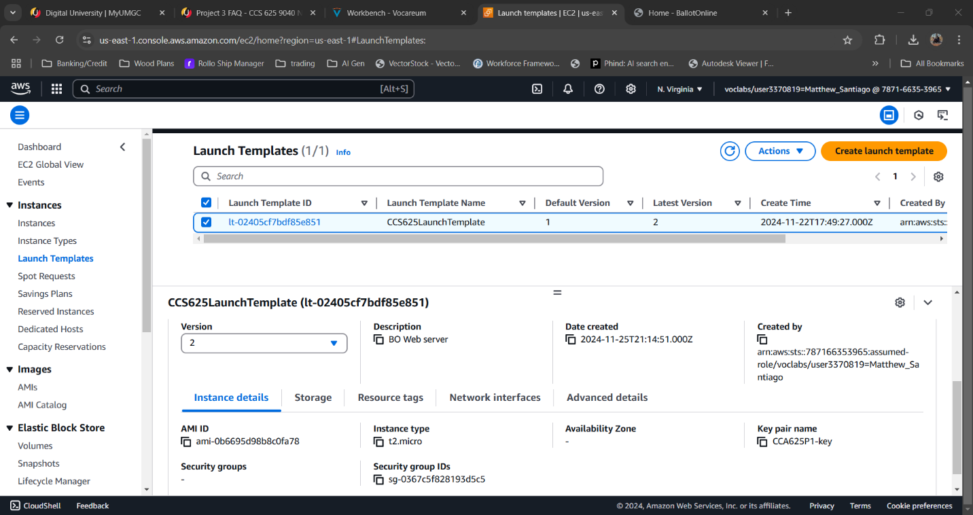

  - In auto scaling section edit the group. Updated the launch template to version 2 then updated it. Also ensured the ELB box is enabled to check health via http.
  - Detached the old instances and watched the new instances get provisioned.
  - Tested navigating to the webpage via the load balancer url.

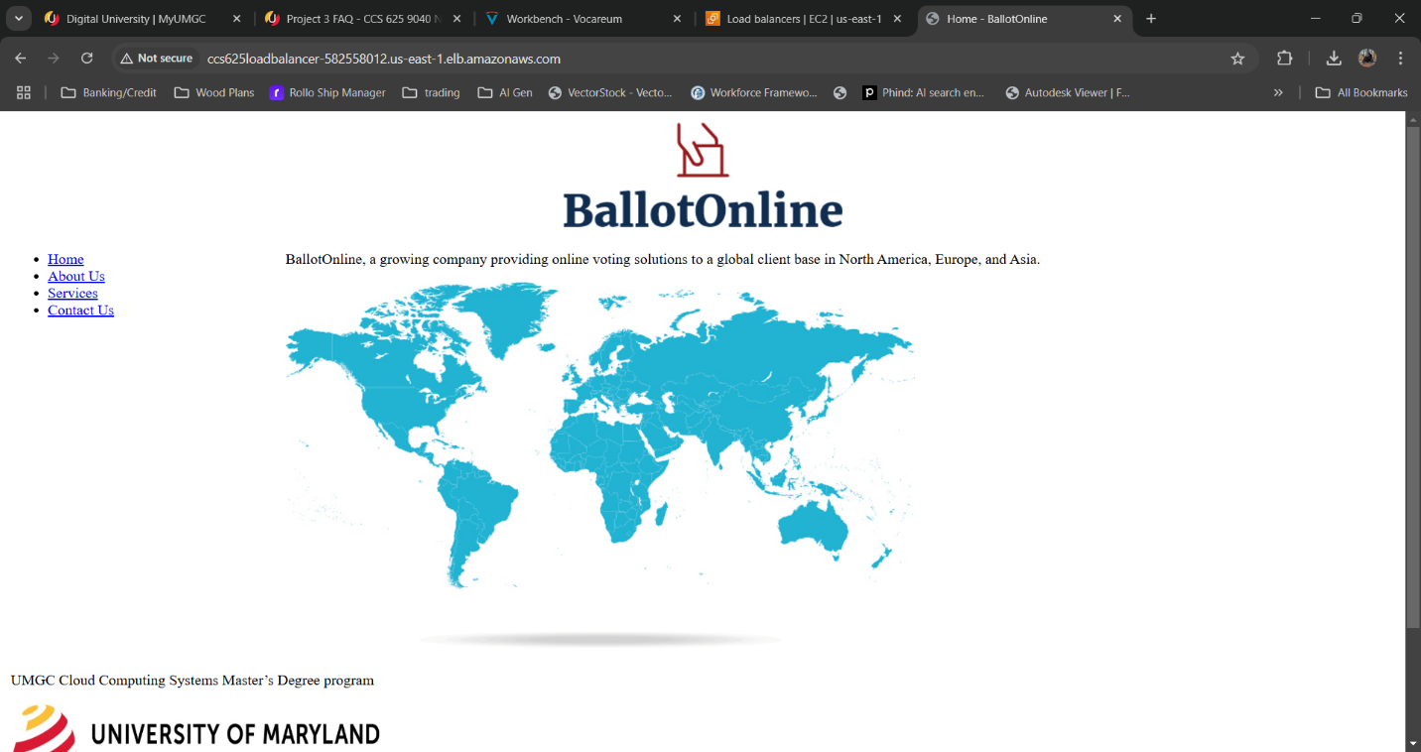
Load balancer DNS Name:
CCS625LoadBalancer-582558012.us-east-1.elb.amazonaws.com
BallotOnline New Web Service URL:
http://CCS625LoadBalancer-582558012.us-east-1.elb.amazonaws.com

Lessons learned:
Completing this lab taught me valuable lessons on how to configure and migrate the BallotOnline website to the new cloud infrastructure. I learned how to install software and system updates while copying files to the new system. Updated the AMI and launch templates and autoscaling to ensure when a instance is interrupted and new instance is created to make sure our services are consistently running for our customers.

Lab 3: Prepare Cloud Test Environment Monitoring Dashboard
Lab Summary: In this lab, I learned how to set up a dashboard using AWS CloudWatch to monitor BallotOnline's servers, load balancer and auto scaling group.

Steps Taken:
- Created a new dashboard in cloudwatch called BallotOnline-Dashboard
  - Created BallotOnline Load Balancer Per Target Stats widget
    - Monitor these stats: HealthyHostCount, UnhealthyHostCount, HTTPCode_Target_2XX_Count, HTTPCode_Target_4XX_Count, and RequestCount.
  - Created BallotOnline Load Balancer Stats widget
    - Monitor these stats: HTTPCode_ELB_502_Count, HTTPCode_ELB_5XX_Count, and HTTPCode_ELB_4XX_Count
  - Created BallotOnline Autoscaling Group Stats widget
    - Monitor these stats: GroupTotalInstances, GroupTerminatingInstances, and GroupPendingInstances
  - Created BallotOnline EC2 Stats widget
    - Monitor these stats: NetworkIn, NetworkOut, and CPUUtilization
  - Created BallotOnline Load Balancer Graph
    - Displaying these stats: HealthyHostCount , UnhealthyHostCount, HTTPCode_Target_2XX_Count, HTTPCode_Target_4XX_Count, RequestCount, and RequestCount Per Target.
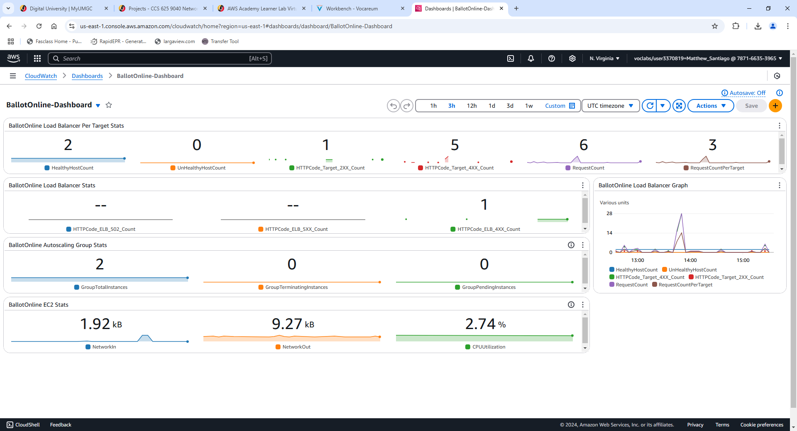
Screenshot of Cloudwatch BallotOnline dashboard

Lessons learned:
Completing this lab taught me how to set up CloudWatch monitoring. I was able to learn how to monitor and track different metrics for the load balancer, auto-scaling groups and EC2 instances. Some of those metrics were: healthy and unhealthy hosts, HTTP response codes, network in/out, etc. Using a dashboard and graph to display those metrics helps to make the data easier to read and comprehend. By using the dashboard it will help us identify when we may need more resources or quickly determine issues in the infrastructure. This lab has taught me to create dashboards to view certain metrics to better view the performance of the infrastructure to produce a reliable, cost effective, robust cloud network for BallotOnline.

Lab 4: Cause Site Outages and Investigate Results in Monitoring Dashboard
Lab Summary: In this lab, I simulated outages and errors in the cloud deployment to test if the infrastructure operates correctly and see how CloudWatch monitoring works.

Steps Taken:
- Logged into AWS and went into CloudWatch then into the BallotOnline Dashboard. Took a screenshot of the baseline dashboard.
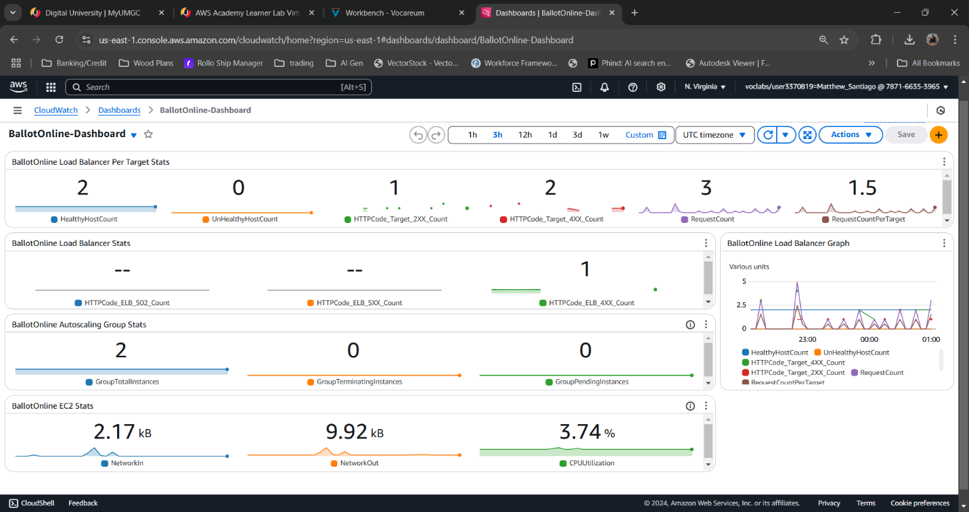
Base Line BallotOnline Dashboard

- HTTP Errors
  - Opened a new browser and went to the Load Balancer URL: http://CCS625LoadBalancer-582558012.us-east-1.elb.amazonaws.com then refreshed the url 20 times
  - I then modified the URL to http://CCS625LoadBalancer-582558012.us-east-1.elb.amazonaws.com/this-page-does-not-exist.html which produced page doesnt exist error. I then refreshed the page 20 times to generate error traffic.
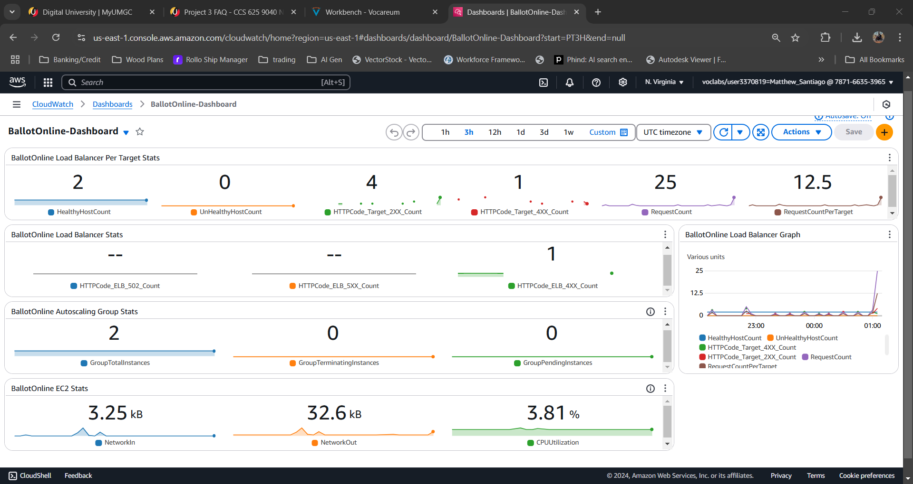
Dashboard with normal HTTP traffic
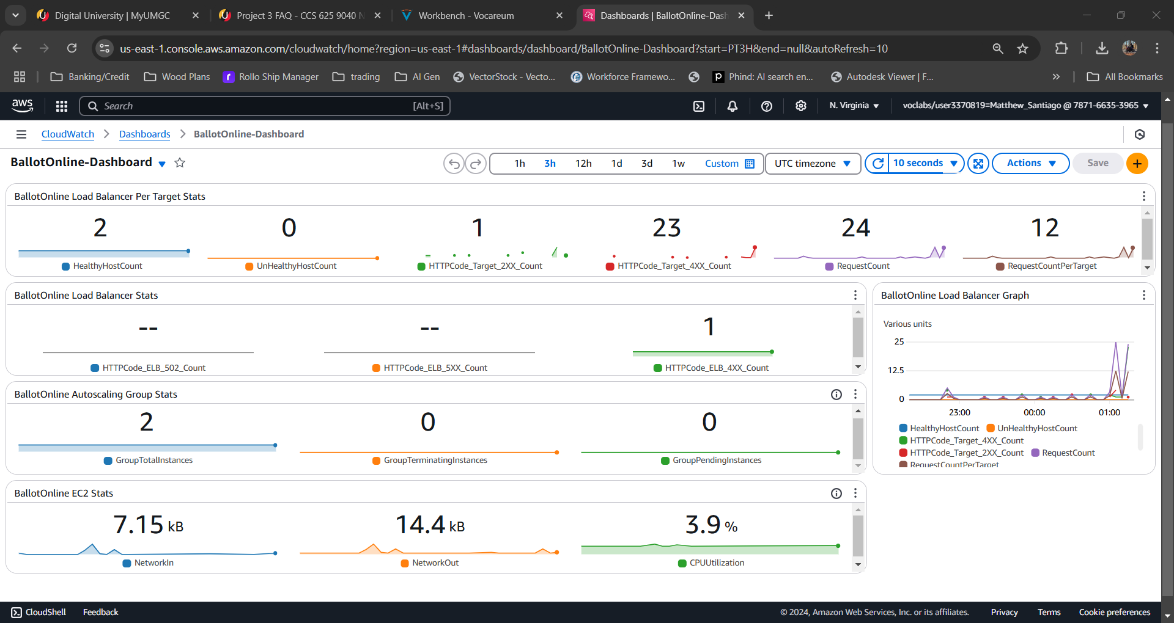
Dashboard with page doesn’t exist errors

- Nginx service error
  - Connected to one of the EC2 instances with command “ssh -i "CCA625P1-key.pem" ec2-user@ec2-35-153-135-68.compute-1.amazonaws.com”
  - Verified nginx was listening on port 80 with this command: netstat -an | grep 80 | grep LISTEN
  - Stoped the nginx service with “sudo nginx -s stop”
  - Verified nginx was not up and listening on port 80 with this command: netstat -an | grep 80 | grep LISTEN
  - Verified the webpage
  - Once the instance was unhealthy Aws automatically shut it down and launched a new instance
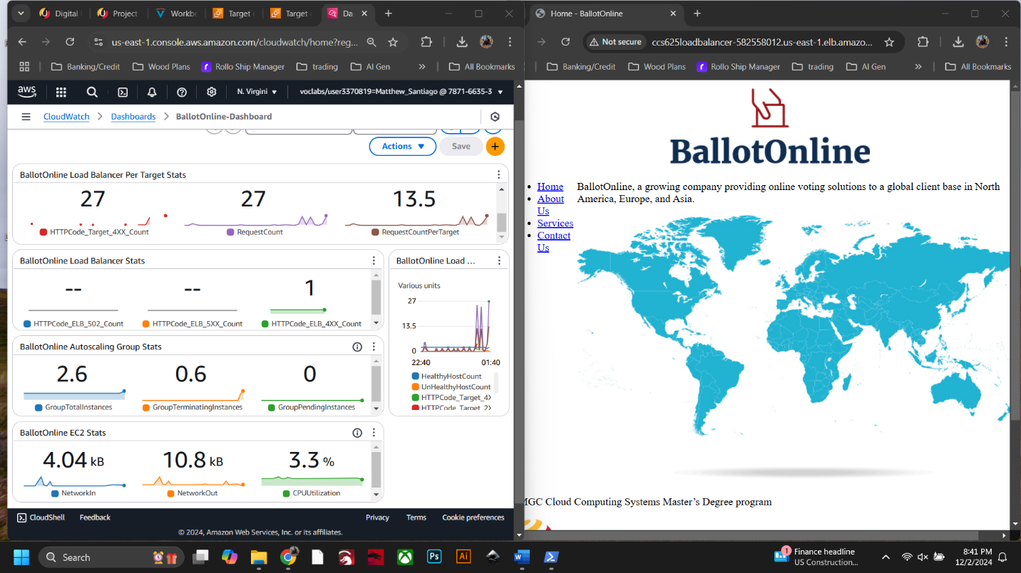
CloudWatch dashboard and the BallotOnline website

  - Repeated the Nginx test again on another instance
  - When verifying the webpage gave bad gateway errors.
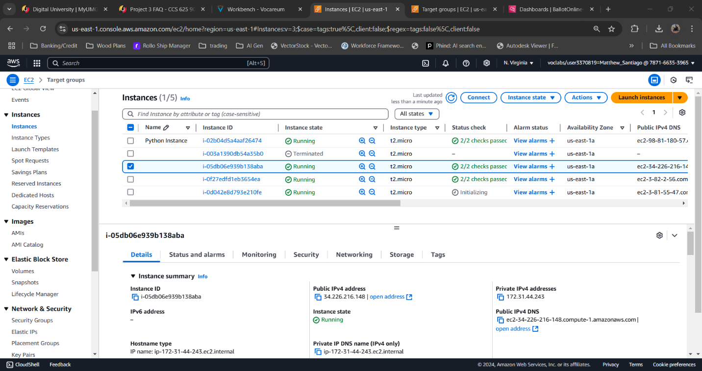
ec2 starting up due to bad health

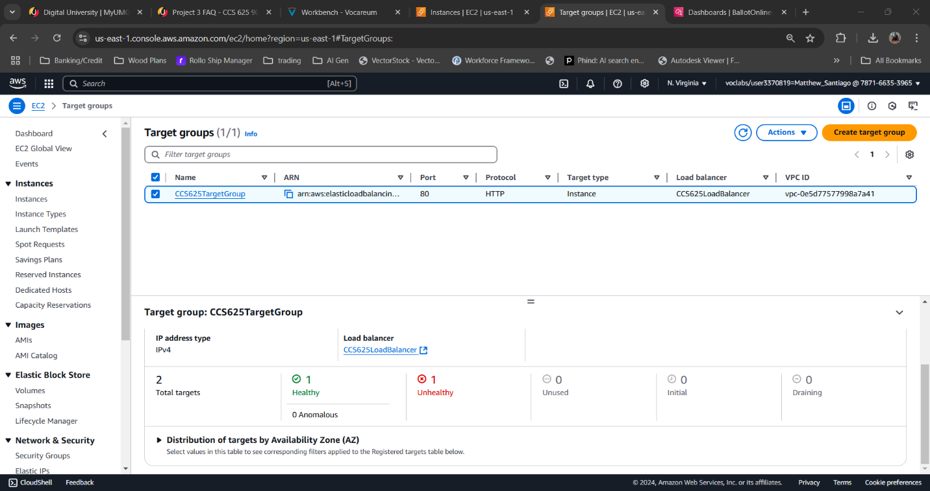
target group unhealthy

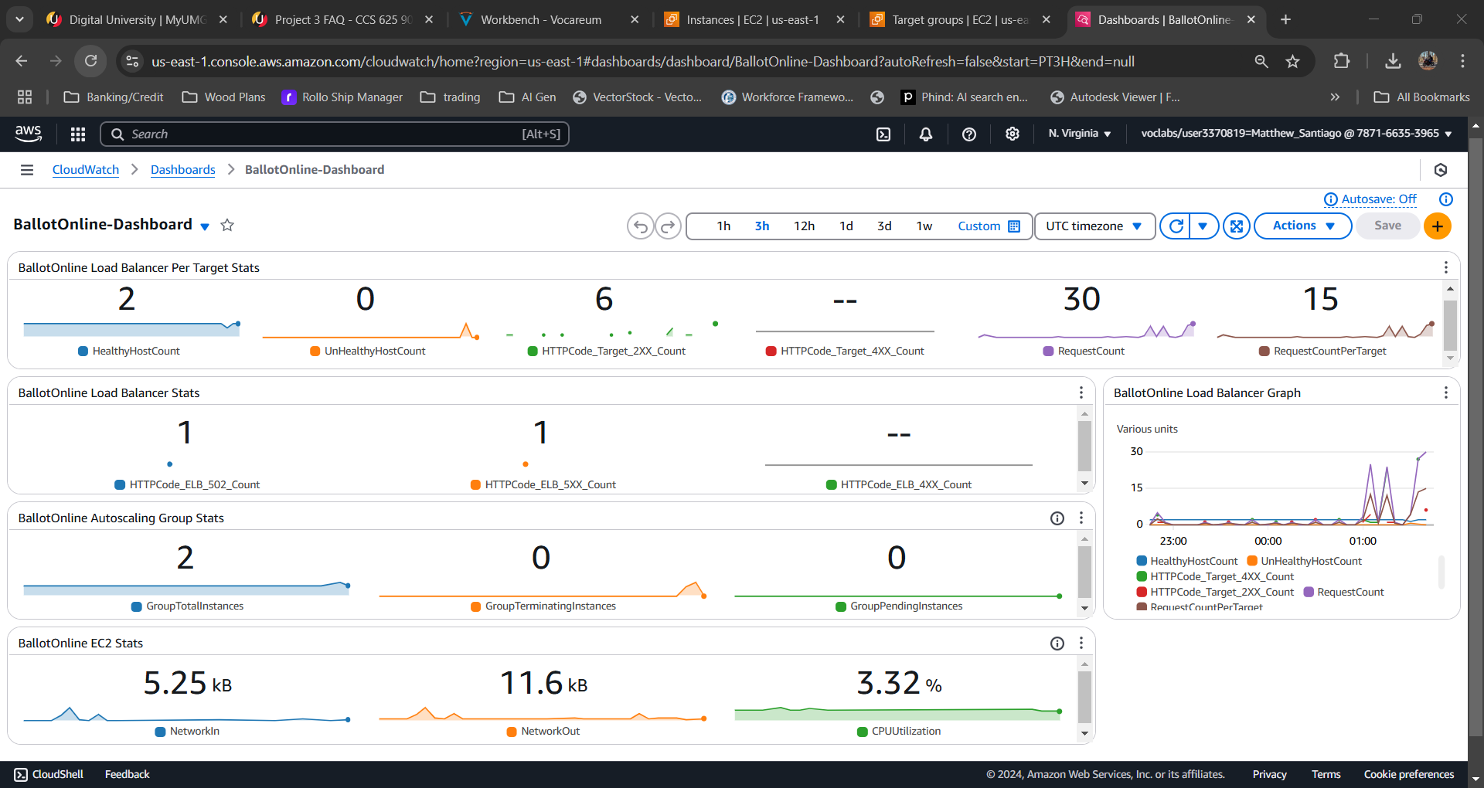
Dashboard showing 5xx errors

Lessons learned:
Completing this lab taught me how monitoring and setting up CloudWatch with auto scaling and load balancers will ensure BallotOnline services are robust and can recover when errors occur. Setting up new infrastructure and testing the responses is a critical task that needs to take place to verify our network can perform when the unexpected happens. This lab also showed me how to monitor the dashboard to see how CloudWatch integrates with the other systems and shows metrics on what is happening to detect if there are outages or errors. With this testing I was able to see how the auto scaling function kicks in to make sure the services we want are healthy and when they are not take them down and initialize another to maintain our services. Using all these services together and determining other metrics to monitor will make sure our network is well monitored and quick to recover so we will meet all our customer’s needs.

Summary of Lessons Learned
Completing these labs was helpful to me because they gave me the opportunity to get real world experience in creating, running and enhancing a cloud infrastructure. It also helped me gain knowledge on how to create a secure network by applying security groups to manage who gets access to the instances and make sure only the authorized users gain access to sensitive resources. Learning to use launch templates made instance deployment quicker and easier after the launch template was complete. The launch template will help reduce manual errors from being made after a template has been approved. Learning how to set up auto scaling groups and load balancers helped me understand how to plan for high network traffic load and make sure that our services are always available. During these labs I had to learn how to install and update software, how to set up web servers, and how to manage website files. I also learned to automate instance deployment by creating AMIs and updating of launch templates. Using the automation of auto scaling and launch templates our services will always be running smoothly without any trouble even in the event of a error. Another important lesson was learning how to monitor of the cloud deployment through the AWS CloudWatch. I developed a dashboard that would help me monitor key factors such as the health of the server, HTTP response codes and the resource consumption. Because cloudwatch displays this data in graphs and charts it was easier to find issues as they happened and watch the automation of the cloud environment fix the issues in real time. Finally, practicing on our own proof of concept cloud environment to simulated outages in the instances to check if the environment could automatically fix the issue was very intriguing. When an instance became unhealthy auto scaling and load balancing came into play and brought in a new instance to replace the faulty one and continue to distribute traffic efficiently. Using CloudWatch and seeing the information in near real time, I was able to know that our cloud infrastructure will be flexible enough to handle any challenges that may happen.
Feasibility of cloud environment for BallotOnline web services deployment
Moving BallotOnline’s web services to the cloud is a good move to support the business. From the experience I gained through this project, AWS cloud proves that it is a good option to move our services into the cloud. Using services like auto scaling, load balancing and CloudWatch we can design a system that is efficient to manage and easy to scale. One of the best benefits of the cloud is the ability to scale quickly. By using AWS auto scaling BallotOnline can automatically increase or decrease the number of instances in response to the amount of traffic or unhealthy instances that occur. By doing this, BallotOnline will only pay for the resources that we use and not for building out our own data center and having servers that may not be in use at times. Deploying our web services on the cloud will be extremely useful during high traffic experienced during elections. During that time is where auto scaling and load balancing will maintain our services while making sure it does not crash.
The cloud will also create reliability for our services. The tests that I did showed when a instance encounters a error, it is replaced immediately. By using load balancers, auto scaling and health checks, the services we offer will always be available even is instances go down. This is essential during elections where smooth and efficient elections leads to increased trust in our product. Security is essential to the validity and trust in elections and AWS cloud proved to handle network security very well. In the labs I created a security group which helped me to restrict the access to our instances to only allow authorized individuals. Managing the cloud is much easier than a datacenter. AWS provided CloudWatch which made monitoring the health of our system and its performance simple. Because of this ease of use we can have more time focusing on improving or making new products for our customers and not having to troubleshoot many issues.
In conclusion, moving BallotOnline’s web services to the cloud will be very valuable and highly recommended. The cloud infrastructure has all services we need to meet our needs for a secure and scalable network that will make sure our services are always available and running. From my time developing the proof of concept network and the testing done, I believe that this is the right path for BallotOnline.

