Project 3: Lab 1 Report

Matthew Santiago
University of Maryland Global Campus
CCS 625 Network Engineering
Andrzej (Andrew) Hoppe
November 24, 2024

Lab Summary: In this lab, we learned how to create security groups, autoscaling and load balanced network.

Steps Taken:
- Created a Security Group
  - Logged into AWS dashboard. Then proceeded to EC2 Dashboard
  - Created a security group named “BallotOnline Web Server security group” that has inbound rules set to SSH from My IP and HTTP protocol from Anywhere IP.

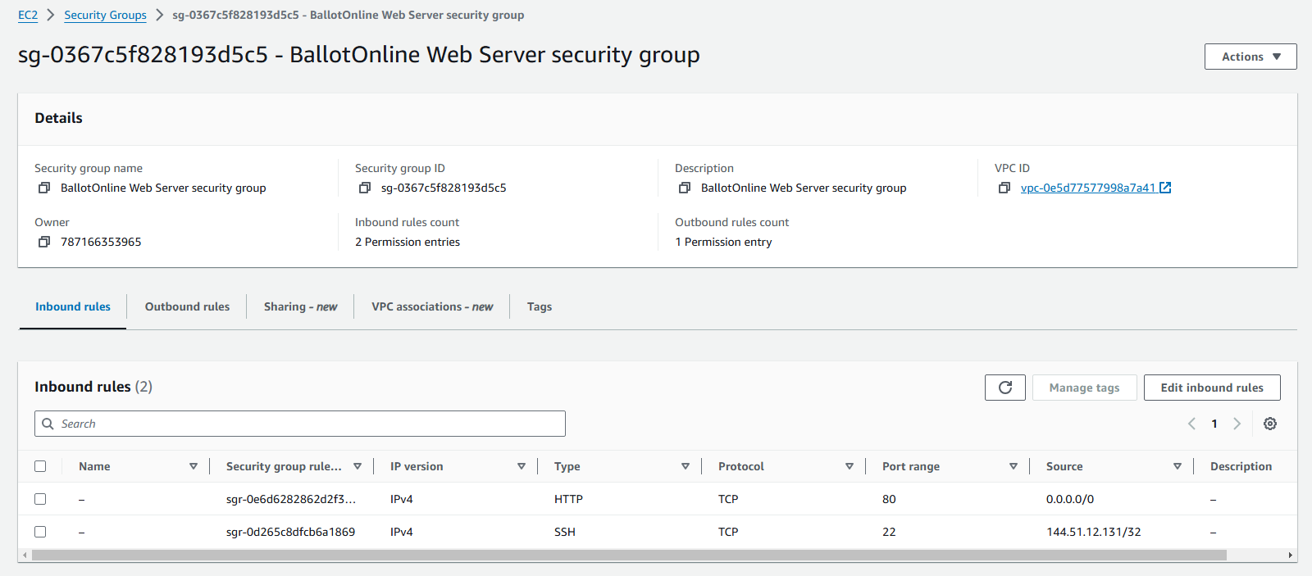
- Configure Launch Template
  - In the EC2 Dashboard went to Launch template. Started to create a new template. Named the template “CCS625LaunchTemplate”.
  - It was set up with autoscaling and Linux operating system, t2.micro instance type.
  - The login key pair set to “CCA625P1-key.pem” and the security group named “BallotOnline Web Server security group” that was created before was selected.
  - Added tags to the launch template named “BallotOnline PoC” then finished creating the template.
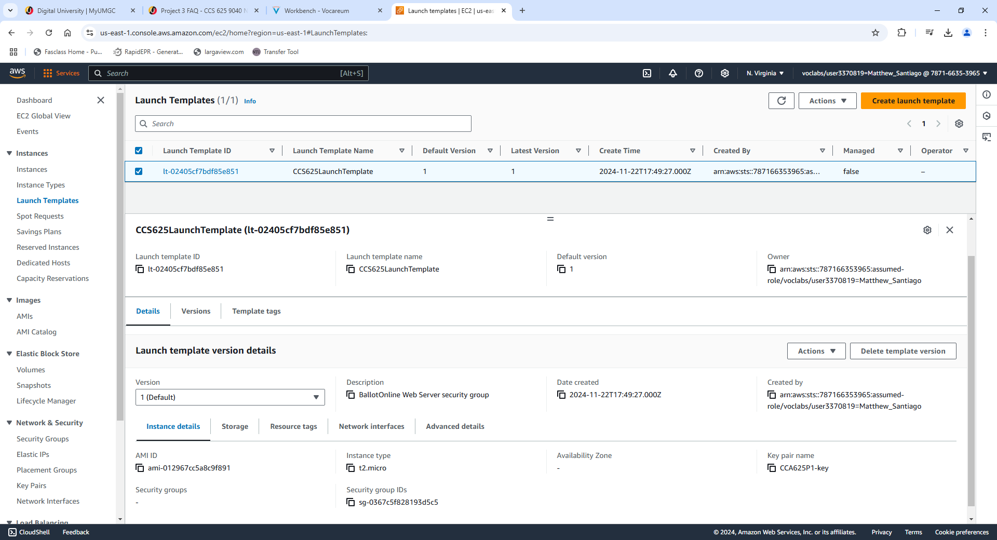

- Auto Scaling and Load Balancer
  - In auto scaling group section created a new auto scaling group named “CCS625 ASG”
  - Chose the us-east 1-a subnet then moved to create a new load balancer.
  - Chose application load balancer and named “CCS625LoadBalancer” and set up for internet facing. Chose us-east 1-a and us-east 1-c availability zones.
  - Created a target group named “CCS625TargetGroup”, enabled metric collection with clouthwatch and configured group size desired to 2 and minimum capacity to 1 and max capacity to 2.
  - Finished created and provisioned the instances.
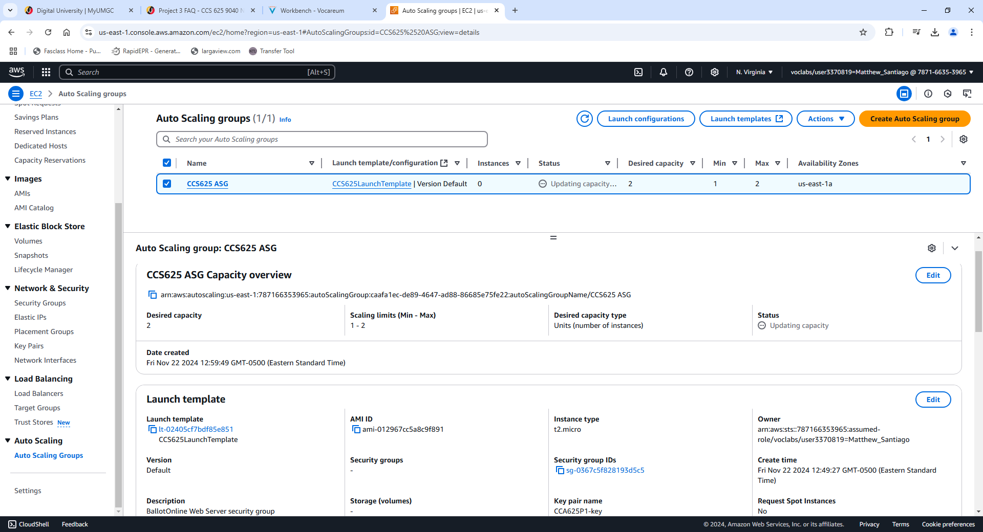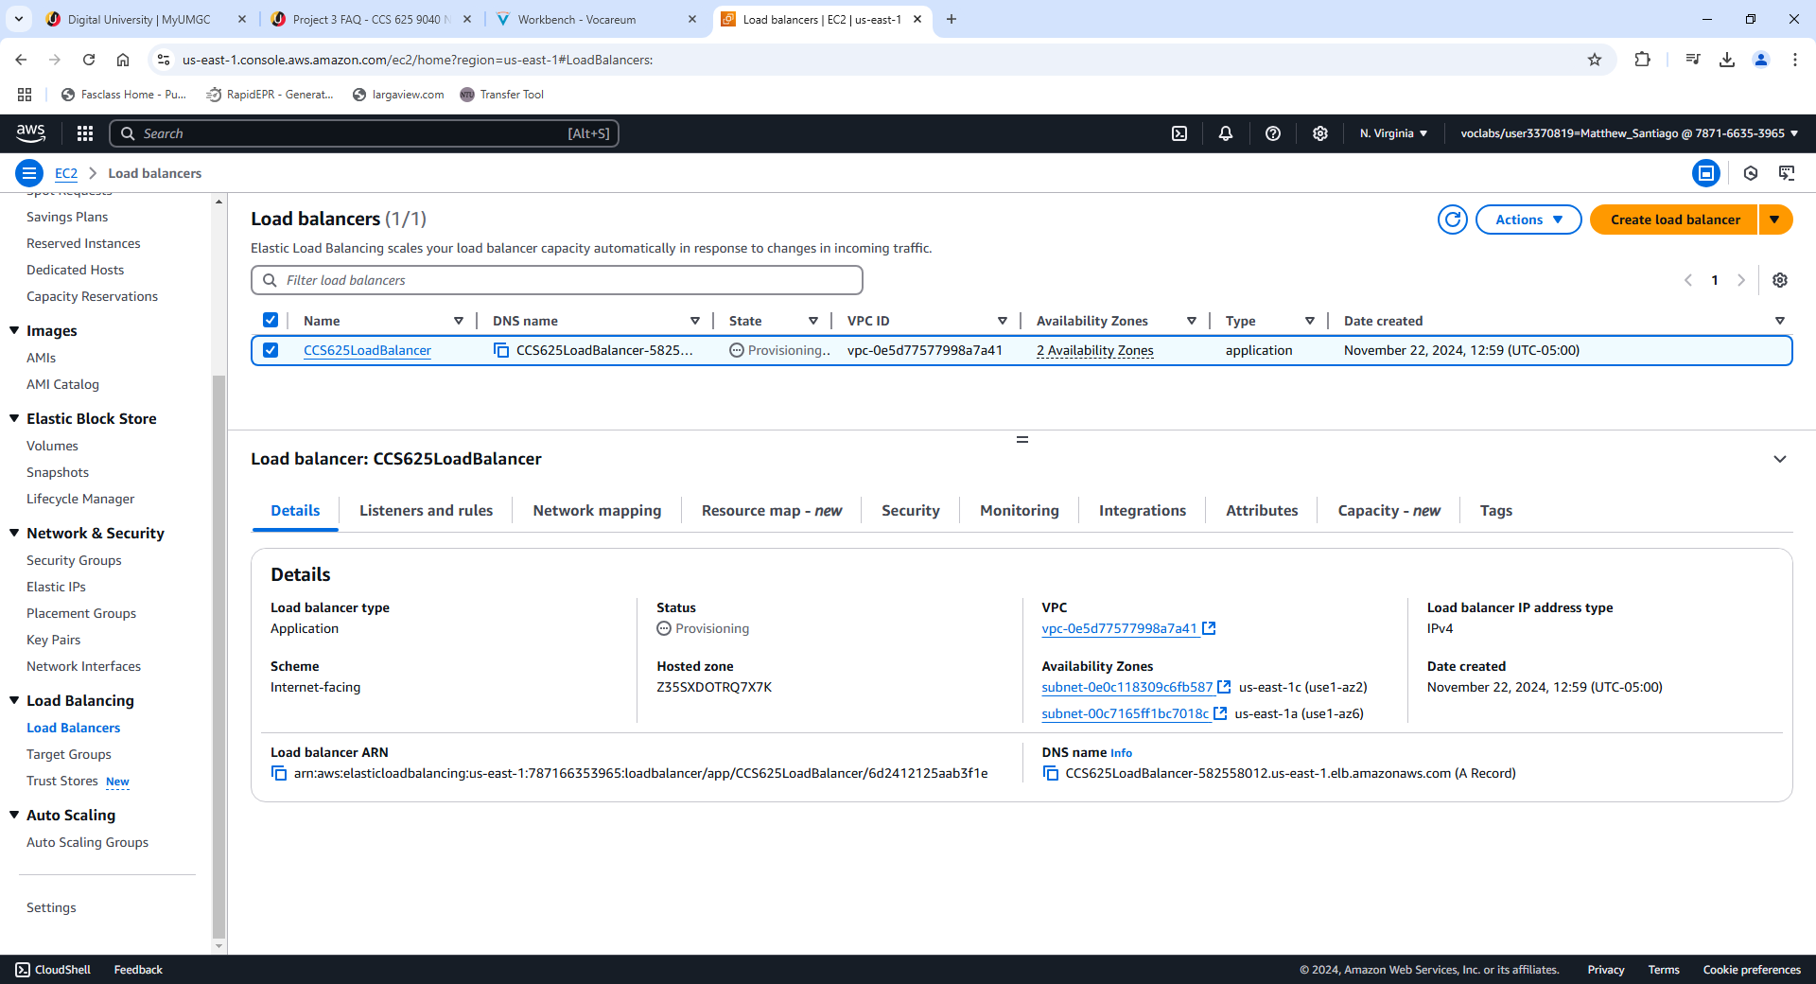
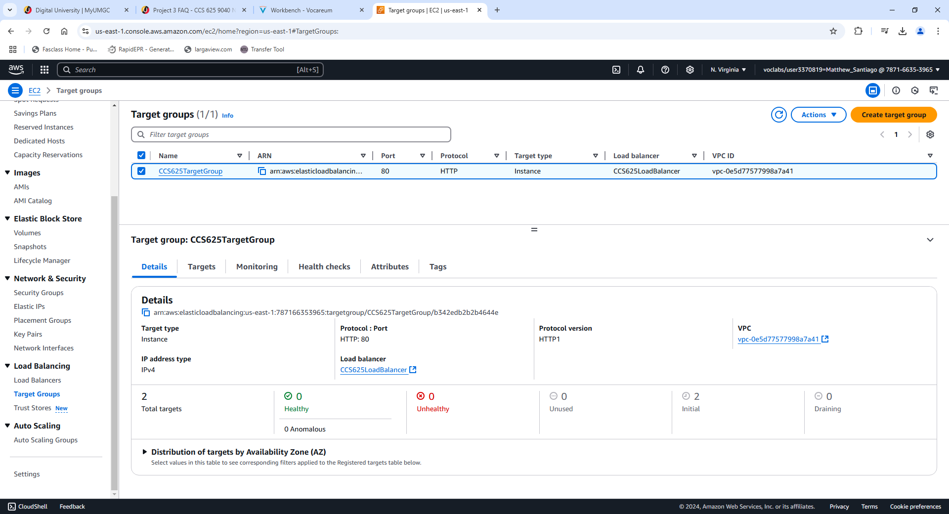

Load balancer DNS Name:
CCS625LoadBalancer-582558012.us-east-1.elb.amazonaws.com
BallotOnline New Web Service URL:
http://CCS625LoadBalancer-582558012.us-east-1.elb.amazonaws.com
Instance 1 IP: 54.204.51.10
Instance 2 IP: 54.165.203.159

Lessons learned:
Completing this lab taught me valuable lessons on creating a network for BallotOnline. Learning how to configure security groups to manage SSH and HTTP connections into our network will make sure we configure our network to be used by only authorized members of our team. More advanced security groups will ensure BallotOnline deployments are secure leading to secure elections. As the lab continued we covered launching templates which will help us quickly deploy instances when needed. Creating effective templates will reduce errors and lead to consistent deployments.
In this lab I also learned how to create and configure auto scaling groups and load balancers. Learning how to effectively configure these services, has taught me to create a network that will maintain high availability and be reliable for our customers and elections.

