Project 3: Lab 2 Report

Matthew Santiago
University of Maryland Global Campus
CCS 625 Network Engineering
Andrzej (Andrew) Hoppe
November 29, 2024

Lab Summary: In this lab, we learned how to deploy the BallotOnline website on Nginx while enabling load balancing and autoscaling.

Steps Taken:
- Connect to 1st instance via SSH on powershell
  - Used the CCA625P1-key.pem key and logged into the instance
  - Command run was: ssh -i "CCA625P1-key.pem" ec2-user@ec2-35-153-135-68.compute-1.amazonaws.com

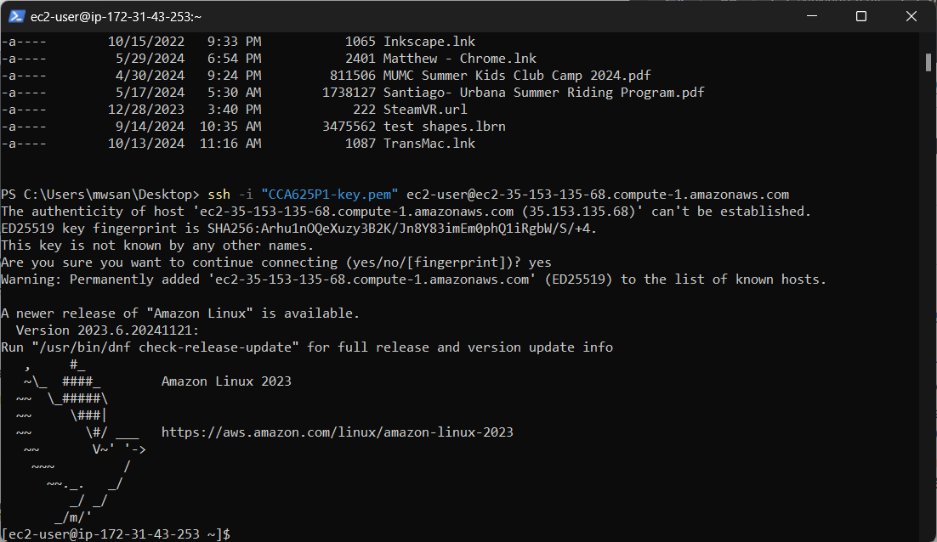
Screenshot of successful ssh login to instance 1.
- Update and install nginx
  - Once logged in ran “sudo yum update” to install security updates.
  - After the yum update was completed ran the “sudo yum install nginx” command to install nginx web server.
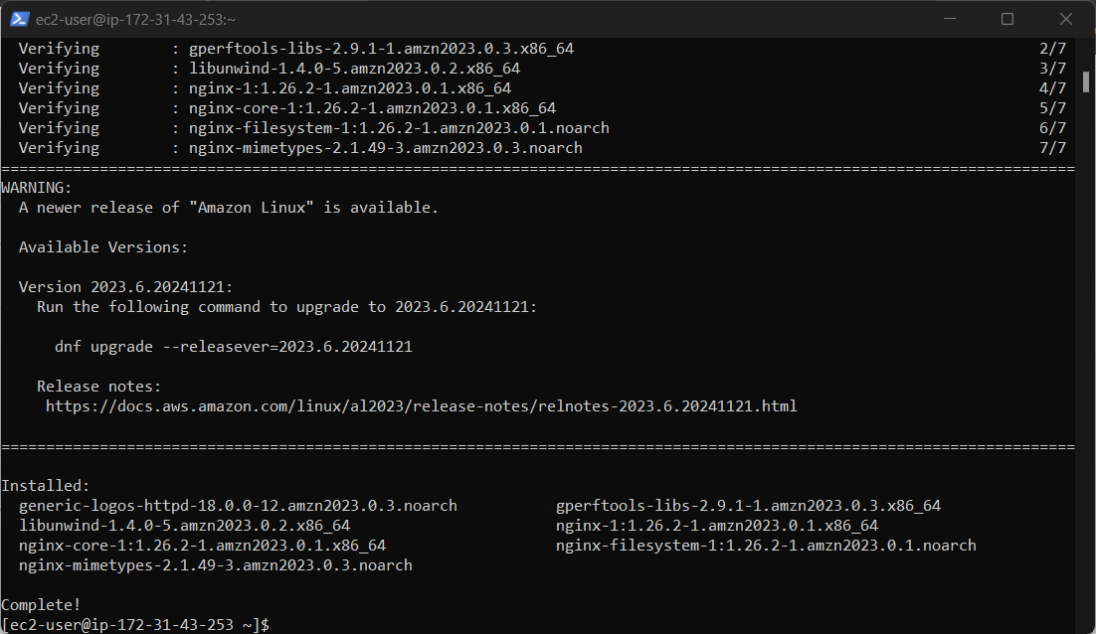Screenshot of successful install of nginx
- Create website files
  - Created the website data file by running this command: sudo mkdir –p /data/www
  - Changed directory into /data/www
  - Ran “sudo wget https://bizballotonline.azurewebsites.net/website.zip” to download the website zip file
  - Ran “sudo unzip website.zip -d /data/www/BallotOnline” to unzip and place the unzip files into ballotonline file in the website folder.
  - Checked to see if the data was copied over correctly by running: “cat /data/www/BallotOnline/index.html”
- Configure the nginx server
  - Changed the file permission of /data/www/BallotOnline/ to 755 by running the command sudo chmod -R 755 /data/www/BallotOnline/
  - Replaced the default nginx config file
    - Take the old config file and rename by “sudo mv /etc/nginx/nginx.conf /etc/nginx/nginx.conf.old”
    - Take the new config file and copy it to nginx directory “sudo cp /data/www/BallotOnline/nginx.conf /etc/nginx/”
    - Started nginx by running sudo nginx
- AMI, template, load balancer, and autoscaling
  - Went to the public IP for instance 1 and tested to see if the instance page was running.
  - Once verified went to ec2 dashboard and selected the instance and selected template create image and named it “CCS 625 BO Web Server Image”
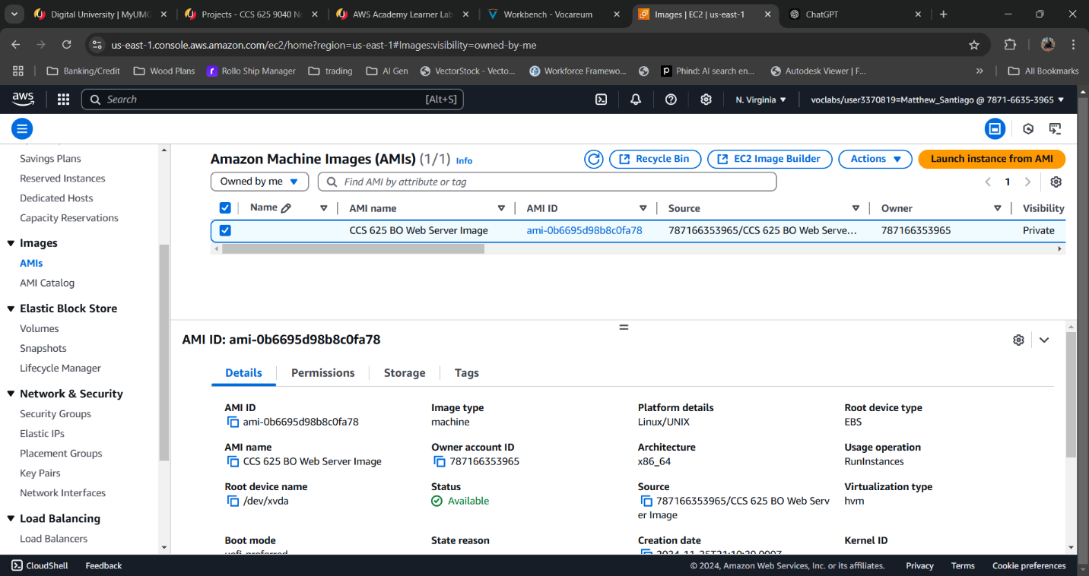

  - Then went to EC2 dashboard instances and went to launch templates. Selected modify and created a new version. Selected the AMI created from above. Then in advanced details added user data: #!/bin/bash nginx
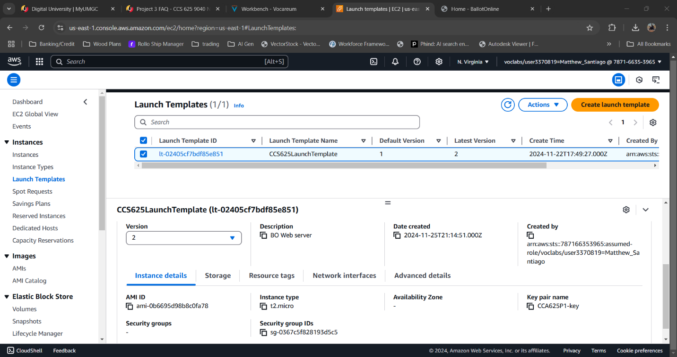

  - In auto scaling section edit the group. Updated the launch template to version 2 then updated it. Also ensured the ELB box is enabled to check health via http.
  - Detached the old instances and watched the new instances get provisioned.
  - Tested navigating to the webpage via the load balancer url.
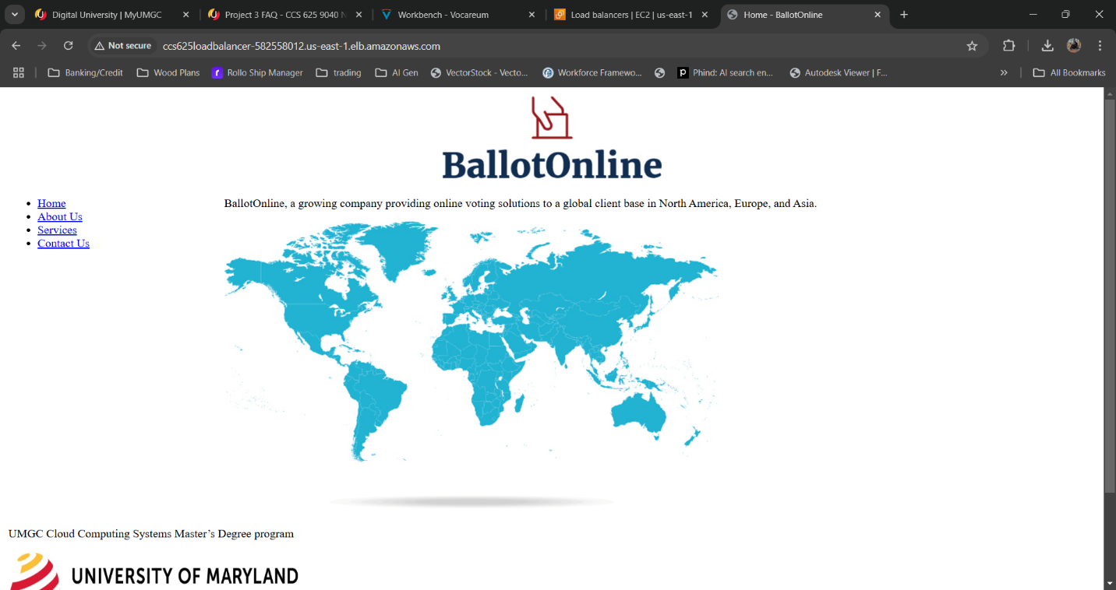
Load balancer DNS Name:
CCS625LoadBalancer-582558012.us-east-1.elb.amazonaws.com
BallotOnline New Web Service URL:
http://CCS625LoadBalancer-582558012.us-east-1.elb.amazonaws.com

Lessons learned:
Completing this lab taught me valuable lessons on how to configure and migrate the BallotOnline website to the new cloud infrastructure. I learned how to install software and system updates while copying files to the new system. Updated the AMI and launch templates and autoscaling to ensure when a instance is interrupted and new instance is created to make sure our services are consistently running for our customers.

