Project 3: Lab 3 Report

Matthew Santiago
University of Maryland Global Campus
CCS 625 Network Engineering
Andrzej (Andrew) Hoppe
December 2, 2024

Lab Summary: In this lab, I learned how to set up a dashboard using AWS CloudWatch to monitor BallotOnline's servers, load balancer and auto scaling group.

Steps Taken:
- Created a new dashboard in cloudwatch called BallotOnline-Dashboard
  - Created BallotOnline Load Balancer Per Target Stats widget
    - Monitor these stats: HealthyHostCount, UnhealthyHostCount, HTTPCode_Target_2XX_Count, HTTPCode_Target_4XX_Count, and RequestCount.
  - Created BallotOnline Load Balancer Stats widget
    - Monitor these stats: HTTPCode_ELB_502_Count, HTTPCode_ELB_5XX_Count, and HTTPCode_ELB_4XX_Count
  - Created BallotOnline Autoscaling Group Stats widget
    - Monitor these stats: GroupTotalInstances, GroupTerminatingInstances, and GroupPendingInstances
  - Created BallotOnline EC2 Stats widget
    - Monitor these stats: NetworkIn, NetworkOut, and CPUUtilization
  - Created BallotOnline Load Balancer Graph
    - Displaying these stats: HealthyHostCount , UnhealthyHostCount, HTTPCode_Target_2XX_Count, HTTPCode_Target_4XX_Count, RequestCount, and RequestCount Per Target.
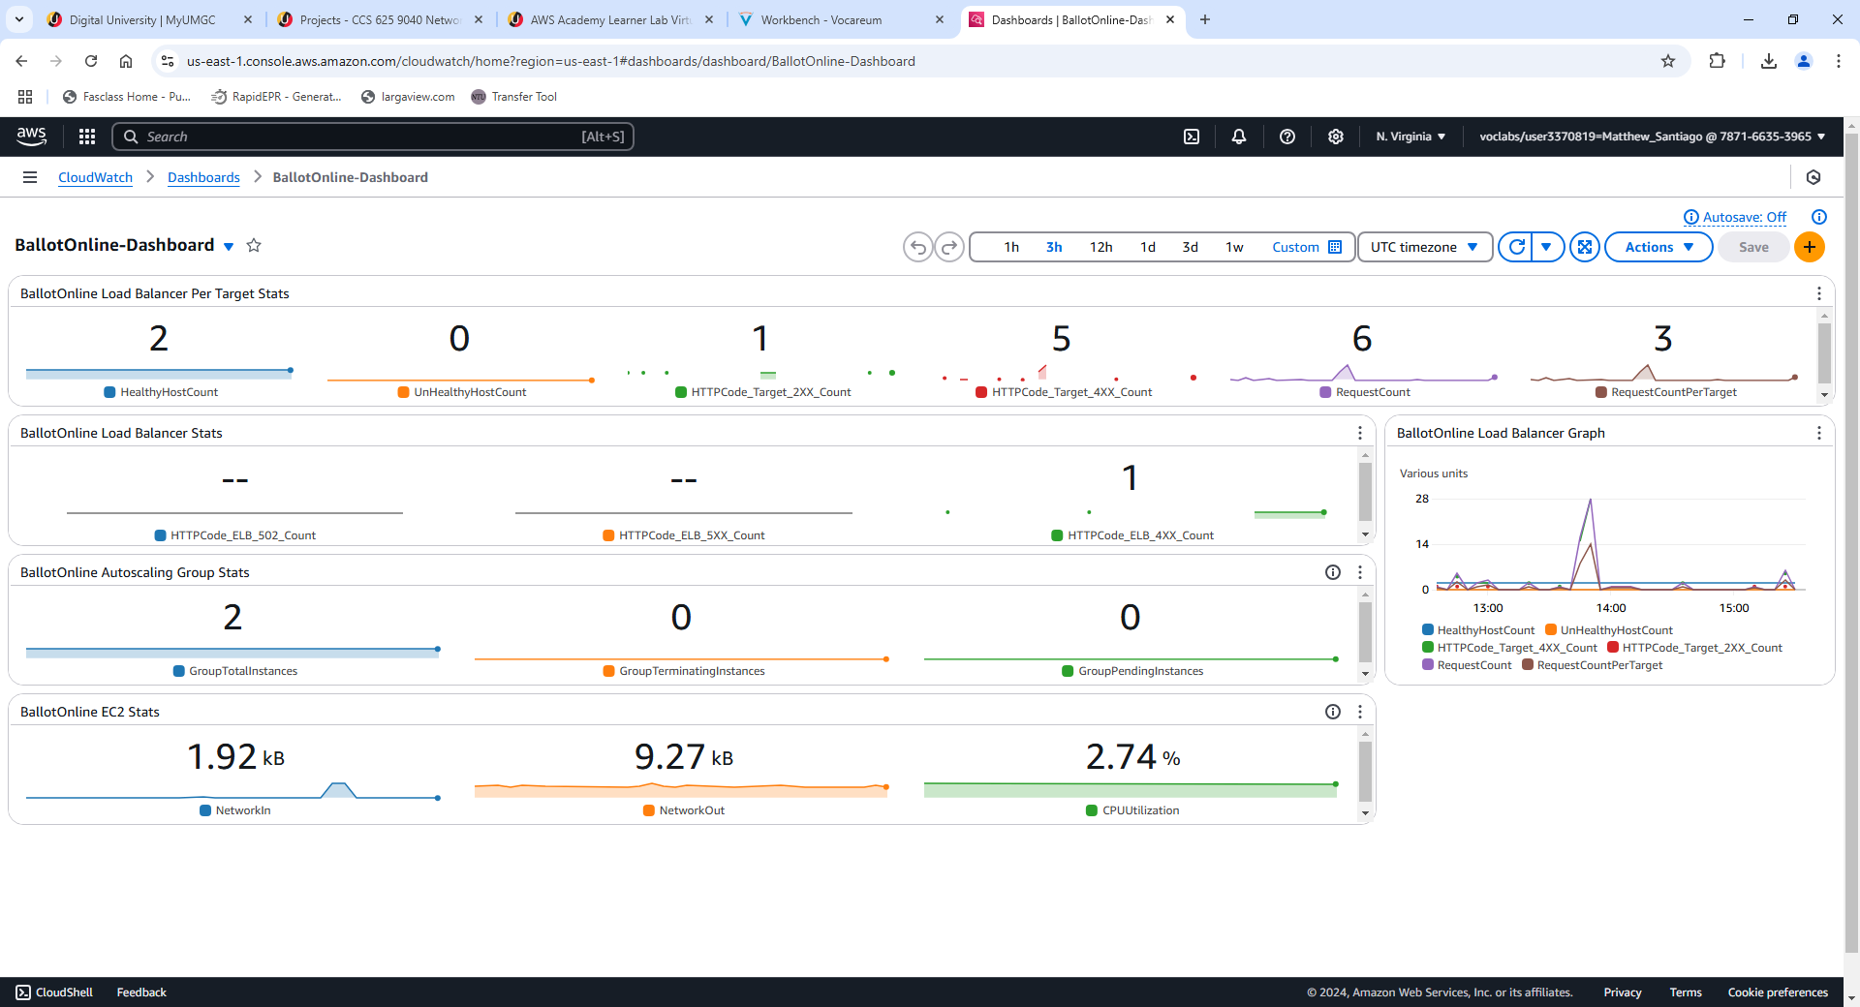
Screenshot of Cloudwatch BallotOnline dashboard

Lessons learned:
Completing this lab taught me how to set up CloudWatch monitoring. I was able to learn how to monitor and track different metrics for the load balancer, auto-scaling groups and EC2 instances. Some of those metrics were: healthy and unhealthy hosts, HTTP response codes, network in/out, etc. Using a dashboard and graph to display those metrics helps to make the data easier to read and comprehend. By using the dashboard it will help us identify when we may need more resources or quickly determine issues in the infrastructure. This lab has taught me to create dashboards to view certain metrics to better view the performance of the infrastructure to produce a reliable, cost effective, robust cloud network for BallotOnline.

