Project 3: Lab 4 Report

Matthew Santiago
University of Maryland Global Campus
CCS 625 Network Engineering
Andrzej (Andrew) Hoppe
December 3, 2024

Lab Summary: In this lab, I simulated outages and errors in the cloud deployment to test if the infrastructure operates correctly and see how CloudWatch monitoring works.

Steps Taken:
- Logged into AWS and went into CloudWatch then into the BallotOnline Dashboard. Took a screenshot of the baseline dashboard.
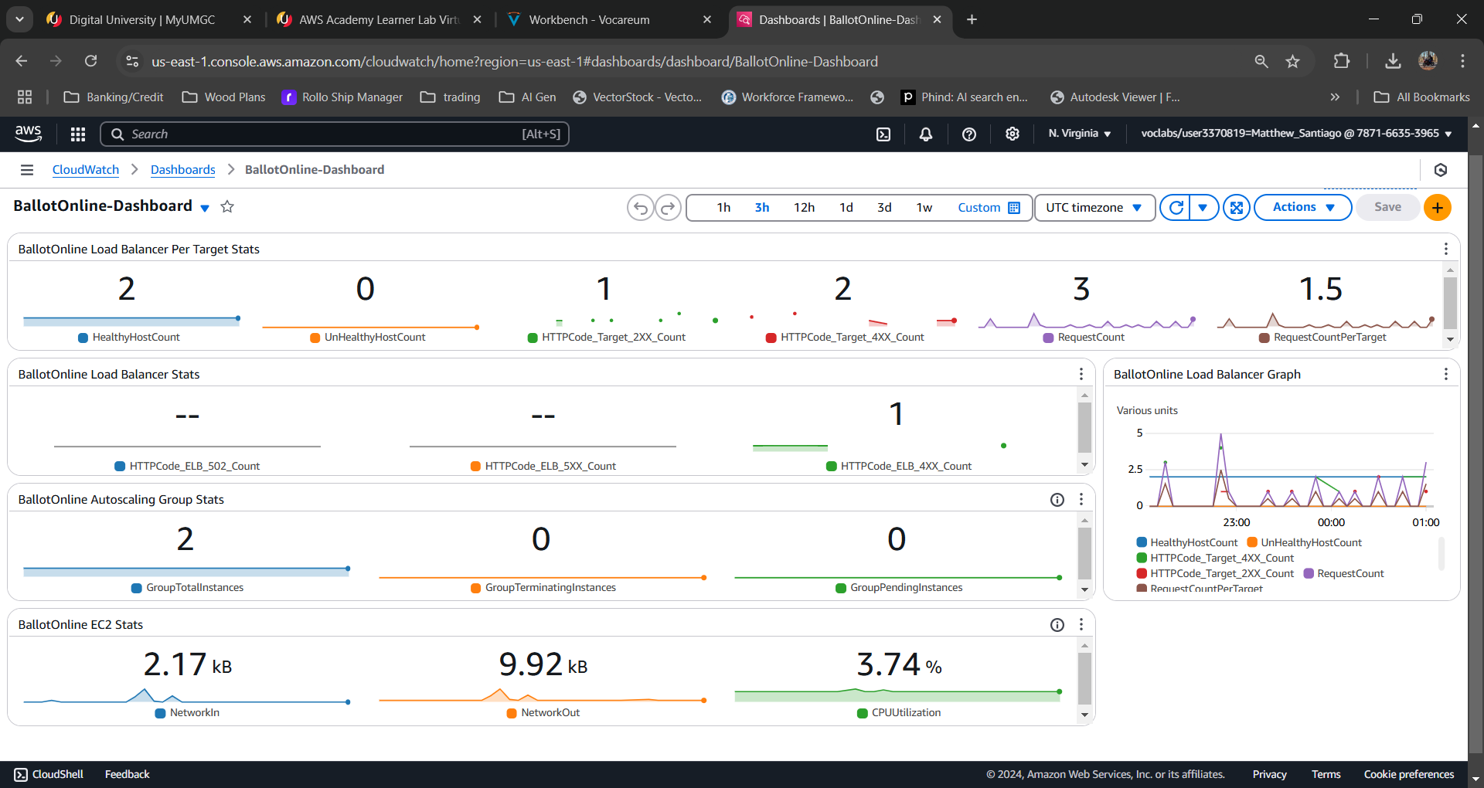
Base Line BallotOnline Dashboard

- HTTP Errors
  - Opened a new browser and went to the Load Balancer URL: http://CCS625LoadBalancer-582558012.us-east-1.elb.amazonaws.com then refreshed the url 20 times
  - I then modified the URL to http://CCS625LoadBalancer-582558012.us-east-1.elb.amazonaws.com/this-page-does-not-exist.html which produced page doesnt exist error. I then refreshed the page 20 times to generate error traffic.
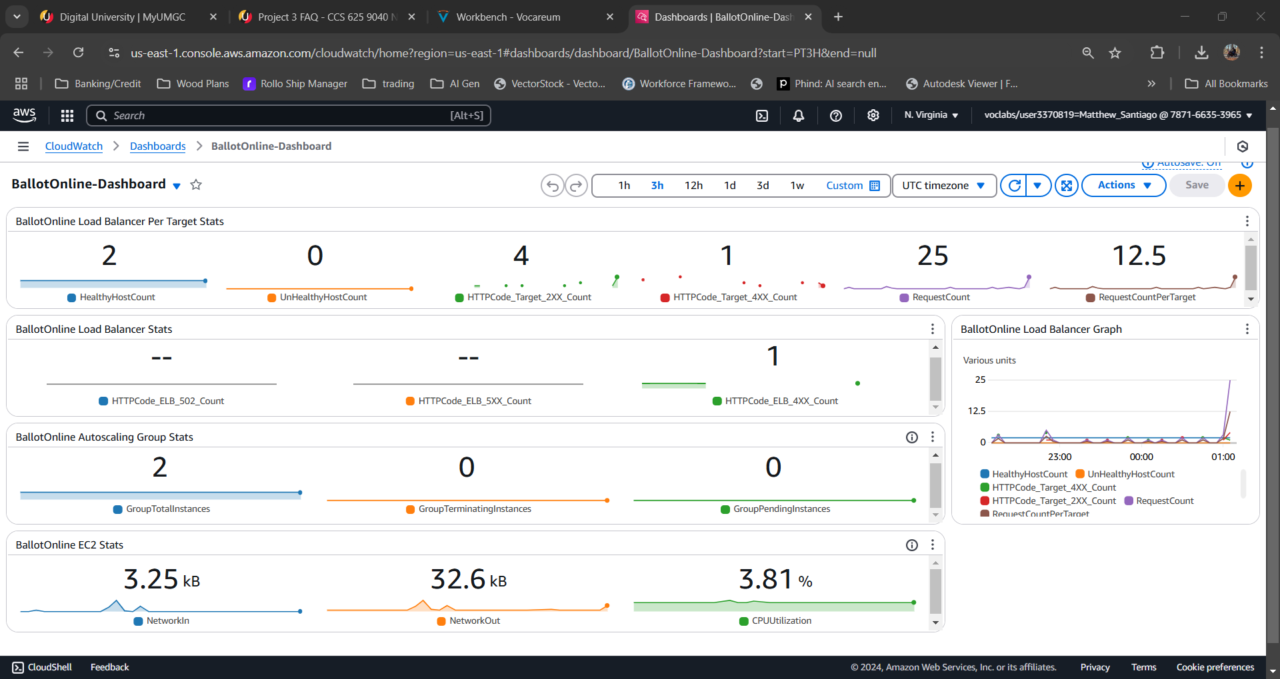
Dashboard with normal HTTP traffic
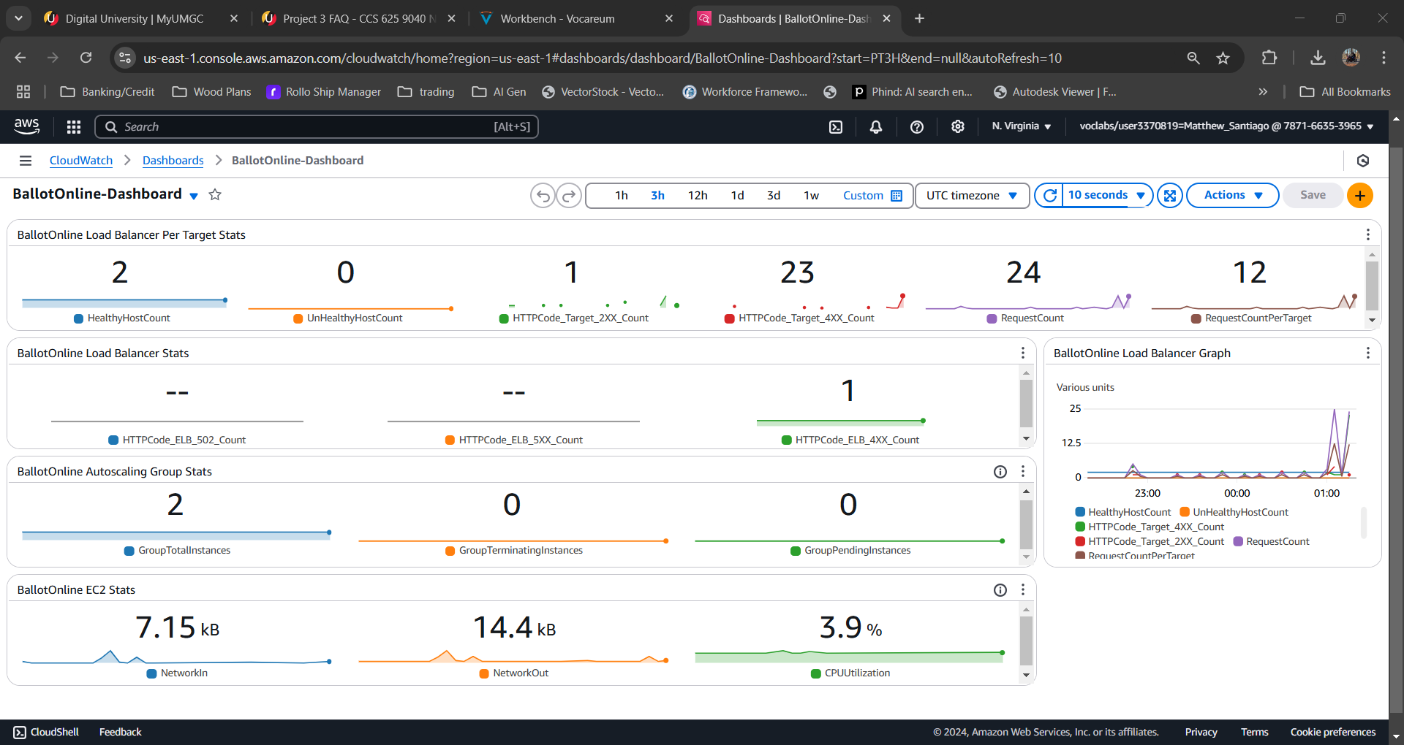
Dashboard with page doesn’t exist errors

- Nginx service error
  - Connected to one of the EC2 instances with command “ssh -i "CCA625P1-key.pem" ec2-user@ec2-35-153-135-68.compute-1.amazonaws.com”
  - Verified nginx was listening on port 80 with this command: netstat -an | grep 80 | grep LISTEN
  - Stoped the nginx service with “sudo nginx -s stop”
  - Verified nginx was not up and listening on port 80 with this command: netstat -an | grep 80 | grep LISTEN
  - Verified the webpage
  - Once the instance was unhealthy Aws automatically shut it down and launched a new instance
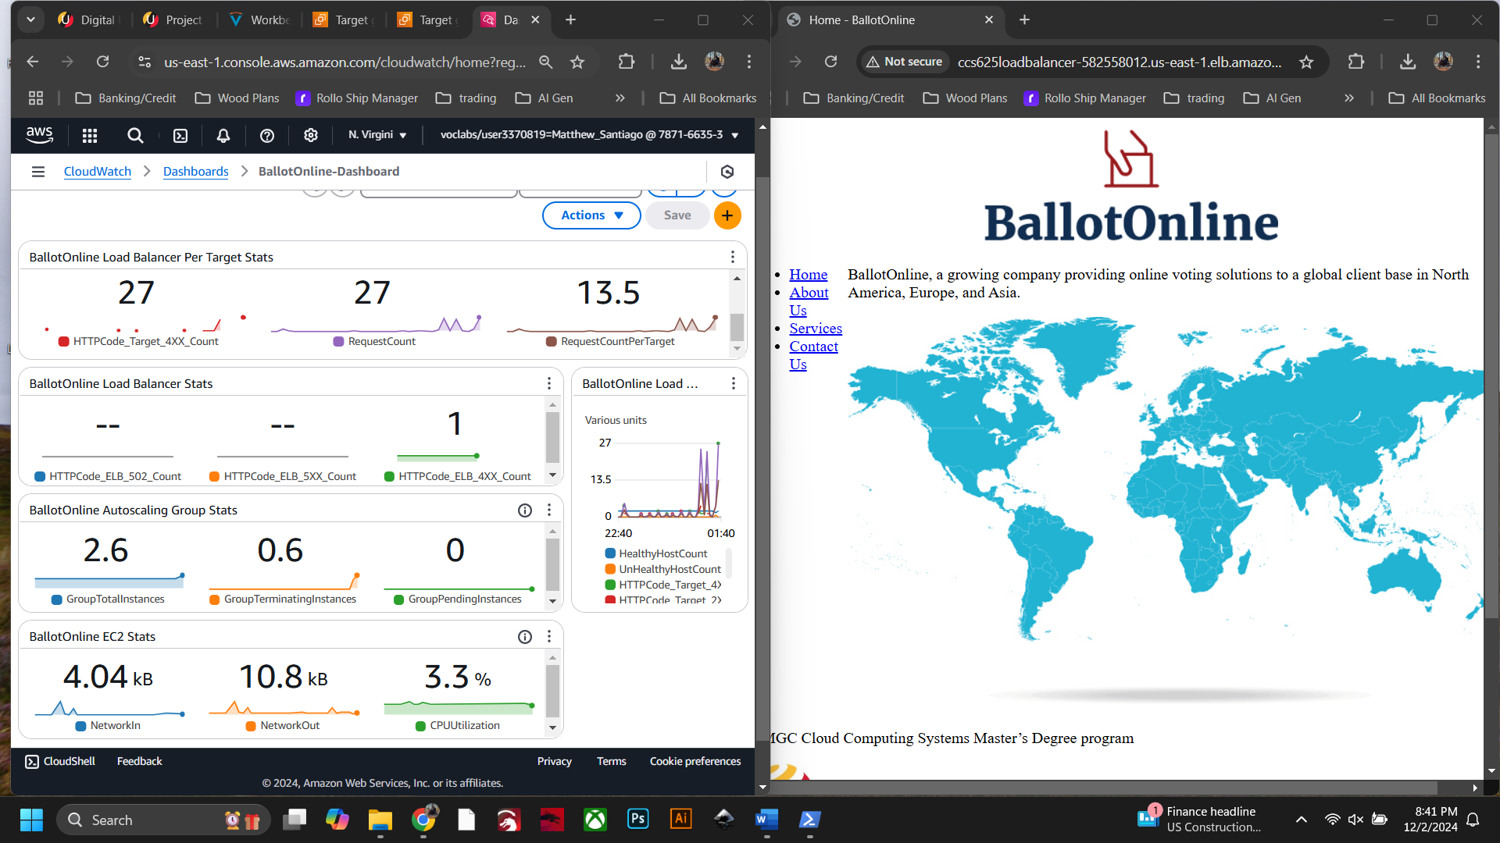
CloudWatch dashboard and the BallotOnline website

  - Repeated the Nginx test again on another instance
  - When verifying the webpage gave bad gateway errors.
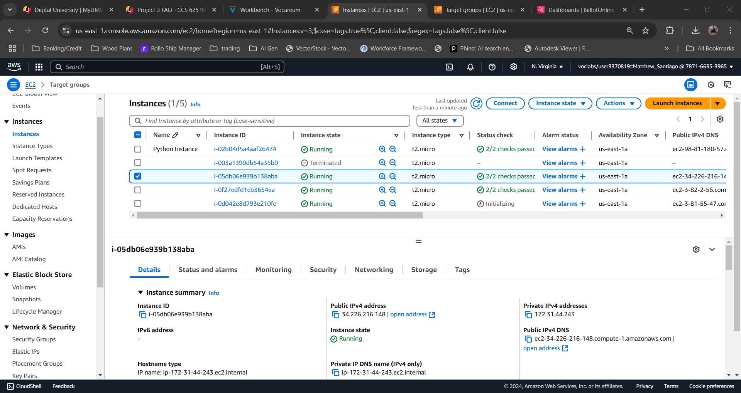
ec2 starting up due to bad health

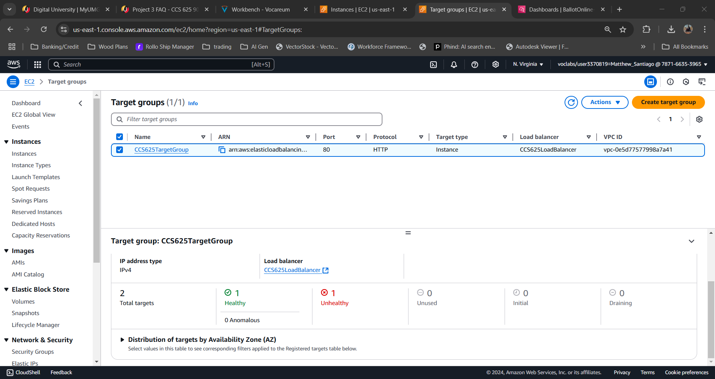
target group unhealthy

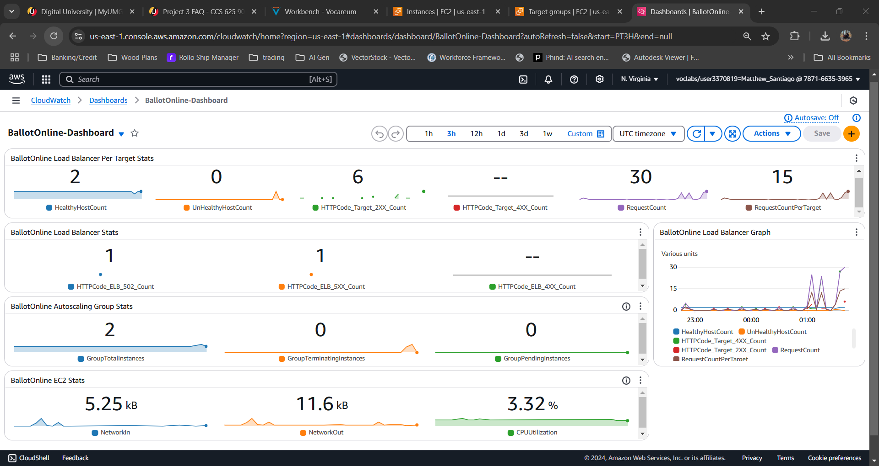
Dashboard showing 5xx errors

Lessons learned:
Completing this lab taught me how monitoring and setting up CloudWatch with auto scaling and load balancers will ensure BallotOnline services are robust and can recover when errors occur. Setting up new infrastructure and testing the responses is a critical task that needs to take place to verify our network can perform when the unexpected happens. This lab also showed me how to monitor the dashboard to see how CloudWatch integrates with the other systems and shows metrics on what is happening to detect if there are outages or errors. With this testing I was able to see how the auto scaling function kicks in to make sure the services we want are healthy and when they are not take them down and initialize another to maintain our services. Using all these services together and determining other metrics to monitor will make sure our network is well monitored and quick to recover so we will meet all our customer’s needs.

