Project 1: Lab 1 Report

Matthew Santiago
University of Maryland Global Campus
CCS 630 Cloud Infrastructure Planning, Design, and Configurations
Alan Castillo
January 13, 2025

Lab Summary:
In this lab, TerraForm was used to deploy a WordPress website for BallotOnline using Amazon Web Services. A Microsoft Copilot AI was configured and embedded into a new WordPress post. Some of the key lesson tasks were creating a new user in AWS IAM, becoming more familiar with AWS CloudShell, deploying infrastructure with TerraForm and validating AI functionality through chat interactions.

Lab Steps:
Section 1: Creating an IAM User​
- Accessed the AWS IAM Console.
- Created a new user with my student email address and assign AdministratorAccess and IAMUserChangePassword policies.
- Generated and saved the Access Key and Secret Key.
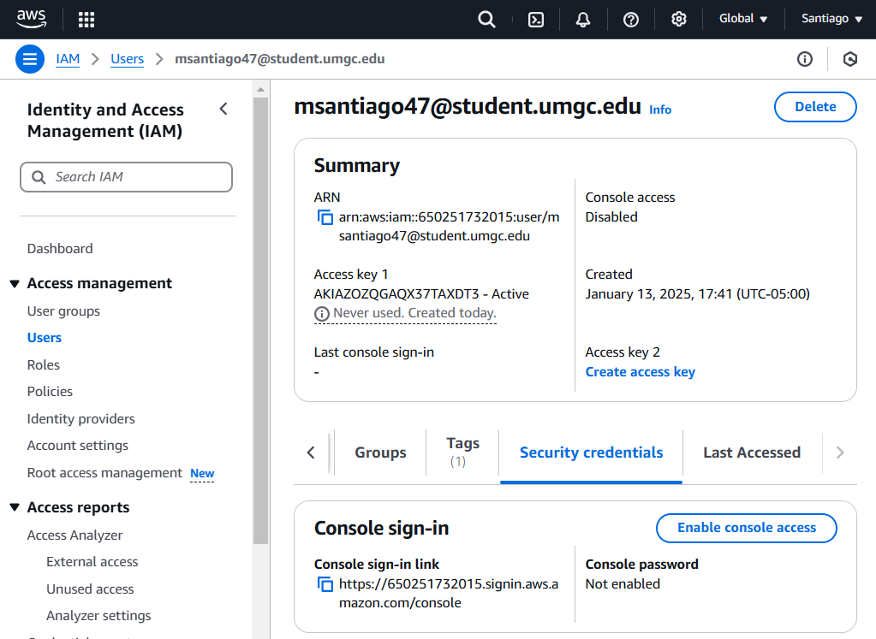
Section 2: Setting Up CloudShell and Terraform​
- Opened AWS CloudShell and uploaded the install_terraform.sh script.
- Performed chmod +x install_terraform.sh, then ran the script.
- Verified TerraForm by running terraform -v.
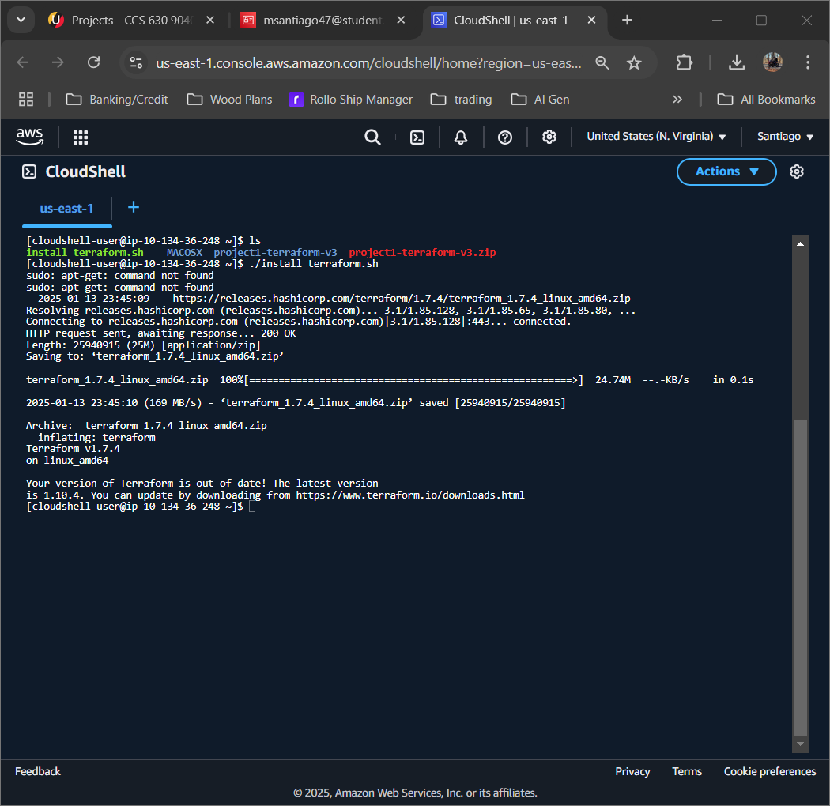
- Uploaded and unzipped project1-terraform-v3.zip
- Changed directory to project1-terraform-v3 to prepare for deployment.
Section 3: Deploying the Terraform Environment​
- Updated the variables.tf file with my new user AWS Access Key, Secret Key, and student email.
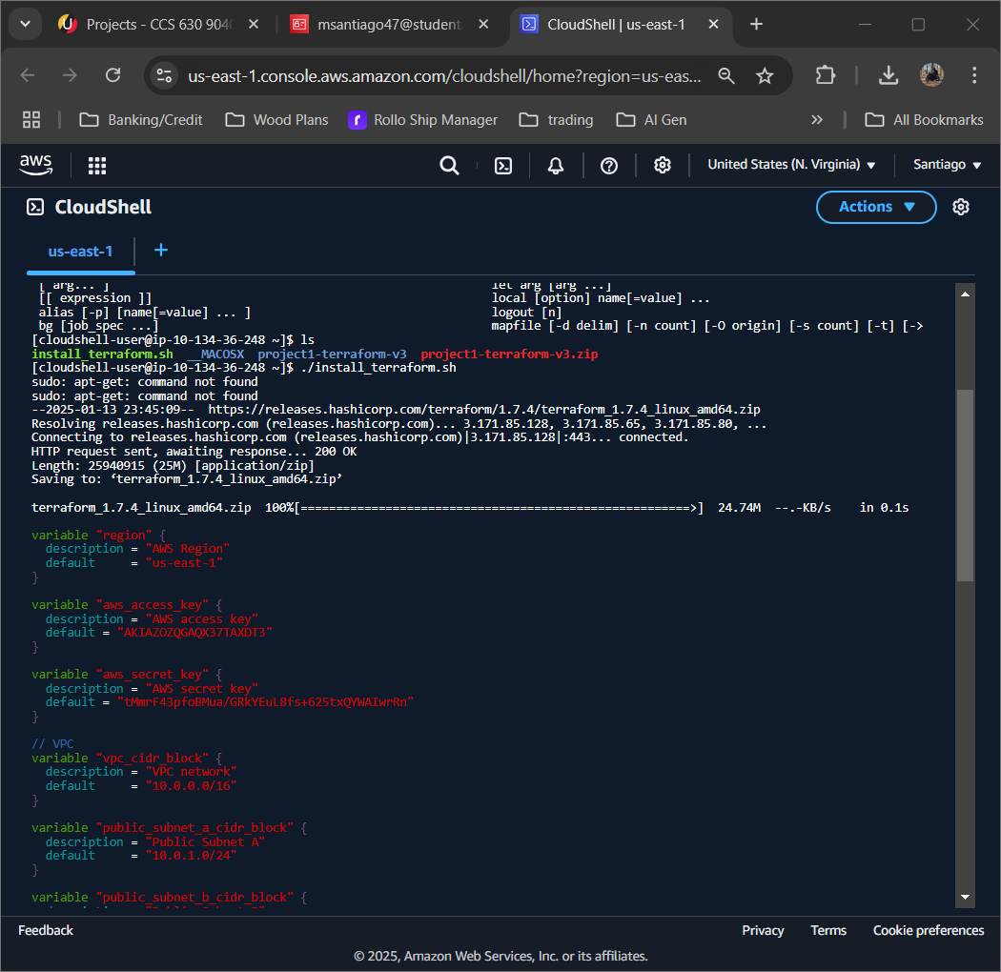
- Updated the ecs.tf file with my user ecsTaskExecutionRole information.
- Ran the following commands sequentially:
  - terraform init
  - terraform plan
  - terraform apply
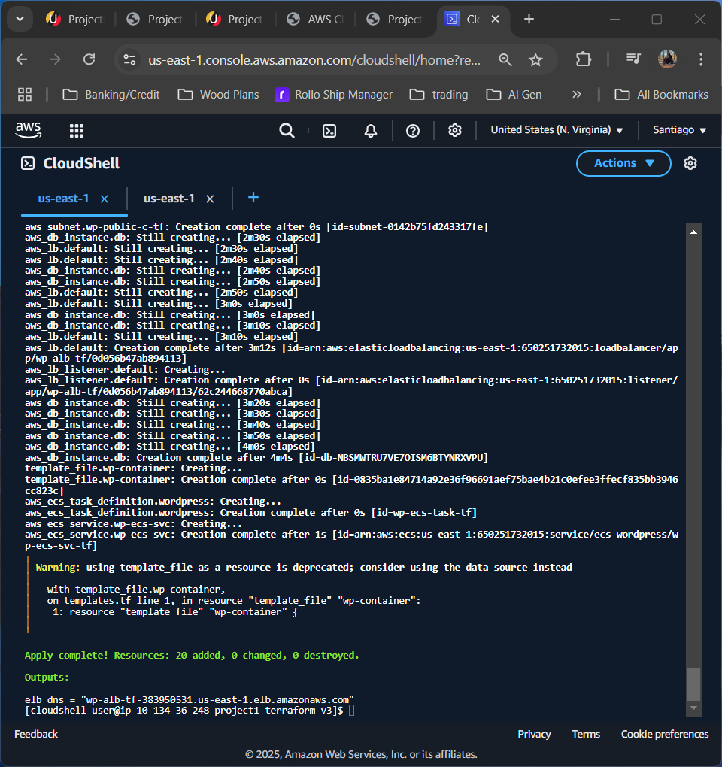
- Accessed WordPress using the URL given by Terraform.
  - wp-alb-tf-383950531.us-east-1.elb.amazonaws.com
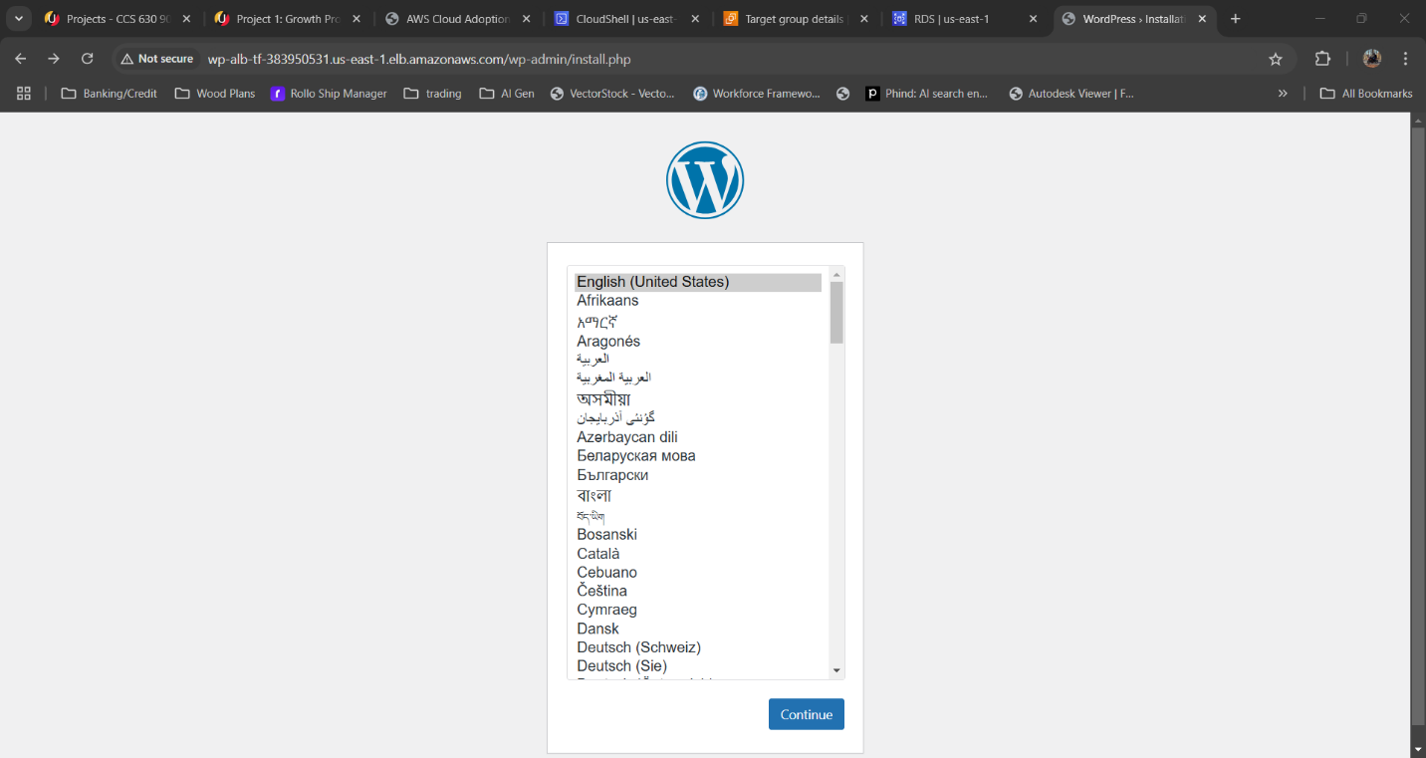
Section 4: Installing WordPress​
- Performed initial WordPress setup by creating admin account:
  - Site Title: BO Website
  - Username: admin
  - Password: Qwerty1234@
  - Email: msantiago47@student.umgc.edu
- Logged in using the new credentials.
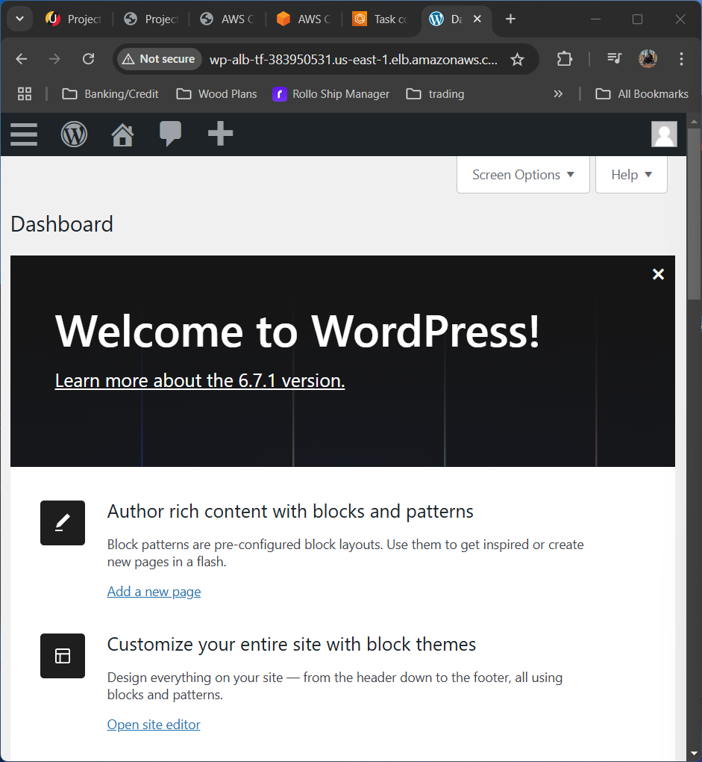
Section 5: Creating an AI Copilot​
- Signed up for Microsoft Copilot Studio.
- Created a new Copilot and upload the Electronic-Voting-Doc.docx for AI training.
- Tested functionality with the following question "What is VVPAT?" then publish the Copilot.
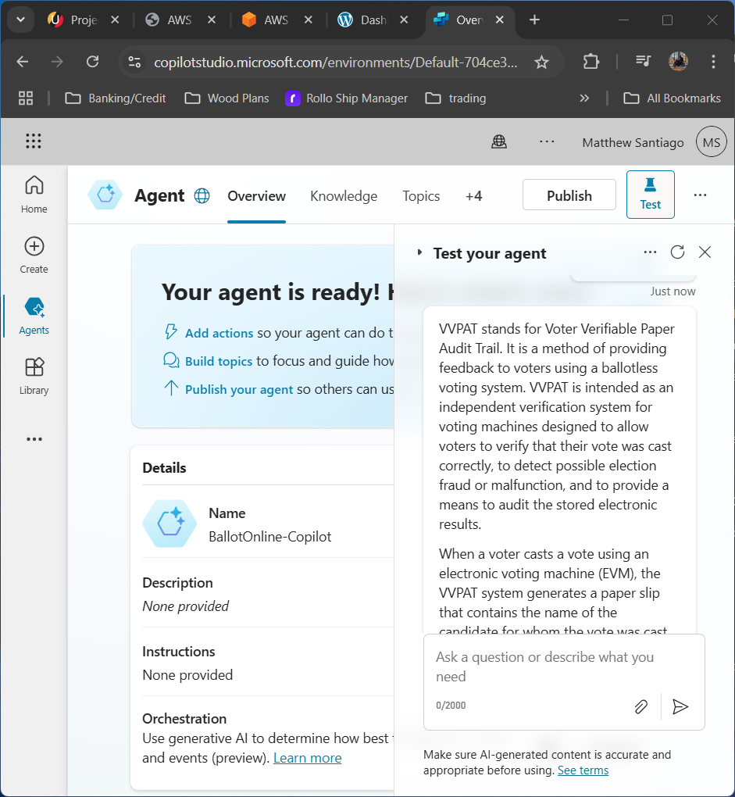
- Copied the html embed code.
Section 6: Embedding AI Copilot on WordPress​
- Logged into WordPress and created a new post.
- Added title “MS AI Copilot” and added a Custom HTML block.
- Pasted the Copilot html embed code and adjusted the height settings in the code to 400px then published the post.
- Previewed and tested the post to make sure the Copilot loaded and responded correctly with citations.
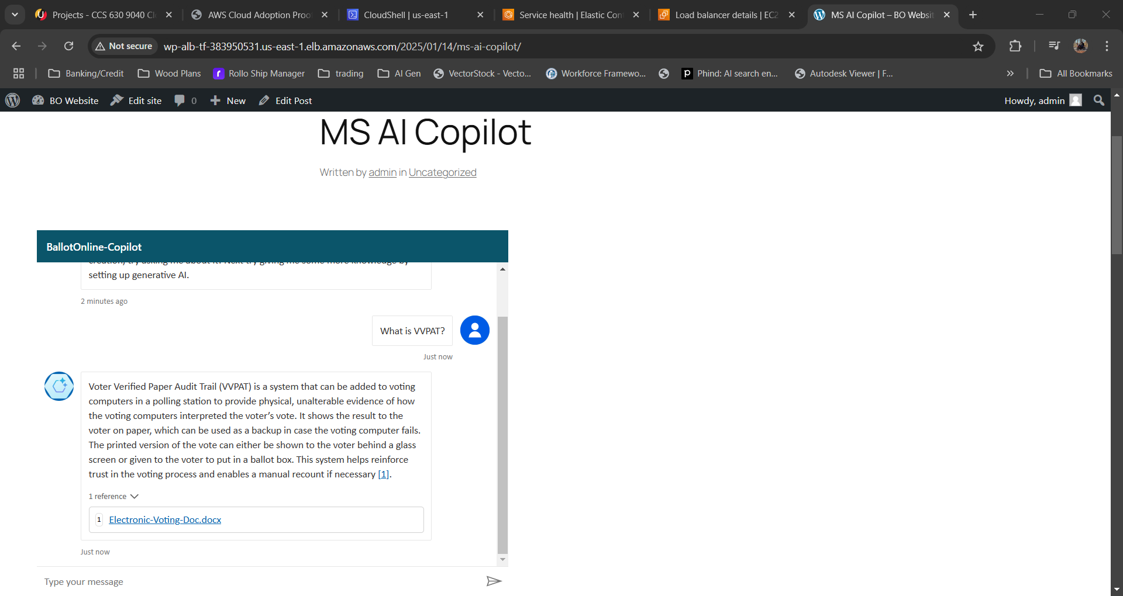

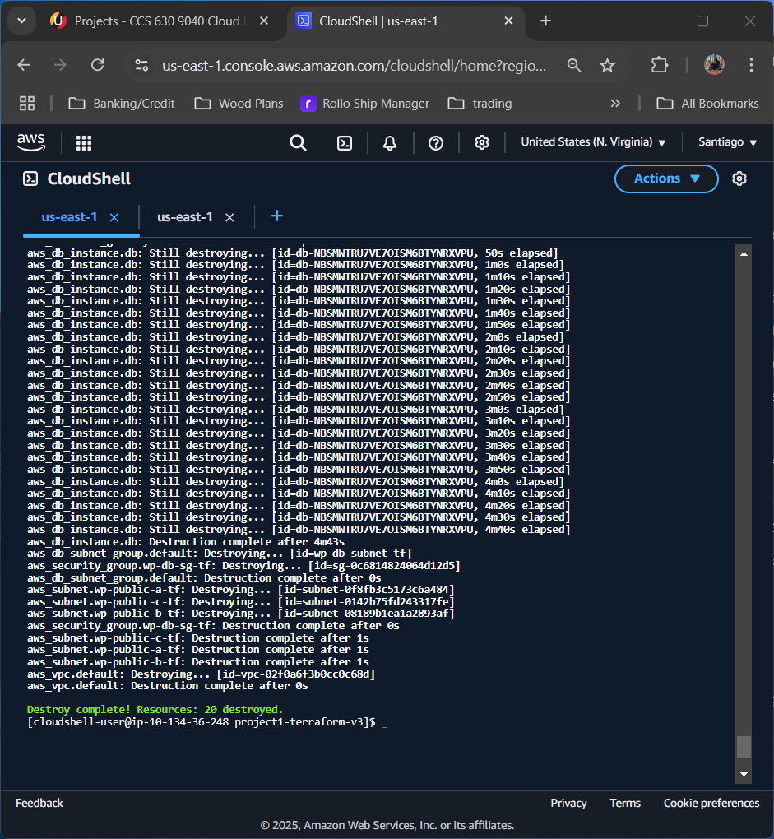

Lessons Learned:
This lab showed me how provision cloud infrastructure using TerraForm through AWS Cloudshell. By using AWS IAM to setting up access controls to the cloud resources showed the need to be detailed and make sure the correct accesses are given. AWS CloudShell was extremely powerful not only for running scripts to deploy infrastructure with TerraForm, but also helped me diagnose issues with deployment and find out that the ecsTaskExecutionRole variable in the ecs.tf was to blame for failed deployments. Also, using Microsoft Copilot to create a custom AI chat bot to use BallotOnline custom information was simple to set up and add to the new BallotOnline website.

