Project 1: Final Report

Matthew Santiago
University of Maryland Global Campus
CCS 670 Cloud Computing Capstone
Gohar Mukhtar
July 15, 2025

Executive Summary
In this report we will look at Microsoft Azure in order to determine if their services are a good fit for BallotOnline’s cloud migration. Initially I conducted research in order to determine the services of Microsoft Azure. The services reviewed were Azure overview, IAAS, PAAS, student hub, and technical documentation. After the research, I conducted 3 proof of concepts testing various aspects of Azure IAAS and PAAS. The first PoC was deploying a web server to host the BallotOnline site. The second PoC was testing Azure’s scalability. The third PoC was to deploy a web server that is scalable, using the CLI while managing the web content through Git. Throughout the testing I found that Azure functions well and is user friendly. The Azure platform simplified the process of configuring Virtual Machines. Also the command line was straightforward and intuitive. The Azure CLI sped up the deployment of a VM and can be used to automate tasks. Based on the information gathered for this report, Microsoft Azure would be a excellent choice for a cloud provider for BallotOnline.
Explore services and offerings of Microsoft Azure cloud
Microsoft Azure provides a cloud platform with many services that BallotOnline can utilize when migrating to the cloud. “Azure is a comprehensive, trusted cloud platform designed to help you efficiently manage all your infrastructure, data, analytics, and AI solutions in one unified place” (Microsoft, n.d.). Microsoft Azure has many benefits just like Amazon Web Services. Some of these benefits are: “global enterprise scale, enhanced security, compliance, backup and recovery capabilities, as well as simplified management across multicloud and distributed environments and the flexibility to choose your preferred technology, tools, and languages” (Microsoft, n.d.). Azure can be used from single users learning the cloud to full enterprise level customers providing services to customers all around the world. This section will briefly cover Azure's services in order for BallotOnline to be able to understand what Azure offers so executives can make an informed decision on the cloud provider to choose.
Once a Azure account is created, you will find yourself in the Azure portal. The portal is a one stop shop for all Azure services and management of infrastructure. Microsoft defines the Azure portal as “a web-based, unified console that lets you create and manage all your Azure resources” (Microsoft, 2024). Azure makes sure that the portal is resilient and always available by having it deployed in each datacenter so that customers will always be able to access the portal even if there is an outage in 1 datacenter (Microsoft, 2024). The portal is a graphical user interface that enables users the ability to “build, manage, and monitor everything from simple web apps to complex cloud deployments” (Microsoft, 2024).
Microsoft Azure has a lot of services, too many to cover, we will focus on some of the most popular services offered by briefly describing what they are and what they do. The first service is App service which is “a fully managed platform as a service (PaaS), to create web applications in popular languages like .NET, Java, Node.js, and Python” (Microsoft, 2025). The second service is Virtual Machines which is on-demand, scalable computing resources but you still need to maintain the virtual machine by performing tasks, such as configuring, patching, and installing the software that runs on it (Microsoft, 2025). The third service is Azure Functions which is “platform-as-a-service (PaaS) provider that provides event-driven and scheduled compute resources for Azure cloud services” (Microsoft, 2025). Lastly, the forth service is Azure Cosmos DB which is “Fully managed, distributed NoSQL, relational, and vector database for modern app development. High performance, high availability, and support for open-source PostgreSQL, MongoDB, and Apache Cassandra” (Microsoft, 2025).
Microsoft Azure also provides a service called student hub which is a site that has various training options for different work roles or paths so individuals new to Azure can learn how to use Azure effectively. The student hub provides: “interactive projects, self paced training, communities, and more” (Microsoft, 2025). In relation to the student hub, Azure also offers technical documentation. On the technical documentation site, it shows a list of services with links and a search bar (Microsoft, 2025). Once a user clicks a link it takes them to that specific service documentation for a in depth documentation of the service from admin info, how to manage the service, solutions, migrations, etc. This documentation site will me priceless in order for BallotOnline to properly set up and manage services effectively but also help answer questions and troubleshoot.
Provision and Prepare Web Server Virtual Machine
Lab Summary:
In this lab, I had to set up a web server through a virtual machine (VM) in Microsoft Azure. In the labe, I needed to create a VM then install a nginx server on the VM, after that I copied the BallotOnline web page files into the nginx server. After that process was complete, I verified the website was up and working.
Steps Taken:
- Provision VM
  - On the Azure Home dashboard created a Azure Virtual Machine.
  - Created a new Resource Group named CCS670PoCRG, named the VM BOWWebServer, selected Region West US 3, and chose the default Ubuntu Server image.
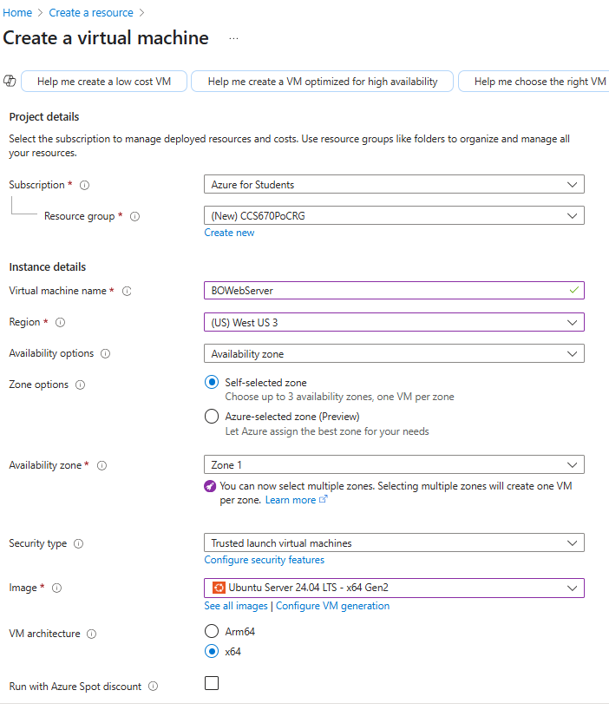
  - Selected size B1ls.
- Configure VM Settings
  - Authentication was SSH public key 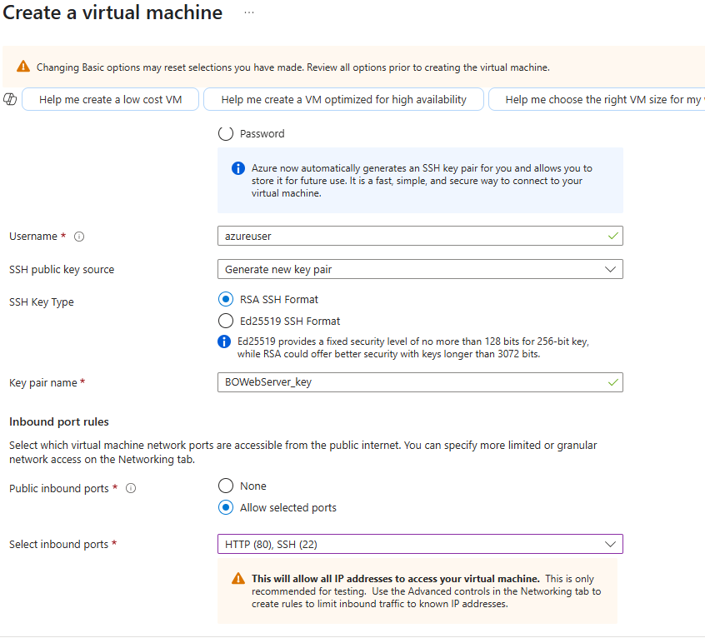
  - Enabled User data with #!/bin/bash nginx 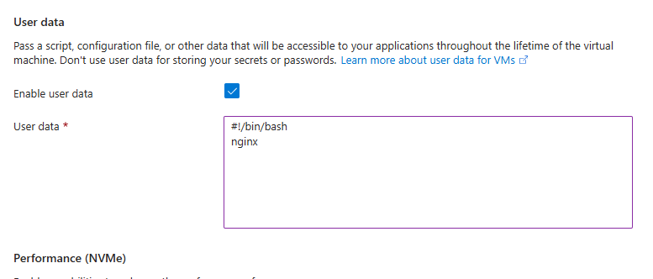
  - Reviewed settings, Created VM , downloaded the private key file.
- Connect and Prepare VM
  - After VM was provisioned, viewed the VM Overview.
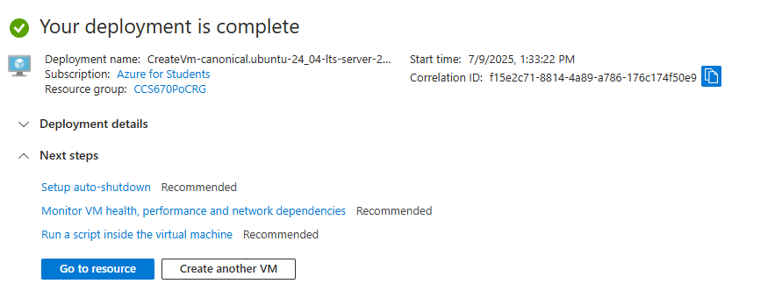
  - Opened Cloud Shell and uploaded the pem file.
  - Ran the SSH command to connect to the VM using the private key file.
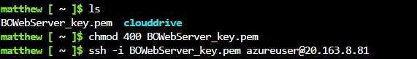
- Install Nginx and BallotOnline Web Page
  - Ran the following commands in Cloud Shell:
    - sudo apt-get update #update packages, wait till it finishes
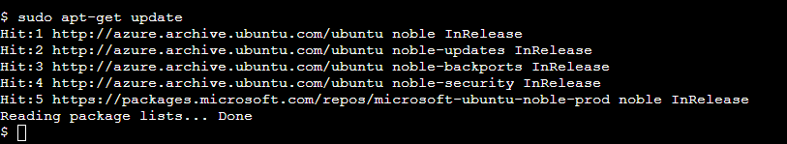
    - sudo apt-get install nginx #install nginx, press Y on prompt
    - ps -ef|grep nginx #make sure nginx is running
    - sudo mkdir -p /data/www #make directory for BO page install
    - cd /data/www #make that directory current
    - sudo wget bizballotonline.azurewebsites.net/website.zip #get BO website
    - sudo apt install unzip #install unzip package
    - sudo unzip website.zip -d /data/www/BallotOnline #unzip BO website
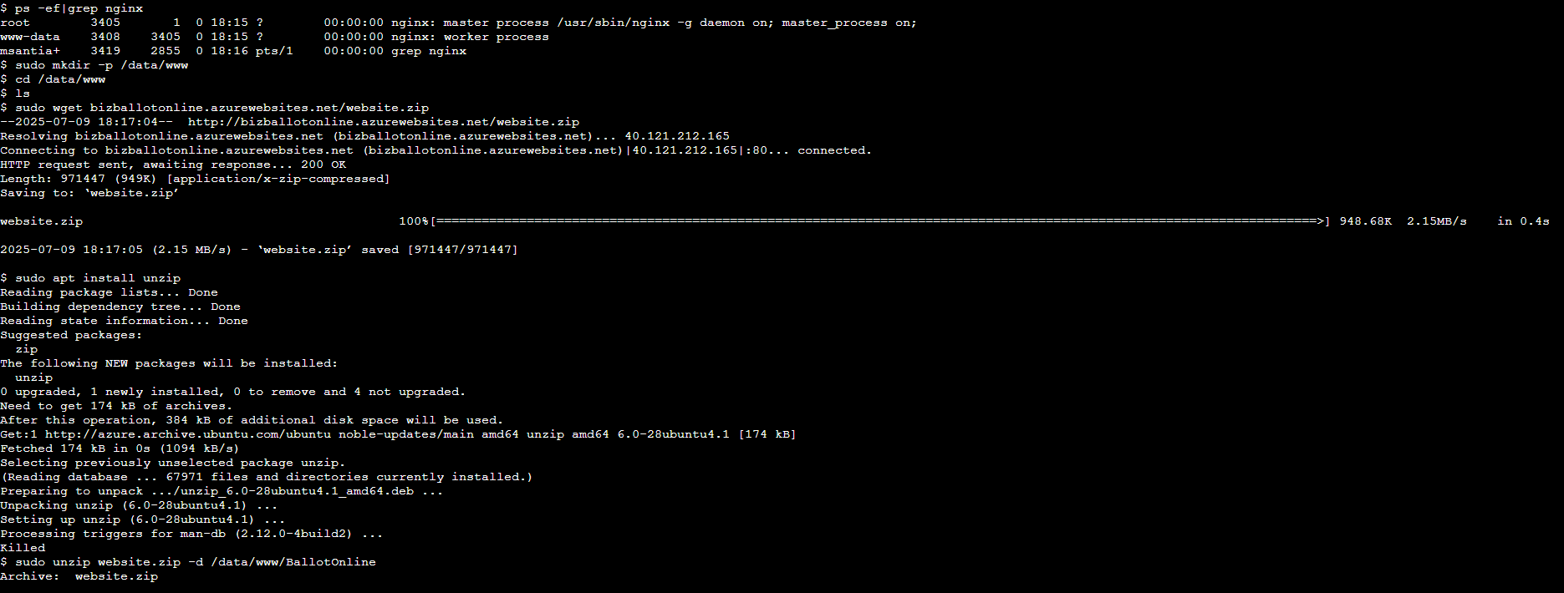
    - sudo chmod -R 755 /data/www/BallotOnline #modify data permissions
    - sudo mv /etc/nginx/nginx.conf /etc/nginx/nginx.conf.orig #save orig
    - sudo cp /data/www/BallotOnline/nginx.conf /etc/nginx/ #update conf
    - cat /etc/nginx/nginx.conf #verify update
    - sudo adduser --system --no-create-home --group nginx #add nginx user
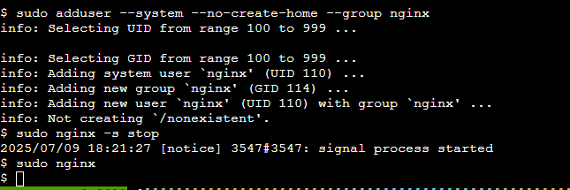
    - sudo nginx -s stop #stop nginx web server
    - sudo nginx #restart nginx web server
    - exit #disconnect from your instance
- Verification
  - Browsed to the VM’s public IP address and confirmed the BallotOnline web page.
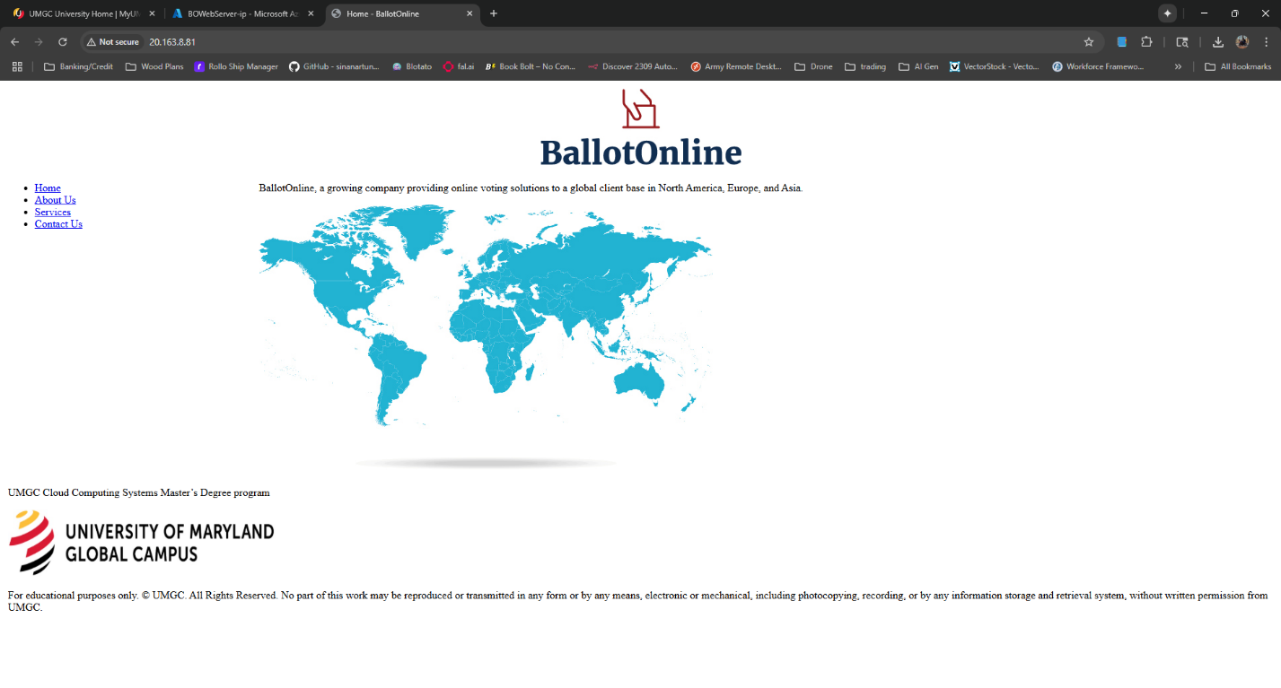
VM Public IP Address: 20.163.8.81

Lessons learned:
Completing this lab helped me better understand deploying virtual machines on Microsoft Azure. During the creation of the virtual machine, I needed to create a resource group as well. Creating this resource group was simple and quick but also showed how to manage resources within Azure. Finishing the deployment of the BOwebServer VM was also simple through the use of the GUI prompts Azure provides, but I did experience some difficulty when trying to choose the correct size for the VM and making sure the correct region and zone has that size available. Once the VM was deployed, the connection to the VM through the private key and cloudshell was straight forward. Running the commands for updating and setting up the nginx server was quick and provided me with invaluable practice in linux commands. After all the commands, updates, and directories were created, the upload and extraction of the website into Azure was seamless. Navigating to the IP address and seeing the webpage load showed a successful configuration and launch of the website. This hands on deployment improved my experience with Azure showing the simplicity of deployments on Azure. It also gave me skills to handle web hosting and simple cloud deployment for the future.
Create Azure VM Scale Set with Load Balancer lab
Lab Summary:
In this lab, I completed a proof of concept in Microsoft Azure by capturing a virtual machine deployment template and image, then deploying a VM Scale Set with a load balancer. This involved exporting the VM template, capturing the image, and configuring the scale set for high availability and load balancing.
Steps Taken:
- Capture Virtual Machine Deployment Template and Image
  - Opened the Overview screen of the VM, went to Automation, and Exported the template.
  - Downloaded the template, see part of the template below:
{
"$schema": "https://schema.management.azure.com/schemas/2019-04-01/deploymentTemplate.json#",
"contentVersion": "1.0.0.0",
"parameters": {
"virtualMachines_BOWebServer_name": {
"defaultValue": "BOWebServer",
"type": "String"
},
"disks_BOWebServer_OsDisk_1_abbeca11914e41ceae147fa2ee1a34ae_externalid": {
"defaultValue": "/subscriptions/da1b8f4e-e2c8-4189-a3a6-aee686c9bb7c/resourceGroups/CCS670PoCRG/providers/Microsoft.Compute/disks/BOWebServer_OsDisk_1_abbeca11914e41ceae147fa2ee1a34ae",
"type": "String"
},
"networkInterfaces_bowebserver808_z2_externalid": {
"defaultValue": "/subscriptions/da1b8f4e-e2c8-4189-a3a6-aee686c9bb7c/resourceGroups/CCS670PoCRG/providers/Microsoft.Network/networkInterfaces/bowebserver808_z2",
"type": "String"
}
},
  - Went back to the VM Overview screen, then captured an image of the VM.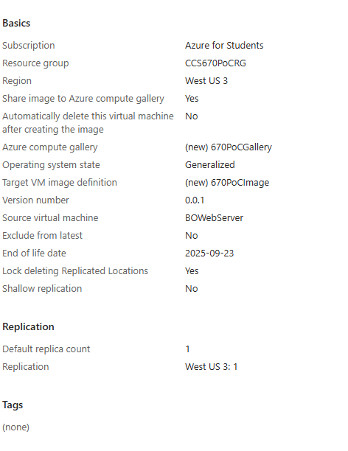
  - After the image was done being captured I deleted the VM.
- Create Azure VM Scale Set with Load Balancer
  - Created a Virtual Machine Scale Set and chose the resource group CCS670PoCRG.
  - Named the scale set 670PoCScaleSet, selected Region West US 3, Availability Zone 2.3, and Orchestration Mode Uniform.
  - Selected the shared BO web server image 670PoCImage from 670PoCGallery, set Size to Standard B1s.
  - Chose OS Disk Type Standard SSD, created a new virtual network, edited the network interface to allow HTTP(80) traffic, and disabled Public IP Address.
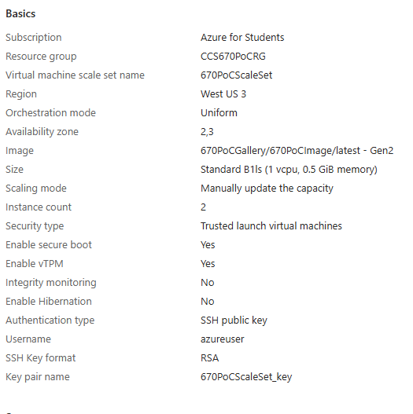
  - Selected Azure load balancer, created a load balancer named CCS670PoCLB, set Instance count to 2 and enabled application health monitoring.
  - Enabled User data to start the nginx web server on new instances.
  - Once the scale set was deployed I verified that two instances of the server were deployed.
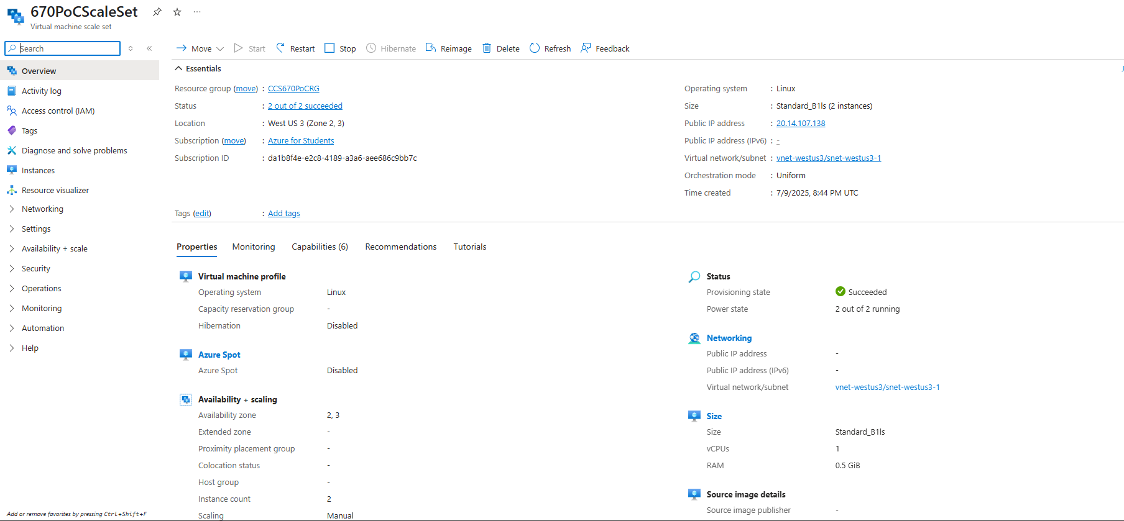
  - Browsed to the scale set’s public IP address (20.14.107.138) and confirmed the BallotOnline web page was active.
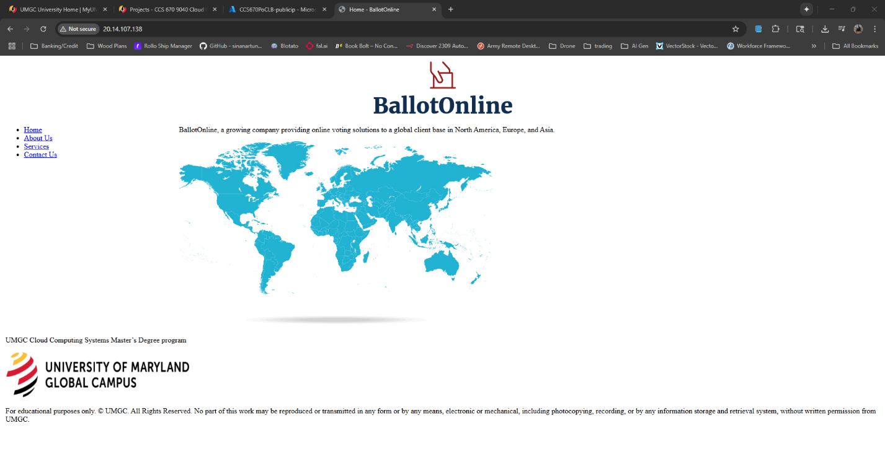
  - Explored Properties and Monitoring tabs and observed metrics like CPU, Network, Disk, and Memory.
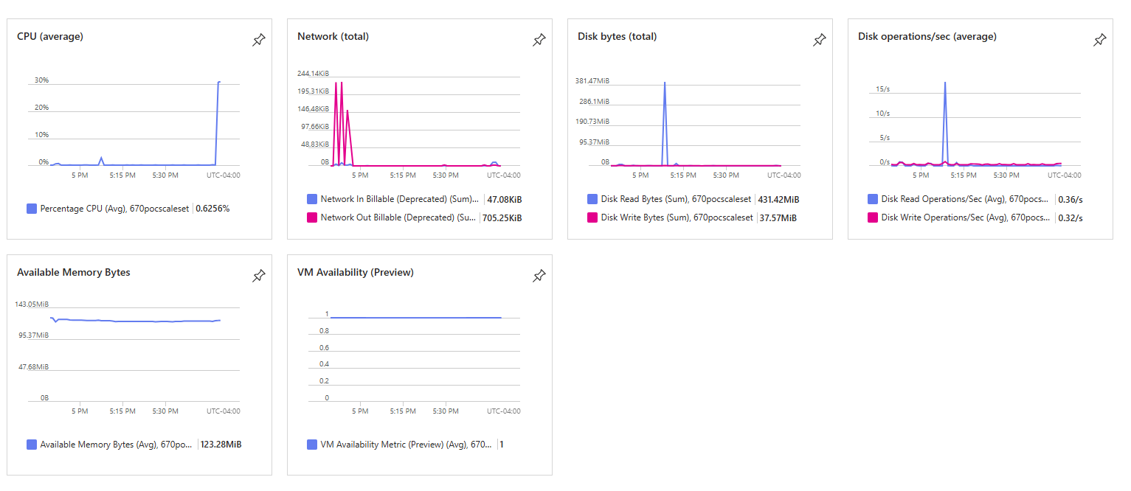

Lessons learned:
Completing this lab helped me to understand how to use Microsoft Azure in order to build a scalable cloud infrastructure. I first downloaded a VM template from the VM we created in a previous lab. Then captured a VM image of that same VM. Once I confirmed the image was properly saved, I created a Scale Set VM and enabled the newly created image to be used when it is created. The scale set VM was also configured to use a load balancer. I learned how to create reusable configurations by using the template exporter and image creation for properly configured deployments. Doing these 2 processes will enable the deployment of nginx preconfigured deployments quicker and streamlined. After the deployment of the scale set and ensuring 2 instances were running, I monitored the CPU and Disk metrics which helped show how performance metrics are captured and can be used to increase performance in the future.
Deploy Azure PaaS Web Application
Lab Summary:
In this lab, I was able to learn and use the Azure Platform as a Service (PaaS) through the deployment of the BallotOnline website and git repository. I was able to deploy the web site through the Azure CLI and simultaneously set up a Git repository for continuous deployment to simplify updates.

Steps Taken:
- Provision Azure Web App using Azure CLI
  - Created a Resource Group
    - az group create --name CCS670WebAppRG --location eastus
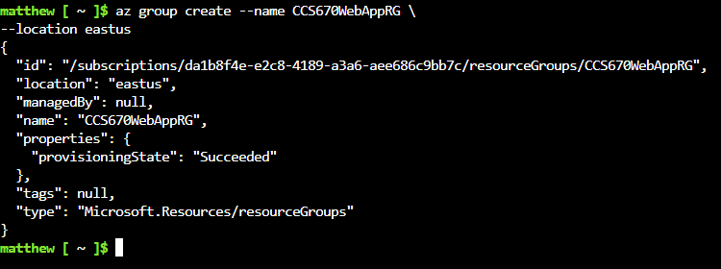
  - Created an App Service Plan
    - az appservice plan create --name CCS670WebAppPlan --resource-group CCS670WebAppRG --sku B1 --is-linux
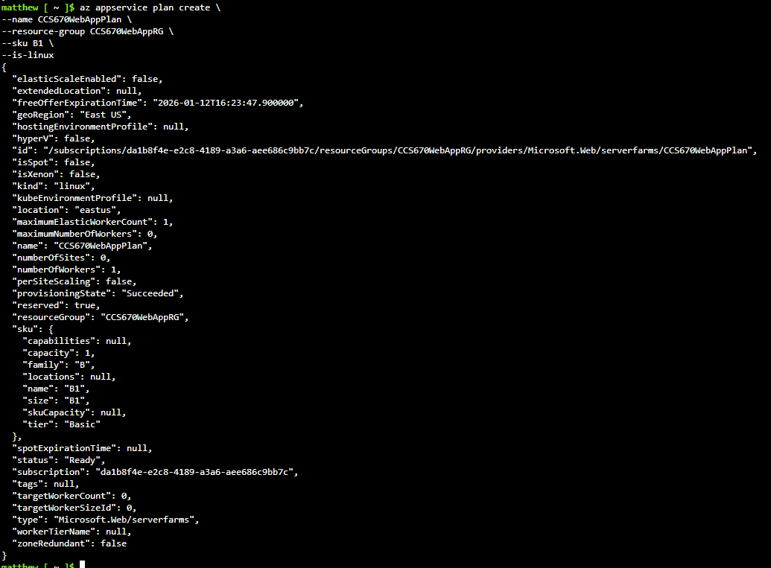
  - Created a Web App
    - az webapp create --name CCS670WebAppMWS --resource-group CCS670WebAppRG --plan CCS670WebAppPlan --runtime "PHP|8.1" --deployment-local-git

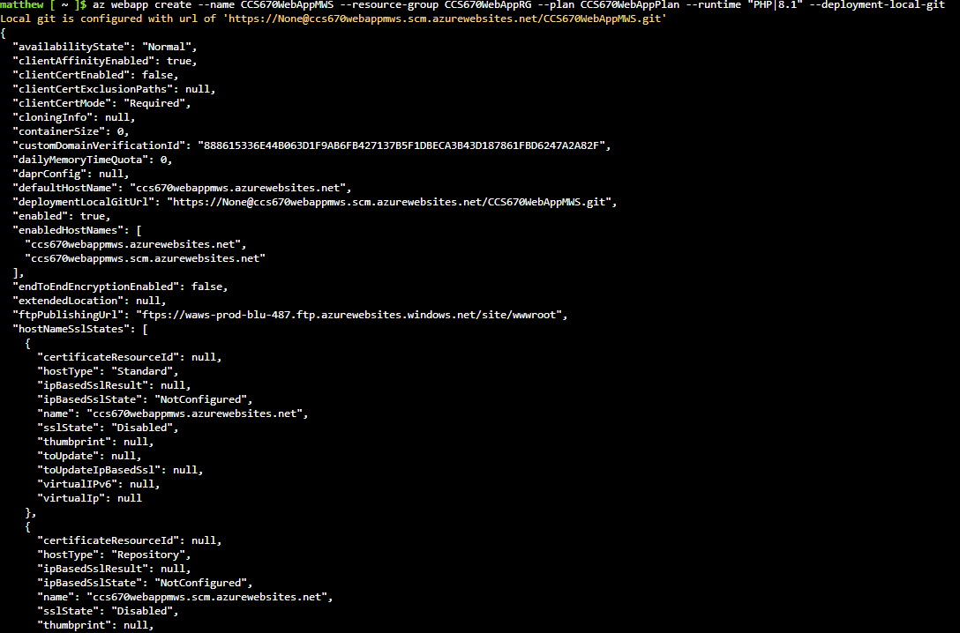

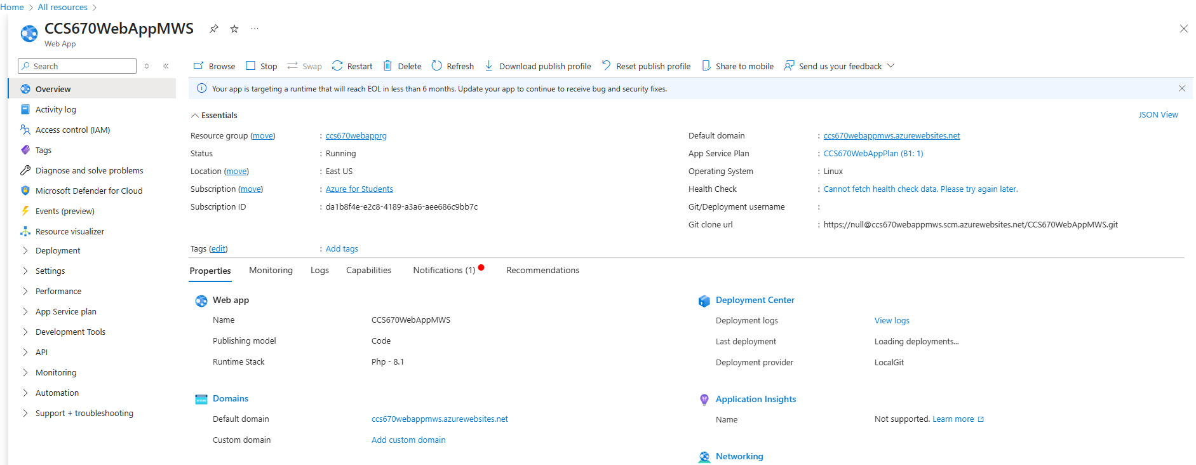
- Set Up Set up Continuous Deployment
  - Download site and configure Local Git Repository
    - wget www.ballotonline.azurewebsites.net/website.zip and unzip website.zip -d websitePHP
    - Initialized Git
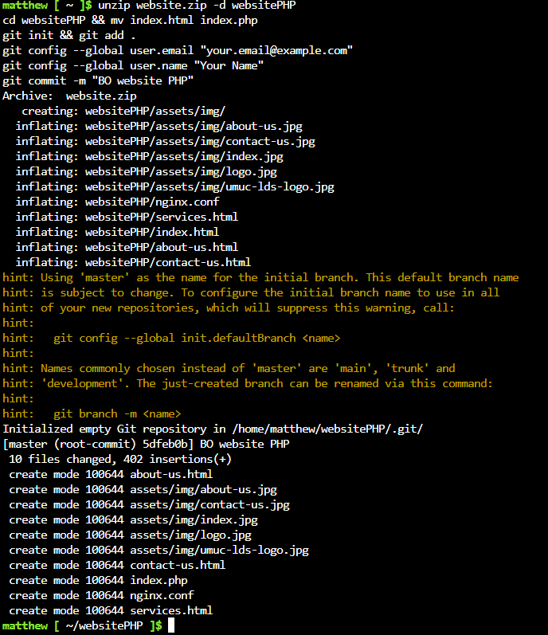
  - az webapp deployment user set --user-name ccs670studentMWS --password ccs670Password
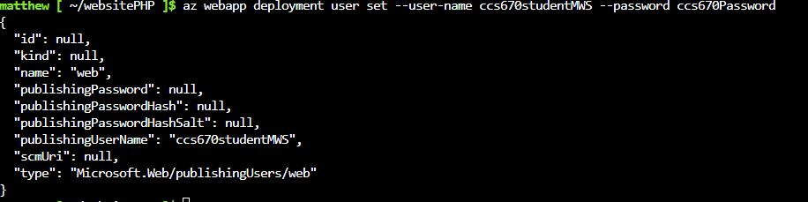
  - local git repository deployed to the git remote repository on my Web app.
    - https://ccs670studentMWS@CCS670WebAppMWS.scm.azurewebsites.net/CCS670WebAppMWS.git
    - Pushed the BallotOnline website code to my Web app
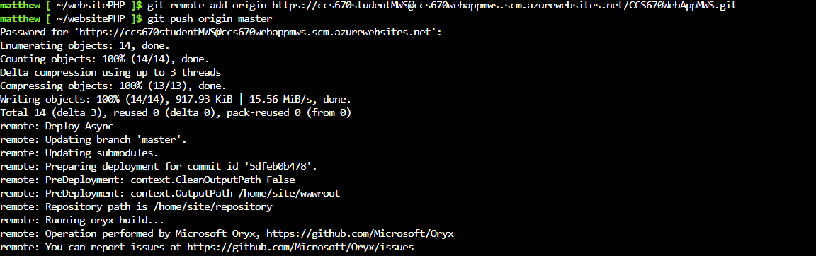
  - Checked Deployment Center logs and went to the site to confirmed it was deployed.
    - https://CCS670WebAppMWS.azurewebsites.net

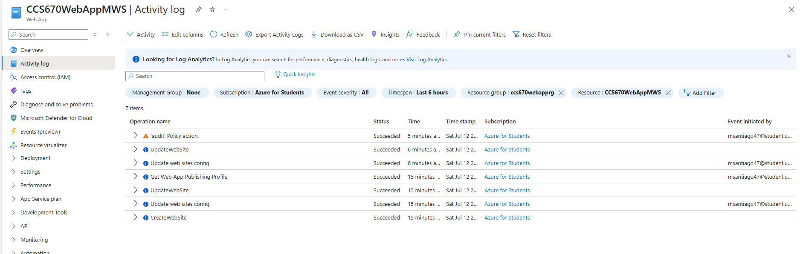
- Explored Azure Web Apps Features
  - Scaled up to Standard S2 plan and explored autoscale settings with rules-based scaling.
  - Monitored metrics under the Monitoring section
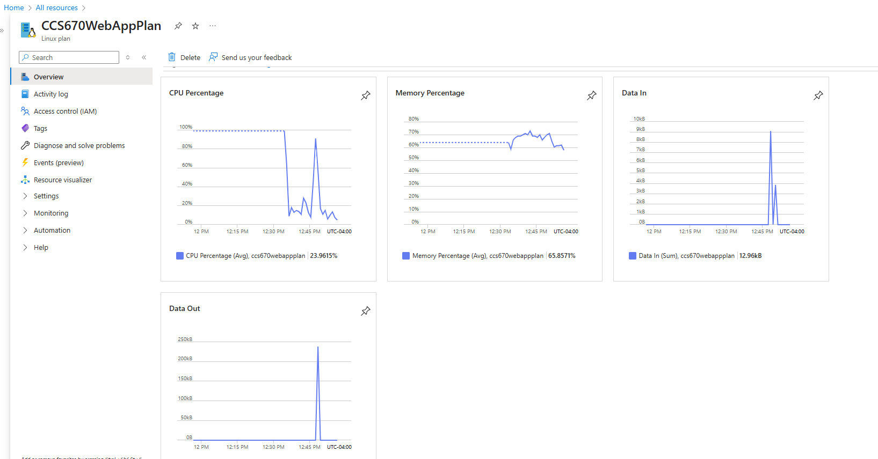
Web App URL
Azure Web App URL: https://CCS670WebAppMWS.azurewebsites.net

Lessons learned:
As I completed this lab, I was able to gain experience in utilizing the Azure CLI to deploy a website and Git repository. Using the CLI to deploy a Git repository to update code for the website was very intriguing. The ease and simplicity of deployment helped me see how that can be used in full scale deployments to quickly update code and increase productivity. Using the CLI to set autoscaling ensures that the site will have redundancy and high availability. The use of the CLI, was much quicker deployment than through the GUI interface and will be used to automate the deployment of future systems.
The ability to change scaling plans was very easy and simple, and using the rules based autoscaling gave more control on how and when I would want the instances to scale when required without manual intervention. While looking at the monitoring section it provided easy to read metrics that helped me choose the best rules based scaling to pick. Completing this lab has given me a new view on cloud deployments in Azure. Everything was simple, quick and easily able to be troubleshoot when needed. I believe this lab has helped me prepare to handle real world cloud deployments by showing me how to deploy through the CLI and Git while also monitoring metrics to choose the correct scaling metrics.
Comparison of AWS IaaS/PaaS services vs. Azure
In this section, we will compare IAAS and PAAS between Amazon Web Services and Azure. Both services have their followers and a good global market share. “AWS commands 32% of the market, while Azure follows close behind with 23%” (Pykes, 2024). Do to both being global leaders as cloud providers there services are similar. Although, because AWS as “the first major cloud provider, AWS gained a significant advantage by establishing early leadership in cloud computing. This allowed AWS to pioneer many fundamental cloud services and set industry standards.” (Pykes, 2024). Azure on the other hand does provide similar services to AWS, but they are focused more in integration with previous Microsoft products. “Azure seamlessly integrates with Microsoft's broad ecosystem, encompassing Windows Server, Active Directory, Office 365, and Microsoft 365” (Pykes, 2024).
Comparing IAAS between Amazon Web Services and Azure, they both offer virtual machines, storage and network resources. IAAS is defined as “a business model that delivers IT infrastructure like compute, storage, and network resources on a pay-as-you-go basis over the internet” (Amazon Web Services, 2025). Azure states that “SQL Server on Azure Virtual Machines performs up to 57 percent faster and costs up to 54 percent less than AWS EC2” (Microsoft, 2025). Although, Datacamp states that “AWS might be more suitable for comprehensive infrastructure-as-a-service (IaaS) capabilities and a broad toolset” (Pykes, 2024). Due to both cloud providers providing excellent services it seems to come down to if BallotOnline will need to move closer to a Microsoft environment or will BallotOnline need a more broad toolset to accomplish different specific tasks.
Comparing PAAS between Amazon Web Services and Azure, both once again provide services that let you launch instances that you do not manage but runs the application. Azure defines PAAS as “a cloud computing model that provides developers with a platform to build, deploy, and manage applications without worrying about the underlying infrastructure” (Microsoft, 2025). Datacamp states “Azure is a top choice for robust Platform-as-a-Service (PaaS) solutions” (Pykes, 2024). When using Azure App Service compared to using AWS Elastic Beanstalk in proof of concept testing, Azure app service felt more intuitive and streamlined making the process simpler and smooth. The use of AWS Elastic Beanstalk in the previous testing was still simple walk through but the configuration felt to take longer and was less intuitive.
Recommendation for BallotOnline regarding using Azure
The recommendation for BallotOnline regarding Azure is that Azure is a great choice for a cloud provider. Throughout testing of Azure’s services I found Azure to be simple to understand and fast to provision instances as compared to AWS. This holds true to Azure’s statement “SQL Server on Azure Virtual Machines performs up to 57 percent faster and costs up to 54 percent less than AWS EC2” (Microsoft, 2025). Azure also states “More than 95 percent of Fortune 500 companies use Azure” (Microsoft, 2025). Due to Azure being integrated into Microsoft environments leads to the intuitive nature and quick learning of their cloud for users that use Microsoft products. Because of this it is recommended for BallotOnline to choose Azure as the cloud provider for migration.
Conclusion
In conclusion, we have shown in this report that Microsoft Azure is a great choice for BallotOnline to use to migrate into the cloud. It is comparable with Amazon Web Services on features and services. Through the proof of concept testing we found it has been easier to navigate and deploy than AWS. Because Azure is integrated into the Microsoft environment, windows administrators will be able to intuitively understand how to use this cloud provider. Also azure is trusted by other fortune 500 companies, which leads to say it is robust and trustworthy cloud provider that provides excellent service. Lastly because most companies use Microsoft operating systems, devices, and software, the integration with azure will make it an easy transition to continuing using those services while migrating to the cloud.

References
Amazon Web Services. (2025). What is IaaS (Infrastructure as a Service)? From Amazon Web Services: https://aws.amazon.com/what-is/iaas/
Microsoft. (2024, Sept 19). What is the Azure portal? From Azure: https://learn.microsoft.com/en-us/azure/azure-portal/azure-portal-overview
Microsoft. (2025). App Service documentation. From Azure: https://learn.microsoft.com/en-us/azure/app-service/
Microsoft. (2025). Azure Cosmos DB documentation. From Azure: https://learn.microsoft.com/en-us/azure/cosmos-db/
Microsoft. (2025). Azure Functions documentation. From Azure: https://learn.microsoft.com/en-us/azure/azure-functions/
Microsoft. (2025). Azure vs. AWS. From Azure: https://azure.microsoft.com/en-us/pricing/azure-vs-aws
Microsoft. (2025). Student Hub. From Azure: https://learn.microsoft.com/en-us/training/student-hub/
Microsoft. (2025). Technical documentation. From Azure: https://learn.microsoft.com/en-us/docs/
Microsoft. (2025, March 27). Virtual machines in Azure. From Azure: https://learn.microsoft.com/en-us/azure/virtual-machines/overview
Microsoft. (2025). What is platform as a service (PaaS)? From Azure: https://azure.microsoft.com/en-us/resources/cloud-computing-dictionary/what-is-paas
Microsoft. (n.d.). What is Azure? From Azure: https://azure.microsoft.com/en-us/explore/
Pykes, K. (2024, July 15). AWS vs Azure: An In-Depth Comparison of the Two Leading Cloud Services. From Datacamp: https://www.datacamp.com/blog/aws-vs-azure

