Project 1: Lab 1 Report

Matthew Santiago
University of Maryland Global Campus
CCS 670 Cloud Computing Capstone
Gohar Mukhtar
July 10, 2025

Lab Summary:
In this lab, I had to set up a web server through a virtual machine (VM) in Microsoft Azure. In the labe, I needed to create a VM then install a nginx server on the VM, after that I copied the BallotOnline web page files into the nginx server. After that process was complete, I verified the website was up and working.
Steps Taken:
- Provision VM
  - On the Azure Home dashboard created a Azure Virtual Machine.
  - Created a new Resource Group named CCS670PoCRG, named the VM BOWWebServer, selected Region West US 3, and chose the default Ubuntu Server image.
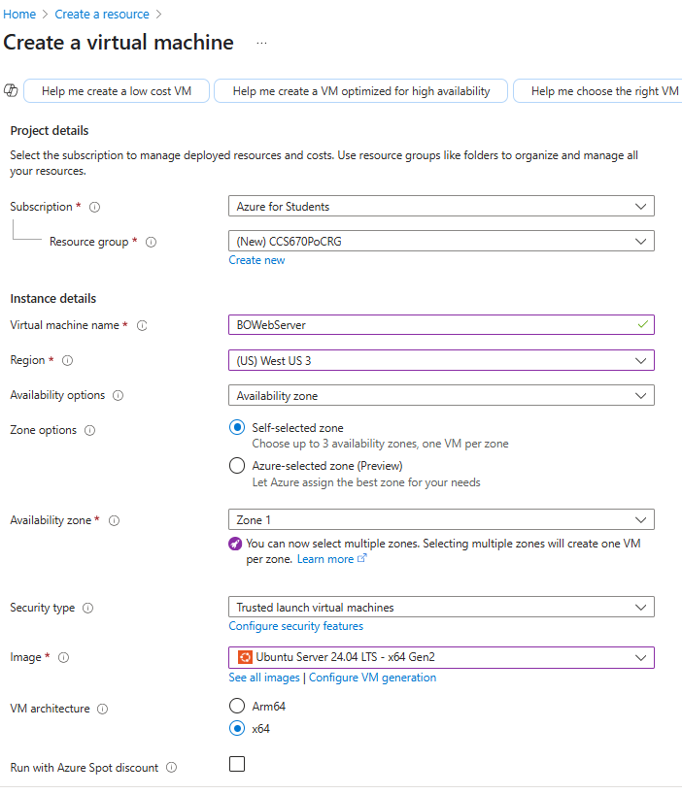
  - Selected size B1ls.
- Configure VM Settings
  - Authentication was SSH public key 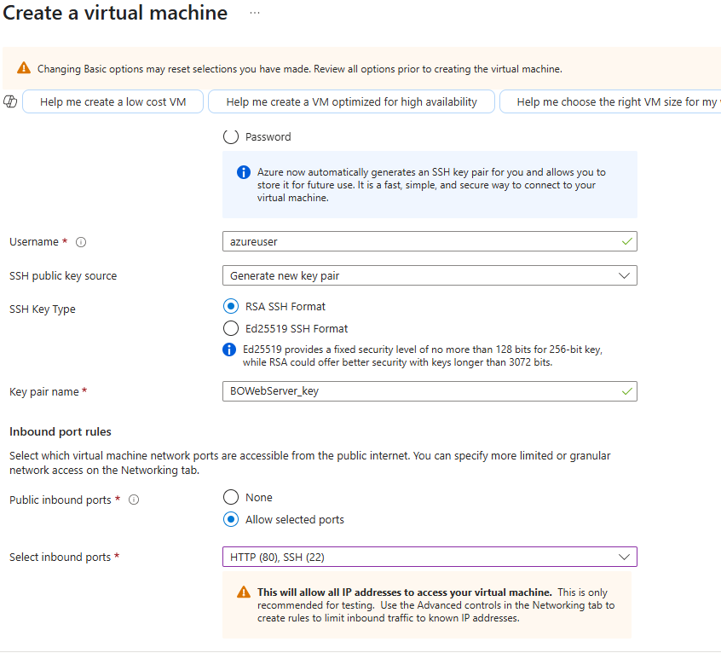
  - Enabled User data with #!/bin/bash nginx 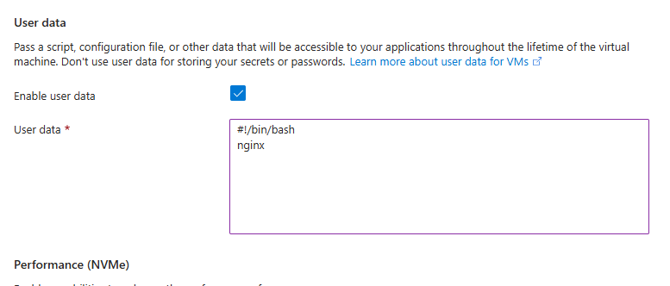
  - Reviewed settings, Created VM , downloaded the private key file.
- Connect and Prepare VM
  - After VM was provisioned, viewed the VM Overview.
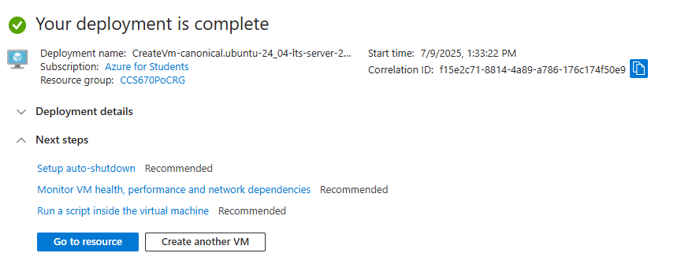
  - Opened Cloud Shell and uploaded the pem file.
  - Ran the SSH command to connect to the VM using the private key file.
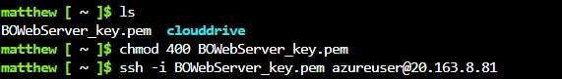
- Install Nginx and BallotOnline Web Page
  - Ran the following commands in Cloud Shell:
    - sudo apt-get update #update packages, wait till it finishes
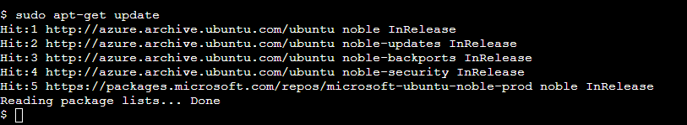
    - sudo apt-get install nginx #install nginx, press Y on prompt
    - ps -ef|grep nginx #make sure nginx is running
    - sudo mkdir -p /data/www #make directory for BO page install
    - cd /data/www #make that directory current
    - sudo wget bizballotonline.azurewebsites.net/website.zip #get BO website
    - sudo apt install unzip #install unzip package
    - sudo unzip website.zip -d /data/www/BallotOnline #unzip BO website
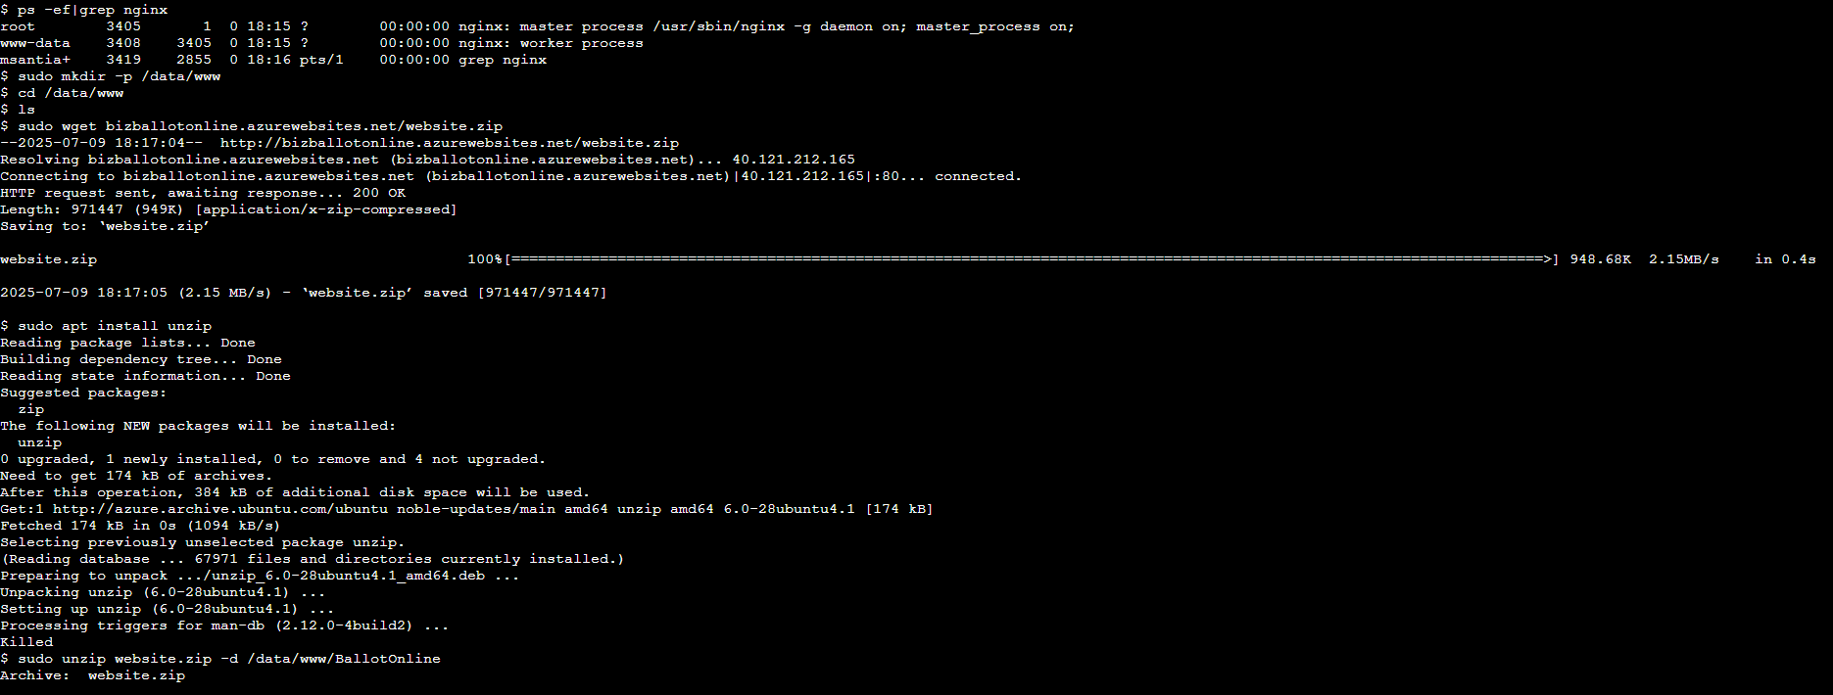
    - sudo chmod -R 755 /data/www/BallotOnline #modify data permissions
    - sudo mv /etc/nginx/nginx.conf /etc/nginx/nginx.conf.orig #save orig
    - sudo cp /data/www/BallotOnline/nginx.conf /etc/nginx/ #update conf
    - cat /etc/nginx/nginx.conf #verify update
    - sudo adduser --system --no-create-home --group nginx #add nginx user
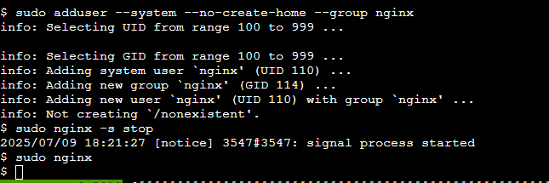
    - sudo nginx -s stop #stop nginx web server
    - sudo nginx #restart nginx web server
    - exit #disconnect from your instance
- Verification
  - Browsed to the VM’s public IP address and confirmed the BallotOnline web page.
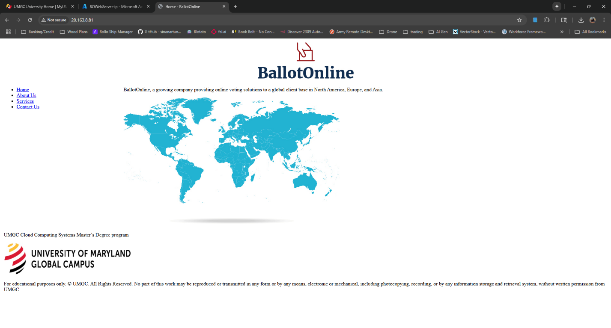
VM Public IP Address: 20.163.8.81

Lessons learned:
Completing this lab helped me better understand deploying virtual machines on Microsoft Azure. During the creation of the virtual machine, I needed to create a resource group as well. Creating this resource group was simple and quick but also showed how to manage resources within Azure. Finishing the deployment of the BOwebServer VM was also simple through the use of the GUI prompts Azure provides, but I did experience some difficulty when trying to choose the correct size for the VM and making sure the correct region and zone has that size available. Once the VM was deployed, the connection to the VM through the private key and cloudshell was straight forward. Running the commands for updating and setting up the nginx server was quick and provided me with invaluable practice in linux commands. After all the commands, updates, and directories were created, the upload and extraction of the website into Azure was seamless. Navigating to the IP address and seeing the webpage load showed a successful configuration and launch of the website. This hands on deployment improved my experience with Azure showing the simplicity of deployments on Azure. It also gave me skills to handle web hosting and simple cloud deployment for the future.

