Project 1: Lab 2 Report

Matthew Santiago
University of Maryland Global Campus
CCS 670 Cloud Computing Capstone
Gohar Mukhtar
July 11, 2025

Lab Summary:
In this lab, I completed a proof of concept in Microsoft Azure by capturing a virtual machine deployment template and image, then deploying a VM Scale Set with a load balancer. This involved exporting the VM template, capturing the image, and configuring the scale set for high availability and load balancing.
Steps Taken:
- Capture Virtual Machine Deployment Template and Image
  - Opened the Overview screen of the VM, went to Automation, and Exported the template.
  - Downloaded the template, see part of the template below:
{
"$schema": "https://schema.management.azure.com/schemas/2019-04-01/deploymentTemplate.json#",
"contentVersion": "1.0.0.0",
"parameters": {
"virtualMachines_BOWebServer_name": {
"defaultValue": "BOWebServer",
"type": "String"
},
"disks_BOWebServer_OsDisk_1_abbeca11914e41ceae147fa2ee1a34ae_externalid": {
"defaultValue": "/subscriptions/da1b8f4e-e2c8-4189-a3a6-aee686c9bb7c/resourceGroups/CCS670PoCRG/providers/Microsoft.Compute/disks/BOWebServer_OsDisk_1_abbeca11914e41ceae147fa2ee1a34ae",
"type": "String"
},
"networkInterfaces_bowebserver808_z2_externalid": {
"defaultValue": "/subscriptions/da1b8f4e-e2c8-4189-a3a6-aee686c9bb7c/resourceGroups/CCS670PoCRG/providers/Microsoft.Network/networkInterfaces/bowebserver808_z2",
"type": "String"
}
},
  - Went back to the VM Overview screen, then captured an image of the VM.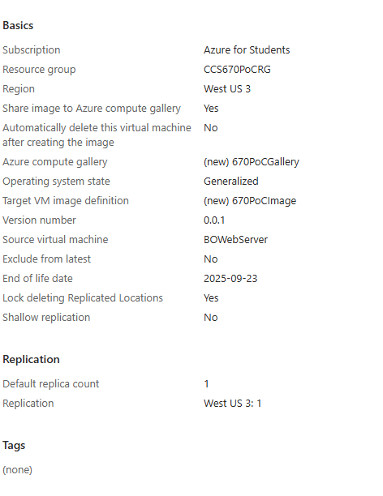
  - After the image was done being captured I deleted the VM.
- Create Azure VM Scale Set with Load Balancer
  - Created a Virtual Machine Scale Set and chose the resource group CCS670PoCRG.
  - Named the scale set 670PoCScaleSet, selected Region West US 3, Availability Zone 2.3, and Orchestration Mode Uniform.
  - Selected the shared BO web server image 670PoCImage from 670PoCGallery, set Size to Standard B1s.
  - Chose OS Disk Type Standard SSD, created a new virtual network, edited the network interface to allow HTTP(80) traffic, and disabled Public IP Address.
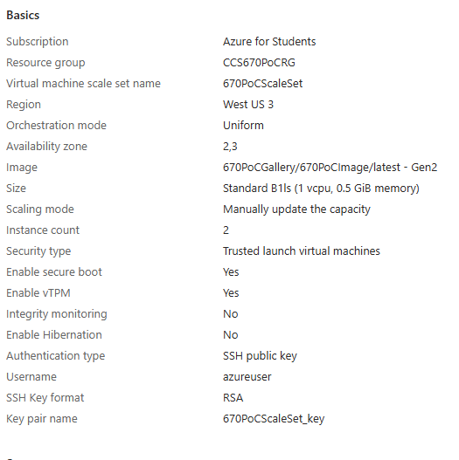
  - Selected Azure load balancer, created a load balancer named CCS670PoCLB, set Instance count to 2 and enabled application health monitoring.
  - Enabled User data to start the nginx web server on new instances.
  - Once the scale set was deployed I verified that two instances of the server were deployed.
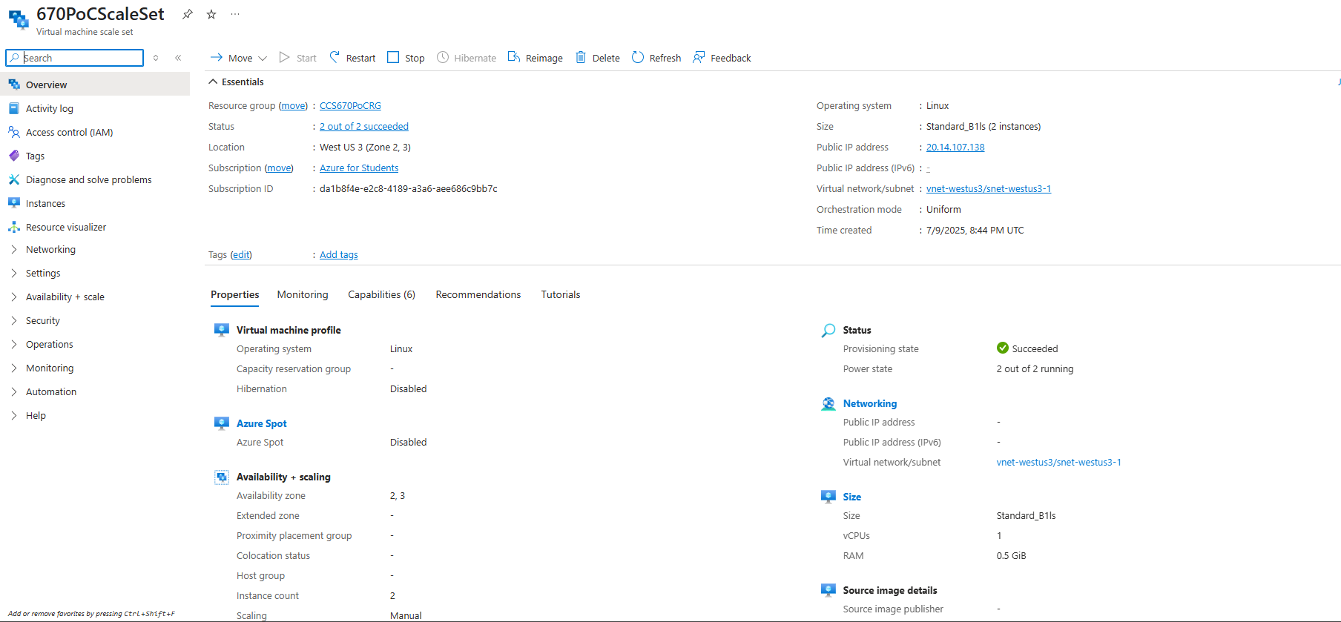
  - Browsed to the scale set’s public IP address (20.14.107.138) and confirmed the BallotOnline web page was active.
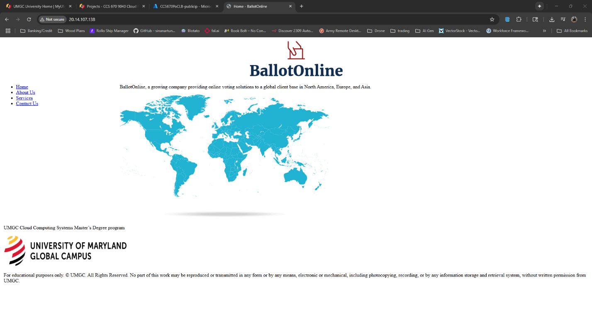
  - Explored Properties and Monitoring tabs and observed metrics like CPU, Network, Disk, and Memory.
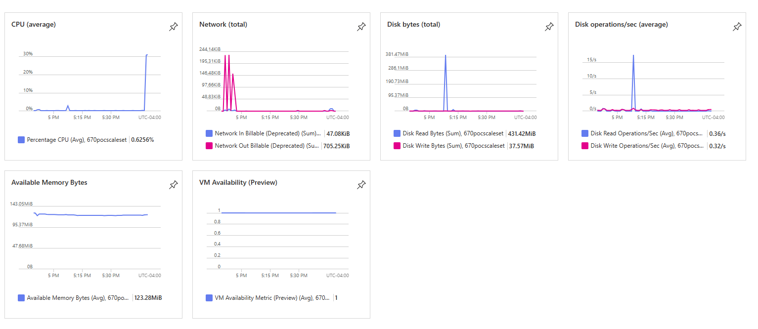

Lessons learned:
Completing this lab helped me to understand how to use Microsoft Azure in order to build a scalable cloud infrastructure. I first downloaded a VM template from the VM we created in a previous lab. Then captured a VM image of that same VM. Once I confirmed the image was properly saved, I created a Scale Set VM and enabled the newly created image to be used when it is created. The scale set VM was also configured to use a load balancer. I learned how to create reusable configurations by using the template exporter and image creation for properly configured deployments. Doing these 2 processes will enable the deployment of nginx preconfigured deployments quicker and streamlined. After the deployment of the scale set and ensuring 2 instances were running, I monitored the CPU and Disk metrics which helped show how performance metrics are captured and can be used to increase performance in the future.

