Project 1: Lab 3 Report

Matthew Santiago
University of Maryland Global Campus
CCS 670 Cloud Computing Capstone
Gohar Mukhtar
July 13, 2025

Lab Summary:
In this lab, I was able to learn and use the Azure Platform as a Service (PaaS) through the deployment of the BallotOnline website and git repository. I was able to deploy the web site through the Azure CLI and simultaneously set up a Git repository for continuous deployment to simplify updates.

Steps Taken:
- Provision Azure Web App using Azure CLI
  - Created a Resource Group
    - az group create --name CCS670WebAppRG --location eastus
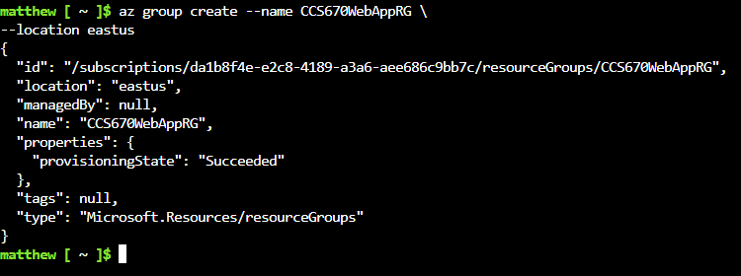
  - Created an App Service Plan
    - az appservice plan create --name CCS670WebAppPlan --resource-group CCS670WebAppRG --sku B1 --is-linux
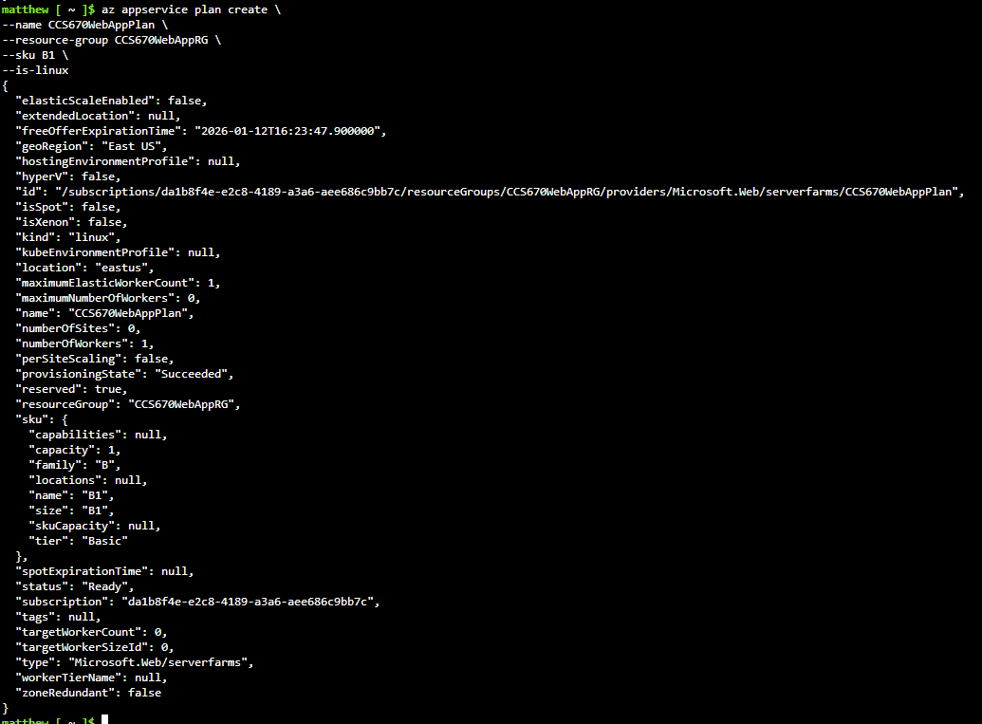
  - Created a Web App
    - az webapp create --name CCS670WebAppMWS --resource-group CCS670WebAppRG --plan CCS670WebAppPlan --runtime "PHP|8.1" --deployment-local-git

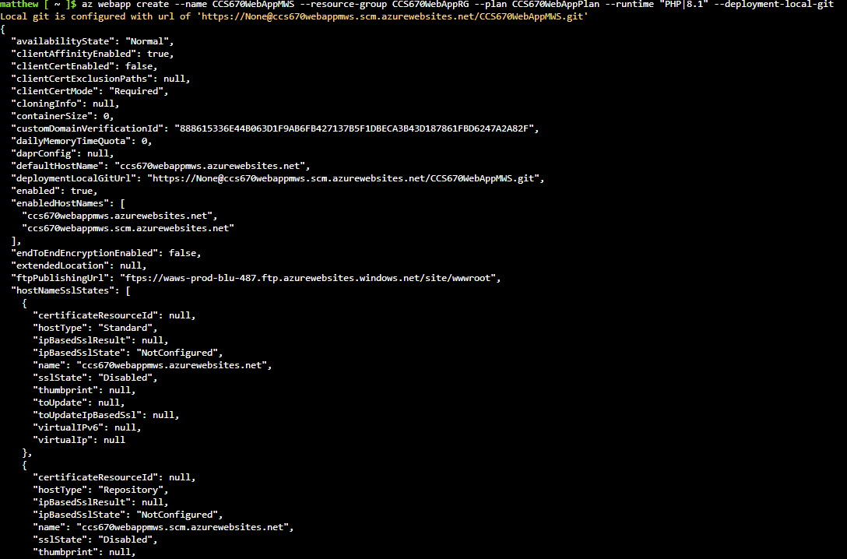

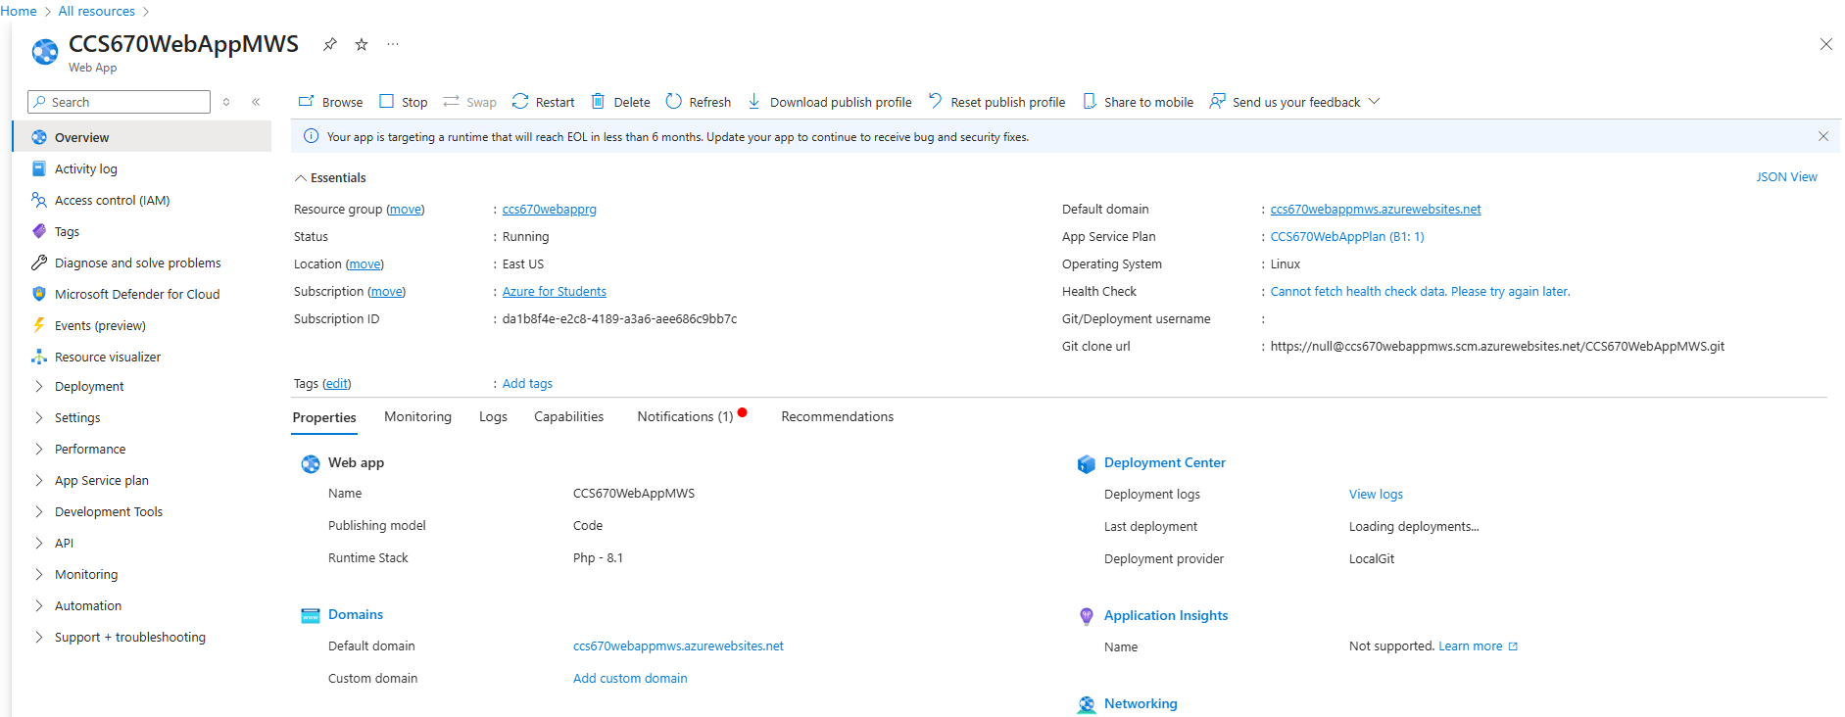
- Set Up Set up Continuous Deployment
  - Download site and configure Local Git Repository
    - wget www.ballotonline.azurewebsites.net/website.zip and unzip website.zip -d websitePHP
    - Initialized Git
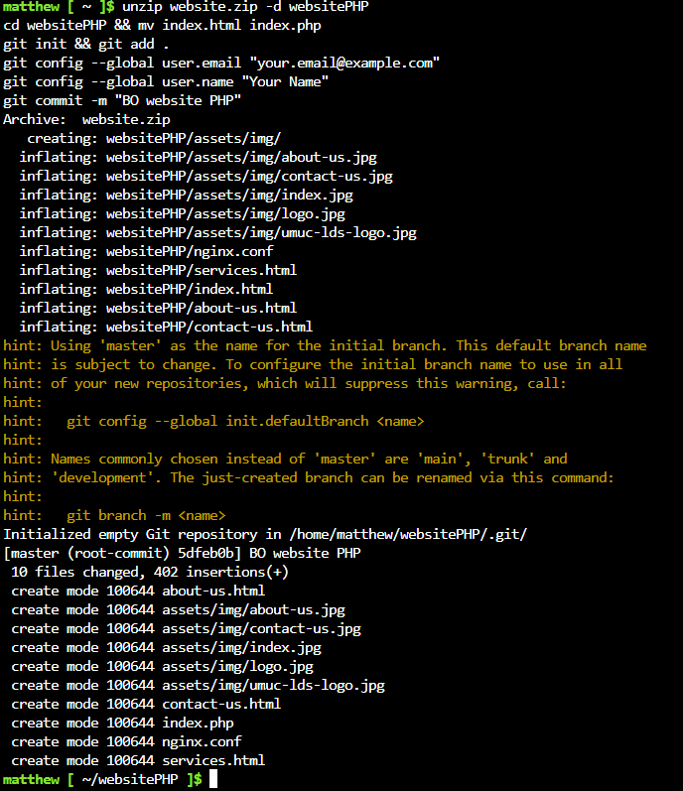
  - az webapp deployment user set --user-name ccs670studentMWS --password ccs670Password
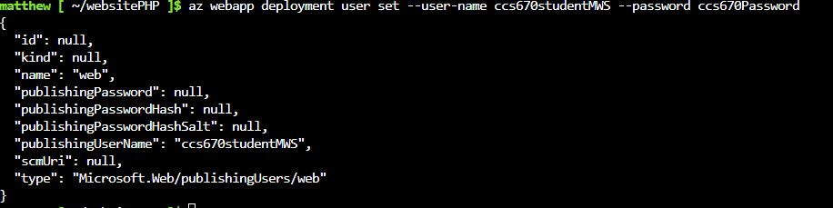
  - local git repository deployed to the git remote repository on my Web app.
    - https://ccs670studentMWS@CCS670WebAppMWS.scm.azurewebsites.net/CCS670WebAppMWS.git
    - Pushed the BallotOnline website code to my Web app
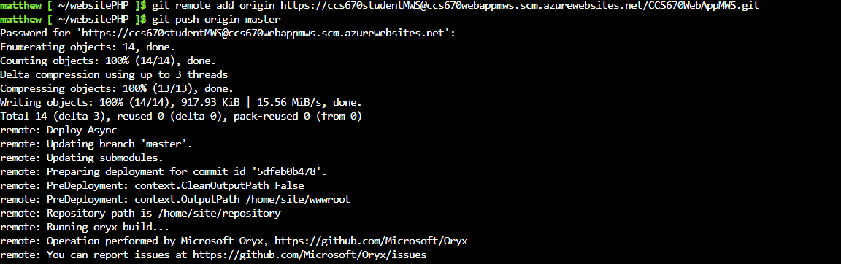
  - Checked Deployment Center logs and went to the site to confirmed it was deployed.
    - https://CCS670WebAppMWS.azurewebsites.net

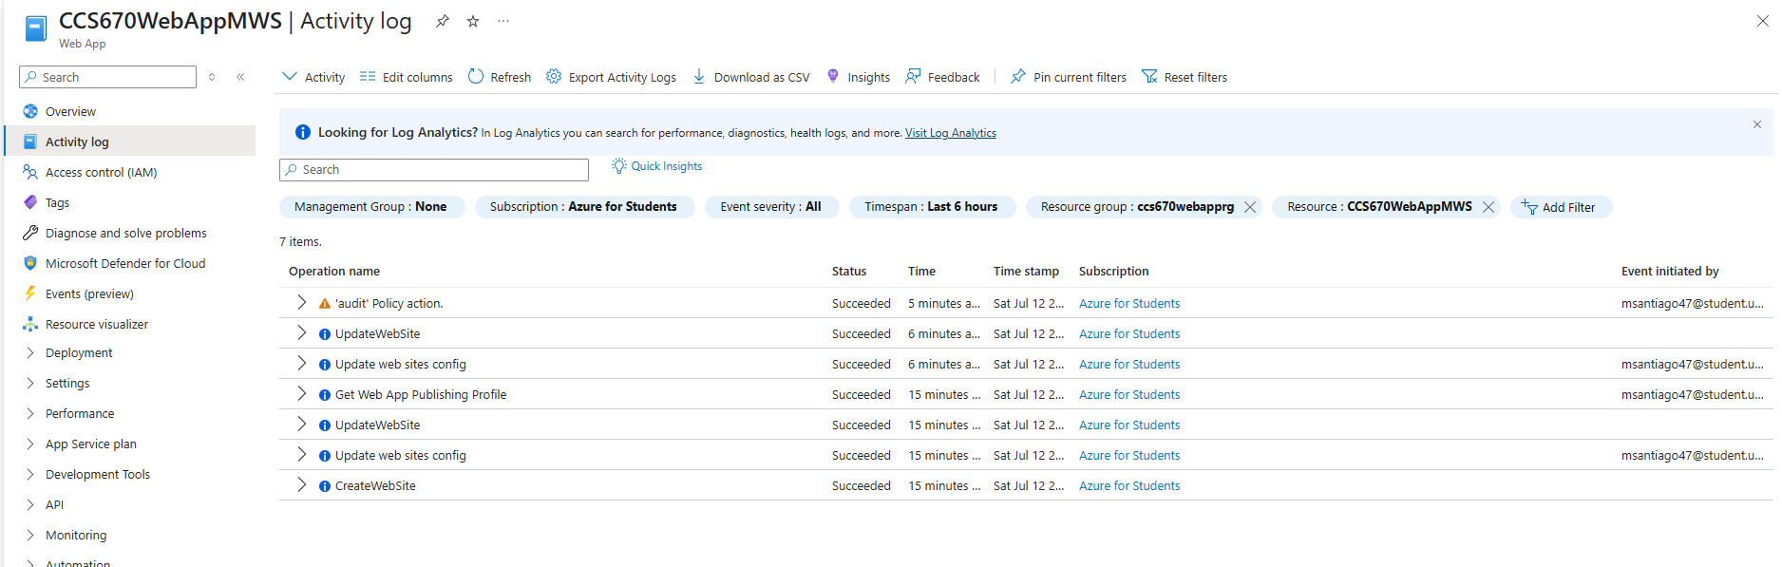
- Explored Azure Web Apps Features
  - Scaled up to Standard S2 plan and explored autoscale settings with rules-based scaling.
  - Monitored metrics under the Monitoring section
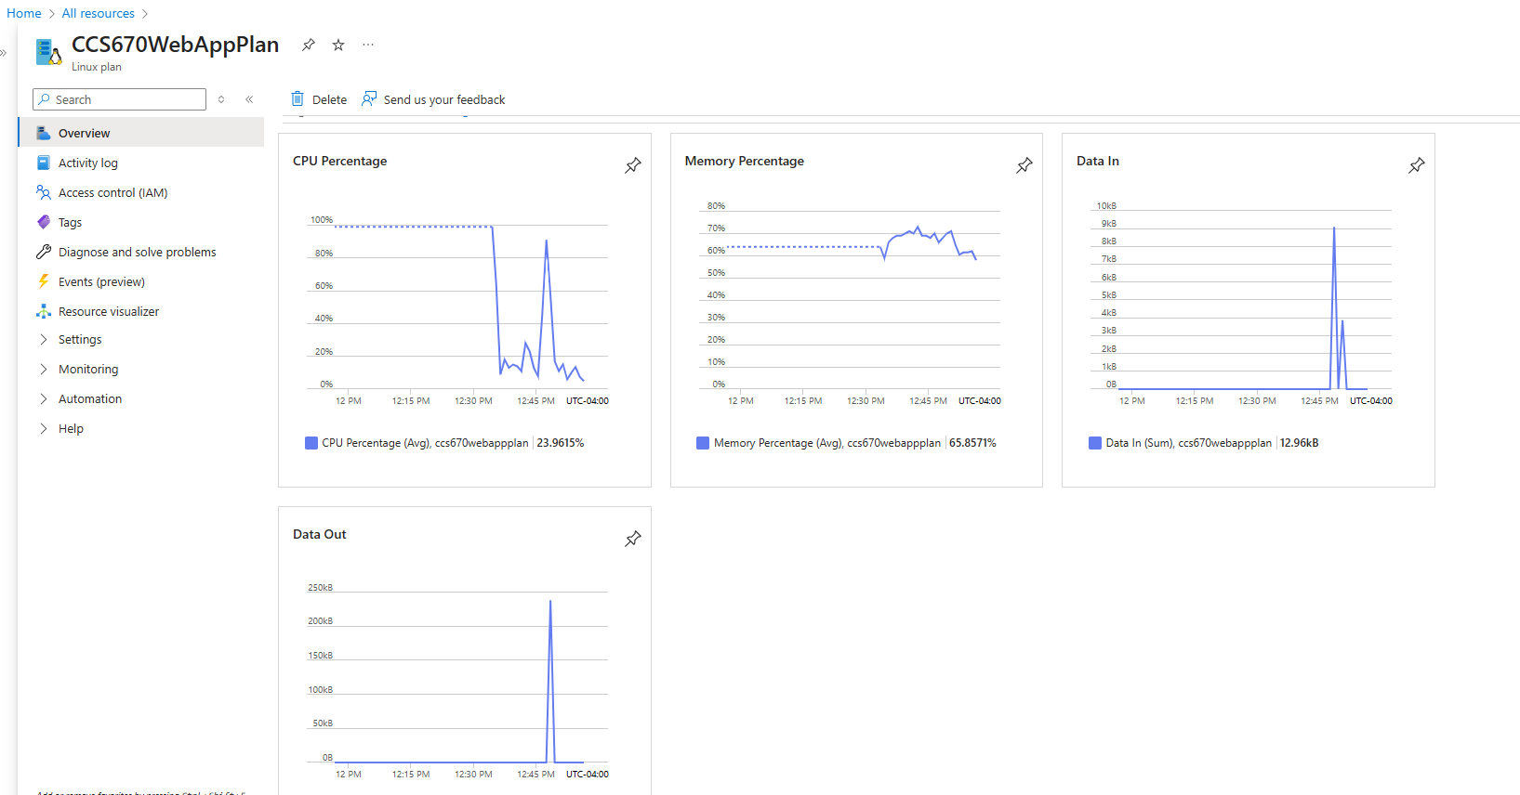
Web App URL
Azure Web App URL: https://CCS670WebAppMWS.azurewebsites.net

Lessons learned:
As I completed this lab, I was able to gain experience in utilizing the Azure CLI to deploy a website and Git repository. Using the CLI to deploy a Git repository to update code for the website was very intriguing. The ease and simplicity of deployment helped me see how that can be used in full scale deployments to quickly update code and increase productivity. Using the CLI to set autoscaling ensures that the site will have redundancy and high availability. The use of the CLI, was much quicker deployment than through the GUI interface and will be used to automate the deployment of future systems.
The ability to change scaling plans was very easy and simple, and using the rules based autoscaling gave more control on how and when I would want the instances to scale when required without manual intervention. While looking at the monitoring section it provided easy to read metrics that helped me choose the best rules based scaling to pick. Completing this lab has given me a new view on cloud deployments in Azure. Everything was simple, quick and easily able to be troubleshoot when needed. I believe this lab has helped me prepare to handle real world cloud deployments by showing me how to deploy through the CLI and Git while also monitoring metrics to choose the correct scaling metrics.

