Project 2: Lab 1 Report
Matthew Santiago
University of Maryland Global Campus
CCS 670 Cloud Computing Capstone
Gohar Mukhtar
July 28, 2025

Lab Summary:
In this lab, I created, deployed and configured a AWS ParallelCluster environment. During the deployment I used a CloudFormation template to deploy the ParallelCluster after that I create a HPC cluster. Once the HPC cluster was created, I verified settings and configuration. After the verification of setting was done, I tested the cluster with a script to make sure all the components of the cluster are working properly.
Steps Taken:
- Deploy ParallelCluster UI via CloudFormation
  - Clicked the following link: https://us-east- 2.console.aws.amazon.com/cloudformation/home?region=us-east- 2#/stacks/create/review?stackName=parallelcluster-ui&templateURL=https://parallelcluster-ui-release-artifacts-us-east-1.s3.us-east-1.amazonaws.com/parallelcluster-ui.yaml
  - Named the stack “ccs670-parallelcluster-ui”
  - Entered my email address: msantiago47@student.umgc.edu
  - Left other options default and submitted
  - Went to the CloudFormation outputs tab to open the link to the ParallelCluster url: https://jnaomq24gg.execute-api.us-east-1.amazonaws.com/pcui
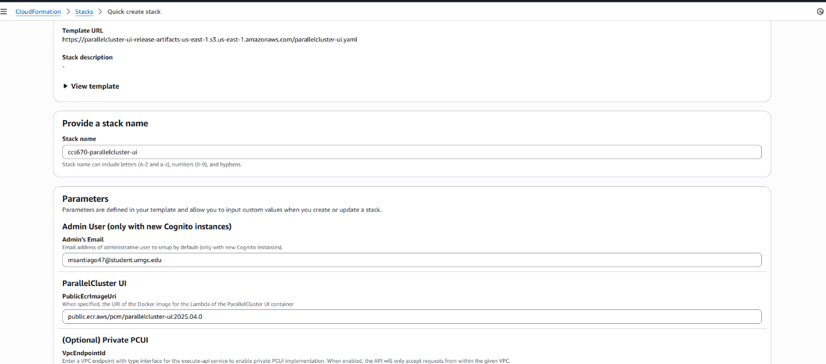
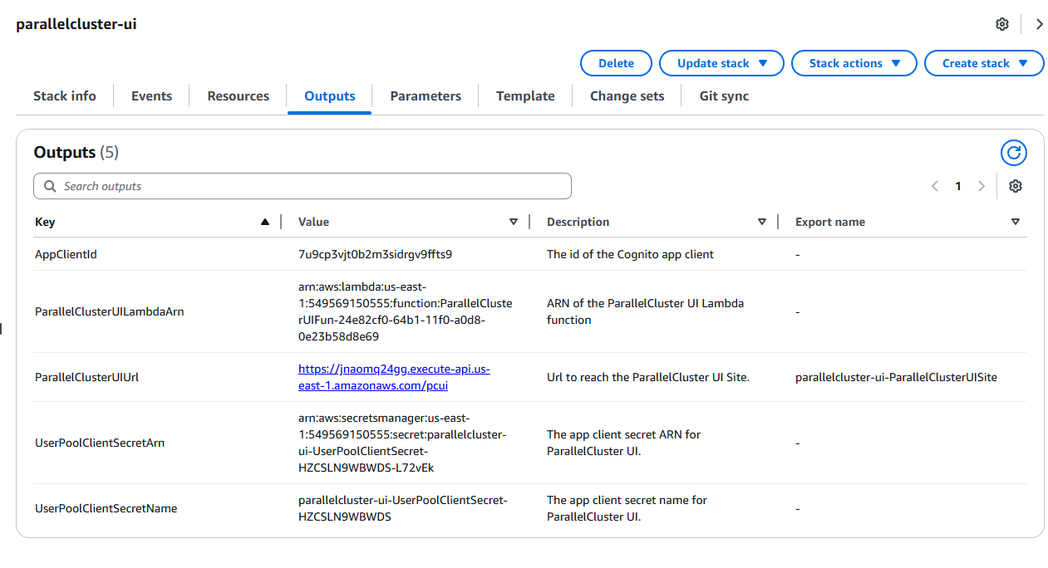
- Accessed the ParallelCluster UI Dashboard
  - Logged with temporary credentials.
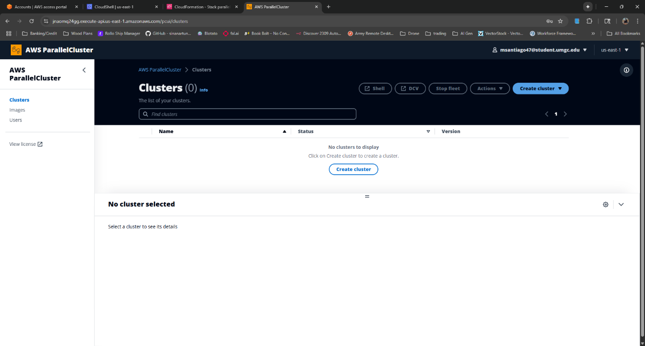
- Create a HPC Cluster
  - Clicked on “Create cluster”.
  - Set cluster name to `hpc-cluster`, selected Region `us-east-1`, OS `Amazon Linux 2`.
  - Selected VPC: `vpc-0973c2dc73b7b2a82` and subnet: `subnet-0487c167dec185bd3`.
  - Head node: Instance type `c5a.2xlarge`, DCV enabled, Port 8443.
  - Queue created: `queue-1` with dynamic nodes set to 4, using `c5.24xlarge` instance type.
  - Confirmed YAML file and ran the Dry Run before creating the cluster.
Screenshot taken: `cluster config YAML` and `queue settings`.
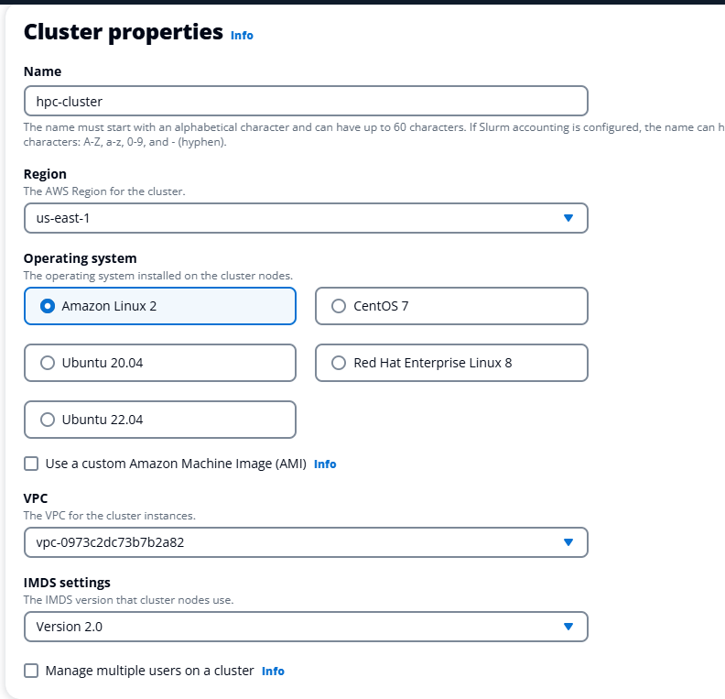
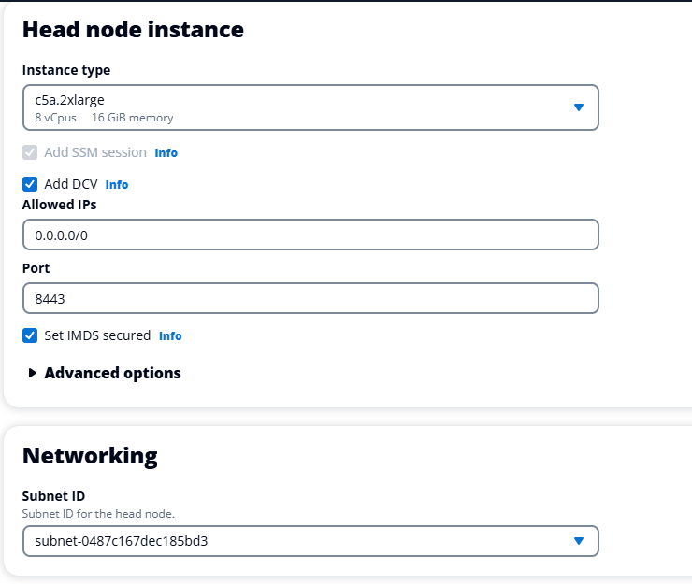
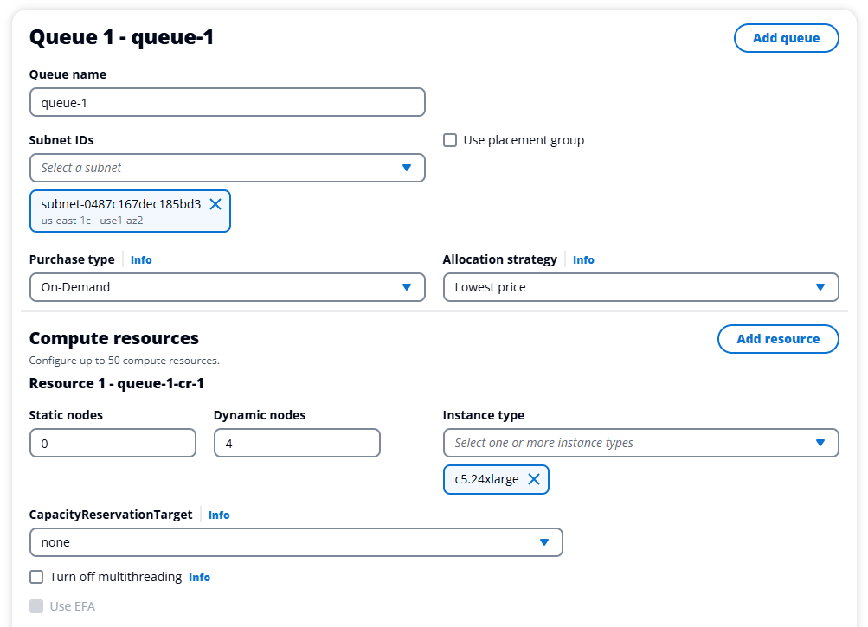
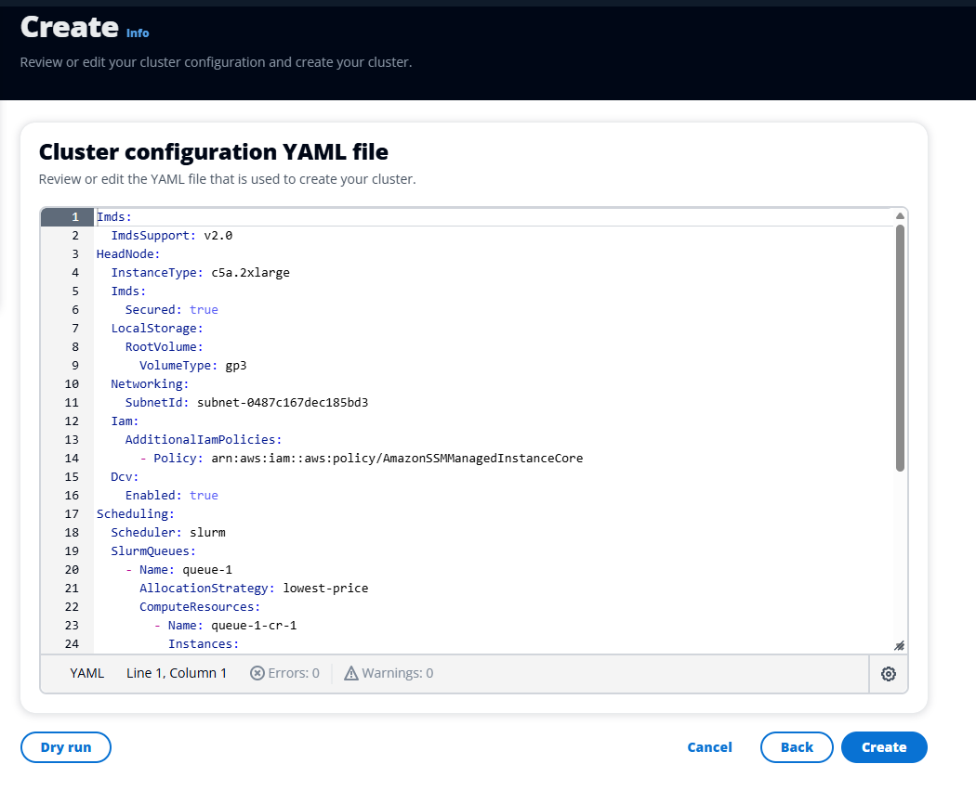
- Connected to Head Node via DCV
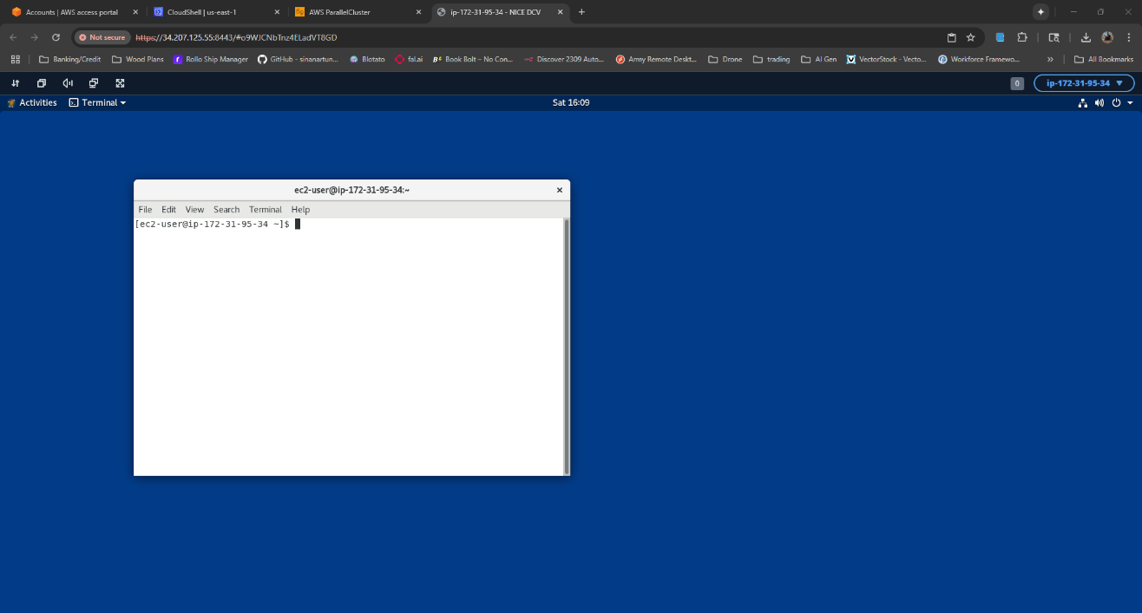
- Explore Environment
  - Ran “module load intelmpi” and “mpirun -V” to check Intel MPI version.
  - Verified module availability and MPI installation.
  - Used “showmount -e localhost” and “df -h” to verify NFS and shared filesystem mounts.
Screenshot taken: `module and MPI version` and `NFS mounts`.
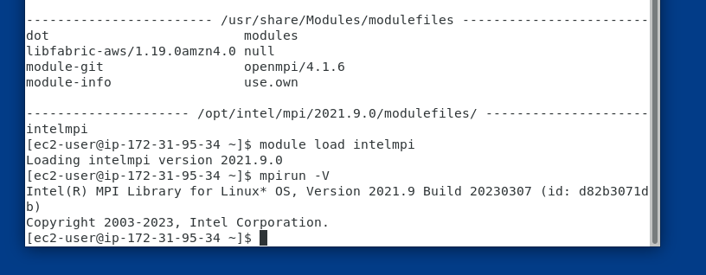
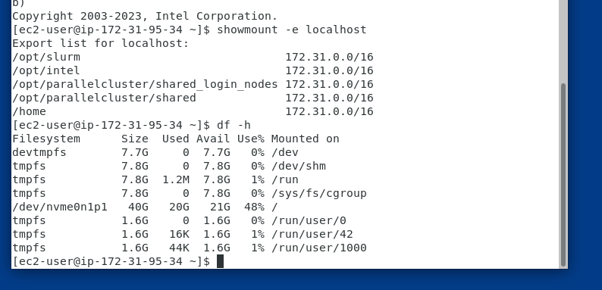
- Submit Sample MPI Job
  - Created a sample MPI program named “mpi_hello_world.c”
  - Compiled the program using “mpicc mpi_hello_world.c -o mpi_hello_world”
  - Ran the program using “mpirun -n 4 ./mpi_hello_world” and verified “Hello World” output from multiple steps and nodes.
  - Created and used a Slurm batch script named “submission_script.sbatch”
  - Submitted the script using “sbatch submission_script.sbatch”
  - Verified results in the output file “hello-world-job_1.out”, which showed successful execution across compute nodes.
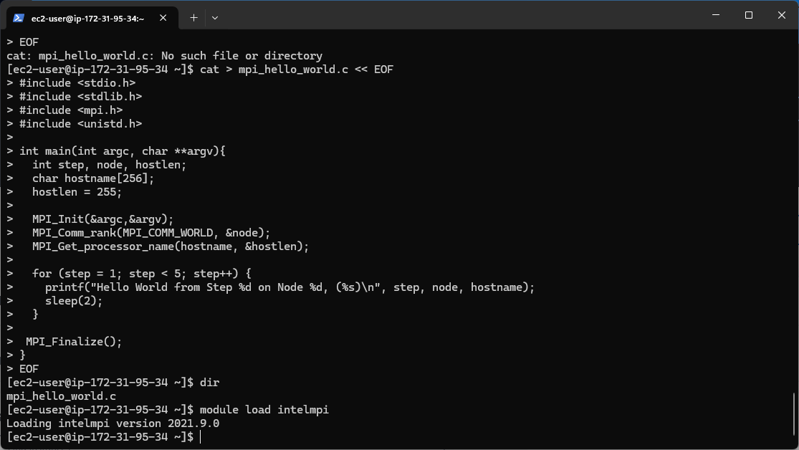
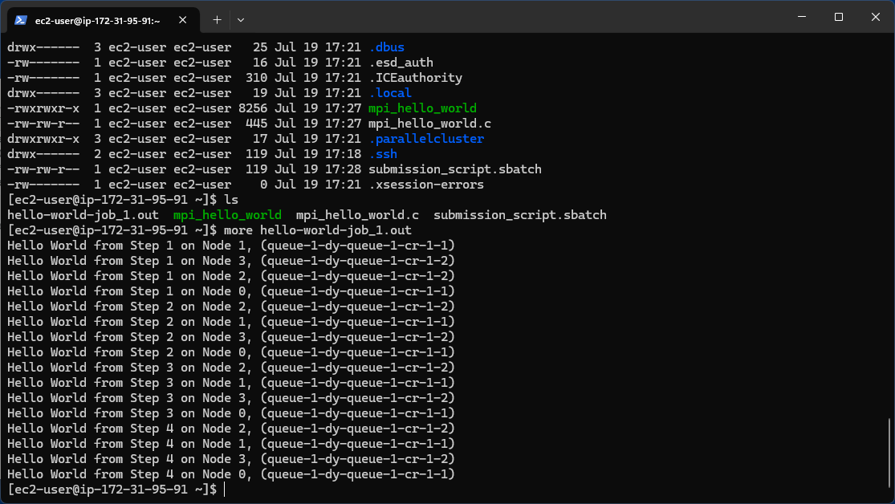
Lessons Learned:
In this proof of concept, I learned how AWS enables easy deployment of high performance computing systems through a simple interface. Deploying the ParallelCluster UI was easy but I did have trouble receiving the email from the system to obtain the login credentials. Modify the IAM user that was used to create the deployment fixed the issue. When creating the cluster I needed to define the VPCs, subnets, IAM roles and the slurm scheduler. Logging into the cluster through DVM and SSH worked perfectly and I was able to issue the commands and run the scripts correctly both ways. The system distributed the tasks efficiently through the cluster, and when tested the nodes performed as expected. This lab proves that the use of high performance clusters BallotOnline will be able to process data quickly at scale to keep up with the demands of live election data.

