Project 2: Lab 2 Report
Matthew Santiago
University of Maryland Global Campus
CCS 670 Cloud Computing Capstone
Gohar Mukhtar
July 29, 2025

Lab Summary:
In this lab, I was tasked to create an Amazon Redshift cluster by using a AWS CloudFormation template. After Amazon Redshift was deployed, I loaded data into the database. Once the data was confirmed it migrated correctly, I conducted several commands to perform various maintain and troubleshooting queries.
Steps Taken:
- Creating & Connecting to your Cluster
  - Deployed CloudFormation stack named "CCS670Lab2"
    - Created VPC, subnets, security groups, IAM roles, and Redshift cluster through the template
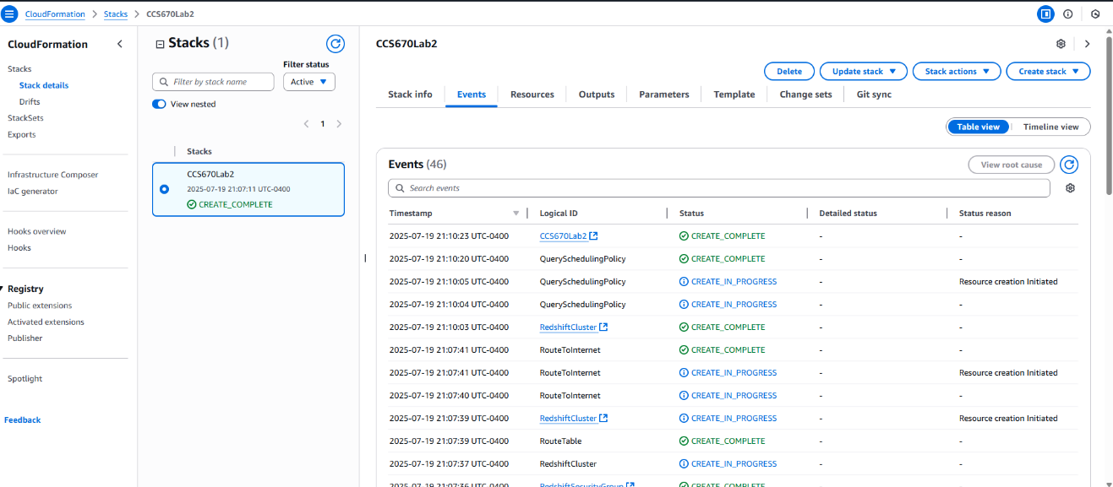
  - Configured Redshift cluster "redshiftcluster-du69vngs2sr8"
  - Navigated to Redshift Query Editor v2
    - Selected "Database user name and password" authentication method with database "dev" and input username/password
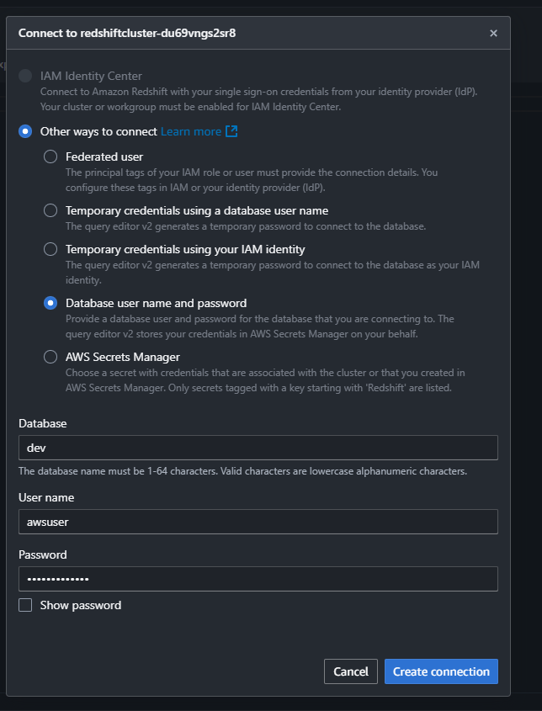
  - Ran “SELECT * FROM pg_user” to verify database connection and user permissions
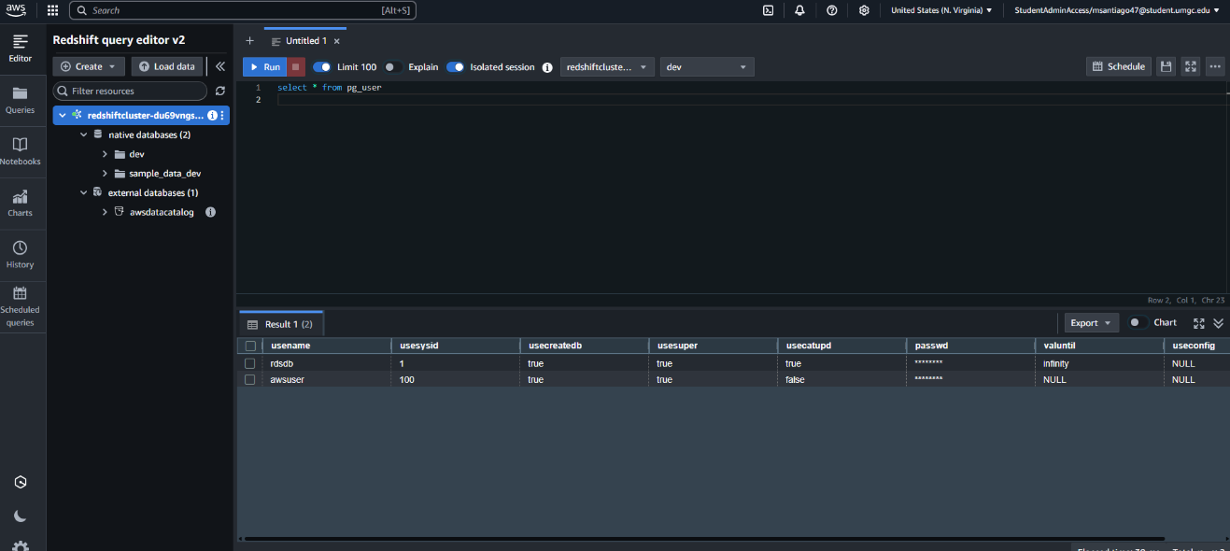
- Data Loading
  - Created tables which included customer, lineitem, nation, orders, part, partsupp, region, and supplier
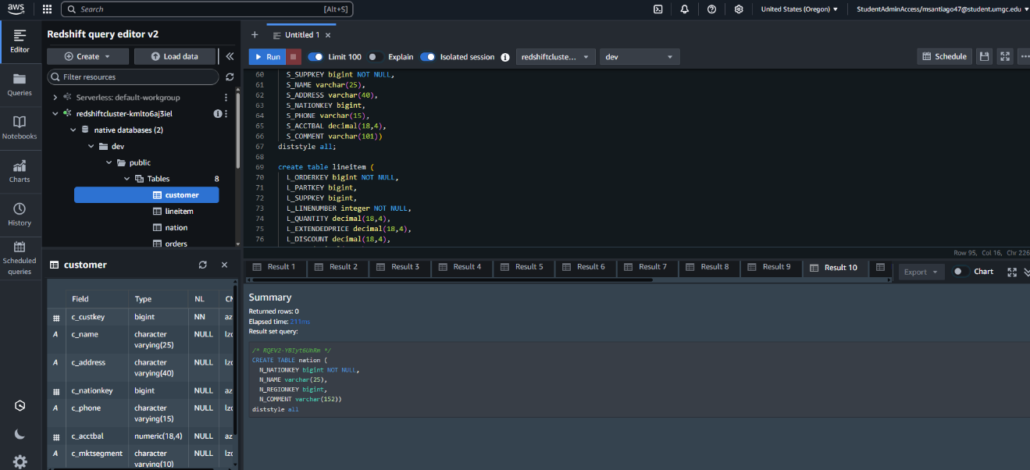
  - Ran several bulk commands to copy data from external source into the new tables.
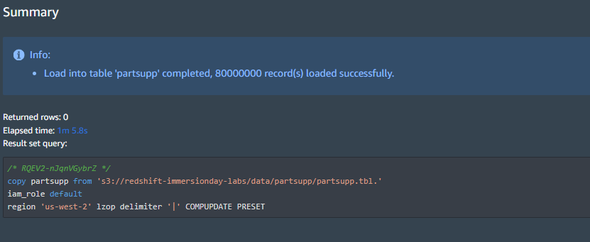
  - Ran analyze commands to understand how to update the metadata.

  - Capture the initial space usage of the ORDERS table by using the STV_BLOCKLIST and STV_TBL_PERM system views
  - Ran DELETE command to remove data from the orders table between 1997-1998
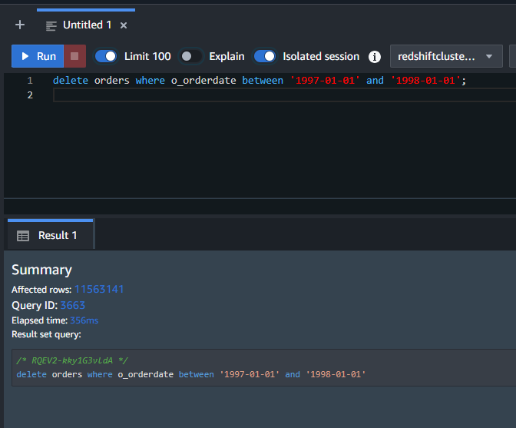
  - Confirmed that Redshift did not automatically reclaim space
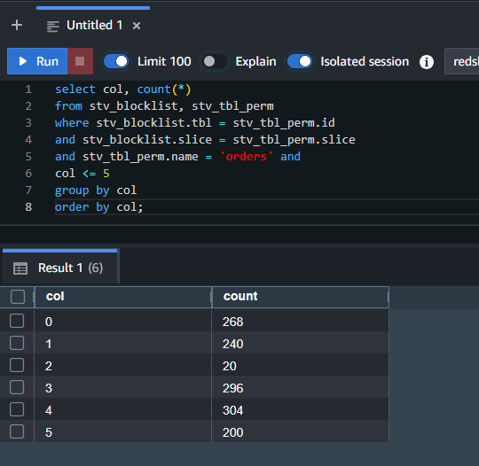
  - Ran the VACUUM command to delete only orders
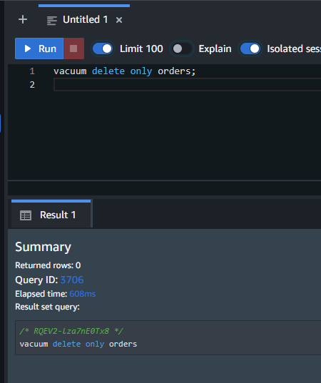
  - Confirmed that the VACUUM command reclaimed space
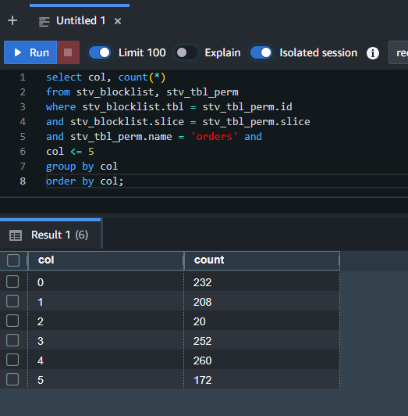
  - Ran several commands to create loading errors and learn how and why they occur.
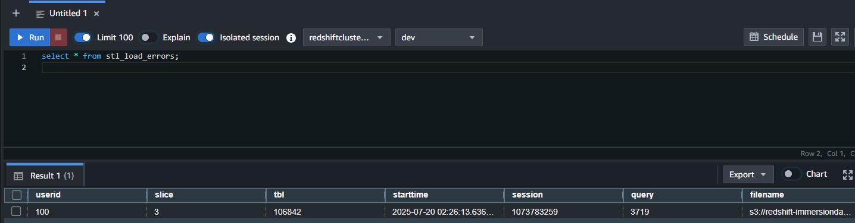

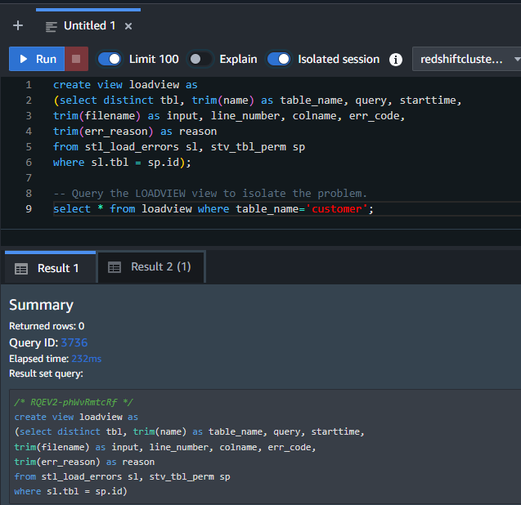
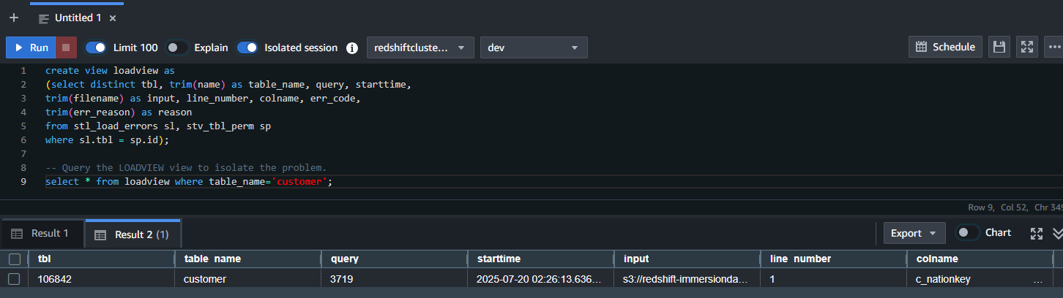
Lessons Learned:
Throughout this lab, I learned that Amazon Redshift is a useful service that is a fast, fully managed, data warehouse for making it simple to analyze data (Amazon Web Services, 2025). Setting up redshift through the use of a cloudformation template was quick and efficient. The initial setup no errors were encountered. Once the redshift cluster was provisioned, logging into the database through redshift query editor v2 was straightforward with the use of credentials set up in the initial cloud formation setup. Once connected running the initial sql commands showed the users which proved the setup of the database was created correctly. Next, I create the tables that BallotOnline would like to use in the database in order to copy over the data from a external database. This creation of tables was simple and quick and no problems were encountered with the provided sql commands. After the tables were created, we imported the data using the COPY command to connect to the external database and retrieve the data. This process was quick with the amount of data transferred, also this process was straightforward with no errors. Once the data was transferred, I performed several maintenance functions to analyze, clean and delete empty data. After those functions were performed, verified the data was in the correct state and double checked troubleshooting commands to make sure everything went correctly. The use of redshift for database management was straightforward and painless. Redshift has proved to be a essential service to consider to be used when migrating to the cloud, its managed feature cuts back on our managing of the service but leads to the service functioning correctly and efficiently throughout the process.

References
Amazon Web Services. (2025). Amazon Redshift Documentation. Retrieved from Amazon Web Services: https://docs.aws.amazon.com/redshift/

