Project 2: Lab 3 Report
Matthew Santiago
University of Maryland Global Campus
CCS 670 Cloud Computing Capstone
Gohar Mukhtar
July 29, 2025

Lab Summary:
In this lab, I learned how to use Amazon Web Services in order to protect our S3 data from ransomware threats. I started by deploying a secure S3 bucket by using a CloudFormation template that specified encryption, access restrictions and enabling Amazon GuardDuty.
Steps Taken:
- CloudFormation Template to Setup
  - Navigated to AWS CloudFormation console and clicked "Create stack"
  - Selected "Upload a template file" and uploaded the provided JSON template
  - Named the stack "reinf-21-rwb"
  - Deployed S3 bucket "rnsmtest" with AES256 server-side encryption enabled
  - Public access block settings: BlockPublicAcls, BlockPublicPolicy, IgnorePublicAcls, RestrictPublicBuckets
  - Implemented bucket policy allowing external account ListBucket permissions for controlled access testing
  - Accepted defaults on configuration screens and successfully deployed the CloudFormation stack
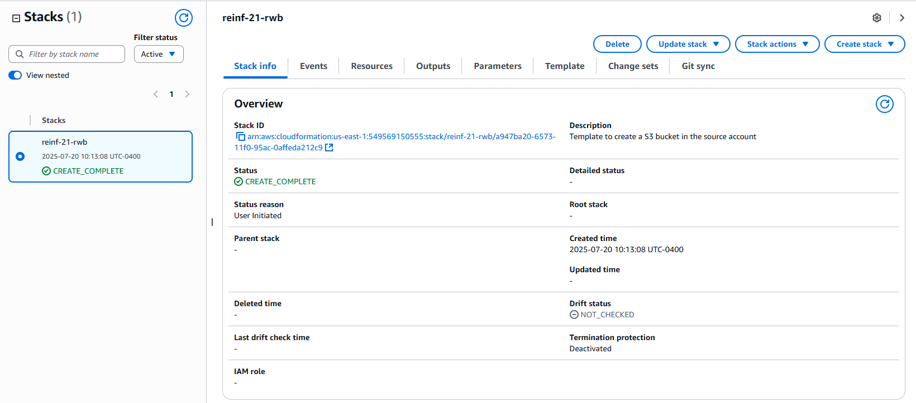
- Detection Controls
  - Navigated to GuardDuty service in the console
  - Enable GuardDuty to activate it
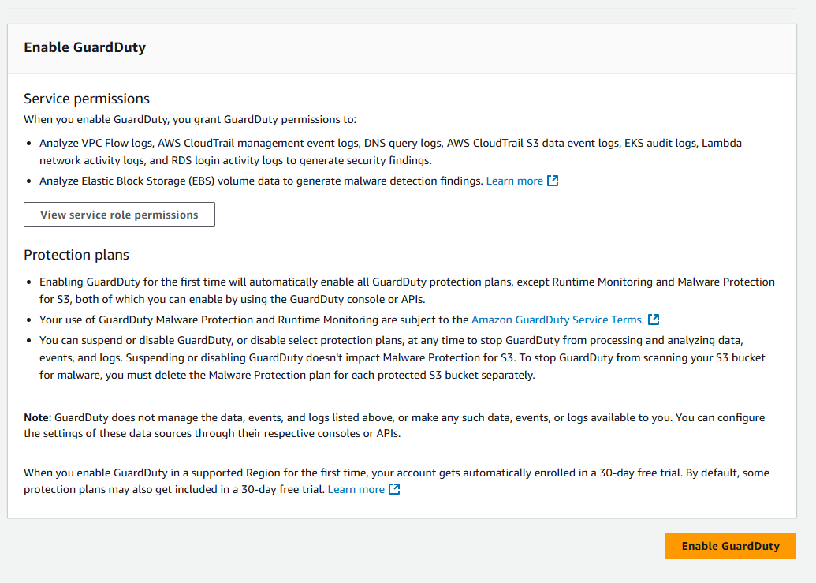
  - Viewed monitoring capabilities for S3 data events
  - Verified "S3 Protection is enabled"
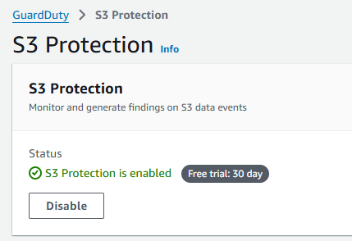
- Review S3 Finding Types
  - Analyzed GuardDuty S3 finding types from AWS documentation
Lessons Learned:
Completing this lab, helped me obtain hands on practice in setting up a S3 bucket with safeguards to protect data. It showed me how to set up a layered defense of the storage S3 bucket in order to mitigate or stop ransomware attacks. Completing the steps outlined above was simple with the use of the CloudFormation. The CloudFormation template showed how it can provide a repeatable secure S3 configuration for multiple deployments. In the setup we enabled Amazon GuardDuty, which “is a threat detection service that helps protect your accounts, containers, workloads, and the data within your AWS environment” (Amazon Web Services, 2025). Also in the CloudFormation template we specified blocking public access which is essential to protect our sensitive election data from outside manipulation and also encrypts it with AES 256 to protect the data when not in use.

