Project 2: Lab 4 Report
Matthew Santiago
University of Maryland Global Campus
CCS 670 Cloud Computing Capstone
Gohar Mukhtar
July 29, 2025

Lab Summary:
In this lab, I needed to use AWS Service Catalog to create a portfolio and add products in the portfolio so end users can access them. The two products that added were a VPC instance and a EC2 instance. These products will be used by normal user to launch these approved services by BallotOnline to ensure all BallotOnline policies and security are built into each template that the user launches.
Steps Taken:
- Creating your First Portfolio
  - Opened AWS Console and went to Service Catalog
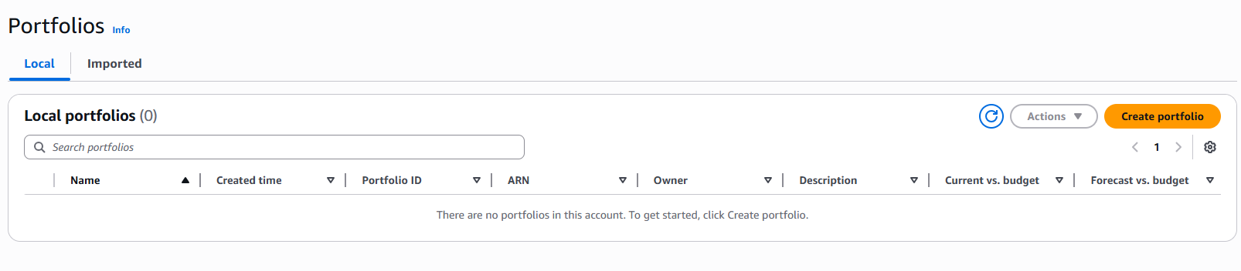
  - Selected "Portfolios" the clicked "Create portfolio"
  - Filled in portfolio details including name "CCS 670 Portfolio" and description
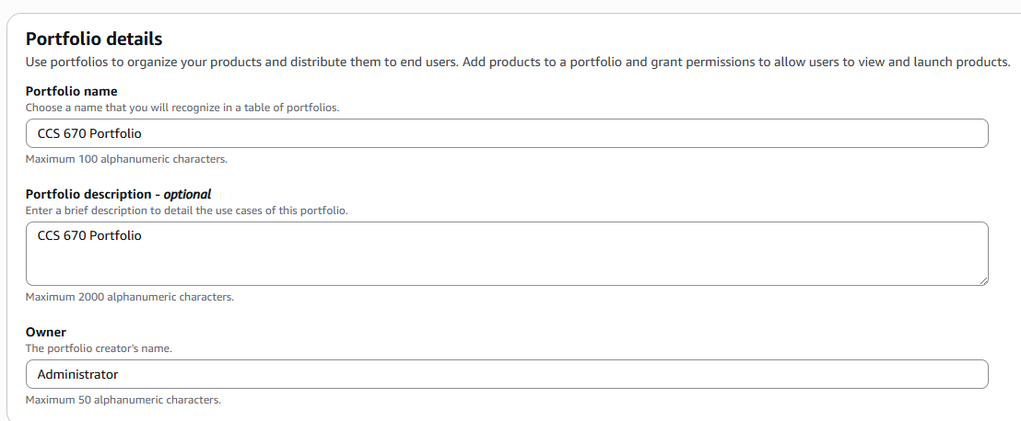
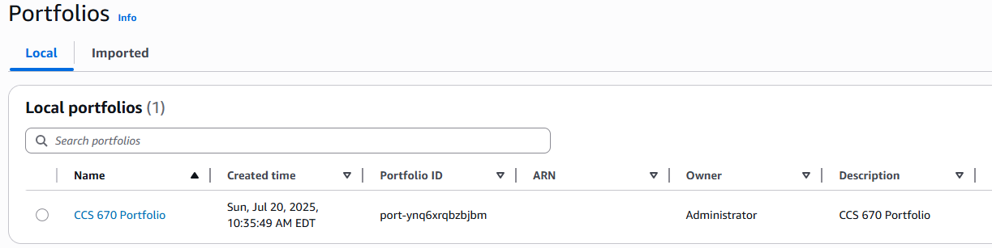
- Products
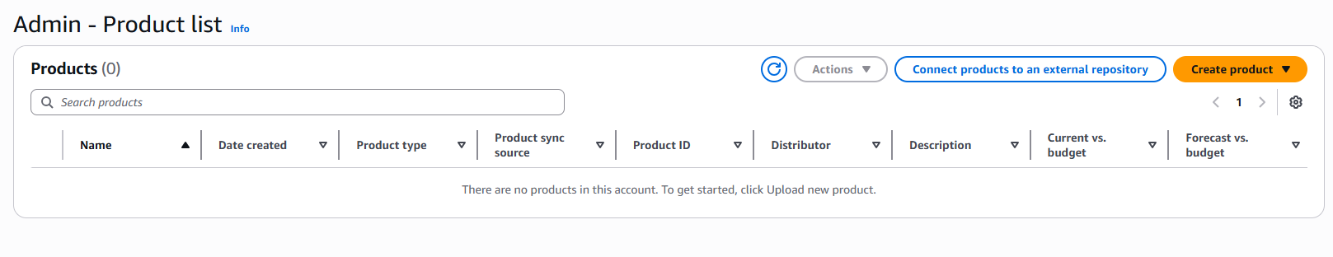
  - Navigated to "Products List" and clicked "Create Product"
    - Configured using Network.yaml template
  - Configured product details with name "VPC" and descriptive information
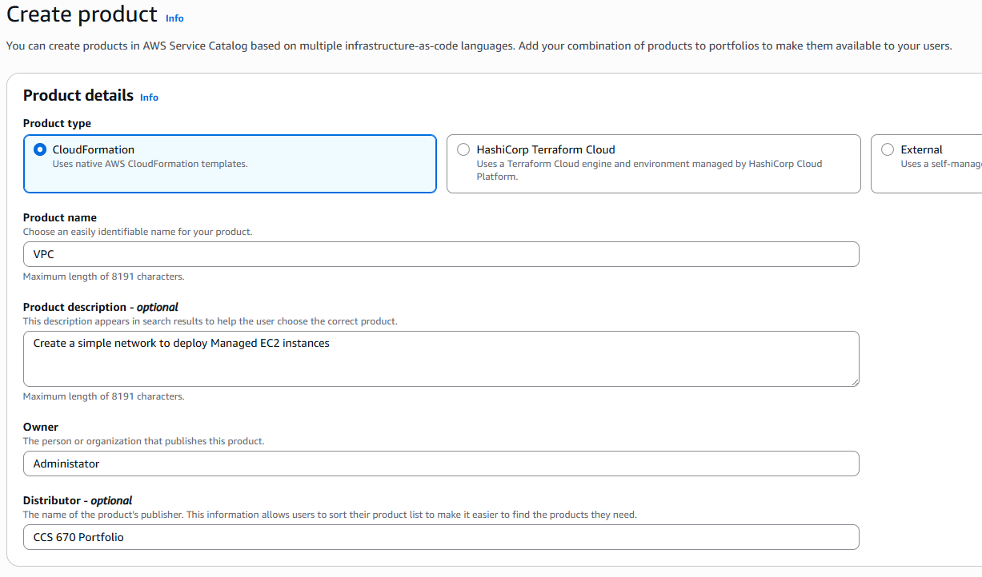
  - Set version details and support information for the VPC product
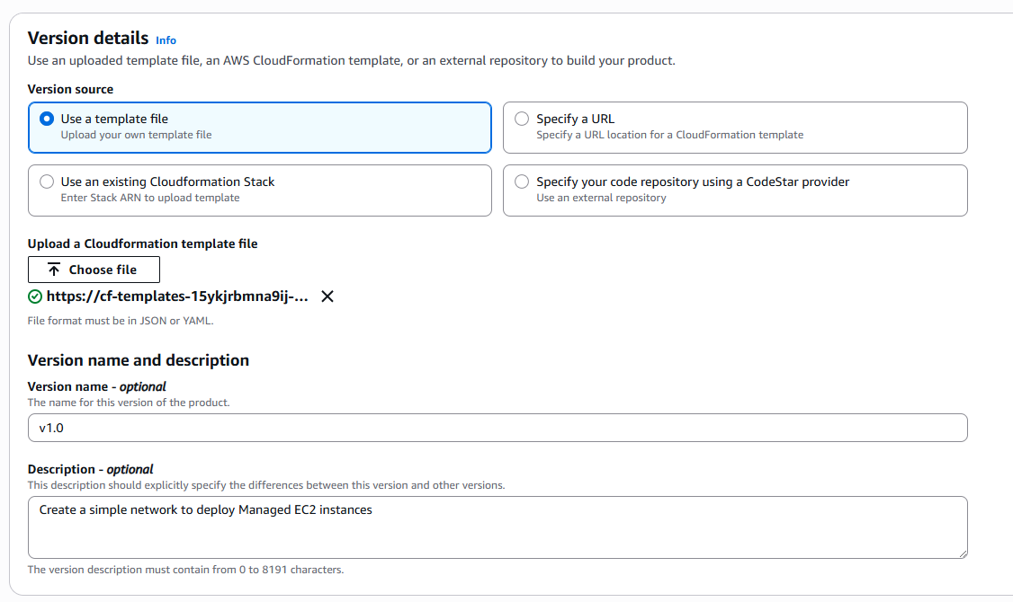
  - Created second product using simple_ec2_ebs_appregistry.yaml template
  - Configured product details with name "Simple EC2" and descriptions
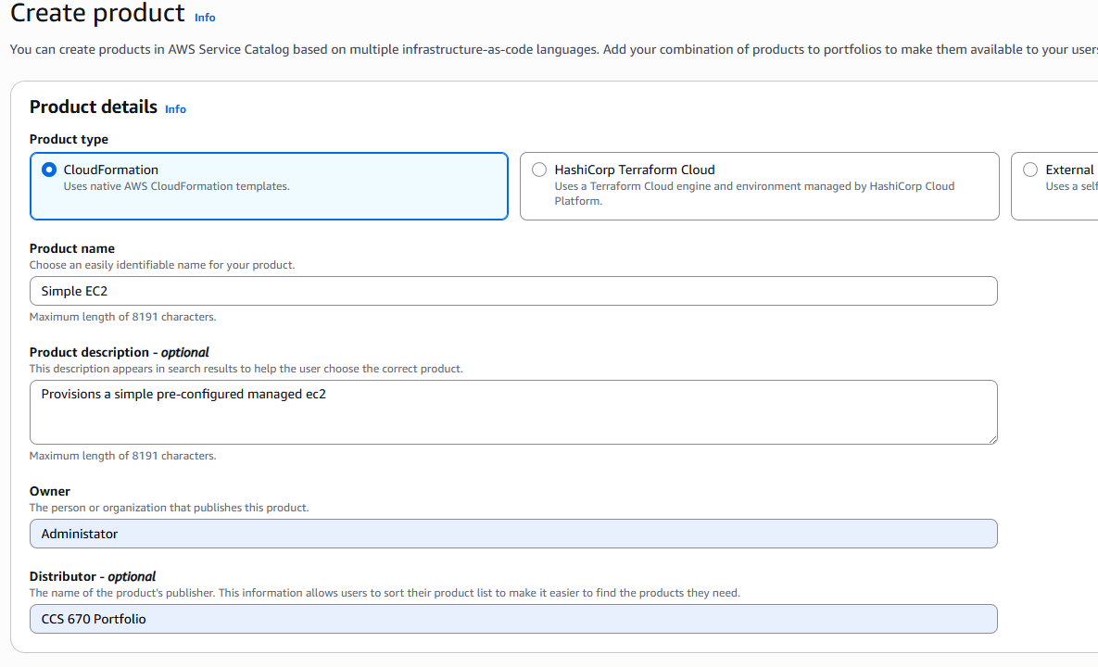
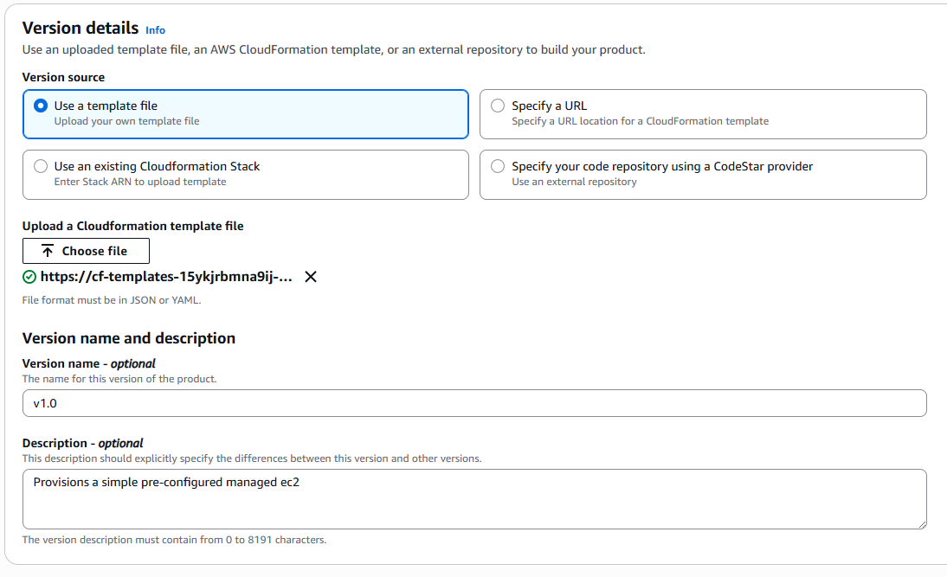
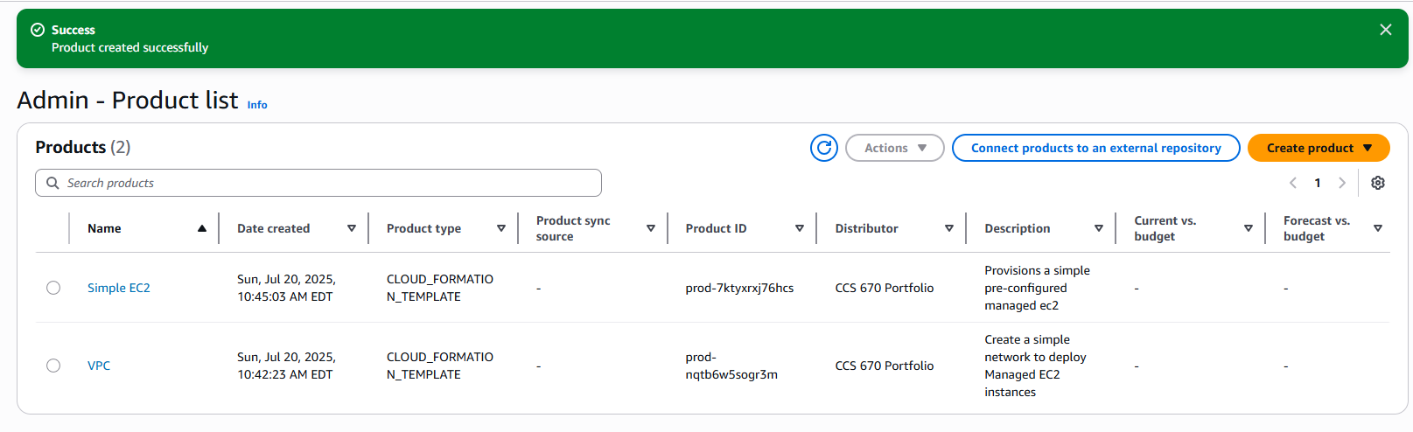
- Associating a Product with a Portfolio
  - Opened VPC product by clicking on its name in the product list
  - Clicked on "Portfolios" tab within the product configuration
  - Clicked "Add product to portfolio" button on the right side
  - Selected radio button next to " CCS 670 Portfolio"
  - Confirmed product addition
  - Repeated the same process for Simple EC2 product to add it to the portfolio
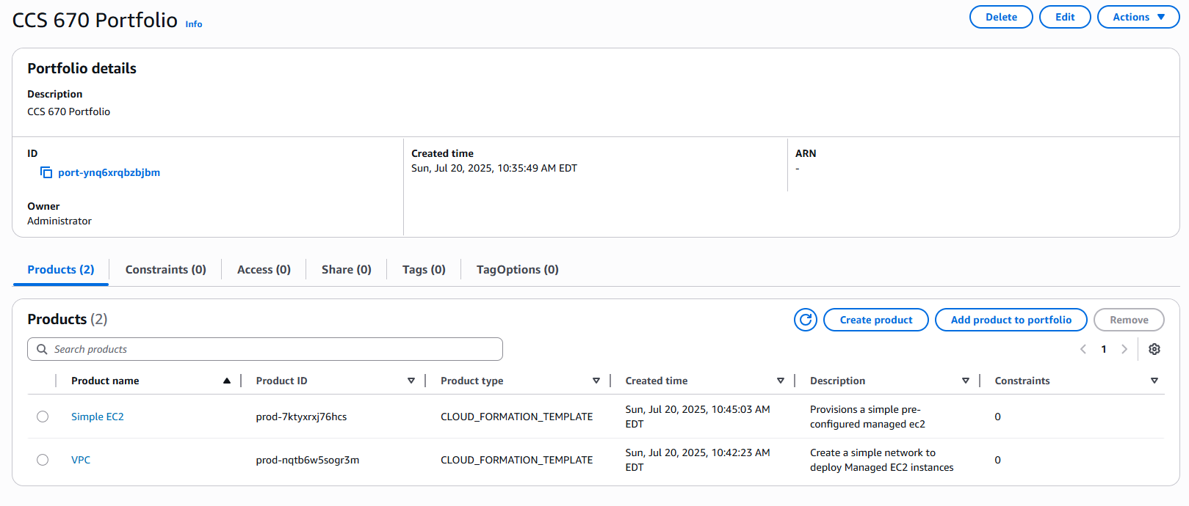
- Granting Portfolio Access
  - Opened portfolio and went to the "Access" tab
  - Clicked "Grant access" button to configure user permissions
  - Confirmed that appropriate users and groups had access to launch products from the portfolio
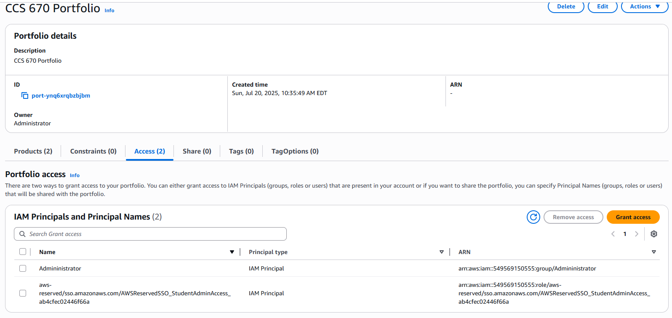
- User Portfolio and Product View
  - Switched to end-user view and went to the products
  - Selected VPC product and clicked "Launch product" button
  - Successfully deployed VPC product and proceeded to launch Simple EC2 product
  - Confirmed successful deployment of both products from the end-user perspective
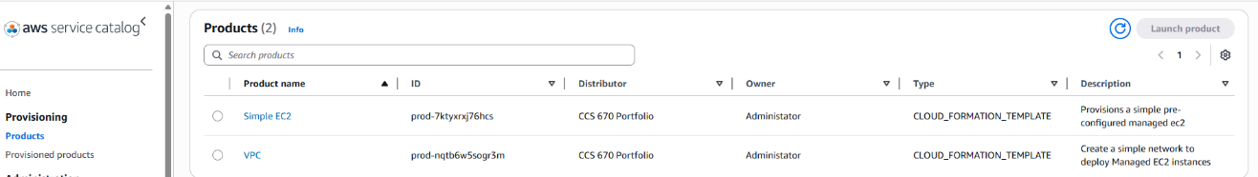
Lessons Learned:
In conclusion, this lab showed me how to use AWS Service Catalog in order to allow BallotOnline provide cloud resources to users while making sure those resources are secure and compliant. AWS service catalog “enables organizations to create and manage catalogs of IT services that are approved for AWS” (Amazon Web Services, 2025). Creating and setting up the service catalog is straightforward. The biggest take away from this lab, is that the creation and standardization of the cloud formation templates is the most essential part. The step to create and add products is simple and quick. The process of creating a properly configured, standardized, and secure CloudFormation template is the hardest part. Using the AWS service catalog for BallotOnline will provide reliability and security. This service will also reduce the human mistakes for deployments of new cloud infrastructure.

References
Amazon Web Services. (2025). AWS Service Catalog. Retrieved from Amazon Web Services: https://docs.aws.amazon.com/whitepapers/latest/introduction-devops-aws/aws-service-catalog.html

