Introduction to Exertion-oriented Programming in SORCER

Draft from 2009

Michael Sobolewski
Polish Japanese Institute of IT
Warsaw, Poland
http://sorcersoft.org/sobol/

Table of Contents

1. Exertion-oriented programming terminology 4
1.1. Introduction 4
1.2. Operands and operators 5
1.3 Operands and operators in SORCER 5
1.4. Positioning of operands 7
1.5. Service context 8
1.6. Service Context Hierarchy 9
1.7. Service signatures 10
1.7.1. Selecting a service provider by its name 11
1.8. Control context; where exertions go? 11
1.8.1. Provider space readiness 11
1.9. Exertions: service tasks and jobs 12
2. Creating applications using the SORCER platform 13
2.1. Metacomputing, SORCER, and iGrid 13
2.2. Designing and implementing the application components 14
2.3. Design an interface 14
2.3.1. The WhoIsIt remote interface 15
2.4. Writing a SORCER service provider 16
2.4.1. The WhoIsItProvider implementation class 16
2.4.2. What the provider can do with the requestor’s Context? 16
2.5. Define the requestor implementation: service task 18
2.6. Define a service task with concatenated signatures 18
2.7. Define a service job with concatenated exertions 19
2.8. Exception handling with exertions 20
3. Configuring SORCER applications 21
3.1. Configurations directories and files 21
3.2. SORCER environment, provider, and requestor properties 21
3.2.1. Provider deployment configuration 21
3.2.2. Provider properties 21
3.2.3. Requestor properties 21
3.2.4. Java System properties for configuration files 22
3.2.45 Suffixed service providers names 22
3.3. File naming conventions 22
3.3.1. Relationship between different categories of properties 22
3.4. Space computing configuration 24
3.5. Service provider discovery/join configuration 25
3.6. Service provider task/thread management 26
3.7. Define an icon for the provider 26
3.8. Define file and URL support for providers and requestors 26
4. Building SORCER applications 28
5. Running SORCER applications 29
5.1. Delivery of Dynamically Loaded Classes (Behavioral Transfer) 30
5.2. Using Exertion Space 33
5.3.SORCER Service Browser (SSB) 33
6. Working with SORCER service beans 35
6.1. Designing by class extension vs. composition 35
6.2. Implementing SORCER service beans 36
7. Testing SORCER 37
8. Working with service jobs 38
8.1. The Worker interface 38
8.2. The WorkerProvider implementation 39
9. Native code integration 39
10. Troubleshooting SORCER 40
10. Java packages 40
10.2. IP addresses 40
10.3. Code server (webster) 40
10.4. Crossing firewalls with limited port ranges 40
10.5. Testing published services: WSU-VTU 42
11. Debugging requestors and providers 42
Eclipse debugger 42
VisualVM 43

1. Exertion-oriented programming terminology

1.1. Introduction
A mashup, called an exertion, is an application that combines data or functionality from two or more external sources to create a new service. Service applications are entering a new age where consumer front-end applications are setting the new standards for user experience, self service and efficiency by leveraging new innovations in distributed application development. Because of this change, the end users are starting to demand the same level of user experience and interactivity from their business applications.

SORCER provides a rich federated service-oriented environment from which SW developers and advanced users can, in a robust and cost-effective fashion, deliver compelling service-oriented mashups that engage users, reduce costs and create competitive advantages. This manual presents how users can apply the SORCER API to easily add exertion-oriented programming and variable-oriented programming to mashups, front-end applications (service requestors) and service providers. In other words, an exertion is a service for a laborious computing effort by a dynamic federation of collaborating service providers (application, tools, utilities) available both locally or in the network. Executing the exertion means exerting the federation of dynamically collaborating service providers. Many simple code examples demonstrate the multiple ways to "mash up" applications, tools, and utilities exposed via SORCER service providers. The SORCER API uses the River/Jini (http://river.apache.org/) programming model to implement its operating system with its federated method invocation (FMI).
A service is the work performed in which a service provider (one that serves) exerts acquired abilities to execute a computation. Services are autonomous units of functionality and can be either local or distributed. Elementary services have no calls to each other embedded in them. Compound services are compositions of elementary and other compound services. Each service implements multiple actions of a cohesive (well integrated) service type, usually defined by an interface type. A service provider can implement multiple service types, and thus can provide multiple services. A service type with operation complemented by its QoS parameters is called a service signature. Service signatures are used as reference to providers. Instances of a service provider are equivalent units of functionality identified by the same signature.
In concurrent engineering computing systems each local or distributed service provider in the collaborative federation performs its services in an orchestrated workflow. Once the collaboration is complete, the federation dissolves and the providers disperse and seek other federations to join. These service providers have to be managed by a relevant service-centric operating system with requests for executing interactions of providers in dynamic virtual federations Error: Reference source not found.
A computing platform that allow software to run on the computer require a processor, operating system, and programming environment with related runtime libraries and user agents. We consider a SO program as the process expression of hierarchically organized services executed by an aggregation of service providers—the virtual SO processor. Its SO Operating System (SOOS) makes decisions about where, when, and how to run these service providers. The specification of the service collaboration in EOL is called an exertion. Exertions manipulate other executable codes (applications, tools, and utilities) locally or remotely via service references—service signatures.
The SORCER environment introduces a modular SOOS with multiple system services, including service management (rendezvous services), a federated file system, and autonomic resource management, to support exertion-object oriented programming. It adds the new layer of abstraction to the practice of SO computing—SO programs expressed in an Exertion-Oriented Language (EOL) verified and validated in real world research projects at Air Force Research Lab and SORCER Lab at TTU.
The central exertion principle is that a computation can be expressed and actualized by the interconnected federation of simple, often uniform, and efficient service providers that compete with one another to be exerted for their services in the dynamically created federation. Each service provider implements multiple actions of a cohesive (well integrated) service type, usually defined by an interface type. A service provider implementing multiple service types provides multiple services. Its service type complemented by its QoS parameters can identify functionality of a provider. In EOL an exertion can be used as a closure over free variables in the exertion’s data and control contexts.
Typically, a reference is the handle of where the data is stored either with internal or external storage. In exertion-oriented language (EOL) service providers are stored locally and externally. They are uniformly accessed through two types of references: class and interface signatures. Class and interface signatures are also called object and net signatures correspondingly.
Exertion-oriented programming (EOP) is a SO programming paradigm using service providers and exertions. Exertions can be created with textual language (netlets), API (exertlets), and user agents that behind visual interactions create exertlets. Netlets are interpreted scripts and executed by the network shell nsh of the SORCER Operating System (SOS). Invoking the exert operation on the exertlet (Java object) returns the collaborative result of the requested service federation.
An exertion is the expression of a structure that consists of a data context, a control context, and component exertions to compose hybrid (remote/local) service collaborations. Conceptually a control context comprises of a control strategy and multiple service signatures, which define the service references to service providers. The signature usually includes the service type, operation within the service type, and expected quality of service (QoS). An exertion's signatures identify the required providers, but the control strategy for the SOS defines how and when the signature operations are applied to the data context in the created federated collaboration at runtime. Please note that the object signatures refer to local objects but net signatures refer to remote object that implement the relevant service type. In the former case the object is an instance of a given class, in the former a class doesn’t matter, only the fact that the required signature’s interface is implemented.
Exertions encapsulate explicitly data, operations, and a control strategy for the collaboration. The SOS dynamically binds the signatures to corresponding service providers—members of the exerted federation. The exerted members in the federation collaborate transparently according to the exertion’s control strategy managed by the SOS. The SOS invocation model is based on the Triple Command Pattern that defines the federated method invocation (FMI).

1.2. Operands and operators
An operand is one of the inputs of an operator. The following arithmetic expression shows an example of operators and operands:
2 + 4 = 6
Here '+' is the operator and '2' and '4' are the operands.
Operands may be compound, and may consist of expressions also made up of operators with operands.
(2 + 4) x 5
In the above expression '(2 + 4)' is the first operand for the multiplication operator and '5' the second. The operand '(2 + 4)' is an expression in itself, which contains an addition operator, with the operands '2' and '4'.

An operation is like an operator, but the point of view is different. For instance, one often speaks of "the operation of addition" when focusing on the operands and result, but one says "addition operator" when focusing on the mapping from one domain to another, the function +: S×S → S.

1.3 Operands and operators in SORCER
In exertion-oriented programming (EOP), the definitions of operand and operator are similar to those in mathematics but based on a generic context—an associative array (dictionary, map, or hashtable)—and operations performed by service provider correspondingly, see Fig. 1. A context is an associative array composed of a collection of unique keys, called paths, and a collection of values, where each path is associated with one operand. The operation of finding the value associated with a path is called a lookup, e.g., Object value = context.getValue(path);, where the expression context.getValue(path) is the operand used internally by SORCER service providers in operators (operations) declared in their interfaces (services). A parameter path is an instance of String, similar to a path of file in UNIX. Both getValue(String path) and putValue(String path, Object value) are two of the most important operation defined by Context. The relationship between a path and its value is sometimes called a mapping or binding. For example, if the value associated with the key "building/room/no" is 218 and "building/room/temperature" is 70, we say that our context maps "building/room/no" to 218 and "building/room/temperature" to 70. A pair <path, value> is called an entry in its associative array.

While a regular list and array maps an integer key (index) to a value of arbitrary data type, a context's path is typed by the Java String class. While the AssociativeContext interface requires paths to be of the String type, the IndexedContext interface can be viewed as a generalization of a list or array. It allows to use directly indexes instead of String path in getValue(int index) and putValue(int index, Object value) with additional functionality typical for indexed collections. While ServiceContext is the generic context implementing interfaces Context, AssociativeContext, and Positioning; two other context classes ListContext and ArrayContext implement the IndexedContext interface as well. While the int keys are recommended in both ListContext and ArrayContext, the predefined paths can be used in these indexed context as well.

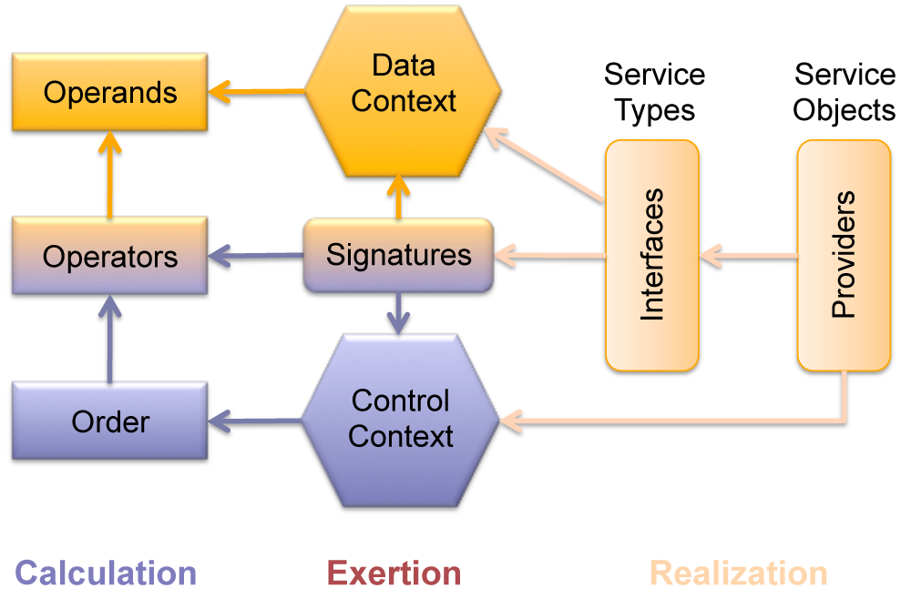
Figure 1. Operands and operators vs. arguments and operations in exertions (arrows indicate the dependency relationship).

In SORCER all related operands are composed into a data context (defined by the sorcer.service.Context interface) that is passed on to every SORCER service provider as the only parameter for every service call. An elementary operand is a key-value pair (an argument) in the data context. Multiple key-value pairs (entries) can be combined into a service context as the data context for service provider processing that incudes both input and output data. Thus in EOP the data context combines operands, the operator is an operation defined in the provider's interface—a pair: operation and interface.
From programming point of view, keys are considered as parameters and values as arguments of the service providers for both data and control strategy definition. A key is expressed by a path of attributes like directories in paths of a file system. Paths define a namespace of the context parameters. A context argument is any object referenced by its path or returned by a context invoker referenced by its path inside the context.
Thus EOP terms correspond to mathematical and programming counterparts as follows:
path-value for short entry—elementary operand
data context, for short context—compound operand
service operation, for short operation—operator
service method, for short method—implementation of operator
service signature, for short signature—a reference to a provider that includes: interface, operation, and a quality of service (QoS))
service type—a special kind of class or interface type
service provider, for short provider—an entity providing implementation of services.

Roughly speaking, an exertion is a specification of operators and related control strategy (control context) with related operands in the form of data contexts.

1.4. Positioning of operands
The position of an operator in relation to its operand(s) may vary. Below is a comparison of three different notations — all represent an addition of the numbers '1' and '2':
1 + 2 (infix notation)
+ 1 2 (prefix notation)
1 2 + (postfix notation)
In EO programming a position of operand is indicated in two different ways. In indexed contexts that implement the IndexedContext interface the index associated with the path `1indicates the operand positioning as follows:

public interface IndexedContext {

public Object putValue(int i, Object value) throws ContextException;

public Object getValue(int i) throws ContextException;
}

Thus, in indexed-based operand positioning the elementary operand is a triplet: path-value-index with the implicit path managed internally by the IndexedContext implementation. ServiceContext that implements Positioning interface allows for positioning by index with the explicit path defined as follow:

public interface Positioning {

public Object getValueAt(int index) throws ContextException;

public List<Object> getValuesAt(int index) throws ContextException;

public Object getInValueAt(int index) throws ContextException;

public Object getOutValueAt(int index) throws ContextException;

public Object getInoutValueAt(int index) throws ContextException;

public Object putValueAt(String path, Object value, int index)
throws ContextException;

public Object putInValueAt(String path, Object value,
int index) throws ContextException;

public Object putOutValueAt(String path, Object value,
int index) throws ContextException;

public Object putInoutValueAt(String path, Object value,
int index) throws ContextException;
}

The sorcer.core.context.ArrayContext class context has an array like access to a service context. It implements additionally complementary (cryptic) methods for handling input, output values with comments and descriptions. Accessing and setting context values is done via integer indices. Implicit context paths describe i-th element of "array" and are used by the following getters and setters (where: v - value, c - comment, d - description, i - input, o - output) as follows:
- a value of the i-th element: by v(i) and the setter v(i, obj); implicit path: array/[i]/value
- a comment of the i-th element: by vc(i) and the setter vc(i, comment); implicit path: array/[i]/comment
- a description of the i-th element: by vd(i) and the setter vd(i, description); implicit path: array/[i]/description
- an input value of the i-th element: by iv(i) and the setter iv(i, obj); implicit path: array/in/[i]/value'
- a comment of the i-th element: by ivc(i) and the setter ivc(i, comment); implicit path: array/in/[i]/comment
- a description of the i-th element: by ivd(i) and the setter ivd(i, description); implicit path: array/in/[i]/description
- an output value of the i-th element: by ov(i) and the setter ov(i, obj); implicit path: array/out/[i]/value
- a comment of the i-th element: by ovc(i) and the setter ovc(i, comment); implicit path: array/out/[i]/comment
- a description of the i-th element: by ovd(i) and the setter ovd(i, description); implicit path: array/out/[i]/description

1.5. Service context

A service context, or simply a context, defined by the Context interface, is a data structure that describes service provider ontology along with related data. A provider‘s ontology is controlled by the provider vocabulary that describes data attributes and the relations between them in a provider's namespace within a specified service domain of interest. A requestor submitting an exertion to a provider has to comply with that ontology as it specifies how the context data is interpreted and used by the provider. In the service context, attributes and their values are used as atomic conceptual primitives, and complements are used as composite ones. A complement is an attribute sequence (path) with a value at the last position. A context consists of a subject complement and a set of defining context complements. The context usually corresponds to a sentence structure of natural language (a subject with multiple complements).
A service context is a tree-like structure described conceptually by the EBNF syntax specification as follows:

context = [ subject ":" ] complement { complement }.
subject = element.
complement = element ";".
element= path [ "=" value ].
path = ["/"] attribute { "/" attribute } [ { "<" association ">" } ] [ { "/" attribute } ].
value = object.
attribute = identifier.
relation = domain "|" product.
association = domain "|" tuple.
product = attribute { "|" attribute }.
tuple = value { "|" value }.
attribute = identifier.
domain = identifier.
association = identifier.
identifier = letter { letter | digit }.

A relation with a single attribute taking values, is called a property and is denoted as attribute|attribute. To illustrate the idea of service context, let’s consider the following example (graphically depicted in Error: Reference source not found where the subject /laboratory/name=SORCER is indicated in green color and the association person in red):

/laboratory/name=SORCER: /university=TTU;
/university/department/name=CS;
/university/department/room;
number=20B;
phone/number=806-742-1194;
phone/ext=237;
/director<person|Mike|W|Sobolewski>/email=sobol@cs.ttu.edu;

where absolute and relative paths are used, and the relation person is defined as follows:
person|firstname|initial|lastname and the following properties are used: firstname, initial, lastname, name, university, email, number, ext.
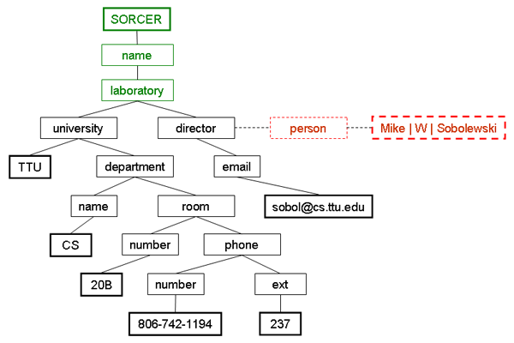
Figure 2. An example of a service context
A context leaf node or data node is where the actual data resides. All absolute context paths define a service namespace. The context namespace with data nodes appended to its context paths is called a context model, or simply a context. A context path is a hierarchical name for a data item in a leaf node. Note that a limited service context can be represented as an XML document—what has been done in SORCER for interoperability—but the power of the Context type comes from the fact that any Java object can be naturally used as a data node. In particular, exertions themselves can be used as data nodes and then executed by providers as needed to run complex iterative programs, e.g., nonlinear multidisciplinary optimization.

1.6. Service Context Hierarchy

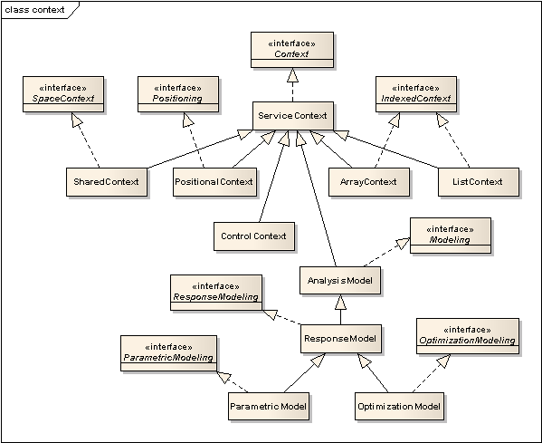
Figure 2. Context hierarchy in SORCER

1.7. Service signatures
An activated exertion initiates the dynamic federation of all needed service providers dynamically—as late as possible—as specified by signatures of top-level and nested exertions. An exertion signature is a classifier of service providers by a service type along with a set of signature attributes or quality of service (QoS). If a service provider that matches the signature is found then the signature’s operation can be invoked on the provider. In SORCER signatures specify indirect invocations of provider methods at runtime. A service Signature is defined by:
- signature name—an optional custom name
- service type—a specific Java interface or class corresponding to the provider’s type; when a class is used then a locally created object is used, otherwise a remote object implementing signature’s interface is found dynamically in the network to be invoked.
- selector of the service—an operation name defined in the service type
- operation type—Signature.Type: PROCESS (default), PREPROCESS, POSTPROCESS, APPEND
- priority—integer value used by exertion’s control strategy
- execution time flag—if true, the execution time is returned in the service context
- notifyees—list of email addresses to notify upon exertion completion
- service attributes—required requestor’s attributes matching provider’s registration attributes

An exertion can comprise of a collection of PREPRROCESS, POSTPROCESS, and APPEND signatures, but with only one PROCESS signature. The PROCESS signature defines the binding provider for the exertion. An APPEND signature defines the context received from the provider specified by this signature. The received context is then appended in runtime to the context later processed by PREPROCESS, PROCESS, and POSTPROCESS operations of the exertion. Appending a service context allows a requestor to use actual network data in runtime not available to the requestor when the exertion is submitted.
Different languages have different interpretations as to what constitutes and operation signature, For example, in C+ and Java the return type is ignored. In SORCER the parameters and return type are all of the Context type.

1.7.1. Selecting a service provider by its name
When executing exertions, use exertion.exert(Transaction) operation. The PROCESS signature defines all parameters that determine the exertion binding. In particular, you might be interested to direct the execution to a particular provider. You can do it as follows:
- Crete a signature with myProviderName for your exertion as follows:
new ServiceSignature("operation", "interfaceName", "myProvidername");
- Update your exertion signature to associate it with the myProviderName name: mySignature.setProviderName("myProviderName");
- Override the exiting provider of an instance of ServiceExertion:
myServiceExertion.exert(null, myProviderName);
where the first argument is a Transaction if needed, and the second one is the provider name.

1.8. Control context; where exertions go?

SORCER extends Jobber synchronous coordination abilities through the use of the asynchronous rendezvous service implementing the Spacer interface. The Spacer service can write exertions into a shared object (exertion) space, implemented with the JavaSpace interface, from which available collaborating providers can retrieve matching exertions, execute them, and return the resulting exertions back to the exertion space. When the attribute access type of a control context is set to PULL then the associated exertion is passed onto a Spacer, otherwise (access type is PUSH) the exertion is passed directly on to the provider specified by its PROCESS signature.
You can set the access type in a control context to PULL as follows:
ControlContext.setAccesType(Access.PULL);
or the PUSH access type:
ControlContext.setAccessType(Access.PUSH);

Another control context attribute—flow type manages the flow of control (sequential or parallel) for all component exertions at the same level.
You can set the flow type in a control context to PAR as follows:
controlContext.setFlowType(Flow.PAR);
or the SEQ flow:
controlContext.setFlowType(Flow.SEQ);

In [X] four use cases are presented to illustrate push vs. pull exertion processing with either PUSH or PULL access types. Thus, Spacers provide efficient load balancing for processing the exertion space. The fastest available provider gets an exertion from the space before other overloaded or slower providers can do so. When an exertion consists of component exertions with different access and flow types, then we have a hybrid case when the collaboration potentially executes concurrently with multiple pull and push collaborations at the same time.

1.8.1. Provider space readiness
There is an option for exertions to be pulled from the exertion space only when the providers are ready to process it. In that case the provider reads the exertion matching its service type (does not take it from the space) and only if its custom method isReady(Exertion):boolean returns true, it takes it from the exertion space. To enable this feature you need:
- to specify the entry in your provider configuration file (*.config) as follows:
spaceReadiness = true;
- to implement the method isReady(Exertion):boolean in your provider extending sorcer.core.provider.ServiceTasker.

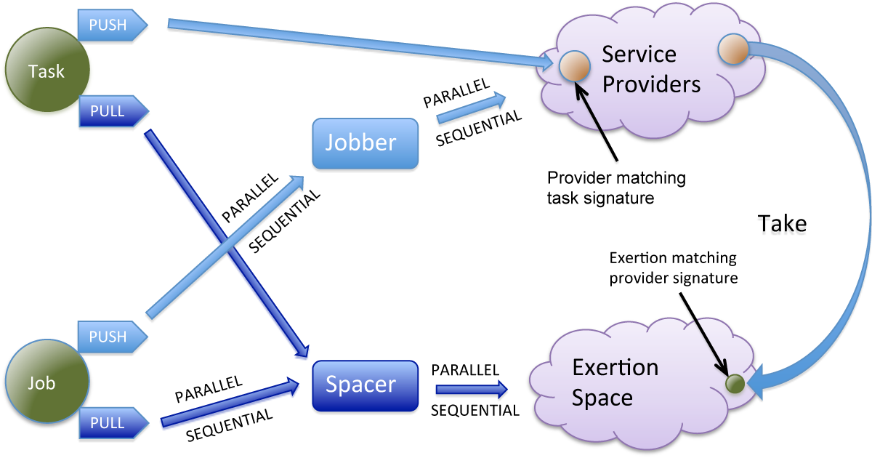
Figure 3. Exertion control strategy and provider access control

1.9. Exertions: service tasks and jobs

A Task instance specifies an elementary step in EO program. It is an analog of a statement in procedural programming languages. Thus, it is a minimal unit of structuring in EO programming. If the provider binds to a Task, it has a method for the task's PROCESS signature. Other signatures associated with the Task exertion provide for appending, preprocessing, and postprocessing service contexts by the same provider or its collaborating providers. An APPEND signature defines the context received from the provider specified by this signature. The received context is then appended at runtime to the task context later processed by PREPROCESS, PROCESS, and POSTPROCESS operations of the task. Appending a service context allows a requestor to use shared network data in runtime. A Task is the single means of passing control to an application service provider in SORCER. Note that a task can specify a batch of operations that operate on the same service context—a Task’s shared execution state. The receiving provider or a group of federating providers coordinated by the provider receiving the task can execute all operations of the task, which are defined by its signatures.

A Job instance specifies a “block” of tasks and other jobs. It is the analog of a procedure in imperative programming languages. In EO programming it is a composite of exertions that makeup the network collaboration. A Job exerts the collaboration reflecting a workflow with branching and looping by using control exertions along with corresponding flow and access types.

The following control exertions define algorithmic logic in EO programming: IfExertion, WhileExertion, ForExertion, DoExertionThrowExertion, TryExertion, BreakExertion, ContinueExertion. Currently implemented in SORCER are IfExertion and WhileExertion exertion types.

To begin processing an exertion, a service requestor exerts the exertion's federation: Exertion.exert(Transaction):Exertion
A Jobber, Spacer, or an application-specific provider receiving the exertion in runtime forms the collaborative federation. The Jobber is responsible for coordinating the execution of the job, much like a command shell coordinates the execution of a batch script. The Jobber acts as a service broker by calling upon the proper service providers to execute the component exertions within the given job according to its control context strategy. The Jobber can dispatch nested service requests either directly, when the jobber finds a proper provider by way of a Cataloger service or falling back to the Jini lookup service. The Spacer can dispatch component exertions indirectly via a shared exertion space through the use of a JavaSpace service.

2. Creating applications using the SORCER platform

2.1. Metacomputing, SORCER, and iGrid

The term “grid computing” originated in the early 1990s as a metaphor for accessing computer power as easy as an electric power grid. Today there are many definitions of grid computing with a varying focus on architectures, resource management and access, virtualization, provisioning, and sharing between heterogeneous compute domains. Thus, diverse compute resources across different administrative domains form a compute grid for the shared and coordinated use of resources in dynamic, distributed, and virtual computing organizations. These organizations are dynamic subsets of departmental grids, enterprise grids, and global grids, which allow programs to use shared resources—collaborative compute federations.
A computer is a programmable device that performs symbol processing, especially one that can process, store and retrieve large amounts of data very quickly, requires a computing platform (runtime) to operate. Computing platforms that allow software to run require a processor, operating system, and programming languages with related runtime libraries or user agents. Therefore, the grid requires a platform that describes a kind of framework to allow software to run utilizing virtual organizations. Different platforms of grids can be distinguished along with corresponding types of virtual federations. However, in order to make any grid-based computing possible, computational modules have to be defined in terms of platform data, operations, and relevant control strategies.
For a grid program, the control strategy is a plan for achieving the desired results by applying the platform operations to the data in the required sequence and by leveraging the dynamically federating resources. A true grid program is the abstraction of hierarchically organized collection of component programs that makes decisions about when and how to run them. This collection is a metaprogram⎯a program that manipulates other programs as its data. Nowadays the same computing abstraction is usually applied to the program executing on a single computer as to the metaprogram executing in the grid of computers, even though the executing environments (platforms) are structurally completely different. Most grid programs are still written using software languages (generating native processor code) such as FORTRAN, C, C++, Java, and interpreted languages such as Perl and Python the way it usually works on a single host. The current trend is still to have these programs and scripts define grid computational modules as services. Thus, most grid computing modules are developed using the same abstractions and, in principle, run the same way on the grid as on a single processor. Applying the same programming abstractions to the grid as to a single computer does not foster transitioning from the current phase of early grid adopters to public recognition and then to mass adoption phases.
Instead of moving executable files around the compute grid, we can autonomically provision the corresponding computational components as uniform services on the grid. All grid services can be interpreted as instructions (metainstructions) of the metacompute grid. Now we can submit a metaprogram in terms of metainstructions to the grid platform that manages a dynamic federation of service providers and related resources, and enables the metaprogram to interact with the service providers according to the metaprogram control strategy. We consider a service as interface type, for example identified as a Java interface. A provider can implement multiple interfaces, thus can provide multiple services. While grid computing is about utilizing virtual organization, metacomputing is about process expression in terms of virtual services.
NCSA Director, Larry Smarr, coined the term “metacomputing” around 1987. "The metacomputer is, simply put, a collection of computers held together by state-of-the-art technology and balanced so that, to the individual user, it looks and acts like a single computer. The constituent parts of the resulting metacomputer could be housed locally, or distributed between buildings, even continents.
The Service-ORiented Computing EnviRonment (SORCER) defines a metacomputing operating system (meta-OS) with all system services necessary, including a federated file system and autonomic resource management, to support service-oriented metaprogramming. It provides an integrated solution for complex metacomputing applications. The SORCER metacomputing environment adds an entirely new layer of abstraction to the practice of service-oriented computing—exertion-oriented (EO) programming with its federated method invocation (FMI). Finally, the term iGrid is used to denote a service-oriented environment that uses the SORCER platform to run services in other types of service grids. Thus the SORCER platform is defined by: exertion-oriented programming environment, SORCER meta-OS, and the service-oriented metaprocessor) as illustrated in Figure 4. The iGrid processor can run various types of heterogeneous services (for example Web services, grid services, JXTA peers) integrated by the SORCER meta-OS.

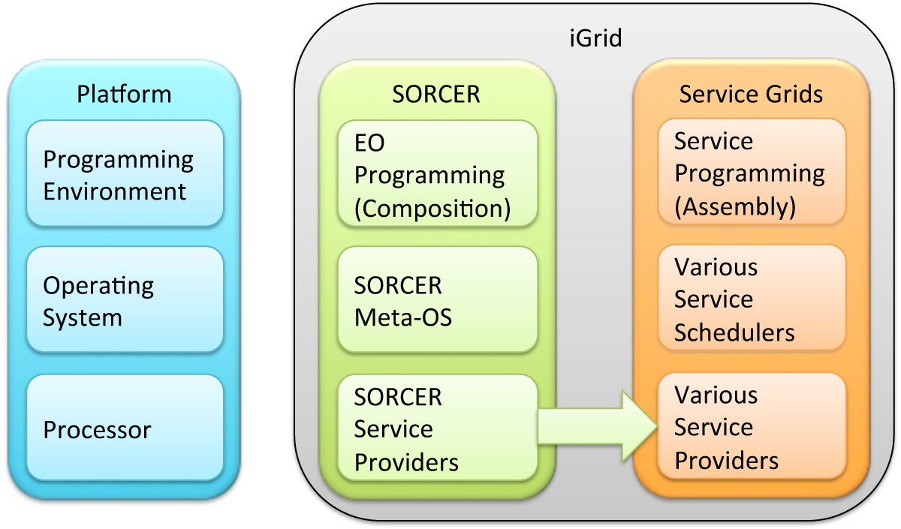
Figure 4. Expending SORCER to iGrid.

2.2. Designing and implementing the application components

First, determine your application architecture, including which components are local objects and which components are remotely accessible. This step includes:
- Defining the service interfaces
In EOP an interface specifies the operations that can be invoked remotely by a requestor as specified by exertion signatures. Service requestors program to service interfaces, not to the implementation classes of those interfaces. The design of such interfaces whether local or remote includes the determination of the types of objects that will be used as parameters used in service contexts and provider components (beans). If any of these interfaces or classes do not yet exist, you need to define them as well.
- Implementing the service providers
Providers must implement one or more interfaces. The provider object class or its bean may include implementations of other interfaces and methods that are available only locally. If any local classes are to be used for parameters or return values of any of these methods, they must be implemented as well. In SORCER either a set of remote or local interfaces can be exposed to requestors. It is not possible to expose both types of interface by the same provider.
- Implementing the service requestors (exertions)
Requestors that use remote objects can be implemented at any time after the service interfaces are defined, including after the providers have been deployed.

2.3. Design an interface
What is an interface?
- An interface specifies a named set of public features.
- The key idea behind interface is to separate the specification of functionality (the interface) from its implementation by a class or component (subsystem).
- Interfaces separate the specification of functionality from its implementation.
- An interface defines a contract.
- If the implementation language doesn't directly support interfaces, just use abstract classes.

A federated distributed application built by using SORCER is made up of service interfaces and service provider classes. The interfaces declare service operations. The classes implement the operations declared in the interfaces and, perhaps, declare additional operations as well. The implementation of operation is called a method. In a federated distributed application, some implementations might reside in some service providers but not others. Providers with operations that can be invoked across the service grid are called remote objects.
The exertion acts as the local representative for the remote objects and basically is, to the service requestor, the federated and dynamic remote reference. It is federated as is combines multiple services into a collaboration. It is dynamic as it invokes providers in runtime (late binding). The requestor invokes an exertion on service signatures, which are responsible for carrying out the method invocation on the remote object as specified by signature’s interface and operation, and the associated context in the exertion. Also, a control strategy that defines the order of executing signatures is defined for exertions. Thus an exertion is a triplet: context (data), set of signatures (operations), and control strategy.
In SORCER, a proxy for a remote object implements the same set of interfaces that the remote object implements. Service interfaces can be exposed to requestors as remote or local. This property enables a proxy to be cast to any of the interfaces that the remote object implements. However, in the case of remote interfaces only those methods defined in a remote interface are available to be called from the implementing service provider.
An object becomes remote by implementing a remote interface, which has the following characteristics:
- Declare the service operations you'd like to call remotely
- The single parameter and returned value of each operation is of the type sorcer.service.Context
- The interface must be public
- The interface must extend java.rmi.Remote
- Each method must declare java.rmi.RemoteException in its throws clause
- Can also declare application-specific exceptions
- Remote objects must be passed as remote interface types
- Local objects must be serializable
- It is recommended to create a local interface first and then a remote that extends java.rmi.Remote as in 4 above
When local interfaces are defined only for service components (beans) that are embedded in SORCER providers then item 4 and 9 must be skipped. When applying item 9, the local implementation allows having it ready in other implementations, for example as beans, and it can be used in a remote ones as well.

2.3.1. The WhoIsIt remote interface
The code below is from the file WhoIsIt.java in modules/examples/ex1/src/sorcer/ex1/provider.

1 package sorcer.ex1.provider;
2 import java.rmi.*;
3 import sorcer.service.Context;
4
5 public interface WhoIsIt extends Remote {
6
7 Context getHostName(Context context)
8 throws RemoteException;
9 }
10 ...
11 }

2.4. Writing a SORCER service provider
- Declare a class, for example WhoIsItProvider that extends sorcer.core.provider.ServiceProvider and implements at least one remote interface (service)
- Mandatory constructor for the provider class is required, for EchoProvider:

public WhoIsItProvider (String[] args, LifeCycle lifeCycle)
throws Exception {
super(args, lifeCycle);
}

- Implement the methods declared in the remote interfaces
- Can declare other methods, but those will only be available locally by provider only

2.4.1. The WhoIsItProvider implementation class
The code below is from the file WhoIsItProvider.java in modules/examples/ex1/src/sorcer/ex1/provider.

1 package sorcer.ex1.provider;
2 import java.net.InetAddress;
3 import java.rmi.RemoteException;
4 import sorcer.core.provider.ServiceProvider;
5 import sorcer.service.*;
6 import com.sun.jini.start.LifeCycle;
7
8 public class WhoIsItProvider extends
9 ServiceTasker implements WhoIsIt {
10
11 public WhoIsItProvider (String[] args, LifeCycle lifeCycle)
12 throws Exception {
13 super(args, lifeCycle);
14 }
15
16 public Context getHostName(Context context)
17 throws RemoteException {
18 String hostname;
19 hostname = InetAddress.getLocalHost().getHostName();
20 context.putValue("provider/hostname", hostname);
21 return context;
22 }
23 ...
24 }

2.4.2. What the provider can do with the requestor’s Context?
The received context contains the data passed from the requestor along with the path names (ontology) specified by the provider for its requestors. The requestor has to obey the “ontological contract”, so the provider knows where the appropriate data items are stored in the context. Thus, the provider can access requestor’s data, process accordingly and return results back to the requestor. Also, the provider can report on actions taken during requestor’s context processing by passing back on to the requestor: traces and exceptions. The provider can also leave for the user related events and logged information with the corresponding SORCER services: Notifier and Logger.
- A provider can Context#getValue(String path):Object from the requestor and can Context#putValue(Object data, String path) for the requestor to be returned.
- A provider can get enumeration of all paths in the context:
Context#getPaths():Enumeration
and search for a particular data items
- A provider can search for its marked values
- A provider can report exception back to the requestor in the returned exertion’s control context:
Context#reportException(Throwable exception)
or
Context#reportException(String message, Throwable exception)
Access context exception by exertion.getExceptions(). If you need to log these exception, use either the context or provider logger as explained in 7 below.
- A provider can indicate a recognizable mark (a kind of footprint) in exertion’s execution path for the requestor in the returned exertion’s control context:
Context#appendTrace(String footprint)
Access an exertion’s trace list by exertion.getTrace()
- A provider can notify about events that took place with the SORCER Notifier service:
Context#notify(Event event);
- A provider can test a data context for validity using its own isContextValid(Context dataContext, Signature forSignature): boolean that overrides Provider default method returning true.

Each provider can use the standard sorcer.core.provider.ServiceProvider logger by calling getLogger(). You can find that logs in the provider logs directory named sorcer-X.log. Using this logger for all your logging might be overwhelming to interpret your provider log. A few other specialized logs are available that can be analyzed using a Log Viewer of the ServiceLoggerManager provider. The Log Viewer provides filtering capabilities by a log level and matching patterns in the form of regular expressions.

A provider can log information with its service context logger and make it available with the SORCER ServiceLoggerManager provider. Context logging uses the standard Java Logger API as follows:
Logger contextLogger = getContextLogger();
contextLogger.info(“this info logged with the context ‘Logger’ for this context”);

To make the context logging with the SORCER ServiceLoggerManager, set the configuration entry for your provider as follows:
remoteContextLogging = true;
In the SORCER Service Browser you can see your context logging using the Log Viewer, the Service UI provided by the ServiceLoggerManager. The default location of logs managed by ServiceLoggerManager is in ${iGrid.home}/logs/remote.

You can use the provider logger, obtained by getProviderLogger() in your provider methods, the same way as the context logger. To have the remote provider log available set the configuration entry for your provider as follows:
remoteProviderLogging = true;
If remoteLogging is set to true then getRemoteLogger() returns the logger with a remote handler to the SORCER ServiceLoggerManager. This handler publishes records to remote location where the ServiceLoggerManager resides. Please note that context and provider loggers use local log handlers for the loggers known to the ServiceLoggerManager, however the corresponding log files can be browsed remotely via ServiceLoggerManager Service UI.
Please note that Context#reportException() passes exceptions in the exertion itself back to the requestor usually regarding processing data received. However, logging using the context logger is also for requestor but in rather detailed format and accumulative. On the other hand, the provider logging is for the provider itself regarding generic provider own specific behavior. It might happen that the same information can be useful for both, the requestor and provider, so in that cases you can use both loggers to record useful feedback into the corresponding log files, local or remote. If you use remote logging then you can review the logs in the SORCER Service Browser.

2.5. Define the requestor implementation: service task
The code below is from the file WhoIsItTaskRequestor.java in modules/examples/ex1/src/sorcer/ex1/requestor.
Below, the requestor creates an elementary exertion—a service task and invokes it by exert operation in the main method (lines 24-25) using the provider name from the "standard" input stream. The resulting context is logged out on line 26. A service task below is created in three steps:
- create service context —lines 36-37
- create service signatures—lines 40-41
- create exertion with a given context and signature—lines 43-44

1 package sorcer.ex1.requestor;
2 import java.net.InetAddress;
3 import java.rmi.RMISecurityManager;
4 import java.util.Scanner;
5 import java.util.logging.Logger;
6 import sorcer.core.context.ServiceContext;
7 import sorcer.core.exertion.ServiceTask;
8 import sorcer.core.signature.ServiceSignature;
9 import sorcer.ex1.provider.WhoIsIt;
10 import sorcer.service.*;
11 import sorcer.util.Log;
12
13 public class WhoIsItTaskRequestor {
14 private static Logger log = Log.getTestLog();
15
16 public static void main(String[] args) throws Exception {
17 System.setSecurityManager(new RMISecurityManager());
18
19 // get a provider name
20 Scanner in = new Scanner(System.in);
21 System.out.println("Enter provider name: ");
22 String providerName = in.nextLine();
23
24 Exertion result = new WhoIsItTaskRequestor().
25 getExertion(providerName).exert();
26 log.info("result: \n" + result.getContext());
27 }
28
29 private Exertion getExertion(String providername)
30 throws Exception {
31 String hostname;
32 InetAddress inetAddress = InetAddress.getLocalHost();
33 hostname = inetAddress.getHostName();
34
35 Context context = new ServiceContext("Who Is It?");
36 context.putValue("requestor/hostname", hostname);
37
38 Signature signature = new ServiceSignature(
39 "getHostName", WhoIsIt.class.getName(), providername);
40
41 Task task = new ServiceTask(
42 "Who Is It?", context, signature);
43 return task;
44 }
45}

2.6. Define a service task with concatenated signatures
The code below is from the file WhoIsItTask2Requestor.java in modules/examples/ex1/src/sorcer/ex1/requestor.
The method getExertion in the WhoIsItTask2Requestor class explains how a task with two signatures can be created. Two signatures: signature1 and signature2 are created with PROCESS and POSTPROCESS signature types set correspondingly. Please note that only one signature of PROCESS type (default type for signatures) can be associated with an exertion. This signature defines a binding to a receiving service provider. When a receiving service provider gets a task then the task signatures are executed in the following order:
- First, all APPEND signatures are processed by the receiving provider in the order specified in the task. The order of signatures is defined by signature priorities, if the task’s flow type is SEQUENTIAL, otherwise they are dispatch in parallel. In the result the task’s service context is appended with dynamic data delivered from context providers specified by these append signatures. Obtained complementary shared context data is managed by the receiving provider according to the remote Observer/Observable design pattern.
- Second, all PREPROCESS signatures are executed in the order specified in the task. The order is as defined in 1). In the result the task context is ready for applying its PROCESS method.
- Third, the PROCESS signature is executed and results are captured in the task context including any exceptions and errors.
- Forth, all POSTPROCESS signatures are executed in the order specified in the task. The order is as defined in 1). Finally the resulting task with the processed context is returned to the requestor.
Thus, in the example below, the signature1 determines the runtime binding to the provider and then signature2 is executed as being of the POSTPROCESS type by the same provider as signature1 matches this provider as well.

1 private Exertion getExertion(String providername) throws
2 Exception {
3 String hostname, ipAddress;
4 InetAddress inetAddress = InetAddress.getLocalHost();
5 hostname = inetAddress.getHostName();
5 ipAddress = inetAddress.getHostAddress();
6
7 Context context = new ServiceContext("Who Is It?");
8 context.putValue("requestor/hostname", hostname);
9 context.putValue("requestor/address", ipAddress);
10
11 Signature signature1 = new ServiceSignature("getHostName",
12 sorcer.ex1.provider.WhoIsIt.class.getName(),
13 providername);
14 signature1.setType(Type.PROCESS);
14 Signature signature2 = new ServiceSignature("getHostAddress",
15 sorcer.ex1.provider.WhoIsIt.class.getName());
16 signature2.setType(Type.POSTPROCESS);
17
18 Task task = new ServiceTask("Who Is It?",
19 context, signature1);
20 task.addSignature(signature2);
21 return task;
22 }

2.7. Define a service job with concatenated exertions
The code below is from the file WhoIsItJobRequestor.java in modules/examples/ex1/src/sorcer/ex1/requestor.

1 private Exertion getExertion(String providername) throws
2 Exception {
3 String hostname, ipAddress;
4 InetAddress inetAddress = InetAddress.getLocalHost();
5 hostname = inetAddress.getHostName();
6 ipAddress = inetAddress.getHostAddress();
7
8 Context context1 = new ServiceContext("Who Is It?");
9 context1.putValue("requestor/hostname", hostname);
10
11 Context context2 = new ServiceContext("Who Is It?");
12 context2.putValue("requestor/address", ipAddress);
13
14 Signature signature1 = new ServiceSignature("getHostName",
15 sorcer.ex1.provider.WhoIsIt.class.getName(),
16 providername);
17 Signature signature2 = new ServiceSignature("getHostAddress",
18 sorcer.ex1.provider.WhoIsIt.class.getName(),
19 providername);
20
21 Task task1 = new ServiceTask("Who Is It?", context1,
22 signature1);
23 Task task2 = new ServiceTask("Who Is It?", context2,
24 signature2);
25 Job job = new ServiceJob();
26 job.addExertion(task1);
27 job.addExertion(task2);
28 return job;
29 }

2.8. Exception handling with exertions

In SORCER the reported exceptions are passed back to the service requestor in an exertion’s control context. To retrieve all exceptions from the network use Exertion#getExceptions():List<ExceptionTrace>.

Context doSomething(Context context) throws RemoteException, MyException {
…
//not fatal exception
reportException(myException);
reportException(“my message”, myException);
…
}

In your Java code you can handle exceptions in a standard way. The relevant SORCER operating system service providers can report them to the service requestor.

try {
…
} catch Exception(e) {
…
// fatal exception
throw new MyException(e);
…
} finally {
…
}

3. Configuring SORCER applications

3.1. Configurations directories and files
There are four directories for each SORCER provider/requestor in the provider/requestor root directory (below xxx is the name of the provider/requestor, also see for file naming conventions in Section Naming Conventions):
- bin—contains provider/requestor startup scripts, named xxx-run.xml or xxx-boot.xml, usually in the Ant XML format. These scripts define the execution configuration for SORCER providers and requestors. xxx-run.xml just runs a single provider, but xxx-boot.xml bootstraps the SORCRCE platform and runs a provider along with a code server and optionally with others providers in the same shared JVM.
- configs—contains deployment configuration files, usually named xxx-prv.cofig, and provider properties files named as xxx-prv.properties.
The component names in xxx-prv.cofig files are standardized, and define for the SORCER provider a relevant proxy with lookup attributes and how to register its proxy with Jini lookup services. The provider proxy is registered with attributes defined in these files. The deployment configuration files allow a single compile-time provider to be customized at runtime (dependency injection)—no source changes required. The xxx-prv.cofig files are mandatory for the startup scripts defined in the bin directory (start-prv.config and boot-prv.config).
On the other hand, application specific properties can be defined in a provider properties file xxx-prv.properties. These properties are defined as a key-value pairs and values can be obtained by calling on the SORCER provider/requestor String value = getProperty("key"); where keys and values are of type String.
- policy—contains policy files that define Java security for providers, usually xxx-prv.policy
- resources—contains other provider related files, for example images, icons, etc.

3.2. SORCER environment, provider, and requestor properties
File names below are relative to the root directory of your project.

The environment (common) properties (key-value pairs) are set in a configuration file in configs/sorcer.env.
A template of the provider configuration file is at: configs/templates/sorcer.env.

3.2.1. Provider deployment configuration
Provider deployment configuration (in Java/Jini format) are set in configuration files in myModue/configs/*-prv.config. A template of the provider deployment configuration file is at: configs/templates/providername-prv.config.

3.2.2. Provider properties
Provider application-specific properties (key-value pairs) are specified in a separate file in myModue/configs/*-prv.properties. The location of this file is specified in myModue/configs/*-prv.config as the component name properties.

Provider application data formats (key-value pairs) are specified in a separate file in configs/data.formats. A template of the provider engineering data formats is given in: configs/templates/data.formats.

3.2.3. Requestor properties
Requestor application-specific properties (key-value pairs) are specified in a separate file in myModue/configs/*-req.properties. In the requestor code, only when subclassing sorcer.core.requestor.ExertionRunner, your SORCER environment and application specific properties are loaded. Otherwise, you have to load them in your own requestor code - see for example the requestors subclassing sorcer.core.requestor.ExertionRunner in modules/examples/ex3 and with no subclassing in modules/examples/ex2.

3.2.4. Java System properties for configuration files
If the environment, data formats, or requestor properties files are not in the standard location as above then their file names can be specified via Java System properties as follows:
sorcer.env.file,
sorcer.formats.file,
requestor.properties.file.

In Ant XML scripts they can be specified as follows:
<sysproperty key="sorcer.env.file" value="../configs/sorcer.env" />
<sysproperty key="sorcer.formats.file" value="../configs/data.formats" />
<sysproperty key="requestor.properties.file" value="../configs/myRequestor.properties" />

3.2.45 Suffixed service providers names
Two suffixed schemas for provider names are available:
1.
# use provider names suffixed with the OS user name
sorcer.provider.name.suffixed = true
2.
# custom suffix for provider names
sorcer.provider.name.suffix = "MWS"

A single attribute sorcer.provider.name.suffixed is used for default global suffixed
names and sorcer.name.suffix for custom global suffixed names specified in your ${IGRID_HOME}/configs/sorcer.env file.
The default vaue for sorcer.provider.name.suffixed is false and for sorcer.provider.name.suffix is the empty string.

Either of the global properties defined in the sorcer.env file can be overridden by attribute:
// overrides the sorce.env property: sorcer.provider.name.suffixed or sorcer.name.suffix as follows
// nameSuffixed = "false";
ignore global suffix and use my own suffix
// nameSuffixed = "mySuffix";

Thus, the specific behavior a provider can be defined in the provider configuration (deployment) file *.config that may optionally contain either
nameSuffixed = "false";
or
nameSuffixed = "mySuffix";

3.3. File naming conventions
Default configuration file names:
In sorcer.util.Env:
public static String SORCER_ENV_FILENAME = "sorcer.env";
public static String PROVIDER_PROPERTIES_FILENAME = "provider.properties";
In sorcer.core.requestor.Runner:
public static String REQUESTOR_PROPERTIES_FILENAME = "requestor.properties";
In sorcer.core.context.ContextManagement:
public final static String CONTEXT_FILENAME = "context.cxt";

3.3.1. Relationship between different categories of properties
In SORCER properties can be specified by variables in different categories as follows:
- OS environment variables:
IGRID_HOME (required) - the directory of your iGrid project;
DATA_SERVER_INTERFACE and DATA_SERVER_PORT (optional), hostname and port of your project HTTP code server;
IGRID_WEBSTER_ITERFACE and IGRD_WEBSTER_PORT (optional), hostname and port of your project HTTP code server. You do not have to specify IGRID_WEBSTER_ITERFACE and IGRD_WEBSTER_PORT if you are not planning to use Unix scripts. If you are limited to Ant scripts only then you can specify your webster in sorecr.env file (provider.webster.interface and provider.webster.port). Remember that in Ant scripts the OS environment variables overwrite the corresponding sorcer.env properties. However, if you want to use an anonymous webster created for you by the SORCER booter (see 4 below), then you can skip your webster specification completely. Setting up your webster is recommended during development of servicer providers only so you have full control over all your code mobility and network configuration (IP addresses and ports). You can specify an explicit value for a webster port or use 0, or negative value. If webster is requested at port = 0 then anonymous port is used and additionally if start port and end port is set then the anonymous port is chosen in the range from start port to end port. In the case of requesting port < 0 the properties are used in the following order: OS system properties, JVM system properties, SORCER environment properties.
- SORCER environment variables specified in the file sorcer.env. The full set of these variables is given in configs/templates/sorcer-all.env, however in the beginning you can start with default values and set only those listed in configs/templates/sorcer.env. Programmatically you can get SORCER environment properties as follows: Sorcer.getProperty(String property).
- Ant XML scripts use selected OS environment variables and SORCER environment properties to be passed on the command line to the JVM via system properties on provider/requestor startup. Ant run/boot scripts import common-run.xml file and build XML scripts import common-build.xml file. Both these files define frequently used Ant properties including those related to OS environment variables and SORCER environment properties.
- The SORCER booter (booter.jar) loads the SORCER platform (sorcer-prv.jar) and related properties from the sorcer.env file before a service provider starts up. The booting process is defined by a boot*.config file. These booting properties are needed to initialize correctly deployment configuration for SORCER providers that is specified in provider's *.config files. Please note that it is possible to startup a service provider with the Jini ServiceStarter utility (start.jar), but in that case the SORCER platform is absent during the bootstrapping process and so, the SORCER environment properties cannot be used in provider configuration scripts. The startup script naming conventions indicate whether Jini starter, *-run.xml, or SORCER booter, *-boot.xml, is used.
- The booter starts up the provider or multiple providers in a shared JRE and each provider loads the SORCER environment properties (sorcer.env) and data formats (data.formats) used in service contexts.
- The location of sorcer.env and data.formats files can be specified by the JVM system properties sorcer.env.file and sorcer.formats.file correspondingly.
- Finally, the starting up provider loads application-specific properties defined in its local properties file. The location and name of application-specific properties file is given by an entry properties in your provider's component sorcer.core.provider.ServiceProvider in the corresponding *.config file.

You can access property values as follows:
- Environment variables: System.getenv(String variable);
- JVM system properties: System.getProperty(String attribute);
- SORCER Booter: Booter.getProperty(String attribute);
- ServiceProvider#getConfiguration() : Configuration // Jini Configuration
- SORCER environment properties: Sorcer.getProperty(String attribute);
- Application-specific properties for your provider/requestor: <prv/req>.getProperty(String attribute);

The relationships between different categories of properties are illustrated in Fig. 6.

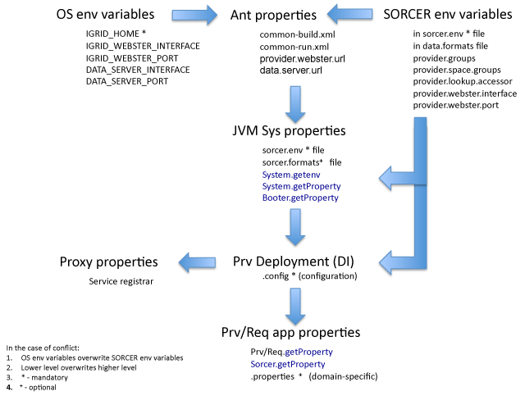
Figure 6. System and domain-specific properties in SORCER.

3.4. Space computing configuration
The following configuration properties (in *.config files) define space computing of a SORCER provider:
- Interfaces to be served by this service provider (subset of its implemented interfaces)
publishedInterfaces (an array of interface types)
- Enable space computing for this provider
spaceEnabled (true or false)
- Group name of the used space by this provider
spaceGroup (String)
- Used space name
spaceName (String, optional if one space exists in the spaceGroup)
- Whether space computing is transactional
workerTransactional (true or false)
- Name given in the exertion’s signature is ignored by the space enabled provider if true
matchInterfaceOnly (true or false)
- Transaction initial lease time for space workers used by this provider workerTransactionLeaseTime (long value)
- Number of provider workers per published interface
workerCount (int number)

The default values of the above properties are as follows:
publishedInterfaces – not defined and mandatory
spaceEnabled=false;
spaceGroup=”sorcer.DEV”
spaceName – not defined
workerTransactional=false;
matchInterfaceOnly =false;
workerTransactionLeaseTime=60000; // 60 seconds
workerCount=1;

The common space computing properties can be defined as the SORCER environment properties (in sorcer.env file) by the following corresponding properties:
provider.space.enabled
provider.space.group
provider.space.name
provider.worker.transactional
worker.transaction.lease.time
provider.worker.count

The SORCER environment space properties are overwritten by properties defined in provider configuration files.

3.5. Service provider discovery/join configuration
Services are found in the SORCER environment using a dynamic service accessor when Exertion.exert(Transaction) is invoked. A dynamic accessor uses one of three available accessor providers specified in sorcer.env as follows:
- for multicast and unicast discovery
provider.lookup.accessor=sorcer.util.ProviderAccessor
- for unicast discovery only or mixed discovery
provider.lookup.accessor=sorcer.util.ProviderLocator
- very light but for multicast discovery only
provider.lookup.accessor=sorcer.util.ProviderLookup
The first one, sorcer.util.ProviderAccessor, is recommended for most cases, so make sure that other two are commented in your sorcer.env file.

The service accessor first stars discovering lookup services (finding lookup services available on the network) in specified service groups (providerGroups defined in the provider’s *.config file or provider.groups in the sorcer.env file). When lookup services are discovered, a service requestor or provider can join the SORCER environment by looking up or registering its services, respectively. The service groups are specified in sorcer.env as follows:
provider.groups=sorcer.DEV,sorcer.PRO
provider.space.group=sorcer.DEV
Common groups have the flowing meaning:
- sorcer.DEV - development group (default group)
- sorcer.QA - quality assurance group
- sorcer.PRO - production/demo group
You can define your own groups and specify one or multiple groups to lookup or register your services.
The SORCER dynamic accessor uses one of the above three accessor providers that use either mulicast or unicast discovery protocols or both at the same time.

Unicast discovery is enabled when lookup locators are specified in the sorcer.env file by a list of URLs:
provider.lookup.locators=jini://10.131.5.101, 10.131.5.102
Above, IP addresses or host names indicate where Jini lookup services are running.

When a SORCER providers stars up, it registers with lookup services found using own discovery manager configured with the service groups and locators specified in the sorcer.env file as described above. However, the service provider can define its own configuration properties for groups and locators used in lookup discovery and then register its services with discovered registries.
These configuration properties specified in the provider configuration file (*.config) are as follows:
providerGroups (an array group names of type String)
lookupLocators (an array group names of type String)
The provider configuration properties overwrite the SORCER environment properties in sorcer.env.

3.6. Service provider task/thread management
Provider resource utilization can be managed by enabling thread management: threadManagement = true; in the provider deployment configuration file. The related default values are as follows:

provider's thread management
threadManagement = true;
maxThreads = 10;
// 15 seconds
threadTimeout = 15000;
loadFactor = 3.0f;
// wait increment for the result of blocked threads
waitForResultIncrement = 50;

Setting up the maximum number of threads and related load factor allows for relevant resource limitation by a service provider. One can say "Use no more than 30 threads for these tasks”. Running too many threads increases resource utilization without increasing throughput. Provider’s resource management allows specification of a "load level" which is a ratio between the number of runnable tasks and the number of threads. For example, if the ratio is 3, then with 30 tasks it is limited to 10 threads. With 300 tasks it is limited to 100 threads. In the case of maxThreads = 1; the provider executes its exertion tasks sequentially.

3.7. Define an icon for the provider
- Create a JPG icon image 16x16 pixels file xxx.jpg and place it into your provider resources directory
- In your xxx-prv.cofig file add the line: iconName="xxx.jpg";
- In your xxx-prv-build.xml include the xxx.jpg file into the top directory of downloadable jar file for requestors.

3.8. Define file and URL support for providers and requestors
The Sorcer utility class is used by service providers and the SorcerRequestor superclass for service requestors with the basic API presented in Figure 5. A properties file for a service provider is specified by the properties entry in its deployment configuration file, for example as follows:
properties = "../configs/jeri-avus-prv.properties";
A service requestor’s properties file is specified by the Java system property requestor.properties.

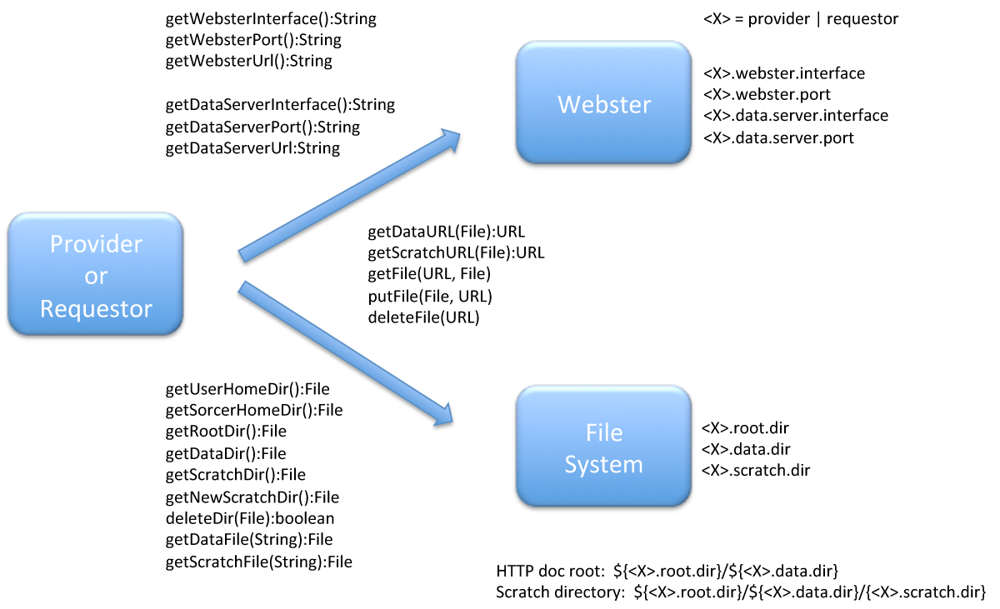
Figure 5. The basic API for file and URL handling by service providers and requestors.

Properties files for service requestors and providers can use a variable notation ${<property>} for a <property> defined in a sorcer.env file, Java system property, and operating system environment property as illustrated in the properties file for Rosen-Suzuki Requestor (${IGRID_HOME}/modules/sorcer/test/rs/configs/rs-model.properties)below.

# Rosen-Suzuki Requestor Properties

# HTTP servers Properties
# for serving codebase
requestor.webster.interface=${provider.webster.interface}
requestor.webster.port=${provider.webster.port}
# for serving data
requestor.data.server.interface=${provider.webster.interface}
requestor.data.server.port=${provider.webster.port}

# Data/file repository configuration
# HTTP server document root: ${requestor.root.dir}/${requestor.data.dir}
requestor.root.dir=${iGrid.home}
requestor.data.dir=data
# Scratch directory format:
# ${requestor.root.dir}/${requestor.data.dir}/${requestor.scratch.dir}
requestor.scratch.dir=astros/requestor/scratch

# Data location
requestor.parametric.out.table=${IGRID_HOME}/modules/sorcer/test/rs/rs-out.data
requestor.parametric.in.table.file=
${IGRID_HOME}/modules/sorcer/test/rs/rs-parameter-in-table.data
requestor.parametric.out.table.file=
${IGRID_HOME}/modules/sorcer/test/rs/rs-parameter-out-table.data
requestor.parametric.in.table.http.file=rs-model/rs-in.data
requestor.parametric.out.table.http.file=rs-model/rs-out.data
requestor.parametric.in.table.url=http://${provider.webster.interface}:
${provider.webster.port}/rs-model/rs-in.data
requestor.parametric.out.table.url=http://${provider.webster.interface}:
${provider.webster.port}/rs-model/rs-out.data

4. Building SORCER applications
Apache Ant (http://ant.apache.org/manual/) is becoming increasingly widely used as a build and deploy tool for Java applications. All Ant XML script templates for building and running SORCER providers and requestors located in modules/examples/ex#. Customizing Ant properties can easily reuse them. An application/project build script (xxx-build.xml) can be found in every application root directory where the src directory with Java sources is located. The provider/requestor run scrip (xxx-run.xml) can be located in the bin subdirectory of the project root directory.

JAR files are packaged with the ZIP file format, so you can use them for tasks such as lossless data compression, archiving, decompression, and archive unpacking. The Java Archive (JAR) file format enables you to bundle multiple files into a single archive file. Typically a JAR file contains the class files and auxiliary resources associated with your services and applications. The manifest in a JAR file (http://java.sun.com/developer/Books/javaprogramming/JAR/basics/manifest.html) is a special file that can contain information about the files packaged in the JAR file. By tailoring this "meta" information that the manifest contains, you enable the JAR file to be used for a variety of purposes. See for details the tutorial "Packaging Programs in JAR Files" at http://java.sun.com/docs/books/tutorial/deployment/jar/index.html.

Preferred classes are designed to be a solution to the infamous "lost codebase" problem of RMI class loading. The "lost codebase" problem prevents RMI from knowing the location from where it should download classes to be used in a distributed computing application. The Preferred class loader provider enables classes to retain consistent location characteristics as they are passed in remote method calls between hosts in a distributed application. The location of the first URL in the path can contain a preferred list for the entire path. A preferred list declares names of certain classes and other resources throughout the path as being preferred or not. When a PreferredClassLoader is asked to load a class or resource that is preferred (according to the preferred list) and the class or resource exists in the loader's path of URLs, the loader will not delegate first to its parent class loader as it otherwise would do; instead, it will attempt to load the class or resource from its own path of URLs only. The preferred list for a path of URLs, if one exists, is located relative to the first URL in the path. If the first URL refers to a JAR file, then the preferred list is the contents of the file named META-INF/PREFERRED.LIST within that JAR file. If the first URL refers to a directory, then the preferred list is the contents of the file at the location META-INF/PREFERRED.LIST relative to that directory URL. If there is no preferred list at the required location, then no classes or resources are preferred for the path of URLs. A preferred list at any other location (such as relative to one of the other URLs in the path) is ignored.
Note that a class or resource is only considered to be preferred if the preferred list declares the name of the class or resource as being preferred and the class or resource actually exists in the path of URLs.

Building a provider or requestor for deployment consists of the following steps:
- Preferred classes - PREFERRED.LIST
- provider-dl.jar, requestor-dl.jar
- ClassDep (in Ant using classdepandjar/org.jini.rio.tools.ant.ClassDepTask)
- ClassDep output sent to 'jar' command
- Not automatic, must pick 'roots'
- Provide ClassDep starting points ('roots')
- Provide packages to include for ClassDep
- Provide packages to exclude (SORCER platform/services)
- Provide packages to hide
- Packaging into jars
- provider: provider.jar, provider-dl.jar
- requestor.jar, requestor-dl.jar

Preferred classes bypasses 'load-local-first' mechanism. If a class is marked 'preferred', and it is available both locally and remotely, the remote version (the preferred version) will be loaded. If the class is only local, an exception occurs. Mark 'preferred' anything the client side should not know about during development (compile time). Requestors side generally knows about interfaces and implementation from sorcer.service.*, exertion-oriented classes in sorcer.core.exertion.*, sorcer.core.context.*, sorcer.core.signature.*, and public interfaces from service(s) of interest.

Preferred list examples are given in modules/examples/ex2/configs. The approach recommended is to create the *-dl JAR files for provider and requestor in *-prv-build.xml and *-req-build.xml respectively. They use created in the configs directory of you module files prv-preferred.list and req-preferred.list.
Create these lists by marking all entries preferred, then selectively back off as illustrated in the two preferred lists below.
- modules/examples/ex2/config/prv-preferred.list

PreferredResources-Version: 1.0
Preferred: true

Name: com/sun/jini/start/*
Preferred: false
Name: com/sun/jini/admin/*
Preferred: false
Name: net/jini/-
Preferred: false
Name: sorcer/service/-
Preferred: false
Name: sorcer/core/exertion/-
Preferred: false
Name: sorcer/core/context/-
Preferred: false
Name: sorcer/core/signature/-
Preferred: false
Name: sorcer/ex2/provider/WorkerProvider.class
Preferred: false

- modules /examples/ex2/config/req-preferred.list

PreferredResources-Version: 1.0
Preferred: true

Name: sorcer/core/exertion/-
Preferred: false
Name: sorcer/core/context/-
Preferred: false
Name: sorcer/core/signature/-
Preferred: false
Name: sorcer/ex2/requestor/WorkerJobRequestor
Preferred: false

5. Running SORCER applications
The SORCER environment is easy to work with an IDE that supports Ant-based development, for example Eclipse or NetBeans.

To start the SORCER environment to play with ready to use services is ${IGRID_HOME}/examples, for example related to the directory ex1 (see README file for details) , run the Ant script
${IGRID_HOME}/bin/iGrid-min-boot.xml

To start a code serveer (webster) for your providers and requestors run the Ant script
${IGRID_HOME}/bin/webster/bin/webster-run.xml

To start a service browser run the Ant script
${IGRID_HOME}/bin/browser/bin/service-browser-run.xml

To run an Ant script:
a) on a command line call ant -f <script filename>
b) in Eclipse IDE select an Ant script then from a popup menu select "Run As/Ant Build"

5.1. Delivery of Dynamically Loaded Classes (Behavioral Transfer)
Program units becoming smaller and mobile as illustrated Figure 6. The fact that a service proxy, exertion, or attached to the provider user interface can be sent over the SORCER environment without the receiving requestor or provider having the corresponding classes is usually called as behavioral transfer in SORCER. Both data and behavior can be exchanged between providers and requestors and vice versa, In other words: both object states and object code can be transferred during exertion execution. Many providers, for example SORCER Jobber, Spacer, or Cataloger are oblivious regarding application-specific proxies and data passed in exertions. Never put in their Java classpath application specific (imported) classes. The same applies to your generic providers serving other applications. Instead make sure that the mobile (exported) classes are served by your code server (webster) and the clients of these exported classes can download them using URLs provided in the provider/requestor codebase.

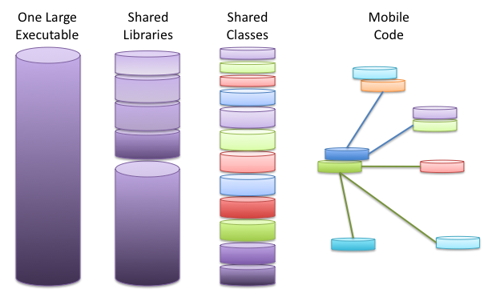
Figure 6. Shrinking programs

We can distinguish three types of webster configuration:
- external webster (see Figure 7)
- internal webster (see Figure 8)
- bootstrapped webster (see Figure 8)

External websters are usually shared across all provider/requestors started up from your SORCER environment/workspace and this configuration is recommended in development. You might need to kill your webster frequently in SORCER application development as webste's served jar files are cached (JRE feature for performance). Thus, each time you update any jar file already served to your clients you have to restart the webster, otherwise you will be serving to your clients still old code.

You can specify you webster by your OS system variables, for example in a C shell script as follows:
setenv IGRID_WEBSTER 192.168.1.236
setenv IGRID_WEBSTER_PORT 50000

If you start your providers/requestors using Unix/Linux shell script, the above is the preferred setup. However, if you mostly work in Java IDE and build and manage your project with Apache Ant, then you can specify your webster in the SORCER environment properties file as follows:
provider.webster.interface=192.168.1.236
provider.webster.port=50000

Take note that OS environment properties overwrite those set in sorcer.env, so if you do not use Unix/Linux startup scripts, please DO NOT define your webster in your OS system variables as that may contribute to webster IP address/port confusion and disastrous consequences for your applications-notorious
nested exception is:
java.lang.ClassNotFoundException
What is hard, especially for beginners in distributed computing, are issues of getting the right files in the right places with the right permissions and the right class annotations (exported webster codebase). About 50% of the messages in the River mailing list (http://river.apache.org/mailing-lists.html) are all about these configuration problems. Thus, use either of the above two webster specification.

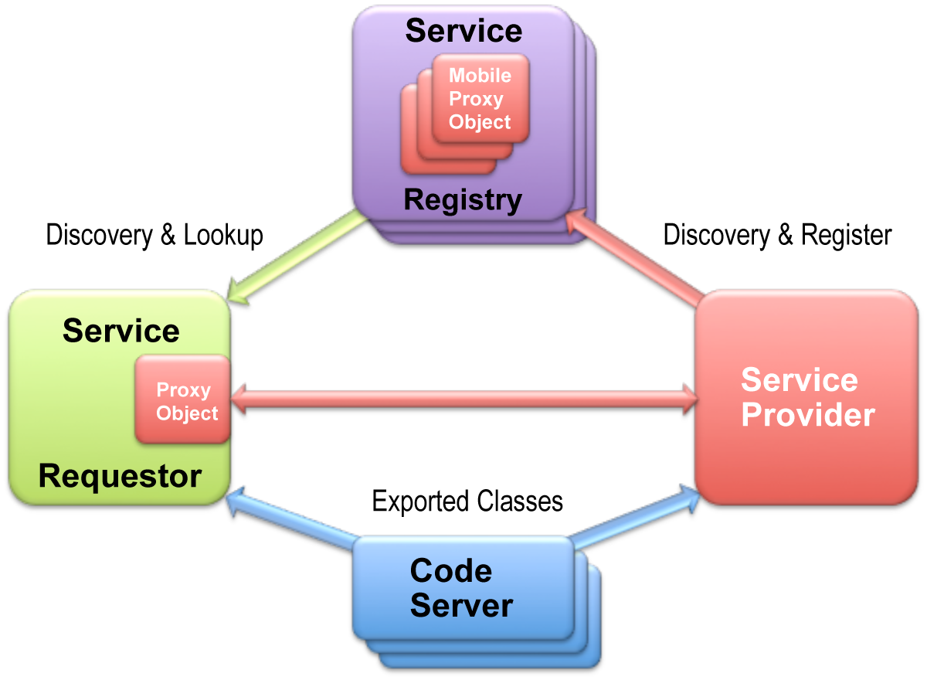
Figure 7. External shared webster (dedined by provider.webster.interface and provider.webster.port in sorcer.env)/

Alternatively you can forget about websters in SORCER and use anonymous websters (see Figure 8) that can startup on your host with anonymous port. However you can control the port and IP address (on multi-homed hosts) in your configuration files, including start and end port ranges, but anyhow you can forget about URLs in you codebase.

Root directories used by websters are listed in bin/webster/webster.run-xml, so make sure all your jar file directories are listed accordingly in this file. In the case of InternalWebster, the root directories are hardcoded in InternalWebster#startWebster, unless they are specified in the Java system property sorcer.webster.roots. For a webster booted internally by a SORCER provider the root directories are specified in configs/startup-boot-prv.config.

jar files in root directories are specified by a Java system property sorcer.codbase.jars. Root directories are relative to the Java system property iGrid.home. Thus, when configuring internal webster do not specify the Java system property: java.rmi.server.codebase.

The following lines should be included in Ant startup scripts for a bootable webster with service requestors:

<property name="requestor.runner" value="sorcer.core.requestor.ExertionRunner" />

<!-- define codebase jars -->
<property name="j1" value="${requestor.name}-dl.jar" />
<property name="j2" value="sorcer-prv-dl.jar" />

<!-- start requestor -->
<target name="run.requestor">
<java classname="${requestor.runner}" fork="yes">
<arg value="="${requestor.class}" />
<classpath refid="project.classpath" />
<sysproperty key="iGrid.home" value="${iGrid.home}" />
<sysproperty key="sorcer.webster.internal" value="true" />
<sysproperty key="sorcer.webster.debug" value="true" />
<sysproperty key="sorcer.codbase.jars" value="${j1} ${j2}" />
<sysproperty key="java.util.logging.config.file" value="${iGrid.home}/configs/sorcer.logging" />
<sysproperty key="java.security.policy" value="../policy/${requestor.name}-req.policy" />
<sysproperty key="sorcer.env.file" value="${iGrid.home}/configs/sorcer.env" />
</java>
</target>

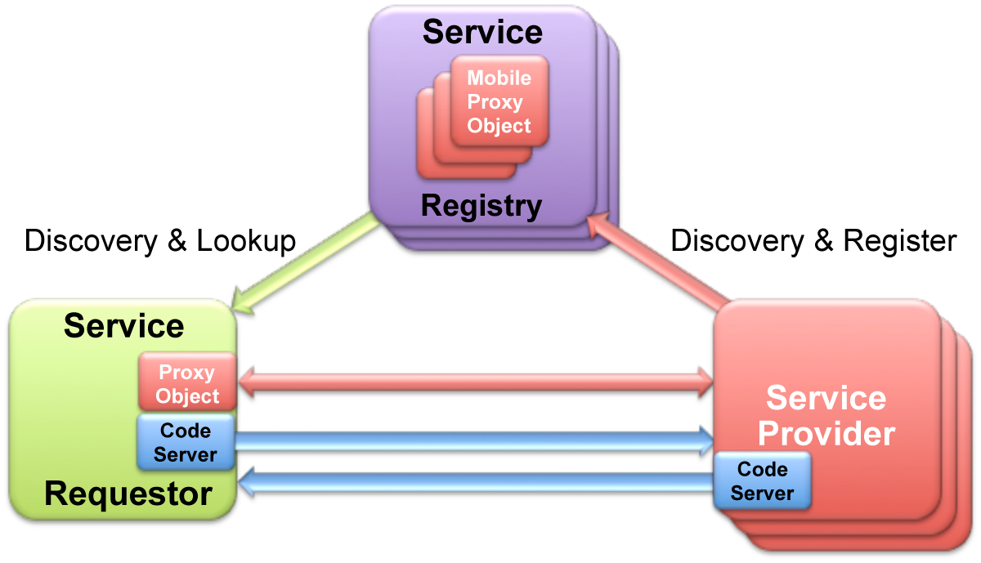
Figure 8. Anonymous websters: internal with a requestor and bootstrapped with multiple providers in a shared JVM.
Recommended conventions for naming Ant XML startup scripts:
*-ext-run.xml or *-run.xml - indicates startup with external webster
*-int-run.xml - indicates startup with internal webster
*-boot.xml - startup with bootstrapped webster

5.2. Using Exertion Space
The SORCER rendezvous (communication and coordination) service provider manages the shared space of exertions submitted by service requestors to be processed asynchronously by available providers in the network. An exertion in the exertion space waits for processing until a service provider takes the exertion from the space and after processing writes it back into the space for the Spacer to take from the exertion space and return the processed exertion back to the requestor. Only exertions with the network access PULL are processed by Spacers. Jobbers process exertions with the default network access set to PUSH. For the exertion myExertion set the network access to PULL, for example as follows: myExertion.getControlContext().setAccessType(Acess.PULL);
Alternatively, for job exertions you can set a service type of job’s signature to sorcer.service.RemoteSpacer, for example create a signature as follows:
myExertion.setProcessSignature(
new ServiceSignature("service", RemoteSpacer.class));

To enable space workers for your service provider in its deployment configuration file the spaceEnabled entry is required:
spaceEnabled = true;
This allows your provider’s space workers to read, write, and take exertions from the shared exertion space of the Spacer service provider.
By default the provider deployment entry of spaceEnabled is set to false. Space workers are enabled for all interfaces specified by the deployment entry publishedInterfaces.
Additional entries that specify space-based behavior of your provider are as follows:
spaceSecurityEnabled = false;
For space-based security, by default is set to false.
matchInterfaceOnly = false;
If matchInterfaceOnly=true then the provider processes all exertions in JavaSpace with its matching interface only, that means that the provider name given in the exertion’s signature is ignored by the provider.
workerTransactional=false
// 60 seconds = 60*1000 ms
workerTransactionLeaseTime=60000;
true if space worker transactional semantics is required and transaction lease time.
workerCount = 1;
The number of space workers per interface specified by the entry publishedInterfaces.
spaceReadiness=false;
Indicates whether space workers support your provider operation isReady(Exertion):boolean before taking the exertion from the exertion space
workerTimeout=5000
Space worker 'take' or 'read' timeout increment (blocking space operations).

5.3.SORCER Service Browser (SSB)
To open a SSB run for example service-browser-run.xml in ${IGRID_HOME}/bin/browser/bin. The SSB configuration file is in ${IGRID_HOME}/bin/browser/configs and its log file in ${IGRID_HOME}/bin/browser/logs directory.

The SORCER service browser comes with support for the following features
- Service Admin
- ServiceUI support
- Service icon support
- Unicast & Multicast discovery
- Filters for interfaces, groups, Name attributes & lookup locators
- Hierarchical & graphical views
- Displays Lookup service events
- Create multiple windows with different filters
- Displays service codebase URLs
- Displays service codebase JAR contents
- Multicast request & multicast announcement monitor
Tree views
- Lookup services
Provides information on all the services that are registered with each Lookup Service.
- Services
Shows a list of unique services.
By expanding each service node you can see the following information
- ServiceID
- Codebase URLs
- Interfaces & methods
- Lookup attributes
- Service methods
Graphical view
By selecting a Lookup Service node in the tree this view will change to a graphical representation of the Lookup Service and the services registered with it. By moving the cursor over each service icon a popup window will display that service's full name and the lookup attributes in the properties window.
To see all a service's attributes in the popup layer, use the View menu to enable this feature
Double click on a service glyph to take you to the service admin view
Service UIs
If you select a service in the tree view that supports a JComponent service UI then the service UI will be displayed in this window.
If your service supports other JFC factories then you can use the "Windows" menu to launch JFrame, JDialog, and JWindow serviceUIs
By default the browser will display the ServiceUI's role name e.g MainUI as the title. If you set the AccessibleContext name on your JComponent the browser will use this name instead of the role name e.g. MyName
Service icons
If your service has a ServiceType attribute that return an Image from ServiceType.getIcon() then the browser will attempt to display this icon in the service's tree
Multiple windows
To open a new browser window use the File->New Window... menu option
The Window menu has options for cascade/tile plus a list of open windows to select from
Using filters
There are four types of filters you can apply to the lookup discovery process.
These can be set via the Filters menu.
You can use C++ style comments in each of the filter views to comment out values
- Interfaces
Type in the full name of the service's interface classes that you want to filter on.
For example net.jini.event.EventMailbox
- Groups
These filters apply the "initialMemberGroups" set by a Lookup Service.
There are two special cases to keep in mind.
For the public group, enter "PUBLIC", for all groups enter "ALL_GROUPS"
- LookupLocators
If you specify any LookupLocators then the brower will only perform Unicast Discovery
Lookup locators are specified as Jini URLs in the format
jini://<host>:<port>
You can leave off the port value to specify the default Lookup Service port.
- Names
This filter allows you to filter on a service's Name attribute
Please note that this filter overrides the interfaces filter
- Plugin filters
This filter allow you to programatically filter out services that you don't want the browser to display
To reset the filters, use the Filters->Reset filters menu
Unicast Discovery
You can add additional Lookup Services that are running outside of the default multicast range by using the "Options->Unicast discovery" menu option.
Enter the jini URL of the Lookup Service in the format jini://<host>:<port> If the LUS is using the default port then you do not have to specify the port
Log file settings
The browser creates a log file called browserLog.txt in the working directory
To monitor the log file use the "View->Log file" menu option
You can change the name and location of the log file by specify the full path in the system property -Dssb.logFile=
The maximum size (in KB) of the log file can be set via the system property -Dssb.logLen= the default size before the log file is overwritten is 500KB
Exported host name or IP Address
You can override the default host name exported by the browser's LUS listener by adding the following JVM command to the browser's start script
-Dssb.browser.exportHost

6. Working with SORCER service beans

6.1. Designing by class extension vs. composition
So far we have developed a service provider by class extension (extending sorcer.core.provider.ServiceProvider). However the design by inheritance creates very strong relationship with its superclasses.
Guideline: Use class extension to model permanent "is-a" relationships.
- Subclasses inherit the interface and, by default, the implementation of their superclass.
- A subclass should have some kind of specialized behavior (it should provide the same service as the superclass, only differently).
- A subclass may also offer new services not offered by the superclass
- The "is-a" relationship means "Is a specialized kind of," so it's the strongest relationship from five: dependency, association, aggregation, and composition
If an interface implementation can be reused than it is better to use the design by composition. Components that implement local interfaces can be plugged into a SORCER provider as reusable components.
Guideline: Use composition to enlist the help of other objects.
- A "front-end" object enlists the help of "back-end" objects
- Front-end object holds references to back-end objects in instance variables
- Front-end object delegates to back-end objects via explicit method invocations
- SORCER beans are used as back-end objects by SORCER providers of the sorcer.core.provider.ServiceProvider type.

Guideline: Understand the difference between inheritance and composition.
Inheritance yields (slightly) better performance:
- Composition's method forwarding/delegation will often be slower than inheritance's dynamic binding
- Composition results in more objects getting instantiated, which can incur a performance cost at allocation, construction and garbage collection time
Composition yields better flexibility:
- Interfaces of classes involved in a composition relationship need not be compatible, so it's easier to change the interfaces
- Composition allows you to delay creation of back-end objects until (and unless) you need them
- Composition allows you to change back-end objects throughout the lifetime of the front-end object
- Composition allows front-end objects to share the same back-end objects
But:
- Composition's method forwarding/delegation results in more code that has to be written, debugged, and maintained.
- Easier to add new subclasses than new front-end classes, unless you use composition with interfaces

6.2. Implementing SORCER service beans
An object becomes a SORCER service bean by implementing an interface, which has the following characteristics:
- Declare the service operations you'd like to call remotely
- The single parameter and returned value of each operation is of the type sorcer.service.Context
- The interface must be public
- Each method must declare java.rmi.RemoteException in its throws clause
- Can also declare application-specific exceptions
- The class implementing the interface and local objects must be serializable

The interface for the WhoIsIt bean can be defined as follows:
The code below is from the file WhoIsIt.java in modules/examples/ex1/src/sorcer/ex1/bean. Please note that "extends Remote" is deleted.
1 package sorcer.ex1.bean;
2 import java.rmi.RemoteException;
3 import sorcer.service.Context;
4
5 public interface WhoIsIt {
6
7 Context getHostName(Context context)
8 throws RemoteException;
9
10 Context getHostAddress(Context context)
11 throws RemoteException;
12 }

The operations of WhoIsItBean are implemented the same way as WhoIsItProvider. The code schema below is from the file WhoIsItBean.java in modules/examples/ex1/src/sorcer/ex1/bean. Please note that "extends ServiceProvider " is deleted and the implemented interface sorcer.ex1.bean.WhoIsIt is not Remote now.
1 package sorcer.ex1.bean;
2 ...
3 public class WhoIsItBean implements WhoIsIt {
4
5 public Context getHostName(Context context)
6 throws RemoteException {
7 ... }
8 return context;
9 }
10
11 public Context getHostAddress(Context context)
12 throws RemoteException {
13 ...
14 return context;
15 }
16 }

The requestor sorcer.ex1.requestor.bean.WhoIsItBeanRequestor working with WhoIsItBean is almost the same as for WhoIsItProvider. Now, only in the task signature the interface have to be of sorcer.ex1.bean.WhoIsIt type instead of sorcer.ex1.provider.WhoIsIt. The WhoIsItBeanRequestor.java file is in modules/examples/ex1/src/sorcer/ex1/requestor/bean.

7. Testing SORCER

There two groups of existing JUnit tests in SORCER.
a) For SORCER (${IGRID_HOME}/modules/sorcer/src/sorcer/junit)
run (${IGRID_HOME}/modules/sorcer/sorcer-build.xml
with the target 'all-test'
b) For SORCER examples (in ${IGRID_HOME}/modules/example):
run (${IGRID_HOME}/modules/examples/example-build-run.xml
with the target 'all-test'

To create a JUnit test cases for testing service provider or requestor adopt the following schema:

1. Select the provider's class for testing (your *.java file)
2. Right Click: New/JUnit Test
a) precede with "junit" the default package name
b) Select relevant methods to your test case fixture
c) Next: for selecting your test case methods in the Java source file
3. To compile the created test case class
a) in your *-build.xml file add the line:
<property name="junit.src" value="./src" />

b) Define the Ant compilation patternset for your JUnit sources
<!-- The JUnit sources to be compiled -->
<patternset id="junit-ant.java">
<include name="junit/sorcer/**/*.java" />
<!-- Exclude source files -->
<exclude name="**/SAVE/*.java" />
<exclude name="**/BAK/*.java" />
</patternset>

c) For the "clean-classes" target (defined in common-build.xml)
add to the patternset <patternset id="ant.classes"> the line
<include name="junit/sorcer/**/*.class" />

b) Add to the classpath
<pathelement location="${support.lib}/junit.jar" />

4. Use the "junit-compile", “junit-test", and "run-test-reports" targets (defined in common-build.xml) in your *-build.xml file accordingly.
See for "all-test" in sorcer-build.xml that uses "junit-compile" and "run-test-reports".

5. Use the same configuration for your requestor to test a task returned by the provider.
In a task's signature instead of the provider name use the class of your provider,
for example new ServiceSignature("doIt", Worker.class, WorkerProvider.class);
where WorkerProvider.class is the implementation class of the interface Worker.class

6. Use the example ex2 in modules/examples/ex2 as the JUnit testing template that follows the above configuration. Take into account that worker-prv-build.xml has the following dependencies:
<target name="all-test" depends="all, junit-test" />
and the target junit-test prints only a JUnit summary at the standard output, but
in worker-req-build.xml with targets:
<target name="all-test" depends="all, junit-prepare, run-test-reports" />
both a JUnit print summary and reports are created by the target run-test-reports.
JUnit reports are created in the directory specified by the target junit-prepare.

8. Working with service jobs

8.1. The Worker interface
The code below is from the file Worker.java in modules/examples/ex2/src/sorcer/ex2/provider.
1 package sorcer.ex2.provider;
2 import java.rmi.*;
3 import sorcer.service.Context;
4
5 public interface Worker extends Remote {
6
7 Context sayHi(Context context)
8 throws RemoteException;
9
10 Context sayBye(Context context)
11 throws RemoteException;
12
13 Context doIt(Context context)
14 throws InvalidWork, RemoteException;
15 }

A custom exception to be thrown when work cannot be done.
1 package sorcer.ex2.provider;
2 public class InvalidWork
3 extends Exception {
4
5 private String message;
6 InvalidWork (String s) {
7 message = s;
8 }
9 public String getMessage() {
10 return message;
11 }
12 }

8.2. The WorkerProvider implementation
The code below is from the file WorkerProvider.java in modules/examples/ex2/src/sorcer/ex2/provider.
1 package sorcer.ex2.provider;
2 import java.net.InetAddress;
3 import java.rmi.RemoteException;
4 import sorcer.core.provider.ServiceProvider;
5 import sorcer.service.*
6 import com.sun.jini.start.LifeCycle;
7
8 public class WorkerProvider extends ServiceProvider
9 implements Worker {
10
11 private String hostname =
12 InetAddress.getLocalHost().getHostName();
13
14 public WorkerProvider(String[] args, LifeCycle lifeCycle)
15 throws Exception {
16 super(args, lifeCycle);
17 }
18
19 public Context sayHi(Context context) throws RemoteException,
20 ContextException, EvaluationException {
21 context.putValue("provider/location", hostname);
22 String reply = "Hi" + " " +
23 context.getValue("reqestor/name") + "!";
24 context.putValue("provider/message", reply);
25 return context;
26 }
27
28 public Context sayBye(Context context) throws RemoteException,
29 ContextException, EvaluationException {
30 context.putValue("provider/location", hostname);
31 String reply = "Bye" + " " +
32 context.getValue("reqestor/name") + "!";
33 context.putValue("provider/message", reply);
34 return context;
35 }
36
37 public Context doIt(Context context) throws InvalidWork,
38 RemoteException, ContextException, EvaluationException {
39 context.putValue("provider/location", hostname);
40 int result = (Integer)
41 context.getValue("requestor/operand/1")
42 * (Integer) context.getValue("requestor/operand/1");
43 context.putValue("provider/result", result);
44 String reply = "Multiplication done" + " "
45 + context.getValue("reqestor/name") + "!";
46 context.putValue("provider/message", reply);
47 return context;
48 }
49 }

8.3. Using Exertion-oriented Language (EOL)
EOL is a metamodel to model connectionist process expressions that model behavioral phenomena as the emergent processes of interconnected federations of service providers. The central exertion principle is that a computation can be expressed and actualized by the interconnected federation of simple, often uniform, and efficient service providers that compete with one another to be exerted for their services in the dynamically created federation. Each service provider implements multiple actions of a cohesive (well integrated) service type, usually defined by an interface type. A service provider implementing multiple service type provides multiple services. Its service type complemented by its QoS parameters can identify functionality of a provider. In EOL an exertion can be used as a closure over free variables in the exertion’s data and control contexts. Typically, a reference is the handle of where the data is stored either with internal or external storage. In exertion-oriented language (EOL) service providers are stored locally and externally. They are uniformly accessed through two types of references: class and interface signatures. Class and interface signatures are also called object and net signatures correspondingly.
Exertion-oriented programming (EOP) is a SO programming paradigm using service providers and exertions. Exertions can be created with textual language (netlets), API (exertlets), and user agents that behind visual interactions create exertlets. Netlets are interpreted scripts and executed by the network shell nsh of the SORCER Operating System (SOS). Invoking the exert operation on the exertlet (Java object) returns the collaborative result of the requested service federation.
An exertion is the expression of a structure that consists of a data context, a control context, and component exertions to compose hybrid (remote/local) service collaborations. Conceptually a control context comprises of a control strategy and multiple service signatures, which define the service references to service providers. The signature usually includes the service type, operation within the service type, and expected quality of service (QoS). An exertion's signatures identify the required providers, but the control strategy for the SOS defines how and when the signature operations are applied to the data context in the created federated collaboration at runtime. Please note that the object signatures refer to local objects but net signatures refer to remote object that implement the relevant service type. In the former case the object is an instance of a given class, in the former a class doesn’t matter, only the fact that the required signature’s interface is implemented.
The context mapping is defined by an exertion signature that includes at least the name of operation (selector) and the service type defining the service provider. Additionally, the signature may also specify the exertion's return path, the type of returned value, and QoS. Two basic signature types are created with the sig operator as follows:
- sig(<selector>, Class) object sig
- sig(<selector>, <service type>) net sig
The operator provider returns a service provider (local or remote) defined by a service signature:
provider(Signature):Object

An exertion specifies the collection of service providers including dynamically federated providers in the network. Its primary service provider is defined by the primary signature marked by the SRV type. Three types of service exertions are distinguished: commands, tasks and jobs. The srv operator defines service exertions as follows:
srv(<name> {, <signature> } , <context> {, <exertion> }):T <T extends Exertion>
For convenience tasks and jobs are also defined with the task and job operators as follows:
task(<name>, { <signature> }, <context>):Task
job(<name> [, <signature> ], <context>, <exertion> {, <exertion> }, <strategy>):Job
An exertion can be described through its relationship with other exertions. The important operation defined on exertions is exertion composition, where the output from one exertion becomes the input to another exertion. Let’s consider three tasks described in EOL by the following services:
f3 = x5 – x6; f4 = x1 * x2; and f5 = x3 + x4
that implement three interfaces: Subtractor, Multiplier, and Adder, respectively. We want to program a distributed service that mimics a function composition:
f3(f4(x1, x2), f5(x3, x4))
and calculate: f3(f4(10.0, 50.0), f5(20.0, 80.0))

Consider “Hello Arithmetic” exertion net job as collaboration of three services:

Task f4 = task("f4", sig("multiply", Multiplier.class), context("multiply",
in("super/arg/x1"), in("arg/x2", 50.0), out("result/y")));
Task f5 = task("f5", sig("add", Adder.class), context("add",
in("arg/x3", 20.0), in("arg/x4", 80.0), out("result/y")));
Task f3 = task("f3", sig("subtract", Subtractor.class), context("subtract",
in("arg/x5"), in("arg/x6"), out("result/y")));

Job f1 = job("f1", context(in("arg/x1", 10.0), result("f3/result/y")),
job("f2", t4, t5, strategy(Flow.PARALLEL, Access.PULL) ),
t3,
pipe(out(f3, "result/y"), in(f5, "arg/x5")),
pipe(out(f4, "result/y"), in(f5, "arg/x6")));
assertEquals(get(exert(f1), "f1/f3/result/y"), 400.0);
Above, five exertions are declared, three tasks f4, f5, and f3 and two jobs: f1 and f2. A few EOL operators are used in the program to define services: sig defines the service operation by its name in the requested service type, e.g., the operation "subtract" defined by the Java interface Subtractor.class in f3; operators in, out specify service input and output parameters by paths in the data context. The expressions that start with the operator task or job are exertions. Jobs f1 and f2 specify service compositions and define its control strategy expressed by the strategy operator. Service jobs define virtual services created from other services. Tasks are elementary exertions and jobs are compound exertions in exertion-oriented programming.
The task f4 requests to multiply its arguments arg/x1 and arg/x2 by the service Multiplier.class. The value of arg/x1 comes from the data context of its parent job j1 as indicated by the prefix super in the path super/arg/x1. The task f5 requests to add its arguments arg/x1 and arg/x2 by the service Adder.class. The task f3 requests to subtract arg/x2 from arg/x1 by the service Subtractor.class where input values are not yet defined. The job f2 requests execution of both f4 and f5 with its control strategy strategy(Flow.PAR, Access.PULL)). This means that the component exrtions f4 and f5 of f2 are executed in parallel and the corresponding service providers will not be accessed directly by the SOS. In this case the corresponding service providers will process their tasks via the SORCER shared exertion space (PULL) when they are available to do so. The default control strategy is sequential (SEQ) execution with PUSH access, which is applied to job f2. The job f1, executes the nested job f2 and then via data pipes (defined with the pipe operator in f1) passes the results of tasks f4 and f5 on to task f3 for arg/x1 and arg/x2 correspondingly. The last statement in the above program exerts the collaboration exert(f1). Exerting means executing the service collaboration and returning the exertion with the processed contexts of all component exertions along with operational details like execution states, errors, exceptions, etc. Then the get operator returns the value of the service collaboration f1 at the path f1/f3/result/y, which selects the value 400.0 from the context of executed task f3 at the path result/y. The invocation exert(f1), creates at runtime a dynamic federation of required collaborating services by SOS with no network configuration. This type of process is referred to as "federated".
Please note that the program above defines a function composition f3:
f3(f4(x1, x2), f5(x3, x4))
as a service composition f1:
f1(f2(f4(x1, x2), f5(x1, x2)), f3(x4, x5))
with two jobs f1 and f2 that are implicit in the function composition f3 since the output from one function becomes the input to another function directly. That’s not the case in the exertion composition since each exertion has a single explicit argument of the Context type, thus two implicit free paths of the task f3, arg/x4 and arg/x5, have to be closed over pipes by the job f1 handling f3 and before handling the job f2 with two task f4 and f5 in parallel. On the one hand, the job composition allows specifying the control strategy for executing component exertions. For example, the job f2 is run in parallel and providers pull the component exertion from the network when they are available at their own pace (asynchronous execution). On the other hand, the job composition allows for simplicity and flexible data integration by hiding details of arguments (always one exertion argument with free context paths—hidden arguments) and data flow between component exertions over context pipes. Since the service composition is explicit and the execution control strategy along with its state is embedded in service exertions they can be rerun from the last state if they have been interrupted.

9. Native code integration

- JNI-based integration

- JNA-based integration

- SWIG-based integration

10. Troubleshooting SORCER

Most network problems in SORCER are the same as in Jini. Usually they are related to configuration problems of some kind. Search for solutions at:

Frequent configuration problems in SORCER are listed below.

10. Java packages
All libraries for SORCER applications are jar files in iGrid-xx/common (off the shelf) and iGrid-xx/lib (SORCER built). In the case of java.lang.ClassNotFoundException or "Could not obtain preferred value for... errors double check if needed classes are in the corresponding jar file. When class cannot be found something is wrong with the classpath or the codebase.

10.2. IP addresses
First double check (ifconfig/ipconfig) if IP addresses are correctly set on your hosts. The Java network layer (by InetAddress.getLocalHost()) determines IP addresses of localhost. Check if returned address is correctly resolved and is not "0.0.0.0". The solution is to use correctly resolved hostname/address pairs on that machine (can be multi-homed). When using BasicJeriExporter, TcpServerEndpoint.getInstance(0) could be replaced by TcpServerEndpoint.getInstance("my_ip_address", 0) (for a suitable "my_ip_address" of course!) in the configuration files for the providers in that machine. The exporter variable related to TcpServerEndpoint defined in a SORCER provider configuration files configs/xxx-prv.cofig can be updated accordingly. In the case of using JrmpExporter , the value of java.rmi.server.hostname property can be set. This property represents the host name string that should be associated with remote stubs for locally created remote objects, in order to allow clients to invoke methods on the remote object. Otherwise InetAddress.getLocalHost() is used.

10.3. Code server (webster)
No code server:
java.rmi.ServerException:
RemoteException in server thread; nested exception is:
java.rmi.UnmarshalException: unmarshalling method/arguments;
nested exception is:
java.lang.ClassNotFoundException: could not obtain preferred value for: ...

Set environment variables IGRID_WEBSTER and IGRID_WEBSTER_PORT correctly to your local host or another coder server (HTTP server) you have decided to use. If in trouble, please check if correct jar files are associated with your proxy and then if they are accessible from a web browser. In the SORCER service browser check its log file to check for exception as above. In the browser click on your service then expend "Codebase URLs", click on a selected URL to see available class files to the requestors.

10.4. Crossing firewalls with limited port ranges
To cross firewalls we might be allowed to use the limited ranges of required ports on limited hosts for SORCER operations. That applies not only to SORCER service providers, but also to Jini services and SORCER Service Browser (SSB). Jini Lookup Services (LUSs) and SSBs can collaborate across firewalls with Jini unicast discovery and join protocols. For example, the related ports, in the range 4160-4260 can be utilized as follows:
- Jini lookup service (LUS)
  - LUS unicast discovery: 4160 (range 4160-4165)
  - LUS lookup port: 4166 (range 4166-4170)
  - LUS code server: 4171 (range 4171-4175)

- SORCER Service Browser (SSB)
  - SSB class server: 4177 (from 4176-4180)
  - SSB listener: 4182 (range 4181-4185)

- The backup port range for unexpected emergencies is 4186-4199
- Ports for SORCER infrastructure and application-specific services in range 4200-4260

In order to use the posts above, the following configuration is requied.
- Configuring Jini LUSs:
In the file <Jini install directory>/installverify/support/startAll.config change the code server port to as follows
private static port = "4171";
instead of:
private static port = "8081";

In the file <Jini install directory>/installverify/support/reggie.config add at the top the import lines:
import net.jini.jeri.*;
import net.jini.jeri.tcp.*;

and below the line:
initialMemberGroups = new String[] { "sorcer.DEV" };
the following lines:
serverExporter = new BasicJeriExporter(TcpServerEndpoint.getInstance(4166), new BasicILFactory());
initialUnicastDiscoveryPort = 4160;
// add the locator for a partnering LUS
initialLookupLocators = new LookupLocator[] { new LookupLocator("<hostname or IP address>", 4160) };

- In the SSB log file you should see the following lines for port utilization:
Log file maximum size (-Dssb.loglen)=300 KB
SORCER: Service Browser v6.0 [SSB-01]
webster start port: 4177, end port: 4180
SSB code Server started on port 4178
Setting codebase to http://10.131.5.101:4178/ssb.jar
Path to files=/Users/sobolemw/workspace/iGrid-09/common/ssb/
initial lookup groups: [sorcer.DEV]
exporter endpoint: TcpServerEndpoint[4185]

That can be achieved by the following specification in the configuration file for the SORCER Service Browser. Please uncomment corresponding entries in the configuration file and provide appropriate values.
import net.jini.jeri.*;
import net.jini.jeri.tcp.*;
import net.jini.discovery.*;
import net.jini.core.discovery.*;

sorcer.sbb.browser.SorcerServiceBrowser {

// If 'discoveryManager' is set in the SSB config file then both
// discovery lookup management and discovery group management are used by // SSB. If "initialLookupLocators' are set
// then only unicast discovery is used, otherwise multicast lookup discovery // is used for the specified 'initialLookupGroups". However, in the latter // additional runtime lookup locators can be added using
// 'Tools/Unicast discovery...'.

// initialLookupGroups = new String[] { "sorcer.DEV" };
// initialLookupLocators = new LookupLocator[] { new
LookupLocator("127.0.0.1", 4160) };
// discoveryManager = new
LookupDiscoveryManager(DiscoveryGroupManagement.NO_GROUPS, null, null);
// listenerExporter = new
BasicJeriExporter(TcpServerEndpoint.getInstance(4185), new
BasicILFactory());
// websterStartPort = 4177;
// websterEndPort = 4180;
}

10.5. Testing published services across disjoint networks

  - Build the provider and requestor in modules/examples/ex1
  - Modify in ex1/config/whoIsIt1-prv.config and ex1/config/whoIsIt2-prv.config the line:

exporter = new BasicJeriExporter(TcpServerEndpoint.getInstance(0), new BasicILFactory());

by replacing the port 0 with the number within the range 4200-4260. Remember, each provider needs a different port number on the same host.

- Add the line:

locators = new String[] { "jini://host1:port1" };

for unicast discovery to allow your providers to register at the collaborating remote university hostname/IP address.

- Set your Webster (code server) port provider.webster.port in the range 4200-4260 in your iGrid/configs/sorcer.env file. Also, make sure your property provider.webster in sorcer.env points to your host name/IP address

- Start your Webster iGrid/bin/webster-run.xml

- Run ex1/bin/whoIsIt1-prv-run.xml and ex1/bin/whoIsIt2-prv-run.xml
- Run the requestor ex1/bin/whoIsItTask-req-run.xml

11. Debugging requestors and providers

Eclipse debugger
The Ant debugger setup is specified by the three jvmarg properties in your run/boot script as shown below. Additionally a debug configuration is required and can be defined in Eclipse, for example by using Run/Debug Configurations..., where Host/Port fields should be defined with the port as given in "address" below.
<jvmarg value="-Xdebug" />
<jvmarg value="-Xnoagent" />
<jvmarg value="-Djava.compiler=NONE" />
<jvmarg value=
"-Xrunjdwp:transport=dt_socket,server=y,suspend=y,address=10000" />

VisualVM
Since Java 6 you can analyze providers problems with VisualVM (jvisualvm). You can monitor CPU, heap, object and class allocations, and threads usage. Additionally you can browse a heap dump, profile you applications, and connect to a remote host. Getting started with VisualVM at https://visualvm.dev.java.net/gettingstarted.html

