|  |  |  |  |  |  |  |  |
| --- | --- | --- | --- | --- | --- | --- | --- |
|  | 1 | 2 | 3 | 4 | 5 | 6 | 7 |
| 北 | ◯ | ◯ | × | × | ◯ | ◯ | ◯ |
| 北西 | ◯ | ◯ | × | × | ◯ | ◯ | ◯ |
| 西 | ◯ | × | × | × | × | × | × |
| 南西 | ◯ | × | × | × | × | × | × |
| 南 | ◯ | ◯ | × | × | ◯ | ◯ | ◯ |
| 南東 | ◯ | ◯ | × | × | ◯ | ◯ | ◯ |
| 東 | ◯ | × | × | × | × | × | × |
| 北東 | ◯ | × | × | × | × | × | × |

[sim1]

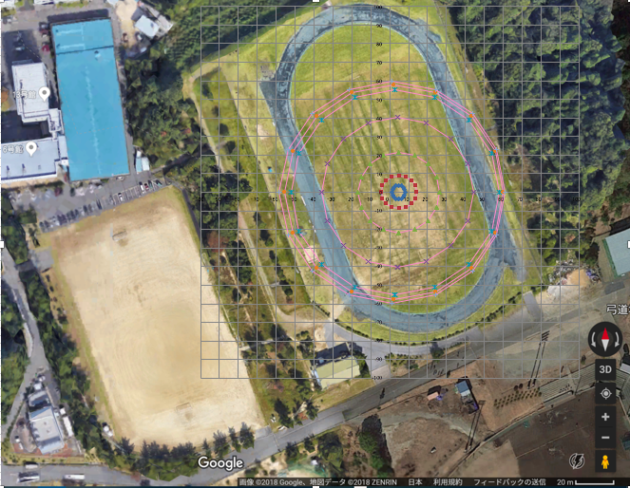

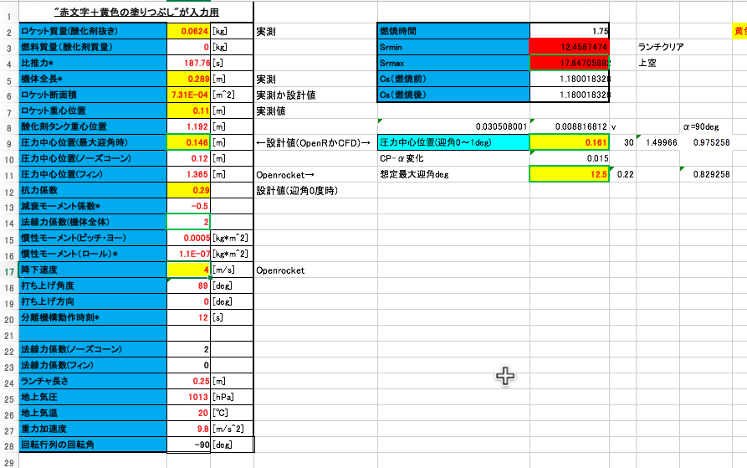

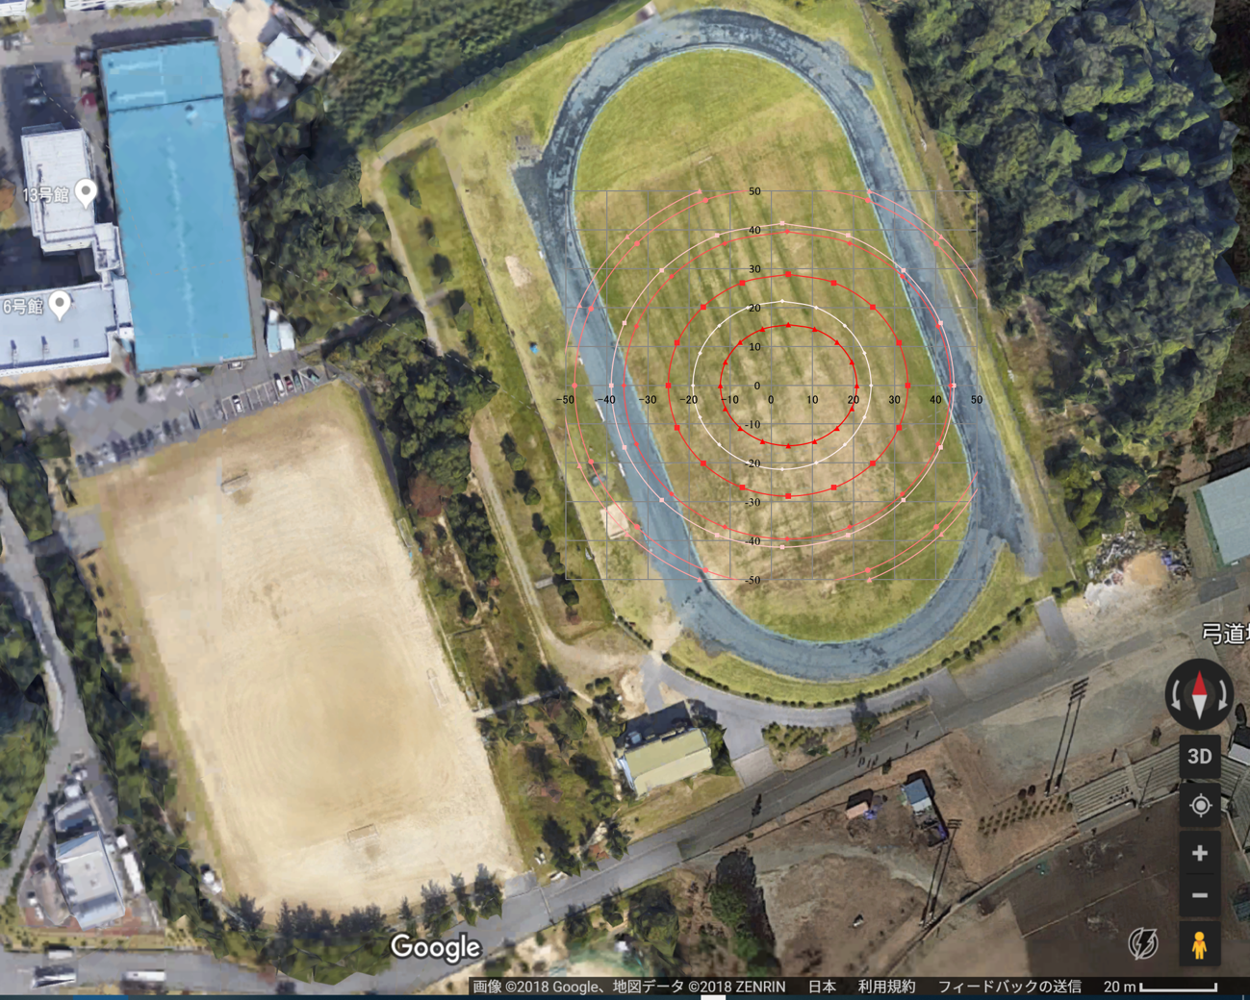[sim2]

