Washington State Geoportal Transition

WAMAs Literacy & Outreach

Recommendations Report

**DRAFT** July 3, 2017

Wynnie Tranfield | [wynnie.tranfield@ocio.wa.gov](mailto:wynnie.tranfield@ocio.wa.gov); [mwtran@uw.edu](mailto:mwtran@uw.edu)

Table of Contents

Executive Summary 2

Project Purpose 3

Table 1: Assessment of Current WA Geospatial Data Providers 3

Mission 4

Audience 4

OCIO’s Open Geoportals Front Page 4

***Recommendation 1*** 4

***Recommendation 2*** 5

***Recommendation 3*** 5

Existing Washington State Open Data Bridge [geo.wa.gov] 5

***Recommendation 1*** 5

***Recommendation 2*** 6

Washington Geospatial Data Context 7

Table 2: [geography.wa.gov] Content Dispersal 7

WA Master Addressing Services 9

***Recommendation 1*** 9

***Recommendation 2*** 9

***Recommendation 3*** 9

Priorities 10

Appendix 1: See Attached Excel Spreadsheet - Geoportal Analysis 10

## Executive Summary

The following document outlines current stakeholder needs for the imminent consolidation of Washington State’s Geoportals. Evaluation of over fifty United States geoportals using user-centered methodologies places Washington on a national scale and makes recommendations for the shift. WAMAS is briefly examined as a service of the OCIO’s Program Office that could be better integrated into future web portals. Recommendations are made for OCIO’s Geoportal front page, the existing Washington State Open Data Bridge, and OCIO’s WAMAS front page.

## Project Purpose

[geography.wa.gov] has been considered the primary Geoportal in Washington State, however, the server will not be available indefinitely. Shifting services to [geo.wa.gov] will ensure sustainable access and centralize maintenance. This shift can be taken as an opportunity to review national trends, update, and refine open data access services to improve usability. Since there was no time to conduct a usability survey specific to the Washington State context, literature on previous Geoportal surveys was examined and extrapolated. All sources examined strongly associated usability with search visualization capabilities and consistent result visualization. Resch and Zimmer[1] went as far as categorizing five crucial components to optimal usability:

1. Map view
2. Search box
3. Detailed search results
4. Symbologies (clear and accurate icons)
5. “Other” (loading times, information visible at a glance, not many windows, general wayfinding)

The current [geo.wa.gov] utilizes a common ESRI sponsored format that ensures the presence of components 1-3, however, symbologies and the elusive “other” require the more attention. Table 1 (below) illustrates disparate agencies currently contributing data to various degrees that will need to be notified of shifting protocols. Geodata is currently unevenly dispersed across the new Open Data Bridge and [geography.wa.gov].

### Table : Assessment of Current WA Geospatial Data Providers

|  |  |  |  |  |  |
| --- | --- | --- | --- | --- | --- |
| **Data** | **Organization** | **Currently on ODB geo.wa.gov** | **Currently Linked on OCIO** | **Currently Linked through geography.wa.gov Applications Catalog** | **Currently Linked through geography.wa.gov GIS Data Catalog** |
| [Washington State Trails Map](http://www.rco.wa.gov/recreation/WashingtonStateTrailsMap.shtml) | WA Recreation and Conservation Office | No | No | Yes | Yes |
| [WA DNR Data](https://fortress.wa.gov/dnr/adminsa/DataWeb/dmmatrix.html) | WA DNR | No | No | No | Yes |
| [WSDOT](http://wsdot.maps.arcgis.com/home/index.html) | WSDOT | Minimal | No | Yes | Yes |
| [Inland Waters, Riparian Boundaries](http://waecy.maps.arcgis.com/home/index.html) | WA Department of Ecology | Yes | No | No | Yes |
| [Fish and Wildlife](http://wdfw.maps.arcgis.com/home/gallery.html#c=organization&o=title) | WA Department of Fish and Wildlife | No | No | Yes | Yes |

### Mission

The Washington State Open Data Bridge (ODB) aims to provide reliable access to WA’s open spatial and tabular data. It presents as a collaborative effort orchestrated by the Geographic Information Technology (GIT) Committee and the Washington Geographic Information Council (WAGIC).

### Audience

Primary users are staff of Federal, State, local and tribal government agencies. Secondary users are the general public, consultants, and students.

## OCIO’s Open Geoportals Front Page

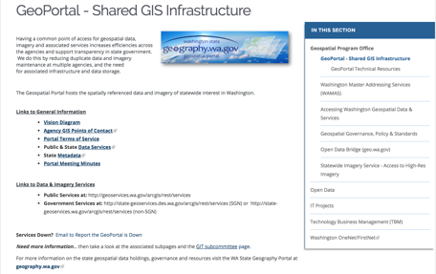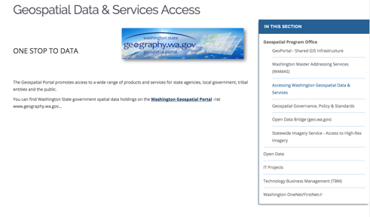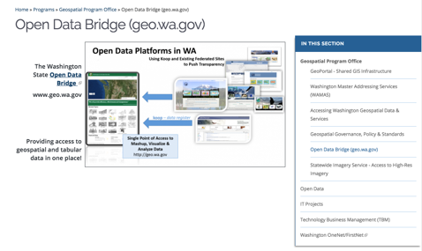

Figure : OCIO>Geoportal Figure : OCIO>Accessing Figure : OCIO>ODB

The current Geospatial Program Office/OCIO portal offers an opportunity for concise wayfinding statements. Three links in the right-hand menu indicate pathways to a geoportal, eliciting confusion. To the user, “Geoportal,” “Accessing Washington Geospatial Data & Services,” and “Open Data Bridge” are all equally plausible links to a functional geoportal. If a user is unsure and works their way down the list, it could take five clicks from the OCIO website to reach the Geoportal.

***Recommendation 1:*** The number of clicks from the OCIO website could be reduced to two if information from the disparate links are combined and reduced for clarity. One page is sufficient to link to geo.wa.gov. **Only one clear link to the Geoportal should be presented on the OCIO right-hand menu.**

* “Accessing Washington Geospatial Data & Services” should be removed
* “Geoportal – Shared GIS Infrastructure” and “Open Data Bridge (geo.wa.gov)” should be consolidated and combined
  + *Open Data Platforms in WA* infographic is communicative, but value can be added by inserting an edited version of the “GeoPortal” blurb
  + Example: Having a common point of access for geospatial data, imagery and associated services increases efficiencies across the agencies and support transparency in state government. The Geospatial Portal hosts the spatially referenced data and imagery of statewide interest in Washington.

***Recommendation 2:*** In order to orient the site to the *user*, information about “Portal Meeting Minutes” and back-end type details should be shifted to what is currently “Geospatial Governance & Standards.” Link options should be uncluttered.

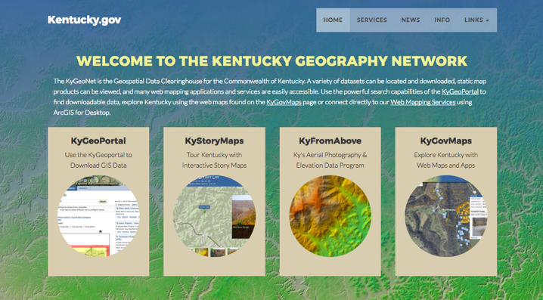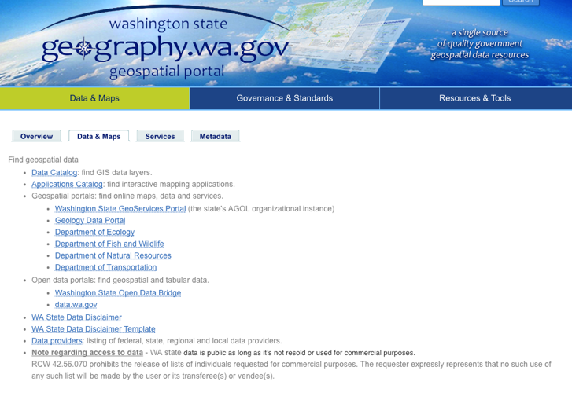

Figure 5: WA Geoportal

Figure 4: KY Geoportal

For example, Kentucky [(Figure 4)](http://kygeonet.ky.gov/), above, offers users a manageable number of information-seeking options with brief descriptions that link directly to the

***Recommendation 3:*** Cluttered, bulleted lists of options are to be avoided. [geography.wa.gov] offers a confusing number of portal options (Figure 5). Necessary caveats such as the WA State Data Disclaimer and RCW 42.56.070 should be linked on the main page, however, the list of Data Providers can be housed under the OCIO “Geospatial Governance, Policy, & Standards” tab.

## Existing Washington State Open Data Bridge [geo.wa.gov]

The Open Data Bridge (ODB) reflects current best practices for governmental open geospatial data portals, including both a keyword search bar and orientating preview map. Other organizations currently utilizing a similar interface include Hawaii, Michigan, Iowa, Kentucky, and Pierce Country, Washington (listed in Appendix 1).

***Recommendation 1:*** Replace the Inslee quotation with the “About” section (currently bottom-right). Instructions could also replace About.

* Proposed About: The Geospatial Program Office with the Office of the Chief Information Officer in the State of Washington serves to promote cooperative geospatial information sharing within Washington state agencies. Access to products and services for state agencies, local and tribal governments, and the public serves to promote effective decision-making and improve efficiency.
* Instructions: Use the Open Data Bridge Portal search, browse, and download Washington State spatial and tabular datasets. Brose by selecting the most relevant topic below, or enter a keyword search term into the search bar.

***Recommendation 2:*** Falling within the symbology category of usability, the “browse” icons conform to a legible metadata standard but are too numerous and confusing for secondary users. “Society” and “Health,” for example, are easily conflated. The current [geo.wa.gov] setup (Figure 6) is further cluttered by attractive but detailed images. The use of images not symbols makes the website look dated.

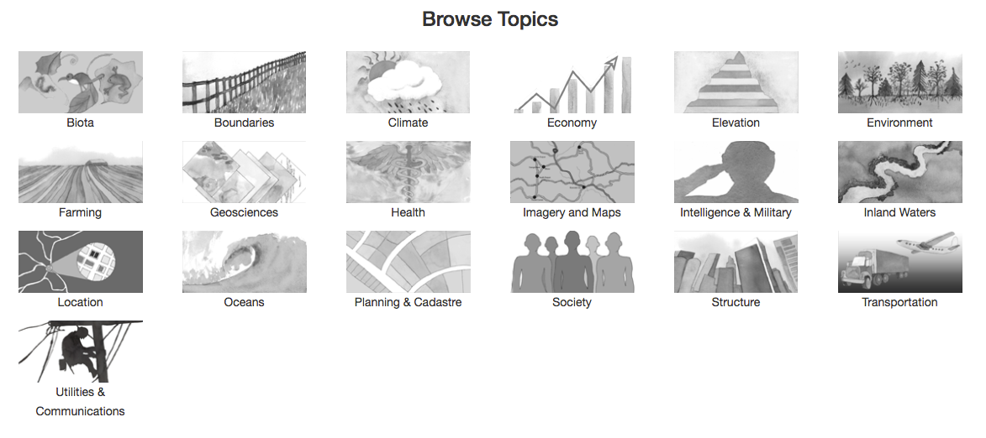

Figure 6: WA Browse Symbols

Michigan [(Figure 7)](http://gis-michigan.opendata.arcgis.com/) halved the browse categories for a cleaner, sharper interface. Fulton County, GA [(Figure 8)](http://fultoncountyopendata-fulcogis.opendata.arcgis.com/) also modified their browse icons to include unique links to tabular data.

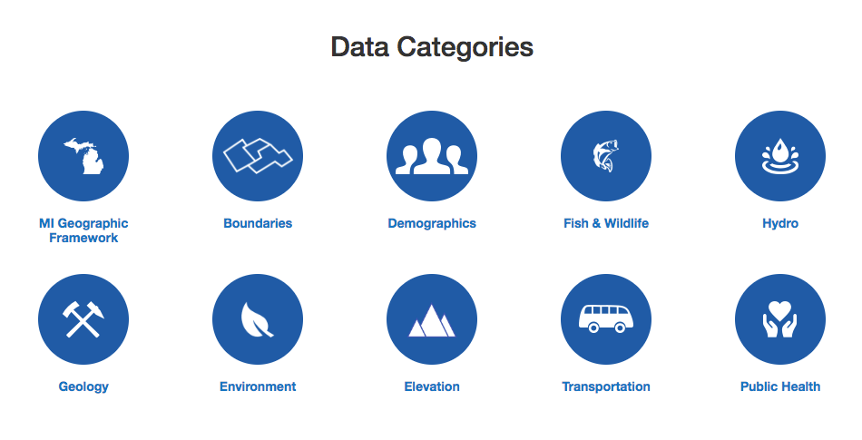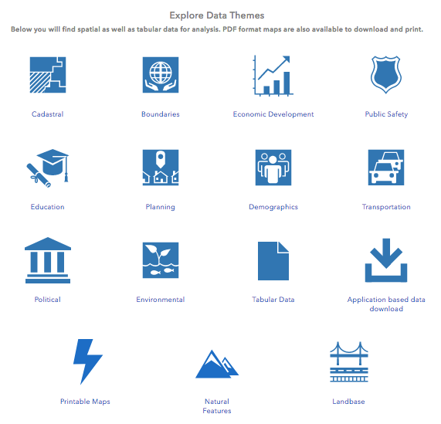

Figure 7: MI Browse Symbols

Figure 8: Fulton, GA Browse Symbols

Modifying the browse icons would also provide the opportunity to add an “Address Services” or “WAMAs” icon, integrating the service.

## Washington Geospatial Data Context

As much as possible, current infrastructure will be salvaged and transferred to the singular portal. Table 2 (below) lists current non-geospatial data on the [geography.wa.gov] site and suggests locations to relocate the information.

ODB=Open Data Bridge, [geo.wa.gov]

### Table : [geography.wa.gov] Content Dispersal

|  |  |  |
| --- | --- | --- |
|  | **Current Data** | **Suggested Phase II** |
| Homepage [geography.wa.gov] | Announcements | ODB>Recent Data |
|  | Our Purpose | ODB>About |
|  | Calendar of Events | OCIO>Geospatial Program Office  *Calendar currently outdated, not a priority* |
|  | WAMAS | -OCIO>Geospatial Program Office>WAMAs  -ODB>Browse>Address Services |
| Data & Maps | Overview | Extraneous, merge with ODB>About |
|  | Data & Maps |  |
|  | *Data Catalog & Applications Catalog* | -ODB integration  -ODB>Browse>Applications Catalog |
|  | *WA Disclaimers* | ODB>Carrying footnote |
|  | *Data Providers* | OCIO>Geospatial Program Office>Geospatial Governance, Policy & Standards>Organizations |
|  | Services |  |
|  | *Geospatial Portal* | OCIO>Geospatial Program Office>Geoportal |
|  | *Washington Master Addressing Service WAMAS* | -OCIO>Geospatial Program Office>WAMAS  -ODB>Browse>Address Services |
|  | *Other Services* | OCIO>Geospatial Program Office>Geoportal |
|  | *Modified Services* | Extraneous |
|  | Metadata |  |
|  | *Metadata Update* | OCIO>Geospatial Program Office>Geospatial Governance, Policy & Standards>Metadata |
|  | *WA Geospatial Clearinghouse, Data Catalog* | OCIO>Geospatial Program Office>Geoportal |
|  | *National GIS Inventory, National Agriculture Imagery Program (NAIP)* | OCIO>Geospatial Program Office>Geoportal>National Resources |
|  | *Metadata Resources* | OCIO>Geospatial Program Office> Geospatial Governance, Policy & Standards>Metadata |
| Governance & Standards | Governance | OCIO>Geospatial Program Office>Geospatial Governance, Policy & Standards |
|  | Policy & Standards | OCIO>Geospatial Program Office>Geospatial Governance, Policy & Standards>Policy |
|  | Geoportal Infrastructure | Extraneous |
| Resources and Tools | Agency Contacts | OCIO>Geospatial Program Office>Geospatial Governance, Policy & Standards |
|  | How To & FAQ | OCIO>Geospatial Program Office>Geoportal>How-to and FAQs |
|  | Links |  |
|  | *Featured Links* | OCIO>Geospatial Program Office>Geoportal>How-to and FAQs |
|  | *National Organizations* | OCIO>Geospatial Program Office>Geospatial Governance, Policy & Standards |
|  | *State and Local Organizations* | OCIO>Geospatial Program Office>Geospatial Governance, Policy & Standards |
|  | *Learn more about GIS* | Extraneous |
|  | State/Local Government Resources | Replace with link to contact OCIO in OCIO>Geospatial Program Office>Geospatial Governance, Policy & Standards |

## WA Master Addressing Services

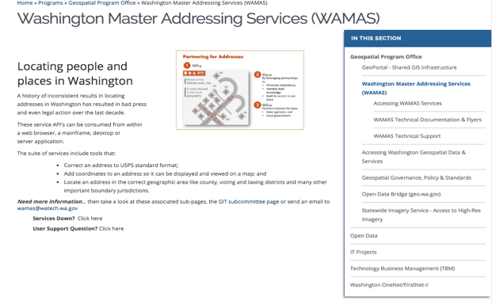

Figure 9: WAMAS Frontpage

WAMAs exists to serve our primary users: federal, state, and tribal agencies. Users must request access to the information. This is not immediately clear from the WAMAS homepage (Figure 9), where an extra click is necessary in order find any information relating to access.

***Recommendation 1:*** Modify WAMAS’ front page to clarify primary users, and include a separate link to “Accessing WAMAS Services.”

***Recommendation 2:*** Combine “Accessing WAMAS Services” and “WAMAS Technical Support.” The WAMAS Training Guide is enormously helpful and may serve to illuminate the process for users before they start filling out forms.

***Recommendation 3:*** Forms should be in either .pdf or CSS format to streamline the process and ease the long-term storage.

**WAMAS Technical Documentation and Flyers**

The content on the Technical Documentation and Flyers is a little dense, links are outdated, and they should not be posted in Word format. Overall, they carry some useful information that could be brought back to the website or training but are very information-dense.

## Priorities

Phase I: Evaluate content on [geography.wa.gov]. Determine redundancies on both the Geoportal and OCIO. Plan for eventual landing.

Phase II: Track Data Catalog geospatial data.

Phase III: Begin transferring data, controlling for redundancies.

Phase IV: After data is transferred, control for aesthetics. Ensure all links are functional.

## Appendix 1: See Attached Excel Spreadsheet - Geoportal Analysis

WA Data Links

<https://nras.maps.arcgis.com/apps/MapSeries/index.html?appid=945142aa4609456d9bd5a616fc31eb69>

<http://www.ecy.wa.gov/services/gis/maps/maps.htm>

1. Resch, B., & Zimmer, B. (2013). User Experience Design in Professional Map-Based Geo-Portals. *ISPRS International Journal of Geo-Information*, *2*(4), 1015–1037. https://doi.org/10.3390/ijgi2041015