K = 0.5; To = 150; Td = 18s; Kp = 7.76; Ki = 0.314; Kd = 1.55;

Kontrol işareti sınırlama (saturasyon) yok.. Kontrol işareti [0 - 5] V ile sınırlı (saturasyon)

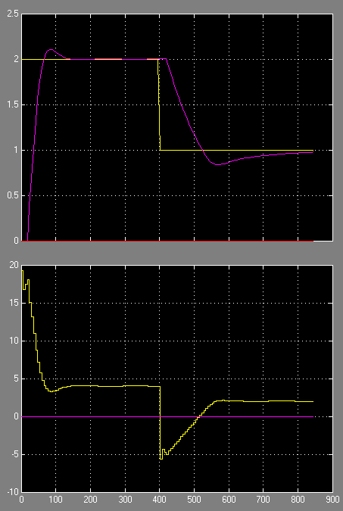 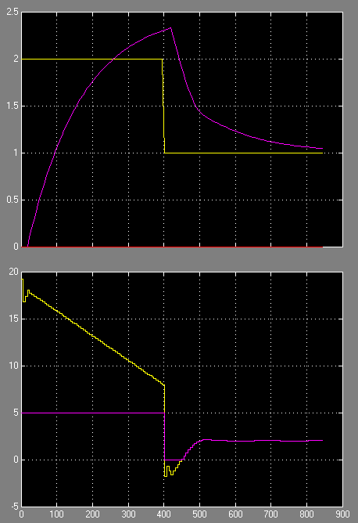

Anti-wind up. (Mavi-Kb=1/50), (Mor-Kb=1/25), ( Yeşil-İntr sınırlı 0 -5V)

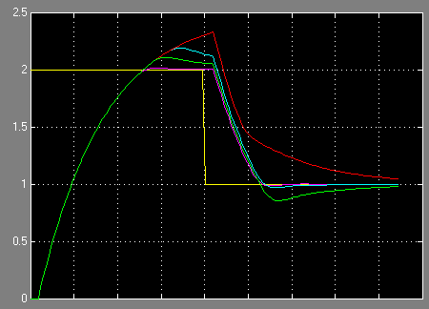 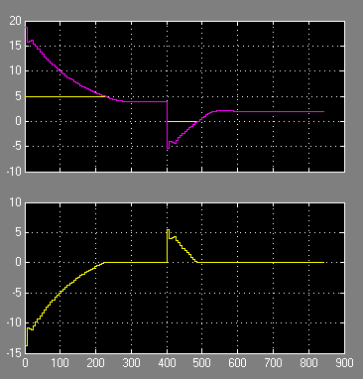

**Conditional Integration, clamping**

Stops integration when the sum of the block components exceeds the output limits and the integrator output and block input have the same sign. Resumes integration when the sum of the block components exceeds the output limits and the integrator output and block input have opposite sign.

**Back Calculation highly depends on the back calculation coefficient*Kb*.** If you don't know how to actually calculate the parameter Kb don't use back-calculation. This method calculates the difference between the actual controller output and the saturated output and subtracts it from the I-Gain path, amplified by Kb. In most of cases the default value Kb = 1 will lead to worse results than clamping, it is even possible that it has no effect at all. Kb should be calculated based on the sampling time or in case a D-Gain is involded, based on D- and I-Gain. Appropriate literatur should be consulted to calculate the coefficient. Back calculation with***a properly set coeffient***enables better dynamics than clamping!

