Bài tập thực hành 04

Lập trình PHP nâng cao

Mục tiêu cần đạt:
Sau buổi các bạn cần nắm thao tác sử dụng PHP nâng cao
- Hiểu và biết cách dùng Cookies và Session
- Tạo form đăng nhập và dùng cookies, session để quản lý các đăng nhập, thực hiện chức năng log out (thoát) khỏi hệ thống
- Biết về SQL Injection.
- Upload file, lưu thông tin về tập tin trong CSDL
- Đọc, và xử lý nội dung trong tập tin

Các bạn đọc và thực hiện viết code như hướng dẫn để làm quen, sau đó đọc trả lời các Yêu cầu ở dưới bài hướng dẫn để thực hiện yêu cầu bài thực hành.

Gợi ý Tham khảo:
- https://www.w3schools.com/php/
- và các nguồn khác mà sinh viên tìm được

Tạo Cookies
Cookies và Session hỗ trợ chúng ta quản lý các phiên đăng nhập/đăng nhập, hoạt động của người dùng trên các website
Tạo tập tin sử dụng khởi tạo cookies ck.php sau:

ck.php

<!DOCTYPE html>
<?php
$cookie_name = "user";
$cookie_value = "Nguyen Thanh Hai";
setcookie($cookie_name, $cookie_value, time() + (86400 / 24), "/"); // 86400 = 24*3600 = 1 day
?>
<html>
<body>

<?php
if(!isset($_COOKIE[$cookie_name])) {
echo "Cookie named '" . $cookie_name . "' chua duoc thiet lap, ban vui long bam f5 de thiet lap cookie!";
} else {
echo "Cookie '" . $cookie_name . "' da duoc thiet lap!<br>";
echo "Gia tri la: " . $_COOKIE[$cookie_name];
}
?>

<p><strong>Note:</strong> You might have to reload the page to see the value of the cookie.</p>

</body>
</html>

Tạo 1 trang đăng ký người dùng với mật khẩu được mã hóa
Tạo csdl qlbanhang, với bảng customers đầu tiên như sau:

CREATE TABLE `customers` (
`id` int(6) UNSIGNED NOT NULL,
`fullname` varchar(50) CHARACTER SET latin1 NOT NULL,
`email` varchar(50) CHARACTER SET latin1 DEFAULT NULL,
`Birthday` date DEFAULT NULL,
`reg_date` timestamp NOT NULL DEFAULT current_timestamp() ON UPDATE current_timestamp(),
`password` varchar(50) NOT NULL
) ENGINE=InnoDB DEFAULT CHARSET=utf8;

Tạo formnhap.php

formnhap.php
<!DOCTYPE HTML>
<html>
<body>

<form action="luu.php" method="post">
Name: <input type="text" name="name"><br>
E-mail: <input type="text" name="email"><br>
Birthday: <input type="date" name="birth"><br>
Password: <input type="password" name="pass"><br>

<input type="submit">
</form>

</body>
</html>
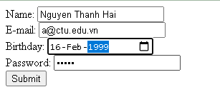

Và luu.php, chú ý lúc này chúng ta sẽ mã hóa mật khẩu với giải thuật md5 để bảo mật mật khẩu:

luu.php
<?php
$servername = "localhost";
$username = "root";
$password = "";
$dbname = "qlbanhang";

// Create connection
$conn = new mysqli($servername, $username, $password, $dbname);
// Check connection
if ($conn->connect_error) {
die("Connection failed: " . $conn->connect_error);
}

$date = date_create($_POST["birth"]);

$sql = "INSERT INTO customers (fullname, email, birthday, password)
VALUES ('".$_POST["name"] ."', '".$_POST["email"] ."', '".$date ->format('Y-m-d') ."','".md5($_POST["pass"])."' )";

if ($conn->query($sql) == TRUE) {
echo "Them sinh vien thanh cong";
} else {
echo "Error: " . $sql . "<br>" . $conn->error;
}

$conn->close();
?>

Sau khi chúng ta nhập xong mật khẩu với 12345 nhưng khi quan sát trong CSDL ta sẽ thấy mật khẩu đã được mã hóa ra chuỗi 827ccb0eea8a706c4c34a16891f84e7b:
Trong trường hợp chúng ta muốn dùng email là username để đăng nhập ta nên đảm bảo 2 student không có email trùng nhau. Để đảm bảo điều này ta có thể chọn email là unique key (vì ta đã chọn id la primary key, và 1 bảng không thể có 2 khóa chính)

ALTER TABLE `customers` ADD UNIQUE( `email`);

Tạo form đăng nhập
Sau khi tạo người dùng xong, ta có thể chạy form đăng nhập với username là email và password lấy từ CSDL

Login.php
<!DOCTYPE HTML>
<html>
<body>

<form action="log.php" method="post">
Username: <input type="text" name="email"><br>
Password: <input type="password" name="pass"><br>

<input type="submit">
</form>

</body>
</html>

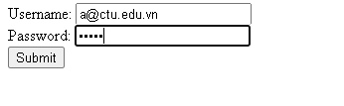

Log.php
<?php
$servername = "localhost";
$username = "root";
$password = "";v b
$dbname = "qlbanhang";

// Create connection
$conn = new mysqli($servername, $username, $password, $dbname);
// Check connection
if ($conn->connect_error) {
die("Connection failed: " . $conn->connect_error);
}

$sql = "select fullname, email from customers where email = '".$_POST["email"]."' and password = '".md5($_POST["pass"])."'";

$result = $conn->query($sql);

if ($result->num_rows > 0) {
echo "Dang nhap thanh cong <br>";
$row = $result->fetch_assoc();
echo "email:".$row['email']. ' Fullname: '.$row['fullname'];

} else {
echo "Error: " . $sql . "<br>" . $conn->error;
}

$conn->close();
?>

Khi chúng ta nhập sai, nhìn vào thông báo lỗi ta thấy
Mật khẩu đã cho không khớp với mã đã băm
Khi ta nhập đúng
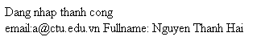

Dùng Cookies lưu lại tên đăng nhập, email và điều hướng
Chỉnh sửa lại log.php với code sau để khi đăng nhập thành công chuyển sang 1 trang chủ, còn nếu không đúng thì trở lại trang đăng nhập

Log.php (modified)
<?php
$servername = "localhost";
$username = "root";
$password = "";
$dbname = "qlbanhang";

// Create connection
$conn = new mysqli($servername, $username, $password, $dbname);
// Check connection
if ($conn->connect_error) {
die("Connection failed: " . $conn->connect_error);
}

$sql = "select id, fullname, email from customers where email = '".$_POST["email"]."' and password = '".md5($_POST["pass"])."'";

$result = $conn->query($sql);

if ($result->num_rows > 0) {

$row = $result->fetch_assoc();

$cookie_name = "user";
$cookie_value = $row['email'] ;
setcookie($cookie_name, $cookie_value, time() + (86400 / 24), "/");
setcookie("fullname", $row['fullname'], time() + (86400 / 24), "/");
setcookie("id", $row['id'], time() + (86400 / 24), "/");

header('Location: homepage.php');

} else {
echo "Error: " . $sql . "<br>" . $conn->error;
//Tro ve trang dang nhap sau 3 giay
header('Refresh: 3;url=login.php');

}

$conn->close();
?>

Tạo 1 trang chủ để khi đăng nhập thành công chuyển qua trang chủ này:

Homepage.php

<!DOCTYPE html>
<html>
<title>W3.CSS Template</title>
<meta charset="UTF-8">
<meta name="viewport" content="width=device-width, initial-scale=1">
<link rel="stylesheet" href="https://www.w3schools.com/w3css/4/w3.css">
<link rel="stylesheet" href="https://fonts.googleapis.com/css?family=Roboto">
<link rel="stylesheet" href="https://fonts.googleapis.com/css?family=Montserrat">
<link rel="stylesheet" href="https://cdnjs.cloudflare.com/ajax/libs/font-awesome/4.7.0/css/font-awesome.min.css">
<style>
.w3-sidebar a {font-family: "Roboto", sans-serif}
body,h1,h2,h3,h4,h5,h6,.w3-wide {font-family: "Montserrat", sans-serif;}
</style>
<body class="w3-content" style="max-width:1200px">

<!-- Sidebar/menu -->
<nav class="w3-sidebar w3-bar-block w3-white w3-collapse w3-top" style="z-index:3;width:250px" id="mySidebar">
<div class="w3-container w3-display-container w3-padding-16">
<i onclick="w3_close()" class="fa fa-remove w3-hide-large w3-button w3-display-topright"></i>
<h3 class="w3-wide"><b>
<?php
$cookie_name = "fullname";
echo 'Chao ban '.$_COOKIE[$cookie_name];

?>

</b></h3>
</div>
<div class="w3-padding-64 w3-large w3-text-grey" style="font-weight:bold">
<a href="#" class="w3-bar-item w3-button">Shirts</a>
<a href="#" class="w3-bar-item w3-button">Dresses</a>

<div id="demoAcc" class="w3-bar-block w3-hide w3-padding-large w3-medium">
<a href="#" class="w3-bar-item w3-button w3-light-grey"><i class="fa fa-caret-right w3-margin-right"></i>Skinny</a>
<a href="#" class="w3-bar-item w3-button">Relaxed</a>
<a href="#" class="w3-bar-item w3-button">Bootcut</a>
<a href="#" class="w3-bar-item w3-button">Straight</a>
</div>
<a href="#" class="w3-bar-item w3-button">Jackets</a>
<a href="#" class="w3-bar-item w3-button">Gymwear</a>
<a href="#" class="w3-bar-item w3-button">Blazers</a>
<a href="#" class="w3-bar-item w3-button">Shoes</a>
</div>
<a href="#footer" class="w3-bar-item w3-button w3-padding">Contact</a>
<a href="javascript:void(0)" class="w3-bar-item w3-button w3-padding" onclick="document.getElementById('newsletter').style.display='block'">Newsletter</a>
<a href="#footer" class="w3-bar-item w3-button w3-padding">Subscribe</a>
</nav>

<!-- Top menu on small screens -->
<header class="w3-bar w3-top w3-hide-large w3-black w3-xlarge">
<div class="w3-bar-item w3-padding-24 w3-wide">LOGO</div>
<a href="javascript:void(0)" class="w3-bar-item w3-button w3-padding-24 w3-right" onclick="w3_open()"><i class="fa fa-bars"></i></a>
</header>

<!-- Overlay effect when opening sidebar on small screens -->
<div class="w3-overlay w3-hide-large" onclick="w3_close()" style="cursor:pointer" title="close side menu" id="myOverlay"></div>

<!-- !PAGE CONTENT! -->
<div class="w3-main" style="margin-left:250px">

<!-- Push down content on small screens -->
<div class="w3-hide-large" style="margin-top:83px"></div>

<!-- Top header -->
<header class="w3-container w3-xlarge">

<p class="w3-right">
<i class="fa fa-shopping-cart w3-margin-right"></i>
<i class="fa fa-search"></i>
</p>
</header>

<div class="w3-container w3-text-grey" id="jeans">
<p>8 items</p>
</div>

<!-- Subscribe section -->
<div class="w3-container w3-black w3-padding-32">
<h1>Subscribe</h1>
<p>To get special offers and VIP treatment:</p>
<p><input class="w3-input w3-border" type="text" placeholder="Enter e-mail" style="width:100%"></p>
<button type="button" class="w3-button w3-red w3-margin-bottom">Subscribe</button>
</div>

<!-- Footer -->
<footer class="w3-padding-64 w3-light-grey w3-small w3-center" id="footer">
<div class="w3-row-padding">
<div class="w3-col s4">
<h4>Contact</h4>
<p>Questions? Go ahead.</p>
<form action="/action_page.php" target="_blank">
<p><input class="w3-input w3-border" type="text" placeholder="Name" name="Name" required></p>
<p><input class="w3-input w3-border" type="text" placeholder="Email" name="Email" required></p>
<p><input class="w3-input w3-border" type="text" placeholder="Subject" name="Subject" required></p>
<p><input class="w3-input w3-border" type="text" placeholder="Message" name="Message" required></p>
<button type="submit" class="w3-button w3-block w3-black">Send</button>
</form>
</div>

<div class="w3-col s4">
<h4>About</h4>
<p><a href="#">About us</a></p>
<p><a href="#">We're hiring</a></p>
<p><a href="#">Support</a></p>
<p><a href="#">Find store</a></p>
<p><a href="#">Shipment</a></p>
<p><a href="#">Payment</a></p>
<p><a href="#">Gift card</a></p>
<p><a href="#">Return</a></p>
<p><a href="#">Help</a></p>
</div>

<div class="w3-col s4 w3-justify">
<h4>Store</h4>
<p><i class="fa fa-fw fa-map-marker"></i> Company Name</p>
<p><i class="fa fa-fw fa-phone"></i> 0044123123</p>
<p><i class="fa fa-fw fa-envelope"></i> ex@mail.com</p>
<h4>We accept</h4>
<p><i class="fa fa-fw fa-cc-amex"></i> Amex</p>
<p><i class="fa fa-fw fa-credit-card"></i> Credit Card</p>
<br>
<i class="fa fa-facebook-official w3-hover-opacity w3-large"></i>
<i class="fa fa-instagram w3-hover-opacity w3-large"></i>
<i class="fa fa-snapchat w3-hover-opacity w3-large"></i>
<i class="fa fa-pinterest-p w3-hover-opacity w3-large"></i>
<i class="fa fa-twitter w3-hover-opacity w3-large"></i>
<i class="fa fa-linkedin w3-hover-opacity w3-large"></i>
</div>
</div>
</footer>

<div class="w3-black w3-center w3-padding-24">Powered by <a href="https://www.w3schools.com/w3css/default.asp" title="W3.CSS" target="_blank" class="w3-hover-opacity">w3.css</a></div>

<!-- End page content -->
</div>

<!-- Newsletter Modal -->
<div id="newsletter" class="w3-modal">
<div class="w3-modal-content w3-animate-zoom" style="padding:32px">
<div class="w3-container w3-white w3-center">
<i onclick="document.getElementById('newsletter').style.display='none'" class="fa fa-remove w3-right w3-button w3-transparent w3-xxlarge"></i>
<h2 class="w3-wide">NEWSLETTER</h2>
<p>Join our mailing list to receive updates on new arrivals and special offers.</p>
<p><input class="w3-input w3-border" type="text" placeholder="Enter e-mail"></p>
<button type="button" class="w3-button w3-padding-large w3-red w3-margin-bottom" onclick="document.getElementById('newsletter').style.display='none'">Subscribe</button>
</div>
</div>
</div>

<script>
// Accordion
function myAccFunc() {
var x = document.getElementById("demoAcc");
if (x.className.indexOf("w3-show") == -1) {
x.className += " w3-show";
} else {
x.className = x.className.replace(" w3-show", "");
}
}

// Click on the "Jeans" link on page load to open the accordion for demo purposes
document.getElementById("myBtn").click();

// Open and close sidebar
function w3_open() {
document.getElementById("mySidebar").style.display = "block";
document.getElementById("myOverlay").style.display = "block";
}

function w3_close() {
document.getElementById("mySidebar").style.display = "none";
document.getElementById("myOverlay").style.display = "none";
}
</script>

</body>
</html>

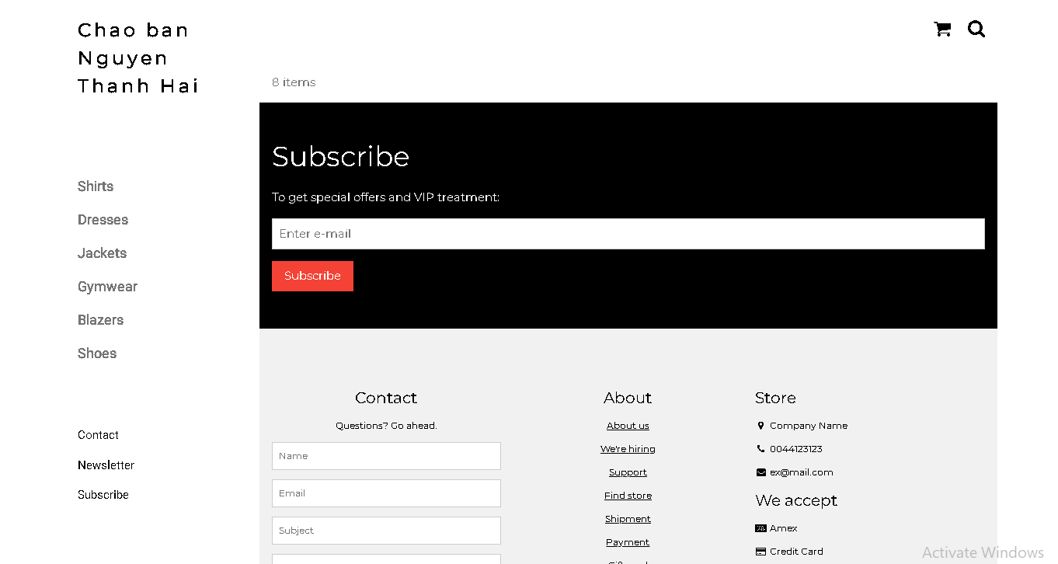

Upload tập tin
Upload file, chúng ta tạo form giao diện để upload file ảnh upload-img.php

Upload-img.php

<!DOCTYPE html>
<html>
<body>

<form action="upload.php" method="post" enctype="multipart/form-data">
Ban chon 1 anh de lam profile:
<input type="file" name="fileToUpload" id="fileToUpload">
<input type="submit" value="Upload Image" name="submit">
</form>

</body>
</html>

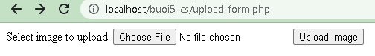

Tập tin upload.php xử lý hành động

upload.php

<?php
$target_dir = "uploads/";
$target_file = $target_dir . basename($_FILES["fileToUpload"]["name"]);
$uploadOk = 1;
$imageFileType = strtolower(pathinfo($target_file,PATHINFO_EXTENSION));

// Check if image file is a actual image or fake image
if(isset($_POST["submit"])) {
$check = getimagesize($_FILES["fileToUpload"]["tmp_name"]);
if($check !== false) {
echo "File is an image - " . $check["mime"] . ".";
$uploadOk = 1;
} else {
echo "File is not an image.";
$uploadOk = 0;
}
}

// Check if file already exists
if (file_exists($target_file)) {
echo "Sorry, file already exists.";
$uploadOk = 0;
}

// Check file size
if ($_FILES["fileToUpload"]["size"] > 500000) {
echo "Sorry, your file is too large.";
$uploadOk = 0;
}

// Allow certain file formats
if($imageFileType != "jpg" && $imageFileType != "png" && $imageFileType != "jpeg"
&& $imageFileType != "gif" ) {
echo "Sorry, only JPG, JPEG, PNG & GIF files are allowed.";
$uploadOk = 0;
}

// Check if $uploadOk is set to 0 by an error
if ($uploadOk == 0) {
echo "Sorry, your file was not uploaded.";
// if everything is ok, try to upload file
} else {
if (move_uploaded_file($_FILES["fileToUpload"]["tmp_name"], $target_file)) {
echo "The file ". htmlspecialchars( basename( $_FILES["fileToUpload"]["name"])). " has been uploaded.";
} else {
echo "Sorry, there was an error uploading your file.";
}
}
?>

Sau khi chúng ta upload thành công giao diện sau sẽ hiển thị
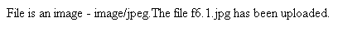

Upload ảnh và lưu dữ liệu về ảnh trong CSDL

Trong phần này chúng ta minh họa tải tập tin ảnh làm ảnh profile của người dùng

Upload-img.php (modified)
<!DOCTYPE html>
<html>
<body>

<form action="upload-csdl.php" method="post" enctype="multipart/form-data">
Ban chon 1 anh de lam profile:
<input type="file" name="fileToUpload" id="fileToUpload">
<input type="submit" value="Upload Image" name="submit">
</form>

</body>
</html>

Thêm cột để lưu đường dẫn ảnh:

ALTER TABLE `customers` ADD `img_profile` VARCHAR(100);

Upload-csdl.php

<?php
$target_dir = "uploads/";
$target_file = $target_dir . basename($_FILES["fileToUpload"]["name"]);
$uploadOk = 1;
$imageFileType = strtolower(pathinfo($target_file,PATHINFO_EXTENSION));

// Check if image file is a actual image or fake image
if(isset($_POST["submit"])) {
$check = getimagesize($_FILES["fileToUpload"]["tmp_name"]);
if($check !== false) {
echo "File is an image - " . $check["mime"] . ".";
$uploadOk = 1;
} else {
echo "File is not an image.";
$uploadOk = 0;
}
}

// Check if file already exists
if (file_exists($target_file)) {
echo "Sorry, file already exists.";
$uploadOk = 0;
}

// Check file size
if ($_FILES["fileToUpload"]["size"] > 500000) {
echo "Sorry, your file is too large.";
$uploadOk = 0;
}

// Allow certain file formats
if($imageFileType != "jpg" && $imageFileType != "png" && $imageFileType != "jpeg"
&& $imageFileType != "gif" ) {
echo "Sorry, only JPG, JPEG, PNG & GIF files are allowed.";
$uploadOk = 0;
}

// Check if $uploadOk is set to 0 by an error
if ($uploadOk == 0) {
echo "Sorry, your file was not uploaded.";
// if everything is ok, try to upload file
} else {
if (move_uploaded_file($_FILES["fileToUpload"]["tmp_name"], $target_file)) {
echo "The file ". htmlspecialchars( basename( $_FILES["fileToUpload"]["name"])). " has been uploaded.";
echo '<br>';

$servername = "localhost";
$username = "root";
$password = "";
$dbname = "qlbanhang";

// Create connection
$conn = new mysqli($servername, $username, $password, $dbname);
// Check connection
if ($conn->connect_error) {
die("Connection failed: " . $conn->connect_error);
}

$id = $_COOKIE['id'];
$sql = "UPDATE customers set img_profile = '".$_FILES["fileToUpload"]["name"]."'";
$sql = $sql. " WHERE ID='".$id."'";

echo $sql;
if ($conn->query($sql) == TRUE) {
echo 'cap nhat csdl thanh cong!<br>';
echo '<a href="homepage.php">Trang chu</a>';
} else {
echo "Error: " . $sql . "<br>" . $conn->error;
}

} else {
echo "Sorry, there was an error uploading your file.";
}
}
?>

Homepage.php (modified với ảnh profile)

<!DOCTYPE html>
<html>
<title>W3.CSS Template</title>
<meta charset="UTF-8">
<meta name="viewport" content="width=device-width, initial-scale=1">
<link rel="stylesheet" href="https://www.w3schools.com/w3css/4/w3.css">
<link rel="stylesheet" href="https://fonts.googleapis.com/css?family=Roboto">
<link rel="stylesheet" href="https://fonts.googleapis.com/css?family=Montserrat">
<link rel="stylesheet" href="https://cdnjs.cloudflare.com/ajax/libs/font-awesome/4.7.0/css/font-awesome.min.css">
<style>
.w3-sidebar a {font-family: "Roboto", sans-serif}
body,h1,h2,h3,h4,h5,h6,.w3-wide {font-family: "Montserrat", sans-serif;}
</style>
<body class="w3-content" style="max-width:1200px">

<!-- Sidebar/menu -->
<nav class="w3-sidebar w3-bar-block w3-white w3-collapse w3-top" style="z-index:3;width:250px" id="mySidebar">
<div class="w3-container w3-display-container w3-padding-16">
<i onclick="w3_close()" class="fa fa-remove w3-hide-large w3-button w3-display-topright"></i>
<h3 class="w3-wide"><b>
<?php
$cookie_name = "fullname";
echo 'Chao ban '.$_COOKIE[$cookie_name];

//them doan nay de lay duong dan anh
$servername = "localhost";
$username = "root";
$password = "";
$dbname = "qlbanhang";

// Create connection
$conn = new mysqli($servername, $username, $password, $dbname);
// Check connection
if ($conn->connect_error) {
die("Connection failed: " . $conn->connect_error);
}

$sql = "select img_profile from customers where id = '".$_COOKIE['id']."'";
//echo $sql;
$result = $conn->query($sql);

//print_r($result);
if ( $result->num_rows > 0) {
//lay link anh tu csdl da luu de hien thi cac anh duoc luu trong uploads
$row = $result->fetch_assoc();
echo '<img src="'.'./uploads/'.$row['img_profile'].'" alt="Anh profile">';
}
?>

</b></h3>
</div>
<div class="w3-padding-64 w3-large w3-text-grey" style="font-weight:bold">
<a href="#" class="w3-bar-item w3-button">Shirts</a>
<a href="#" class="w3-bar-item w3-button">Dresses</a>

<div id="demoAcc" class="w3-bar-block w3-hide w3-padding-large w3-medium">
<a href="#" class="w3-bar-item w3-button w3-light-grey"><i class="fa fa-caret-right w3-margin-right"></i>Skinny</a>
<a href="#" class="w3-bar-item w3-button">Relaxed</a>
<a href="#" class="w3-bar-item w3-button">Bootcut</a>
<a href="#" class="w3-bar-item w3-button">Straight</a>
</div>
<a href="#" class="w3-bar-item w3-button">Jackets</a>
<a href="#" class="w3-bar-item w3-button">Gymwear</a>
<a href="#" class="w3-bar-item w3-button">Blazers</a>
<a href="#" class="w3-bar-item w3-button">Shoes</a>
</div>
<a href="#footer" class="w3-bar-item w3-button w3-padding">Contact</a>
<a href="javascript:void(0)" class="w3-bar-item w3-button w3-padding" onclick="document.getElementById('newsletter').style.display='block'">Newsletter</a>
<a href="#footer" class="w3-bar-item w3-button w3-padding">Subscribe</a>
</nav>

<!-- Top menu on small screens -->
<header class="w3-bar w3-top w3-hide-large w3-black w3-xlarge">
<div class="w3-bar-item w3-padding-24 w3-wide">LOGO</div>
<a href="javascript:void(0)" class="w3-bar-item w3-button w3-padding-24 w3-right" onclick="w3_open()"><i class="fa fa-bars"></i></a>
</header>

<!-- Overlay effect when opening sidebar on small screens -->
<div class="w3-overlay w3-hide-large" onclick="w3_close()" style="cursor:pointer" title="close side menu" id="myOverlay"></div>

<!-- !PAGE CONTENT! -->
<div class="w3-main" style="margin-left:250px">

<!-- Push down content on small screens -->
<div class="w3-hide-large" style="margin-top:83px"></div>

<!-- Top header -->
<header class="w3-container w3-xlarge">

<p class="w3-right">
<i class="fa fa-shopping-cart w3-margin-right"></i>
<i class="fa fa-search"></i>
</p>
</header>

<div class="w3-container w3-text-grey" id="jeans">
<p>8 items</p>
</div>

<!-- Subscribe section -->
<div class="w3-container w3-black w3-padding-32">
<h1>Subscribe</h1>
<p>To get special offers and VIP treatment:</p>
<p><input class="w3-input w3-border" type="text" placeholder="Enter e-mail" style="width:100%"></p>
<button type="button" class="w3-button w3-red w3-margin-bottom">Subscribe</button>
</div>

<!-- Footer -->
<footer class="w3-padding-64 w3-light-grey w3-small w3-center" id="footer">
<div class="w3-row-padding">
<div class="w3-col s4">
<h4>Contact</h4>
<p>Questions? Go ahead.</p>
<form action="/action_page.php" target="_blank">
<p><input class="w3-input w3-border" type="text" placeholder="Name" name="Name" required></p>
<p><input class="w3-input w3-border" type="text" placeholder="Email" name="Email" required></p>
<p><input class="w3-input w3-border" type="text" placeholder="Subject" name="Subject" required></p>
<p><input class="w3-input w3-border" type="text" placeholder="Message" name="Message" required></p>
<button type="submit" class="w3-button w3-block w3-black">Send</button>
</form>
</div>

<div class="w3-col s4">
<h4>About</h4>
<p><a href="#">About us</a></p>
<p><a href="#">We're hiring</a></p>
<p><a href="#">Support</a></p>
<p><a href="#">Find store</a></p>
<p><a href="#">Shipment</a></p>
<p><a href="#">Payment</a></p>
<p><a href="#">Gift card</a></p>
<p><a href="#">Return</a></p>
<p><a href="#">Help</a></p>
</div>

<div class="w3-col s4 w3-justify">
<h4>Store</h4>
<p><i class="fa fa-fw fa-map-marker"></i> Company Name</p>
<p><i class="fa fa-fw fa-phone"></i> 0044123123</p>
<p><i class="fa fa-fw fa-envelope"></i> ex@mail.com</p>
<h4>We accept</h4>
<p><i class="fa fa-fw fa-cc-amex"></i> Amex</p>
<p><i class="fa fa-fw fa-credit-card"></i> Credit Card</p>
<br>
<i class="fa fa-facebook-official w3-hover-opacity w3-large"></i>
<i class="fa fa-instagram w3-hover-opacity w3-large"></i>
<i class="fa fa-snapchat w3-hover-opacity w3-large"></i>
<i class="fa fa-pinterest-p w3-hover-opacity w3-large"></i>
<i class="fa fa-twitter w3-hover-opacity w3-large"></i>
<i class="fa fa-linkedin w3-hover-opacity w3-large"></i>
</div>
</div>
</footer>

<div class="w3-black w3-center w3-padding-24">Powered by <a href="https://www.w3schools.com/w3css/default.asp" title="W3.CSS" target="_blank" class="w3-hover-opacity">w3.css</a></div>

<!-- End page content -->
</div>

<!-- Newsletter Modal -->
<div id="newsletter" class="w3-modal">
<div class="w3-modal-content w3-animate-zoom" style="padding:32px">
<div class="w3-container w3-white w3-center">
<i onclick="document.getElementById('newsletter').style.display='none'" class="fa fa-remove w3-right w3-button w3-transparent w3-xxlarge"></i>
<h2 class="w3-wide">NEWSLETTER</h2>
<p>Join our mailing list to receive updates on new arrivals and special offers.</p>
<p><input class="w3-input w3-border" type="text" placeholder="Enter e-mail"></p>
<button type="button" class="w3-button w3-padding-large w3-red w3-margin-bottom" onclick="document.getElementById('newsletter').style.display='none'">Subscribe</button>
</div>
</div>
</div>

<script>
// Accordion
function myAccFunc() {
var x = document.getElementById("demoAcc");
if (x.className.indexOf("w3-show") == -1) {
x.className += " w3-show";
} else {
x.className = x.className.replace(" w3-show", "");
}
}

// Click on the "Jeans" link on page load to open the accordion for demo purposes
document.getElementById("myBtn").click();

// Open and close sidebar
function w3_open() {
document.getElementById("mySidebar").style.display = "block";
document.getElementById("myOverlay").style.display = "block";
}

function w3_close() {
document.getElementById("mySidebar").style.display = "none";
document.getElementById("myOverlay").style.display = "none";
}
</script>

</body>
</html>

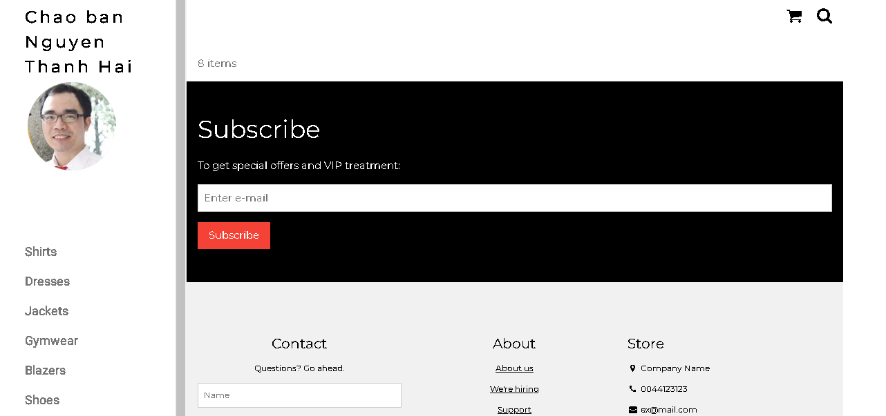

Ở đây do biểu diễn từng bước nên đoạn này chúng ta lấy dữ liệu link ảnh profile từ id của người dùng. Trong thực tế, các bạn có thể lưu link ảnh profile vào cookie/session ngay từ khi đăng nhập.

Upload file csv và đọc dữ liệu vào mảng
Thao tác đọc dữ liệu từ các tập tin là quan trọng, giúp chúng ta backup dữ liệu và phục hồi hay import dữ liệu từ các hệ thống khác. Ví dụ dưới đây giúp minh họa cho các bạn thao tác đọc dữ liệu từ tập tin csv và từ đó đưa vào mảng để phục vụ cho việc xử lý.

read-csv.php
<?php
$csv = array();
$name_file = 'cus.csv';
$lines = file($name_file, FILE_IGNORE_NEW_LINES);

//dua du lieu tu file csv vao mang:
foreach ($lines as $key => $value)
{
$csv[$key] = str_getcsv($value);
}

//in mang
echo '<pre>';
print_r($csv);
echo '</pre>';
?>
Tạo tập tin cus.csv với dữ liệu như sau
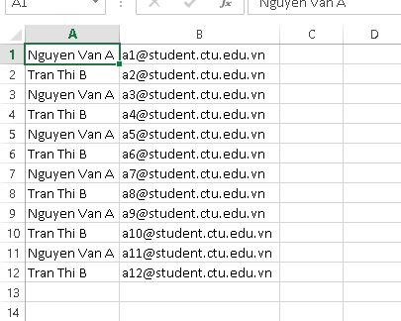
Khi chạy code đọc trên ta sẽ có dữ liệu đã được đưa vào mảng và hiển thị

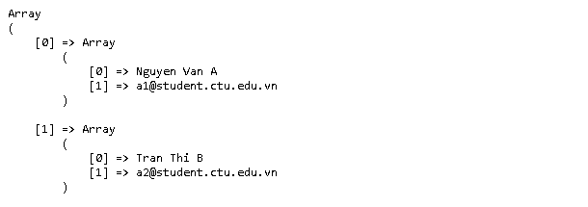

Yêu cầu bài thực hành:
- Bạn hãy chạy tất cả các lệnh hướng dẫn ở trên và chụp lại màn hình kết quả.
- Trong vài trường hợp, hacker có thể sử dụng các kỹ thuật SQL Injection để hack hệ thống của bạn. Bạn hãy trình bày SQL Injection là gì và thử các ví dụ trình bày trong . Ứng dụng kỹ thuật đó vào trang đăng nhập mà bạn đã tạo, chụp lại các kết quả.
SQL Injection là kỹ thuật tấn công bằng cách chèn các đoạn mã SQL vào dữ liệu đầu vào của ứng dụng. Nếu chương trình ghép trực tiếp dữ liệu người dùng vào câu lệnh SQL mà không kiểm tra phù hợp, kẻ tấn công có thể làm thay đổi ý nghĩa của câu truy vấn, từ đó truy cập hoặc thao tác dữ liệu trái phép.
Ví dụ:
Giả sử trang đăng nhập sử dụng câu lệnh:
$sql = "SELECT fullname, email FROM customers
WHERE email = '" . $_POST["email"] . "'
AND password = '" . md5($_POST["pass"]) . "'";
Nếu người dùng nhập email:
' OR '1'='1' #
thì câu truy vấn có thể bị biến đổi để điều kiện kiểm tra email luôn đúng và phần còn lại bị vô hiệu hóa tùy theo cú pháp SQL. Khi đó, nếu không có biện pháp bảo vệ, chương trình có thể xác thực sai người dùng.
Áp dụng cho trang đăng nhập
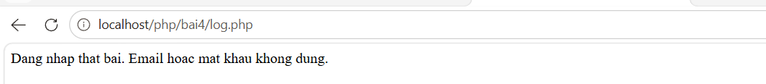
- Dựa vào link, bạn hãy cho biết Cookie là gì, diễn giải ý nghĩa các tham số trong setcookie(). Cách lưu, lấy, xóa giá trị trong cookie.
Cookie là dữ liệu nhỏ được website gửi đến trình duyệt và lưu trên thiết bị người dùng. Trình duyệt có thể gửi cookie trở lại máy chủ trong các yêu cầu tiếp theo nếu cookie còn hiệu lực và phù hợp với phạm vi sử dụng. Cookie thường được sử dụng để lưu thông tin tùy chọn, nhận diện người dùng hoặc duy trì trạng thái đăng nhập.
Các tham số của setcookie()
setcookie(name, value, expires, path, domain, secure, httponly);
- name: Tên cookie.
- value: Giá trị cookie.
- expires: Thời điểm hết hạn, tính theo Unix timestamp. Nếu không thiết lập thời hạn, cookie thường chỉ tồn tại trong phiên trình duyệt.
- path: Đường dẫn trên website mà cookie có hiệu lực. Giá trị / áp dụng cho toàn website.
- domain: Tên miền áp dụng cookie.
- secure: Nếu là true, trình duyệt chỉ gửi cookie qua kết nối HTTPS.
- httponly: Nếu là true, JavaScript phía trình duyệt không thể truy cập cookie thông qua document.cookie.
Cách lưu cookie:
<?php
setcookie("user", "nguyenvana", time() + 3600, "/");
?>
Cách lấy cookie:
<?php
if (isset($_COOKIE["user"])) {
echo $_COOKIE["user"];
} else {
echo "Cookie chua ton tai";
}
?>
Cách xóa cookie()
<?php
setcookie("user", "", time() - 3600, "/");
?>
- Dựa vào link, bạn hãy cho biết Session dùng để làm gì. Cách lưu, lấy, xóa giá trị trong Session.
Session là cơ chế lưu trữ dữ liệu trên máy chủ để duy trì thông tin của người dùng qua nhiều yêu cầu trong cùng một phiên làm việc. Trình duyệt thường giữ mã định danh phiên, còn dữ liệu session được lưu phía máy chủ. Session thường được dùng để quản lý trạng thái đăng nhập, lưu mã người dùng hoặc lưu thông tin tạm thời trong quá trình sử dụng website.
Cách lưu:
<?php
session_start();
$_SESSION["user"] = "nguyenvana";
$_SESSION["fullname"] = "Nguyen Van A";
?>
Cách lấy giá trị:
<?php
session_start();
if (isset($_SESSION["user"])) {
echo $_SESSION["user"];
} else {
echo "Chua dang nhap";
}
?>
Cách xóa:
<?php
session_start();
unset($_SESSION["user"]);
?>
Cách xóa toàn bộ dữ liệu:
<?php
session_start();
$_SESSION = [];
session_destroy();
?>
- Bạn hãy so sánh Cookie và Session.

Cookie là dữ liệu được lưu trữ trên trình duyệt của người dùng, còn Session là dữ liệu được lưu trữ trên máy chủ.
Cookie được tạo bằng hàm setcookie() và được đọc thông qua mảng $_COOKIE. Session được khởi tạo bằng hàm session_start() và dữ liệu được lưu, lấy thông qua mảng $_SESSION.
Cookie có thể được thiết lập thời gian hết hạn cụ thể hoặc tồn tại đến khi kết thúc phiên trình duyệt. Session thường tồn tại trong thời gian phiên làm việc, tùy thuộc vào cấu hình máy chủ.
Cookie có dung lượng lưu trữ nhỏ, thường khoảng 4 KB cho mỗi cookie. Session có dung lượng phụ thuộc vào tài nguyên và cấu hình lưu trữ trên máy chủ.
Cookie được lưu trên máy người dùng nên người dùng có thể xem hoặc chỉnh sửa nếu không được bảo vệ. Session lưu dữ liệu trên máy chủ nên phù hợp hơn để quản lý thông tin phiên đăng nhập, tuy nhiên vẫn cần bảo vệ mã định danh phiên.
Cookie có thể được xóa bằng cách thiết lập thời gian hết hạn trong quá khứ. Session có thể xóa một giá trị bằng unset() hoặc hủy phiên bằng session_destroy().

- Chỉnh sửa các đoạn gán, khởi tạo, lấy giá trị cookie trong log.php và homepage.php thay bằng cách dùng Session. Tạo tập tin thoat.php để xóa các giá trị trong session, cookie thực hiện chức năng log out khỏi hệ thống.
Chỉnh sửa log.php

<?php
session_start();

$servername = "localhost";
$username = "root";
$password = "";
$dbname = "qlbanhang";

$conn = new mysqli($servername, $username, $password, $dbname);

if ($conn->connect_error) {
die("Connection failed: " . $conn->connect_error);
}

$email = $_POST["email"];
$pass = md5($_POST["pass"]);

$stmt = $conn->prepare(
"SELECT id, fullname, email
FROM customers
WHERE email = ? AND password = ?"
);

$stmt->bind_param("ss", $email, $pass);
$stmt->execute();

$result = $stmt->get_result();

if ($result->num_rows > 0) {
$row = $result->fetch_assoc();

session_regenerate_id(true);

$_SESSION["id"] = $row["id"];
$_SESSION["fullname"] = $row["fullname"];
$_SESSION["email"] = $row["email"];

header("Location: homepage.php");
exit;
} else {
echo "Dang nhap that bai. Email hoac mat khau khong dung.";
header("Refresh: 3;url=login.php");
exit;
}

$stmt->close();
$conn->close();
?>
File thoát:

<?php
session_start();

// Xoa toan bo du lieu Session
$_SESSION = [];

// Xoa cookie ma dinh danh Session neu co
if (ini_get("session.use_cookies")) {
$params = session_get_cookie_params();

setcookie(
session_name(),
"",
time() - 42000,
$params["path"],
$params["domain"],
$params["secure"],
$params["httponly"]
);
}

// Huy Session
session_destroy();

// Quay ve trang dang nhap
header("Location: login.php");
exit;
?>

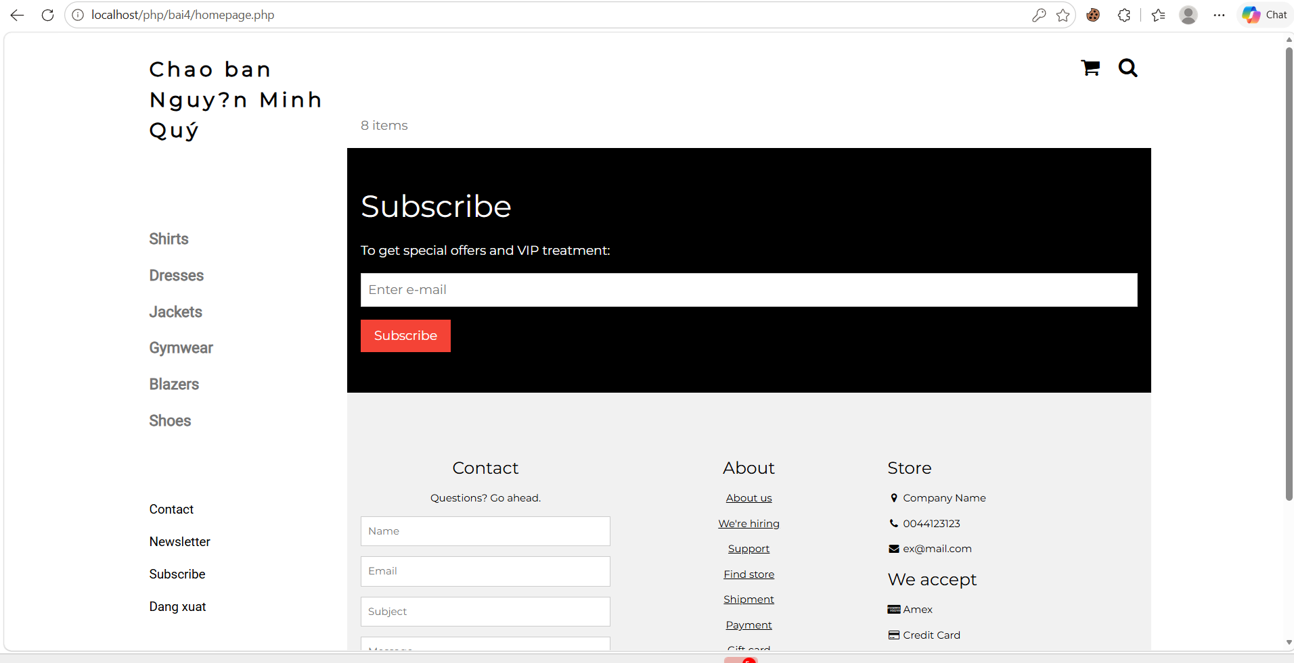

- Bạn hãy tạo form sua_mk.php cho phép người dùng chỉnh sửa mật khẩu sau khi đăng nhập. Yêu cầu gồm 3 input: ô để nhập mật khẩu cũ, 1 ô để nhập mật khẩu mới, 1 ô cho phép nhập mật lại mật khẩu mới. Khi nhập xong cần đảm bảo: mật khẩu cũ là khớp với CSDL đang lưu, 2 ô nhập mật khẩu mới phải khớp với nhau và không giống với mật khẩu cũ, nếu đáp ứng điều kiện thì tiến hành băm mật khẩu với md5 và lưu mật khẩu mới vào CSDL.

<?php
session_start();

if (!isset($_SESSION["id"])) {
header("Location: login.php");
exit;
}

$servername = "localhost";
$username = "root";
$password = "";
$dbname = "qlbanhang";

$conn = new mysqli($servername, $username, $password, $dbname);

if ($conn->connect_error) {
die("Connection failed: " . $conn->connect_error);
}

$thongbao = "";

if ($_SERVER["REQUEST_METHOD"] == "POST") {
$mk_cu = $_POST["mk_cu"];
$mk_moi = $_POST["mk_moi"];
$mk_lai = $_POST["mk_lai"];

// Lay mat khau hien tai trong CSDL
$id = $_SESSION["id"];

$stmt = $conn->prepare(
"SELECT password FROM customers WHERE id = ?"
);
$stmt->bind_param("i", $id);
$stmt->execute();

$result = $stmt->get_result();
$row = $result->fetch_assoc();

if (!$row || md5($mk_cu) != $row["password"]) {
$thongbao = "Mat khau cu khong dung";
} elseif ($mk_moi != $mk_lai) {
$thongbao = "Hai mat khau moi khong khop";
} elseif ($mk_moi == $mk_cu) {
$thongbao = "Mat khau moi khong duoc trung mat khau cu";
} else {
$mk_mahoa = md5($mk_moi);

$stmt2 = $conn->prepare(
"UPDATE customers SET password = ? WHERE id = ?"
);
$stmt2->bind_param("si", $mk_mahoa, $id);

if ($stmt2->execute()) {
$thongbao = "Doi mat khau thanh cong";
} else {
$thongbao = "Loi cap nhat mat khau";
}

$stmt2->close();
}

$stmt->close();
}

$conn->close();
?>

<!DOCTYPE html>
<html>
<body>

<h2>Doi mat khau</h2>

<form method="post" action="sua_mk.php">
Mat khau cu:
<input type="password" name="mk_cu" required>
<br><br>

Mat khau moi:
<input type="password" name="mk_moi" required>
<br><br>

Nhap lai mat khau moi:
<input type="password" name="mk_lai" required>
<br><br>

<input type="submit" value="Doi mat khau">
</form>

<p><?php echo htmlspecialchars($thongbao); ?></p>

</body>
</html>
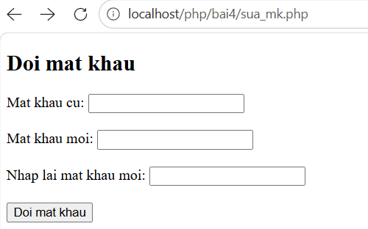
- Bạn đọc trong để tìm hiểu và mô tả các cơ chế, các hàm/thủ tục để thực hiện việc upload.
Dựa theo phần hướng dẫn upload file trong tài liệu, quy trình upload tập tin bằng PHP gồm các bước sau:
- Tạo form HTML cho phép người dùng chọn tập tin.
- Form sử dụng phương thức POST và thuộc tính enctype="multipart/form-data" để gửi dữ liệu tập tin.
- PHP nhận thông tin tập tin thông qua mảng $_FILES.
- Kiểm tra loại tập tin, kích thước và sự tồn tại của tập tin.
- Dùng move_uploaded_file() để di chuyển tập tin từ thư mục tạm đến thư mục lưu trữ.
- Nếu cần, lưu tên tập tin hoặc đường dẫn tập tin vào CSDL để sử dụng về sau.
Các hàm và thành phần quan trọng:
- $_FILES: Mảng chứa thông tin về tập tin được tải lên, gồm tên, loại, kích thước, tên tập tin tạm và mã lỗi.
- isset(): Kiểm tra biến hoặc phần tử có tồn tại hay không.
- basename(): Lấy phần tên tập tin từ một đường dẫn.
- pathinfo(): Trích xuất thông tin đường dẫn; kết hợp với PATHINFO_EXTENSION để lấy phần mở rộng.
- getimagesize(): Kiểm tra thông tin ảnh và lấy kích thước, kiểu MIME đối với tập tin ảnh hợp lệ.
- file_exists(): Kiểm tra tập tin đã tồn tại hay chưa.
- move_uploaded_file(): Di chuyển tập tin được upload từ thư mục tạm đến vị trí đích.
- htmlspecialchars(): Mã hóa ký tự đặc biệt khi hiển thị tên tập tin để tránh chèn mã HTML.
- mysqli: Kết nối và cập nhật dữ liệu tập tin vào CSDL.
- Bạn hãy đọc, mô tả chức năng của hàm này và các tham số trong hàm (tham khảo thêm từ read-csv.php).
Hàm file() trong PHP dùng để đọc toàn bộ nội dung của một tập tin và đưa từng dòng vào một mảng. Mỗi phần tử của mảng tương ứng với một dòng trong tập tin.
Cú pháp:
file(filename, flags, context);
- filename: Đường dẫn hoặc tên tập tin cần đọc.
- flags: Tham số tùy chọn để điều chỉnh cách đọc tập tin.
- FILE_USE_INCLUDE_PATH: Tìm tập tin trong đường dẫn include.
- FILE_IGNORE_NEW_LINES: Loại bỏ ký tự xuống dòng ở cuối mỗi dòng.
- FILE_SKIP_EMPTY_LINES: Bỏ qua các dòng trống.
- context: Tham số tùy chọn, dùng để cung cấp ngữ cảnh cho thao tác đọc tập tin.
- Bạn hãy tạo 1 tập tin csv ít nhất 10 dòng dữ liệu với các cột dữ liệu như bảng customer trong csdl qlbanhang. Tạo tập tin upload-csv.php với giao diện cho phép upload các tập tin csv, và tập tin upload-csv-processing để xử lý nút xử lý sự kiện upload file csv và đưa dữ liệu vào bảng customers trong CSDL. Gợi ý:
  - Xem cấu trúc của bảng customer, mở excel và nhập liệu lưu lại với định dạng CSV.
  - Tham khảo upload-img.php để thiết kế giao diện upload file
  - Tham khảo upload-csdl.php để thiết kế action xử lý việc upload file, chú ý chỉnh sửa loại tập tin chấp nhận các file csv. Tham khảo: ,. Ở đoạn sau khi upload thành công, bạn lấy tên file vừa upload đưa vào hàm đọc tập tin. Bạn tham khảo read-csv.php chỉnh sửa đọc dữ liệu từ csv đưa vào mảng để lần lượt thực hiện insert từng dòng dữ liệu trong csv vào CSDL.
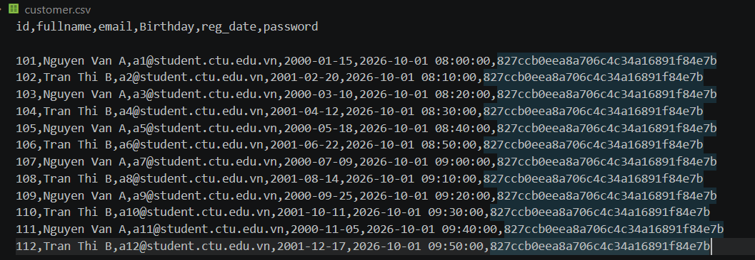
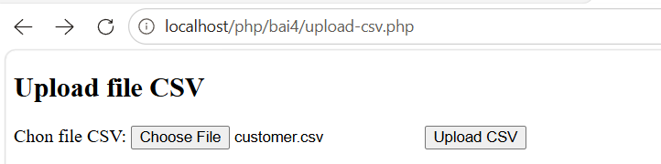
Trường hợp nộp file khác csv
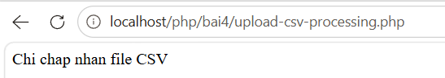
Trường hợp nộp đúng csv
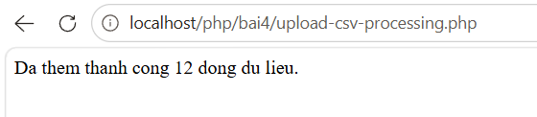

Chú ý:
- Các bạn nộp file word: Đặt tên file: <mssv><hoten><bai4>.docx nộp lên classroom, kèm với các file code đã tạo (ngoại trừ file word trả lời câu hỏi, các file còn lại các bạn nén vào file .zip).
- Mỗi câu các bạn trả lời bằng hình/trả lời dạng text tùy vào yêu cầu của câu hỏi, và ghi rõ số thứ tự câu hỏi mà bạn trả lời.
- Các bài phát hiện copy từ các bài của bạn khác sẽ không được tính điểm.
- Chú ý: Các câu trả lời có tham khảo trên Internet phải trích dẫn link

https://www.w3schools.com/sql/sql_injection.asp
https://www.w3schools.com/php/php_cookies.asp
https://www.w3schools.com/php/php_sessions.asp
https://www.w3schools.com/php/php_file_upload.asp
https://www.w3schools.com/php/func_filesystem_file.asp
https://www.php.net/manual/en/features.file-upload.post-method.php,
https://stackoverflow.com/questions/6654351/check-file-uploaded-is-in-csv-format

