Instructions to install and run code:

1. Check for the presence of python3 by writing python or python3 in the command prompt.

(<https://www.python.org/downloads/>) to download python if you do not have one.

1. Install following dependencies using pip:
   1. Flask
      1. python3 -m pip install flask 

(Note if you are missing any dependencies, install them accordingly)

1. Install My SQL connector for python by downloading it from: <https://dev.mysql.com/downloads/connector/python/>

After the installation of these files

Open a terminal/command prompt in the downloaded folder of the codebase

The current directory in the directory tree must be where the python is located.

Check if there’s anything running in localhost:5000 then type

1. python ./main.py to run the server 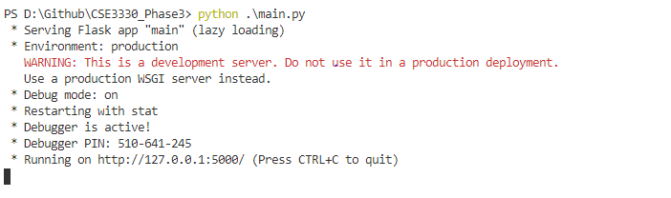
2. then open a browser and navigate to localhost:5000/ or <http://127.0.0.1:5000/> 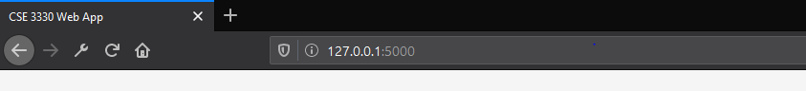
3. Then follow the GUI for all the steps to fulfill requirements

