**Supplementary Materials**

**Table S1. Regions defined for each network**

|  |  |  |  |
| --- | --- | --- | --- |
| Network | **Region of Interest (ROI) label** | **Description of anatomical region** | **MNI coordinates (x,y,z)** |
| DMN | PHG | Parahippocampal/hippocampal gyrus | *L(-24,-26,-20), *R(24,-26,-20) |
| DMN | MTG | Middle temporal gyrus | *L(-52,-18,-18), R(62,-10,-16) |
| DMN | IPL | Inferior parietal lobule | L(-46,-64,32), R(50,-62,34) |
| DMN | PCC | Posterior cingulate cortex | L(-6,-54,32), R(6, -60, 32) |
| DMN | mPFC | Medial prefrontal cortex | L(-6,62,-4), R(6,62,-4) |
| DMN | dmPFC | Dorsal medial prefrontal cortex | R(6,50,20) |
| DMN | SFG | Superior frontal gyrus | L(-24,24,42), R(22,28,44) |
| DAN | pIPS | Posterior intraparietal sulcus | L(-28,-68,48), R(30,-66,48) |
| DAN | aIPS | Anterior intraparietal sulcus | L(-40,-46,46), R(38,-46,46) |
| DAN | MT | Middle temporal/visual cortex (V5) | L(-52,-60,-8), R(58,-52,-10) |
| DAN | MOT | Premotor motor cortex | L(-48,6,30), R(48,10,28) |
| DAN | FEF | Frontal eye field | L(-26,2,54), R(28,4,54) |
| DAN | MFG | Middle frontal gyrus | L(-46,34,22), R(46,34,22) |
| SAL | IPL | Inferior parietal lobule | L(-60,-40,36), R(60,-38,38) |
| SAL | aINS | Anterior insula/cingulo-operculum | L(-38,16,2), R(42,16,2) |
| SAL | dACC | Dorsal anterior cingulate cortex | L(6,32,30), R(-6,26,32) |
| SAL | aPFC | Anterior prefrontal cortex | L(-30,48,26), R(32,48,26) |
| ECN | SFG | Superior frontal gyrus | L(-6,42,44), R(6,50,38) |
| ECN | alPFC | Anterior lateral prefrontal cortex | L(-46,42,-6), R(48,36,-10) |
| ECN | dlPFC | Dorso-lateral prefrontal cortex | L(-44,12,48) |
| ECN | IFG | Inferior frontal gyrus | L(-52,20,20), R(54,26,18) |
| ECN | IPL | Inferior parietal lobule | L(-50,-60,32) |
| ECN | MTG | Middle temporal gyrus | L(-58,-38,0) |
| ECN | STG | Superior temporal gyrus | R(52,-32,0) |

**Table S1 caption:** Network regions of interest (ROIs) empirically derived from the study sample using independent components analysis (ICA) based decomposition of the rsfMRI signal. Networks were identified from ICA with older and younger adults, based on knowledge of spatial activation patterns for canonical brain networks of interest. Network acronyms refer to: DMN (Default Mode Network), DAN (dorsal attention network), SAL (Salience network), and ECN (Executive Control Network). Regions were identified based on peak Z-scores for functionally distinct regions within networks. These were determined with a stepwise thresholding procedure, beginning at Z = 2.33. Guided by knowledge from existing literature, we increased the threshold until distinct functional-anatomical clusters were formed. Since the range of Z values varied by IC, the thresholds also varied by IC. For example, for the DMN, a relatively high threshold was necessary to separate the peaks in the medial wall (posterior cingulate cortex, PCC) from the lateral parietal cortices (inferior parietal lobules, IPLs). *Regions identified as part of network based on a previous study from our group (Voss et al., 2010a,b) finding age- and fitness-related individual differences in network membership. Note other regions identified from rsfMRI in this sample also overlap substantially with regions identified in previous study (Voss et al., 2010a,b); note from Voss et al., 2010b, previously referred to “fronto-parietal” network is referred to as DAN in the current study, and previously referred to “fronto-executive” network contains primarily regions in the SAL network in the current study.

**Results with the compcor processing stream**

*CompCor processing and analyses*. Preprocessing before nuisance regression included motion corrected with AFNI’s 3dvolreg, distortion correction with gradient field maps, brain extraction using the T1 anatomical mask registered to functional space, spatial smoothing using FSL’s SUSAN at 6 mm FWHM, normalization with median intensity scaling, and denoising with non-aggressive ICA-AROMA (Pruim et al., 2015). ICA-AROMA is a validated data-driven method to identify motion-related signal in the data. The program uses FSL’s Multivariate Exploratory Linear Decomposition into Independent Components (MELODIC) tool to extract independent components from the data and classifies them as motion related based on whether they exceed one of three criteria: (1) a decision boundary combining the edge fraction and maximum realignment parameters correlation, (2) a cerebrospinal fluid fraction higher than 10%, or (3) a high-frequency content larger than 35%. On average, at baseline ICA-AROMA yielded 38.4 ± 5.3 total independent components from the data, and it classified 24.1 ± 5.3 (62.6 ± 12.2%) components as motion-related artifacts which were regressed out of the data. Similarly, post-intervention ICA-AROMA yielded 39.2 ± 6.1 total independent components from the data, and it classified 23.5 ± 6 (59.3 ± 13.1%) components as motion-related artifacts which were regressed out of the data.

Denoised data were temporally smoothed with a bandpass filter temporal filtering (.008 < *f* < 0.08 Hz) before nuisance regression processing. Next, subject-specific white matter and cerebrospinal fluid nuisance regressors were derived from the partial volume estimates generated by FSL’s FAST segmentation. The partial volume estimates were pushed to EPI space, and the WM and CSF probability masks were thresholded to 99% and eroded. We then used principal components analysis to extract the first 5 principal components from the WM and CSF denoised and bandpassed timeseries. These 10 timeseries regressors were used in addition to the 6 motion parameter regressors as described in the main text. For all analyses below, we also used the mean of all pair-wise ROI-ROI correlations across all four networks (i.e., mean of all within- and between- network FC estimates). This has been shown to be an effective post-hoc method for minimizing common shared variance across all FC pairs (Geerligs et al., 2017; Saad et al., 2013).

*Intervention-related changes in functional connectivity (FC) of cortical-association networks that degrade with aging.* As reported in the main text, there was a significant session*group interaction for average SAL network FC (β=.58 (SE=.24), t(182.9)= 2.41, p=.02). Below we show a summary of model estimates for each group and network outcome (Figure S1), followed by a graph showing model-estimated SAL FC for each group pre and post- intervention (Figure S2).

**Figure S1. Summary of standardized beta coefficients for intervention effects on functional brain networks as estimated by compcor preprocessing method**

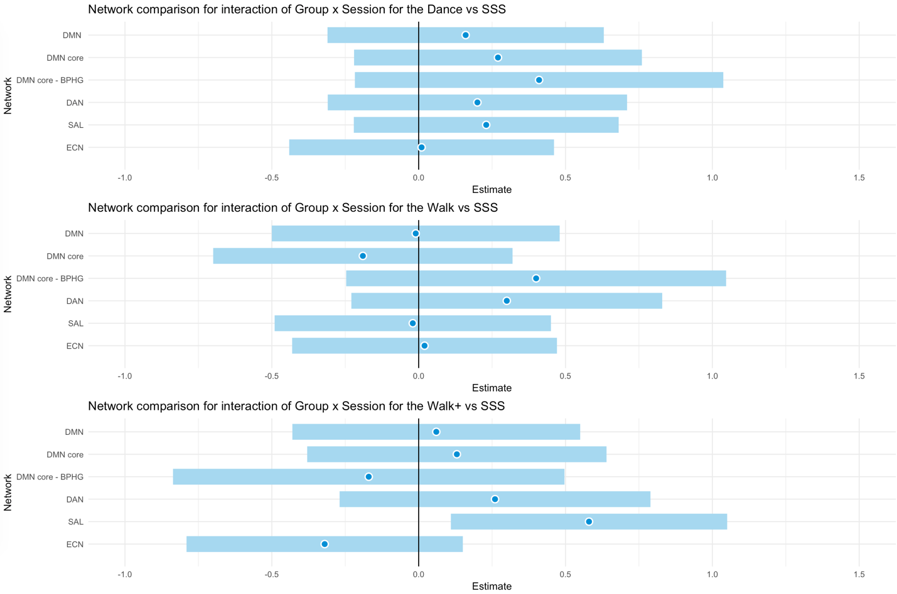

**Caption:** Coefficients for each experimental group (DANCE, WALK, WALK+) are shown with reference to the stretching (SSS) active control group. For each estimate, the blue dot reflects the standardized beta coefficient and the surrounding band is the 95% confidence interval.

**Figure S2. The WALK+ group showed selective increases in salience (SAL) network functional connectivity also with CompCor processing**

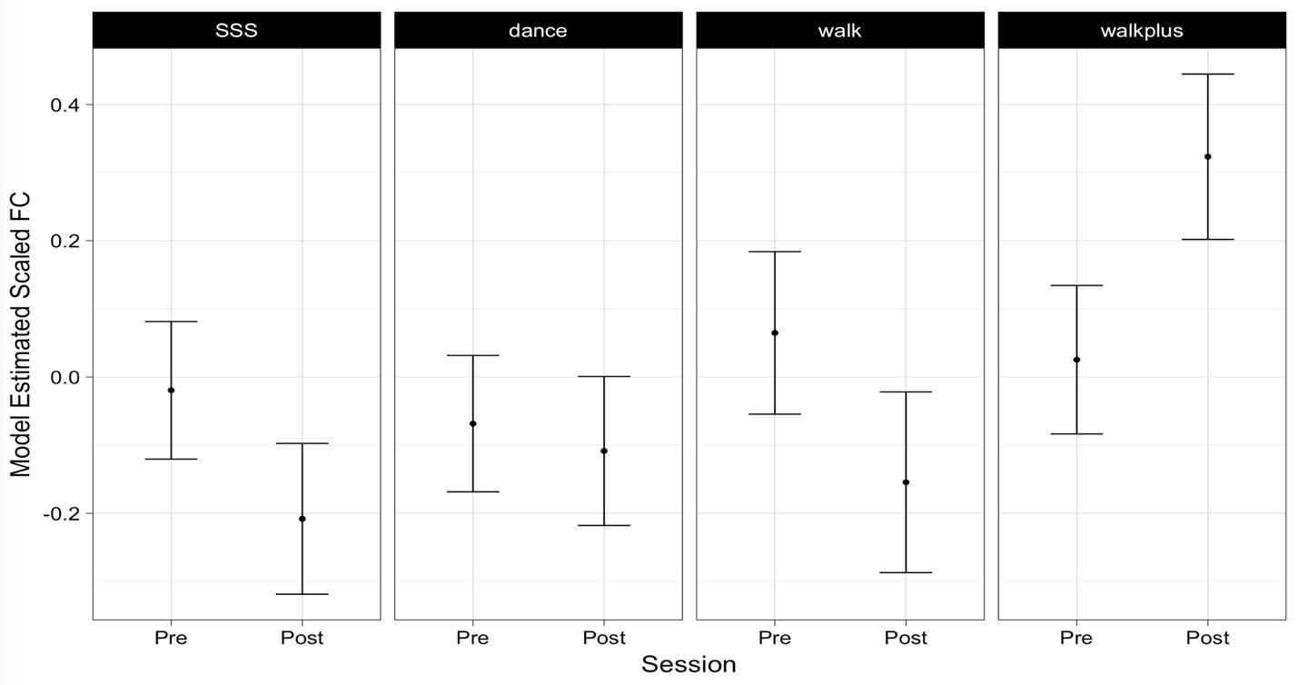

**Caption:** Model adjusted SAL FC estimates shown for each group pre- and post- for each intervention group; no groups differed in baseline FC from the SSS control group. Point estimates shown along with their 95% confidence interval.

**Re-analysis of cross-sectional relationships between average network FC and CRF after controlling for moderate-to-vigorous physical activity (MVPA)**

We have previously reported that CRF is associated with greater DMN FC (Voss et al., 2010a) and that relationship is particularly strengthened after controlling for individual differences in MVPA (Voss et al., 2016). We interpreted these results to suggest that although DMN FC may be able to increase after 1-year of aerobic training (Voss et al., 2010b), factors associated with “sedentary fitness” levels such as genetics may be important in predicting individual differences in DMN FC.

Here we present a re-analysis of the cross-sectional relationships of CRF with network outcomes and additionally add covariates to account for AA and cardiovascular medication use, and models to predict composite cognitive constructs. Additionally, we report significant cross-sectional relationships with CompCor FC preprocessing.

*Cross-sectional relationships of CRF with network outcomes*. For baseline FC measures, we ran a multiple linear regression that included age, sex, education, current medication status (AA use 0=no, 1=yes), (cardiovascular medication use 0=no, 1=yes), MVPA, and CRF as predictors of FC. Similar to intervention analyses above, for models based on CompCor preprocessing we also included a regressor for the mean FC of all ROI-to-ROI pairs across network nodes.

Consistent with our previously reported results, the DMN was the most consistent network outcome that was positively related to greater CRF after accounting for MVPA. In particular, CRF was a significant predictor of average DMN FC (β=.18 (SE=.09), t=2.13, p=.03; model F(7,181)=4.0, p<.001, adjusted R2=.10), DMN Core FC (β=.26 (SE=.09), t=3.02, p=.003; model F(7,181)=4.07, p<.001, adjusted R2=.10), and DMN Core FC with the bilateral parahippocampal gyrus (BPHG) (β=.21 (SE=.09), t=2.49, p=.01; model F(7,181)=3.9, p<.001, adjusted R2=.10). In contrast, MVPA showed a negative relationship with average DMN FC (β=-.21 (SE=.08), t=-2.53, p=.01), a marginally negative relationship with DMN Core FC (β=-.16 (SE=.08), t=-1.94, p=.05), and a negative relationship with DMN Core FC with the BPHG (β=-.21 (SE=.08), t=-2.55, p=.01). There was no cross-sectional relationship between CRF or MVPA with average DAN, SAL, or ECN FC.

Using the same regression approach as described in the main text and with CompCor preprocessing approach, there was only a positive association between CRF and DMN Core FC (β=.18 (SE=.08), t=2.08, p=.04; model F(8,180)=4.98, p<.001, adjusted R2=.15). However, there was also a positive relationship between MVPA and average ECN FC (β=.12 (SE=.06), t=2.05, p=.04; model F(8,180)=29.2, p<.001, adjusted R2=.55). The adjusted R2 is much higher because the overall mean network FC predictor was a strong predictor of DMN Core FC (β=.39 (SE=.07), t=5.56, p<.001) and ECN FC (β=.74 (SE=.05), t=14.46, p<.001).

*Cross-sectional relationships of CRF with cognitive outcomes*. With respect to cognition, at baseline greater CRF was a predictor of greater fluid abilities (β=.20 (SE=.08), t=2.41, p=.02; model F(7,181)=6.31, p<.001, adjusted R2=.17) and was marginally associated with better vocabulary (β=.17 (SE=.09), t=1.98, p=.05; model F(7,181)=4.43, p<.001, adjusted R2=.11).

In contrast, greater MVPA was marginally associated with faster processing speed (β=.15 (SE=.08), t=2.01, p=.05; model F(7,181)=8.50, p<.001, adjusted R2=.22). MVPA was negatively associated with episodic memory (β=-.18 (SE=.08), t=-2.31, p=.02; model F(7,181)=7.38, p<.001, adjusted R2=.19).

**References**

Geerligs, L., Tsvetanov, K.A., Cam, C.A.N., Henson, R.N., 2017. Challenges in measuring individual differences in functional connectivity using fMRI: The case of healthy aging. Human Brain Mapping.

Pruim, R., Mennes, M., van Rooij, D., Llera, A., Buitelaar, J., Beckmann, C., 2015. ICA-AROMA: A robust ICA-based strategy for removing motion artifacts from fMRI data. Neuroimage 112, 267-277.

Saad, Z.S., Reynolds, R.C., Jo, H.J., Gotts, S.J., Chen, G., Martin, A., Cox, R.W., 2013. Correcting brain-wide correlation differences in resting-state FMRI. Brain Connect 3(4), 339-352.

Voss, M., Erickson, K., Prakash, R., Chaddock, L., Malkowski, E., Alves, H., Kim, J., Morris, K., White, S., Wójcicki, T., Hu, L., Szabo, A., Klamm, E., McAuley, E., Kramer, A., 2010a. Functional connectivity: a source of variance in the association between cardiorespiratory fitness and cognition? Neuropsychologia 48(5), 1394-1406.

Voss, M., Prakash, R., Erickson, K., Basak, C., Chaddock, L., Kim, J., Alves, H., Heo, S., Szabo, A., White, S., Wojcicki, T., Mailey, E., Gothe, N., Olson, E., McAuley, E., Kramer, A., 2010b. Plasticity of brain networks in a randomized intervention trial of exercise training in older adults. Front Aging Neurosci 2.

Voss, M., Weng, T., Burzynska, A., Wong, C., Cooke, G., Clark, R., Fanning, J., Awick, E., Gothe, N., Olson, E., McAuley, E., Kramer, A., 2016. Fitness, but not physical activity, is related to functional integrity of brain networks associated with aging. NeuroImage 131, 113-125.