#### Application1:

**Application Names:** Real Time Biomedical Data Streaming and Visualization(RIMES)

**Descriptions:** Real tIme bioMEdical data Streaming platform (RIMES) is a data-intensive virtual environment under joint development by Computer Network Information Center(CNIC) and University of California, San Diego(UCSD). RIMES extends scientists’ desktops to biomedical grid computation resources and mass storage systems, by means of streaming biomedical data through internet-based Data Turbine cloud. Researchers may conduct activities related to job submission, data processing and real time visualization within the environment. RIMES may also be suitable to other data-intensive areas such as geosciences and ecoinformatics.

**Codes, hardware used:**

* Data Turbine(<http://www.dataturbine.org/>)
* NAMD(http://www.ks.uiuc.edu/Research/namd/)
* JMOL(http://jmol.sourceforge.net/)
* RDV(http://code.google.com/p/rdv/)

**Results:**

* Software: RIMES client/server
* Platform: Data turbine Cloud Platform
* The RIMES client and API make it easy to conduct remote molecule trajectory visualization on Tiled Display Walls (TDW) , or web-based portals, such as duckling. The RIMES service, which is based on DUCKLING and OPAL2, makes it available to extend scientists desktops to biomedical Grid/Cloud computation resources and mass storage systems.

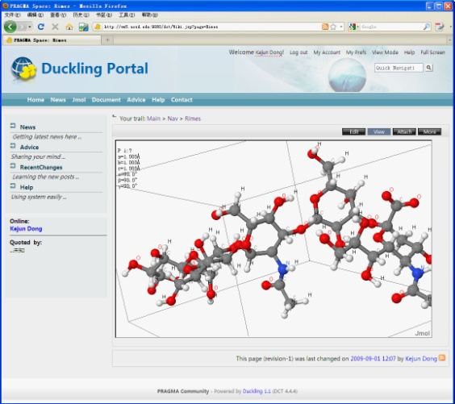 

Sink-enabled web-based 3D visualization on Duckling portal

**Publications:** Kejun Dong, Kai Nan, Sameer Tilak, Cindy Zheng, Dong Xu, Jurgen Schulze, Peter Arzberger, Wilfred Li, Real tIme bioMEdical data Streaming platform (RIMES): A data-intensive virtual environment, , 3rd International Joint Conference on Computational Sciences and Optimization, CSO 2010: Theoretical Development and Engineering Practice, v 2, p 342-346, 2010.

#### Application2:

**Application Names:** Duckling and Conference Service Platform

**Descriptions:** DUCKLING, an Open Source software (<http://duckling.sourceforge.net>), is a collaboration environment suit, developed by a PRAGMA member institution – CNIC, Chinese Academy of Sciences. In the DUCKLING’s development cycles, PRAGMA, as a collaborative frame work, provided the collaborations, use cases and feedbacks insured the software usefulness, enhanced the software quality and helped with its dissemination. Conference Service Platform (<http://csp.escience.cn>), shortly CSP, based on Duckling, provides a web-based platform to help organize conferences, meetings and workshops. The features of CSP include user registration, hotel reservation, abstract and paper submission/review, and agenda publishing.

**Codes, hardware used:**

* Duckling(http://duckling.sourceforge.net)
* Tomcat(http://tomcat.apache.org/)

**Results:**

* Software: Duckling
* Platform: Conference Service Platform Cloud Service (<http://csp.escience.cn>)
* Websites:
  + http://pragma18.pragma-grid.net
  + http://pragma19.pragma-grid.net
  + http://pragma20.pragma-grid.net
  + http://pragma21.pragma-grid.net
* The CNIC team worked with many other PRAGMA teams to use/test/enhance DUCKLING for many applications. Working with PRAGMA teams, DUCKLING was used to setup four PRAGMA workshop websites which successfully handled international conference planning, arranging and organizing tasks. Now, DUCKLING has become the standard tools for PRAGMA workshop websites.

**Publications:** Yihua Zheng, Kai Nan, Deting Yang, Kejun Dong, Realization on Conference-Oriented Cloud Collaboration Platform, Journal of Huazhong University of Science and Technology(National Science Edition), Vol.39 Sup. I, p33-37. 2011.6.

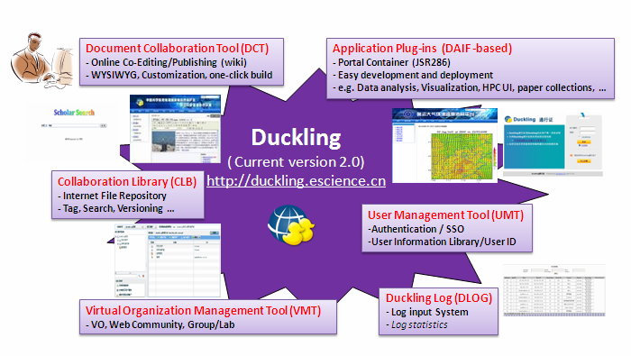

#### Application3:

**Application Names:** Automatic User Interface for OPAL Service based on Duckling

**Descriptions:** Based on Duckling and OPAL2 toolkit, a joint team from UCSD/NBCR and CNIC develop an automatic user interface generation service for OPAL service and integrate all available OPAL service in Duckling, a web-based portal container. Automatic interface generation will automatically generate an application specific interface after collecting the information from OPAL web services. The project is supported by PRIME project and will be finished by late August.

**Codes, hardware used:**

* Duckling(http://duckling.sourceforge.net)
* OPAL (http://www.nbcr.net/software/opal/)

**Results:**

* A portal based on Duckling and OPAL2
* People can submit OPAL2 jobs through the duckling portal service, which is generated automatically from OPAL service.

**Publications:** N/A.