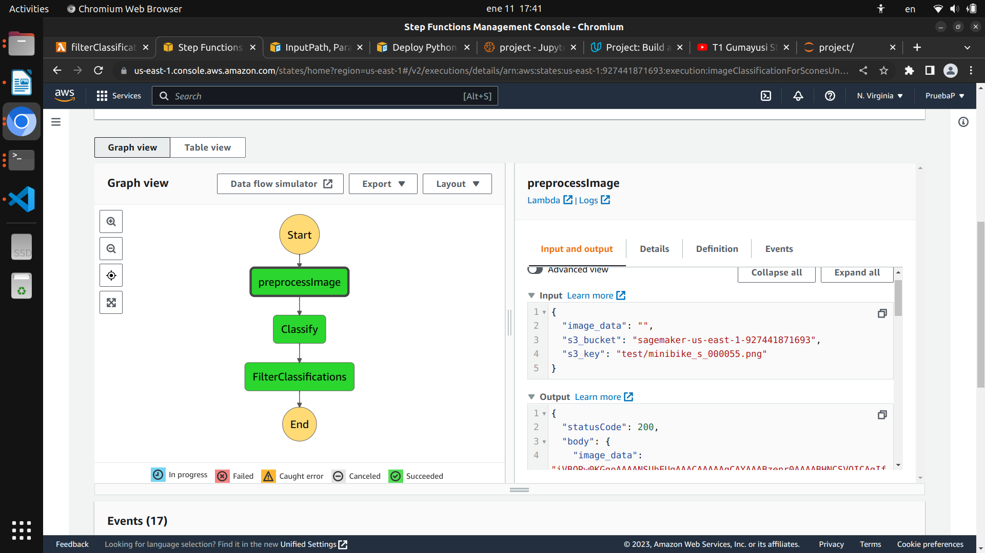
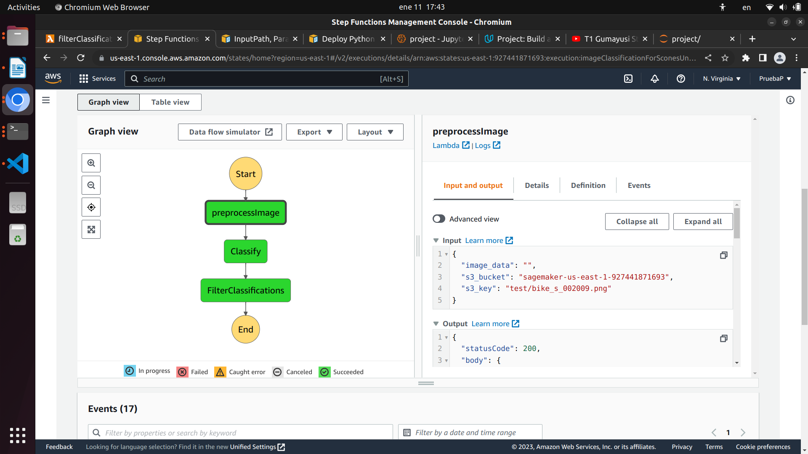
Screenshots depicting successful processing of different images
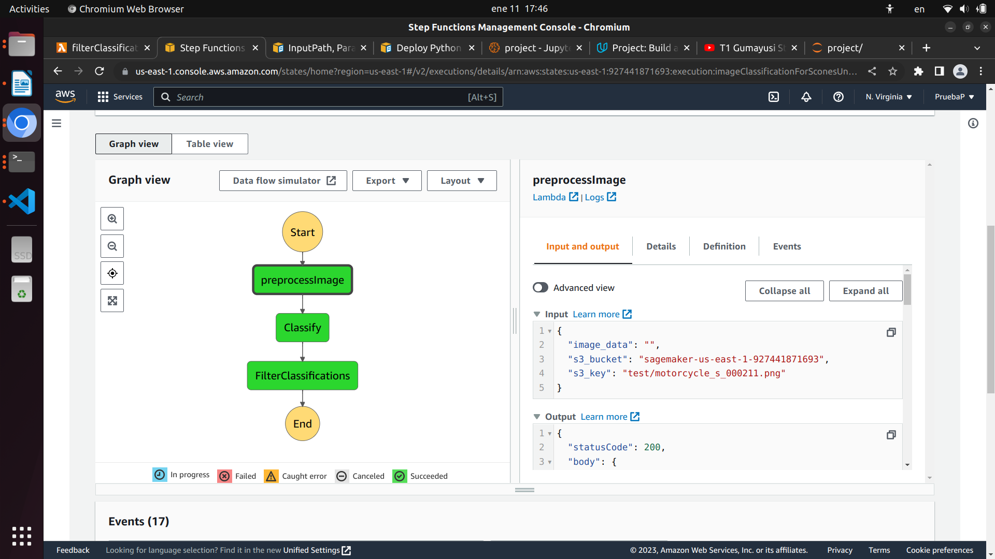
To test that the workflow fails when the filter encounters a prediction with a confidence below the THRESHOLD level, I will change the THRESHOLD to 100%. The following images demonstrate what happens when the workflow executes with this THRESHOLD:
