GPMS: Graduation Project Management System

User Guide

May 2016

Version 1.00

United Arab Emirates University

Copyright and third-party information as required

Document Revisions

|  |  |  |
| --- | --- | --- |
| Date | Version Number | Document Changes |
| 05/25/2016 | 0.1 | Initial Draft |
|  |  |  |
|  |  |  |
|  |  |  |
|  |  |  |
|  |  |  |
|  |  |  |
|  |  |  |
|  |  |  |

Table of Contents

1 Introduction 6

1.1 Scope and Purpose 6

1.2 Process Overview 6

2 Configuration 8

2.1 Creating Database from scratch 8

2.2 Setting Credentials for the JDBC in the server. 9

2.3 Setting Download Folder for images in the server. 10

2.4 Setting Tool Variables 11

2.5 Setting Logo for the organization 13

3 Resources Management 14

3.1 Setting Guidelines Section 14

3.2 Upload Student Resources 14

3.3 Edit Student Resources 15

4 Rubric Management 16

5 Assessment of Learning Outcomes 20

5.1 Create Assessment Sheet 20

5.2 Viewing Assessment Sheet 21

6 Users/Accounts Management 22

6.1 Create Student/Faculty Account 22

6.2 Updating/Resetting Password 24

6.3 Batch uploading 24

6.4 Batch Uploading Project/Proposals 25

7 Projects Management 26

7.1 Uploading Project from XML file 27

7.2 Creating Project Manually 28

7.3 Allocating Projects 28

7.4 Searching Projects 31

7.4.1 Search View of Students 31

7.4.2 Search View of Faculty 32

7.4.3 Search View of Coordinator/Admin 32

7.4.4 Freezing Projects 33

8 Projects Deliverable Management 33

8.1 Viewing Project Deliverables 34

9 Projects Scheduling 35

9.1 Creating Schedule 35

9.2 Creating Schedule Slots 36

9.3 Creating a Schedule Slot 37

9.4 Viewing Schedule 38

10 Projects Grading 39

10.1 Faculty Advisor Grading 40

10.2 Faculty Examiner Grading 41

10.3 Viewing Grades 41

11 Appendices 43

12 Index 44

# Introduction

## Scope and Purpose

The Senior Project Management System (GPMS), is a software system that manages the senior projects of undergraduate students. Management includes three views, namely, student, faculty, and coordinator (Admin). Faculty can be either advisor or examiner. Advisor posts project proposals for students to select and work on and after that she grades them according to rubrics set by the college. Examiner faculty grades projects. Coordinator manages global college setup of the system such as rubric set up, scheduling, and others. Finally students can see proposals, get allocated to project, submit their deliverables/reports, and see their grades.

GPMS has great benefits for the college and can be considered as a repository for student projects, deliverables, and grades. It is a valuable tool in which we can apply different techniques in computer science to mine the grades, identify weaknesses, check for cheating, and reuse previous student experiences.

This manual describes different capabilities and task each role/user can perform in a step by step fashion. In term of technical knowledge, we assume that coordinator should be familiar of XML files, CSV files, and a text editor. We also assume that there will be a technical person who will install the data base (MySql 5.4) and Apache Tomcat Server V.7 on a Windows/Linux machine.

## Process Overview

GPMS provides the following capabilities and processes:

1. Login/logout
2. Software tool configuration
3. Manage Accounts
   1. Create, edit, and search student accounts
   2. Create, edit, and search faculty accounts
4. Managing Resources for students
   1. Add resource file
   2. Remove resource file
   3. Add/edit guidelines
5. Manage Rubrics that is essentials for the grading process
   1. Create new rubrics
   2. Edit rubrics
   3. View rubrics
6. Manage proposals/projects for students
   1. Create and Edit Projects
   2. Search and view projects
7. Assessment of Learning Outcomes
   1. Create Assessment sheet
   2. Create Learning outcomes
   3. Mapping learning outcomes to rubric (assessment tools)
   4. Generate Assessment Report
8. Deliverable managements
   1. Upload file
   2. Remove file
   3. View files
9. Project Scheduling
   1. Create schedule
   2. Populate/update slots
   3. View schedules
10. Grading
    1. Edit/Assign grades
    2. View Grades

# Configuration

In this section, we will present the main configuration steps for the database, initial data, and accounts. These configurations are to be performed by the administrator (coordinator).

## Creating Database from scratch

We have provided 3 scripts for building the database from scratch. The files are included in the source project under db_scripts folder. As a pre-condition, you should have installed MySql version 5 or above on your computer. To run the scripts follow these steps:

1. Open MySql client
2. Run the first script which creates all tables from scratch.

|  |
| --- |
| mysql>\. Path_of_script….\db_scripts\db_tables.sql |

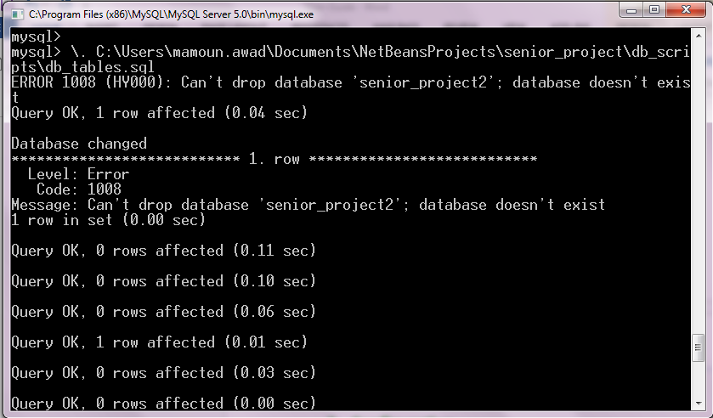Note: ignore the error “Cannot drop database…” if you encounter one.

1. Run the second script which creates functions, stored procedures, and triggers.

mysql>\. Path_of_script….\db_scripts\functions.sql

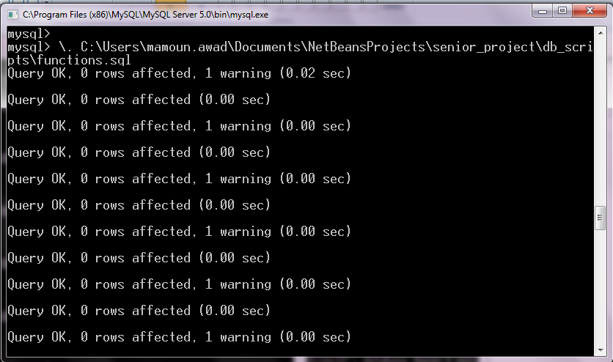

1. Run the third script which creates initial accounts and variables.

mysql>\. Path_of_script….\db_scripts\db_insert.sql

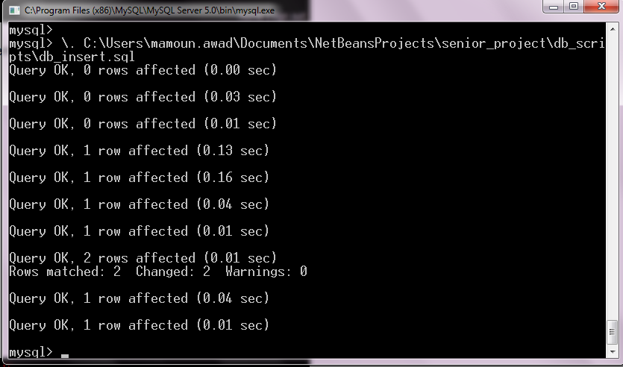

mysql>\. Path_of_script….\db_scripts\functions.sql

Now the database is ready to be used and managed.

## Setting Credentials for the JDBC in the server.

1. Go to the configuration folder of tomcat:

…..\Apache Tomcat v7.0\conf\Catalina\localhost

1. Using any of the text editors, edit the ‘Resource’ element in the xml file ‘senior_project.xml’ such that you add your own user id and password of MySql database.

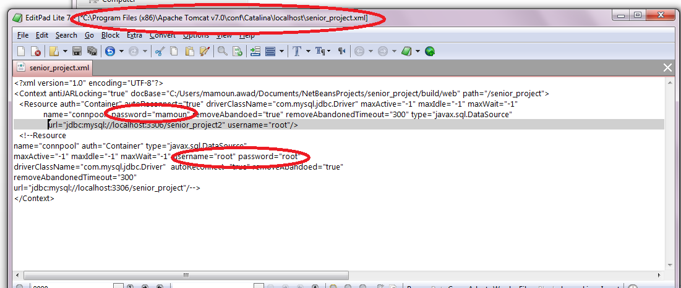

Figure Setting database variables

In NetBeans, you can edit the configuration file under the folder web/META-INF, edit the file “context.xml” such that you add the user id and password.

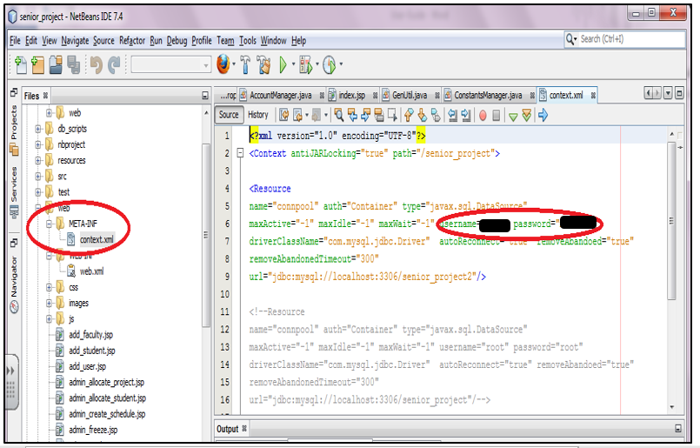

Figure Setting Database using NetBeans

## Setting Download Folder for images in the server.

The download folder is a local folder in which logos and other resources are used by the tool. This setup is necessary to make the tool work especially when uploading new logo image. Admin must set the folder as follows:

1. Go to the configuration folder of tomcat:

…..\Apache Tomcat v7.0\conf\Catalina\localhost

1. Using any of the text editors, edit the ‘Environment’ element in the xml file ‘senior_project.xml’ such that you add your own folder in the value attribute.

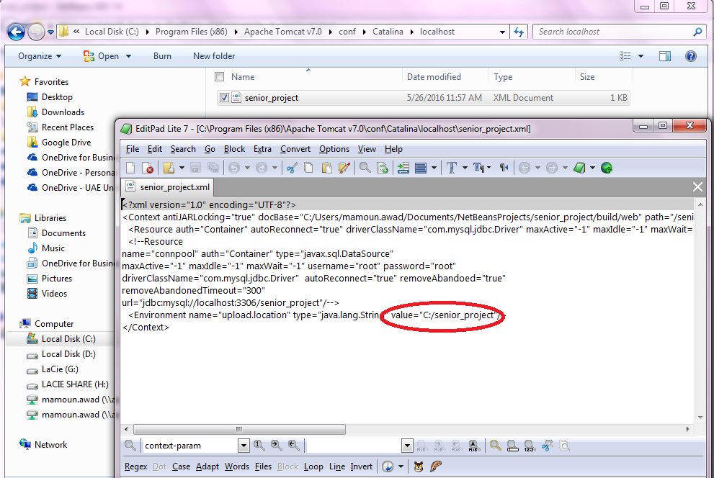

Figure Setting Download folder.

In NetBeans, you can edit the configuration file under the folder web/META-INF, edit the file “context.xml” such that you edit the Environment element as follows.

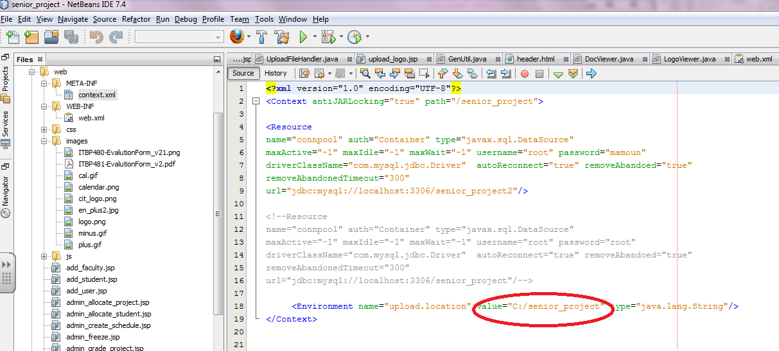

Figure Setting download Folder using NetBeans

## Setting Tool Variables

The administrator has to set up a set of variables for the tool. These variables are critical for creating proposals, deadlines, messages, etc. In the following we will list each variable and define its purpose and how to set them up. Notice that these variables have to be set all together.

1. Proposal Semester: this variable is used when creating new proposals for the students. The value of this variable will be used as the default semester of the proposal. In order to set it up, the admin has to go to the link “CONFIGURE Tool >> General” and provide a value. The format of the value is: year-[sp|fa|su]. For example to consider proposals for spring 2016, the admin has to enter 2016-sp.
2. Current Semester: this variable is used to define the current semester. The value of this variable is important for scheduling, proposal creation, reporting, etc. In order to set it up, the admin has to go to the link “CONFIGURE Tool>> General” and provide a value. The format of the value is: year-[sp|fa|su]. For example to consider proposals for fall 2016, the admin has to enter 2016-fa.
3. Deliverable Due Date: this variable is used to define the deadline for students to submit their reports, code, and other deliverables. In order to set it up, the admin has to go to the link “CONFIGURE Tool>> General” and select a date value.
4. Senior Day Date: this variable is used to define the Senior Day in which senior students present their work. In order to set it up, the admin has to go to the link “CONFIGURE Tool>> General” and select a date value for it.
5. Grades Due Date: this variable is used to define the due date for advisors to post grades. In order to set it up, the admin has to go to the link “CONFIGURE Tool>> General” and select a date value for it.
6. Senior I Rubric: this variable defines the rubric used for grading for Senior I. For now, admin has to select the “Original rubric” which is a default/dummy rubric. Later we will present how to create new rubric in Section ‎3. In order to set it up, the admin has to go to the link “CONFIGURE Tool>> General” and select “Original Rubric” from the drop list of the variable.
7. Senior II Rubric: this variable defines the rubric used for grading for Senior II. For now, admin has to select the “Original rubric” which is a default/dummy rubric. Later we will present how to create new rubric. In order to set it up, the admin has to go to the link “CONFIGURE Tool>> General” and select “Original Rubric” from the drop list of the variable.
8. Assessment Sheets Map 1/2: these variables defines the mapping of assessment sheet to the rubric defined in item 6 and 7. For now, admin has to select the “Dummy 1” or “Dummy 2” for the mapping. Later we will elaborate how to create new assessment sheet and mapping in Section ‎5. In order to set it up, the admin has to go to the link “CONFIGURE Tool>>General” and select “Dummay1” or “Dummy 2” from the drop list of the variable(s).

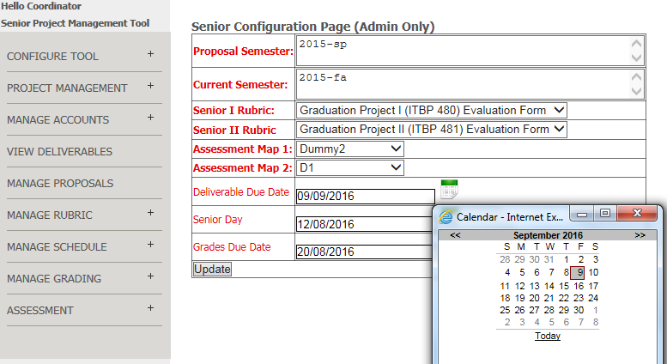

Figure configuring the tool

Now when you go to the home page, these dates have to be reflected there.

## Setting Logo for the organization

The administrator can set the logo of the organization/institution and upload the logo image. The logo image can be in png, gif, or jpg format. To set up the logo image:

1. Expand the Configure Tool menu item.
2. Select Logo Image
3. Browse/Select the image and upload it.

The logo should be automatically uploaded on the header of the tool.

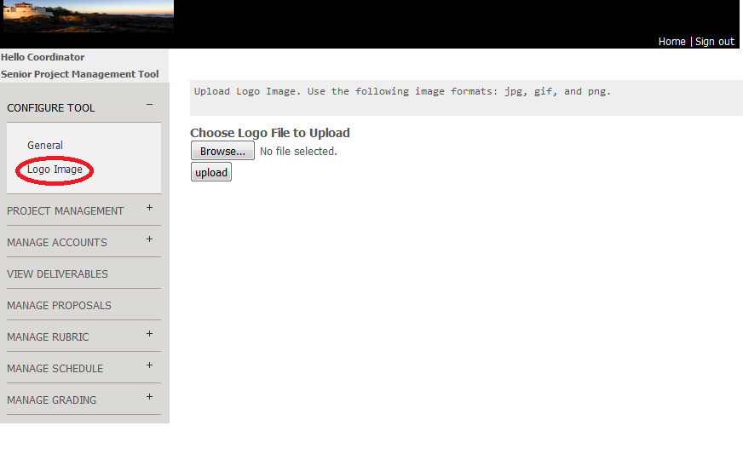

Figure Uploading Logo Image

# Resources Management

The contents of the home page of GPMS can be edited by the admin. The home page has three main parts. First, deadlines and due dates which can be set up via setting tools’ variable in Section ‎2.4. Second, guidelines section in which the Admin can provide bulleted general information. And finally, resources section in which student can download.

## Setting Guidelines Section

The administrator can set the text of the guidelines section by going to ‘Configuration Tool>upload resources’. A form will be displayed in which you edit the resources and guidelines (See Figure 7).

|  |  |
| --- | --- |
| 1. In the Left hand side menu, expand ‘Configuration Tool’ and then click on ‘upload resources’ 2. The resource page will be displayed. 3. In the second part of the page, ‘Manually Insert Guidelines’, edit the default/current text in the text area as needed. 4. Click on ‘Set Guidelines’ button.   (A) | (B) |

Figure Setting the Guidelines section

## Upload Student Resources

The administrator can create topic of resources and upload files related to that topic, for example, Admin can create a resource topic ‘Templates’ and upload different templates file under that topic. Admin can also edit the list by removing files from topic. Notice that once a topic has no files, the topic will be automatically deleted.

Figure 8 presents how to create new resource category/type and upload file to it. You can add more files to the same category by selecting the resource type from the drop list and then browse and select files (See Figure 9). Notice that the page will consider selecting resource category first to upload file to it. If there is no resource category was selected, then the page will see if there is a new category name was entered. If no category was selected or entered, and error will be displayed.

|  |  |
| --- | --- |
| Upload Resource file to a new Topic:   1. In the Left hand side menu, expand ‘Configuration Tool’ and then click on ‘upload resources’ 2. The resource page will be displayed. 3. In the first part of the page, ‘Resource Upload Form’, 4. Enter the resource topic in the field ‘New resource Type’. Make sure not to have commas in the name. 5. Browse and select file using the ‘browse’ button. 6. Click on ‘upload File’   (A) | (B) |

Figure Creating new Resource type and uploading file under that type.

|  |  |
| --- | --- |
| Upload Resource file to a Topic:   1. In the Left hand side menu, expand ‘Configuration Tool’ and then click on ‘upload resources’ 2. The resource page will be displayed. 3. In the first part of the page, ‘Resource Upload Form’, 4. Select from the drop list ‘Current Resources’ a resource type. 5. Browse and select file using the ‘browse’ button. 6. Click on ‘upload File’   (A) | (B) |

Figure Upload Resource file to an existing resource type.

## Edit Student Resources

Admin can also edit the list by removing files from topic. Notice that once a topic has no files, the topic will be automatically deleted.

To remove a resource, we should first view the current files under that resource. Show how to do so.

|  |  |
| --- | --- |
| View Resource files of a topic:   1. In the Left hand side menu, expand ‘Configuration Tool’ and then click on ‘upload resources’ 2. The resource page will be displayed. 3. In the first part of the page, ‘Resource Upload Form’, 4. Select a resource from the ‘Current Resources’ drop list. 5. Click on ‘Show Files’ and a page will be displayed as shown in the opposite figure.   (A) | (B) |

Figure 10 Edit Resource files

Now, the Admin can click on the links beside each file to remove it or she can click on the link of the file to view/download the file.

# Rubric Management

Rubric is a set of instructions and rules that governs the process of grading senior projects. Rubric can change over the years in which different criteria is added, removed, and edited. In GPMS, only the coordinator can create and edit rubrics. We recommend not to edit the rubric because grading depends on it. In order to create a rubric, go to ‘Manage Rubric’ in the left hand side menu items, expand it, and click on ‘Create Rubric’. You will be given two options to create rubric, namely, upload the rubric from a file or fill the rubric form item by item.

To upload the rubric from a file, you must have an xml file in the following format:

1. Rubric name: this is a description of the rubric. Notice that there will be an automatic generated ID for the rubric.
2. One or more items: each item represent a grading criteria. Each grading item must have:
   1. Item name: name of grading criteria
   2. Details: description of the grading criteria
   3. Max grade: Highest score of the grading criteria.

Table 1 presents a template of the xml file where the coordinator can edit the red font text, save, and upload it. Figure 11 shows an example of a complete rubric with 6 criteria, namely, project plan, background & relate work, project design, IT integration, presentation, and report.

Table Rubric Template in Xml format

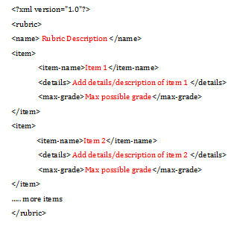

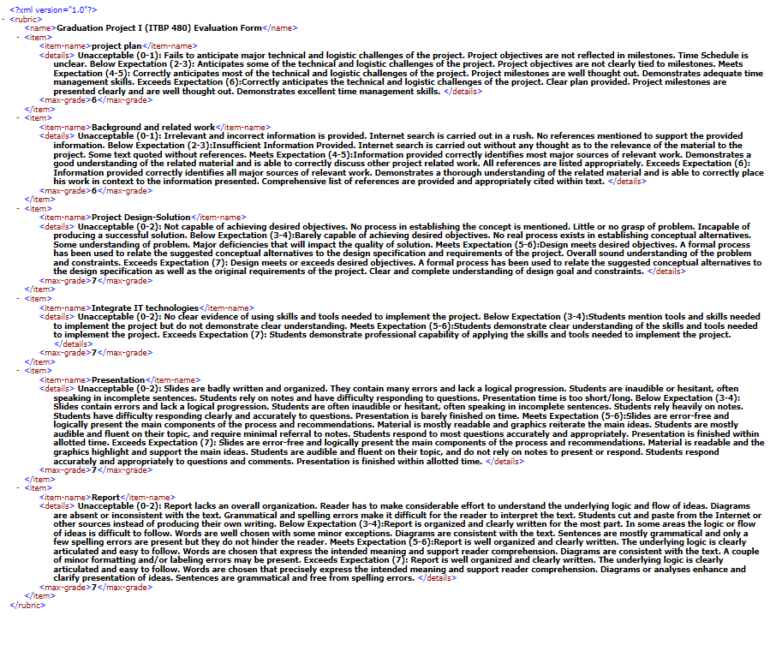

Figure Sample Rubric

Once the coordinator finished the preparation of the rubric, he can upload it as follows.

1. Click browse button to find the file.
2. Click upload Rubric.
3. The file with all items are displayed in the page.
4. Coordinator can view the items and edit them.
5. Click on Submit Rubric to finalize the process.

In case there was any error in the format, an error will be displayed and uploading is declared failure. Now the coordinator can view rubric as follows:

1. Click on the Rubric Management > view Rubric on the left hand side menu items.
2. A form will be displayed with the current uploaded rubrics.
3. Select the rubric and click view.

|  |  |
| --- | --- |
| Figure uploading a rubric in the xml format. Notice that once the xml file is selected, the rubric can be further edited, and finally uploaded. | Figure Viewing a rubric |

Rubrics can also be created manually by filling the rubric form as follows:

1. Enter the description for the rubric
2. Enter item name, item description, and max grade for each item.
3. Click on ‘Add Grade Item’ to add the item.
4. Repeat step 2 and 3 as needed
5. Click on Submit Rubric to finalize the process.

Notice that rubric ID and item ID are read only fields since they are automatically generated (see 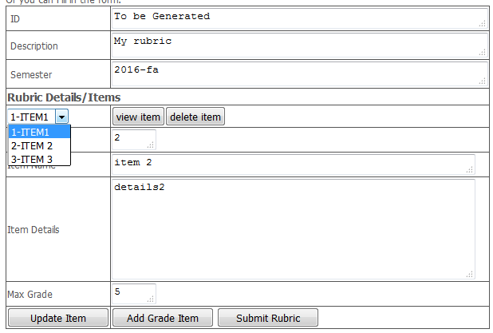

Figure 14).



Figure creating rubric manually

Once the rubric is uploaded successfully, it can be selected for grading as in Section ‎10.

# Assessment of Learning Outcomes

Assessment involves the use of empirical data on student learning to refine programs and improve student learning ‎[3].  The main step of assessment is to create learning outcomes and map them to curriculum. Learning outcomes describes students’ capability to demonstrate in terms of knowledge, skills, and values upon completion of a course, a span of several courses, or a program. Solid and clear articulation of learning outcomes serves as the foundation to evaluating the effectiveness of the teaching and learning process ‎[1]‎[2]. In GPMS, Coordinator can create assessment sheet, create learning outcomes, and map learning outcomes to assessment tools. Assessment tools are limited to rubric criteria already defined in Section ‎4.

## Create Assessment Sheet

Coordinator should create an assessment sheet. The sheet has ID, and Name. The sheet defines one or more learning outcomes. Each learning outcome has ID, name, and description. In order for the Coordinator to create assessment sheet, she should perform the followings steps in Table 2 and Figure 15.

Table Creating Assessment Sheet Steps

|  |
| --- |
| 1. In the left hand side main menu, click on Assessment. Once expanded, click on ‘Create Assessment’. 2. The assessment form will show up in the browser. 3. Fill up the description of the assessment. Notice that the IDs of the assessment/learning outcomes are automatic generated. 4. Fill up the name/description of the learning outcomes. 5. Click ‘add Outcome’. 6. For already created outcomes, select and then click ‘view outcome’ to view the outcome. 7. For already created outcomes, select and then click ‘delete outcome’ to delete the outcome. 8. For already created outcomes, select and edit the outcome, and then click ‘update outcome’ to update the outcome. 9. Repeat steps 4 and 5 as necessary to add more outcomes. 10. Click ‘Create Assessment’ to finalize the creation of the assessment. |

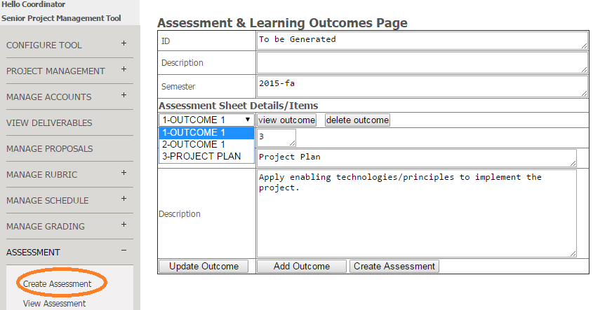

Figure Creating Assessment Learning outcomes Form.

## Viewing/Remove Assessment Sheet

Coordinator, faculty, and students can view the assessment sheets. To view the assessment sheet, do the following step in Table 3, see Figure 16.

Table View Assessment Sheet Steps

|  |
| --- |
| 1. In the left hand side main menu, click on Assessment. Once expanded, click on ‘View/Remove Assessment’. 2. The assessment form will show up in the browser. 3. Select the assessment from the drop list and click on ‘view’ to view the assessment or ‘Remove’ to remove the assessment sheet. Notice that you cannot remove an already mapped/used/referenced assessment sheet |

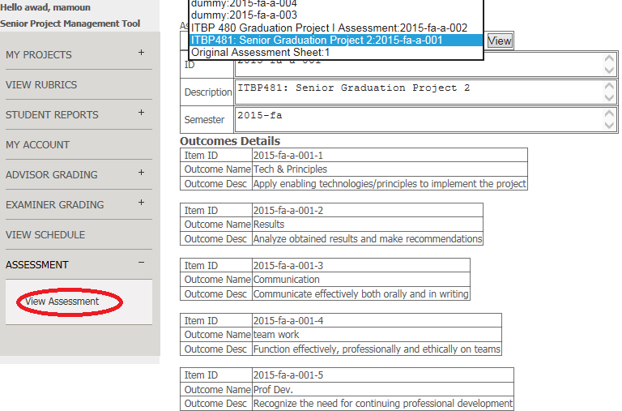

Figure Viewing Assessment and Learning outcomes.

## Create Assessment/Rubric Mapping

To evaluate the learning process, Coordinator needs to create a map between the learning outcomes (modelled in the assessment sheets) and the assessment tools (modelled in the rubrics). This mapping is necessary to generate reports and produce statistics about the learning process. Each mapping will have a unique ID in which it can be used by referencing its ID. Each academic year, coordinator can create new mapping or use a previous mapping to assess the learning process of senior projects courses. Mapping can only be removed if the mapping was not used/referenced. In order for the Coordinator to create a new mapping, she should perform the followings steps in Table 4 and Figure 17.

Table Creating new Mapping steps

|  |
| --- |
| Precondition: At least one rubric and one assessment sheet must have been created before.  Steps:   1. In the left hand side main menu, click on Assessment. Once expanded, click on ‘Mapping Outcomes’. 2. The mapping form will show up in the browser. 3. The top part of the form is used to select the rubric and the assessment sheet from the drop list. 4. Click on ‘Set Mapping’ button to view the learning outcomes and the rubric items. You can repeat steps 3 and 4 to start over. 5. Select from the rubric items, learning outcomes, and weight. 6. Click on ‘Add Mapping’ to add or ‘Remove Mapping’ to remove a mapping. 7. Once a mapping is added/removed the current mapped items is displayed under ‘Current Mapping’ Section. 8. You can repeat steps 5 thru 7 until you finish. Notice that each learning outcome can be mapped to more than rubric item. 9. Click ‘Submit Mapping’ to finalize the mapping. |

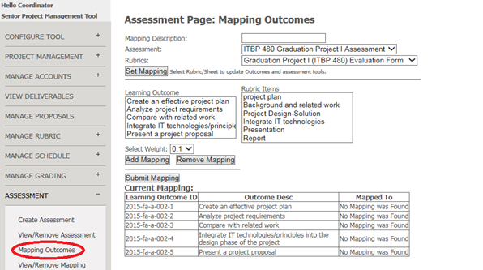

Figure Creating new Mapping of learning outcomes Form.

## Viewing/Remove Assessment/Rubric Mapping

Coordinator can view the assessment/rubric mapping. To view the mapping, do the following step in Table 5, see Figure 18.

Table View Assessment/rubric Mapping Steps

|  |
| --- |
| 1. In the left hand side main menu, click on Assessment. Once expanded, click on ‘View/Remove Mapping’. 2. The Mapping form will show up in the browser. 3. Select a maping from the drop list and click on ‘view’ to view the mapping or ‘Remove’ to remove a mapping. |

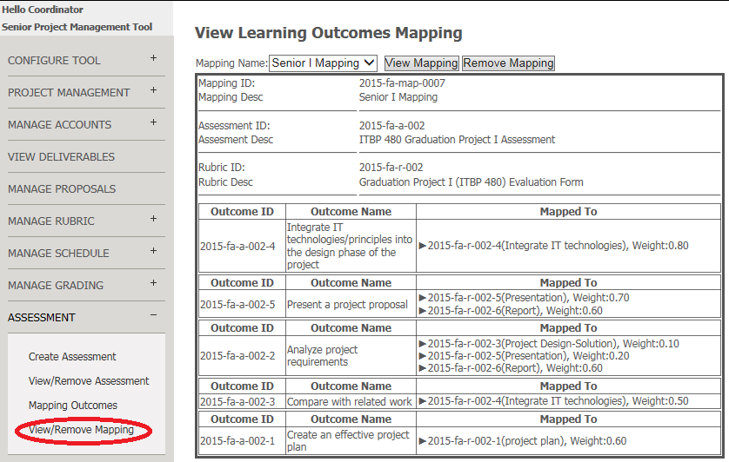

Figure Viewing/Removing Mapping of Learning outcomes.

# Users/Accounts Management

There are 3 different kinds of users of the SPMT, namely, students, faculty, and coordinator/admin. The system allows only the Admin to create and upload accounts.

## Create Student/Faculty Account

Faculty and student have different privileges and views in SPMT. Admin can create faculty/student account manually as follows:

1. On the left hand side menu click on Manage Accounts > add Student/Faculty
2. Fill up the form
3. Click Update.

Notice that the ID is uniquely identifying the user and in case it exists previously, user information will be updated rather than created (See Table 4).

Table Create/Edit new Account (faculty account on left and Student account on right)

|  |  |
| --- | --- |
|  |  |

In order to view current student/faculty, you can use the same page to search as follows:

1. On the left hand side menu click on Manage Accounts > add Student/Faculty
2. Fill in ID (to search by ID) and/or First Name (to search for Name)
3. Click Search by ID/Name.

Any user whose ID contains the term entered in ID field and whose First/last name contain the term entered in the First Name field will be displayed. Figure 17 shows the results of running two different queries. Notice that all students will be displayed when providing no criteria for search. Same applicable for searching faculty.

|  |  |
| --- | --- |
| (A) | (B) |

Figure Searching Students Results for two queries, (A): empty DI/Name, and (B): ID=20 and Name=’ed’

## Updating/Resetting Password

Passwords and email can be reset/changed by going to Manage Account > My Account. All users can reset their password in a traditional way.

## Batch uploading

Admin can upload accounts, allocations, and grades in a batch mode. However, files uploaded must follow CSV format.

1. Batch Uploading of Students/Faculty records

Students can be uploaded in batch mode by preparing a text file that has a student record in each line. Fields of ID, first name, last name, email, and department/track are mandatory fields and must be separated by commas. Notice that any of the fields must not have comma. In case of invalid format, a parsing error will result. For example the following file, Table 5, all records will be uploaded to the database; however, the 5th and 8th records will have no email. Notice that the first line starting with ‘#’ is a comment line and will not be processed.

Table Sample Student CSV file

|  |
| --- |
| #ID, First Name, Last Name, Email, Track  201000439,Jafra , Alsawi,201000439@uaeu.ac.ae,sweb  201000436,Maithah , Hassan,201000436@uaeu.ac.ae,CSD  201004180,Salma, Alkhatri,salma@gmail2.com,sweb  201006736,Fatima,Almeqbali,fatma@yahoo.com,sweb  200913721,Manea, Hantoubi,,sweb  201001418,Ahmed, Makhzoumi,201001418@uaeu.ac.ae,Networking  201003619,Mohammed, Albahri,201003619@gmail.com,sweb  201001182,Khaled, Al Shehhi,,Info Security |

After uploading the Admin should view the uploaded students to make sure there was no uploading error. Currently, the tools does not provide a complete report of all records, however, the logs will have such errors. Table 6 shows an example of errors that might occur. First record is not an error, however, it has been uploaded in the system; hence, information will be updated instead. 2nd record has only 4 fields. Last record has empty ID. For the second and third records, the system will ignore the records and will not add them to the database.

Table Sample CSV file with errors

|  |
| --- |
| #ID, First Name, Last Name, Email, Track  201000439,Jafra , Alsawi,201000439@uaeu.ac.ae,sweb  201401182,Al Saleh,,Info Security  ,Alm, Jasim,, [alim@uae.ac.ae](mailto:alim@uae.ac.ae), Info Security |

Here are the steps to upload student records in a batch mode (See Figure 18):

1. On the left hand side menu click on Manage Accounts > upload files
2. Browse and select the file
3. Select ‘Student’ type from the drop list (students, faculty, and projects)
4. Click upload.

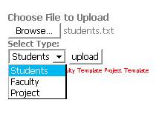

Figure Uploading Page

The above steps are applicable for faculty uploading in batch mode. The only difference is that fields are slightly different. For faculty we keep track of her ID, First Name, Last Name, email, affiliation, and department. Table 7 shows an example of CSV faculty file.

Table sample CSV file for faculty

|  |
| --- |
| #ID, First Name, Last Name, email, track, affiliation  mamoun.awad,Mamoun, Awad, mamoun@uaeu.ac.ae,SWEB, Associate Prof.  Yatif, Yacine, Atif, Atif@gmail.com,ECOM, Professor  alakas, abdurrahman, Lakas, alakas@uaeu.ac.ae, Networking, Associate Prof.  mhayajneh, Mohamad, Hayajneh, hayajneh@yahoo.com,CSD, Associate Prof.  jose, jose, thomas, thomas@yahoo.com, Int. Systems, Assistant Prof.  nzaki, Nazar, Zaki, zaki@gmail.com, Int. Systems, professor  kshuaib, Khaled, Shauib, khaled@yahoo.com,Networking, Professor |

In both faculty and students, the passwords will be set as the user’s ID and users are requested to change their passwords immediately.

## Batch Uploading Project/Proposals

Admin can upload all projects/proposal on the system using this capability. Faculty (and Admin) normally can manage projects/proposals, however, at deployment time of the system, it might be handy if the admin uploads all project at once and faculty can later edit them. The GPMS expects a CSV file that contains the following information for each project: project title, advisor ID, and semester. Table 8 shows a sample of project CSV file.

Table sample CSV file for Projects

|  |
| --- |
| #Project Title, advisor ID, semester  Prediction of chess-match outcome from early moves using data mining,yatif,2014-sp  Flynet Flying Ad Hoc Network Using UAVs.,alakas,2014-fa  Tracking criminals� activities using social media,nzaki,2014-fa  Security of Smart Maters for Smart Grid.,kshuaib,2014-fa  Prevention of Traffic Accident,jose,2014-fa  Energy Smart Application Tool, kshuaib,2015-fa  Social Network Analysis,nzaki,2015-fa  Dar Zayed for Cultural Mobile App.,mamoun.awad,2015-fa  FlyNet: Deploying Flying Ad hoc Networks Using UAVs,alakas,2015-fa  OCULUS RIFT VIRTUAL REALITY,jose,2015-fa |

Here are the steps to upload projects in a batch mode,

1. On the left hand side menu click on Manage Accounts > upload files
2. Browse and select the file
3. Select ‘Project’ type from the drop list
4. Click upload

Currently, the tools does not provide a complete report of all records, however, the logs will have such errors. The main errors are empty project title and invalid advisor ID.

After uploading the projects, faculty/admin can view them by going to Project Management>> Search Projects. For uploading details information for each project, faculty/admin have a dedicated page for that as we will see in XXXX.

# Projects Management

In the GPMS, faculty posts projects to students. Students then should team up and select one project. In this section, we will show how projects can be posted and updated. Later on, we will show how to allocate/assign student to a project. Projects are normally created by faculty. Faculty will have a full control over projects she creates. That includes creating project, editing projects, and allocating project to students. For a project, GPMS, keeps track of the following information.

|  |  |
| --- | --- |
| Field | Meaning |
| ID | Proposal/project ID is a read only field and it will be automatically generated. |
| Title | Title of the project |
| Advisor ID | The ID of the faculty supervising student of this project |
| Abstract | The abstract of the project |
| Objectives | The objectives of the project |
| Department | Track/department this projects belongs to. |
| Tools | Software and hardware tools needed for this project |
| Allocated | Use the value 1 to indicate that the project has been selected/allocated to students. |
| Frozen | Admin field used to make the project read only especially after allocating the project. Faculty can edit the project as long as it has not been frozen by the admin. |

Faculty has two options to create projects. First, projects can be uploaded from an xml file. Next, project can be created manually by filling a form.

## Uploading Project from XML file

Project can be uploaded from XML file. The xml file has the following format in Table 9.

Table Project proposal XML template

|  |
| --- |
| <?xml version="1.0" encoding="UTF-8"?>  <proposal>  <faculty></faculty>  <objectives> project objectives </objectives>  <abstract> project abstract </abstract>  <track> department </track>  <title> project title </title>  <semester>project semester </semester>  <tools> tools used </tools>  </proposal> |

As we mentioned above, new project ID will be assigned to the project. Notice that the faculty field should be left empty because this field will be filled automatically with the faculty logged in.

The following are the steps to upload a project proposal (See Figure 19 below):

1. In the left hand side menu, click on the project management
2. Select/click on ‘Edit Proposals’
3. In the top side of the form, browse and select the file to upload.
4. Click upload proposal to preview the proposal
5. Edit any of the proposal fields as necessary.
6. Click on submit proposal.

If everything went OK, a message will be displayed along with proposal ID.

|  |
| --- |
|  |

Figure Create/Uplaod senior project form

## Creating Project Manually

Projects can be created manually as follows, see Figure 19.

1. In the left hand side menu, click on the project management
2. Select/click on ‘Edit Proposals’
3. From the drop down menu, faculty can select from her own previous proposals
4. Edit any of the proposal fields as necessary.
5. Click on ‘submit proposal’ to create new proposal, click ‘update proposal’ to update the current selected proposal, or click ‘delete proposal’ to delete a proposal.

Notice that the ‘Allocated/Frozen’ and ‘ID’ fields are read only and cannot be changed in this form. Additionally, notice that deleting/updating a proposal can be done only when the project was not allocated to students. Otherwise, deletion/update will fail.

## Allocating Projects

In this section, we show how to assign project to a team of students. As a precondition to this function, students must have records in the tool and advisors must have created projects. GPMS can allow up to 4 students to form a group. The following steps show how to allocate a project to students.

1. Faculty should login first
2. In the left hand side menu, faculty can click on ‘My Projects’ to view, edit, or allocate projects.
3. Select/click on ‘Allocate My Projects’ and a form will show up as in **Error! Reference source not found.**.
4. Select a proposal from the list and allocation information is presented. In **Error! Reference source not found.**, the selected project was not assigned to any student; hence, status message says ‘Not Allocated’.
5. Edit/Assign allocation by selecting students from the drop list and click ‘Add Students’. The selected student will be moved to the allocated list.

|  |  |
| --- | --- |
| (A) | (B) |

Figure Selecting Project for allocation (A), selecting students (B)

Now the project status becomes allocated and it cannot be edited. Faculty can view project/students allocation as follows:

1. In the left hand side menu, faculty can click on ‘My Projects’ to view, edit, or allocate projects
2. Click on ‘View Project’ and a form will be displayed as in Figure 21 (A).
3. Select the project you want to display. Notice that only allocated projects will be viewed in the drop list.
4. Information of project and students allocated are displayed as in Figure 21 (B).

|  |  |
| --- | --- |
| 2. (A) | (B) |

Figure View Allocation of a project

Notice that once a project is allocated with at least one student, the project becomes read only and cannot be edited. GPMS also realizes the fact that during the period of assigning projects to students, it can happen that some students will withdraw and others wants to join. In order to do so, faculty can use the ‘Allocate My Projects’ to edit allocation as necessary as follows (See Figure 22).

1. In the left hand side menu, faculty can click on ‘My Projects’ to view, edit, or allocate projects.
2. Select/click on ‘Allocate My Projects’ and a form will show up as in Figure 22.
3. Select a proposal from the list and allocation information is presented.
4. In Figure 22, we have selected an allocated project; hence, list of students allocated to the project is displayed.
5. Faculty now can move students by selecting students and click on release (to de-allocate students) and add student (to allocated student) to/from the project.

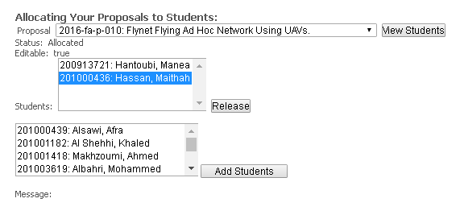

Figure Edit allocation

Admin/coordinator can also edit allocation of any faculty. The form is little different. Admin has to select faculty, then a list of proposals of that faculty will be retrieved in a drop list. Admin can select the project to edit as in Figure 23.

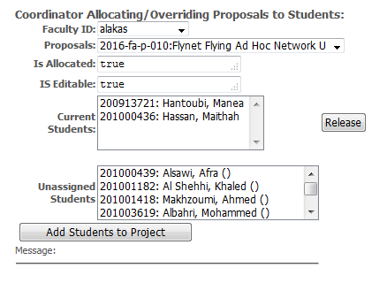

Figure Coordinator/Admin view of editing allocation

## Searching Projects

Users can search for projects information. Each kind of user has different view of the search. In this subsection, we will show search projects capability in GPMS per user type.

### Search View of Students

Searching projects is very important for the students. For that, we provide a simple search in which all projects are listed in a drop list in which project id and title are shown. Student can select and view project information by selecting from the drop list (See Figure 24).

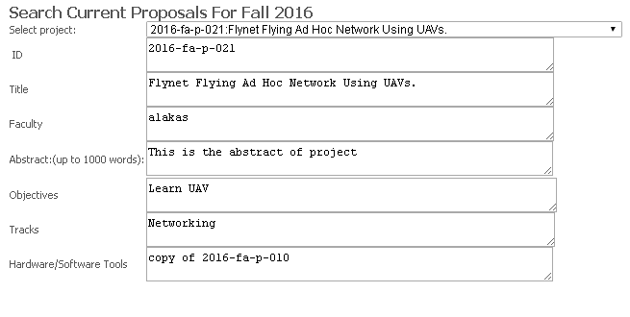

Figure Simple Search of Projects

Also, we provide an advanced search, in which student can search by faculty ID/Name, title, semesters and other criteria. List of projects satisfying the criteria is shown and student can view specific project thru a link (See Figure 25).

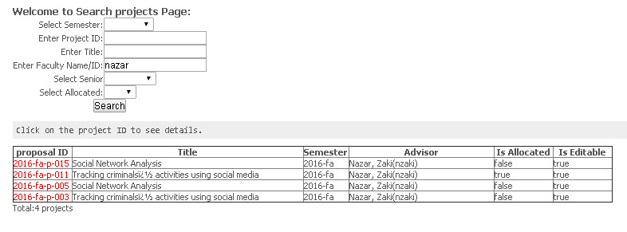

Figure Advanced Project Search

### Search View of Faculty

Faculty can search his own proposal/projects. The steps of doing so embedded in creating/managing proposals listed in Section ‎7.1and Section ‎7.2.

### Search View of Coordinator/Admin

Admin can search all proposal/projects. The steps of doing so is identical to the student view. However, in order to do so, admin has to go to ‘Project Management >> Search Projects’. Form identical to Figure 25 will be shown.

The admin can also search allocations of projects/students. This is a handy capability in which the coordinator/admin wants to look for specific student’s project. Admin can search allocations as follows.

|  |  |  |
| --- | --- | --- |
| 1. In the left hand side menu, Admin can click on ‘Project Management> Search Allocation’. 2. A form with different criteria will be displayed and admin can enters the search criteria (See Figure 26). 3. Only students allocated to projects will be displayed. | |  | | --- | | Figure Search Allocation Page | |

In addition to this view, Admin can list all senior projects of the current semester during scheduling. This shortcut can be accessed by going to ‘Manage Schedule> View Projects’ (See Figure 27).

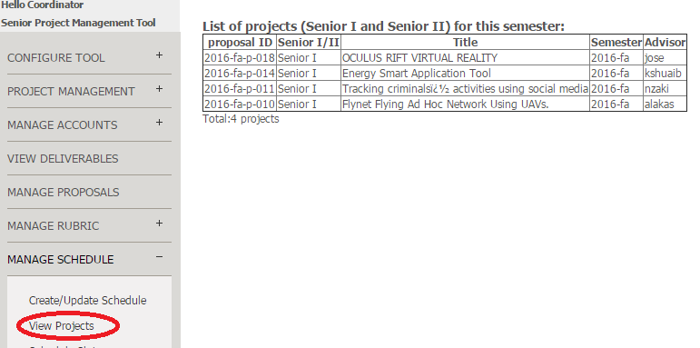

Figure Projects of the current semester.

### Freezing Projects

At the end of each semester, Admin can freeze all projects to prevent any changes to projects descriptions, allocations, grades, schedule, etc. Also, it is a good feature to start fresh with new semester. Figure 28 shows how to freeze a project.

|  |  |  |
| --- | --- | --- |
| 1. In the left hand side menu, Admin can click on ‘Project Management> Freeze Projects’. 2. A form with semester drop list will be displayed. 3. Select the semester an click freeze. | |  | | --- | | Figure Freezing/unfreezing projects | |

# Projects Deliverable Management

In the GPMS, students submit/upload their deliverables. Submission is governed by the Deliverable Due Date set by the Admin (See Section ‎2.4). Deliverable can be reports, code, and others. Examiners (other faculty) and advisor can view them during grading period. To upload deliverable item, student should do the following (See Figure 29 Part A for details):

Table Upload Deliverable of Project by Student.

|  |
| --- |
| 1. One of the students assigned for the project should log in 2. Click on the left hand side menu item ‘My Project’ and a form will be displayed with project information. 3. Click on Browse button to select the file. 4. Select the type of uploaded file. 5. Select type of senior (senior I or Senior II). 6. Click on upload. 7. A successful/failure message will be displayed at the end. |

|  |  |
| --- | --- |
| (A) | (B) |

Figure Upload a report for senior I

Once the file upload successfully, the project information is updated automatically to display a link of the file for viewing/downloading (See Figure 29 Part B). Student can also remove the file if he/she opts to and upload a new one.

## Viewing Project Deliverables

Advisor and examiners can view the project deliverables in their view. When the advisor/examiner view their assigned project, the uploaded files will be automatically appear with the project information.

|  |  |
| --- | --- |
| 1. Faculty should log in 2. Click on the left hand side menu item ‘Student Reports’ and then select either advisor or examiner based on the role of the faculty 3. Project information will be displayed along with deliverables files (links)   (A) | (B) |

Figure Steps and page of viewing the uploaded files for a project.

In case the faculty could not see a recently uploaded file, he should logout and then log in because GPMS cashes these files once faculty/examiner logins in.

# Projects Scheduling

In GPMS, admin can schedule examination sessions projects. Examination includes setting date, time, and examination committee. Currently the Admin can create a schedule for each semester. The schedule will be assigned an ID and it has time/date slots. Once schedule is created, faculty advisor, examiners, and students can view and see the time/date of their presentation/examination session.

## Creating Schedule

Admin can only create a schedule. Schedule is meant to be used for all senior project in specific semester. After creating schedule, Admin should use another tab to create and assign slots.

|  |  |
| --- | --- |
| 1. Admin should log in 2. Click on the left hand side menu item ‘Manage Schedule > Create/Update Schedule’ 3. Schedule form will be displayed (See beside figure). If the schedule was set for the current semester, the current schedule will be displayed. 4. Admin enters number of rooms, number of time slots, visibility (can faculty and students see the schedule). 5. Notice that the semester is read only and it is assigned the tool variable ‘current semester’. 6. Click update/create the schedule to finalize the process.   (A) | (B) |

## Creating Schedule Slots

After creating a schedule, Admin should populate the slots of the schedule with examiners and projects. Shows how to fill up the schedule slots with projects. Notice that it is possible that the Admin creates conflicts slots in term of more than one examiners are assigned in one room, more than one examiners are assigned simultaneously to more than one projects, more than one projects are assigned, an advisor was selected to examiner his own senior, etc. The system performs such checking and report that results to the Admin. Admin can edit and check again or save (See Figure 32).

|  |  |
| --- | --- |
| 1. Admin should log in 2. Click on the left hand side menu item ‘Manage Schedule > Schedule Slots’ 3. Schedule slots form will be displayed (See beside figure). 4. Admin selects slots, project, and examiners from drop lists. 5. To check for conflict, Admin can click on ‘Check’ button. 6. To save schedule slots, Admin should remove all conflicts and click on ‘Save’.   (A) | (B) |

Figure Filling up schedule slots by Admin

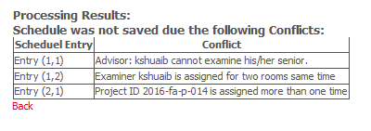

Figure Example of Conflict Checking Report

## Creating a Schedule Slot

It is convenient to create one slot at time in many cases. For that, ‘Schedule One Slot’ gives you a view of only one schedule slot to specify. The capability is redundant but helpful especially, if you don’t want to check for conflicts or if you have only one remaining project to schedule. Admin can schedule one project as follows (See Figure 33).

|  |  |
| --- | --- |
| 1. Admin should log in 2. Click on the left hand side menu item ‘Manage Schedule > Schedule One Slot’ 3. A form with slot information to be filled is presented (See beside figure). 4. Admin selects slot information: time id, room id, first examiner, second examiner, and project. All selections are from drop list. 5. Before update the schedule, Admin can check previous information of the slot by clicking on ‘Check’. 6. After Admin edit the information as needed, she clicks on ‘Update’ for finalize the process.   (A) | (B) |

Figure scheduling one project only

It is important to mention that time/slot IDs and room IDs are confined with the number of slots/rooms defined when the schedule was first created. The form in Figure 33 makes sure that the user always enters a valid slot id and room id.

## Viewing Schedule

To view the schedule that was created, the admin should do the steps in the below figure. Notice that Admin can select to view previous semesters’ schedules.

|  |  |
| --- | --- |
| 1. Admin should log in 2. Click on the left hand side menu item ‘Manage Schedule > View Schedule’ 3. Schedule slots form will be displayed (See beside figure). 4. Slots of the current semester schedule will be displayed. 5. To view schedule of other semester, select the semester and click view.   (A) | (B) |

Figure Viewing Schedule

In order for faculty and students to view the schedule, Admin should first make it visible by going to ‘Manage Schedule > Create/Update Schedule’ and in the form change the ‘is Visible’ field to yes (See Figure 35.A). For students/faculty to view the current schedule, they should go just click ‘Schedule’ from the left hand side menu (See Figure 35.B).

|  |  |
| --- | --- |
| (A) | (B) |

Figure Making schedule visible and Viewing the schedule by faculty/students.

# Projects Grading

In the GPMS, a project is graded based on a committee of at most 2 faculty. The average grade that is assigned by the committee contributes to 40% of the grade while the grade assigned by the advisor contributes to 60%. The grading criteria is the one set by the coordinator (See Section ‎3- Rubric Management and Section ‎2.4-Setting Tool Variables). In this section, we present the grading process by both faculty advisor and examiners.

## Faculty Advisor Grading

Faculty advisor can assign grades to her students based on the preset rubric for the current semester. To grade a project, the faculty advisor should perform the following steps:

|  |  |
| --- | --- |
| 1. Faculty should log in 2. Click on the left hand side menu item ‘Advisor Grading>Grade Project’ 3. Grading page will be displayed. Each criterion of grading can be clicked on to see details of that criterion. 4. Faculty select the senior project to grade from the drop list. 5. Once project is selected, the students with their grades are displayed. 6. Faculty can edit the grades and provide comments. 7. Faculty can assign grades for first student and copy the same grades to the second by click on ‘Copy First Row’. 8. After entering all grades, faculty should click on ‘Save’ button to finalize the grading process. |  |

Figure Steps and page of grading a project for Advisor.

Notice that in case of any mistake such as assigning grade that is greater than the max grade defined in the rubric, and/or proving invalid input an error message will be displayed and faculty is instructed to fix the grade (see Figure 37). Once the grade is entered correctly and save, the total grade is calculated and displayed out of 40. When the student sees her grade, it will be normalized out of 60.

|  |  |
| --- | --- |
|  |  |

Figure Errors in Grading

## Faculty Examiner Grading

Faculty examiner can assign grades to her students based on the preset rubric for the current semester. To grade a project, the faculty should perform the following steps:

|  |  |
| --- | --- |
| 1. Faculty should log in 2. Click on the left hand side menu item ‘Examiner Grading>Grade Project’ 3. Grading page will be displayed. Each criterion of grading can be clicked on to see details of that criterion. 4. Faculty select the senior project to grade from the drop list. 5. Once project is selected, the students with their current grades are displayed. 6. Faculty can edit the grades and provide comments. 7. Faculty can assign grades for first student and copy the same grades to the second by click on ‘Copy First Row’. 8. After entering all grades, faculty should click on ‘Save’ button to finalize the grading process. |  |

Figure Steps and page of grading a project as an examiner.

Notice that in case of any mistake such as assigning grade that is greater than the max grade defined in the rubric, and/or proving invalid input an error message will be displayed and faculty is instructed to fix the grade (see Figure 37). Once the grade is entered correctly and save, the total grade is calculated and displayed out of 40.

## Viewing Grades

Faculty advisor and examiner can view the grades assigned by them by going to ‘Advisor/Examiner Grading> View Grades’. For faculty advisor, the grades of the examination committee will show up along her grades. In case of examiner, only her grade will show up.

|  |  |
| --- | --- |
| (A) | (B) |

Figure Viewing Grades for Advisor (A) and Examiner (B)

For a student, she has to go click on the ‘My Grades’ on the left hand side menu item and he grades (if available) will be displayed, see below figure.

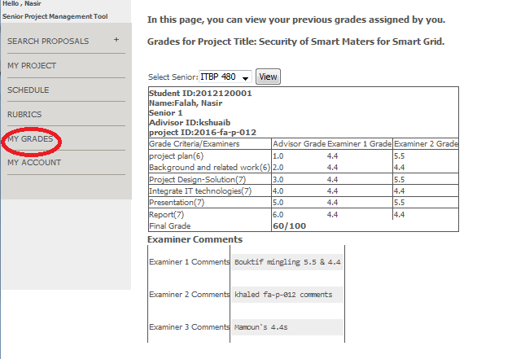

Figure Viewing Students Grades

# Appendices

[Appendices are optional, and are used to provide additional detailed information that may help the end user manage the overall application. Examples could include references to standards (such as W3C standards), technical specifications required for regulatory compliance, checklists, or other information of a technical nature.]

# Index

1. Testa, Marcia A., and Donald C. Simonson. "Assessment of quality-of-life outcomes." *New England journal of medicine* 334.13 (1996): 835-840.
2. Valencia, Sheila. "Assessment: A portfolio approach to classroom reading assessment: The whys, whats, and hows." *The reading teacher* 43.4 (1990): 338-340.
3. Allen, Mary J. *Assessing academic programs in higher education*. Bolton, MA: Anker Publishing Company, 2004.
4. Assessment Primer: Outcomes Assessment Components: <http://assessment.uconn.edu/primer/components.html>
5. Whys and Hows of Assessments: <http://www.cmu.edu/teaching/assessment/howto/basics/grading-assessment.html>