Spotify Data Analysis and Machine Learning Regression Study

Haya Darwish
Josh Belisario
Conor Cleary
Technological University
Nature of enterprise
Lecturer: Keith Nolan

Introduction
This report will go over a structure analysis of a dataset with the use of statistics and visual methods, the purpose of the analysis is to explore all the different patterns you can see within the dataset such as trends and relationships,
The following sections will go through the Dataset overview, Data cleaning summary, Descriptive statistics and Visual Analysis supported by graphs, basic machine learning applications and discussing the limitations and ethical considerations which will provide a structured evaluation of the dataset used.

Dataset Overview
The Dataset consists of 3 main variables which are numeric variables:
- track_popularity
- artist_followers
- album_total
I found these were the best variables when cleaning the data set. It removed a lot of rows making the graphs in the future smaller and easier to read.

Data Cleaning Summary
When Cleaning the Dataset I was already familiar with the code I could use because my leaving cert also had a similar task. I used the base code from my leaving cert project to remove all singles, track popularity under 50 and removed any artist followers under 500k to make the dataset smaller.
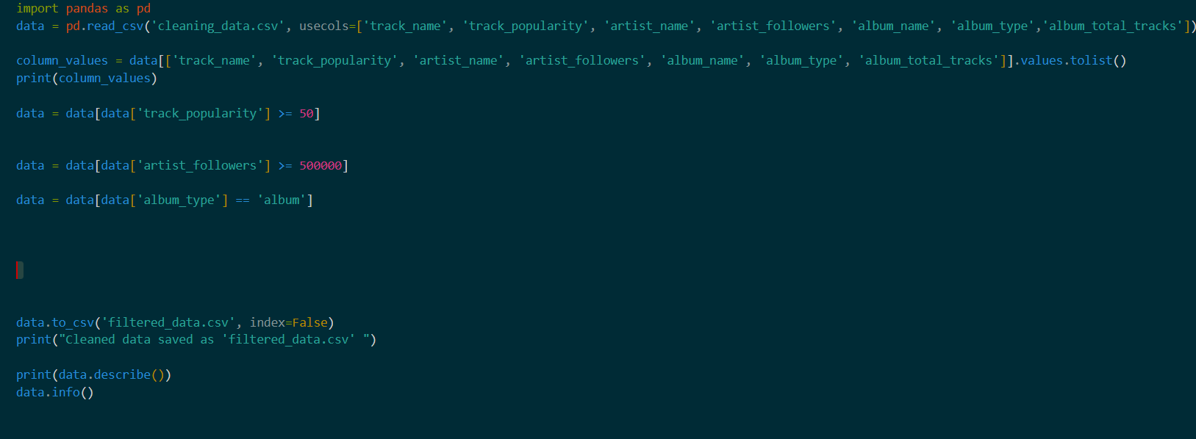
This is the code I used to clean the dataset. I sampled it from a dataset I did for the leaving
Certificate but based it off the Spotify Dataset instead of the last Dataset I had done.
I used pandas to clean the dataset. Below I have shown the work from my last dataset I cleaned to show the difference between the two of them.
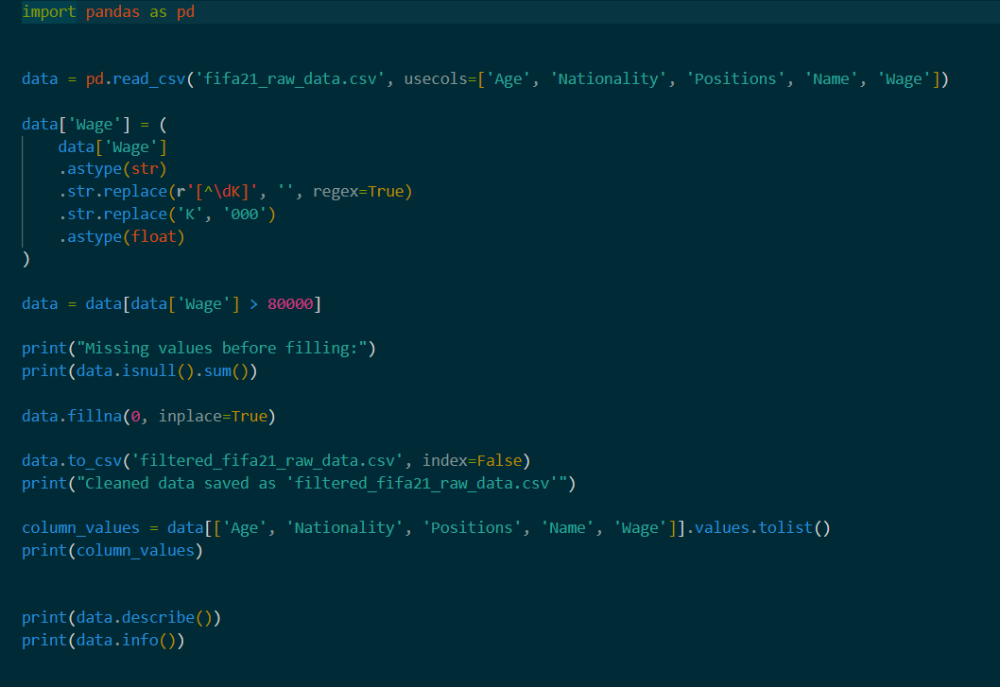
This is the code I based my data cleaning off. It is an old data set I cleaned.

Descriptive Statistics
Variable | Mean | Median | Mode | Min | Max | Standard Deviation
Track_popularity | 68.82925546 | 69 | 71 | 50 | 99 | 9.765489542
Artist_followers | 38377632.49 | 18208465 | 145396321 | 502300 | 145542136 | 43655014.98
Album_total | 15.8005788 | 15 | 12 | 4 | 137 | 43655014.98

Note:
- track_popularity is consistent as most tracks are grouped around the 60-75 range
- artist_followers is highly skewed due to the dataset having very few popular artists.
- album_total is generally focused on around to 12 – 16 tracks per artists but some outliers exist.

Visual Analysis with graphs
Distribution of Track Popularity
- Grouped around the 60-75 popularity which correlates to the mean of 68.8
- Skewed to the righ8t due to only a few tracks being popular
- Confirms the descriptive statistics for track_popularity
Album length vs Track popularity
- Most points are grouped at lower scores showing that most tracks aren’t guaranteed going popular
- Few points are outliers due to having very high popularity despite the average album length

Average Popularity by Artist
- Few artists are very popular
- Most artists have low average track popularity
- Matches the skew in aritist_followers due to popularity being concentrated in top artists

Machine Learning Summary
Applied linear regression model to predict track popularity based on two numerical features: artist followers and total number of tracks on the album. To start working on the machine learning we had to clean the data first, remove unnecessary columns and handle missing values. Then, the filtered data was split into training and testing sets using an 80/20 split.
The model was trained using the training set and evaluated using the test set using two performance metrics: R^2 score and Root Mean Squared Error (RMSE). R^2 measures how well the model explains the variation in track popularity, while RMSE indicates the average prediction error.
The results show that the model achieves R^s score of ≈0.0156, and RMSE of ≈ 9.75 popularity points. Those results indicate that the model average as good regarding the RMSE, while the R^2 score is very low but from research this happens often in real-world ML and the some of the common reasons is that the target y is influenced by many hidden factors, the data is noisy, target is complex, or features are limited.

Sources:
https://chatgpt.com/share/699d7274-db64-8010-b1de-4d06bdacd739

