AV：81个有效样本、其中13个是阳性样本

VVC：104个有效样本，其中7个阳性样本

BV：104个有效样本，其中，7个阳性样本、9个中间型样本

类别不均衡处理方法：

1. 上采样：
2. 权重交叉熵

VVC疾病分类

vvc_inv3.py:AUC=0.85,specificity=0.7,sensitivity/recall=1

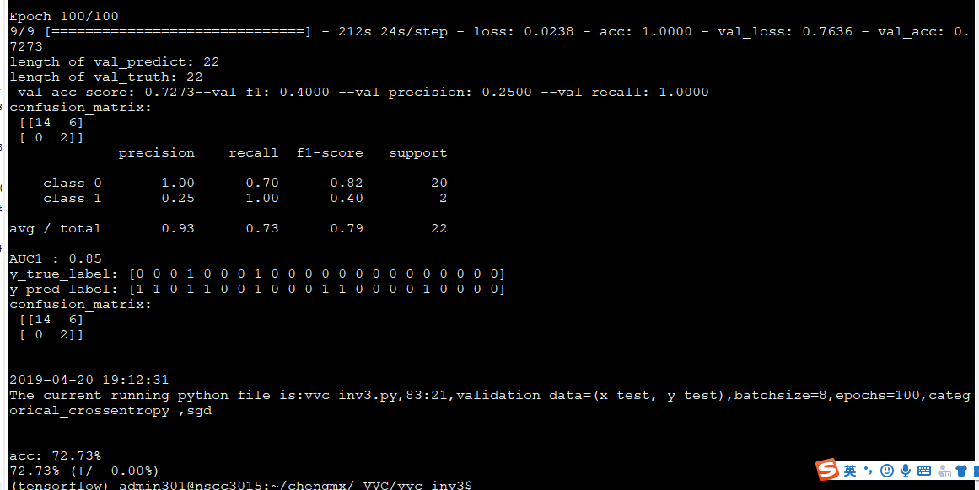

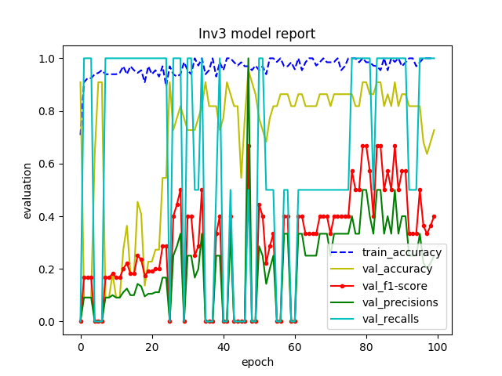

Vvc_oversampling.py: AUC=0.929

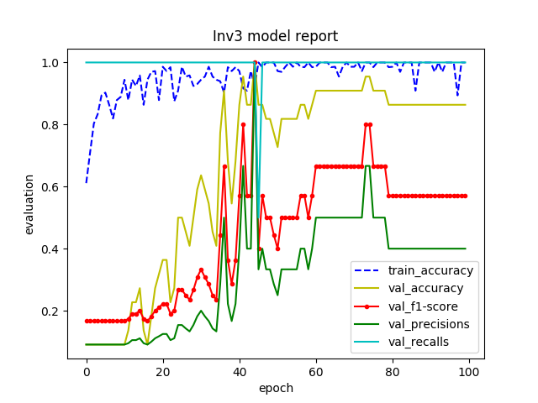

Vvc_customed_loss.py: AUC=0.929

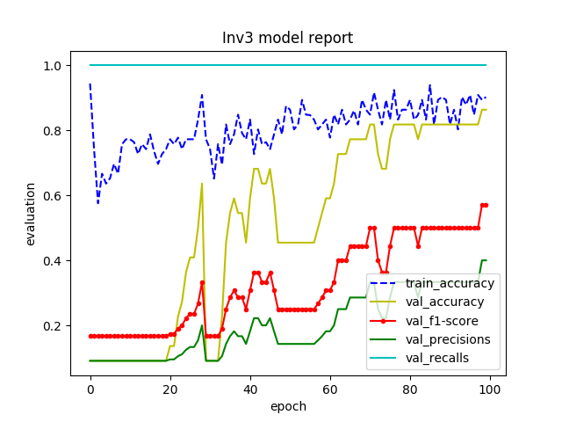

Epochs=150:

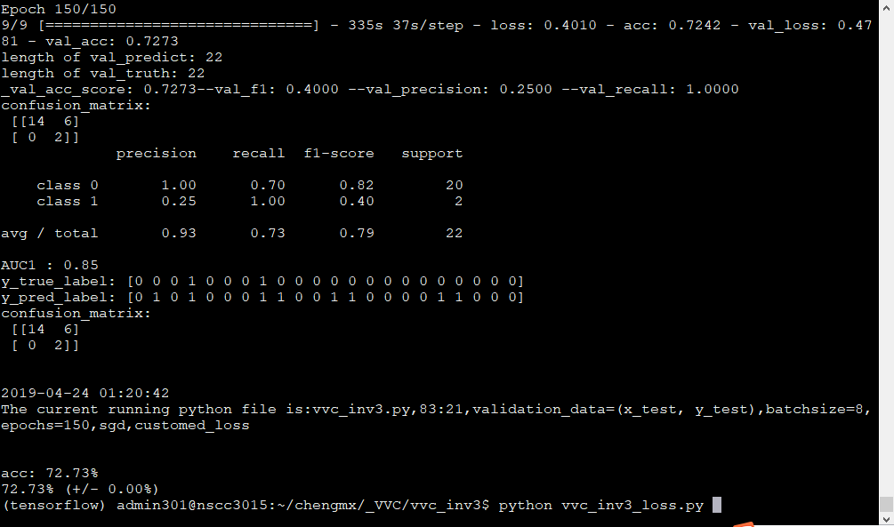

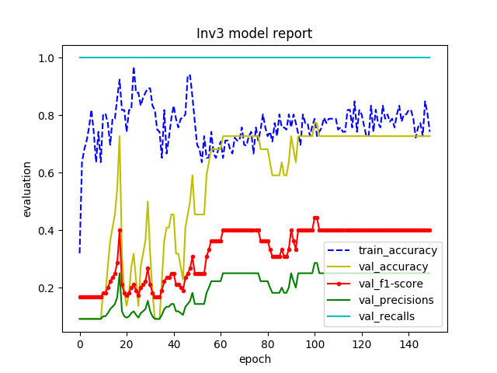

Vvc_oversampling_customed_loss.py: AUC=0.5

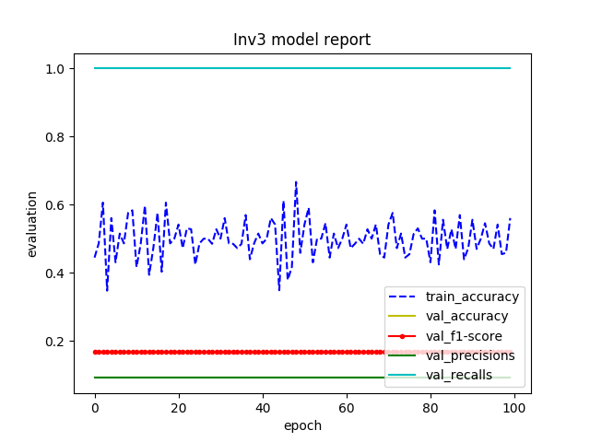

Resnet50.py: specificity=0.82,sensitivity=0.67,AUC=0.74

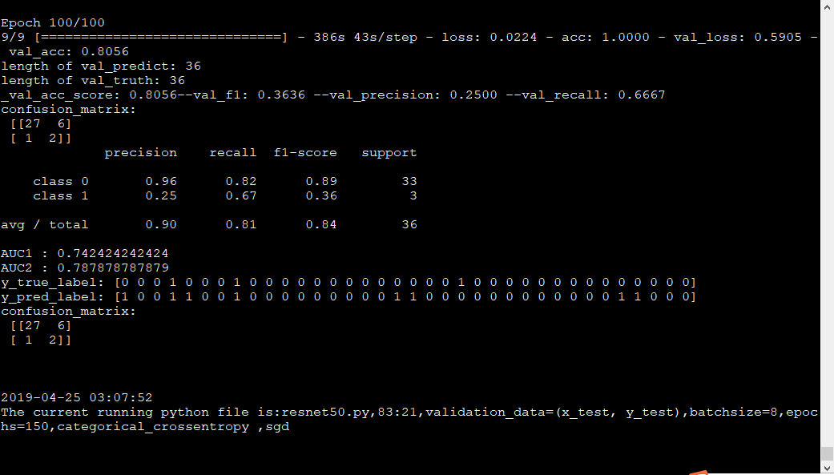

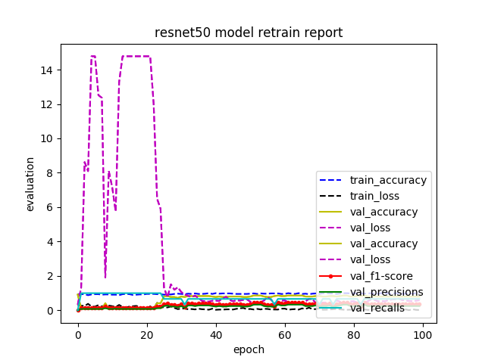

Resnet50_oversampling.py: specificity=0.88, sensitivity=0.67,AUC=0.77

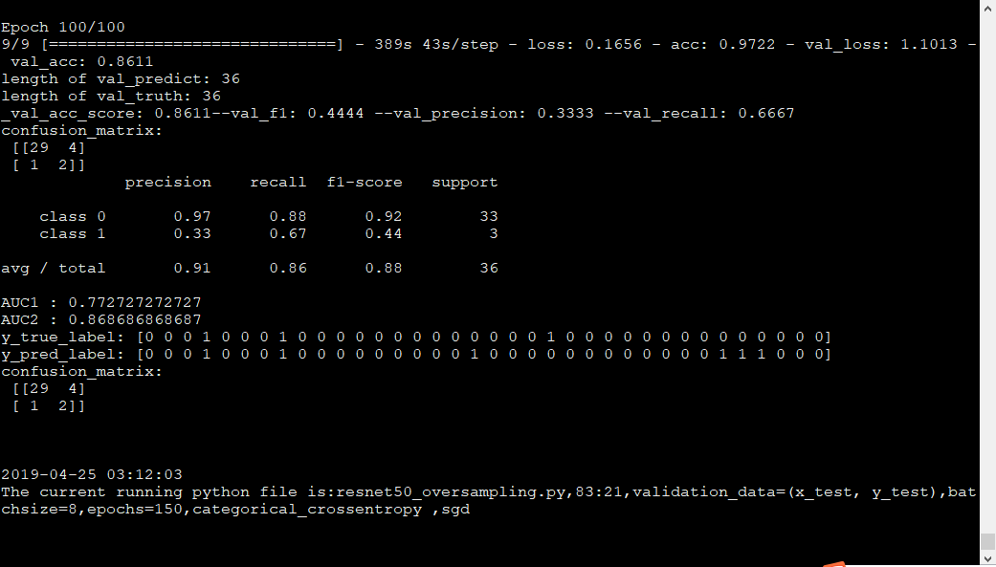

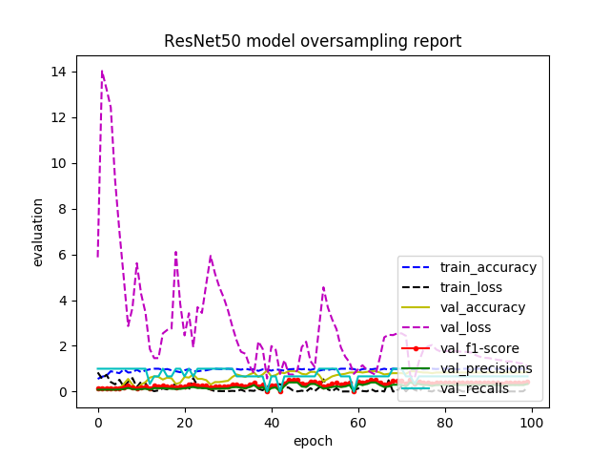

Resnet50_customed_loss.py: specificity=0.79, sensitivity=0.67, AUC=0.5

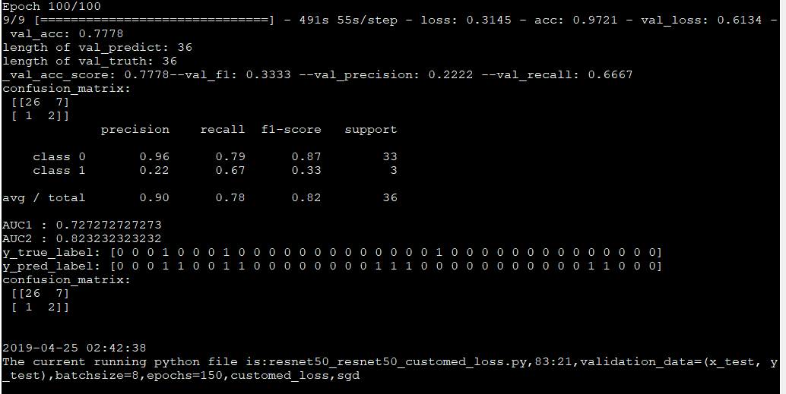

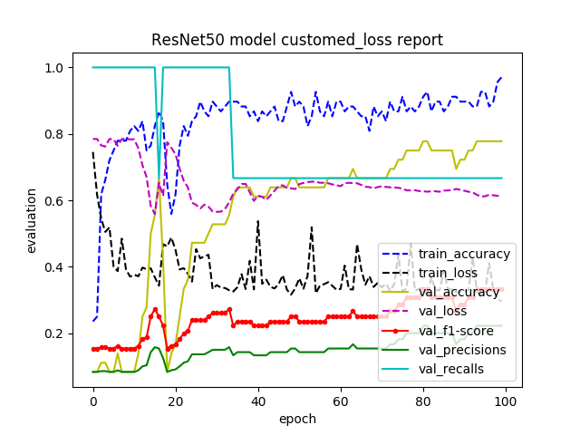

Resnet50_oversampling_customed_loss.py:只训练到第99个epoch

specificity=0,sensitivity=1,AUC=0.5

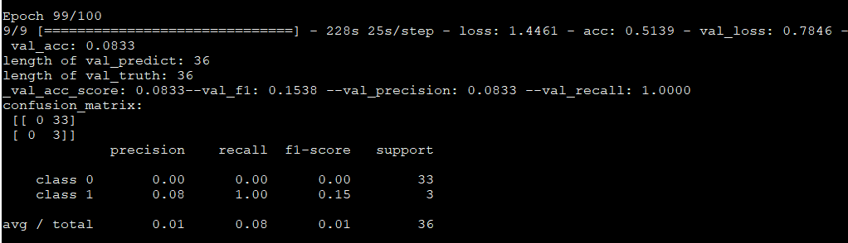

Resnet50_retrain.py: specificity=1,sensitivity=0,AUC=0.5

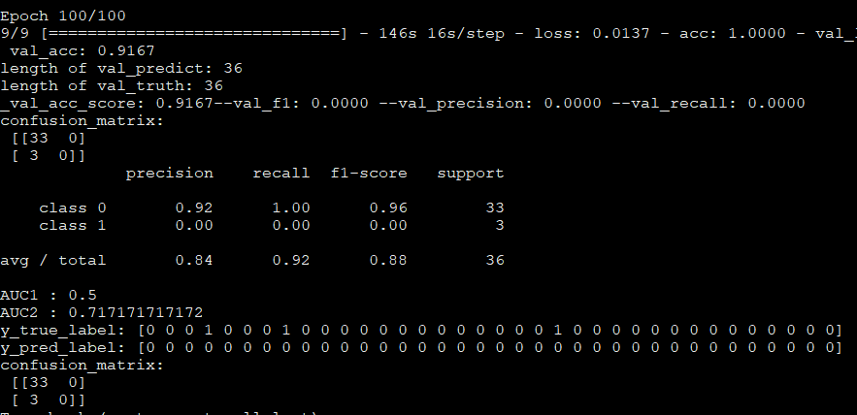

VGG19_oversampling.py:只训练到第43个epoch，但每个epoch结果均为下图：

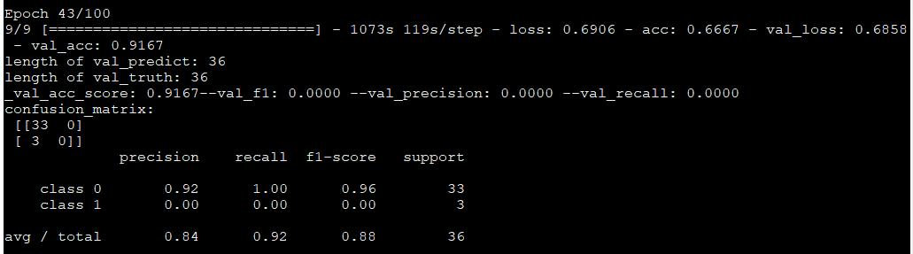

Vgg19_loss.py: 只训练到第44个epoch，但每个epoch结果均为下图，可见目前分类效果差：

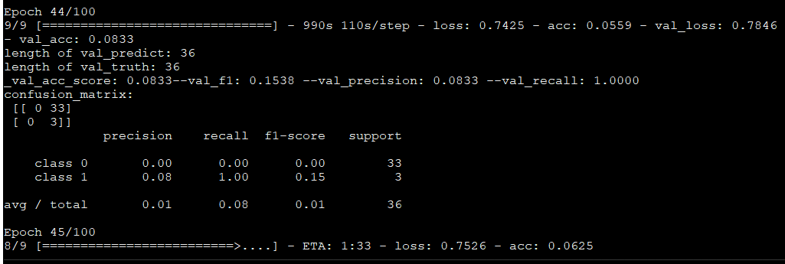

Vgg19_oversampling_loss.py:只跑了43个epoch,但可见分类效果差

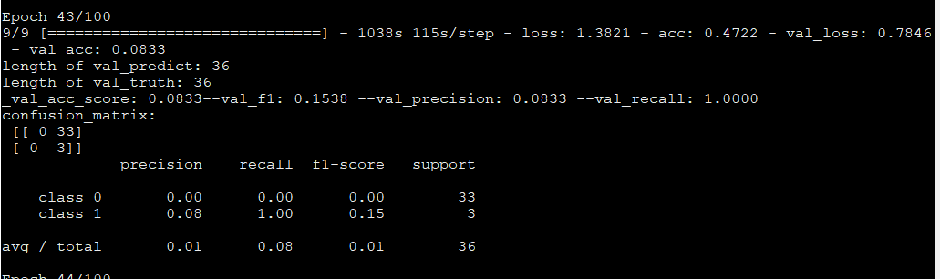

Vgg19_retrain.py: AUC=0.5, specificity=1, sensitivity=0

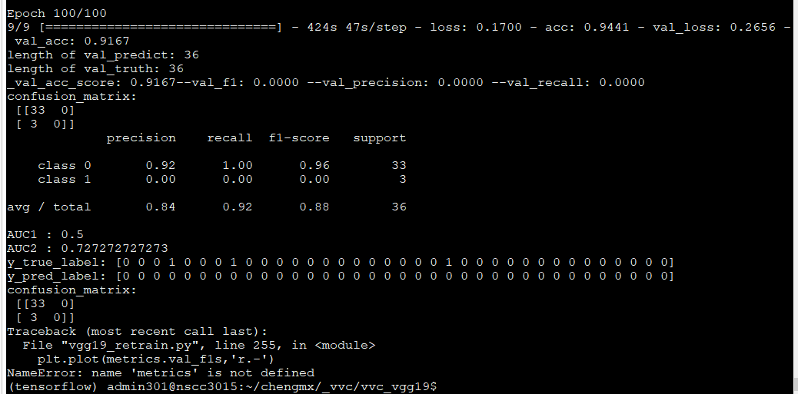

Alexnet.py: AUC=0.5, specificity=1,sensitivity=0

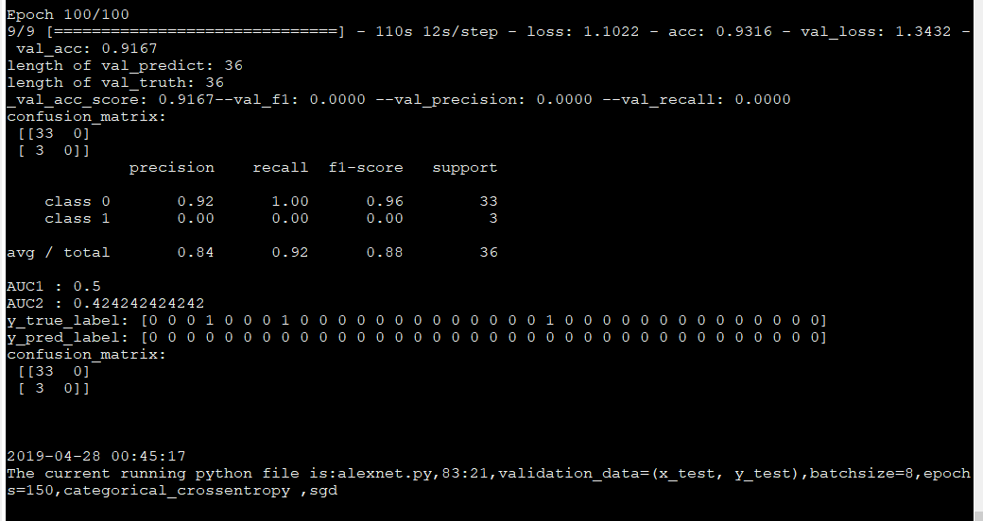

Alexnet.oversampling.py: AUC=0.75,specificity=0.85,sensitivity=0.67

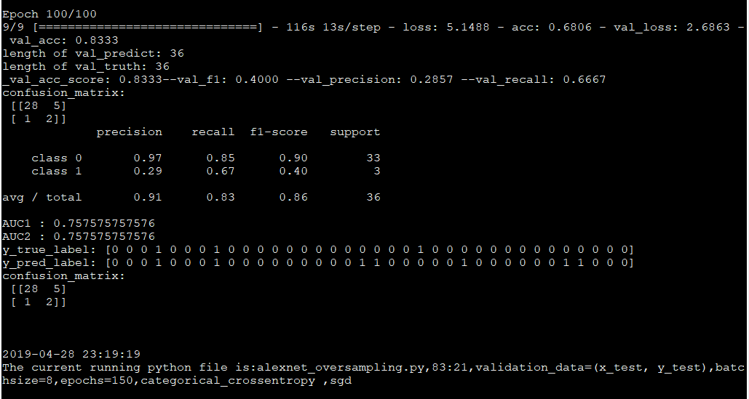

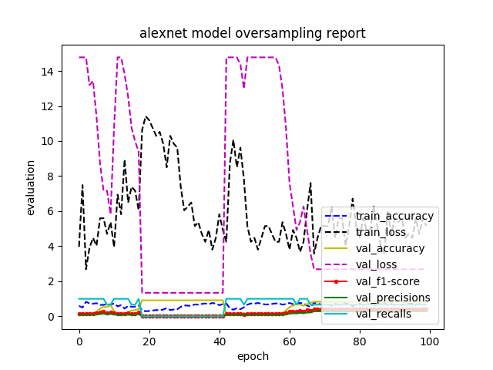

Alexnet_customed_loss.py: specificity=0.67 sensitivity=1 AUC=0.83

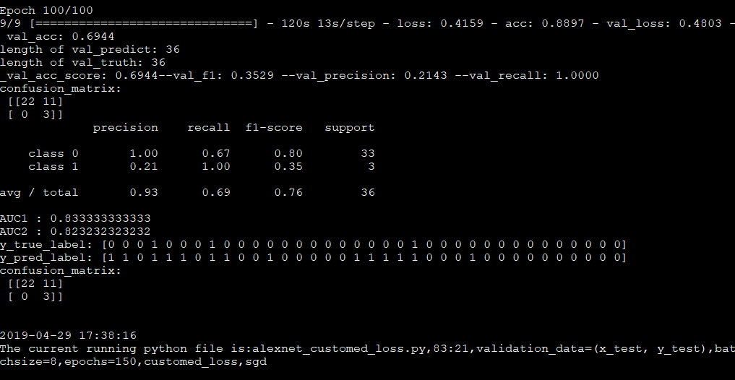

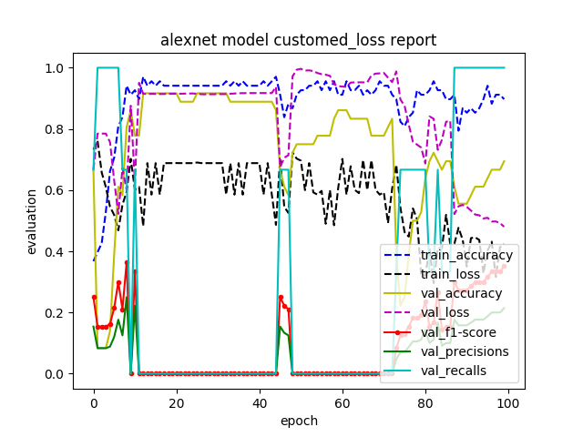

学习率为0.00001时，继续训练20个epoch，运行结果如下：

AUC=0.818, specificity=0.64, sensitivity=1

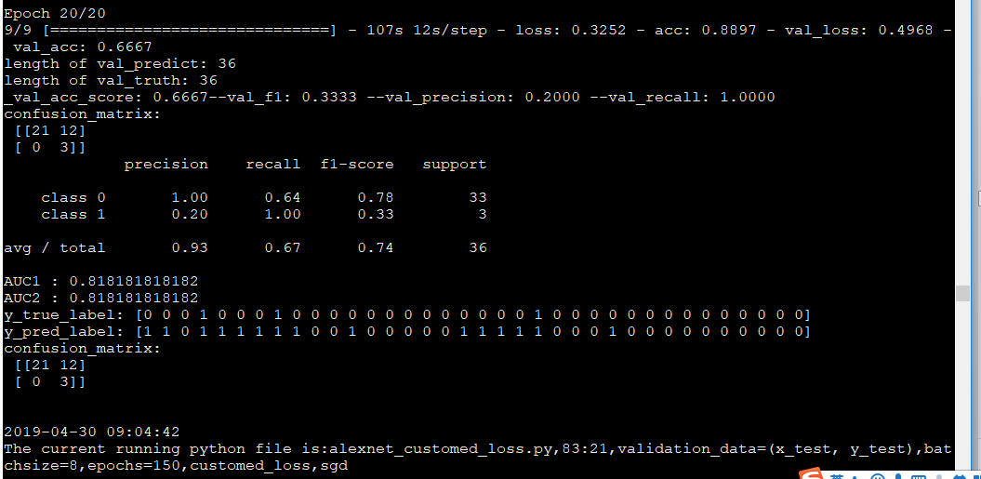

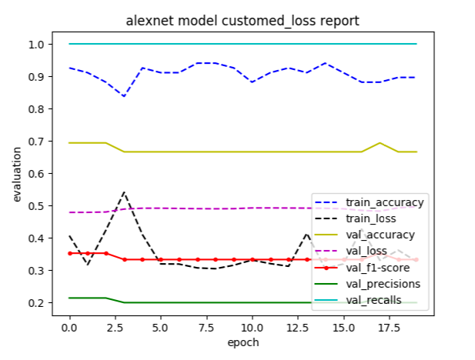

学习率为0.0001时，继续训练20个epoch，运行结果如下：上下对比，可看出学习率越低，0类的recall越大

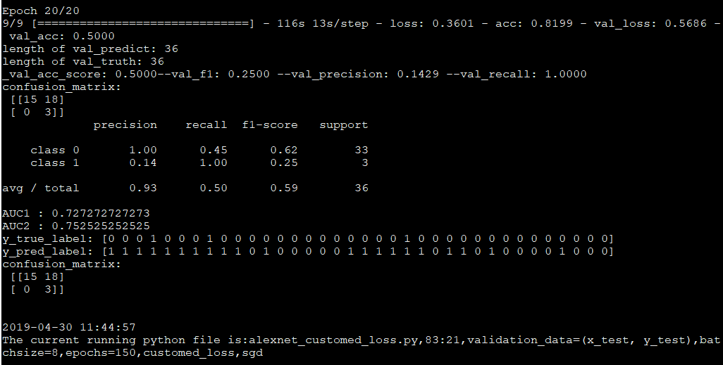

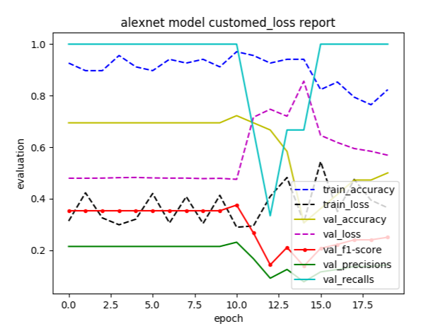

AV分类

Av_inv3.py:AUC=0.464, specificity=0.93,sensitivity/recall=0

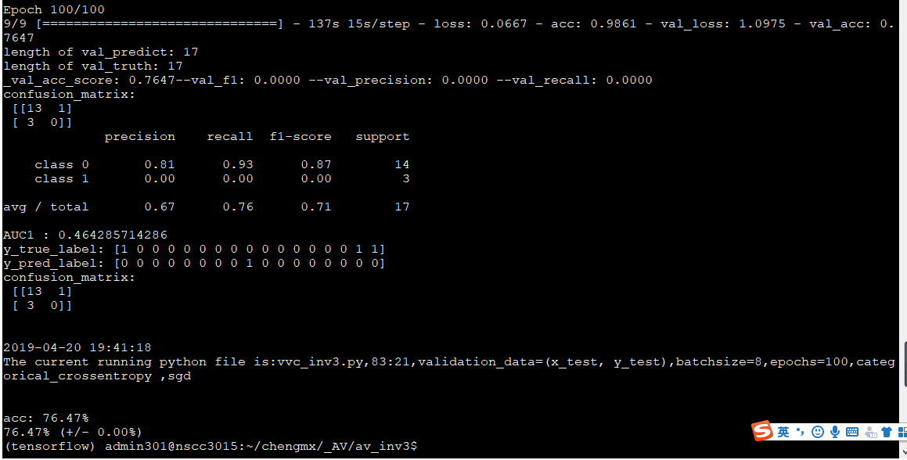

2019.5.6运行av_inv3.py结果截图：AUC=0.64，specificity=0.93,sensitivity/recall=0.33

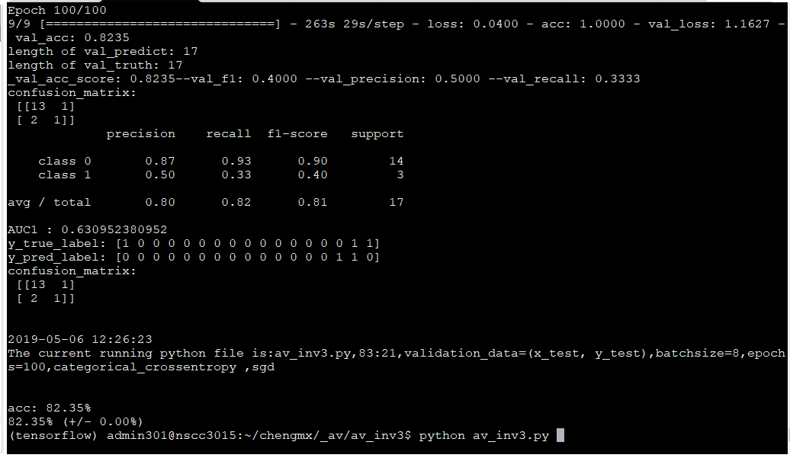

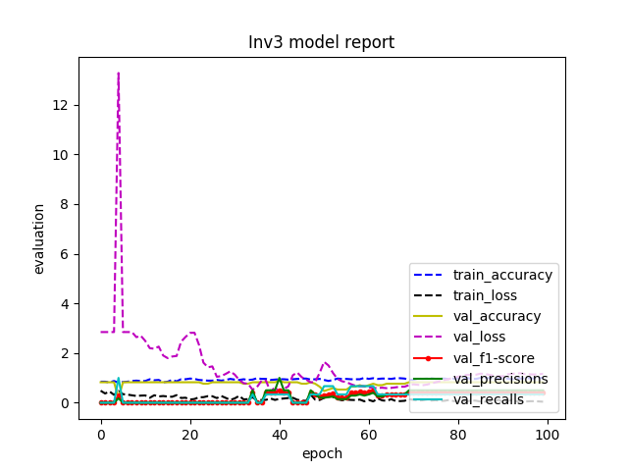

Av_inv3_oversampling.py: AUC=0.595,specificity=0.86, sensitivity/recall=0.33

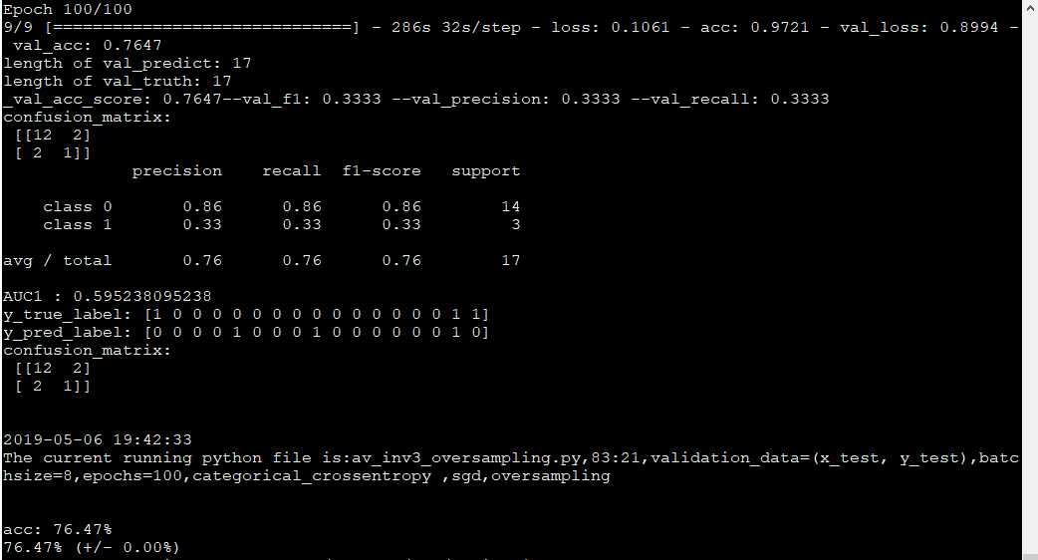

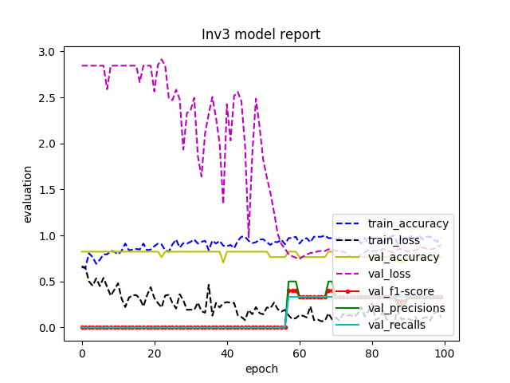

Av_inv3_loss.py:AUC=0.417,specificity=0.5, sensitivity/recall=0.33

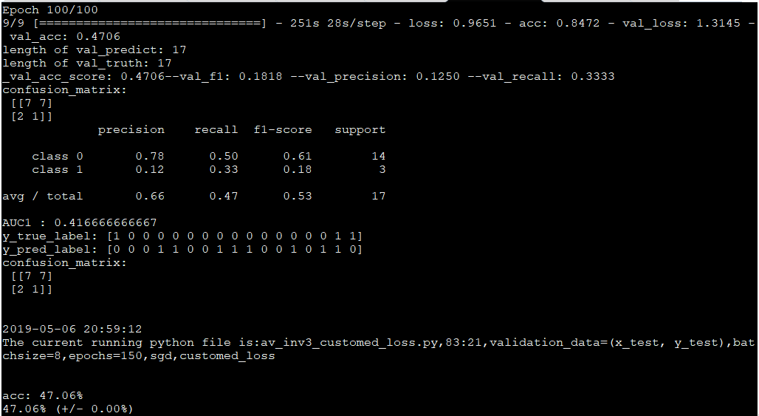

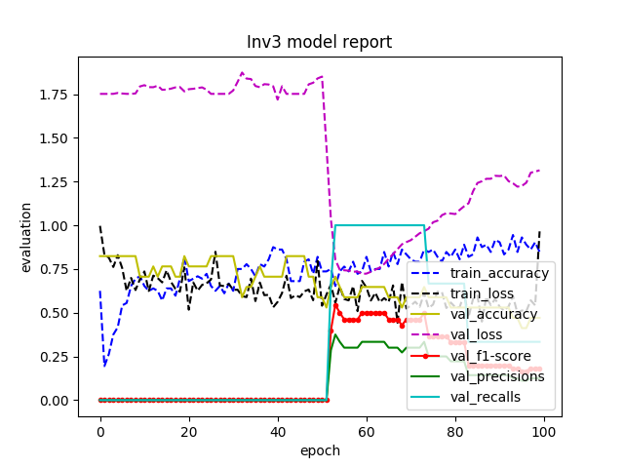

Av_inv3_oversampling_loss.py:AUC=0.57,specificity=0.14,recall=1

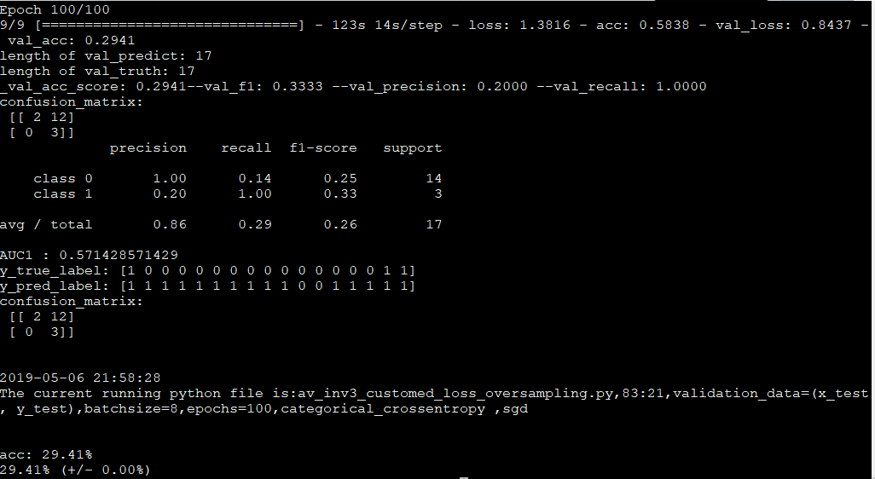

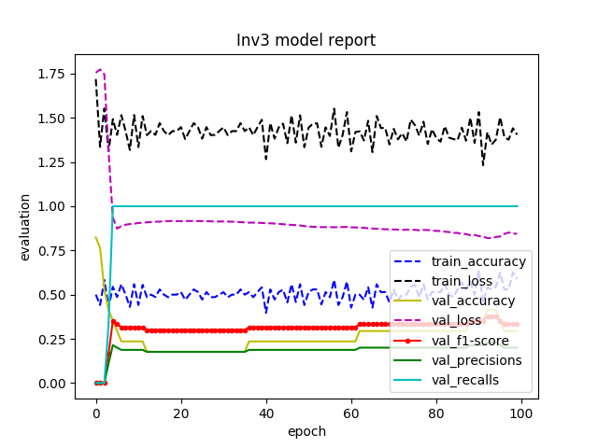

Av_inv3_retrain.py:AUC=0.63,specificity=0.93,recall=0.33

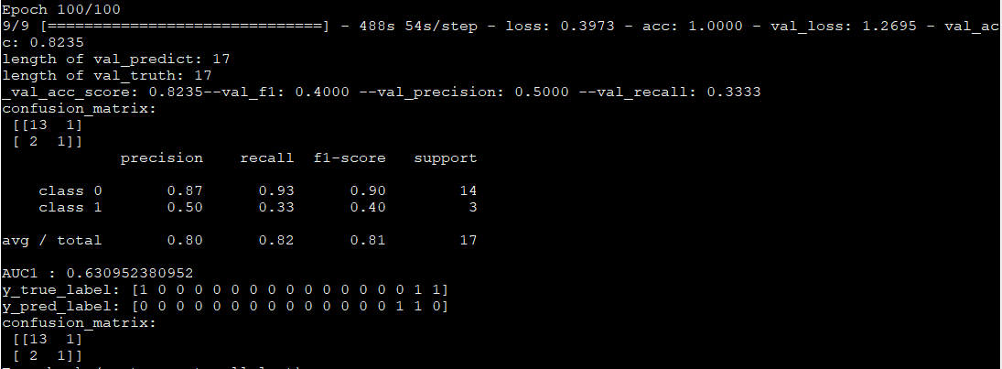

Resnet50网络的训练集和测试集的比例为2:1，其它网络的为4:1

Av_resnet50.py:AUC=0.41,specificity=0.83,sensitivity=0

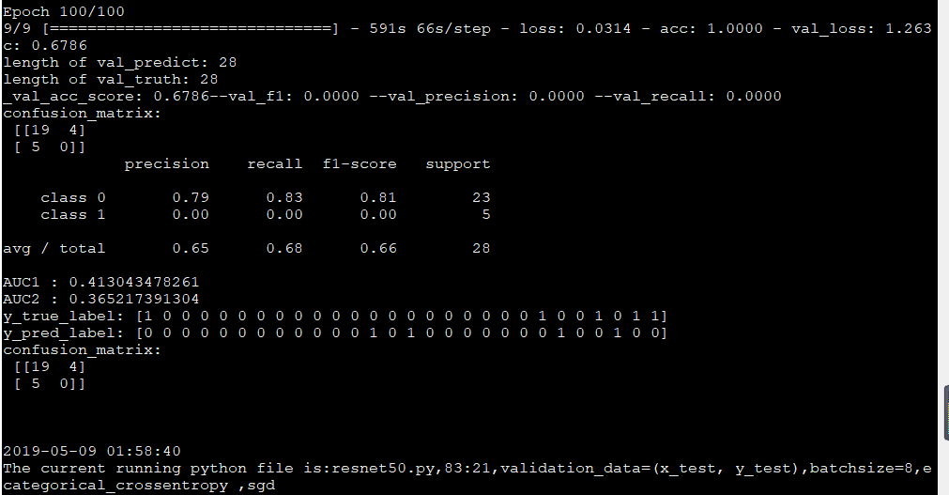

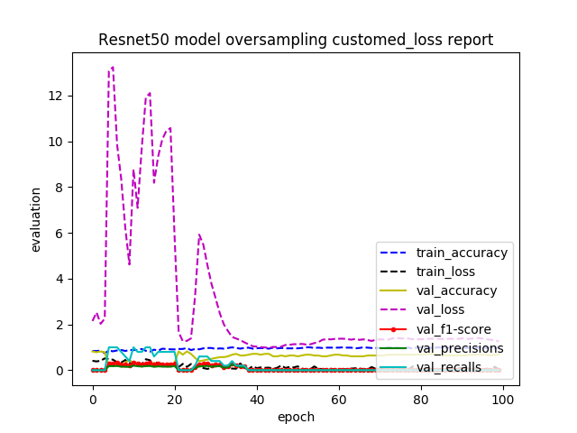

Av_resnet50_oversampling.py: AUC=0.53，specificity=0.87,sensitivity=0.2

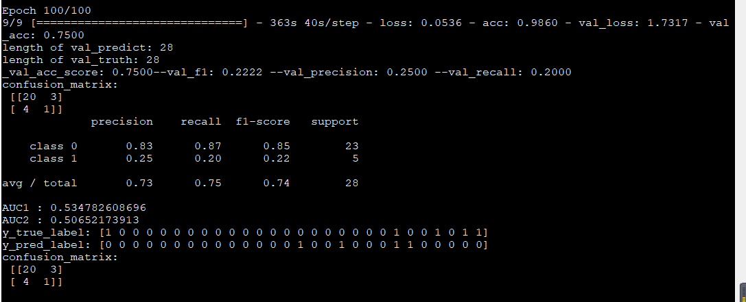

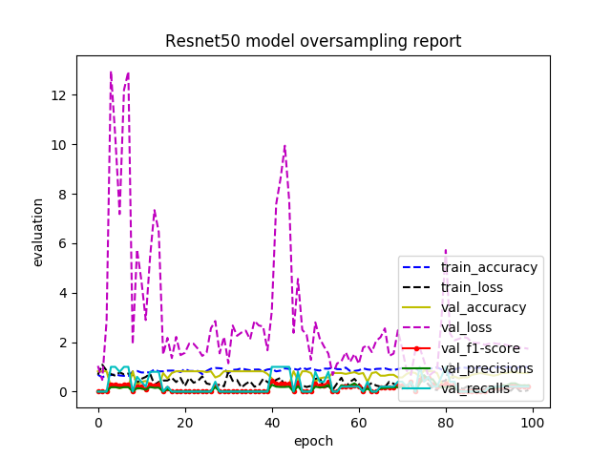

Av_resnet50_customed_loss.py: AUC=0.39，specificity=0.78,sensitivity=0

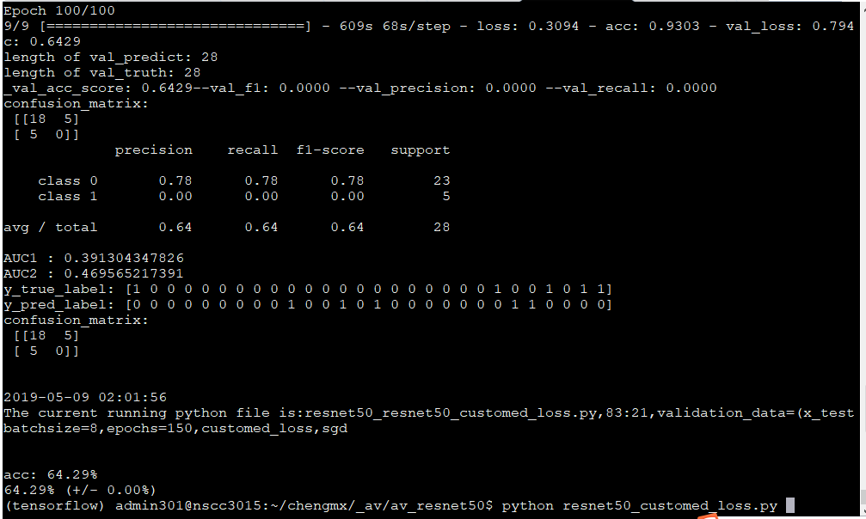

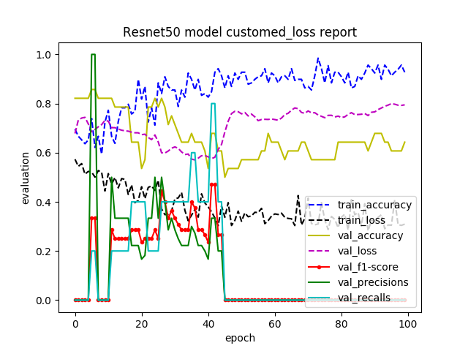

Av_resnet50_oversampling_customed_loss.py: AUC=0.5，specificity=0,sensitivity=1

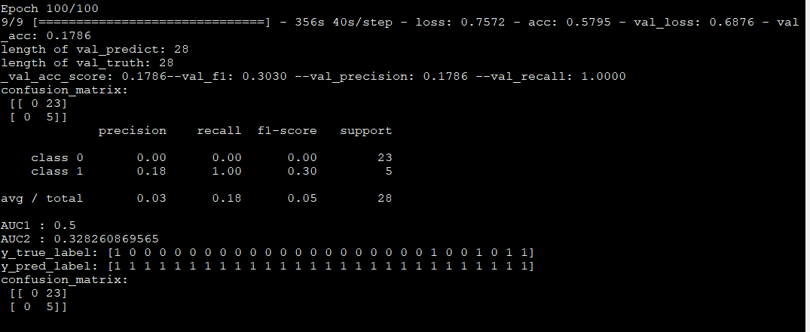

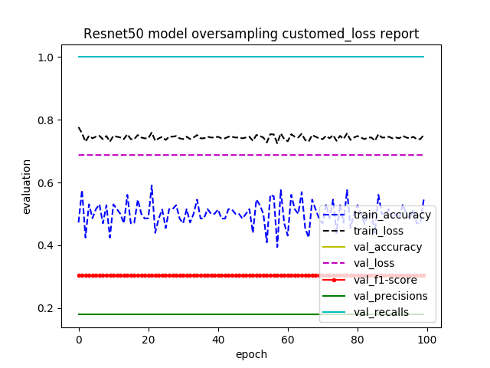

Av_resnet50_retrain.py:AUC=0.5，specificity=1,sensitivity=0

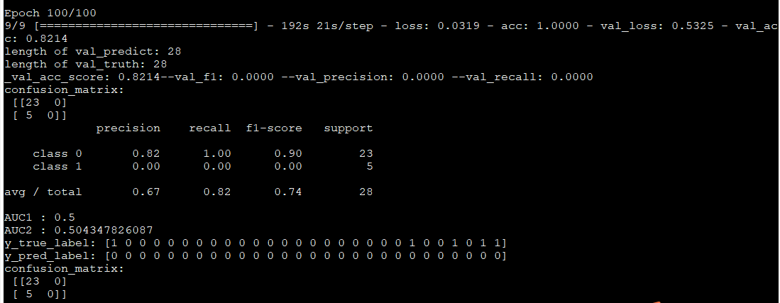

VGG19的训练集及测试集样本比例为2:1

Av_vgg19_retrain.py:AUC=0.5,specificity=1,sensitivity=0

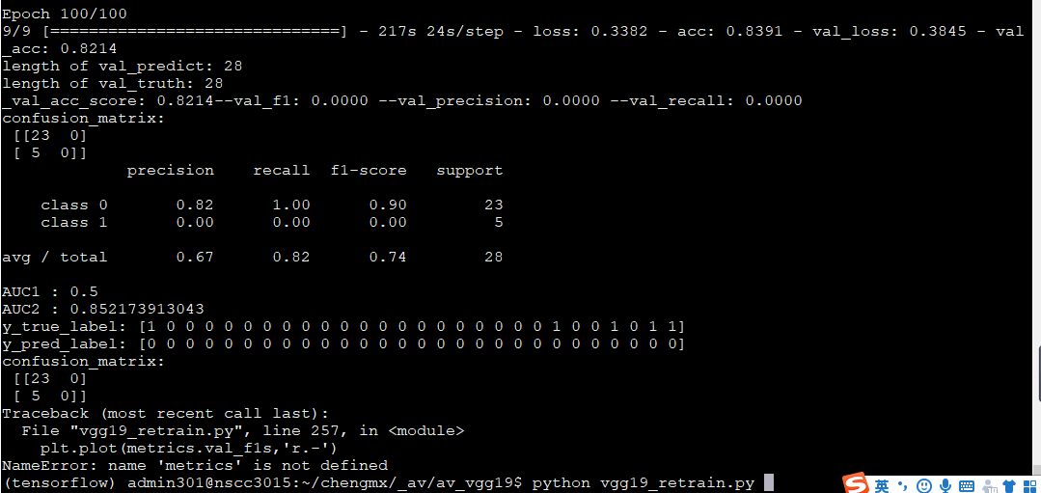

BV分类

Bv_inv3.py:因为bv有三类，所以

