NARRATIVE

Significance

We apply to the Humanities Collections and Reference Resources program for funding for a two-year implementation project to continue our work preserving and giving free electronic access to Walt Whitman’s manuscript annotations, hosted at the Walt Whitman Archive (http://www.whitmanarchive.org/manuscripts/marginalia/). These thousands of documents, written and drawn upon by America’s most famous poet, show the process by which he came into writerly being. In his poetry, Whitman famously depicts himself as a “rough,” an expression of the American land and way of life. Yet his annotations reveal that from classical rhetoric to the poetry of Tennyson, from Persian mysticism to nineteenth-century phrenological journals, the influences on Whitman’s work were historically deep and culturally diverse. For the first time, any students, scholars, or casual readers with access to the World Wide Web are able to explore the fertile ground of Whitman’s self-education through his reactions to the literature, history, science, theology, and art being discussed during his era.

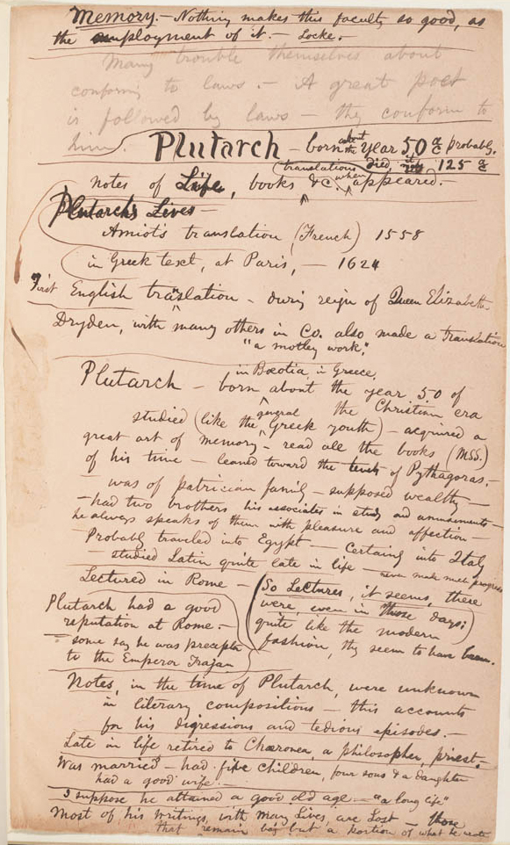
In the broader field of literary studies, there are few projects that gather and display an author’s marginalia. Annotations made by writers in the margins of printed texts or images are crucial sources for analysis in literary, philosophical, and historical study because they are rare evidence of direct interaction between a reader and his or her influences. Marginalia also demonstrate the range of such influences, which often reach far beyond the genres in which the annotator worked. In a famous marginal note, Whitman wrote that “all kinds of light reading, novels, newspapers, gossip, etc, serve as manure for the few great productions.” While a small number of influential scholarly studies in literature, history, and bibliography have emerged from the archival study of marginalia, such study has not penetrated the methodologies of the humanities or social sciences because collections of annotations are available for only a few writers, such as Herman Melville and Samuel Taylor Coleridge, and statesmen such as John Adams. Print editions, even simple transcriptions, of documents that combine printed text, marginalia, and images, are expensive; this cost may partly explain the paucity of published annotations collections. But even among digital archives, initiatives to preserve annotations are still rare. The powerful searching tools of a digital platform make such collections far more accessible, while the availability of both images and transcriptions of texts address economic and ergonomic challenges faced by print editions.
Figure 1. Whitman’s notes on Plutarch. <http://whitmanarchive.org/manuscripts/ marginalia/annotations/duk.00192.html>

Whitman’s responses to his reading range from the caustic to the puzzled to the awestruck, and take the form of everything from simple underlining of significant passages to full-length critical expositions. Much guesswork and close reading has been done with Whitman’s work to assert its origins or its debt to the literary environment: these documents offer concrete links even as they challenge a range of assumptions about Whitman and the relationship between American literature and cultural and intellectual history.

Defining any genre within Whitman’s work is tricky, since the poet made a habit of hybridizing literary forms for most of his career—breaking boundaries was his style. There are thousands of documents on which Whitman wrote, for example, no more than a simple identifying citation (as in the case of hundreds of newspaper clippings). And there are a host of documents that muse on a previous author, but that are known to be drafts of later-published work or lectures. We focus on Whitman’s notes that comment on other writers’ works, and we distinguish annotation from marginalia. “Annotations” are Whitman-authored notes entirely in manuscript, while “marginalia” are manuscript notes that are together with, and usually in the margins of, a printed version of the original text such as a book or clipping from a periodical. Given the widespread reprinting characteristic of periodical publication during Whitman’s time, precise bibliographic information about the source of a text the poet read and annotated has been difficult to derive in the case of clippings and extracts, but with the help of digitized periodical databases we have been able to specify or disambiguate many sources.

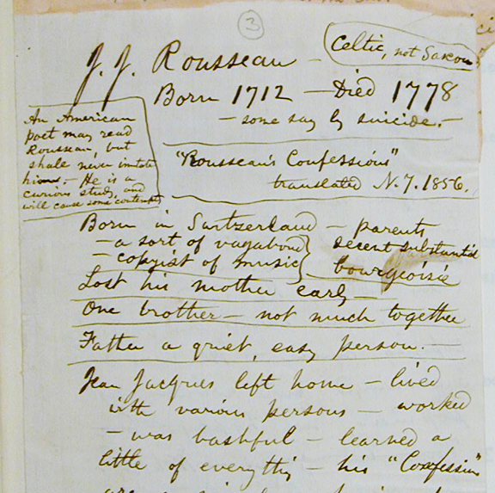
Whitman’s marginalia reveal crucial links between his social context and his poetry—the origins of some of his most famous poems may be found recorded in the margins of his reading in nineteenth-century books and periodicals. Finding such connections can bring startling new interpretations to bear on Whitman’s poetry, and indeed, suggest useful methods for research into other nineteenth-century authors’ works. Take Leaves of Grass, for example, the poet’s most influential work. Matt Miller has demonstrated that when we turn to Whitman’s annotations, we discover a different chronicity to the composition of the first edition of Leaves of Grass than has been assumed. Rather than composing his famous 1855 text largely from scratch beginning in a mystical inspiration starting in late 1853, the poet transformed notes he had taken earlier (on a range of texts and about American literary style) into long poetic lines. An annotation on Plutarch in the collections at Duke University offers an example (fig. 1). While annotations such as this may not appear to be poetry, Miller points out that not only do they often feature content that ends up in his poems, but with its hanging indentation and topical fragmentation, Whitman’s annotational style “looks like his signature line” (Miller 118). The major archives of Whitman documents contain over 1000 such documents, some many pages long, many previously uncollected and unpublished.

But more fundamentally, Miller’s work suggests that Whitman’s compositional method relied upon annotations no less than on poetic transformation. Whether writing poetry or prose, the poet turned to the notes he had taken—while reading, or following a conversation or performance, or from his imagination—when it came time to generate his work. Thus Whitman’s annotations represent a fundamental compositional mechanism. They are the root of much of Whitman’s published work and key to understanding not just the sources and the chronology, but the very form of both his poetry and prose. Indeed, it is possible to see in some annotations the layering of literary theory, content, and practice. In another document from the Duke holdings, Whitman engages with Jean-Jacques Rousseau, taking detailed notes on the French writer that will help scholars better understand Whitman’s relation to continental literature and philosophy (fig. 2). But the poet also makes a note about how to handle figures like Rousseau: “An American poet may read Rousseau,” Whitman notes in a box at the top left, “but shall never imitate him.—He is a curious study, and will cause some contempt.”
Figure 2. Whitman’s notes on Rousseau. <http://whitmanarchive.org/manuscripts/marginalia/ annotations/duk.00174.html>

Digitization and free access to these annotations will change dominant interpretations of Whitman’s poetry, partly through revelations about dating and sources, and partly through recontextualization. Take the famous “trapper’s bride” scene in the poem that became “Song of Myself.” It has long been known that Whitman based this scene, an unusually positive representation of miscegenation for the mid-nineteenth century, on a painting by Alfred Jacob Miller called The Trapper’s Bride. But a document in the Library of Congress reveals a more sustained engagement with the question of the representation in visual and poetic art of Native Americans. In the margins of an 1856 clipping on Indians in art from The Crayon, the poet references The Trapper’s Bride (“by a Baltimore artist,” Whitman remembers) and then implies that his own treatment of the subject in the 1855 Leaves wasn’t sufficient: “Has any poem yet really pourtrayed them? Would not the Indian…be a good theme for a full poem?” (LOC card 16). This comment may suggest that a much-later poem like “Osceola”—which fulfills this directive to devote an entire poem to the Native theme—had its origins considerably earlier than has been supposed. And the annotations speak eloquently to the recent surge in transnational approaches to literature. Whitman’s “Prayer of Columbus,” for example, parts of which are inscribed in the wall of the District of Columbia’s Archives/Navy Memorial metro station, seems to have been inspired by his reading of an article in the Irish Republic (LOC card 720; Detroit Catalog No. 32).

It has long been asserted, too, usually based on internal textual evidence, that Whitman was influenced by middle-eastern spiritual writing; the Middlebury collection contains a fascinating set of annotations on Persian poetry that confirms and complicates that assertion, and that will do much to animate the story of American literature, in Wai Chee Dimock’s elegant formulation, “through other continents.” Kenneth Price’s Whitman and Tradition (1990) was a prescient study that showed Whitman’s complex relationship to European literature and criticism by studying his marginalia. The methodological emphasis Price put on Whitman’s annotations, however, has remained rare until recently. The Whitman’s Annotations project has already begun to impact published scholarship and creative work. Recent essays by H.J. Jackson, Aaron Dinin, Laura Estill, Jena Osman, Nicole Gray, Matt Cohen, and Kathryn Brigger Kruger have drawn on the marginalia and annotations presented by the Archive to offer fascinating reinterpretations of everything from nineteenth-century phrenology and Whitman’s Swedenborgianism to the meaning and practice of note-taking itself.

We also learn much about the poet’s life and education from his annotations as a corpus, and it is to this rich offering that we want to turn in the project’s next phase. Having never attended college, Whitman’s reading and his conversations with people, together with his visits to the theatre and opera, were his education. By offering insight into the self-educative possibilities of urban nineteenth-century America, these documents illuminate how Whitman created himself both as a prose writer and editor—and then how he transformed himself to a poet. For this phase of the project we propose to digitize a spectacular geography scrapbook, sewn together and annotated by Whitman beginning in the 1850s, held at Ohio Wesleyan University’s Special Collections. Though it was not included in our original projections, thanks to savings in our scanning budget—the product of generously low rates charged by several libraries, including Bryn Mawr, Yale, and Ohio Wesleyan—we were able to obtain scans of the entire volume and the many clippings, sometimes entire newspapers, laid into it.

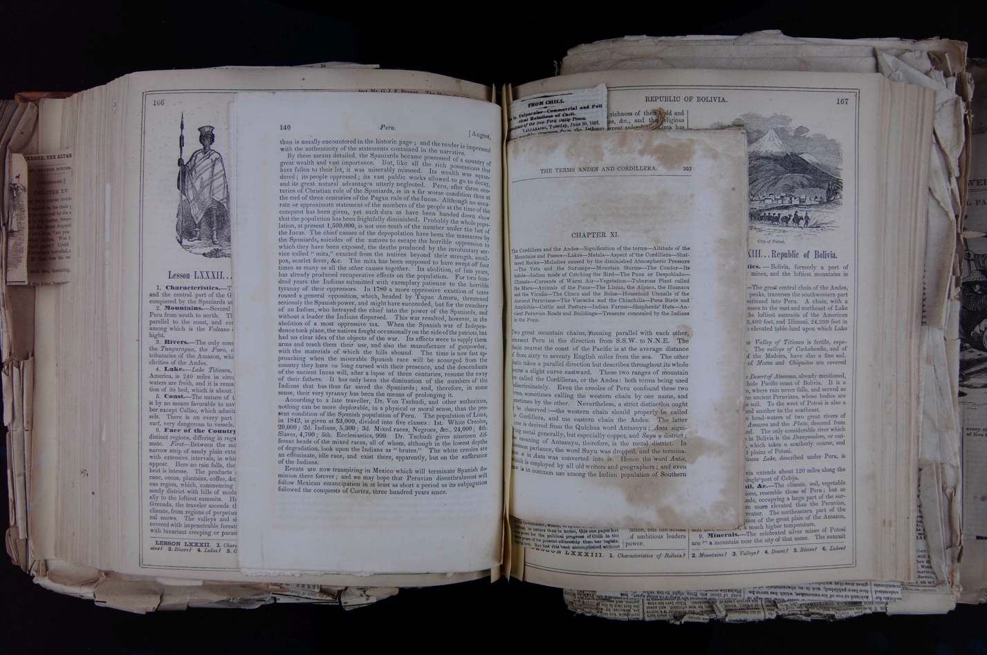
Figure 3. Whitman's Geography Scrapbook, Ohio Wesleyan University Libraries, Special Collections.

The scrapbook is made up of extracts from a number of books and magazines, interleaved with yellow paper and hundreds of clippings tipped, pasted, or laid in. The text is predominantly from S.G. Goodrich’s Geographical and Historical View of the World (1854), Emma Willard’s Universal History: In Perspective (1854), and Smith’s Atlas of Modern and Ancient Geography (1855). Excerpts from Lorenzo Johnson’s Memoria Technica: Or the Art of Abbreviating Those Studies Which Give the Greatest Labor to the Memory (1847) sit next to lists both short and long in Whitman’s hand and clippings about comets. A few scraps of this notebook were transcribed in Edward Grier’s Notebooks and Unpublished Prose Manuscripts, but the scrapbook has never been made publicly available. It’s a massive tome: there are roughly 1,090 scans to encode, excluding pages Whitman left blank (though these will be noted in our markup). There are also 110 scans of clippings held at the back of the volume that we will encode.

The volume is significant for many reasons. Many of the texts in it were published before or just after the first edition of Leaves of Grass (1855), suggesting that it may have had an impact on the early development of that work. The volume contains handwritten lists of important terms in Whitman’s poetry, as well as definitions of scientific disciplines, that illuminate Whitman’s early engagement with science and higher learning—an engagement that would profoundly shape his conception of both the human place in the grand flow of time and space and of the potential for a democratic poetry. There are even hints in the volume that the entire scrapbook aimed at gathering the materials for a great synthetic work of poetry or prose. On the inside front cover (fig. 4), Whitman wrote, in a note titled “Persons”: “In ‘History & Geography of the World,’ introduce every where lists of persons—the great persons of every age and land.” Other notes in the scrapbook support this suspicion, including one Whitman made in a section on South Asia (scan 567-8). Whitman may, in this scrapbook, have been “writing with scissors,” as Ellen Gruber Garvey has described nineteenth-century home scrapbook practices.

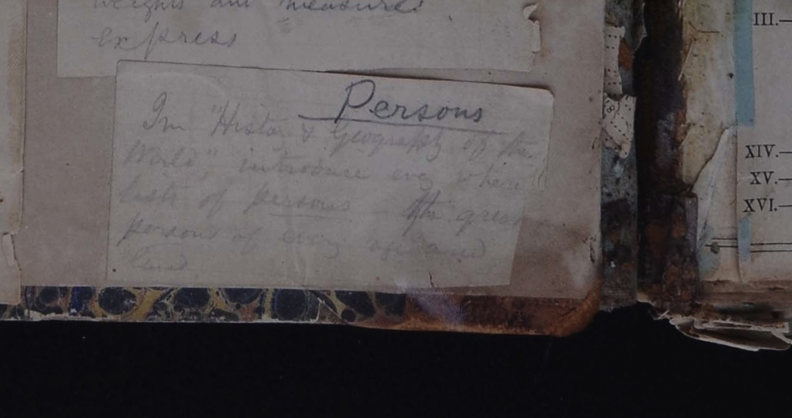
The scrapbook may also be the most concentrated source for analyzing Whitman’s knowledge of global cultures, with its hundreds of pages of maps, images, and narrative descriptions of world culture, geography, and history updated by items Whitman clipped from newspapers and magazines relating to those regions and peoples. This scrapbook will be a key document in a series of curated web pages we propose to create for this phase of the project, which are described in detail below (see “Dissemination”).
Figure 4. Detail of paste-on, inside front cover of Whitman's geography scrapbook, Ohio Wesleyan University Libraries, Special Collections.

Another substantial contribution the digitization of this volume will make is toward locating bibliographic source information for the many extracts and clippings it contains, only a few of which have been tracked down. These citations will be added to our growing “virtual library catalog” of Whitman’s reading—a feature of Walt Whitman’s Annotations that we propose to upgrade during this grant period, as described in the next section.

History, Scope, and Duration of the Project

An edition of Whitman’s marginalia was first proposed at the annual Whitman Archive group meeting in July 2005. In 2005-2006, initial discussions of the scope and nature of Whitman’s marginal annotations led the project director to look at other marginalia projects and online interfaces for them for guidance. As few of these had been created at that time, a brainstorming session and extended email conversation were held in summer 2006 at Duke University with participants from Duke Library’s digital projects group, professor Timothy Lenoir’s digital humanities group, and humanities and social science scholars with experience working with marginalia and other complex multimedia documents. The conclusion of this working group was that the Archive’s extant stylesheets were incapable of representing marginal annotations, and that current open-source solutions to both the capture and the display of search results with documents of this mixed nature were also unavailable. In response to this, we applied for and were awarded a Digital Humanities Start-Up Grant to draft an interface and encoding scheme. This grant also supported the digital imaging of 100 annotations documents from Duke’s Special Collections. A later version of the software resulting from that project is now also being used at Melville’s Marginalia Online, and Walt Whitman’s Annotations is still using many of the schema elements we created at that time.

Between 2011 and 2014, this project was funded by an NEH Humanities Collections and Reference Resources Grant (PW-50772-11). This grant supported a three-year project to preserve and give free electronic access to Walt Whitman’s manuscript annotations, to be hosted at the Walt Whitman Archive (http://www.whitmanarchive.org). For the grant period, we proposed to scan, transcribe, encode, and prepare for web display 800 pages of such documents, and in the process to lay the groundwork and infrastructure for an extensible archive of the whole corpus. To enable that work, we proposed to create a spreadsheet with a list of all known annotations documents and encoding guidelines for our XML versions. To present our gathered materials, we proposed to develop two interfaces: one for navigating the document scans and transcriptions (fig. 5), and one, database-driven, that presents a queryable hand list of texts that Whitman is known to have read (fig. 6).
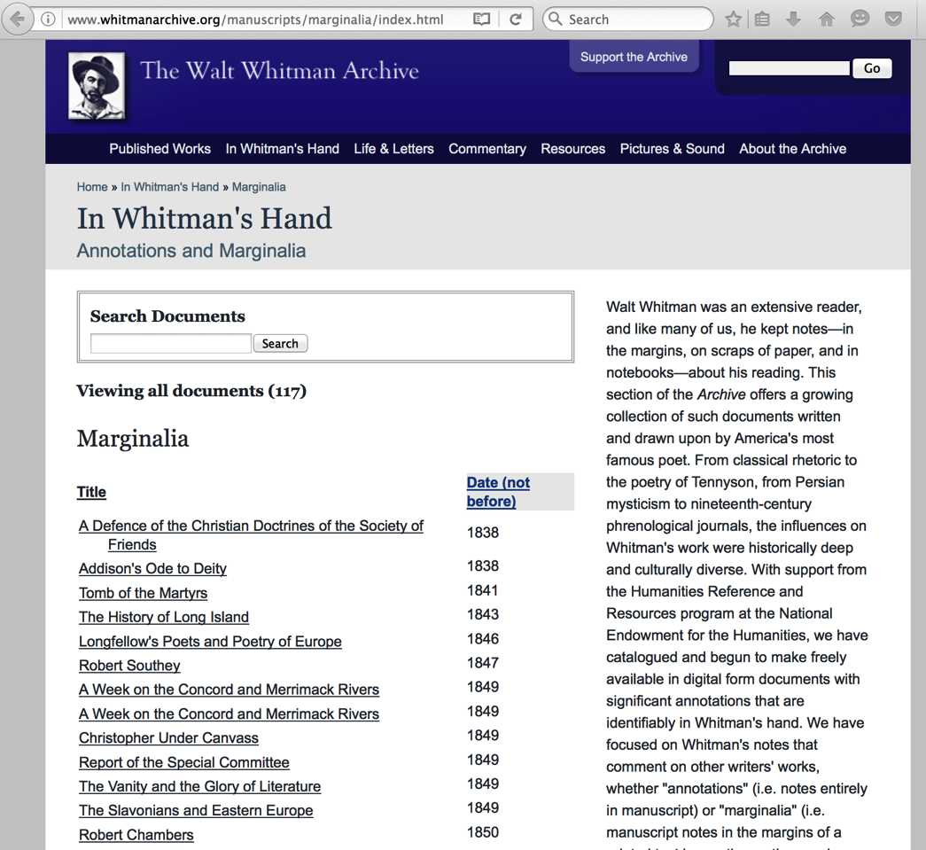
In the previous grant period, we identified and obtained scans of as many documents as we could. We estimated that we would obtain 2,300 images in total over the course of the grant period. Thanks to the generosity of our partner archives, we were able to afford to obtain many more images than we planned, including those from documents discovered in the process of the work: in the end, we gathered around 4,450 page images. Only half of these (the number promised in our work plan) have gone through the Archive’s documentation and storage process, so much work remains in this area; we propose to process 1200 images, upload them to a digital management system for long-term preservation, and record information about them in the Whitman Archive tracking database during the period applied for here. This work will be performed by graduate research assistants (GRAs) at the University of Texas. (Many more images remain to be obtained at the Library of Congress. Fortunately, the Library is currently digitizing its Whitman holdings; they have already made a sizable portion of their Whitman materials publicly available—the Thomas Harned collection of Walt Whitman—and the announced plan is for the Library to make the even larger Charles Feinberg Collection of Walt Whitman freely available as well.)
Figure 5. Index page for Walt Whitman's Annotations screenshot. <http://www.whitmanarchive.org/manuscripts/marginalia/>

In the previous grant period we transcribed, checked, proofed, found bibliographical information for, and published 800 scans’ worth as promised—some 117 documents in total. As Whitman’s annotations are added to the archive, they are tagged with identifiers and cross-referenced to other materials already on the Archive; all XML files and images are downloadable. During the previous funding period we also created interfaces for users to access the documents, published an introduction to the collection, and created a database of Whitman’s reading (currently listing 442 items), partly derived from the documents we encoded and partly from secondary sources. We apply now for funding for a two-year project to continue preserving these annotations and providing free electronic access to them at the Archive. For the purposes of this two-year project and with NEH support, we propose to continue transcribing, encoding, proofing, and making available to the public documents with significant annotations that are identifiably in Whitman’s hand, focusing on the scrapbook described in the previous section and an additional 200 scans, for a total of 1400 scans. Those additional scans will be selected for their relation to four thematic groupings, described in detail in the “Dissemination” section below. This work will be performed by GRAs and the PI at the University of Texas.

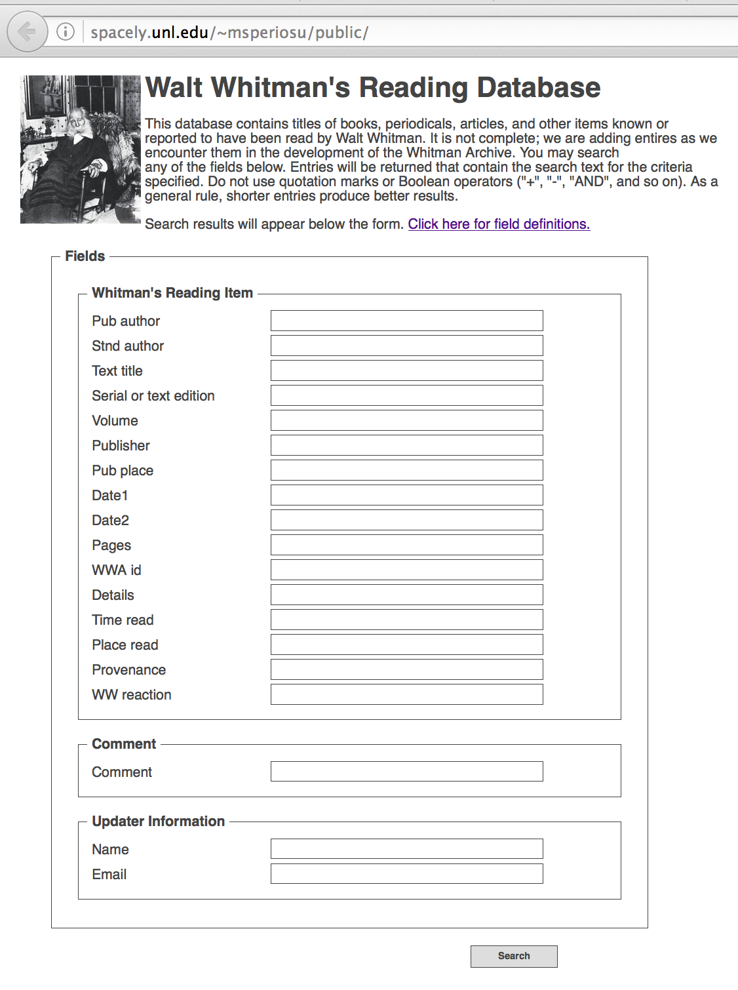
Encoding more documents with accompanying facsimile images is our main deliverable, but we also propose using part of the funds to expand our database of Whitman’s reading by at least 200 entries and to convert it to XML with a SOLR and XSLT interface. (We are in the planning stages of adapting the side-by-side document viewer we created as well, but that will be an undertaking of the Archive as a whole, since the viewer could be used in many sections of the site.) The database features basic bibliographic information about each text Whitman read, a brief description of his reaction (if known), and a “source” field describing the evidence for the assertion that Whitman read a particular text.

After designing the data structure and the initial interface, we found that the MySQL and PHP architecture were difficult to maintain, hard to expose as data, and more powerful than we needed. The interface, too, was not easy to integrate with other Archive resources, one of our key points of leverage as an organization. In consultations with the Archive’s technical staff and with Carl Stahmer, Director of Digital Scholarship at the University Library at UC-Davis, we determined to migrate to an XML format for the data, and present it using a faceted SOLR search with XSLT stylesheets. The data will then be more easily manipulable, available for download as a set, automatically integrated with other Archive resources, and encoded in a way that does not require us to train data enterers on a new technology. This work, as well as day-to-day maintenance, final proofing of documents, and publication, is subcontracted to the University of Nebraska and performed by staff at the Archive and the Center for Research in the Digital Humanities.
Figure 6. Whitman's Reading Database screenshot. <http://spacely.unl.edu/~msperiosu/public/>

Methods and Standards

This project draws on a range of technical frameworks. The procedures, standards, and technologies described below have been chosen both with best practices and protocols for scholarly preservation in mind and with an eye to the rapidly changing state of open-source tools for this kind of work. While we are reasonably certain of the technological configuration for the project, then, we have tried to indicate aspects of that configuration that may shift over the intervening months.

The Walt Whitman Archive
The Whitman Archive sets out to make Whitman’s vast work easily and conveniently accessible to scholars, students, and general readers. We have been providing free access to carefully preserved Whitman material for the last twenty years, and we have projected another fifteen years of work. The Archive’s long-term goal is to encode and to provide digital images of all the documents in Whitman’s vast oeuvre, including manuscripts, letters, notebooks, daybooks, and published work. Since 1995 the Archive has received generous support from several universities, from four different federal agencies, and from two private foundations. During this time we have garnered positive publicity in the Chronicle of Higher Education, the Washington Post, the American Scholar, PMLA, the Arab Times Online, the BBC, The Guardian, India Times, and other publications. The 2007 edition of American Literary Scholarship says that the Whitman Archive “may be the most important editorial undertaking in the history of Whitman studies.” Our work in creating an integrated finding guide to Whitman’s dispersed poetry manuscripts has been honored with the C. F. W. Coker Award from the Society of American Archivists. The project is hosted on UNIX servers running Tomcat and Cocoon, with XML documents encoded in TEI P4 and P5. Over the next few years the Archive will complete its migration of all XML documents to P5 and will move away from Cocoon to a SOLR-and-XSLT-based structure.

Original Document Handling
All document handling and imaging covered in this proposal has already been completed by conservators at the institutions possessing the originals or by Archive staff in the Library of Congress, using a digital SLR camera (Canon 5D) in a stand and light environment approved by LOC staff.

Image Processing, File Storage, and Backup
All images received from library digitization services or collected by members of our team by digital photography are converted into lossless TIFF (Tagged Image File Format) files at the maximum possible resolution. These master images are in color whenever possible, and in grayscale otherwise. As the image files are collected, they are added to a central repository on the Walt Whitman Archive GNU/Linux web servers at the University of Nebraska-Lincoln and renamed according to the Whitman Archive schema, indicating the source, timestamp, and a unique identifier. Copies of the master images are also kept on our development machines; uploaded to web space using Box, a secure content and online file sharing platform; and deposited in the UNL Libraries’ preservation system, Ex Libris Rosetta. Source code associated with the project is stored on an SVN versioning system hosted by the Center for Digital Research in the Humanities; we anticipate that this feature will be transitioned to GitHub to facilitate public access to our resources.

TEI Markup Levels
We use the current Whitman Archive encoding guidelines to encode our transcriptions in TEI-compliant XML markup. This includes standard MARC metadata about each object, as well as the assignment of a unique identifier within the Whitman Archive (the Whitman Archive ID) to each document. This ID is a key referential linking mechanism within the Archive; once assigned, the transcriptions will be linkable to any other XML document in the Archive. We also assign, where appropriate, a Work ID, which allows individual parts of a transcription to be linked to published works of Whitman’s to which they contributed. Under the Digital Humanities Start-Up Grant, we created a small number of extensions to the current Whitman Archive DTD (Document Type Definition) and honed several of the uses of attributes to suit the peculiar relationship between space and textual content in these documents (see the links in Appendix B). While the manuscript encoding captures a range of textual features such as strikeouts, insertions, erasures, and so forth, much of the content of the annotations documents is printed text—the original text on which Whitman made comments. Much of the capture of printed text is automated (often based on extant freely available OCR text), and markup of printed text is minimal (indicating source information, heads, paragraphs, block quotes, and illustrations). Our implementation of Schematron facilitates the creation of uniform XML (in particular by enforcing a controlled vocabulary for attributes, identifiers, and repositories) across the various sections of the Archive.

Documentation
We use the project management tools SVN and Trac to create a workflow that is largely self-documenting. All revisions to all files associated with the project are tracked in our version control repository, and project tasks and milestones are managed in an issue tracker, as well as through the Archive’s Wiki and Changelog blog for reporting changes publicly. Project data is backed up in a timely and secure manner. We also provide XML schemas for our custom document formats, and image and XML files, with complete credits information, are downloadable from the index pages of each document.

Sustainability of project outcomes and digital content

Day-to-day maintenance of Whitman Archive is supported in part by an endowment established under an NEH Challenge Grant and by the Center for Digital Research in the Humanities at the University of Nebraska-Lincoln. At the point that the Whitman Archive is no longer in an active production stage, the University of Nebraska-Lincoln University Libraries will assume full responsibility for the long-term maintenance of the project. This work will be supported in part by endowment funding for Whitman Archive. The current sustainability plan involves deposit of Archive assets in Ex Libris Rosetta, and Archive staff have deposited almost all of the Archive’s TIFF images in Rosetta for preservation purposes. The University Libraries maintain a dark archive and is a member of the Digital Preservation Network (DPN), the mission of which is to preserve the scholarly record for future generations (http://www.dpn.org/). A further piece of the Archive’s sustainability plan is making the entirety of the Whitman Archive as open as possible. The sustainability of the Archive is advanced when its materials are readily available for others to build on and to curate in new and complementary ways. The Whitman Archive offers free public access to online resources and distributes its content under a Creative Commons license. Our text encodings are available for download and can be reused according to the terms of our CC license.

Dissemination

The primary means of dissemination will be free public online access at the Walt Whitman Archive. Our texts are available for download and can be reused on a non-commercial basis. Over 650 other sites around the world link to the Walt Whitman Archive, and the site is woven into the coursework of hundreds of classes across the U.S. The Archive sees over 30,000 unique visitors weekly during the academic year, from all over the globe. The Archive is also being made accessible through an API created to expose data from many projects hosted by the Center for Research in the Digital Humanities at the University of Nebraska-Lincoln. Major milestones in the publication of the annotations will periodically be disseminated on the Whitman Archive’s email list, social media entities, on the TEI email list, and at other scholarly editing conferences such as the Society for Textual Scholarship, the Modern Language Association, Digital Humanities, and the American Literature Association annual meetings, both to raise awareness about the resource and to solicit feedback on its functionality. The Archive is also often analyzed as a model project at the nexus of digital humanities and scholarly editing. The October 2007 issue of PMLA, the leading journal in literary studies, featured an exchange focused on the Whitman Archive, and the journal Archive (2011) offered an extended discussion of the Whitman Archive from five different contributors. Evaluation of results and workflows will be pursued during the annual two-and-a-half day meeting (customarily in June or July) with the larger Whitman Archive staff and consultants at the University of Nebraska-Lincoln. All project participants and implementers of our software, such as the Melville’s Marginalia Online project, will be asked to reflect in writing on the progress of the project as a whole and to suggest directions for future development.
Beyond the Archive, all of us working on this project experienced intense interest from each of the audiences we presented the project to, as well as from individual researchers who heard about our work. We anticipate the use of these materials in academic research will become much more common in the coming years, both by historians and by those interested in literary history, the American nineteenth century, and Whitman’s world. We measure the access to Whitman’s Annotations by using the Archive’s web traffic software (which include both Google Analytics and a standard UNIX usage measurement tool, AWStats). Within the first six months of the Whitman’s Annotations section’s publication, it received 2,668 visits from web users, an encouraging number. However, based on our experience promoting the previous phase of this project, we are proposing an expansion of our efforts to draw attention to the annotations.
Because these documents are organized by the annotational practice that Whitman employed (e.g. annotation or marginalia), rather than by theme, author, or title, users may have trouble knowing where to start, beyond employing our keyword search and results faceting options. As the collection grows, we anticipate this effect will become more pronounced. Borrowing a tactic from institutions (such as the Library of Congress) with similarly heterogeneous collections, we propose to create curated subsections of the marginalia and annotations collection. In collaboration with the PI, the GRAs working on transcription and encoding will create short narratives to accompany image-heavy web pages that organize sets of marginalia and annotations documents around themes of interest in the humanities broadly, but that also bring little-studied Whitman documents to light. The four clusters we project would each incorporate both new material encoded during the grant period and previously published material. The topics we propose are these:

Whitman and World Culture: The Ohio Wesleyan scrapbook is, in effect, organized by the planet’s cultures, and provides a magnificent platform for exploring Whitman’s learning about world history, his era’s theories of civilization, and particular cultures’ growth and transformations. This section would also highlight Whitman’s reading in such works as Volney’s Ruins, and would contain a subsection highlighting Whitman’s little-studied readings in African history and Indian literature, religion, and history, including his notes on “The Hindu Drama,” “Indian Epic Poetry,” and the Bhagavad Gita.

Whitman and Islam: Scholars have long had an interest in Whitman’s relationship to non-Christian religious traditions, but recent public conflicts have made an exploration of U.S. writers’ complex relations to Islam particularly urgent. This section will explore what we know of Whitman’s readings in and reactions to the history and culture of Islam, grounded in his notes on “Ferdusi, and the primeval mythologists of Hindostan” held in the New York Public Library’s Berg Collection and the Harry Ransom Center’s copy of Whitman’s annotated Rubaiyat of Omar Khayyam.

Whitman and English Literature: Kenneth Price long ago argued that Whitman’s relationship to the English literary tradition was deeper and less fractious than scholars had thought. For the first time, the materials Price based his influential argument on are being gathered in one place. This section will collate important documents relating to Whitman’s development of his peculiar literary form, his attitude to old-world hierarchical social order and its effect on literary art, and his attitude toward the role of the poet in society. Materials on Chaucer, Milton, Shakespeare, and Tennyson will be the centerpieces of this section, which will draw heavily on materials from the Library of Congress and Duke University’s Trent Collection.

Whitman Reads Brooklyn: While the other curated sections focus on far-flung themes, this one turns to the poet’s rich local life, particularly in his early career. Recent discoveries of Whitman’s early periodical publications have enriched our picture of his life in, and in relation to, Brooklyn, New York. Not only is Brooklyn a key literary figure in Whitman’s work, but it was an important site of his civic engagement. This section will highlight a range of manuscripts and clippings as well as Whitman’s annotated copies of The Pioneers of New York, History of Long Island, and Lomas and Peace’s The Wealthy Men and Women of Brooklyn and Williamsburgh. This section will also provide suggestive links to Brooklyn-focused documents from the Archive’s growing collection of Whitman’s journalism.

Work Plan

Months 1-6
- Set up work flow and coordinate reading database conversion and interface development at annual summer Whitman Archive planning meeting (All)
- Define schema for reading database (UNL)
- Migrate reading database to XML (UNL and UT)
- Create draft SOLR and XSLT interfaces (UNL)
- Process OWU scrapbook images (UT)
- Begin transcription and encoding of OWU scrapbook (UT)
- Draft and proof first curated section, “Whitman and Islam” (UT)
- Update Whitman Archive project tracking database (UT)
Months 7-12
- Complete transcription and encoding of OWU scrapbook (UT)
- Transcribe and encode documents related to second curated section, “Whitman and World Culture” (UT)
- Draft second curated section, “Whitman and World Culture” (UT)
- Publish first curated section; proof second curated section (UT and UNL)
- Process remaining images (UT)
- Proof and publish reading database (UT and UNL)
- Update Whitman Archive project tracking database (UT)
Months 13-18
- Publish second curated section (UNL)
- Proof and publish OWU scrapbook (UT and UNL)
- Transcribe and encode documents related to third curated section, “Whitman Reads Brooklyn” (UT)
- Draft third curated section, “Whitman Reads Brooklyn” (UT)
- Add 200 entries to reading database (UT)
- Discuss progress and plans, solicit feedback at annual summer Whitman Archive planning meeting (all)
- Update Whitman Archive project tracking database (UT)
Months 19-24
- Transcribe and encode documents related to fourth curated section, “Whitman and English Literature” (UT)
- Draft fourth curated section, “Whitman and English Literature” (UT)
- Proof and publish remaining encoded transcriptions and images (UT and UNL)
- Proof and publish third and fourth curated sections (UT and UNL)
- Update Whitman Archive project tracking database (UT)

Principal Staff

Matt Cohen, this project’s PI, is Associate Professor of English at the University of Texas at Austin and, since 2002, a contributing editor at the Walt Whitman Archive. He has prepared digital editions of Horace Traubel’s biography of Whitman, With Walt Whitman in Camden (9 vols.) and the first book-length translation of Whitman’s poetry into Spanish, Álvaro Armando Vasseur’s Walt Whitman: Poemas (1912). He led the first phase of the Whitman Archive’s NEH-funded effort to gather and digitize Whitman’s marginalia, the first installment of which was published in December 2015. He has published numerous books, editions, and articles in the areas of scholarly editing, bibliography, American literature, and book history, including the prize-winning monograph The Networked Wilderness: Communicating in Early New England (U. of Minnesota Press, 2010) and the forthcoming Whitman’s Drift: Imagining Literary Distribution (U. of Iowa Press, 2017). He is also the editor of a collection of essays forthcoming from Cambridge University Press, titled The New Whitman Studies: Twenty-First Century Critical Revisions. Cohen has organized several conferences in book history, textual scholarship, and digital humanities, and has served in leadership positions in the Society for Textual Scholarship, the MLA’s Bibliography and Textual Studies forum, and the MLA’s early American literature forum. He will devote part of his research time and two summers to the work on this project.
Nicole Gray, Research Assistant Professor in the Department of English at the University of Nebraska-Lincoln, will serve as Archive liaison and XSLT developer for this project. She has worked as project manager and associate editor for the Whitman Archive since 2014, and has co-edited or contributed to the publication of Whitman’s fiction, correspondence, marginalia, and notebooks. She has attended courses at the University of Virginia’s Rare Book School and the University of Victoria’s Digital Humanities Summer Institute, and published articles on editorial theory and practice that have appeared in PMLA, Scholarly Editing, Nineteenth-Century Literature, and The Papers of the Bibliographical Society of America. She will serve as editor of Scholarly Editing for its 2017 issue. She will commit 1.5 months of work over the two years of this project.
Karin Dalziel joined Nebraska’s Center for Digital Research in the Humanities in May of 2006, and is now the Digital Design/Developer Specialist. On this project she will be responsible for coordinating the conversion of the reading database to an XML and SOLR basis. Dalziel has several years of experience with design, web standards, encoding systems, and XSLT and works with team members to create attractive, accessible, and usable websites. Dalziel received her Bachelor’s in Fine Art from UNL in May of 2006 and a Master’s in Library Science from the University of Missouri-Columbia in 2008. She will commit 1 month of work to the project during its first year. Dalziel will be working with Jessica Dussault, a programmer/analyst at the Center for Digital Research in the Humanities, on this project. She will commit three weeks of work to the project during its first year.
The co-directors of the Whitman Archive are Ed Folsom, Carver Professor of English at the University of Iowa, and Kenneth M. Price, Hillegass University Professor of American Literature at the University of Nebraska-Lincoln. Folsom is the editor of the Walt Whitman Quarterly Review, the international scholarly journal of record for Whitman studies. He is the author of Walt Whitman’s Native Representations (Cambridge UP, 1994) and the editor or co-editor of six books about Whitman. With Kenneth Price, Folsom co-authored Re-Scripting Walt Whitman: An Introduction to His Life and Work (Blackwell, 2005). Price is also the author of Whitman and Tradition (Yale UP, 1990) and To Walt Whitman, America (U of North Carolina P, 2004), and the editor of two other books on Whitman. Folsom’s and Price’s essays on Whitman and their reviews of Whitman scholarship have appeared in numerous journals and books. For twenty years, the co-directors have shared responsibilities for the Whitman Archive and expect to continue to work as collaborators on it for years to come. Folsom oversees the Iowa center of the Archive, where he and an assistant generate the ongoing bibliography of Whitman-related materials. Price oversees Whitman Archive work at Nebraska while also co-directing the Center for Digital Research in the Humanities. On this project, Folsom and Price provide overall intellectual and editorial guidance and direction, proof encoded transcriptions and the curated sections, and publicize these contributions to the Whitman Archive. Price and Folsom will each dedicate as much time as necessary to meet the goals of this project.
With the exception of H.J. Jackson (who has retired from her faculty position at the University of Toronto), the advisory board members have agreed to remain on the board: Terry Catapano (Columbia University), Michael Winship (University of Texas at Austin), William Sherman (University of York), and Steven Olsen-Smith (Boise State University). Sherman and Olsen-Smith are leading textual scholars who possess theoretical, bibliographic, and methodological expertise on marginal annotations. Michael Winship is a renowned bibliographer and historian of nineteenth-century American literature; Terry Catapano is a sought-after consultant on the technological infrastructure--metadata, project architecture, interface and search design--of electronic humanities archival projects. This board will provide ongoing guidance and annual evaluation of the work described in the Work Plan. Reports will be delivered to the board by project staff in April of each funded year, and board members will be consulted regularly as the work goes forward.
Katherine Walter, Professor and Chair of Digital Initiatives & Special Collections, University of Nebraska-Lincoln Libraries, will serve as PI for the sub-award to the University of Nebraska. Two GRAs from the University of Texas’s English PhD program will perform transcription, encoding, image processing, and reading list updating, as well as researching sources for the curated sections. The GRAs will be committed exclusively to the project, both during the academic year and two summers.

