FIT3140

Voting Station: Project Scope

# Vision

This project is a motion detection based voting booth system that is implemented using Cloud databasing.

# Description:

The voting station uses an Arduino One board with a motion sensor wired in to control the web application sessions. To be able to vote in the voting booth, the user creates a long motion when entering that the motion sensor detects, this increments the VCA (Voters Currently Available) and CCA (Connections Currently Available). Once signed in, users are given a set of options to choose from and must select one to submit their vote. After the voting process is complete the server decrements the CCA by one which means the voter’s connection to the server has ended and they may no longer submit a vote. When the voter leaves the station, the motion detector should detect a short motion which decrements the VCA by one.

This system uses Google Firebase to implement cloud-based storage. Firebase allows the all user’s applications to be updated and synced in real-time and keeps the data even when the application is closed. The VCA and CCA are stored on the project’s firebase to ensure that they are always correct and there is no lag between them being incrementing. The server will make a new session available when VCA>CCA and close the session when CCA is decremented. This ensures that all voters that walk in to the booth are able to vote and that they are only able to vote once.

Visualization of system:

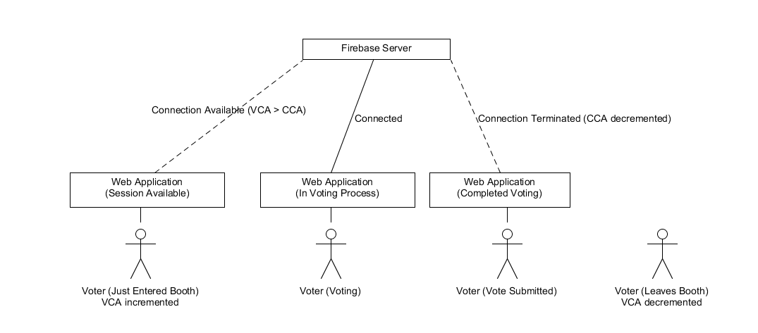

# Constraints:

* Relies on users to operate correctly:
  + Users may create a long motion when a short motion is required or vice versa. This would create incorrect values for VCA and CCA.
  + Users may deliberately abuse system by creating extra motions.
* Motion sensor may detect motion that is not created by a voter (insects etc.)

# Deliverables:

* Web Application: Voting application written in JavaScript/HTML
* Firebase: real-time cloud-based databasing
* Risk Register: Assessment of risks and methods of resolving