CO3 PROGRAMS

1. Work with built-in packages

**Calendar module**

Program:

import calendar

mm=int(input("enter month:"))

yy=int(input("enter the year:"))

print(calendar.month(yy,mm))

print(calendar.calendar(2022))

**Output:**

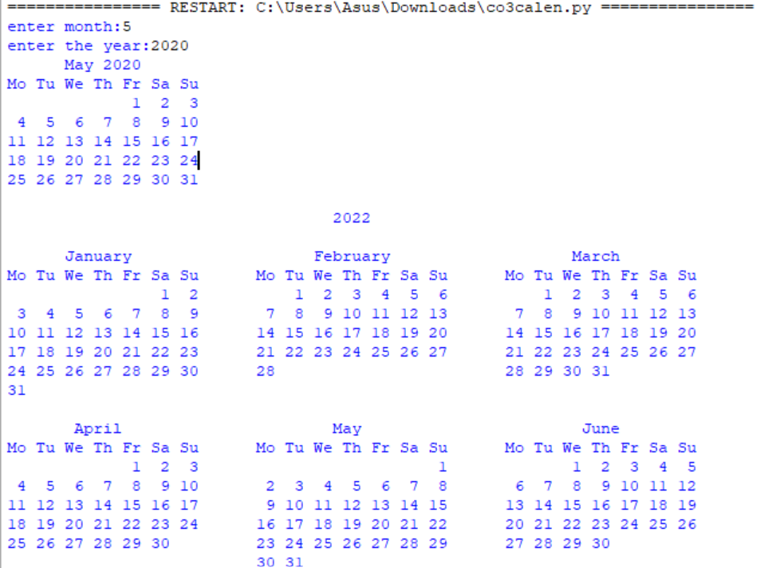

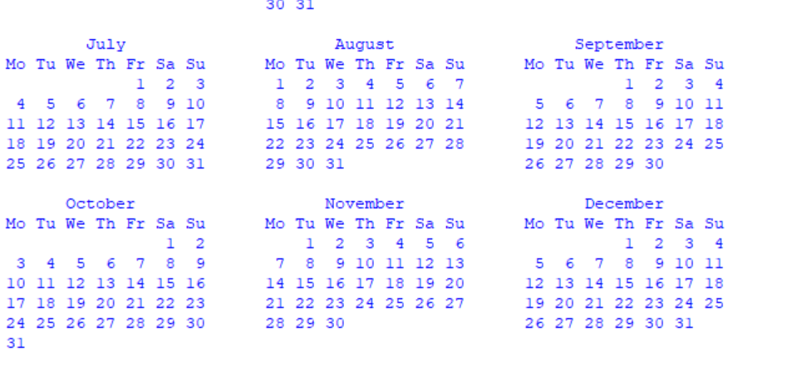

**Date-Time module**

**Program:**

import datetime

t=datetime.time(22,56,44)

print(t)

print("hour",t.hour)

print("min",t.minute)

print("se",t.second)

print("mis",t.microsecond)

print("***********************")

d=datetime.date.today()

print(d)

print("year",d.year)

print("month",d.month)

print("day",d.day)

print(":::::")

d1=datetime.date.today()

print(d1)

td=datetime.timedelta(days=2)

print(td)

d2=d1+td

print(d2)

print("====")

dt=datetime.datetime.combine(d,t)

print(dt)

**Output:**

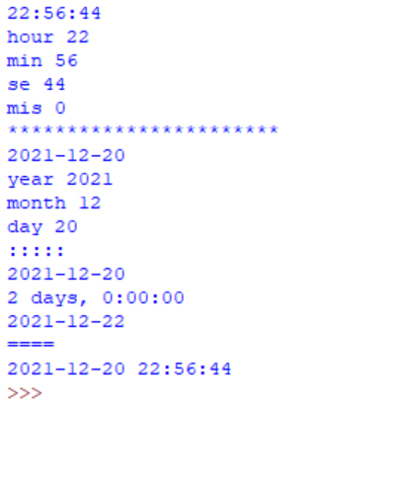

**Time module**

**Program:**

import time

print("current time in second",time.time())

print("===============")

print("current time",time.ctime())

print("===============")

print("current time after 30 sec:",time.ctime(time.time()+30))

print("===============")

t=time.localtime()

print("time:",t)

print("===============")

print("current month",t.tm_mon)

print("current year",t.tm_year)

print("current day",t.tm_mday)

print("current hour",t.tm_hour)

print("current miniut",t.tm_min)

print("current second",t.tm_sec)

print("===============")

**Output:**

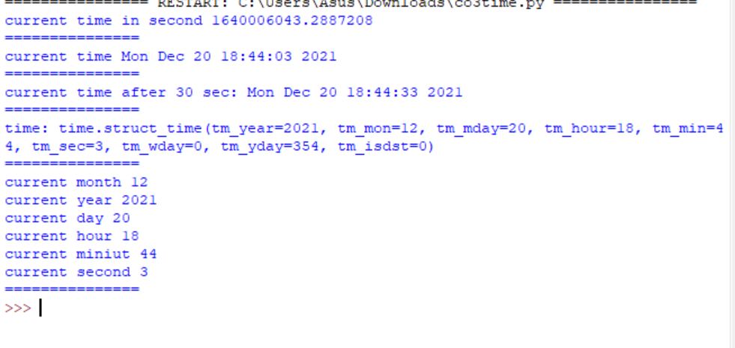**Math module**

**Program:**

import math

print(math.pi)

import math as m

print(m.pi)

print("===============")

from math import pi,sqrt

print(math.pi)

print(sqrt(4))

print("===============")

print("cos",math.cos(90))

print("===============")

print("sin",math.sin(90))

print("===============")

print("tan",math.tan(0))

**Output:**

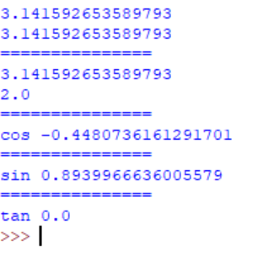

**Random module**

**Program:**

import random

list1 = [1, 2, 3, 4, 5, 6]

print(random.choice(list1))

print("*************")

import random

random.seed(5)

print(random.random())

print(random.random())

print("***********")

import random

r1 = random.randint(5, 15)

print("Random number between 5 and 15 is % s" % (r1))

r2 = random.randint(-10, -2)

print("Random number between -10 and -2 is % d" % (r2))

print("**************")

import random

list1 = [1, 2, 3, 4, 5, 6]

print(random.choice(list1))

string = "geeks"

print(random.choice(string)

tuple1 = (1, 2, 3, 4, 5)

print(random.choice(tuple1))

**Output:**

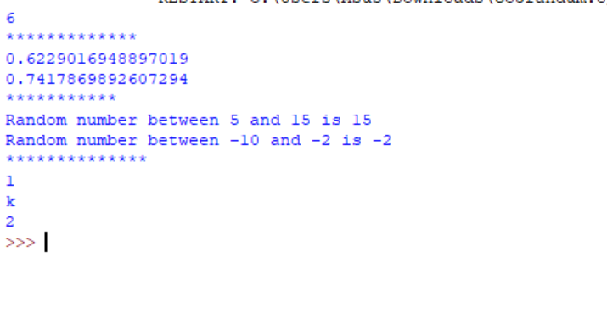

**Statistics module**

**Program:**

import statistics

l1=[1,2,3,4,4]

print("mean",statistics.mean(l1))

print("median",statistics.median(l1))

print("mode",statistics.mode(l1))

print("harmonic_mean",statistics.harmonic_mean(l1))

print("statistics_varience",statistics.variance(l1))

print("statistics_median_low",statistics.median_low([-11,5.5,-3.4,7.1,-9,22]))

**Output:**

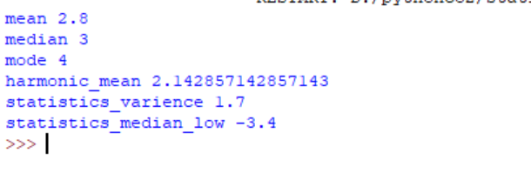

2. Create a package graphics with modules rectangle, circle and sub-package 3D-graphics with modules cuboid and sphere. Include methods to find area and perimeter of respective figures in each module. Write programs that finds area and perimeter of figures by different importing statements. (Include selective import of modules and import * statements)

**graphicsuse.py**

**Program:**

from graphics import rectangle

from graphics import circle

from graphics.ThreeD_graphics import cuboid

from graphics.ThreeD_graphics import sphere

l=int(input("Enter the length of rectangle: "))

b=int(input("Enter the breath of rectangle: "))

rectangle.area(l,b)

rectangle.perimeter(l,b)

print()

r=int(input("Enter the Radius of Circle: "))

circle.area(r)

circle.perimeter(r)

print()

l=int(input("Enter the length of Cuboid: "))

b=int(input("Enter the breadth of Cuboid: "))

h=int(input("Enter the height of Cuboid: "))

cuboid.area(l,b,h)

cuboid.perimeter(l,b,h)

print()

r=int(input("Enter the radius of Sphere: "))

sphere.area(r)

sphere.volume(r)

**Package : graphics**

**circle.py**

**Program:**

def area(r):

print("Area of Circle: ",3.14*r*r)

def perimeter(r):

print("Perimeter of Circle: ", 2*3.14*r)

**rectangle.py**

**Program:**

def area(l,b):

print("Area of Rectangle: ", l*b)

def perimeter(l,b):

print("Perimeter of Rectangle: ", 2*(l+b))

**Sub-Package : ThreeD_graphics**

**Program:**

**cuboid.py**

def area(l,b,h):

print("Area of Cuboid: ",(2*l*b)+(2*l*h)+(2*h*b))

def perimeter(l,b,h):

print("Perimeter of Cuboid: ", 4*(l+b+h))

sphere.py

**Program:**

def area(r):

print("Surface Area of Sphere: ",4*3.14*r*r)

def volume(r):

print("Volume of Sphere: ",(4/3)*3.14*r*r*r)

**Output:**

