**Co2 Programs**

1-Program to find the factorial of a number?

**Program:**

n=int(input('type a number : '))

f=1

for i in range(1,n+1): f=f*i

print ('factorial of',n, '=',f)

**output:**

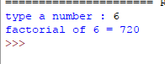

2-Generating the Fibonacci series of N terms?

**Program:**

n=int(input("type in the limit:"))

a=0

b=1

sum=0

count=1

print("Fibonacci Series:",end=" ")

while(count<=n):

print(sum,end = " ")

count+=1

a=b

b=sum

sum=a+b

**Output:**

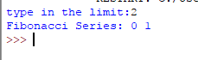

3-find the sum of all numbers in a list?

**Program:**

list1=[10,20,30,40]

total=sum(list1)

print("sum of list is:",total)

**output:**

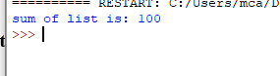

4-Generating a list of four digit numbers in a given range with all their digits even and the number is a perfect square?

**Program:**

from math import sqrt as s

for i in range(1000,5000):

if s(i)==int(s(i))and i%2==0:

print(i,end=" ")

**output:**

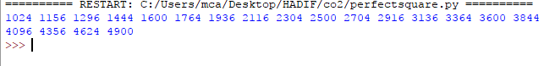

5-Display the given pyramid with step number accepted from user?

**Program:**

rows=int(input("type the number of rows:"))

for i in range(1,rows+1):

for j in range(1,i+1):

print(i*j,end=' ')

print()

**output:**

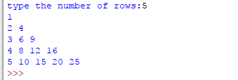

**7-**add ‘ing’ at the end of a string.If it already end with ‘ing’,then add ‘ly’

**Program:**

str=input("type a string:")

print("input string is:",str)

if(str.endswith("ing")):

str=str+'ly'

else:

str=str+'ing'

print("the formatted string is:",str)

**output:**

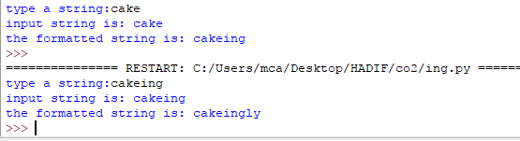

**8-**Accept the list of words and return length of longest word?

**Program:**

a=[]

n= int(input("Enter the number of elements in list:"))

for x in range(0,n):

  element=input("Enter element "+ str(x+1) )

  a.append(element)

  max1=len(a[0])

  temp=a[0]

for i in a:

    if(len(i)>max1):

        max1=len(i)

        temp=i

print("Longest Word:",temp)

print("Length of longest word :",max1)

**Output:**

**9-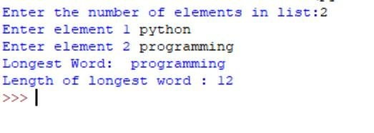**Construct following pattern using nested loop?

**Program:**

n= int(input("Enter the limit:"))

for i in range(n):

 for j in range(i):

     print ('* ', end="")

 print('')

for i in range(n,0,-1):

    for j in range(i):

        print('* ', end="")

    print('')

**Output:**

