**EXP No.1**

**DDL Commands – CREATE, ALTER, DROP**

Output:

1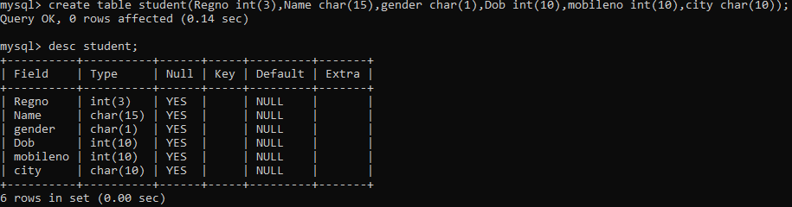

2.

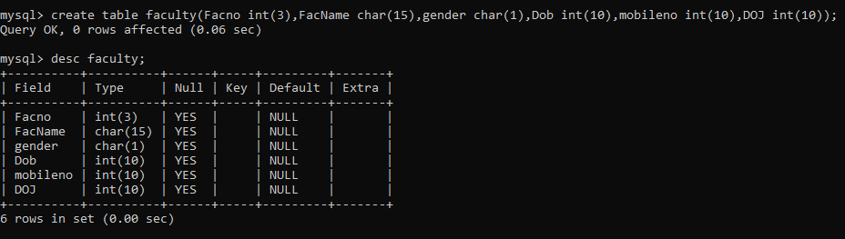

3.

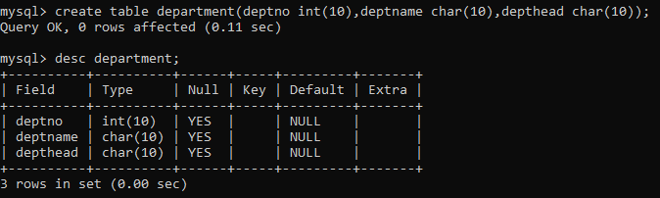

4.

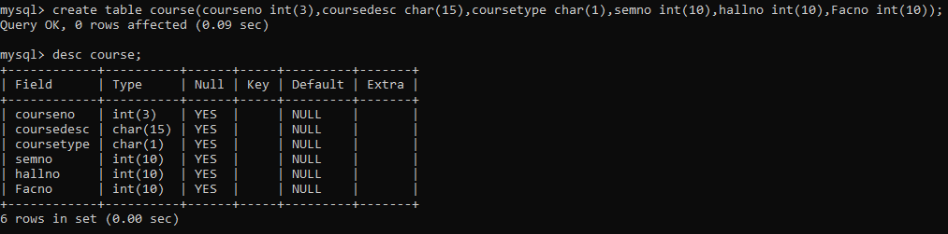

5.

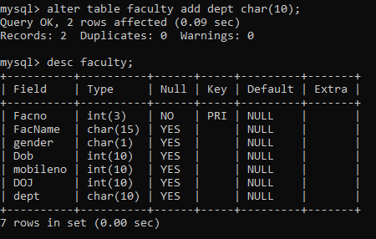

EXP NO.2

**DDL Commands with Constraints – PRIMARY, FOREIGN KEY, UNIQUE, CHECK**

Output:

1.

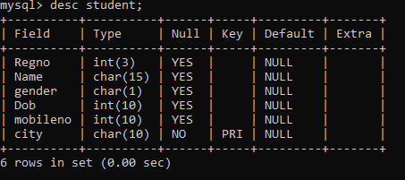

2.

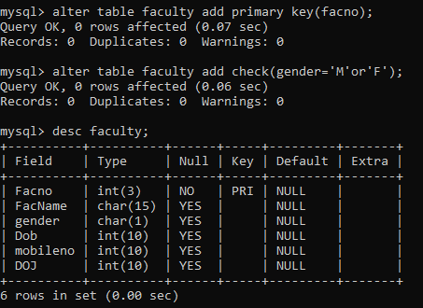

3.

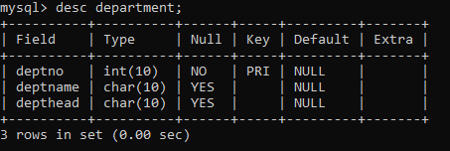

4.

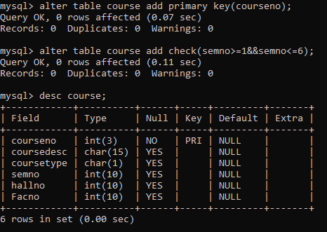

Exp no.3

**DML Commands – INSERT, SELECT, UPDATE, DELETE**

Output:

1.

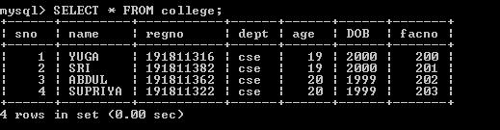

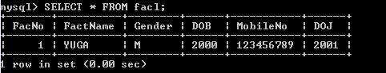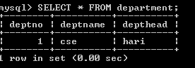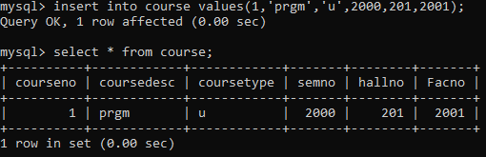

2.



3.



4.

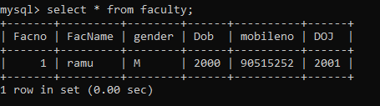

5.

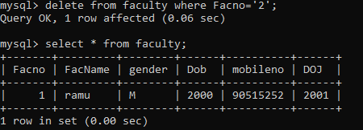

6.

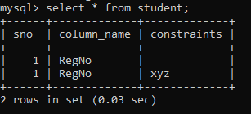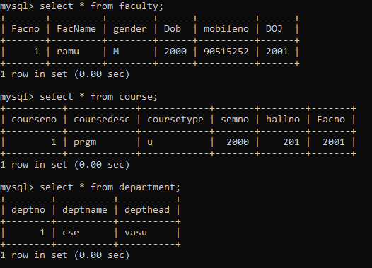

Ex. No.: 4

**SELECT with various clause – WHERE, pattern matching**

**Output:**

**1.**

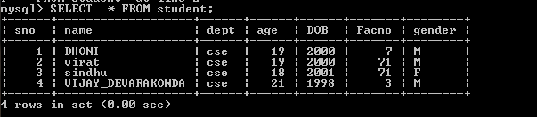

2.

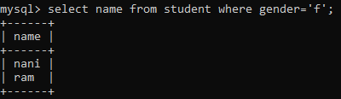

3.

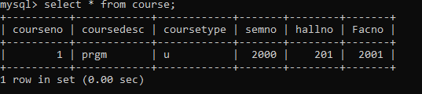

4.



5.

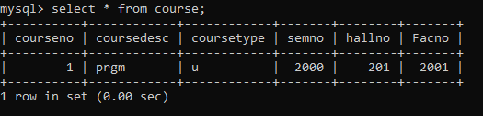

6.



7.

