Ex. No.: 5

**SELECT with various clause – BETWEEN, IN, Aggregate function**

Output:

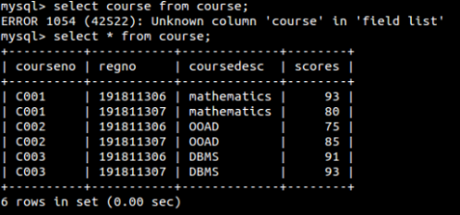

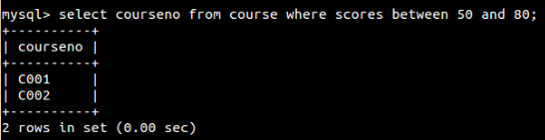

1.

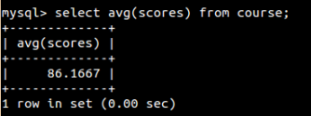

2.

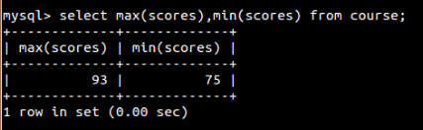

3.

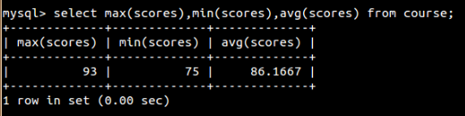

4.

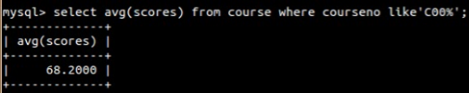

5.

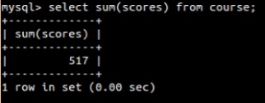

6.



7.

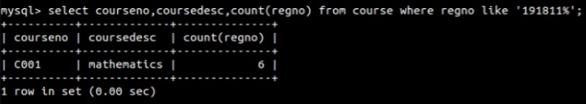

Ex. No.: 6

**SELECT with various clause – GROUP BY, HAVING,**

**ORDER BY**

Output:

1.



2.



3.

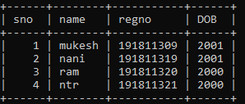

4.

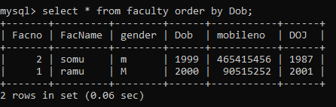

Ex. No.: 7

**SubQuery& Correlated Query**

**Output:**

1)

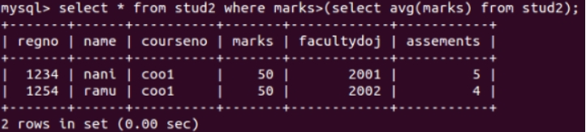

2)

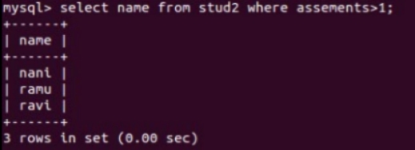

3)



4)



Ex. No.: 8

**Joins – EquiJoin, InnerJoin, OuterJoin**

**Output:**

1)

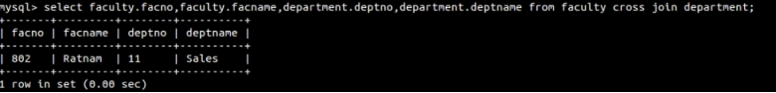

2)



3)

