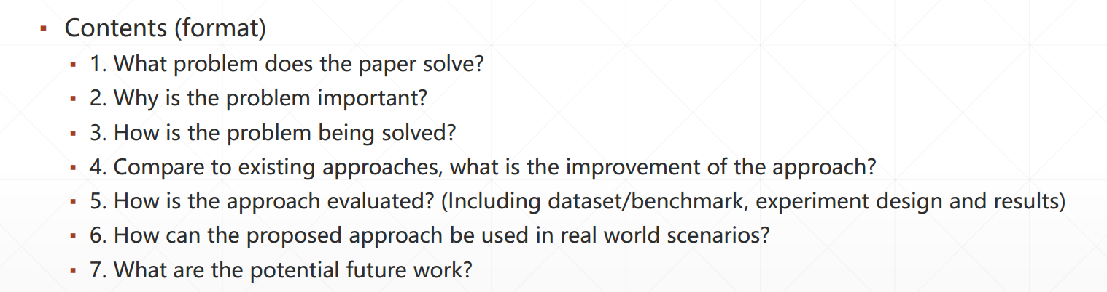

# What problem does the paper solve?

1. The  **difference of performanc**e including running time、 loss of fault detection between the two method——**test-suite reduction and regression test selection.**
2. How well if the two methods combined together
3. They present **a new criterion** to measure **the quality of tests** with respect to **software changes.**

# Why is the problem important?

1. Changing of the software is frequent and unavoidable. The regression testing may take a lot of time with the scale up. It will accelerate the testing speed with improvement of the efficiency.
2. It provides us with a consultant of balance between the time-saving and loss of fault detection

# How is the problem being solved?

1. experiments on 4,793 commits from 17 open-source projects
2. they propose a new test criterion called Change-Related Requirements which approximates the change-related faults
3. they combination the two approaches.

# Compare to existing approaches, what is the improvement of the approach?

The improvement of this approach can be evaluated in three ways——**number of tests running, change-related requirements,** **detection of change related faults.**

This paper compared the number of tests running in 17 different projects, from the experiment, we can see that **the combination of regression selection and regression reduction selects fewer tests** while the quality of the detecting is the same（both **two approaches run fewer tests on average compared with regression testing**）.**.**

This paper put forward a new metric named CRR（change-related requirements）to get **change related faults** which test suites need to find. The CRR focus on change which have more possibility of causing faults compared with broadly test suits and specific test suits. It could also be used as a criterion for comparing test reduction and test selection.

Test-suite reduction can miss on median up to 2.74% change-related statements and 5.93% change related mutants that regression test selection finds, while (safe) regression test selection cannot miss any change related fault that the full test suite can find.