CST2120 – Coursework 3 – Single Page Web Application

Ignas Lamanauskas M00655420

**Description of the project:**

My idea for single page web application was recipe sharing website. Website is offering variety of recipes from itself, but the main idea is that people can share their recipes as well just by completing easy form of recipe. Application is very user friendly because it is not necessary to register to share recipe with the others.

**Issues application has and what I didn’t managed to do:**

1. Main issue I have with this web application is when user creates a new recipe it’s gets added to a main page and all of its data is saved in JSON format, but unfortunately you cannot open the recipe itself to have a better view. I don’t know where the problem hides because when a new recipe is created it adds the same HTML code as hard-coded one, but it is not working (I explained this quickly in video presentation).
2. Image uploading is working and image gets uploaded to a “uploads” folder, but unfortunately, I can’t get it from the address and don’t know how to change the address. (I mentioned this issue in the video)
3. Image preview – when user chooses the picture to upload with his recipe, image is shown in a “square” as a preview. This was working and suddenly at some point it stopped and it’s not showing anymore. I could not fix it afterwards so I will leave code for it to maybe get some points.
4. MySQL connection – Unfortunately, I couldn’t make that recipe data when it gets created will be transferred to MySQL database. I can connect and insert hard-coded data inside my database but unfortunately, I cannot insert data from the function. (There is one picture of what I have tried and other similar ways but none of them were working).

**MySQL issue:**

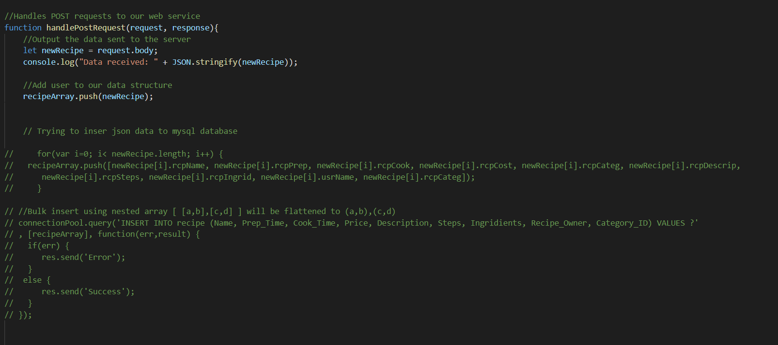

**Database design:**

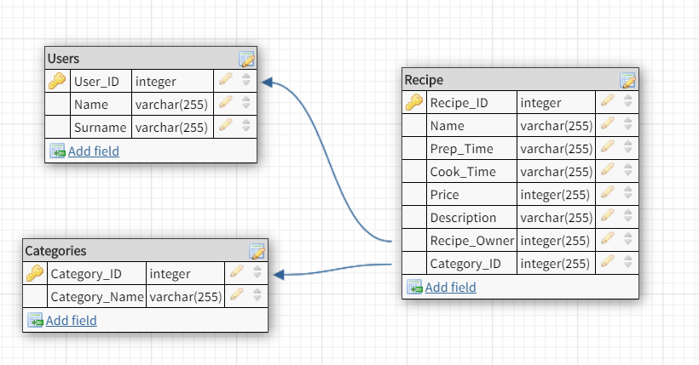

**Front-end Tests:**

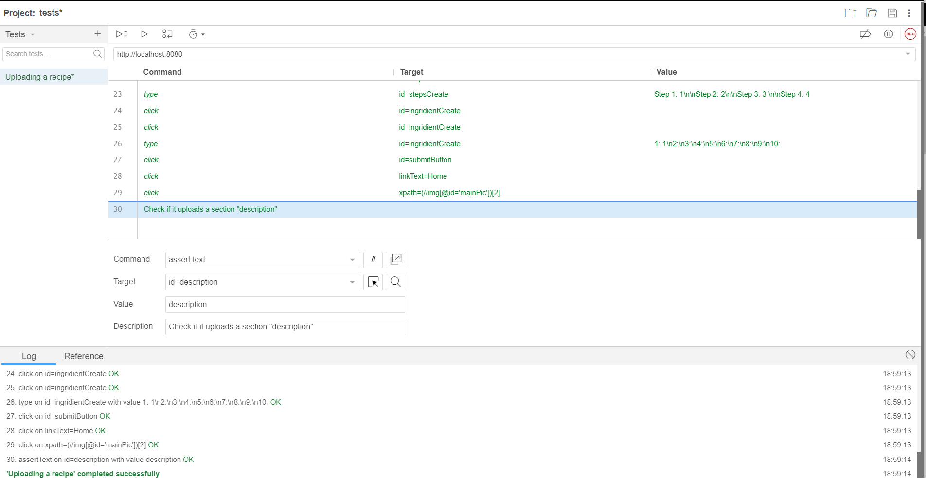

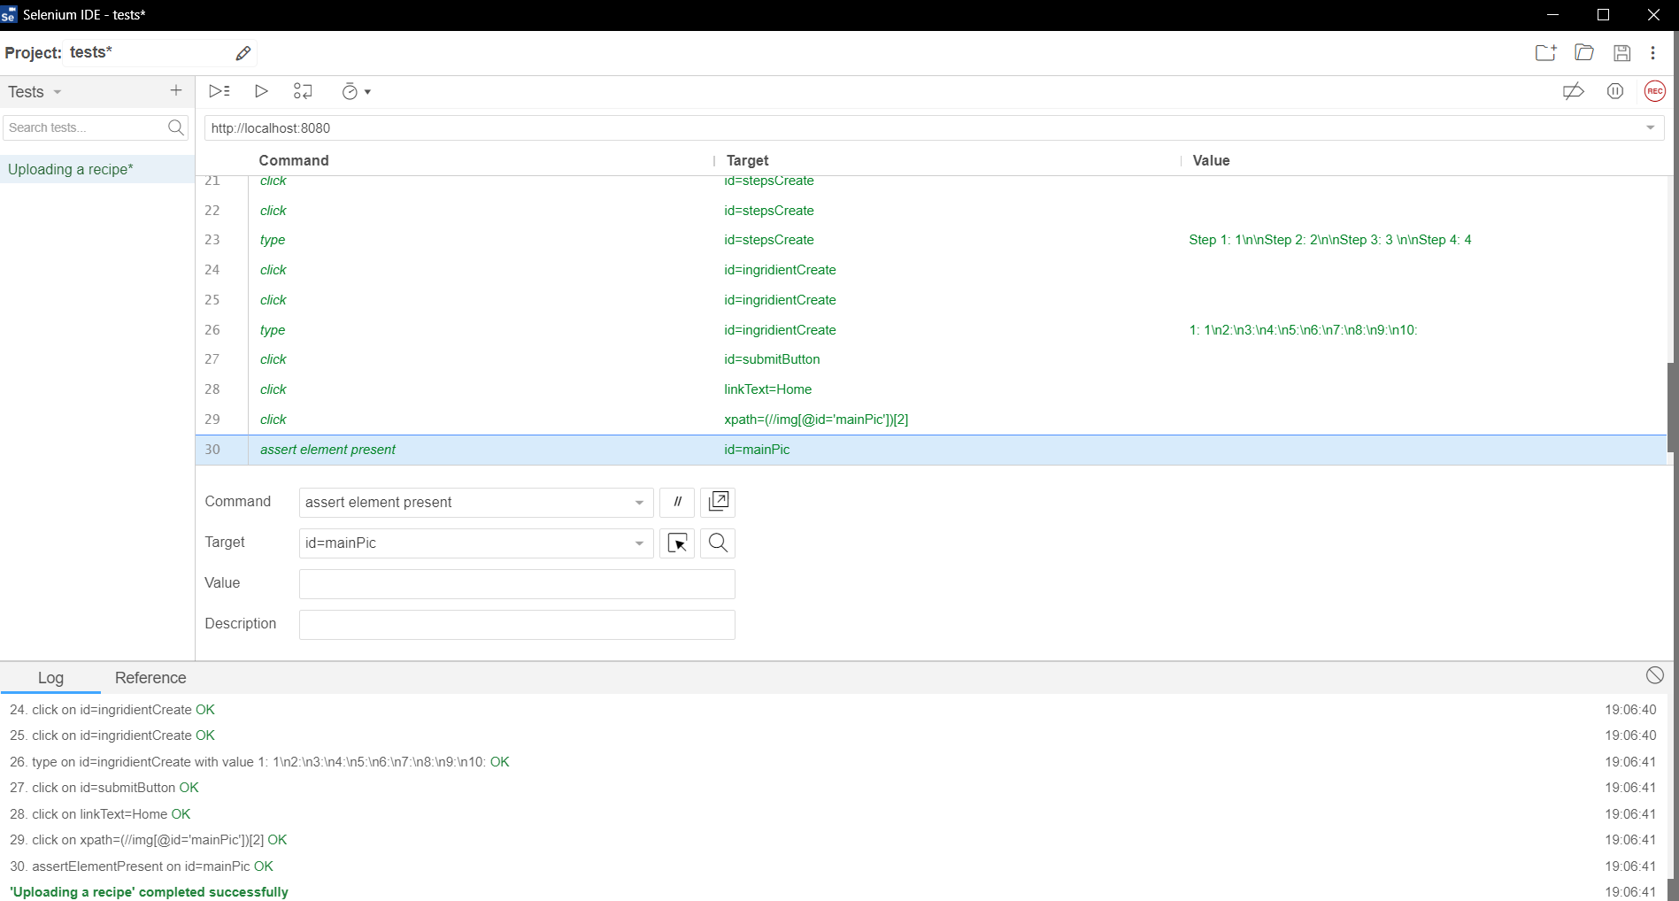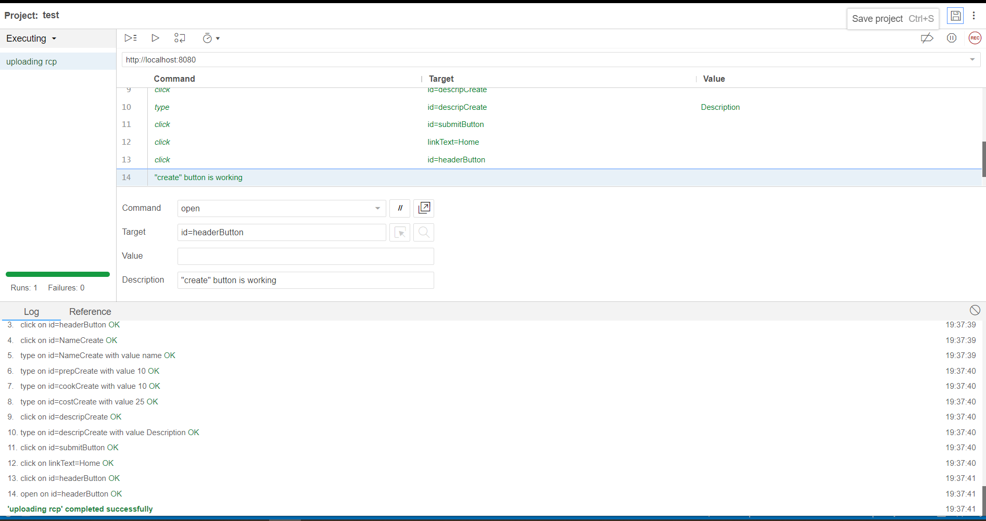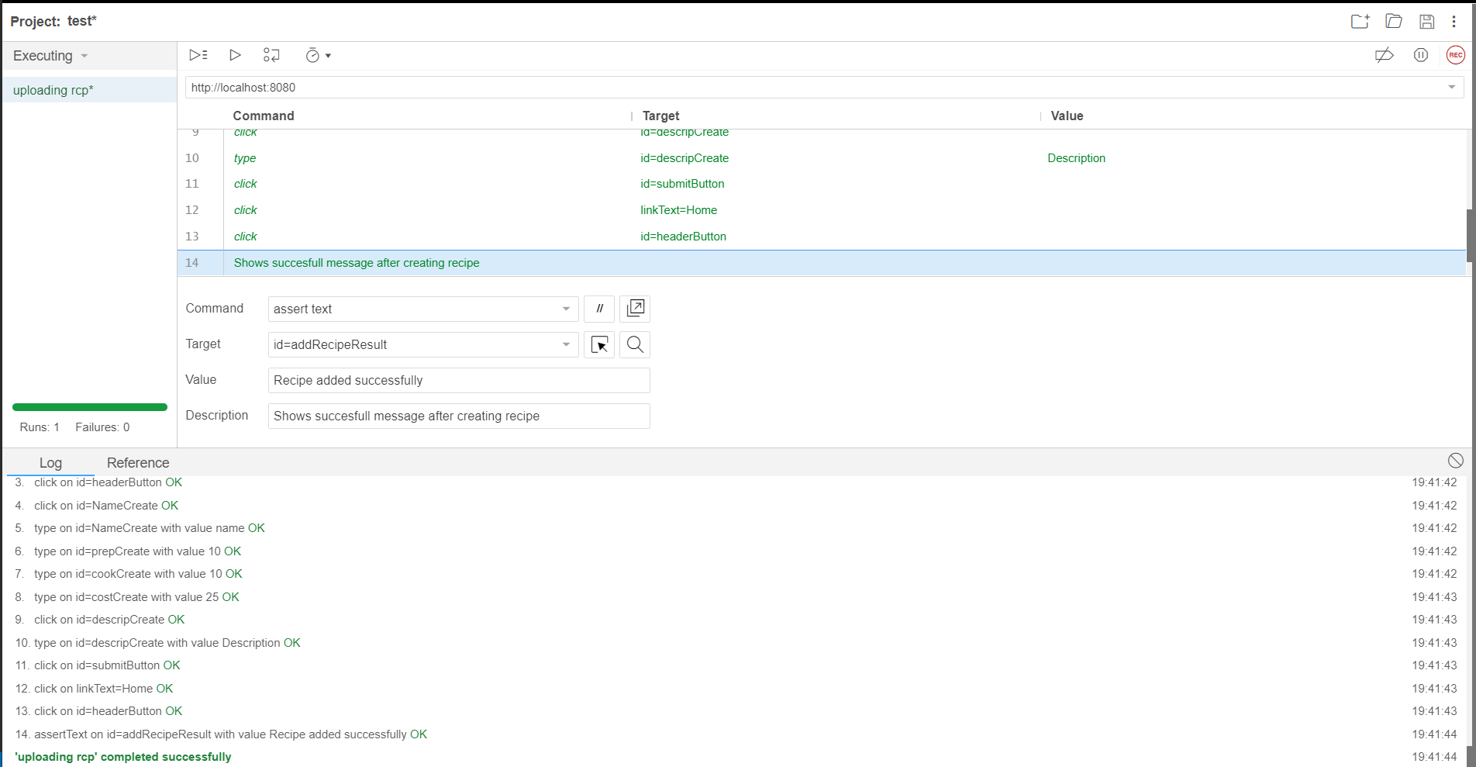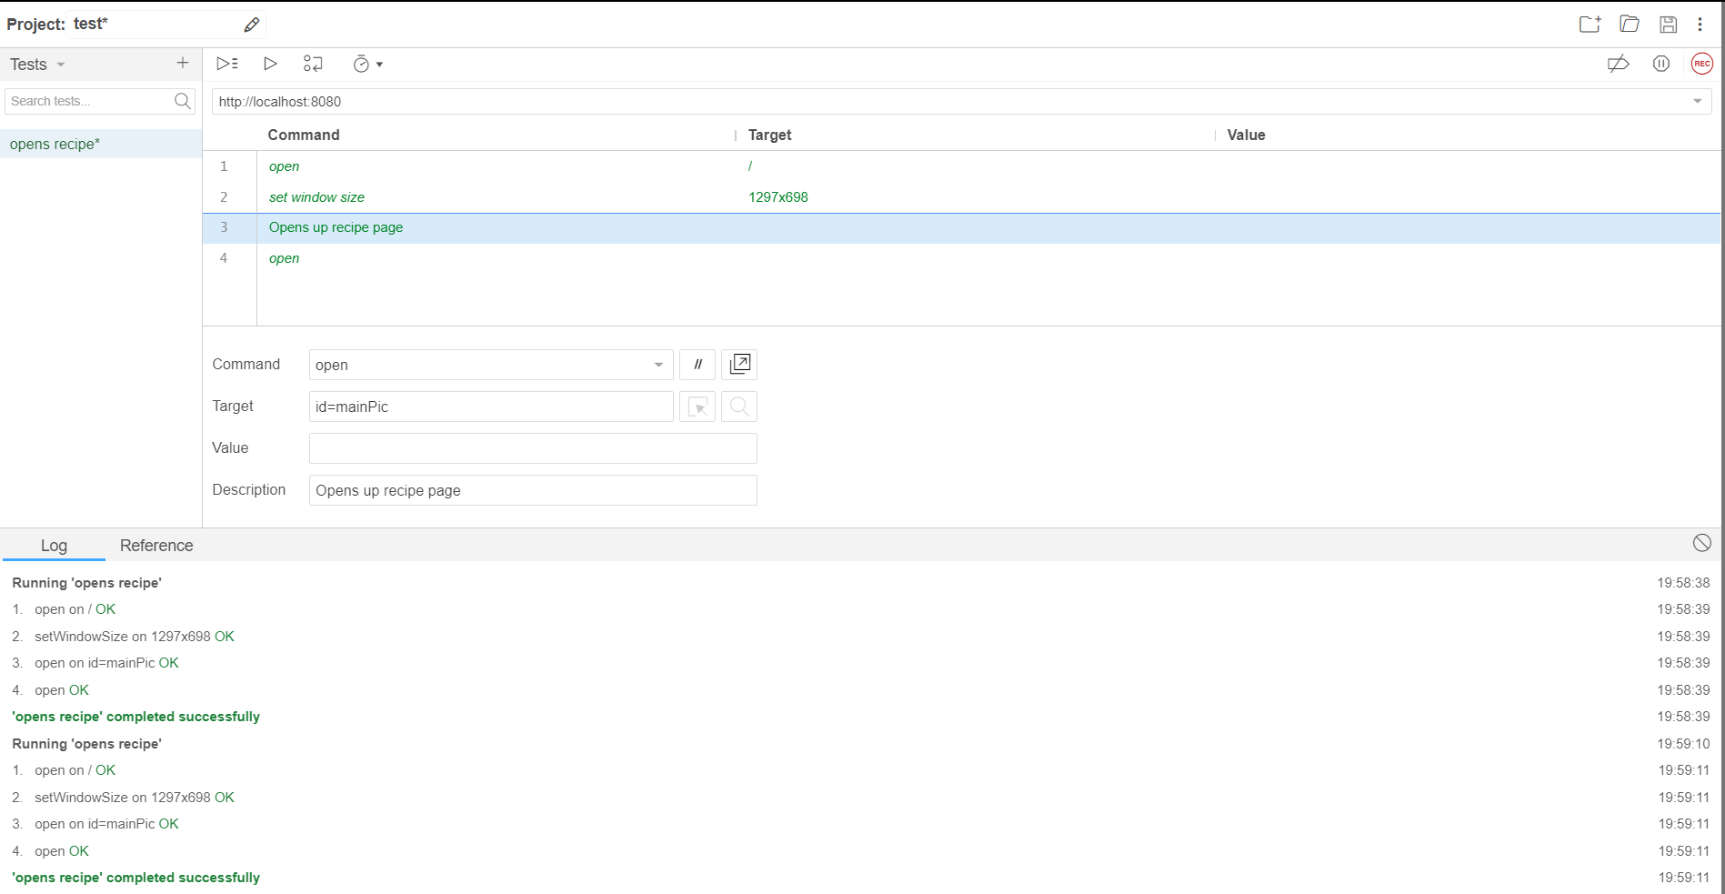

**HTML Test:**

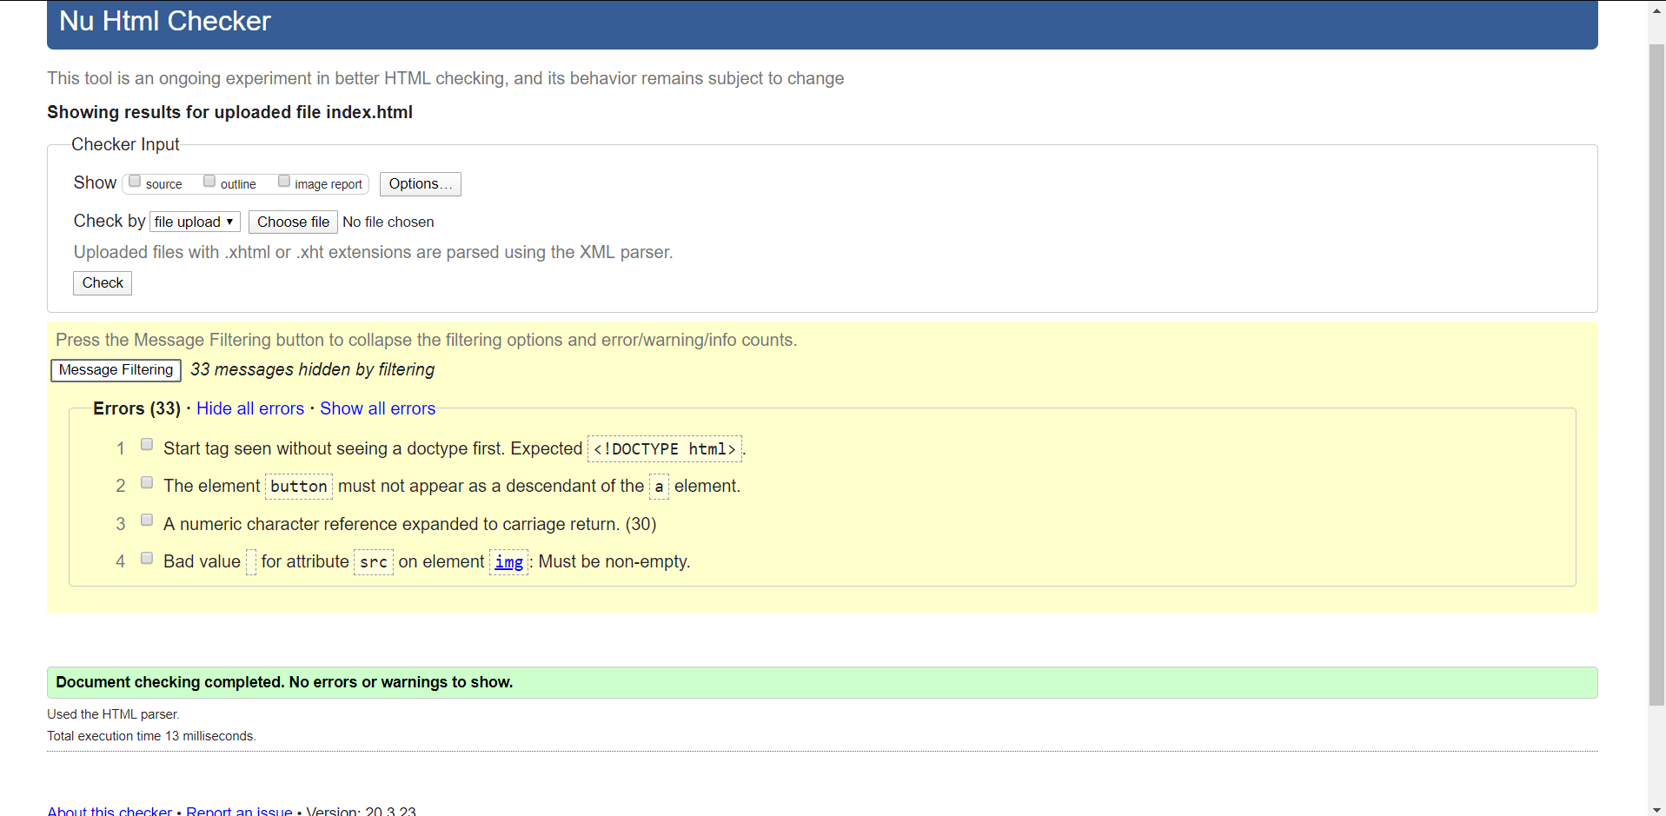

**Explanation:**  
1. I could fix this error but whenever I add this line to my code, some parts of the website change and I don’t know the reason why.

2. I wanted that image would be clickable to get transferred to another page and I didn’t know other way to do it.

3. That’s a weird error of “ ; “ in my recipe creation page of hard-coded steps and ingredients text areas, which I did not want to fix.

4. That’s for the image-preview function to be working.

**CSS testing:**

**1**

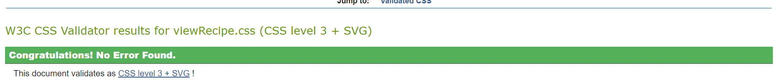

**2**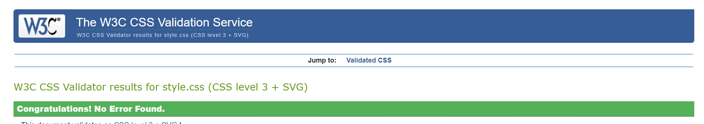

**3**

